Assessments of California, Oregon and Washington Stocks of Black Rockfish

(*Sebastes melanops*) in 2015

by

Jason M. Cope, David Sampson, Andi Stephens, Meisha Key, Patrick P. Mirick, Megan Stachura, Tien-Shui Tsou, Phillip Weyland, Aaron Berger, Troy Buell, Elizabeth Councill, E.J. Dick, Kari H. Fenske, Melissa Monk, Brett T. Rodomsky

Northwest Fisheries Science Center

U.S. Department of Commerce

National Oceanic and Atmospheric Administration

National Marine Fisheries Service

2725 Montlake Boulevard East

Seattle, Washington 98112-2097

3/31/2016

**Table of Contents**

[Assessments of California, Oregon and Washington Stocks of Black Rockfish 1](#_Toc448933024)

[Table of Contents 2](#_Toc448933025)

[Executive Summary 4](#_Toc448933026)

[Stock 4](#_Toc448933027)

[Catches 4](#_Toc448933028)

[Data and assessment 8](#_Toc448933029)

[Spawning stock output 9](#_Toc448933030)

[Recruitment 14](#_Toc448933031)

[Exploitation status 16](#_Toc448933032)

[Ecosystem considerations 21](#_Toc448933033)

[Reference points 21](#_Toc448933034)

[Management performance 25](#_Toc448933035)

[Unresolved problems and major uncertainties 26](#_Toc448933036)

[Harvest projections and decision tables 26](#_Toc448933037)

[Research and data needs 32](#_Toc448933038)

[Introduction 36](#_Toc448933039)

[1.1 Basic Information 36](#_Toc448933040)

[1.2 Life History 37](#_Toc448933041)

[1.3 Ecosystem Considerations 38](#_Toc448933042)

[1.4 Fishery Information 38](#_Toc448933043)

[1.5 Summary of Management History 38](#_Toc448933044)

[1.6 The Historical Fishery 40](#_Toc448933045)

[1.7 Management Performance 41](#_Toc448933046)

[1.8 Fisheries off Canada and Alaska 41](#_Toc448933047)

[2 Assessment 42](#_Toc448933048)

[2.1 Data 42](#_Toc448933049)

[2.1.1 Commercial Fishery Landings 42](#_Toc448933050)

[2.1.2 Sport Fishery Removals 48](#_Toc448933051)

[2.1.3 Estimated Discards 52](#_Toc448933052)

[2.1.4 Biological Parameters and Data 53](#_Toc448933053)

[2.1.5 Size and Age Composition Data 55](#_Toc448933054)

[2.1.6 Abundance Indices 62](#_Toc448933055)

[2.2 History of Modeling Approaches Used for this Stock 72](#_Toc448933056)

[2.2.1 Black Rockfish South of Cape Falcon 72](#_Toc448933057)

[2.2.2 Black Rockfish North of Cape Falcon 72](#_Toc448933058)

[2.2.3 Response to 2007 STAR Panel Recommendations, South of Cape Falcon Assessment 73](#_Toc448933059)

[2.2.4 Response to 2007 STAR Panel Recommendations, North of Cape Falcon Assessment 74](#_Toc448933060)

[2.3 Model Description 75](#_Toc448933061)

[2.3.1 Modeling framework 75](#_Toc448933062)

[2.3.2 Fleet and survey designations 75](#_Toc448933063)

[1.1.1 Model likelihood components 76](#_Toc448933064)

[2.3.3 Model tuning 76](#_Toc448933065)

[2.3.4 Model parameterization 77](#_Toc448933066)

[2.4 Model Selection and Evaluation 77](#_Toc448933067)

[2.4.1 Key assumptions and structural choices 77](#_Toc448933068)

[2.4.2 Alternative model considerations 78](#_Toc448933069)

[2.4.3 Model convergence 78](#_Toc448933070)

[2.5 California Model 78](#_Toc448933071)

[2.5.1 California Base Model Results 78](#_Toc448933072)

[2.5.2 California Uncertainty and Sensitivity Analysis 79](#_Toc448933073)

[2.5.3 California Likelihood Profiles 80](#_Toc448933074)

[2.5.4 California Retrospective Analysis 80](#_Toc448933075)

[2.5.5 California Reference Points 80](#_Toc448933076)

[2.6 Oregon Model 81](#_Toc448933077)

[2.6.1 Response to July 2015 STAR Panel Recommendations 81](#_Toc448933078)

[2.6.2 Model Selection and Evaluation 82](#_Toc448933079)

[2.6.3 Oregon Base Model Results 83](#_Toc448933080)

[2.6.4 Oregon Uncertainty and Sensitivity Analyses 84](#_Toc448933081)

[2.6.5 Oregon Likelihood Profiles 85](#_Toc448933082)

[2.6.6 Oregon Retrospective Analysis 85](#_Toc448933083)

[2.6.7 Oregon Reference Points 85](#_Toc448933084)

[2.7 Washington Model 85](#_Toc448933085)

[2.7.1 Washington Base Model Results 85](#_Toc448933086)

[2.7.2 Washington Uncertainty and Sensitivity Analyses 86](#_Toc448933087)

[2.7.3 Washington Likelihood Profiles 87](#_Toc448933088)

[2.7.4 Washington Retrospectives 87](#_Toc448933089)

[2.7.5 Washington Reference Points 87](#_Toc448933090)

[3 Harvest Projections and Decision Tables 87](#_Toc448933091)

[3.1.1 California Projections and Decision Tables 88](#_Toc448933092)

[3.1.2 Oregon Projections and Decision Tables 88](#_Toc448933093)

[3.1.3 Washington Projections and Decision Tables 88](#_Toc448933094)

[4 Regional Management Considerations 88](#_Toc448933095)

[5 Research Needs 89](#_Toc448933096)

[6 Acknowledgments 90](#_Toc448933097)

[7 Literature Cited 90](#_Toc448933098)

[8 Tables 95](#_Toc448933099)

[8.1 Tables Common to All Assessments 95](#_Toc448933100)

[8.2 CA Tables 99](#_Toc448933101)

[8.3 OR Tables 115](#_Toc448933102)

[8.4 WA Tables 138](#_Toc448933103)

[9 Figures 157](#_Toc448933104)

[9.1 Figures Common to All Assessments 157](#_Toc448933105)

[9.2 CA Data Figures 168](#_Toc448933106)

[9.3 CA Model Figures 179](#_Toc448933107)

[9.4 OR Data Figures 233](#_Toc448933108)

[9.5 OR Model Figures 248](#_Toc448933109)

[9.6 WA Data Figures 327](#_Toc448933110)

[9.7 WA Model Figures 344](#_Toc448933111)

Executive Summary

Stock

The assessments described in this document apply to the black rockfish (*Sebastes melanops*) stocks that reside in the waters from Point Conception (34°27' N latitude) in the south to the U.S. boundary with Canada (approximately 48°30' N latitude). Following the consensus recommendations from a preliminary stock assessment workshop in April 2015 (PFMC 2015), the stock assessment team (STAT) decided to prepare separate geographic stock assessments that are spatially stratified with boundaries at the CA/OR border (42°00' N latitude) and OR/WA border (46°16' N latitude).

Black rockfish are also caught from the waters off British Columbia and Alaska, but there have not been any formal assessments of stock status for those areas.

Catches

Black rockfish are caught by a wide variety of gear types and in recent decades have been a very important target species for recreational charter-boats and private sport anglers in Washington and Oregon, and to a lesser extent in California. In recent years the recreational fishery has accounted for most of the black rockfish catches (Figure ES-1 to Figure ES-3). Black rockfish can also be an important component of nearshore commercial fisheries, either as incidental catch by the troll fishery for salmon or as directed catch by jig fisheries for groundfish. Further, in California and Oregon there are nearshore fisheries that catch and sell fish live for the restaurant trade. Washington closed nearshore commercial fisheries in state water in late 1990’s and never allowed the live-fish fishery to develop. In all states there have been almost no trawl-caught landings of black rockfish in recent years (Table ES-1), but trawl landings in the past were substantial (Figure ES-1 to Figure ES-3).

Detailed reports of commercial landings of black rockfish are generally unavailable prior to 1981, when the Pacific Fishery Information Network (PacFIN) database began. The catch series prior to 1981 for these assessments were derived by applying available estimates or assumed values for the proportion of black rockfish landings in reported landings of rockfish. Observer data, which are available only for the past decade, indicate low levels of discarding of black rockfish, generally less than 2% of total catch.

Because of their nearshore distribution and low abundance compared to other rockfish species, black rockfish are unlikely to have ever comprised a large percentage of rockfish landings, but it seems quite certain that they have been more than a trivial component for many years. Black rockfish were one of only four rockfish species mentioned by scientific name in reports of rockfish landings in Oregon during the 1940s, and they were one of only six rockfish species mentioned by scientific name in reports of rockfish landings in California during the same period. Mentions of black rockfish extend back before the year 1900 in Washington.

Table ES-1: Recent black rockfish removals by state.

|  |  |  |  |  |  |
| --- | --- | --- | --- | --- | --- |
|  | Removals in mt | | | | |
| Year | WA rec | OR comm | OR rec | CA comm | CA rec |
| 2005 | 325 | 100 | 327 | 74 | 187 |
| 2006 | 312 | 95 | 281 | 63 | 199 |
| 2007 | 286 | 103 | 272 | 85 | 152 |
| 2008 | 222 | 100 | 253 | 85 | 168 |
| 2009 | 251 | 136 | 310 | 94 | 271 |
| 2010 | 219 | 102 | 318 | 52 | 217 |
| 2011 | 231 | 98 | 221 | 27 | 192 |
| 2012 | 281 | 98 | 233 | 22 | 221 |
| 2013 | 325 | 108 | 328 | 35 | 385 |
| 2014 | 355 | 124 | 362 | 41 | 361 |

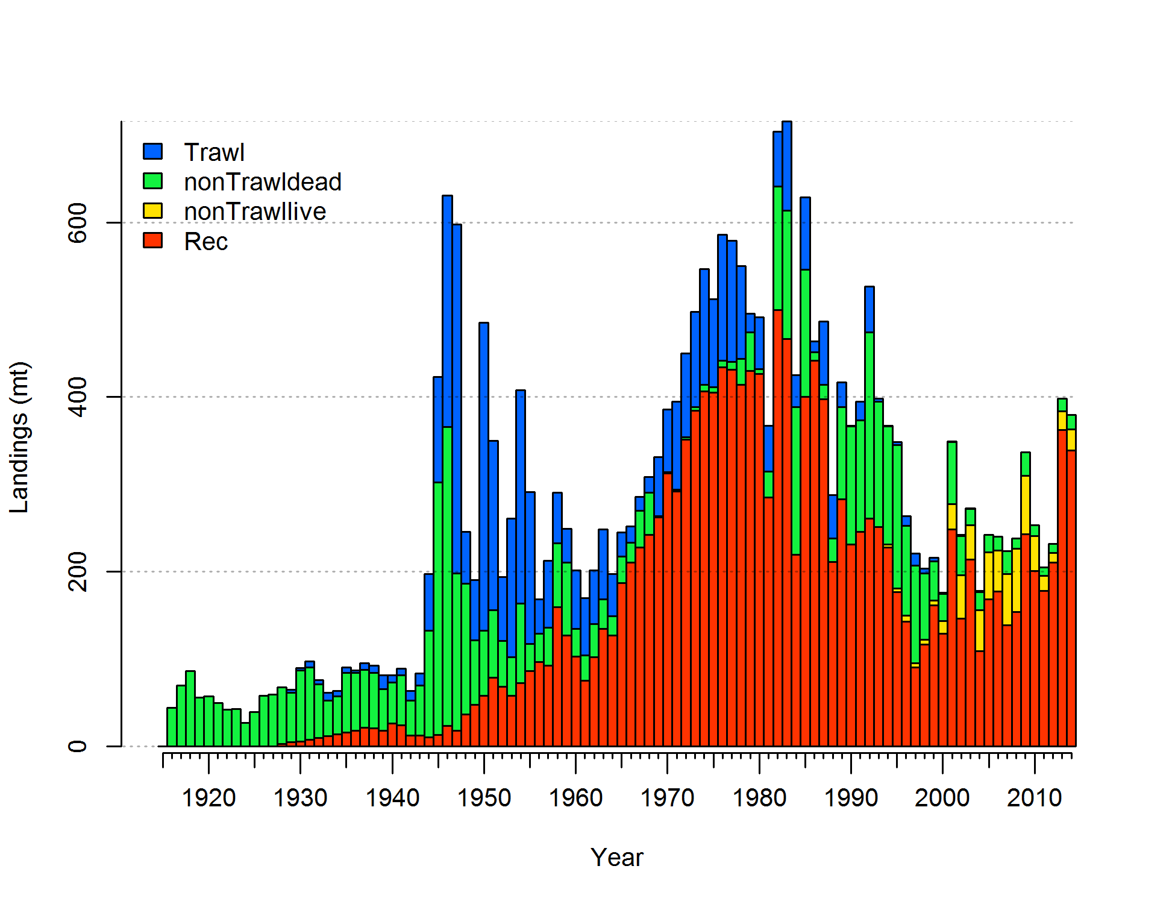

Figure ES-1. Landings history of black rockfish for California.

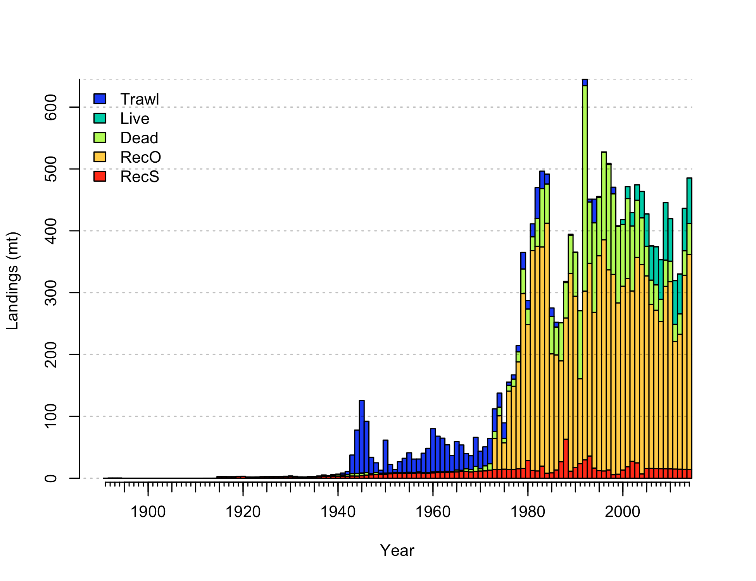

Figure ES-2. Landings history of black rockfish for Oregon.

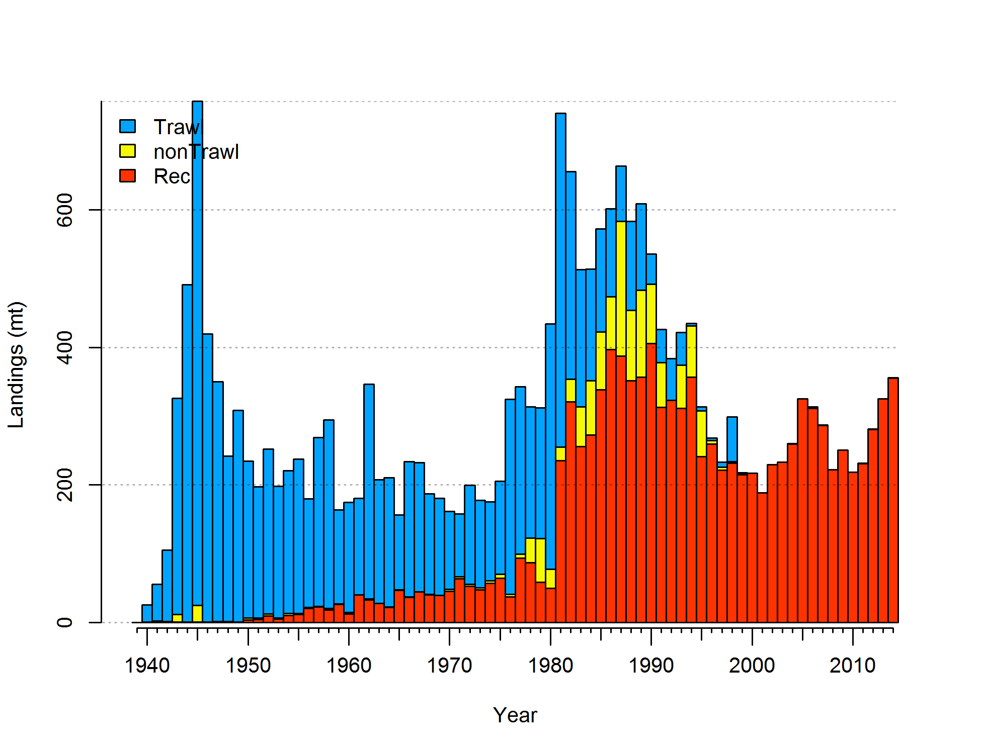

Figure ES-3. Landings history of black rockfish for Washington.

Data and assessment

The last stock assessments for black rockfish were conducted in 2007 for areas north and south of Cape Falcon (45°46´ North latitude). The current assessments assume three areas instead of two, delineated by the state lines as was agreed upon at a pre-assessment and data workshop in March 2015. The prior assessments used Stock Synthesis 2, while the current assessments use Stock Synthesis 3. The Washington base assessment includes a dockside and tag-based CPUE series, but does not include the abundance estimate time series from that same tagging study which was included in the last assessment due to too many violations in the assumptions of abundance estimation. The same two commercial and single recreational fleets are used as in the last assessment for Washington. The Oregon assessment has three commercial fleets and two recreational fleets, while using five surveys and an additional research study for biological compositions. California also has three commercial fleets and 1 recreational fleet with three surveys of abundance, all based on recreational fisheries. All area models include age data as conditional age at lengths. Length compositions are also included in all models.

Spawning stock output

Spawning stock outputs are all at or above limit reference points (Table ES-2. Only California shows declines significantly below this reference point at any point in the time series. California and Washington stocks show a declining population through most of the 20th Century, with stronger declines in the 1980s, and recoveries beginning in the mid-1990s. Oregon stocks follow this pattern, but with a decline in the most recent period. California (33%) is below the target biomass reference point with an increasing biomass trend (Figures ES-4 and ES-5). The Oregon stock dropped after the quick ramp up of catches in the late 1970s and continued a steady decline until around year 2000, settling in at a stock status around 60% of initial conditions. The Washington stock, currently 43%, dropped below the target biomass by in the early 1980s, then risen above since the late 1990s and has fluctuated above that point through 2014 (Figures ES-8 and ES-9).

Table ES-2: Recent trend in beginning of the year biomass and depletion for black rockfish by assessment area.

|  |  |  |  |  |  |  |  |  |  |  |  |  |  |  |  |  |  |
| --- | --- | --- | --- | --- | --- | --- | --- | --- | --- | --- | --- | --- | --- | --- | --- | --- | --- |
|  | California | | | | |  | Oregon | | | | |  | Washington | | | | |
| Year | Spawning | ~95% |  | Estimated | ~95% |  | Spawning | ~95% |  | Estimated | ~95% |  | Spawning | ~95% |  | Estimated | ~95% |
| Output | confidence | depletion | confidence |  | Output | confidence | depletion | confidence |  | Output | confidence | depletion | confidence |
|  | interval |  | interval |  |  | interval |  | interval |  |  | interval |  | interval |
| 2006 | 228 | 145-311 |  | 0.21 | 0.13-0.3 |  | 817 | 705-929 |  | 59 | 57.6-60.5 |  | 576 | 466-686 |  | 0.42 | 0.35-0.5 |
| 2007 | 231 | 145-317 |  | 0.22 | 0.13-0.31 |  | 819 | 707-931 |  | 59.1 | 57.7-60.6 |  | 564 | 455-672 |  | 0.42 | 0.35-0.49 |
| 2008 | 241 | 151-332 |  | 0.23 | 0.14-0.32 |  | 822 | 710-933 |  | 59.4 | 57.9-60.8 |  | 557 | 449-665 |  | 0.41 | 0.34-0.48 |
| 2009 | 257 | 159-354 |  | 0.24 | 0.14-0.34 |  | 827 | 716-939 |  | 59.8 | 58.4-61.2 |  | 558 | 450-665 |  | 0.41 | 0.34-0.48 |
| 2010 | 268 | 162-374 |  | 0.25 | 0.15-0.36 |  | 826 | 714-938 |  | 59.7 | 58.2-61.1 |  | 551 | 444-657 |  | 0.41 | 0.34-0.47 |
| 2011 | 285 | 170-401 |  | 0.27 | 0.15-0.38 |  | 826 | 714-938 |  | 59.7 | 58.2-61.1 |  | 550 | 444-656 |  | 0.41 | 0.34-0.47 |
| 2012 | 305 | 180-430 |  | 0.29 | 0.17-0.41 |  | 834 | 722-946 |  | 60.2 | 58.8-61.6 |  | 552 | 446-658 |  | 0.41 | 0.34-0.47 |
| 2013 | 322 | 189-454 |  | 0.30 | 0.17-0.43 |  | 842 | 729-954 |  | 60.8 | 59.4-62.2 |  | 557 | 449-664 |  | 0.41 | 0.34-0.48 |
| 2014 | 329 | 191-468 |  | 0.31 | 0.18-0.44 |  | 841 | 729-954 |  | 60.8 | 59.4-62.2 |  | 567 | 456-678 |  | 0.42 | 0.35-0.49 |
| 2015 | 353 | 204-503 |  | 0.33 | 0.19-0.48 |  | 836 | 723-949 |  | 60.4 | 58.9-61.8 |  | 582 | 467-698 |  | 0.43 | 0.36-0.5 |

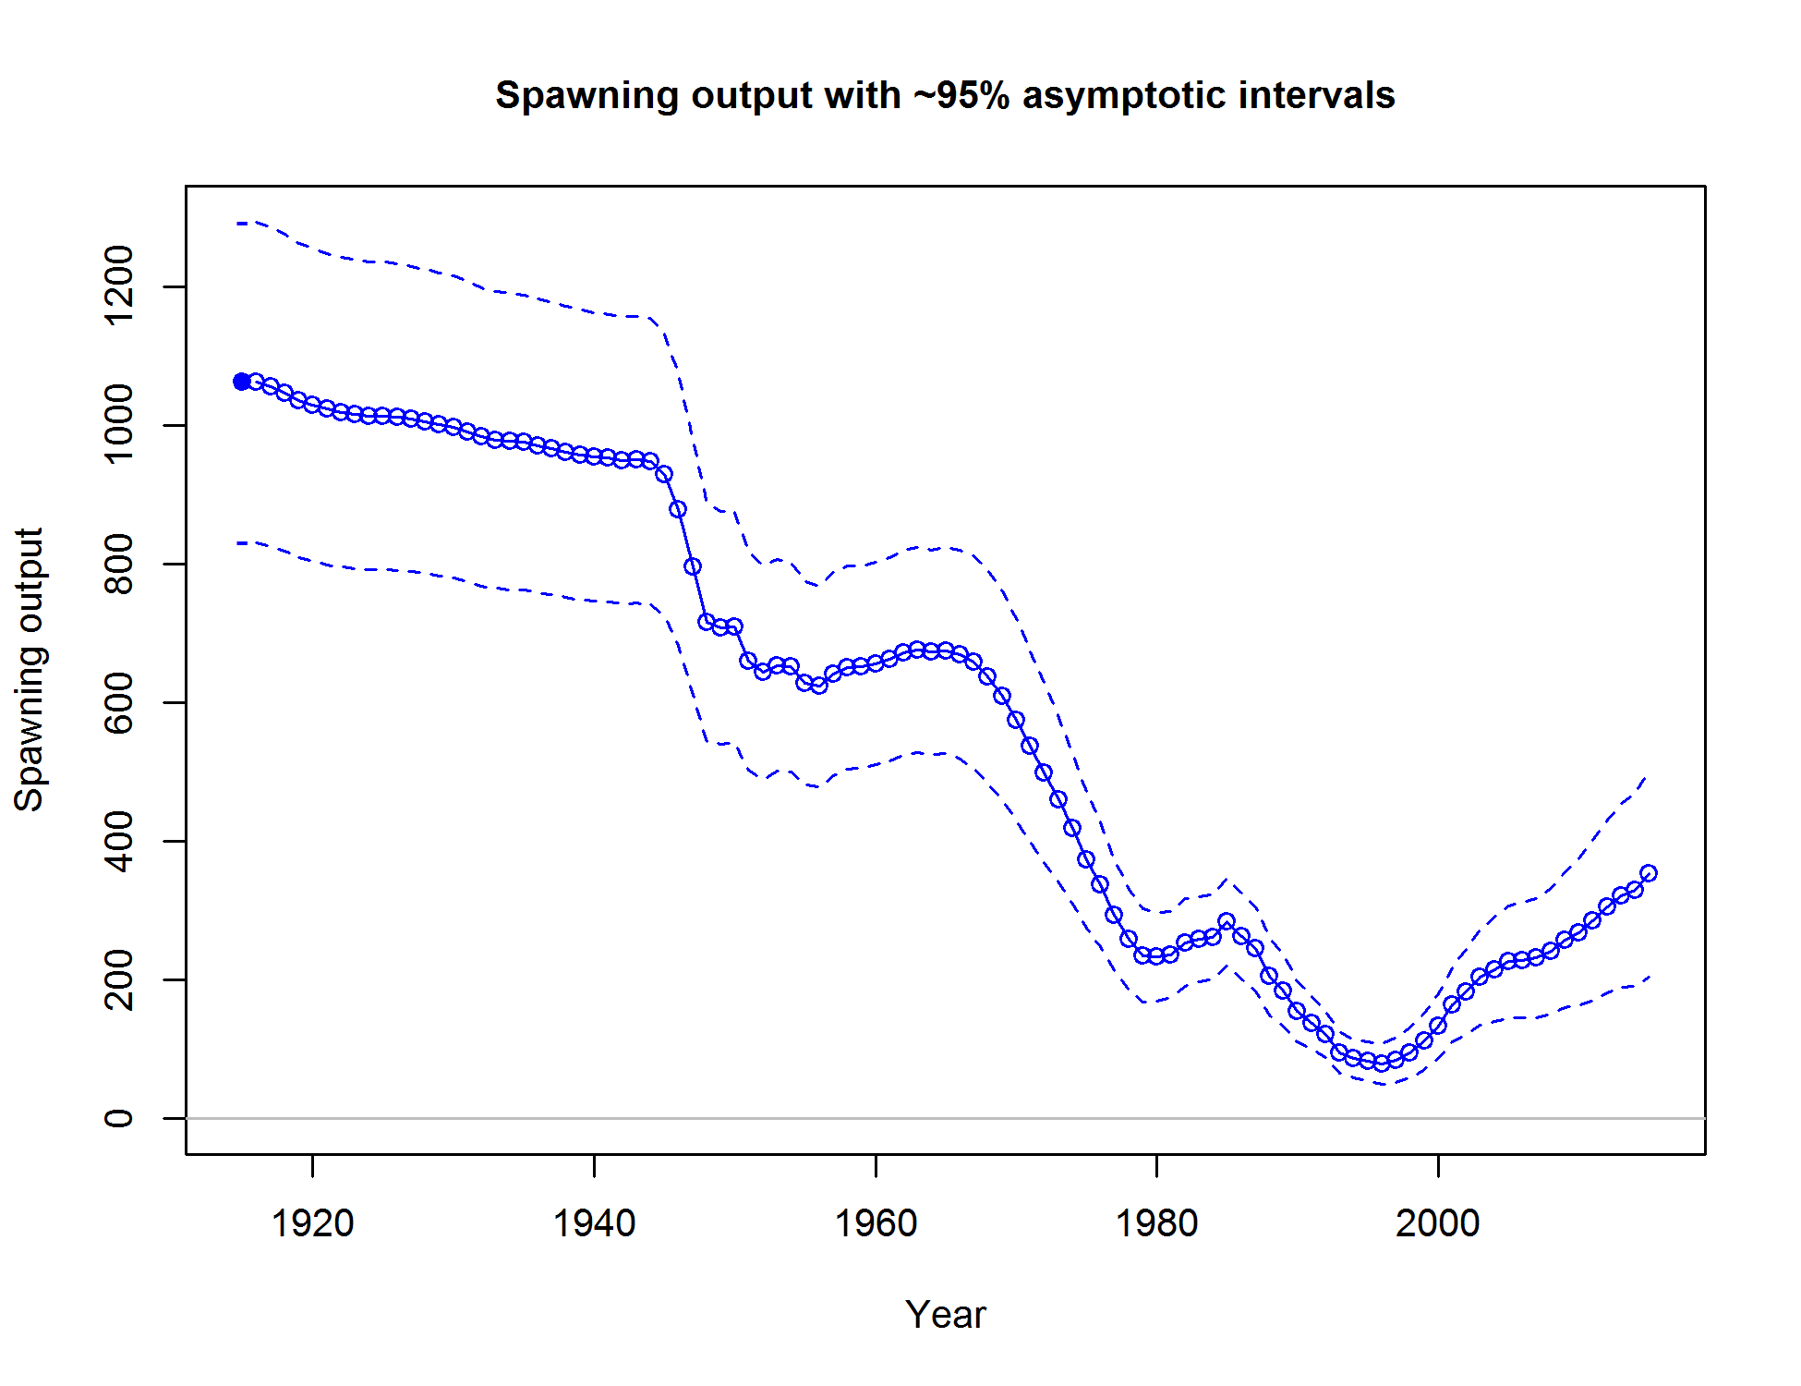

Figure ES-4. Time series of spawning output of black rockfish in California.

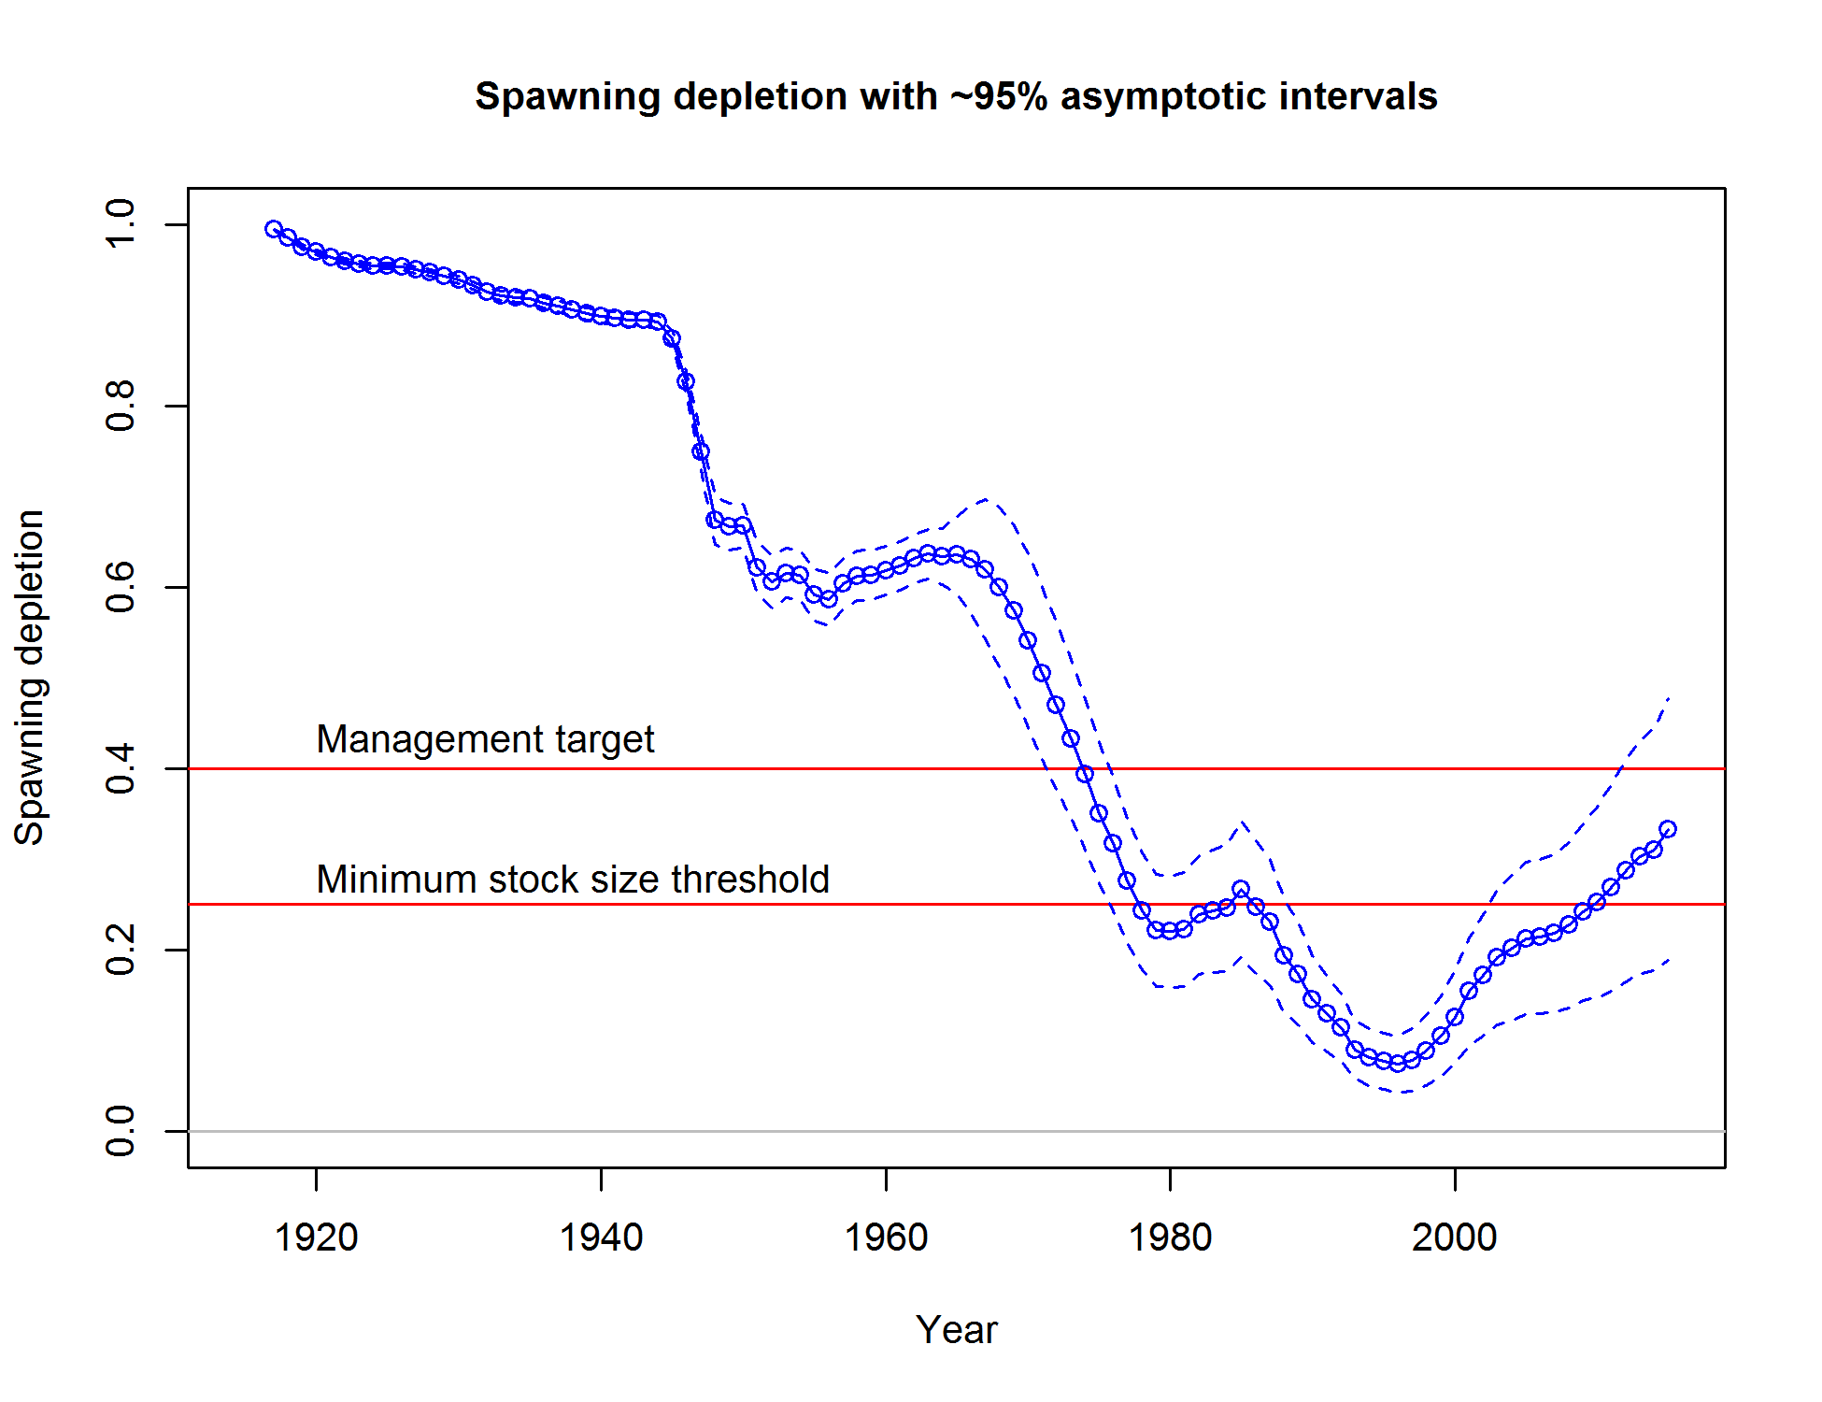

Figure ES-5. Time series of stock status (depletion) of black rockfish in California.

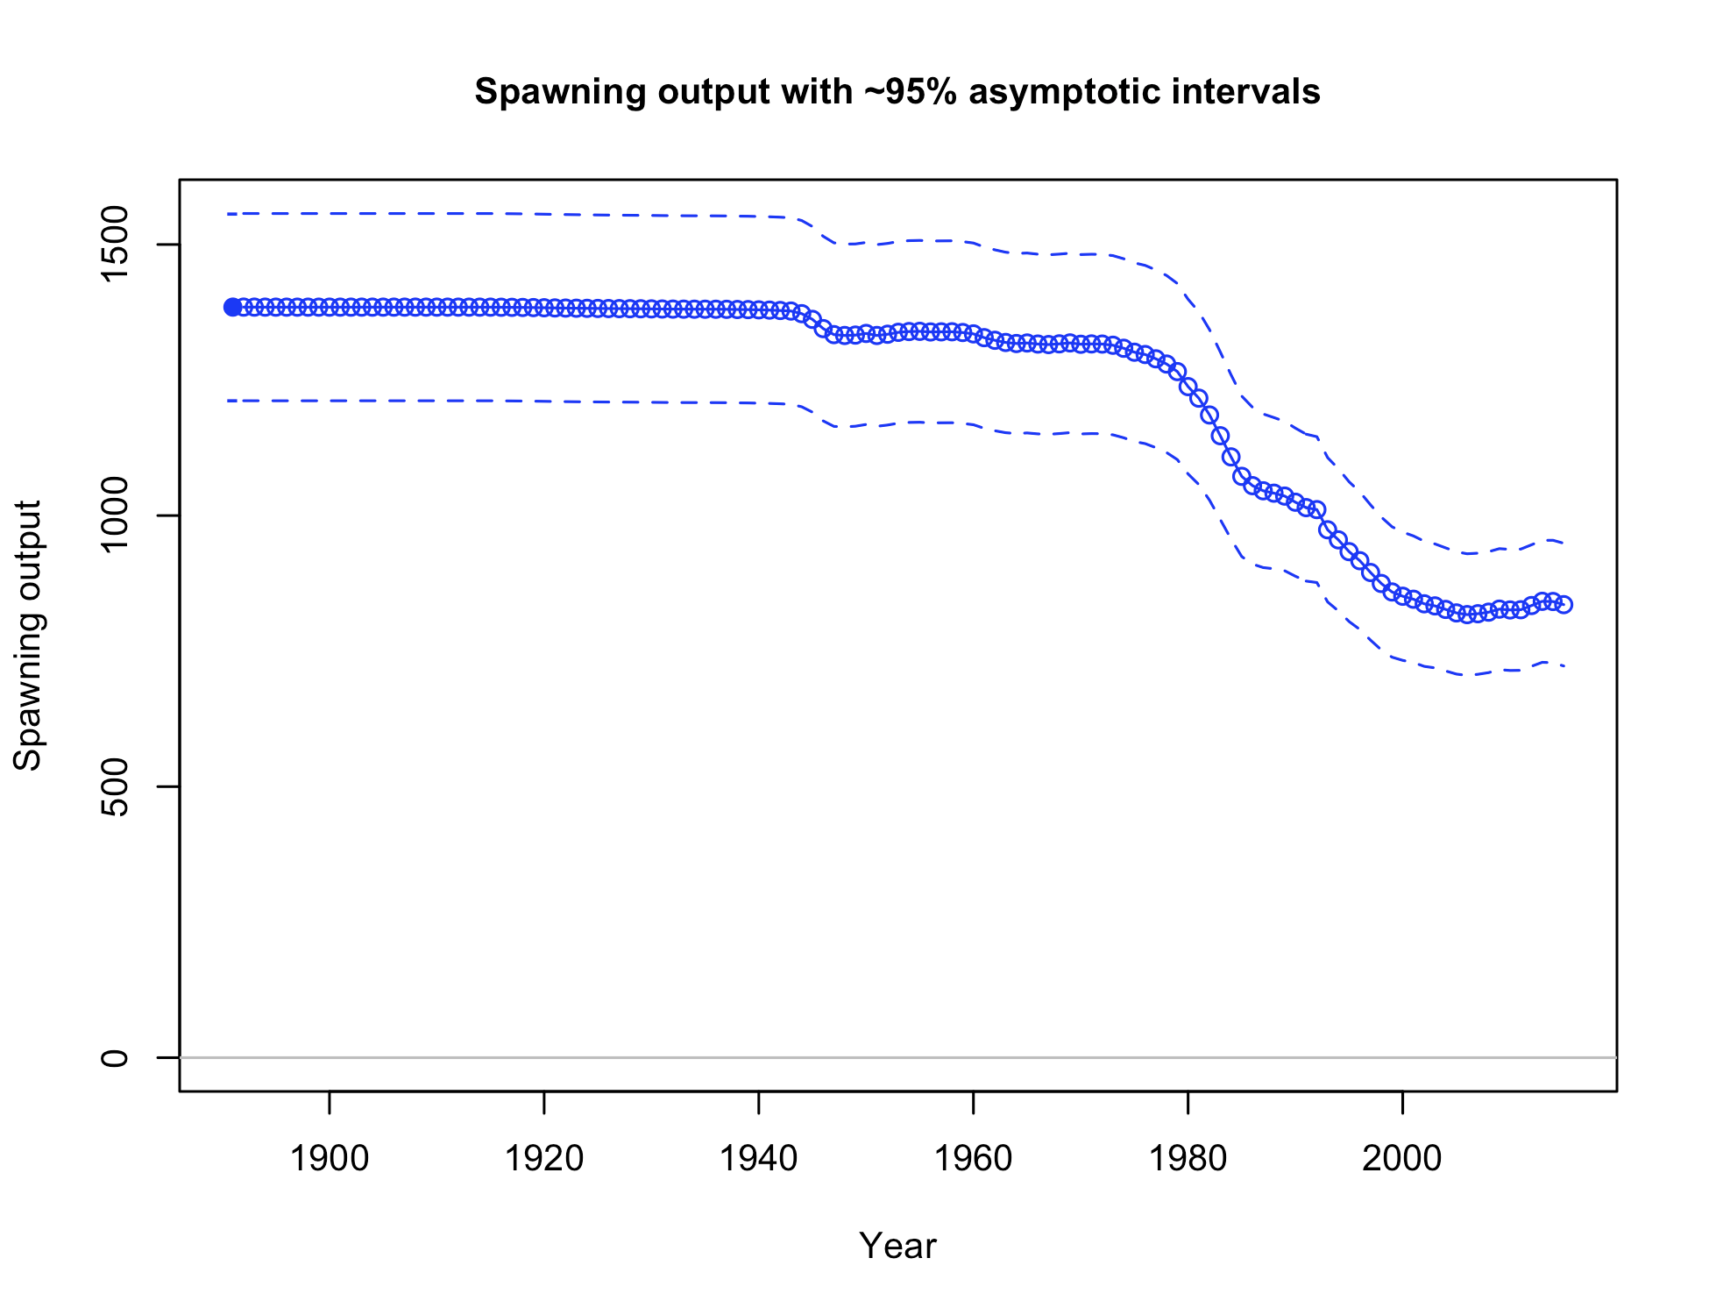

Figure ES-6. Time series of spawning output of black rockfish in Oregon.

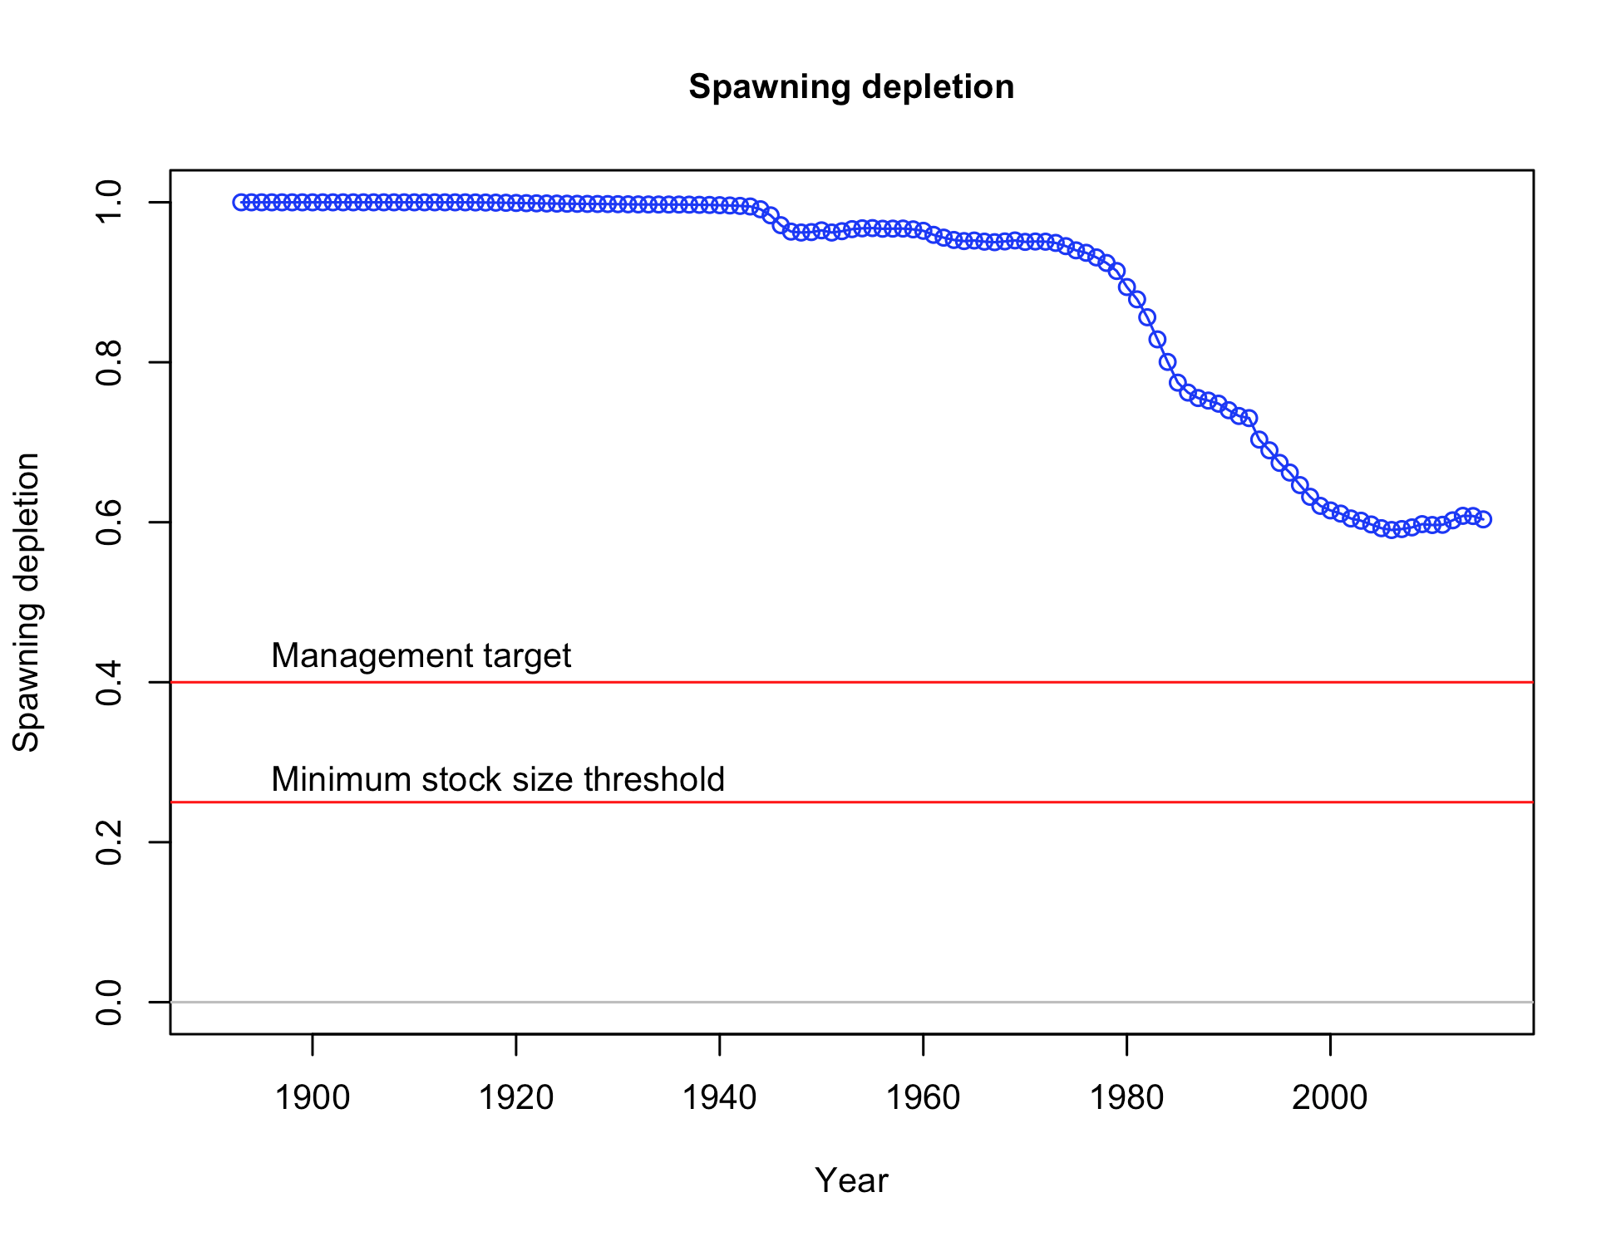

Figure ES-7. Time series of stock status (depletion) of black rockfish in Oregon.

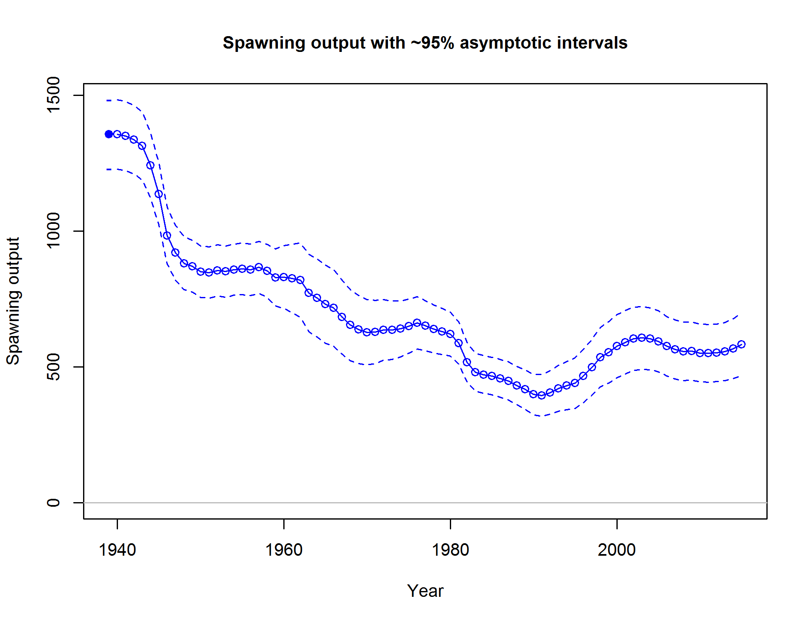

Figure ES-8. Time series of spawning output of black rockfish in Washington.

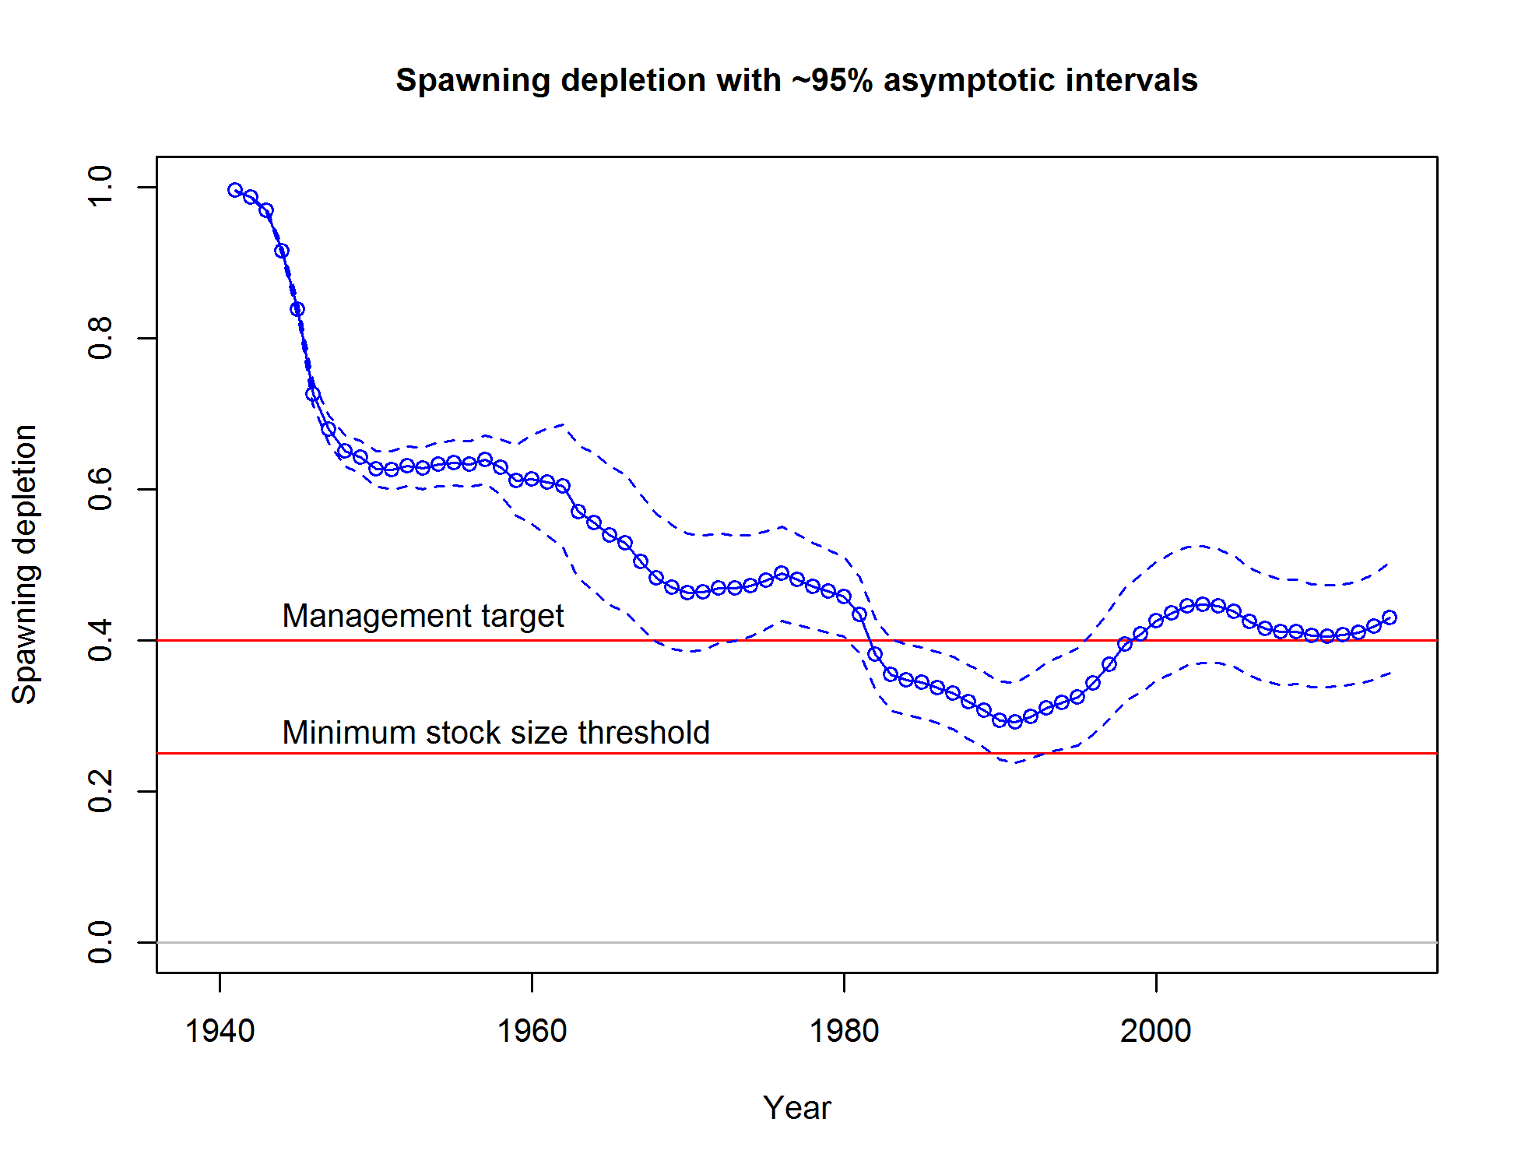

Figure ES-9. Time series of stock status (depletion) of black rockfish in Washington.

Recruitment

The California model shows a few extraordinarily high recruitment events that are supported by the length composition data, index data and on-the-water reports (Table ES-3; Figure ES-10). Oregon recruitment is highly uncertain (Table ES-3; Figure ES11). Washington recruitment is dynamic, but also shows the most informed recruitment time series, which is consistent with the extent of length and age compositions available to that assessment (Table ES-3; Figure ES12). Both California and Washington support elevated recruitment in the late 2000s.

Table ES-3. Recent trend in recruitment for black rockfish by assessment area.

|  |  |  |  |  |  |  |  |  |
| --- | --- | --- | --- | --- | --- | --- | --- | --- |
|  |  |  |  |  |  |  |  |  |
|  | California | |  | Oregon | |  | Washington | |
| Year | Estimated | ~95% |  | Estimated | ~95% |  | Estimated | ~95% |
| recruitment | confidence | recruitment | confidence |  | recruitment | confidence |
| (1,000’s) | interval | (1,000’s) | interval |  | (1,000’s) | interval |
| 2005 | 1371 | 714-2029 |  | 3490 | 3415-3565 |  | 1773 | 1257-2288 |
| 2006 | 984 | 465-1504 |  | 3488 | 3414-3563 |  | 3518 | 2543-4493 |
| 2007 | 1327 | 565-2088 |  | 3489 | 3414-3564 |  | 1739 | 1181-2297 |
| 2008 | 4509 | 2176-6842 |  | 3491 | 3416-3565 |  | 3346 | 2312-4379 |
| 2009 | 4323 | 1560-7086 |  | 3494 | 3419-3568 |  | 518 | 184-852 |
| 2010 | 2997 | 841-5153 |  | 3493 | 3418-3568 |  | 2670 | 1178-4161 |
| 2011 | 1765 | 306-3223 |  | 3493 | 3418-3568 |  | 1157 | 161-2153 |
| 2012 | 1701 | 1206-2195 |  | 3497 | 3422-3571 |  | 1899 | 1396-2402 |
| 2013 | 1719 | 1226-2213 |  | 3501 | 69-6932 |  | 1901 | 1398-2404 |
| 2014 | 1728 | 1233-2223 |  | 3500 | 69-6932 |  | 1907 | 1403-2411 |
|  |  |  |  |  |  |  |  |  |

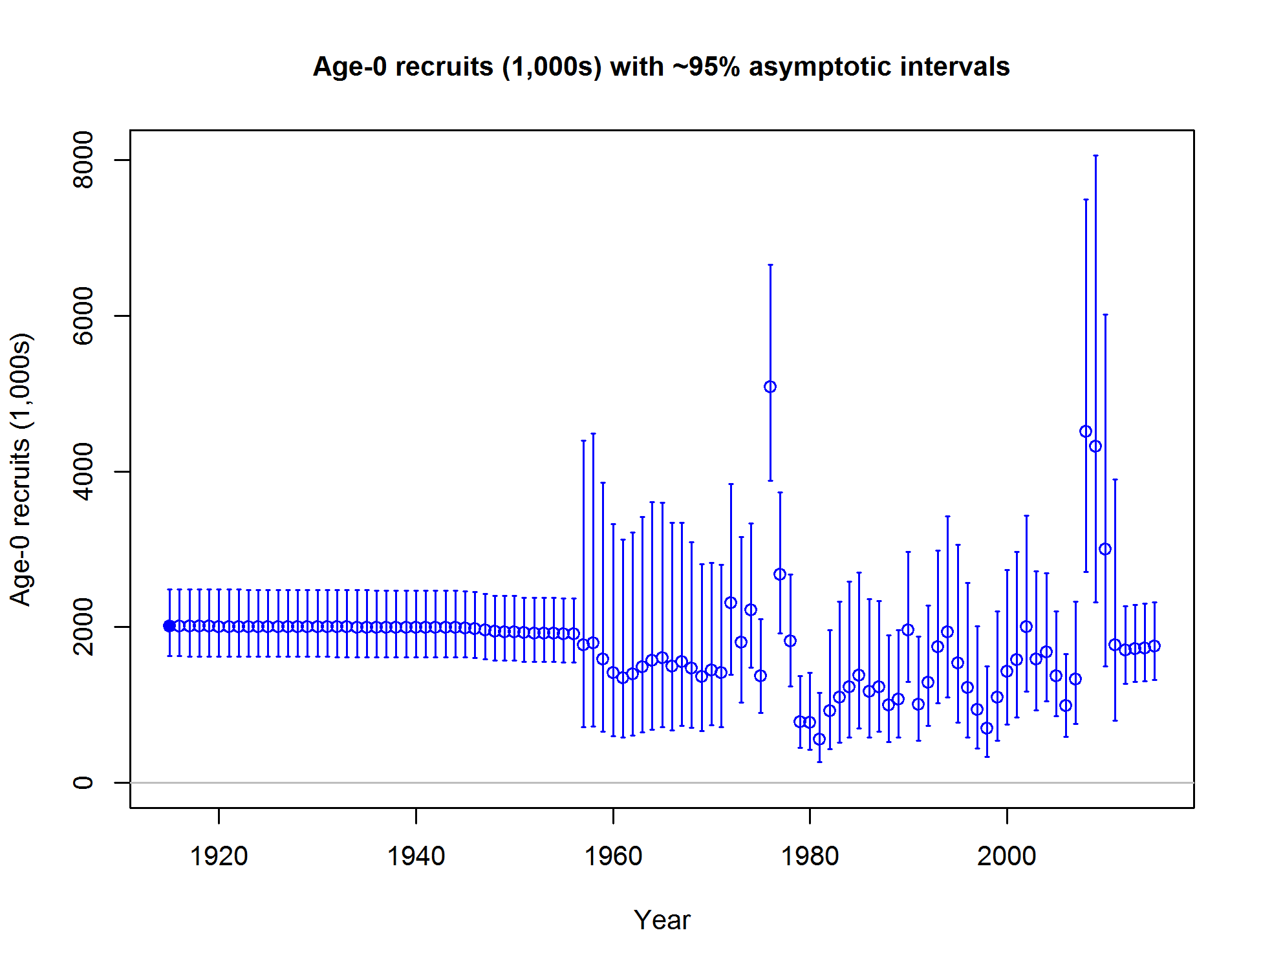

Figure ES-10. Time series of black rockfish recruitment in California.

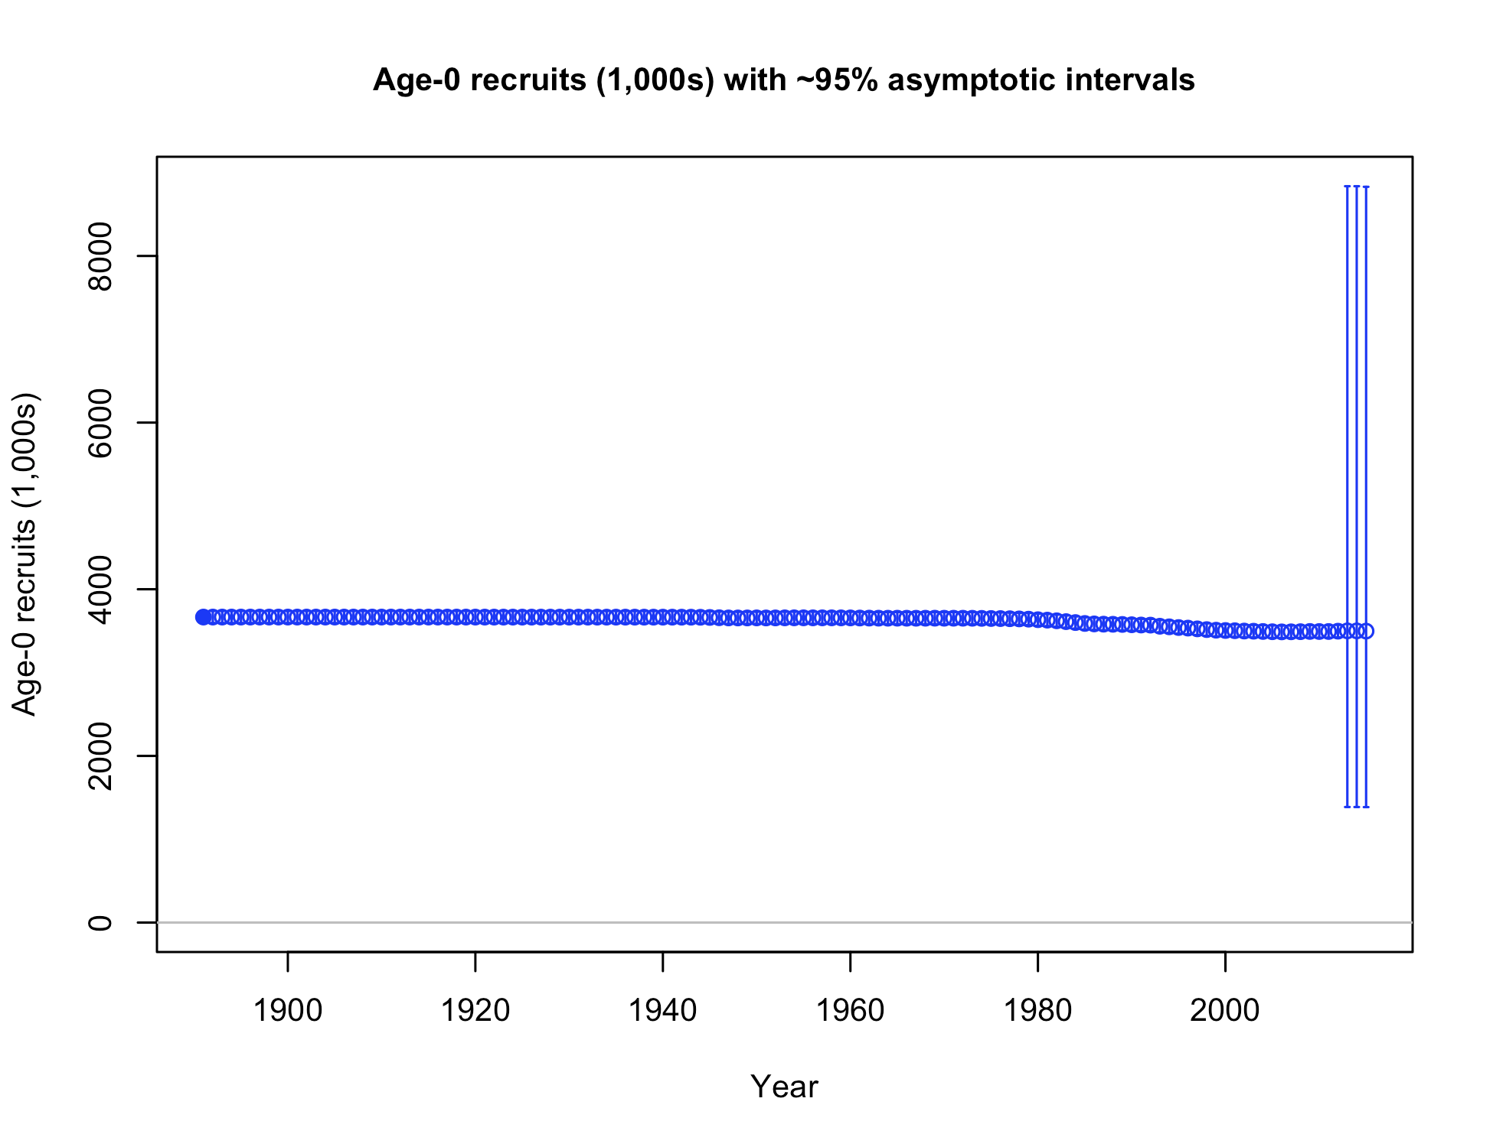

Figure ES-11. Time series of black rockfish recruitment in Oregon. Recruitment deviations were not estimated in the Oregon model.

**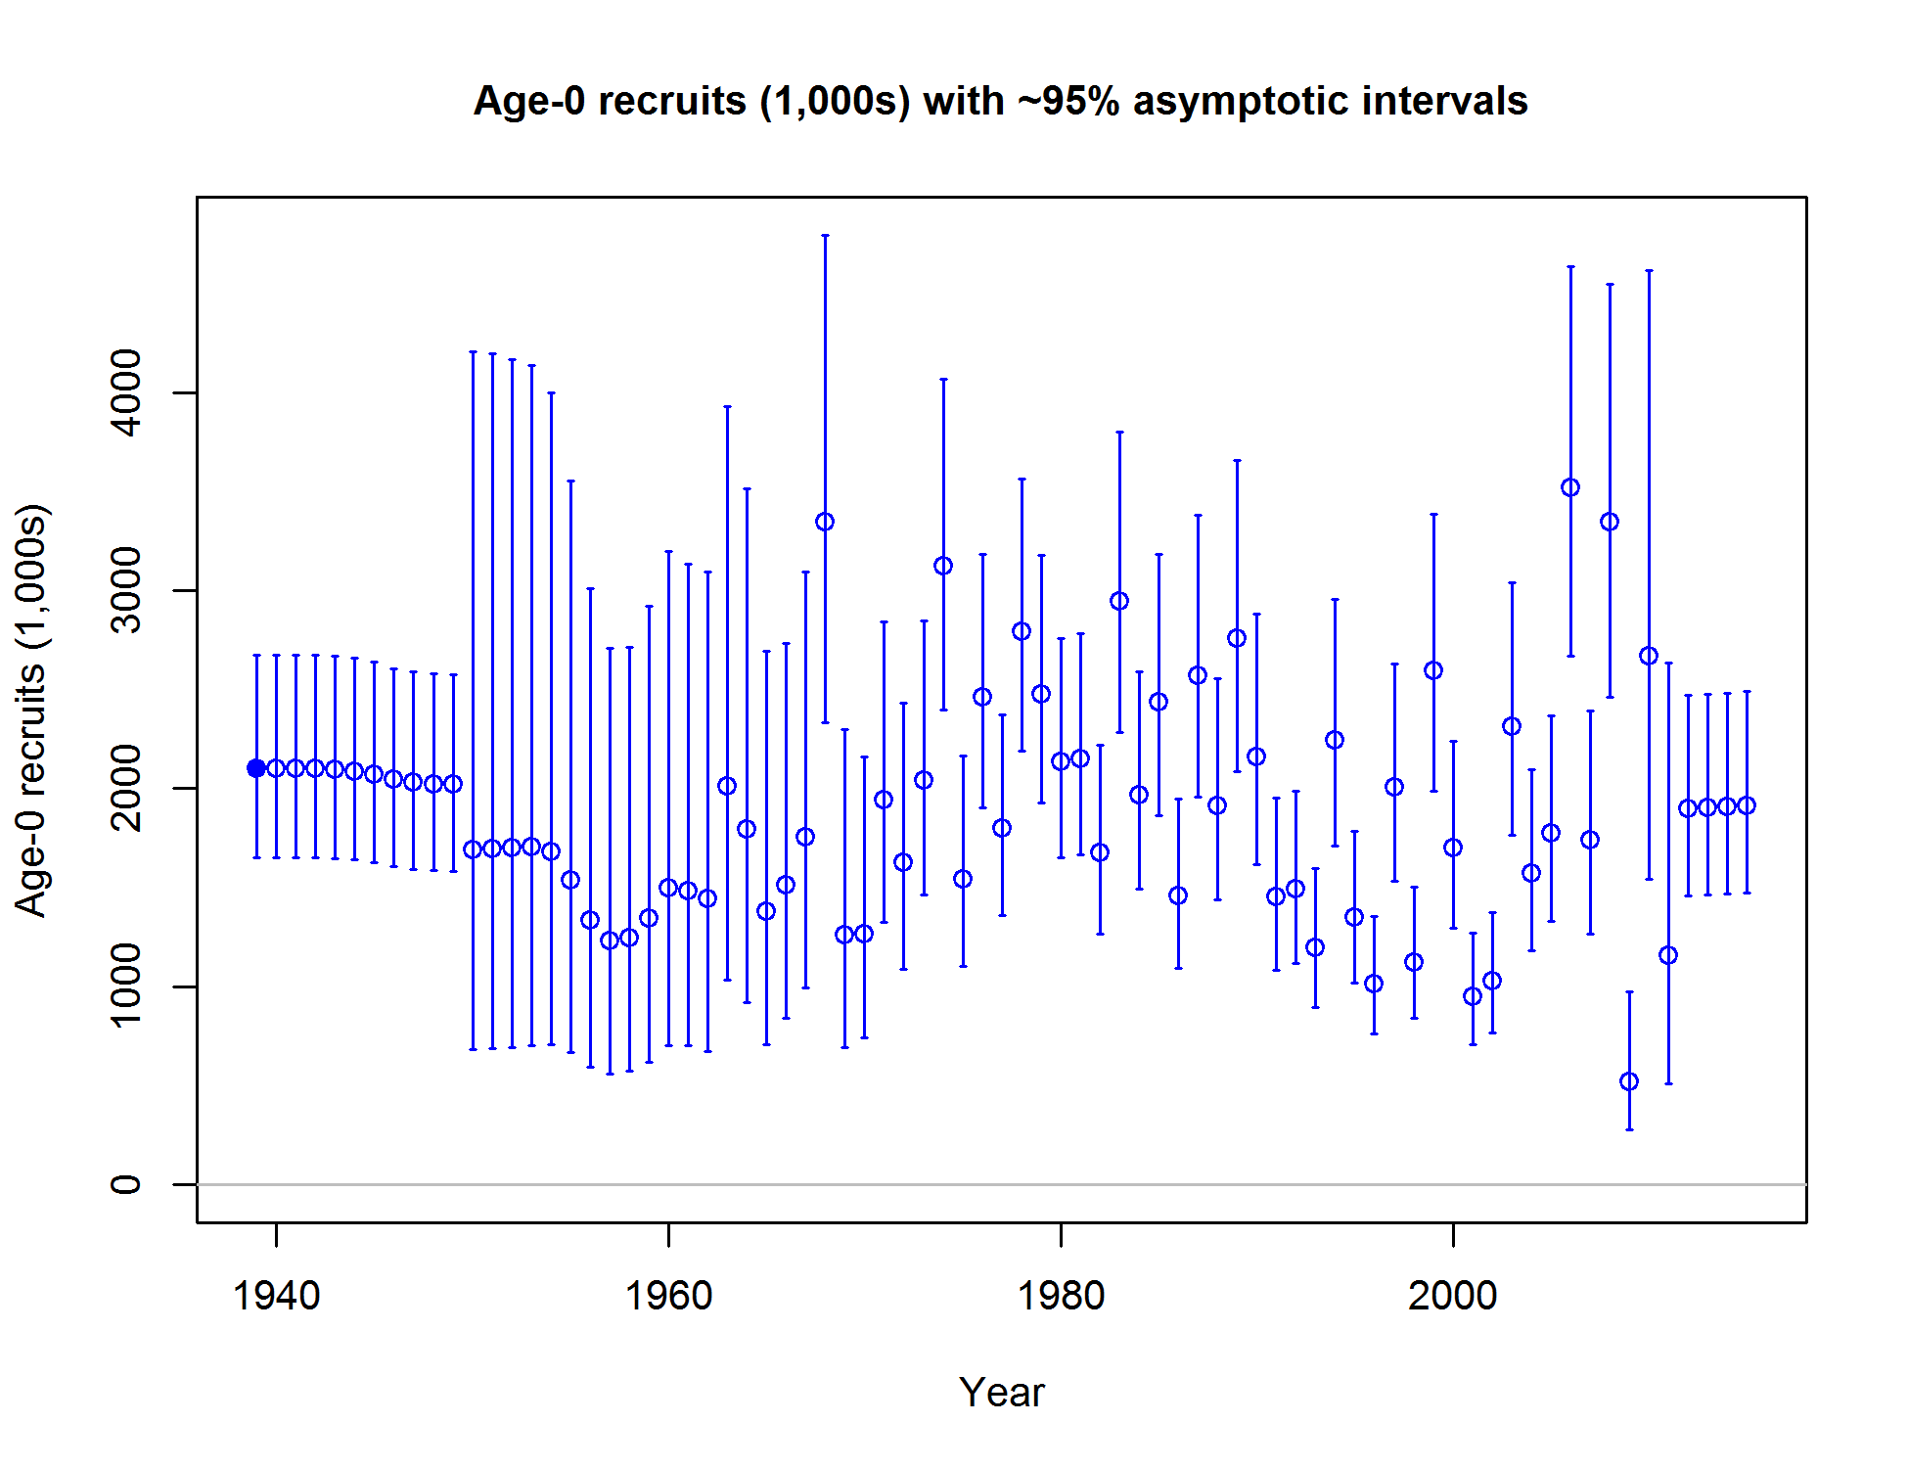**

Figure ES-12. Time series of black rockfish recruitment in Washington.

Exploitation status

California and Washington models indicate that current fishing practices are near or above the SPR rate fishing intensity target, while the Oregon model is quite a bit above the target (table ES-4, compare to SPR=0.5; Figure ES-13 to Figure ES-18), though the steepness value (0.773) indicates a much lower value of SPR for sustainable removals. Fishing rates have been above the target in California in nearly all years since the 1980s, but have dropped considerably in recent years. Oregon fishing rates have been consistently high in recent years. Washington shows a dramatic decline in fishing intensity since the late 1990s and has fluctuated mostly below the target since.

Table ES-4. Recent trend in spawning potential ratio (entered as 1-SPR) and summary exploitation rate (catch divided by biomass of age-3 and older fish)

|  |  |  |  |  |  |  |  |  |  |  |  |  |  |  |  |  |  |  |
| --- | --- | --- | --- | --- | --- | --- | --- | --- | --- | --- | --- | --- | --- | --- | --- | --- | --- | --- |
|  | Washington | | | | |  | Oregon | | | | | |  | California | | | | |
| Year |  | ~95% |  |  | ~95% |  |  | ~95% |  |  | | ~95% |  |  | ~95% |  |  | ~95% |
| Estimated 1-SPR | confidence | Harvest rate | confidence |  | Estimated 1-SPR | confidence | Harvest rate | | confidence |  | Estimated 1-SPR | confidence | Harvest rate | confidence |
| interval | (ratio) | interval |  | interval | (ratio) | | interval |  | interval | (ratio) | interval |
| 2005 | 0.60 | 0.48-0.72 |  | 0.09 | 0.06-0.12 |  | 0.38 | 0.37-.040 |  | 0.08 | 0.076-0.084 | |  | 0.54 | 0.47-0.61 |  | 0.08 | 0.07-0.1 |
| 2006 | 0.58 | 0.45-0.7 |  | 0.08 | 0.06-0.11 |  | 0.35 | 0.33-.036 |  | 0.07 | 0.066-0.074 | |  | 0.54 | 0.47-0.61 |  | 0.08 | 0.07-0.1 |
| 2007 | 0.53 | 0.41-0.65 |  | 0.08 | 0.05-0.1 |  | 0.35 | 0.33-.036 |  | 0.07 | 0.066-0.074 | |  | 0.52 | 0.45-0.59 |  | 0.08 | 0.06-0.09 |
| 2008 | 0.53 | 0.41-0.66 |  | 0.08 | 0.05-0.1 |  | 0.33 | 0.32-.034 |  | 0.07 | 0.066-0.074 | |  | 0.45 | 0.38-0.51 |  | 0.06 | 0.05-0.07 |
| 2009 | 0.65 | 0.52-0.78 |  | 0.10 | 0.07-0.14 |  | 0.39 | 0.38-.041 |  | 0.09 | 0.086-0.094 | |  | 0.48 | 0.41-0.55 |  | 0.07 | 0.06-0.08 |
| 2010 | 0.56 | 0.42-0.69 |  | 0.08 | 0.05-0.11 |  | 0.37 | 0.36-.039 |  | 0.08 | 0.076-0.084 | |  | 0.44 | 0.37-0.51 |  | 0.06 | 0.05-0.07 |
| 2011 | 0.46 | 0.33-0.59 |  | 0.06 | 0.04-0.08 |  | 0.30 | 0.29-.031 |  | 0.06 | 0.058-0.062 | |  | 0.45 | 0.38-0.51 |  | 0.06 | 0.05-0.07 |
| 2012 | 0.45 | 0.32-0.57 |  | 0.05 | 0.03-0.07 |  | 0.31 | 0.29-.032 |  | 0.06 | 0.056-0.064 | |  | 0.49 | 0.42-0.56 |  | 0.07 | 0.06-0.08 |
| 2013 | 0.57 | 0.44-0.7 |  | 0.08 | 0.05-0.11 |  | 0.38 | 0.37-.039 |  | 0.08 | 0.076-0.084 | |  | 0.52 | 0.45-0.59 |  | 0.08 | 0.06-0.09 |
| 2014 | 0.53 | 0.4-0.67 |  | 0.07 | 0.05-0.1 |  | 0.41 | 0.40-0.43 |  | 0.09 | 0.086-0.094 | |  | 0.54 | 0.47-0.61 |  | 0.08 | 0.07-0.1 |

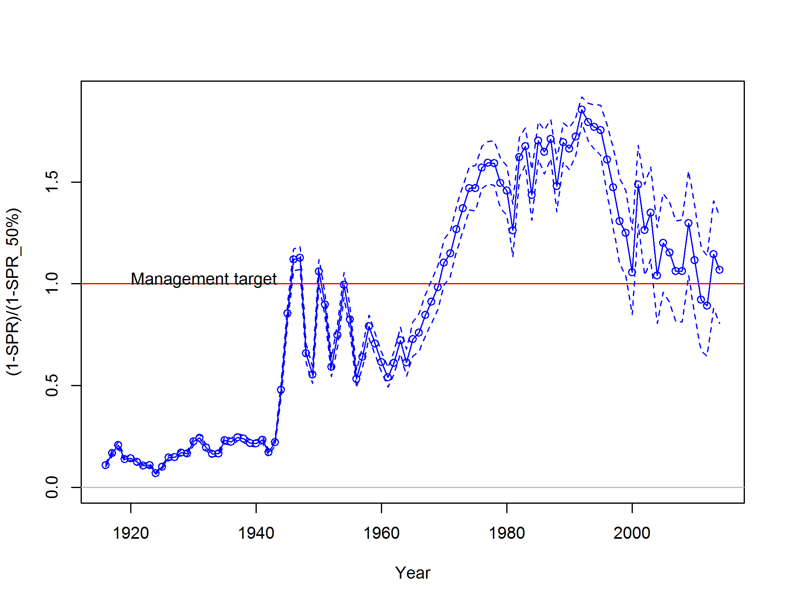

Figure ES-13. Estimated spawning potential ratio (SPR) for the California assessment. Relative SPR is plotted so that higher exploitation rates occur on the upper portion of the y-axis. The management target is plotted as a red horizontal line and values above this reflect harvests in excess of the overfishing proxy based on the SPR50% harvest rate. The last year in the time series is 2014.

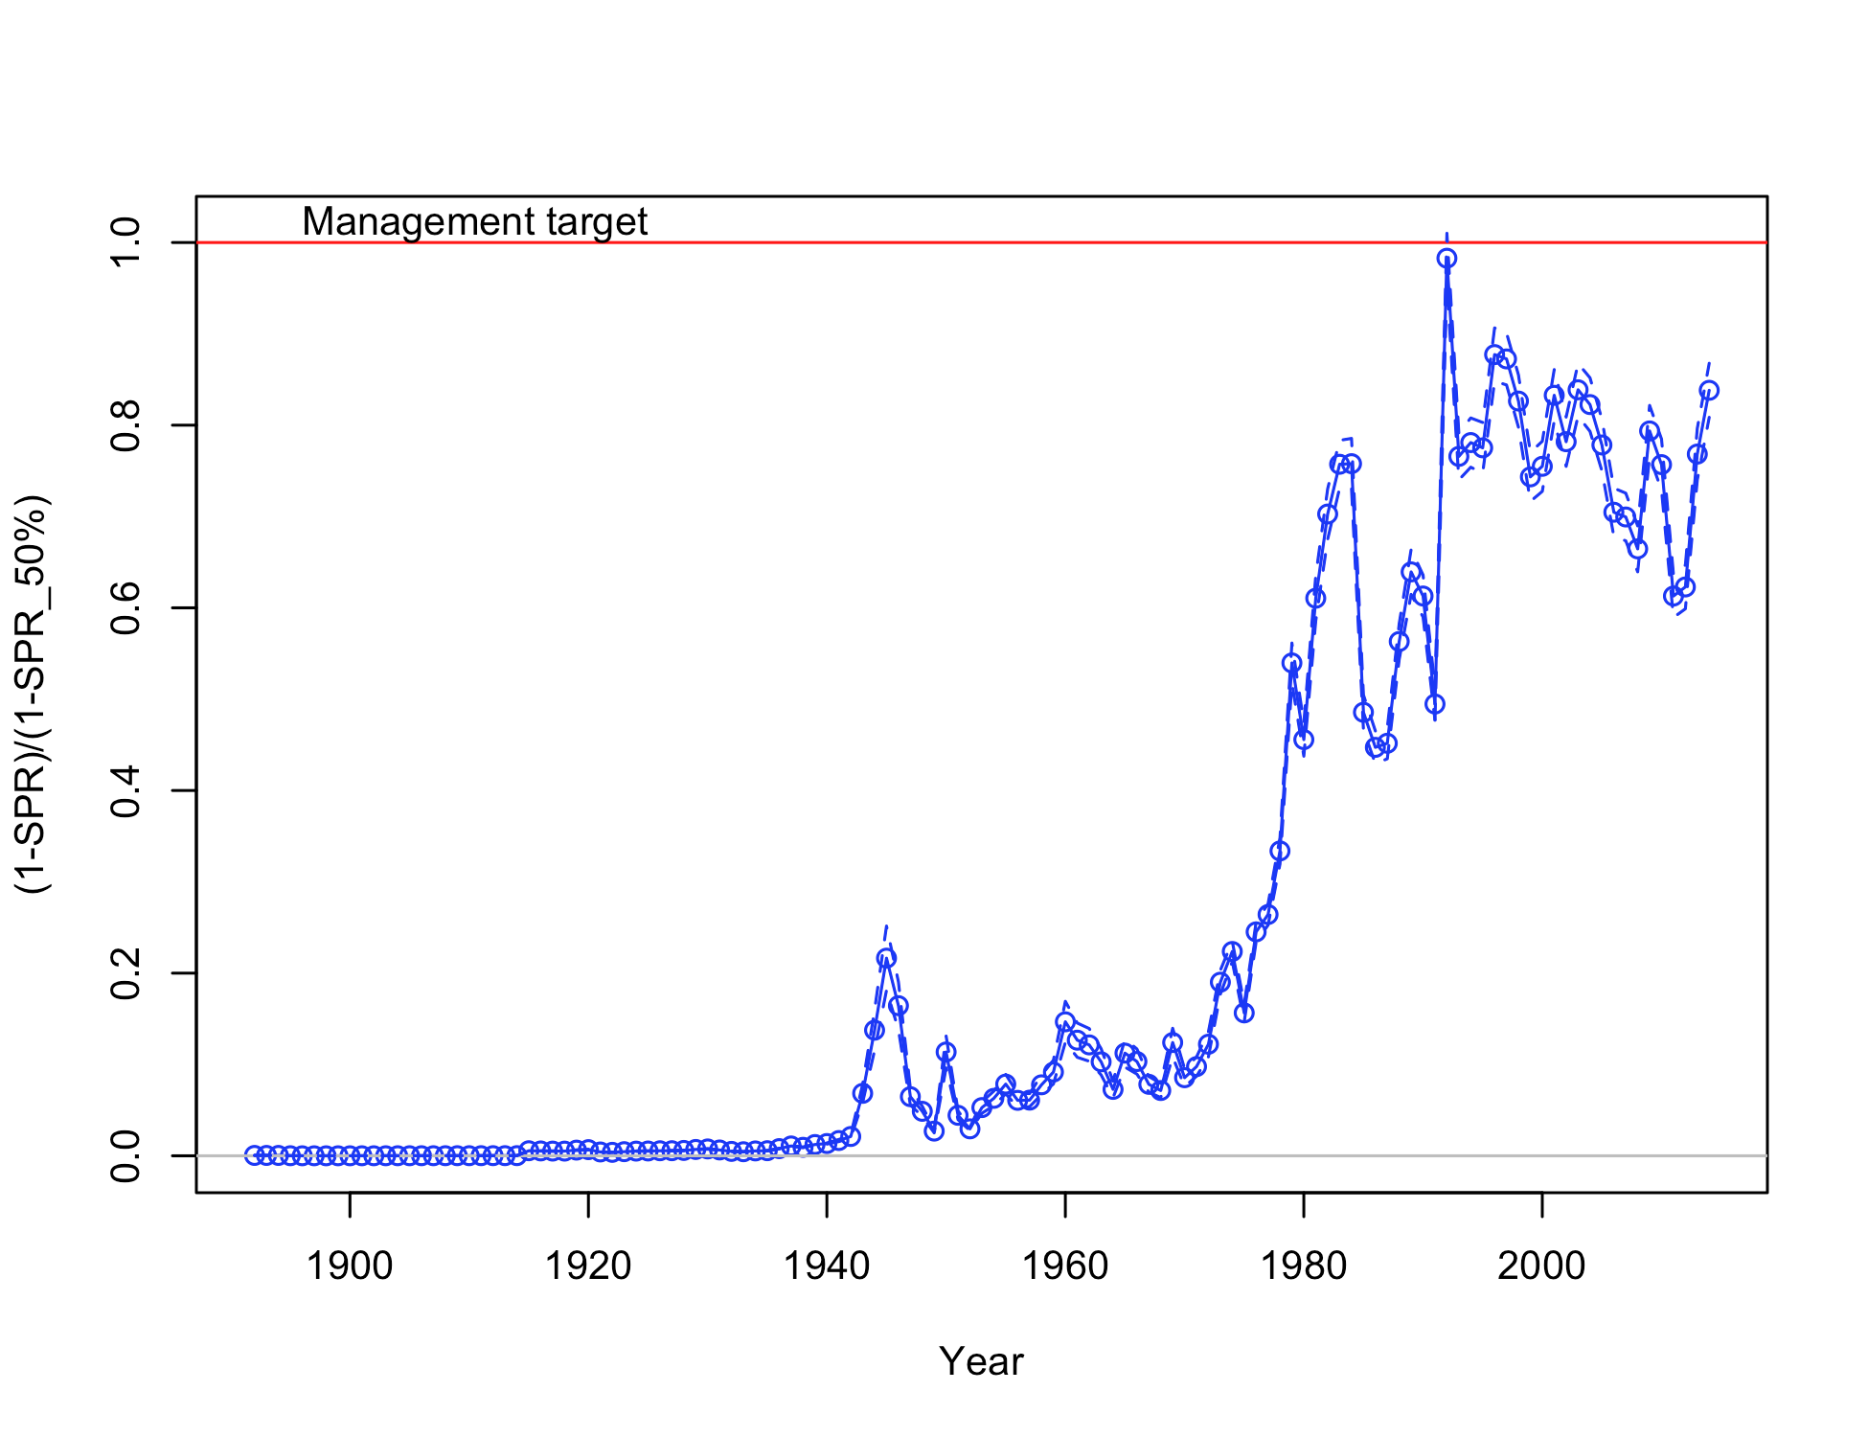

Figure ES-14. Estimated spawning potential ratio (SPR) for the Oregon assessment. Relative SPR is plotted so that higher exploitation rates occur on the upper portion of the y-axis. The management target is plotted as a red horizontal line and values above this reflect harvests in excess of the overfishing proxy based on the SPR50% harvest rate. The last year in the time series is 2014.

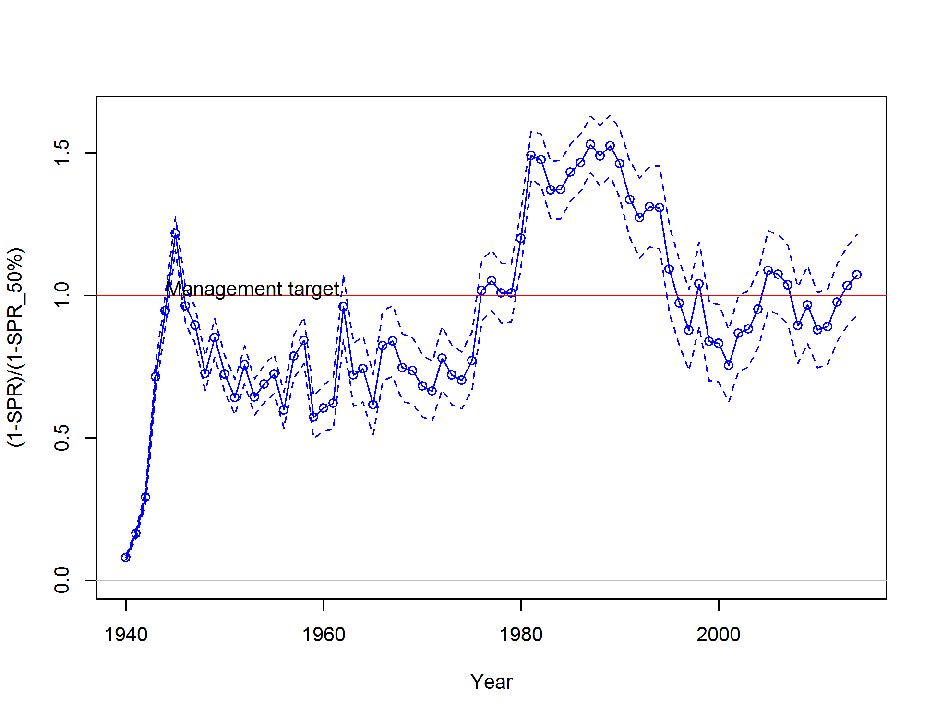

Figure ES-15. Estimated spawning potential ratio (SPR) for the Washington assessment. Relative SPR is plotted so that higher exploitation rates occur on the upper portion of the y-axis. The management target is plotted as a red horizontal line and values above this reflect harvests in excess of the overfishing proxy based on the SPR50% harvest rate. The last year in the time series is 2014.

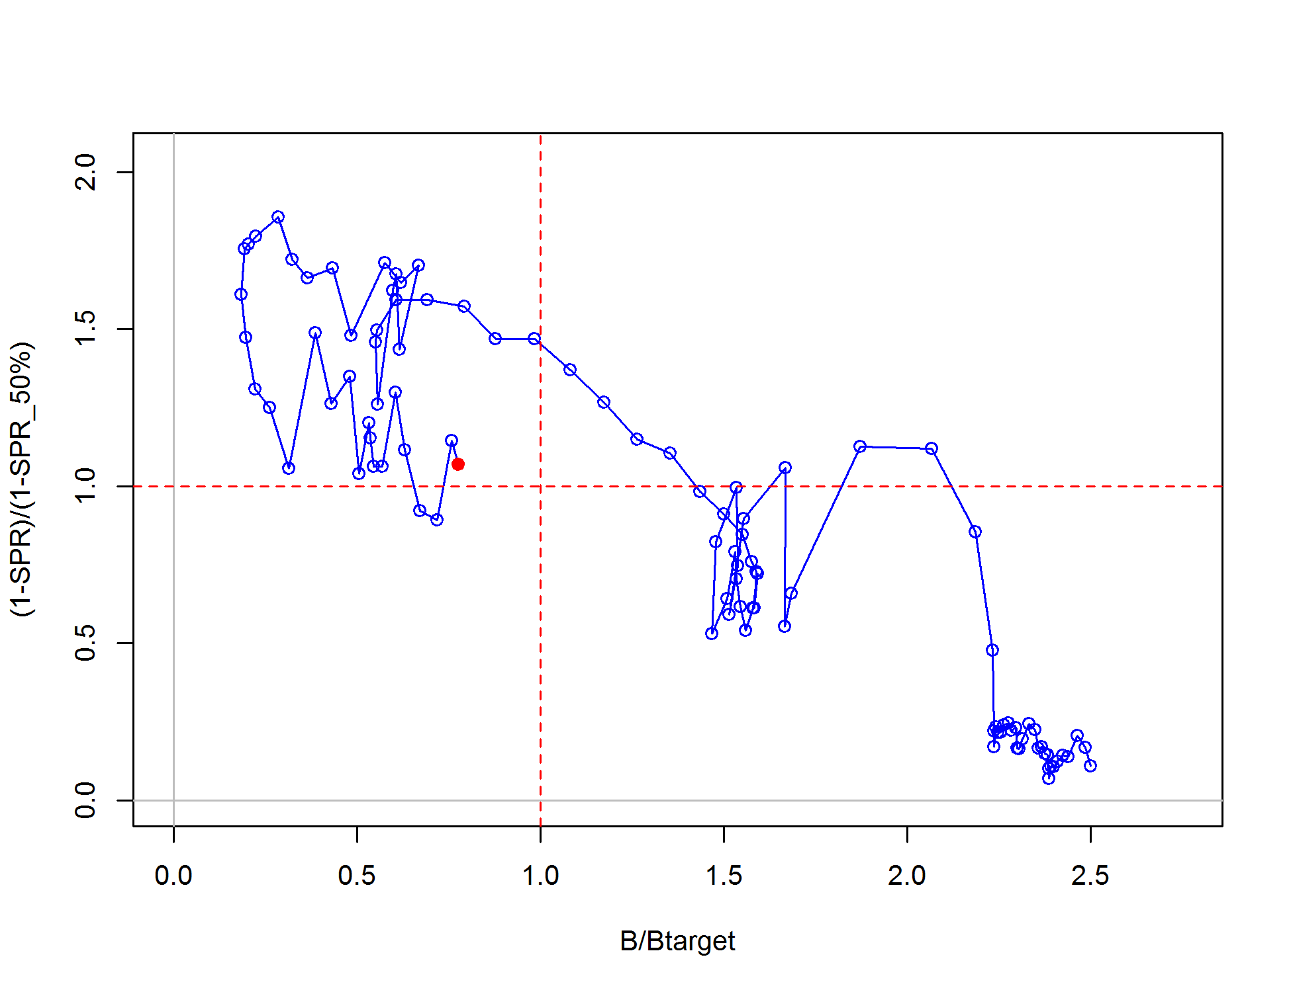

Figure ES-16. Phase plot of relative spawning biomass vs fishing intensity for the California model. The relative fishing intensity is (1-SPR) divided by 1-the SPR target. The vertical red line is the relative spawning biomass target defined as the annual spawning output divided by the spawning biomass corresponding to 40% of the unfished spawning biomass.

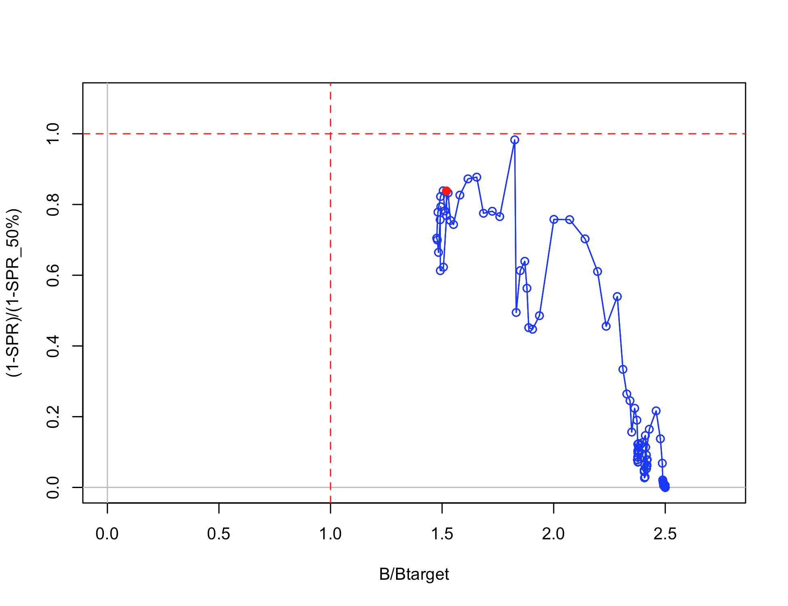

Figure ES-17. Phase plot of relative spawning biomass vs fishing intensity for the Oregon model. The relative fishing intensity is (1-SPR) divided by 1-the SPR target. The vertical red line is the relative spawning biomass target defined as the annual spawning biomass divided by the spawning output corresponding to 40% of the unfished spawning biomass.

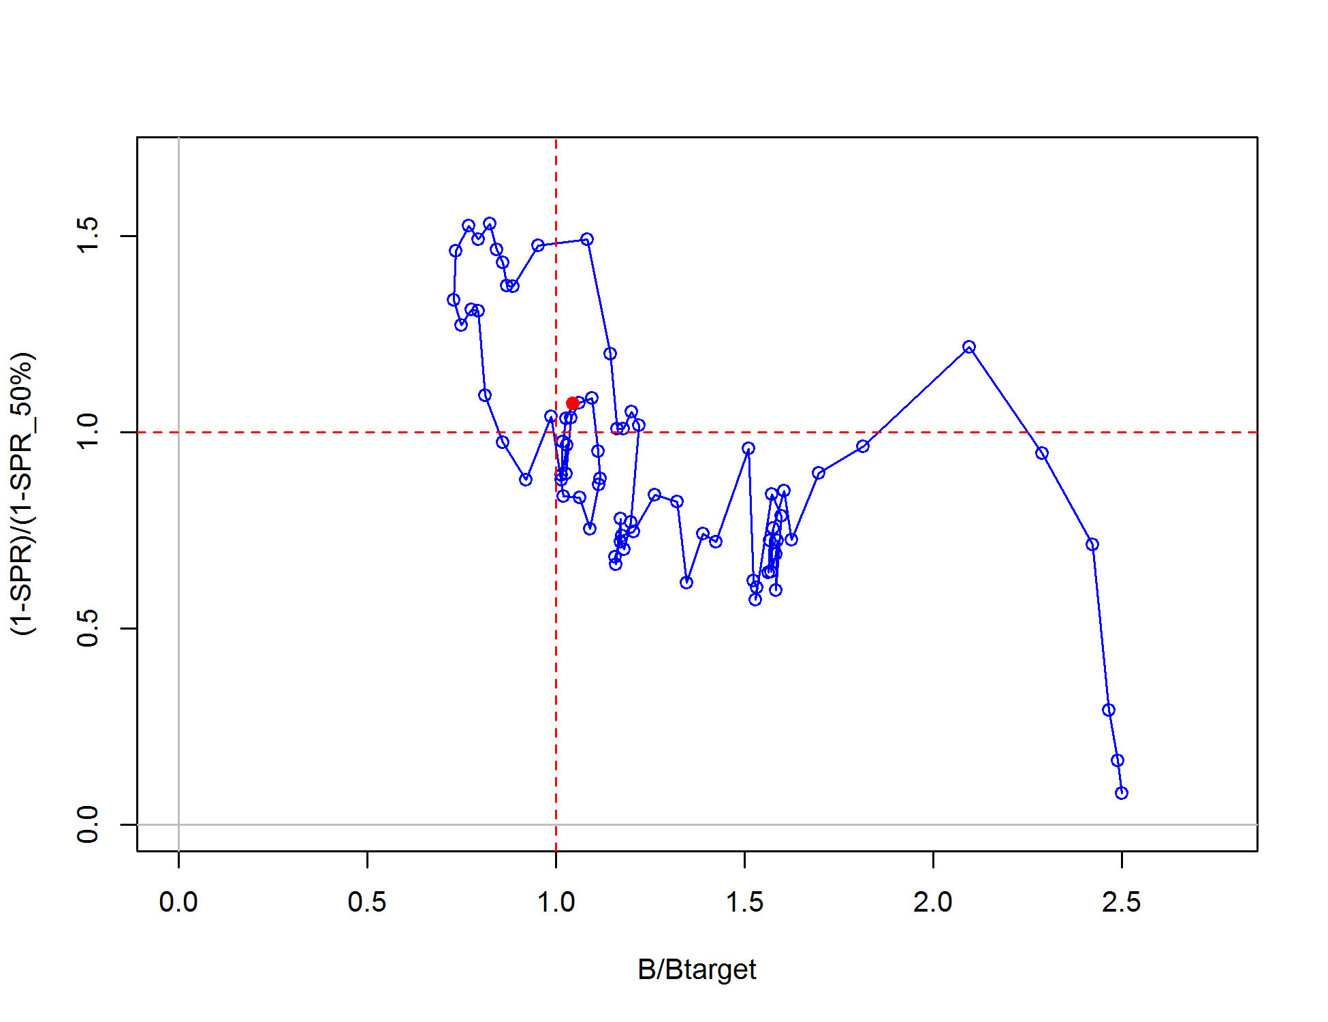

Figure ES-18. Phase plot of relative spawning biomass vs fishing intensity for the Washington model. The relative fishing intensity is (1-SPR) divided by 1-the SPR target. The vertical red line is the relative spawning biomass target defined as the annual spawning output divided by the spawning biomass corresponding to 40% of the unfished spawning biomass.

Ecosystem considerations

Ecosystem considerations were not explicitly included in these models, though growth deviations were considered in the Washington model. While no mechanisms have been put forth for these time-varying changes in growth, an environmental component is possible. Limited data in Oregon and California also suggest the possibility that growth has changed over time.

Reference points

Reference points were based on the rockfish FMSY proxy (SPR50%), target relative biomass (40%) and model-estimated selectivity for each fleet. California is below the target biomass reference point, but above the limit reference biomass (25%). Oregon is well above the target biomass. Washington relative biomass is above the target biomass. California and Washington yield values are lower than the previous assessment for similar reference points due to lower overall natural mortality values (Table ES-5). The proxy MSY values of management quantities are the most conservative compared to the estimated MSY and MSY relative to 40% biomass for both California and Washington (Table ES-5). The equilibrium estimates of yield relative to biomass are provided in Figure ES-19 to Figure ES-21.

Table ES-5. Summary of reference points for each black rockfish base case model.

California

|  |  |  |
| --- | --- | --- |
| **Quantity** | **Estimate** | **~95% Confidence Interval** |
|
| Unfished Spawning output (mt) | 1062 | 830-1293 |
| Unfished age 3+ biomass (mt) | 9540 | 8862-10219 |
| Unfished recruitment (R0) | 2010 | 1580-2440 |
| Depletion (2015) | 0.33 | 0.19-0.48 |
| ***Reference points based on SB40%*** |  |  |
| Proxy spawning output (*B40%*) | 425 | 332-517 |
| SPR resulting in *B40%* (*SPR50%*) | 0.444 | 0.44-0.44 |
| Exploitation rate resulting in *B40%* | 0.075 | 0-0.0811 |
| Yield with *SPR50%* at *B40%* (mt) | 343 | 316-369 |
| ***Reference points based on SPR proxy for MSY*** |  |  |
| Spawning output | 489 | 382-595 |
| *SPRproxy* | 0.5 |  |
| Exploitation rate corresponding to *SPRproxy* | 0.064 | 0.06-0.07 |
| Yield with *SPRproxy* at *SBSPR* (mt) | 319 | 295-344 |
| ***Reference points based on estimated MSY values*** |  |  |
| Spawning output at *MSY* (*SBMSY*) | 254 | 199-309 |
| *SPRMSY* | 0.295 | 0.29-0.3 |
| Exploitation rate corresponding to *SPRMSY* | 0.117 | 0.11-0.13 |
| *MSY* (mt) | 376 | 345-408 |

Oregon

|  |  |  |
| --- | --- | --- |
| **Quantity** | **Estimate** | **~95% Confidence Interval** |
|
| Unfished Spawning biomass (mt) | 1385 | 1212-1557 |
| Unfished age 3+ biomass (mt) | 11611 | 11318-11905 |
| Unfished recruitment (R0) | 3666 | 3594-3738 |
| Depletion (2015) | 60.4 | 58.9-61.8 |
| ***Reference points based on SB40%*** |  |  |
| Proxy spawning biomass (*B40%*) | 554 | 485-623 |
| SPR resulting in *B40%* (*SPR50%*) | 0.444 |  |
| Exploitation rate resulting in *B40%* | 0.116 | 0.108-0.125 |
| Yield with *SPR50%* at *B40%* (mt) | 518 | 503-532 |
| ***Reference points based on SPR proxy for MSY*** |  |  |
| Spawning biomass | 637 | 558-717 |
| *SPRproxy* | 0.5 |  |
| Exploitation rate corresponding to *SPRproxy* | 0.116 | 0.108-0.125 |
| Yield with *SPRproxy* at *SBSPR* (mt) | 518 | 503-532 |
| ***Reference points based on estimated MSY values*** |  |  |
| Spawning biomass at *MSY* (*SBMSY*) | 318 | 276-360 |
| *SPRMSY* | 0.286 | 0.283-0.289 |
| Exploitation rate corresponding to *SPRMSY* | 0.209 | 0.197-0.221 |
| *MSY* (mt) | 616 | 602-630 |

Washington

|  |  |  |
| --- | --- | --- |
| **Quantity** | **Estimate** | **~95% Confidence Interval** |
|
| Unfished Spawning output (mt) | 1356 | 1228-1483 |
| Unfished age 3+ biomass (mt) | 9119 | 8467-9772 |
| Unfished recruitment (R0) | 2102 | 1593-2610 |
| Depletion (2015) | 0.43 | 0.36-0.5 |
| ***Reference points based on SB40%*** |  |  |
| Proxy spawning output (*B40%*) | 542 | 491-593 |
| SPR resulting in *B40%* (*SPR50%*) | 0.444 | 0.44-0.44 |
| Exploitation rate resulting in *B40%* | 0.086 | 0.08-0.09 |
| Yield with *SPR50%* at *B40%* (mt) | 337 | 298-376 |
| ***Reference points based on SPR proxy for MSY*** |  |  |
| Spawning output | 624 | 565-683 |
| *SPRproxy* |  |  |
| Exploitation rate corresponding to *SPRproxy* | 0.072 | 0.07-0.08 |
| Yield with *SPRproxy* at *SBSPR* (mt) | 311 | 275-346 |
| ***Reference points based on estimated MSY values*** |  |  |
| Spawning output at *MSY* (*SBMSY*) | 294 | 267-322 |
| *SPRMSY* | 0.274385 | 0.27-0.28 |
| Exploitation rate corresponding to *SPRMSY* | 0.149 | 0.14-0.16 |
| *MSY* (mt) | 383 | 337-430 |

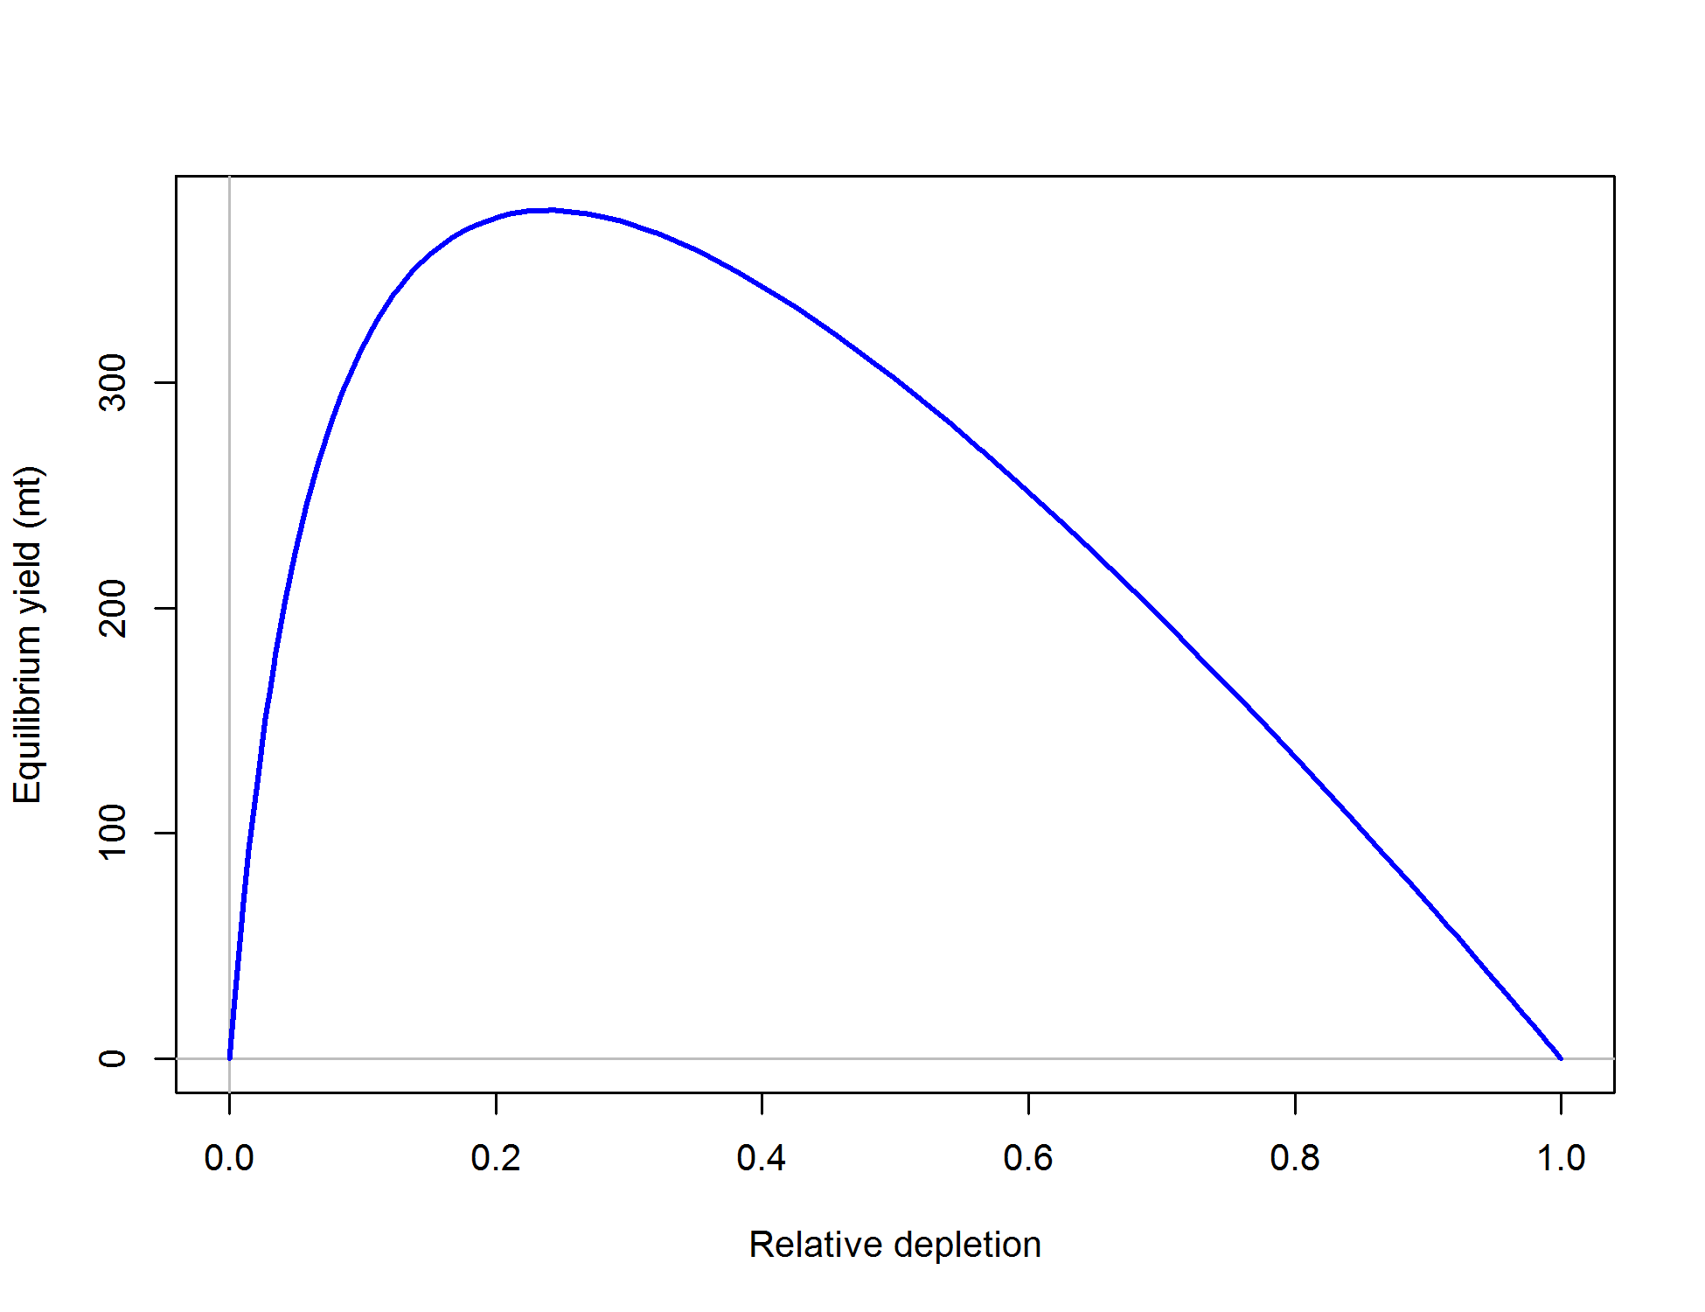

Figure ES-19. Equilibrium yield curve (derived from reference point values reported in Table ES-5) for the California base case model. Values are based on 2014 fishery selectivity and distribution with steepness fixed at 0.773. The depletion is relative to unfished spawning biomass.

**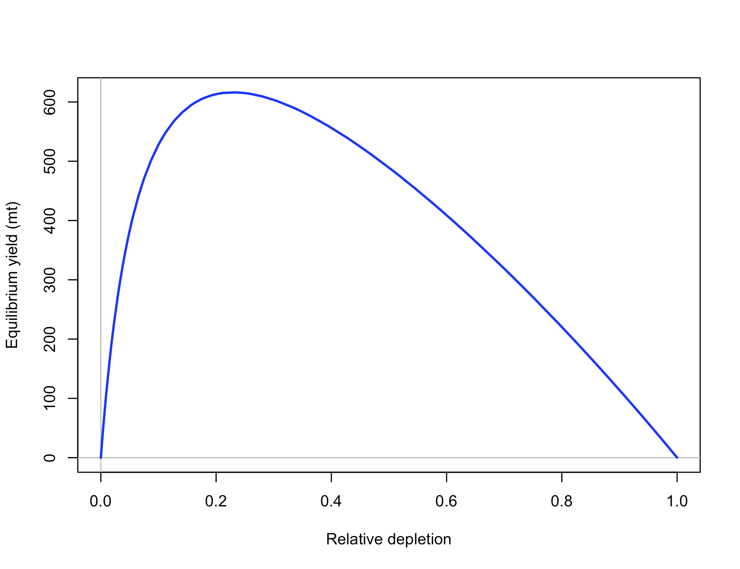**

Figure ES-20. Equilibrium yield curve (derived from reference point values reported in Table ES-5) for the Oregon base case model. Values are based on 2014 fishery selectivity and distribution with steepness fixed at 0.773. The depletion is relative to unfished spawning biomass.

**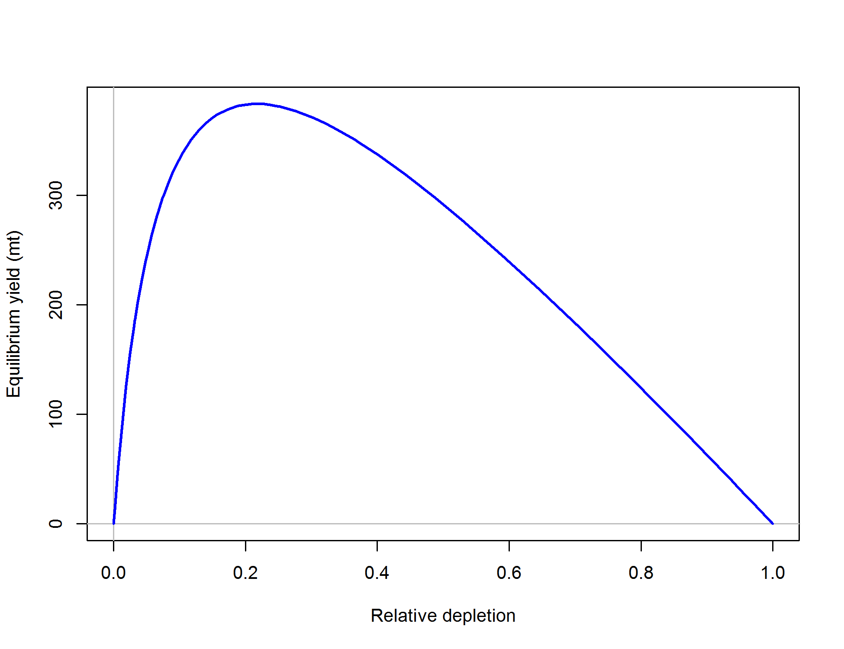**

Figure ES-21. Equilibrium yield curve (derived from reference point values reported in Table ES-5) for the Washington base case model. Values are based on 2014 fishery selectivity and distribution with steepness fixed at 0.773. The depletion is relative to unfished spawning biomass.

Management performance

Removals have been below the equivalent ABC-ACL since the prior assessment (Table ES-6), but those specified ABCs from the 2007 assessments are higher than those coming from the current assessment models. Removals over the last few years have or may have exceeded the newly estimated ABC-ACL values in some years. The differences in the treatment of natural mortality between the previous and current assessments are the biggest reason for this discrepancy.

Table ES-6. Recent trend in total catch and commercial landings (mt) relative to the management guidelines.  Estimated total catch reflect the commercial landings plus estimated discarded biomass.

|  |  |  |  |  |  |  |  |  |
| --- | --- | --- | --- | --- | --- | --- | --- | --- |
|  |  |  |  |  |  |  |  |  |
|  | OFL (mt) | |  | ABC/ACL (mt) | |  | Removals (mt) | |
| Year | CA + OR | WA |  | CA + OR | WA |  | CA + OR | WA |
| 2007 | 722 | 540 |  | 722 | 540 |  | 577 | 287 |
| 2008 | 722 | 540 |  | 722 | 540 |  | 593 | 222 |
| 2009 | 1469 | 490 |  | 1000 | 490 |  | 784 | 251 |
| 2010 | 1317 | 464 |  | 1000 | 464 |  | 650 | 219 |
| 2011 | 1163 | 426 |  | 1000 | 426 |  | 523 | 232 |
| 2012 | 1117 | 415 |  | 1000 | 415 |  | 563 | 282 |
| 2013 | 1108 | 411 |  | 1000 | 411 |  | 845 | 325 |
| 2014 | 1115 | 409 |  | 1000 | 409 |  | 865 | 356 |

Unresolved problems and major uncertainties

The most significant uncertainty for all models is the treatment and value of natural mortality and the form of fleet selectivity (e.g., length-based asymptotic vs. age-based dome-shaped selectivity). Data-driven selection between the extreme “kill” (using a ramping of M) or “hide” hypotheses are not currently resolvable. The current California and Washington base models instead use a form of the “kill” hypothesis by not implementing the age-based selectivity (“hide” hypothesis) and estimating female and male natural mortality, thus avoiding a fixing natural mortality as was necessary in the Oregon model. The Oregon model also contained a step in female natural mortality, a specification not used in the California or Washington models. Another important issue is the highly uncertain historical time-series of removals in all states, which needs further consideration. The development of fishery-dependent indices of abundance still requires further attention. Steepness, while fixed, is still highly uncertain for rockfishes and currently is mismatched to the MSY proxy. And while the steepness profile shows low sensitivity in several derived quantities, steepness strongly defines the yield capacity of stocks, and therefore could cause major uncertainty in the recommended management quantities. Stock structure and its relationship to the current political/management boundaries are also not fully understood, both within U.S. jurisdiction and between the U.S. and Canada. While this is a common challenge faced in most west coast stock assessments, further improvement on this topic will likely rely on black rockfish-specific data.

Harvest projections and decision tables

Black rockfish assessments for California and Washington have a preliminary distinction as category 1 stock assessments, thus harvest projections and decision tables are based on using P\*=0.45 and sigma = 0.36, resulting in a multiplier on the OFL of 0.956. The Oregon black rockfish assessment is a category 2 assessment, with a P\*=0.45 and sigma = 0.72 with a multiplier of 0.913 applied to the OFL. These multipliers are also combined with the rockfish MSY proxy of FSPR=50% MSY and the 40-10 harvest control rule to calculate OFLs, ABCs and ACLs. Projections for each state are provided in Table ES-7 to Table ES-9.

Uncertainty in management quantities for the base model of each state was characterized by exploring various model specifications in a decision table. Initial exploration included natural mortality and steepness values, and uncertainty in historical trawl catches for the WA and CA models. OR explored the scale factor coming from the value of the tagging catchability (Q) parameter, as well as M values. For the CA and WA models, there was very little sensitivity to steepness and trawl catches, but natural mortality produced sensitive results of predicted population scale and status. Discussion with the STAR panel resulted in high and low states of nature +/- 0.03 from the base case natural mortality values for females and males. High and low catch streams (rows) were determined by the forecasts, as described above, for each state of nature. Thus the low catch stream is based on the forecast from the low state of nature. The OR model demonstrated little sensitivity to *M*, but high sensitivity to the tagging survey Q. High and low states of nature, respectively, were based on a fixed tag of Q = 0.125 and Q estimated by the model. Resultant decision tables are provided in Table ES-10 to Table ES-12.

Table ES-7. Harvest projection of potential OFL and prescribed removals, summary biomass (age-3 and older), spawning output, and depletion for the California base case model projected with total projected catch equal to the 420 mt for 2015 and 2016. The predicted OFL is the calculated total catch determined by FSPR=50%.

|  |  |  |  |  |  |
| --- | --- | --- | --- | --- | --- |
|  | Predicted OFL | Projected removals | Age 3+ biomass | Spawning output | Depletion (%) |
| Year |
| 2015 | 354 | 420 | 5,773 | 353 | 33% |
| 2016 | 354 | 420 | 5,800 | 396 | 37% |
| 2017 | 349 | 334 | 5,754 | 450 | 42% |
| 2018 | 347 | 332 | 5,747 | 503 | 47% |
| 2019 | 344 | 329 | 5,716 | 538 | 51% |
| 2020 | 341 | 326 | 5,677 | 555 | 52% |
| 2021 | 338 | 323 | 5,640 | 558 | 53% |
| 2022 | 336 | 321 | 5,608 | 554 | 52% |
| 2023 | 334 | 319 | 5,583 | 547 | 52% |
| 2024 | 333 | 318 | 5,565 | 539 | 51% |
| 2025 | 332 | 318 | 5,550 | 532 | 50% |
| 2026 | 332 | 317 | 5,540 | 526 | 50% |

Table ES-8. Harvest projection of potential OFL and prescribed removals, summary biomass (age-3 and older), spawning output, and depletion for the Oregon base case model projected with total projected catch equal to the 580 mt for 2015 and 2016. The predicted OFL is the calculated total catch determined by FSPR=50%.

|  |  |  |  |  |  |
| --- | --- | --- | --- | --- | --- |
|  | Predicted OFL | Projected removals | Age 3+ biomass | Spawning output | Depletion (%) |
| Year |
| 2015 | 606 | 580 | 7819 | 795 | 60% |
| 2016 | 590 | 580 | 7665 | 780 | 59% |
| 2017 | 577 | 526 | 7577 | 763 | 58% |
| 2018 | 570 | 520 | 7506 | 749 | 57% |
| 2019 | 565 | 515 | 7449 | 736 | 56% |
| 2020 | 561 | 512 | 7401 | 724 | 55% |
| 2021 | 558 | 510 | 7361 | 715 | 54% |
| 2022 | 556 | 508 | 7326 | 707 | 54% |
| 2023 | 554 | 506 | 7296 | 700 | 53% |
| 2024 | 553 | 504 | 7269 | 694 | 53% |
| 2025 | 551 | 503 | 7245 | 689 | 52% |
| 2026 | 550 | 502 | 7819 | 685 | 52% |

Table ES-9. Harvest projection of potential OFL and prescribed removals, summary biomass (age-3 and older), spawning output, and depletion for the Washington base case model projected with total projected catch equal to the 283 mt for 2015 and 2016. The predicted OFL is the calculated total catch determined by FSPR=50%.

|  |  |  |  |  |  |
| --- | --- | --- | --- | --- | --- |
|  | Predicted OFL | Projected removals | Age 3+ biomass | Spawning output | Depletion (%) |
| Year |
| 2015 | 319 | 283 | 5,645 | 582 | 43% |
| 2016 | 320 | 283 | 5,652 | 610 | 45% |
| 2017 | 319 | 305 | 5,651 | 632 | 47% |
| 2018 | 315 | 301 | 5,629 | 643 | 47% |
| 2019 | 312 | 299 | 5,615 | 646 | 48% |
| 2020 | 311 | 297 | 5,609 | 644 | 48% |
| 2021 | 311 | 297 | 5,610 | 640 | 47% |
| 2022 | 311 | 297 | 5,616 | 636 | 47% |
| 2023 | 311 | 297 | 5,625 | 634 | 47% |
| 2024 | 312 | 298 | 5,635 | 632 | 47% |
| 2025 | 312 | 299 | 5,645 | 632 | 47% |
| 2026 | 313 | 299 | 5,655 | 632 | 47% |

Table ES-10. Summary decision table of 12-year projections for the California model beginning in 2017 for alternate states of nature based on natural mortality. Columns range over low, mid, and high state of nature, and rows range over different assumptions of total catch levels corresponding to the forecast catches from each state of nature. Catches in 2015 and 2016 are allocated to each fleet based on the percentage of landings for each fleet in 2014.

|  |  |  |  |  |  |  |  |  |
| --- | --- | --- | --- | --- | --- | --- | --- | --- |
| California | | | **State of nature** | | | | | |
| Low | | Base case | | High | |
| *Mfemale* = 0.15 ; *Mmale* = 0.10 | | *Mfemale* = 0.18; *Mmale* = 0.13 | | *Mfemale* = 0.21 ; *Mmale* = 0.16 | |
| **Relative probability of states of nature** | | | 0.25 | | 0.5 | | 0.25 | |
| **Management decision** | Year | Catch (mt) | Spawning output | Stock status | Spawning output | Stock status | Spawning output | Stock status |
| Low catch | 2017 | 185 | 325 | 27% | 450 | 42% | 589 | 62% |
| 2018 | 207 | 378 | 31% | 517 | 49% | 668 | 70% |
| 2019 | 222 | 418 | 34% | 567 | 53% | 721 | 76% |
| 2020 | 232 | 446 | 37% | 598 | 56% | 748 | 79% |
| 2021 | 240 | 463 | 38% | 613 | 58% | 754 | 79% |
| 2022 | 246 | 474 | 39% | 620 | 58% | 748 | 79% |
| 2023 | 251 | 482 | 40% | 621 | 59% | 736 | 77% |
| 2024 | 255 | 488 | 40% | 620 | 58% | 722 | 76% |
| 2025 | 259 | 493 | 41% | 617 | 58% | 707 | 74% |
| 2026 | 262 | 498 | 41% | 615 | 58% | 694 | 73% |
| Base catch | 2017 | 334 | 325 | 27% | 450 | 42% | 589 | 62% |
| 2018 | 332 | 364 | 30% | 503 | 47% | 654 | 69% |
| 2019 | 329 | 389 | 32% | 538 | 51% | 694 | 73% |
| 2020 | 326 | 402 | 33% | 555 | 52% | 708 | 74% |
| 2021 | 323 | 406 | 33% | 558 | 53% | 703 | 74% |
| 2022 | 321 | 406 | 33% | 554 | 52% | 689 | 72% |
| 2023 | 319 | 404 | 33% | 547 | 52% | 670 | 70% |
| 2024 | 318 | 401 | 33% | 539 | 51% | 651 | 68% |
| 2025 | 318 | 400 | 33% | 532 | 50% | 634 | 67% |
| 2026 | 317 | 400 | 33% | 526 | 50% | 619 | 65% |
| High catch | 2017 | 478 | 325 | 27% | 450 | 42% | 589 | 62% |
| 2018 | 461 | 350 | 29% | 490 | 46% | 641 | 67% |
| 2019 | 444 | 360 | 30% | 510 | 48% | 666 | 70% |
| 2020 | 428 | 357 | 29% | 512 | 48% | 666 | 70% |
| 2021 | 415 | 348 | 29% | 503 | 47% | 650 | 68% |
| 2022 | 404 | 335 | 28% | 489 | 46% | 626 | 66% |
| 2023 | 395 | 322 | 27% | 473 | 45% | 600 | 63% |
| 2024 | 388 | 311 | 26% | 458 | 43% | 576 | 60% |
| 2025 | 382 | 303 | 25% | 446 | 42% | 555 | 58% |
| 2026 | 377 | 296 | 24% | 437 | 41% | 538 | 56% |

Table ES-11. Summary decision table of 12-year projections for the Oregon model beginning in 2017 for alternate states of nature based on natural mortality. Columns range over low, mid, and high state of nature, and rows range over different assumptions of total catch levels corresponding to the forecast catches from each state of nature. Catches in 2015 and 2016 are allocated to each fleet by the overall percentage of landings for each fleet over the last 10 years.

|  |  |  |  |  |  |  |  |  |
| --- | --- | --- | --- | --- | --- | --- | --- | --- |
| Oregon | | | **State of nature** | | | | | |
| Low | | Base case | | High | |
| *Tag Q estimated* | | *Tag Q = 0.25* | | *Tag Q = 0.125* | |
| **Relative probability of states of nature** | | | 0.25 | | 0.5 | | 0.25 | |
| **Management decision** | Year | Catch (mt) | Spawning output | Stock status | Spawning output | Stock status | Spawning output | Stock status |
| 2014 Catch | 2017 | 485 | 117 | 16% | 804 | 60% | 1808 | 80% |
| 2018 | 485 | 105 | 14% | 796 | 60% | 1802 | 79% |
| 2019 | 485 | 93 | 13% | 788 | 59% | 1794 | 79% |
| 2020 | 485 | 81 | 11% | 779 | 59% | 1786 | 79% |
| 2021 | 485 | 71 | 10% | 771 | 58% | 1778 | 78% |
| 2022 | 485 | 61 | 8% | 762 | 57% | 1771 | 78% |
| 2023 | 485 | 53 | 7% | 755 | 57% | 1765 | 78% |
| 2024 | 485 | 44 | 6% | 748 | 56% | 1759 | 77% |
| 2025 | 485 | 36 | 5% | 743 | 56% | 1754 | 77% |
| 2026 | 485 | 28 | 4% | 737 | 55% | 1750 | 77% |
| State harvest guideline: 440.8 rec/139.2 comm. | 2017 | 580 | 117 | 16% | 804 | 60% | 1808 | 80% |
| 2018 | 580 | 98 | 13% | 789 | 59% | 1794 | 79% |
| 2019 | 580 | 78 | 11% | 772 | 58% | 1779 | 78% |
| 2020 | 580 | 59 | 8% | 754 | 57% | 1762 | 78% |
| 2021 | 580 | 43 | 6% | 736 | 55% | 1745 | 77% |
| 2022 | 580 | 29 | 4% | 718 | 54% | 1729 | 76% |
| 2023 | 580 | 18 | 3% | 702 | 53% | 1715 | 75% |
| 2024 | 580 | 9 | 1% | 687 | 52% | 1702 | 75% |
| 2025 | 580 | 3 | 0% | 673 | 51% | 1690 | 74% |
| 2026 | 580 | 2 | 0% | 661 | 50% | 1679 | 74% |
| High catch | 2017 | 645 | 117 | 16% | 804 | 60% | 1808 | 80% |
| 2018 | 645 | 92 | 13% | 783 | 59% | 1789 | 79% |
| 2019 | 645 | 68 | 9% | 760 | 57% | 1767 | 78% |
| 2020 | 645 | 45 | 6% | 735 | 55% | 1744 | 77% |
| 2021 | 645 | 26 | 4% | 710 | 53% | 1721 | 76% |
| 2022 | 645 | 13 | 2% | 686 | 52% | 1699 | 75% |
| 2023 | 645 | 4 | 1% | 664 | 50% | 1679 | 74% |
| 2024 | 645 | 2 | 0% | 643 | 48% | 1660 | 73% |
| 2025 | 645 | 1 | 0% | 624 | 47% | 1644 | 72% |
| 2026 | 645 | 0 | 0% | 607 | 46% | 1629 | 72% |

Table ES-12. Summary decision table of 12-year projections for the Washington model beginning in 2017 for alternate states of nature based on natural mortality. Columns range over low, mid, and high state of nature, and rows range over different assumptions of total catch levels corresponding to the forecast catches from each state of nature. Catches in 2015 and 2016 are allocated to each fleet based on the percentage of landings for each fleet in 2014.

|  |  |  |  |  |  |  |  |  |
| --- | --- | --- | --- | --- | --- | --- | --- | --- |
| Washington | | | **State of nature** | | | | | |
| Low | | Base case | | High | |
| *Mfemale*= 0.133 ; *Mmale* = 0.115 | | *Mfemale*= 0.163 ; *Mmale* = 0.145 | | *Mfemale*= 0.193 ; *Mmale* = 0.175 | |
| **Relative probability of states of nature** | | | 0.25 | | 0.5 | | 0.25 | |
| **Management decision** | Year | Catch (mt) | Spawning output | Stock status | Spawning output | Stock status | Spawning output | Stock status |
| Low catch | 2017 | 193 | 498 | 34% | 632 | 47% | 844 | 59% |
| 2018 | 200 | 525 | 36% | 660 | 49% | 871 | 61% |
| 2019 | 206 | 545 | 38% | 679 | 50% | 886 | 62% |
| 2020 | 210 | 559 | 38% | 692 | 51% | 894 | 63% |
| 2021 | 215 | 569 | 39% | 701 | 52% | 899 | 63% |
| 2022 | 218 | 578 | 40% | 709 | 52% | 905 | 64% |
| 2023 | 221 | 585 | 40% | 716 | 53% | 912 | 64% |
| 2024 | 224 | 593 | 41% | 724 | 53% | 919 | 65% |
| 2025 | 226 | 600 | 41% | 731 | 54% | 927 | 65% |
| 2026 | 228 | 607 | 42% | 737 | 54% | 935 | 66% |
| Base catch | 2017 | 305 | 498 | 34% | 632 | 47% | 844 | 59% |
| 2018 | 301 | 508 | 35% | 643 | 47% | 855 | 60% |
| 2019 | 299 | 511 | 35% | 646 | 48% | 855 | 60% |
| 2020 | 297 | 508 | 35% | 644 | 48% | 849 | 60% |
| 2021 | 297 | 504 | 35% | 640 | 47% | 843 | 59% |
| 2022 | 297 | 499 | 34% | 636 | 47% | 839 | 59% |
| 2023 | 297 | 494 | 34% | 634 | 47% | 837 | 59% |
| 2024 | 298 | 491 | 34% | 632 | 47% | 838 | 59% |
| 2025 | 299 | 489 | 34% | 632 | 47% | 840 | 59% |
| 2026 | 299 | 487 | 34% | 632 | 47% | 843 | 59% |
| High catch | 2017 | 464 | 498 | 34% | 632 | 47% | 844 | 59% |
| 2018 | 448 | 483 | 33% | 619 | 46% | 831 | 58% |
| 2019 | 436 | 461 | 32% | 599 | 44% | 810 | 57% |
| 2020 | 428 | 436 | 30% | 576 | 42% | 785 | 55% |
| 2021 | 423 | 409 | 28% | 553 | 41% | 761 | 53% |
| 2022 | 419 | 385 | 27% | 532 | 39% | 742 | 52% |
| 2023 | 417 | 363 | 25% | 514 | 38% | 728 | 51% |
| 2024 | 415 | 344 | 24% | 500 | 37% | 718 | 50% |
| 2025 | 414 | 327 | 23% | 488 | 36% | 711 | 50% |
| 2026 | 413 | 313 | 22% | 478 | 35% | 706 | 50% |

Research and data needs

Recommended avenues for research to help improve future black rockfish stock assessments:

1. Further investigation into the movement and behavior of older (> age 10) females to reconcile their absence in fisheries data. If the females are currently inaccessible to fishing gear, can we find where they are?
2. Appropriate natural mortality values for females and males. This will help resolve the extent to which dome-shaped age-based selectivity may be occurring for each.
3. All states need improved historical catch reconstructions. The trawl fishery catches in particular require particular attention. Given the huge historical removals of that fleet in each state, the assessment is very sensitive to the assumed functional form of selectivity. A synoptic catch reconstruction is recommended, where states work together to resolve cross-state catch issues as well as standardize the approach to catch recommendations.
4. Identifying stanzas or periods of uncertainty in the historical catch series will aid in the exploration of catch uncertainty in future assessment sensitivity runs.
5. The ODFW tagging study off Newport should be continued and expanded to other areas. To provide better prior information on the spatial distribution of the black rockfish stock, further work should be conducted to map the extent of black rockfish habitat and the densities of black rockfish residing there.
6. An independent nearshore survey should be supported in all states to avoid the reliance on fishery-based CPUE indices.
7. Stock structure for black rockfish is a complicated topic that needs further analysis. How this is determined (e.g., exploitation history, genetics, life history variability, biogeography, etc.) and what this means for management units needs to be further refined. This is a general issue for all nearshore stocks that likely have significant and small scale stock structure among and within states, but limited data collections to support small-scale management.

Table ES-13. Summary tables of the result for each state assessment model for black rockfish. OFL and ACL values for California and Oregon are combined across both states (see ES-6).

|  |  |  |  |  |  |  |  |  |  |  |
| --- | --- | --- | --- | --- | --- | --- | --- | --- | --- | --- |
| California |  |  |  |  |  |  |  |  |  |  |
|  | 2005 | 2006 | 2007 | 2008 | 2009 | 2010 | 2011 | 2012 | 2013 | 2014 |
| Landings (mt) | 257 | 258 | 233 | 248 | 359 | 265 | 216 | 239 | 414 | 396 |
| Total removals (mt) | 261 | 261 | 237 | 252 | 365 | 269 | 219 | 243 | 421 | 402 |
| OFL (mt) | 722 | 722 | 722 | 722 | 1469 | 1317 | 1163 | 1117 | 1108 | 1115 |
| ACL (mt) | 722 | 722 | 722 | 722 | 1000 | 1000 | 1000 | 1000 | 1000 | 1000 |
| 1-SPR | 0.60 | 0.58 | 0.53 | 0.53 | 0.65 | 0.56 | 0.46 | 0.45 | 0.57 | 0.53 |
| Exploitation rate (catch/ age 3+ biomass) | 0.09 | 0.08 | 0.07 | 0.07 | 0.10 | 0.08 | 0.06 | 0.05 | 0.08 | 0.07 |
| Age 3+ biomass (mt) | 2987 | 3143 | 3315 | 3456 | 3496 | 3447 | 3975 | 4714 | 5346 | 5610 |
| Spawning Output | 226 | 228 | 231 | 241 | 257 | 268 | 285 | 305 | 322 | 329 |
| ~95% CI | 146-306 | 145-311 | 145-317 | 151-332 | 159-354 | 162-374 | 170-401 | 180-430 | 189-454 | 191-468 |
| Recruitment | 1371 | 984 | 1327 | 4509 | 4323 | 2997 | 1765 | 1701 | 1719 | 1728 |
| ~95% CI | 714-2029 | 465-1504 | 565-2088 | 2176-6842 | 1560-7086 | 841-5153 | 306-3223 | 1206-2195 | 1226-2213 | 1233-2223 |
| Depletion (%) | 0.21 | 0.21 | 0.22 | 0.23 | 0.24 | 0.25 | 0.27 | 0.29 | 0.30 | 0.31 |
| ~95% CI | 0.13-0.3 | 0.13-0.3 | 0.13-0.31 | 0.14-0.32 | 0.14-0.34 | 0.15-0.36 | 0.15-0.38 | 0.17-0.41 | 0.17-0.43 | 0.18-0.44 |

|  |  |  |  |  |  |  |  |  |  |  |
| --- | --- | --- | --- | --- | --- | --- | --- | --- | --- | --- |
| Oregon |  |  |  |  |  |  |  |  |  |  |
|  | 2005 | 2006 | 2007 | 2008 | 2009 | 2010 | 2011 | 2012 | 2013 | 2014 |
| Landings (mt) | 426 | 374 | 372 | 351 | 443 | 418 | 318 | 329 | 434 | 483 |
| Total removals (mt) | 427 | 376 | 374 | 353 | 446 | 420 | 319 | 330 | 436 | 485 |
| OFL (mt) | 722 | 722 | 722 | 722 | 1469 | 1317 | 1163 | 1117 | 1108 | 1115 |
| ACL (mt) | 722 | 722 | 722 | 722 | 1000 | 1000 | 1000 | 1000 | 1000 | 1000 |
| 1-SPR | 0.38 | 0.35 | 0.35 | 3.3 | 0.39 | 0.37 | 0.3 | 0.31 | 0.38 | 0.41 |
| Exploitation rate (catch/ age 3+ biomass) | 0.08 | 0.07 | 0.07 | 0.07 | 0.09 | 0.08 | 0.06 | 0.06 | 0.08 | 0.09 |
| Age 3+ biomass (mt) | 8277 | 8582 | 8608 | 8753 | 8230 | 8366 | 8971 | 8929 | 8322 | 8040 |
| Spawning Output | 820 | 817 | 819 | 822 | 827 | 826 | 826 | 834 | 842 | 841 |
| ~95% CI | 708-933 | 705-929 | 707-931 | 710-933 | 716-939 | 714-938 | 714-938 | 722-946 | 729-954 | 729-954 |
| Recruitment | 3490 | 3488 | 3489 | 3491 | 3494 | 3493 | 3493 | 3497 | 3501 | 3500 |
| ~95% CI | 3415-3565 | 3414-3563 | 3414-3564 | 3416-3565 | 3419-3568 | 3418-3568 | 3418-3568 | 3422-3571 | 69-6932 | 69-6932 |
| Depletion (%) | 59.3 | 59 | 59.1 | 59.4 | 59.8 | 59.7 | 59.7 | 60.2 | 60.8 | 60.8 |
| ~95% CI | 57.8-60.7 | 57.6-60.5 | 57.7-60.6 | 57.9-60.8 | 58.4-61.2 | 58.2-61.1 | 58.2-61.1 | 58.8-61.6 | 59.4-62.2 | 59.4-62.2 |

|  |  |  |  |  |  |  |  |  |  |  |
| --- | --- | --- | --- | --- | --- | --- | --- | --- | --- | --- |
| Washington |  |  |  |  |  |  |  |  |  |  |
|  | 2005 | 2006 | 2007 | 2008 | 2009 | 2010 | 2011 | 2012 | 2013 | 2014 |
| Landings (mt) | 321 | 307 | 283 | 219 | 247 | 216 | 228 | 277 | 321 | 350 |
| Total removals (mt) | 325 | 312 | 287 | 222 | 251 | 219 | 232 | 282 | 325 | 356 |
| OFL (mt) | 540 | 540 | 540 | 540 | 490 | 464 | 426 | 415 | 411 | 409 |
| ACL (mt) | 540 | 540 | 540 | 540 | 490 | 464 | 426 | 415 | 411 | 409 |
| 1-SPR | 0.54 | 0.54 | 0.52 | 0.45 | 0.48 | 0.44 | 0.45 | 0.49 | 0.52 | 0.54 |
| Exploitation rate (catch/ age 3+ biomass) | 0.07 | 0.06 | 0.06 | 0.05 | 0.05 | 0.04 | 0.04 | 0.05 | 0.06 | 0.06 |
| Age 3+ biomass (mt) | 4984 | 4899 | 4814 | 4779 | 4980 | 5119 | 5427 | 5550 | 5699 | 5690 |
| Spawning Output | 594 | 576 | 564 | 557 | 558 | 551 | 550 | 552 | 557 | 567 |
| ~95% CI | 482-706 | 466-686 | 455-672 | 449-665 | 450-665 | 444-657 | 444-656 | 446-658 | 449-664 | 456-678 |
| Recruitment | 1371 | 984 | 1327 | 4509 | 4323 | 2997 | 1765 | 1701 | 1719 | 1728 |
| ~95% CI | 714-2029 | 465-1504 | 565-2088 | 2176-6842 | 1560-7086 | 841-5153 | 306-3223 | 1206-2195 | 1226-2213 | 1233-2223 |
| Depletion (%) | 0.44 | 0.42 | 0.42 | 0.41 | 0.41 | 0.41 | 0.41 | 0.41 | 0.41 | 0.42 |
| ~95% CI | 0.36-0.51 | 0.35-0.5 | 0.35-0.49 | 0.34-0.48 | 0.34-0.48 | 0.34-0.47 | 0.34-0.47 | 0.34-0.47 | 0.34-0.48 | 0.35-0.49 |

# Introduction

## Basic Information

Black rockfish (*Sebastes melanops*) are an important component of the recreational fisheries in the nearshore waters off central and northern California, Oregon, and Washington, as well as the non-trawl commercial fisheries in California and Oregon. They range as far north as Amchitka and Kodiak islands in Alaska and are considered uncommon south of central California (Love et al. 2002).

A previous assessment of black rockfish off Oregon and California (Ralston and Dick 2003) reviewed the evidence supporting genetic stock structure for black rockfish and other rockfish off the U.S. West Coast and concluded that the Oregon and California populations of black rockfish are probably not genetically heterogeneous. That assessment treated the black rockfish off California and Oregon as a unit stock. Previous assessments of black rockfish off Washington (Wallace et al. 1999, 2007) describe a study of coastal black rockfish genetic structure using 10 sampled sites collected from northern California to southern British Columbia t 1995-97. Results of that study support the notion of separate genetic stocks north and south of Cape Falcon. However, a later study (Baker 1999) of black rockfish collected from eight sites along the northern Oregon coast concluded that black rockfish from north and south of Cape Falcon were genetically very similar.

Although a stock boundary line at the Columbia River seems reasonable for black rockfish, both because it is a state fishery management boundary and because the Columbia River plume is likely to be a natural barrier to the north-south exchange of black rockfish adults and larvae, the 2007 assessment of black rockfish off Oregon and California (Sampson 2007) differed slightly from Ralston and Dick (2003) in placing the northern boundary at Cape Falcon rather than at the Columbia River. The boundary was changed to avoid overlap with the separate northern assessment (Wallace et al. 2007) and to simplify the process of assembling historical commercial landings data, which are largely available in terms of Pacific Marine Fisheries Commission (PMFC) statistical areas. The northern boundary of PMFC Area 2C is at Cape Falcon (Figure 1). Given the spatial resolution of the historical commercial fishery data, it is very problematic to estimate the catch of black rockfish taken north of Cape Falcon but south of the Columbia River.

During a preliminary workshop in April 2015 (PFMC 2015), to discuss approaches for assessing black rockfish, China rockfish (*S. nebulosus*), and kelp greenling (*Hexagrammos decagrammus*), it was agreed that the assessments for these nearshore species should at a minimum be spatially stratified with boundaries at the CA/OR border (42°00' N latitude) and the OR/WA border (46°16' N latitude). Such a spatial stratification would be consistent with two ideas: (a) these nearshore species do not exhibit much adult movement and (b) exploitation and management histories have varied significantly among the three states. Together these features would likely create appreciable state-to-state differences in age composition for each of the three species. Stock assessment teams were advised that they could use geographic strata that were finer than the state level if there were data to support such an approach (Figure 1).

At the same nearshore stock assessment workshop, it was agreed that recreational catch histories for the stocks of black rockfish should be assembled on the basis of port of landing rather than location of fish capture, even though fishing vessels landing their catches into a port in one state might have captured fish in waters off a neighboring state.

Accounting for location of capture is very problematic for recreationally caught fish and for commercial catches taken with non-trawl types of gear (e.g., hook-and-line), for which there are no or very limited logbooks that report fishing location. For these regional assessments the commercially caught black rockfish were apportioned to assessment region based on the port of landing, with the exception of trawl caught fish landed into Astoria, OR. Most of these fish were assumed to have been caught off Washington and most of the trawl landings into Astoria were therefore included with the catch history for the Washington assessment region. Details are provided below in Section 2.1.1.1 The PacFIN Era – 1981 to 2014.

## Life History

Adults tend to occur in schools over rocky structure at depths less than 40 fathoms, and sometimes feed actively on or near the surface. They feed on a wide variety of prey including zooplankton, krill, mysids, sand lance, and juvenile rockfish (Love 1969), and are subject to predation by lingcod and marine mammals.

Although tagging studies have documented some individuals moving long distances (several hundreds of miles), the vast majority of recaptured individuals were found close to the areas of initial capture and tagging (Culver 1987; Ayres 1988; Starr and Green 2007; Wallace et al. 2010). Results from a 2004-05 study off Newport, OR of 42 black rockfish implanted with acoustic tags indicated that all but seven fish remained within range of a 3 x 5 km array of acoustic receivers during one full year of monitoring and had relatively small home ranges that did not vary seasonally (Parker et al. 2007). Green and Starr (2011) report similar findings from a study in Carmel Bay, CA of 23 acoustically tagged black rockfish. The extensive Washington state tagging study also supported low movements for most individuals, with some exceptional movements recorded (Wallace et al. 2010).

Like all members of the genus *Sebastes,* black rockfish have internal fertilization and bear live young approximately two months after insemination. Black rockfish are quite fecund, with a six-year-old female annually producing about 300,000 embryos and a 16-year-old producing about 950,000 embryos (Bobko and Berkeley 2004). Recent studies have demonstrated that the relative number and quality of larvae increase with age in female black rockfish (Berkeley et al. 2004; Hixon et al. 2014). Parturition of larvae occurs during winter (Wyllie-Echeverria 1987) and larvae and small juveniles are pelagic for several months to a year (Boehlert and Yoklavich 1983). Settlement occurs in estuaries, tide-pools, and in the nearshore at depths less than 20 m (Stein and Hassler 1989).

Black rockfish begin recruiting to nearshore fisheries at 3-4 years of age, corresponding to a fork length of about 25‑30 cm, and 50% of females attain maturity at about 6-8 years, corresponding to a fork length of about 38‑42 cm. Adult female black rockfish grow 3‑5 cm larger than males, with a few females attaining fork lengths greater than 55 cm.

## Ecosystem Considerations

No formal ecosystem considerations have been made given the lack of data for such an undertaking. Differences in growth though time have been considered in the model specification in the Washington model. Though the mechanism is not specified, this could certainly be due to process error driven by environmental conditions.

## Fishery Information

Black rockfish are harvested by a wide variety of fishing methods including trawling, trolling, and hook-and-line fishing with jigs and long-lines. Although black rockfish have never been a dominant component of any commercial fisheries, they are important as incidental catch in the troll fishery for salmon and the troll and jig fisheries for groundfish. With the decline of salmon fishing opportunities in the late 1970s and early 1980s black rockfish became a vital target of marine recreational fisheries in Oregon and Washington, especially during periods of restricted or slack fishing for salmon, halibut, and tuna.

Black rockfish are also an important component of the recreational fisheries in northern California but are of less significance south of Cape Mendocino due to their reduced prevalence compared to other species.  Since 1990 annual recreational harvests of black rockfish have averaged 229.6 tons off California, 304.4 tons off Oregon, and 272.5 tons off Washington.  Commercial annual harvests by non-trawl gear types during the same period averaged 44.6 tons in California, 62.0 tons in Oregon, and 14.7 tons in Washington.  Harvests by trawl on average during this period have been less than 19.3 tons annually for all three states combined.

## Summary of Management History

Prior to 2000 the Pacific Fishery Management Council (PFMC or Council) managed the fishery for black rockfish as part of the *Sebastes* complex, with no separate Acceptable Biological Catch (ABC) or Optimum Yield (OY) for black rockfish. In 2000 the Council established an ABC of 1,200 mt for black rockfish caught north of Cape Mendocino (in the Eureka, Columbia, and Vancouver INPFC statistical areas), but left black rockfish south of Cape Mendocino as part of the "other rockfish" category. For 2001 through 2003 the ABC for black rockfish caught north of Cape Mendocino was 1,115 mt annually, and black rockfish south of Cape Mendocino remained part of the "other rockfish" category and without a separate ABC or OY.

Regulation of the black rockfish fisheries by the PFMC prior to 2004 was accomplished primarily by trip limits for commercial fisheries and bag limit restrictions for recreational fisheries, with different limits applying in different geographic regions (see Table 1 in Ralston and Dick, 2003). Some other important regulations include the following.

* 1953: California prohibited trawling within three miles of shore.
* 1995: The commercial hook-and-line fishing in Washington state waters (0-3 miles) was closed to preserve recreational fishing opportunities and avoid localized depletion; the closure was extended to trawlers in 1999. Oregon established black rockfish management areas with reduced daily commercial fishery trip limits in area near ports with large recreational fisheries.
* 2000: Black rockfish began to be managed by the Council as a minor nearshore species. Commercial trip limits were significantly reduced, with specific restrictions applying to black rockfish. California instituted seasonal closures for commercial and recreational fisheries inside 20 fathoms, reduced the bag limit for rockfish from 15 to 10 fish, and limited recreational gear to one line with three hooks.
* 2002: California adopted a Nearshore Fishery Management Plan and began more active management of nearshore fisheries including the use of seasonal, regional, and depth-specific closures. Oregon adopted an Interim Nearshore Fishery Management Plan in anticipation of increased pressure on nearshore stocks due to reduced fishing opportunities for groundfish in federal waters. Regulations included fishing-sector specific caps on retained harvests, set approximately at the levels attained in 2000.
* 2003: The Council established Rockfish Conservation Areas (RCAs) to control catches of overfished rockfish species, and large portions of the shelf were closed to fishing. Differential trip limits were applied north and south of a management boundary at 40º10’ N. latitude for nearshore *Sebastes* species. Nearshore permittees in California became subject to depth restrictions consistent with the shoreward non-trawl RCA boundary. In California the commercial and recreational fisheries for rockfish were closed early.
* In 2004 and 2005: the sport fishery in Oregon closed in September 2004 due to early attainment of the state's limit for sport-caught black rockfish. This was the first time that the sport rockfish fishery in Oregon had not been open all year. In 2005 it closed early again.
* In 2008 the groundfish trawl fishery was closed in Washington from the seaward RCA boundary to the shore north of 48°10' N. latitude to address increased encounters with yelloweye rockfish and canary rockfish.

In recent years California, Oregon and Washington regulations for the marine sport fisheries, which has been the major source of mortality on black rockfish, have become quite complicated and variable through time. Tools for regulating the sport fishery include closed areas, depth restrictions, seasonal closures, and bag limits.

California had no recreational bag limit for rockfish until 1990 when a 15 fish per day per angler limit was implemented. In 2000 the limit was reduced to 10 fish per day for each angler’s combined bag of rockfish, cabezon and greenling. The fishing season was year-round prior to 2000 and since then has been variable by state management area. There were no gear restrictions prior to 2000. In 2000 anglers were limited to fishing one line with three hooks. Since 2001 they have been restricted to one line with two hooks. There is no minimum size limit for black rockfish.

Oregon had no recreational bag limits for marine fishes until 1976 when the state established a 25-fish limit. In 1978 the state established a daily limit of 15 fish for each angler’s combined bag of rockfish, cabezon and greenling, which stayed in effect until 1994 when the state established a 10-fish-per-angler daily bag limit specifically for black rockfish. Following the early closure of the fishing season for black rockfish in 2004, the daily bag limit for black rockfish was dropped to 5 fish at the start of 2005 but was increased in-season to 6 fish. The per-angler daily bag limit was 6 fish during 2006 and 2007, 5 fish at the start of 2008 and increased in-season to 6 fish, 6 fish at the start of 2009 and increased in-season to 7 fish where it has remained since.

The goal of Oregon’s sport fishery management is to maintain year-round fishing opportunities. In-season adjustments to regulations can be made more restrictive or less restrictive, depending on circumstances and the prospects for early attainment of harvest caps. Seasonal depth restrictions (e.g., inside 30 fathoms April 1 to September 30) are one tool used regularly in recent years to control the fishery, driven largely by the need to avoid bycatch of the primary rebuilding species, canary rockfish and yelloweye rockfish.

Washington had a recreational daily bag limit for rockfish (all species) of 15 fish per day from 1961 to 1991, 12 fish per day from 1992 to 1994, and 10 fish per day from 1995 to 2015. The bag limit for blue rockfish plus black rockfish in Marine Area 4B (Neah Bay) has been 6 fish per day since 2010. Fishing seasons for groundfish species are structured to provide year-round fishing opportunities, if possible. Depth restrictions vary by state management area, being more restrictive in the north compared to the south due to higher encounter rates with overfished yelloweye rockfish and canary rockfish. There is no minimum size limit for black rockfish.

## The Historical Fishery

Removal histories have been a significant axis of uncertainty in the past assessments of black rockfish. Because of concerns about the effects of initial equilibrium assumptions on the level of depletion estimated in the preliminary base model, the 2003 Stock Assessment Review (STAR) panel worked with the Stock Assessment Team (STAT) to develop a catch history that avoided the need to assume historical catch and equilibrium conditions in the first year of the assessment. The assumed catch reconstruction began in 1946, ramping up from zero in 1945 and all prior years. In hindsight, this may not have been a good assumption, as indicated by the following text from Cleaver (1951) that describes catches of rockfish from 1941 to 1949 in Oregon.

"The rockfish are caught by otter trawl and long-line gear. The principal species caught by the otter trawl are the black rockfish (*Sebastodes melanops*); green or yellow-tail rockfish (*S. flavidus*); red or orange rockfish (*S. pinniger*); and rosefish (*S. alutus*) …The landings of rockfish (all species) rose rapidly during the war from 1,301,400 pounds in 1941 to a peak of over 17,000,000 in 1945. Subsequently the landings fell rapidly because of decreased demand and leveled off at about 4,000,000 per year in 1949.”

Cleaver also states, in an introductory section on Bottom Fisheries, that the "otter trawl fishery accounts for at least 95 percent by weight of the bottom fish landings."

That black rockfish is one of only four species that Cleaver identifies as composing the large landings of rockfish in Oregon (most of which was actually taken off of Washington waters) during WWII suggests that black rockfish were not a trivial fraction of the large catches taken during the 1940s. One might also suppose that the otter trawl fishery took a large portion of the landings of black rockfish. Cleaver's statements are certainly at odds with the catch reconstruction developed in the previous assessments.

It seems that black rockfish were also landed in appreciable quantities in California during the 1940s. Black rockfish was identified by scientific name as one of the "half-dozen of the larger and more abundant species [that] make up over half of the annual California commercial poundage landed …" (Anon. 1949).

A major task for the 2007 assessments of black rockfish in was developing a plausible reconstruction of historical landings of black rockfish and exploring the consequences of those landings. For the current set of assessments catch histories from the past assessments have been reconsidered. Formal catch reconstructions have been conducted in California (Ralston et al. 2010) and Oregon (Karnowski et al. 2014), but even those relatively newer attempts were reconsidered in light of contributions from state agencies. For this assessment, Washington provided a first step in an approach to provide a reconstructed historical catch time series for a stock, something needed for all species in the state’s waters.

## Management Performance

In 2004 the coastwide ABC established for black rockfish was based on the projected yields derived from separate northern (Wallace et al. 1999) and southern (Ralston and Dick 2003) stock assessments (Table 1). The northern assessment covered the Washington coast and the northernmost portion of Oregon, from Cape Falcon to the WA/OR border at the Columbia River. The southern assessment covered the entire Oregon coast and the California coastline north of Point Arena.

To account for the spatial overlap of the two assessment areas, 12% of the projected yield from the northern assessment was transferred to the southern region when deriving the coastwide ABC and OY values of 1,315 mt for 2004. State-by-state harvest guidelines were established: 326 mt for California, 450 mt for Oregon, and 540 mt for Washington. A similar approach was taken in 2005 and 2006 and the OY for the area south of the Columbia River was apportioned to harvest guidelines for California and Oregon based on a 42:58 split. The basis for this apportionment is unclear was to support separate harvest guidelines for each state. The catches were apportioned by the average catch share by state in the 1985-2002 period (PFMC 2004).

In all years when there has been an OY specified for black rockfish the estimated catch has been less than the OY, except for 2003 when the estimated coastwide catch exceeded the ABC for north of Cape Mendocino. In 2003 the estimated coastwide catch exceeded the OY by 183 mt for the region north of Cape Mendocino, but 290 mt of this coastwide catch was recreational harvest taken south of Cape Mendocino.

## Fisheries off Canada and Alaska

Black Rockfish is a “Non-Quota” species in the Department of Fisheries and Oceans Management Plan, and is not formally assessed in nearshore Canada waters (DFO, 2014).

Stock assessments are not conducted for black rockfish stocks in Southeast Alaska or Central Alaska, and there is no concern for these stocks at this time, because the directed fisheries for black rockfish and pelagic shelf rockfish in these areas are small with reduced fishing effort in recent years. In the Westward region (Kodiak area) directed fisheries for black rockfish have been conservatively managed in the past, and a stock assessment program in this region is being developed based on acoustic techniques as an index of abundance with a goal of incorporating these data into an age-structured model in the future (Alaska Department of Fish and Wildlife, 2015).

# Assessment

## Data

The full complement of data and data types for each model are given in Figure 12 (CA), Figure 80 (OR), and Figure 176 (WA).

The following sections detail each data set and its preparation for each assessment model.

Comparisons of the total removals in each fishery for the current and previous assessments are in Figure 20 (CA), Figure 81 (OR), and Figure 179 (WA).

### Commercial Fishery Landings

The systems along the U.S. West Coast for monitoring commercial fishery landings in the past did not keep track of the landings of individual rockfish species, largely because many rockfish species have similar market characteristics and therefore were landed as an unsorted mix of species. Black rockfish in particular, which are a nearshore species and much less abundant than many of the offshore rockfish species, were generally landed in mixed-species categories. As a consequence, the historical records do not provide a detailed accounting of the landings of black rockfish. The basic approach taken to develop the landings series in this assessment (as in past assessments) was to apply values for the proportion of black rockfish sampled in mixed-rockfish landings. Data on the proportions of black rockfish are sparse, with the consequence that the landings reconstructions are highly uncertain.

All three regional assessments use data for the modern era (for 1981 to 2014) from the Pacific Fishery Information system (PacFIN), which is a central repository for U.S. West Coast groundfish landings and auxiliary information collected by the three state fishery agencies and other agencies. A description of basic state data collection systems and overview of PacFIN is provided in Sampson and Crone (1997). Updated dockside sampling protocols and data processing procedures for Washington are described in Tsou et al. (2015) and Tsou and Weyland (2015). A variety of sources were used to reconstruct regional landings histories for years earlier than 1981. Comparisons of the commercial catch in each fishery for the current and previous assessments are in Figure 20 (CA), Figure 81 (OR), and Figure 179 (WA).

#### The PacFIN Era – 1981 to 2014

The PacFIN system provides estimates of commercial fishery rockfish landings by species for those strata (year, quarter, port, area, gear type, condition [alive or dead], and market category) that have species composition data available to apportion the landings to species. For the commercial fisheries in California the source of the information provided to PacFIN is the CalCOM database, which is the repository for commercial groundfish market sample data managed by the California Cooperative Groundfish Survey (Pearson et al. 2008). In either system, when no species composition data are available, the system reports the landings as the nominal species or as the mixed-species category that it was sold as (e.g., small rockfish), depending on how the landings were originally reported. The amount of unspecified rockfish that cannot be apportioned to species varies by year, area, and gear type. In many instances the landings of unspecified rockfish reported by PacFIN are quite substantial.

Although the separate geographic assessments by state region would ideally have strict geographic separation of landed catch to the location of capture, this is not possible to accomplish because information on the fishing location is generally unavailable. Until recently logbooks that report area of capture were only available for landings by the groundfish trawl fleet. Oregon has required a logbook for commercial vessels participating in its nearshore fishery since 2004. At the same nearshore stock assessment workshop (PFMC 2015) it was agreed that catch histories for the three “stocks” of black rockfish should be assembled on the basis of port of landing rather than location of fish capture, based on the assumption that neighboring state would catch approximately equal amounts from off each other’s waters. The one exception to this “port-of-landing equals the state-of-capture” rule is for trawl-caught fish landed at Astoria, OR, the vast majority of which were caught in waters off Washington.

Staff from the Oregon Department of Fish and Wildlife (ODFW) used species composition samples collected during 1976 to 1993 to conduct an analysis of the spatial distribution of black rockfish landed at Astoria, OR. Astoria is the northernmost port in Oregon and is located near the mouth of the Columbia River, which forms the boundary between Oregon and Washington. The aggregate proportion of black rockfish “expanded pounds” that were taken north of the Columbia River (i.e., from waters off Washington) was 98.6%. This percentage was applied to all historical trawl landings of rockfish at Oregon’s Columbia River District ports prior to 1976.

Non-trawl landings into Astoria were assumed to have been caught from Oregon waters.

Starting in 1994 black rockfish landed into Oregon were legally required to be sorted and sold in a separate black rockfish market category and were also reported as separate retained catches in the mandatory trawl logbooks. Based on the retained catches reported in the logbooks, the estimated proportion of the trawl-caught black rockfish that were caught from off Washington and landed into Astoria ranged from 65 to 100 percent. These black rockfish are accounted for in the Washington regional assessment (Table 48).

The Washington Department of Fish and Wildlife (WDFW) provided commercial fishery landings based on fish ticket records of black rockfish harvested off Oregon by vessels landing at ports in Washington. Landings were less than 1 mt per year for the period 1971 to 2014; therefore, all landings to Washington ports were assumed to occur in waters off Washington in this assessment.

The landings data series for black rockfish landed in California, Oregon, and Washington during 1981 to 2014 were assembled from three PacFIN or CalCOM data sets. The first data set consisted of direct estimates of black rockfish landings by state (described as BLCK in PacFIN), which the systems derived from fish tickets, species composition estimates, and trawl-logbooks provided by the California Department of Fish and Wildlife (CDFW), the ODFW, and the Washington Department of Fish and Wildlife (WDFW). The second data set consisted of landings of black rockfish that were nominally landed in the black rockfish market category (described as BLK1 in PacFIN) but no direct species composition samples were available to confirm their purity. Prior to 1993, there was no sorting requirement in the states and no explicit market category for black rockfish, which were landed in a mixed-species rockfish category. Starting in 1994, black rockfish landed in Oregon were legally required to be landed and sorted into a separate black rockfish market category. Similar sorting requirements were implemented in 2001 in California and in 2006 in Washington.

The third PacFIN data set (URCK in PacFIN) was derived from landings of rockfish for which species composition sample estimates were unavailable, but which might feasibly contain some black rockfish. This derivation involved applying estimates of the percentages of black rockfish (%*Black*) to the landings of unspecified rockfish.

For each regional assessment the final values for annual commercial landings of black rockfish were the sum of the original PacFIN estimates, to which were added the nominal landings of black rockfish (listed as black rockfish on fish tickets but not verified by sampling) and the estimates of black rockfish in the unspecified rockfish landings.

The landings series during the PacFIN era are quite erratic, sometimes exhibiting large variations between years. While these changes could be a true reflection of changing fishing patterns, they may be no more than artifacts of low levels of species composition sampling. A study of the groundfish landings estimates for California (Pearson et al. 2007) evaluated the reliability of species composition sampling for various rockfish species. The study noted that black rockfish are readily misidentified as blue rockfish, that the hook-and-line fishery in California was not well sampled until the 1990s, and that many of the California landings estimates are based on "borrowed" data or by treating the black rockfish market category as "pure".

#### California Commercial Fishery Landings – 1916 to 2014

The commercial fishery landings data series for California (Table 6) were separated into three fisheries, including Trawl (TWL), dead commercial non-trawl and live commercial non-trawl. Non-trawl landings are primarily made with hook-and-line (HKL) gears. The commercial landings data series was assembled from two sources during two time periods. 1916-1968 estimates came from California’s historical catch reconstruction efforts (Ralston et al 2010), and 1968-2014 came from the California commercial landings survey (CalCOM). The same sources that were used in the 2007 assessment were also used in the reconstruction efforts (e.g., U.S. Fishery Statistics, Nitsos (1965)). A comparison of the historical estimates is provided in Figure 13.

Under analysis, specific concerns with the landings data were identified: 1) the very high landings after WWII, 2) the low landings during the 1970s, 3) the very high landings in the early 1980s, and 4) the very low landings in 1986. Don Pearson (NOAA-NMFS-SWFSC) examined these concerns and provided the following explanations for the potential anomalies.

1. The very high landings after WWII followed an identical pattern to all rockfish landings after the war and therefore are to be expected.
2. Hook-and-line landings of rockfish in Eureka in 1969-1971 were very low (based on landing receipts). The landings began to increase after 1971, suggesting the trend of low landings of black rockfish during the 1970s is reasonable.
3. In the late 1970s through the early 1980s, the extremely high level of landings of black rockfish is problematic. Port sample data for Eureka suggests that a lot of black rockfish were landed in the unspecified rockfish market category (250). Some landings of 250 were entirely black rockfish. At the same time, widow rockfish were frequently landed in this market category, driving total landings for the market category to high levels and consequently the estimate of black rockfish landings went up as a result of the expansion process.

The problem is amplified by the fact that landing estimates for Fort Bragg and Crescent City relied on “borrowing” of species compositions from Eureka and as a result, the landing estimates of black rockfish for those ports were high. If the species compositions for Eureka were not reflective of Fort Bragg and Crescent City, then the total landing estimates for black rockfish would be higher than the actual landings. By 1985, widow rockfish were being sorted into their own market category, the black rockfish market category (252) was being used more often, black rockfish were less common in samples taken from the unspecified rockfish market category, and total landings in the unspecified market category were going down and therefore black rockfish landing estimates were probably more accurate.

1. Landing estimates in 1986 for black rockfish based on actual samples (as opposed to “Nominal” or “Borrowing”) showed one of the lowest actual counts of black rockfish in the samples observed between 1978 and 1989. This suggests that the landings estimate in 1986 may be reasonable. Species compositions of rockfish (all market categories except widow) in 1986 suggest a possible switch in effort to yellowtail, chilipepper and other species.

The catches in the early 1980s were particularly questionable, so additional discussion with Bob Leos (CDFW), who had been working as a port sampler during the era, provided further insight into those catches. Mr. Leos identified unrealistic catch values in the trawl fishery in region 2 for 1981 and in region 1 for 1982. Region 1 also had unrealistically high catches for years 1983 and 1985 in the hook-and-line fishery. Consulting with Mr. Leos provided the basis for correcting the values for those regions and years to 52.5 mt, 62.6 mt, 147 mt and 145.5 mt, respectively. These corrected values were calculated based on averages within the region in question across years in the 1980s. This average was the corrected value that was then summed to the other regions with the corresponding year of the inaccurate value to get the final catch for that year. Further investigation into such values by year and region should be explored as an overall historical catch reconstruction for future stock assessments. Sensitivity to these and another (see California recreational catch in 2003 in section 2.1.2.1) catch was explored in a sensitivity to the pre-STAR panel base model and showed a large difference in the scale and stock status (i.e., the old catches resulted in a more depleted stock), demonstrating the correction of these values was an important consideration to model interpretation.

#### Oregon Commercial Fishery Landings – 1892 to 2014

The commercial fishery landings data series for Oregon (Table 25) were assembled from four primary sources: 1) PacFIN, as described above; 2) the Pacific Marine Fisheries Commission (PMFC) landings data series for 1956 to 1980; 3) Fishery Statistics of the U.S. for 1927 to 1955; and (4) the ODFW’s Ocean Recreational Boat Survey for 1979 to 2014 (provided by P. Mirick, ODFW). Details regarding the PMFC and Fishery Statistics of the U.S. data series are provided in the 2007 assessment document.

Much of the information underlying the commercial catch reconstruction was assembled from primary sources described above in a database documented in Karnowski et al. (2014). Careful review of the Karnowski et al. database uncovered some unusual features in the species composition information that underlies the landings reconstruction. For example, during the period 1963 to 1975 the annual %*Black* values used in the Karnowski et al. database varied from 0% to 100%, and produced very erratic year-to-year variations in the landings of black rockfish.

Staff from ODFW recommended using an alternative reconstruction of historic landings that was based on a fixed set of PMFC-area specific %*Black* values for the time period 1949 to 1975 (2.2% for area 2A, 4.5% for 2B, 4.4% for 2C, and 14.1% for 3A). There were similar issues with high variability in the %*Black* values used in the Karnowski et al. database for the period 1976 to 1986. For this period staff from ODFW recommended an alternative reconstruction of historic landings based on the following fixed set of PMFC-area specific %*Black* values: 0.77% for area 2A, 0.29% for 2B, 0.54% for 2C, and 6.82% for 3A.

#### Washington Commercial Fishery Landings – 1940 to 2014

Commercial fishery landings of black rockfish in Washington are compiled from a variety of sources including PacFIN, agency reports, historical fish ticket information and communication with agency personnel (Table 48). Since 1935, commercial fishing vessels have been required to submit a fish receiving ticket (‘fish ticket’) for each landing. Rockfish landings from domestic fishers are usually reported in mixed-species market categories, and are routinely sampled for species composition by port samplers. The information required on the ticket and sampling methods have changed through time. Due to these changes, we separated the data into three time periods 1935-1969, 1970-1980, and 1981-present based on the level of detail available in the data for compiling landing history in Washington for this assessment.

##### 1935 to 1969

Although the original paper fish tickets are no longer available for this period, WDFW recently digitized the daily aggregated data from printed reports, to assist in reconstructing the commercial groundfish fishery landings history for Washington. These daily aggregated data reports contain summaries of daily catches for port-groups by gear and area fished. The data are available for 1935 and for 1949-1969, and were used as the basis for the black rockfish catch reconstruction for this time period.

During this period, mixed-species, nominal market categories were typically used for reporting of the aggregated data. Market categories such as “red rockfish”, “black rockfish” (BLK1), and “unidentified rockfish” (URCK) are typical on fish tickets during this time, lumping all red colored fish and black colored fish into these categories for reporting. For bottom trawl gears, the BLK1 market category consisted of mostly yellowtail rockfish and silvergrey rockfish (Greg Lippert, pers. comm.). To split the black rockfish landings out of the BLK1 market category, we assumed 10% of the BLK1 landings were *S. melanops* (BLCK). We further assumed that no other nominal market categories in the trawl fishery contained *S. melanops* (see table below).

For the commercial jig and troll fisheries, rockfish were landed in the unidentified rockfish (URCK) market category. No species composition samples are available during this time, so we assumed 85% of URCK landings were *S. melanops*, which matches the species composition data from the 1985-1989 commercial jig fishery. These estimates were also supported by interviews with port samplers active during portions of this period. The rockfish caught by troll gears composed of mostly yellowtail and black rockfishes. Wright (1967) reported rockfish species composition of the troll landings by port. We assumed 80% of URCK caught off central Washington were BLCK and 20% for northern Washington landings.

##### 1970 to 1980

Original fish ticket data were used for commercial catch estimate during this period. Fishing areas were better defined and reported during this period; there were no longer interstate areas due to the introduction of current management areas, with a boundary line at the OR/WA state border. However, issues with URCK market category remained. Species composition sampling of URCK were conducted for trawl and jig fisheries but not for salmon troll and the ‘other gears’ gear types.

To estimate the trawl landings of black rockfish in the category URCK, we applied the current WDFW species composition algorithm by gear, port, and quarter. If no species composition samples were taken during a quarter, we first borrowed annual composition data for the gear/port group. If those data were not available, a coastwide annual composition for the particular gear type was applied. There was no borrowing of composition information across gear groups or years.

The commercial jig fleet operates in nearshore waters and black rockfish is the dominant component of the URCK landing for this gear type. Species composition sampling was not conducted during the 1970-1980 time period. Based on the samples collected in the 1980s, we assumed that black rockfish made up 80% of the total rockfish landed by the jig fleet. For the troll fishery, the same proportions as for the pre-1970 time period were applied.

Rockfish (URCK) were also landed in small amounts by other commercial fleets, such as fixed gears and salmon troll. The fleets in the 70s and 80s predominantly targeted sablefish and halibut in waters too deep for black rockfish. Port samplers did not recall observing any black rockfish in the fixed gear landings (James Beam and Greg Lippert, pers. comm.). Therefore, we assumed fixed gear landings were negligible. For URCK landed by the salmon troll fleet, the majority of troll landings was yellowtail rockfish with smaller numbers of widow, canary, and black rockfish (Wendy Beeghley and James Beam, pers. comm.). We assumed that 10% of the troll rockfish landings were black rockfish for 1970-1980.

##### 1981 to the Present (the PacFIN era)

Rockfish landings from this period are pulled from the PacFIN table called VDRFD. Landings in this table are the products of nominal landings, as well as area and species compositions. For the remaining URCK in this table, we applied a coastwide annual composition for each gear, as described above. After this step, there are still small amounts of URCK for trawl and setline gears. These landings are not included in this assessment.

For the jig-gear fishery, dockside sampling was conducted by the WDFW Ocean Sampling Program (OSP) during 1985-1991. These species composition data are not available in PacFIN. For landings during 1985-1991 the URCK species compositions were stratified by year and port. For other years, species compositions were stratified by port only. For jig-caught fish landed into Seattle annual species compositions from Neah Bay were applied (Table 49) because there was no port sampling in Seattle.

The URCK market category was used until 2000, after which it was replaced by the Slope, Shelf, and Nearshore rockfish market categories. The commercial nearshore fishery was closed in 1999, so starting in 2000 there are negligible black rockfish landings in any market categories. In 2005 mandatory sorting was established for black rockfish, so all black rockfish landed should be recorded on fish tickets in the BLK1 category.

To assign URCK commercial salmon troll landings, we used the same reasoning assumption as applied to earlier periods (see 1970-1980) to assign 10% of the URCK landed in the salmon troll fishery to black rockfish. After a complete nearshore closure in 1999, black rockfish landings have been negligible.

#### Foreign Fishery Catches of Black Rockfish

Rogers (2003) developed catch reconstructions for removals by foreign trawlers operating off the U.S. West Coast during the late 1960s to mid-1970s. Although this study reports that Japanese vessels operating in the Columbia and Eureka statistical areas (Oregon and northern California) caught substantial amounts of black rockfish, with cumulative catches of more than 500 mt over 10 years, it seems very unlikely that foreign vessels could have operated sufficiently close to shore to catch appreciable amounts of black rockfish. This assessment does not include Rogers' estimates of foreign fleet removals of black rockfish.

### Sport Fishery Removals

Comparisons of the catch in each recreational fishery for the current and previous assessments are in Figure 20 (CA), Figure 81 (OR), and Figure 179 (WA).

#### California Sport Fishery Removals – 1928 to 2014

Recreational catch estimates for California go back to 1928 (Figure 12), based on the historical catch reconstruction efforts of Ralston et al 2010, up to 1980. It is recognized there are uncertainties in the approach that warrant further refinement to improve estimates in the future. For example, the analysis is based on relatively recent species compositions, and information on boat and shore modes is sparse.

In this case, it is challenging to account for long-term trends in species compositions and relative abundance in the catches (Ralston et al 2010). Currently, all of the skiff and shore modes are pooled in the reconstruction, hence making it difficult to separate the catch into these two fisheries. Information from 1962 to 1972 for skiff and shore modes has now been digitized and can be used for refining future catch reconstructions of black rockfish. A comparison of historical catches estimated for this assessment and those from the 2007 assessment is provided in Figure 13.

Estimates in California during 1980 to 2014 were obtained from the Recreational Fisheries Information Network (RecFIN), with supplemental information provided (for the 2007 assessment) by California Department of Fish and Wildlife (CDFW, D. Wilson-Vandenberg) for 1993-96, when the catch of black rockfish by commercial passenger fishing vessels (CPFV) was not included in the RecFIN estimates. The estimated black rockfish catches for 1990-92 were derived by linear interpolation from catches during 1989 and 1993 because the Marine Recreational Fisheries Statistics Survey (MRFSS) was unfunded for those years and the fishery was not sampled.

MRFSS estimates are available for 1980-2003 and in some years, a number of extreme estimates were noticed in the private/rental (PR) mode, particularly in the early 1980s as well as in 2003. Year 2003 was particularly outstanding, with an order of magnitude difference in the estimate of effort in wave 4 and region 7, resulting in a total removal estimate in 2003 of 655 mt, 2 to 3 times higher than most RecFIN estimates. John Budrick (CDFW recreational fisheries, Groundfish Management Team) confirmed this seemed to be an outrageous value, so a correction was made by taking the average wave 4 catches in years 2004-2008. Adding this new wave value to the other waves and regions gives an estimated removal of 214 mt in 2003.

The California Recreational Fisheries Survey (CRFS) was used to sample the California recreational fishery beginning in 2004. In 2010, there was also a large estimate of 21 mt for the beach/bank (BB) mode, with a note explaining “California did not sample Beaches and Backs May 2010-December 2010.” Given that, this estimate was adjusted to the mean (3.32 mt) of the CRFS estimates for this mode from 2004-2014.

#### Oregon Ocean Boats, 1973 -2014

To produce total catch estimates, the Oregon Recreational Boat Survey (ORBS) applies catch rates from a subsample of vessels (from dockside interviews) to total effort counts at fine levels of stratification (e.g., by week, port, fishery, and type of boat).

For estimates of landings, catch rates are verified by ORBS biologists. However, estimates of discarded mortality are based on angler-reported data and thus are less certain. To estimate discard mortality, ORBS first estimates the number of discarded fish (by species), to which it then applies stratified mortality rates based on the depth of capture to account for the depth-dependent mortality rates associated with barotrauma (PFMC 2014). Since the greatest source of black rockfish removals has been from landed catch (typically only 1% of removals are from discard mortality), there has been a relatively high degree of certainty in sport fishery removals.

Since 2001, ORBS has produced comprehensive year-round estimates of catch and effort for all developed Oregon ports (which are available from RecFIN). However, prior to 2001, ORBS sampling was typically only conducted at major ports during the peak months of sport fishing activity, and no estimates of landed catch were made for unsampled ports and times. Accordingly, ODFW reconstructed historic ORBS estimates of black rockfish to include landed catch from all ports and times (not yet available on RecFIN), as is done in recent years.

The sport reconstruction addressed four spatial and temporal coverage biases identified during an external review of ORBS by the RecFIN Statistical Subcommittee (Van Vorhees et al. 2000):

1. “major ports” that were sampled each year were not sampled during the winter months
2. “minor ports” were not sampled at all during some years
3. effort counts for private boats excluded afternoon and night trips
4. undeveloped launch sites were never sampled (e.g., beaches).

The sport reconstruction utilized ratio estimators, based on years with complete sampling, to expand catches from years with partial sampling. For instance, the contribution of winter catch to total catch during years with complete sampling was used to the expand catches for years with missing winter catch. Similarly, the contribution of catch from a minor port to that of the major ports during years with complete sampling was used to expand catches of years that the minor port was not sampled. The reconstructed catch and effort estimates for ocean boats ramp up in a near linear fashion from the beginning of the time series in 1973 to an initial peak in 1984. Attempts to estimate ocean boat catch prior to 1973 by fitting a linear function to this initial ramp up resulted in negative catch for 1972, therefore the ocean boat fishery was assumed to have started in 1973. This comports well with anecdotal information on the early years of the ocean boat fishery, but is in contrast to the treatment of shore based and estuary boat fisheries described below.

#### Oregon Estuary Boats and Shore, 1915-2014

Since ORBS has only produced estimates of catch and effort for the ocean boat fishery, estimates of historic black rockfish removals from the estuary boat and shore fisheries were obtained from MRFSS.

Both MRFSS and ORBS were similar in that a dockside angler intercept survey component was used to obtain catch rates. However, MRFSS used a random-digit phone survey to estimate total effort, whereas ORBS used visual counts to estimate private boat effort (i.e., of vessels crossing the ocean bar or trailer counts) and obtained a census of charter effort via logbooks.

Although MRFSS had comprehensive spatial and temporal coverage, MRFSS estimates were determined to be biased during the same external review that identified ORBS biases (Van Vorhees et al. 2000).

The first bias was inclusion of freshwater fishing trips in effort counts for marine fisheries that caused the estimates of trips by boat (and presumably also shore-based trips) to be overestimated by 17%. Specifically, trips from zip codes non-adjacent to the ocean were being recorded as marine trips in the phone survey. Accordingly, the reconstruction applied a scaling factor to both the shore and estuary boat estimates to remove the freshwater bias.

The second MRFSS bias was an area bias for the boat estimates, whereby ocean boat landings were overestimated by 23% which led to an underestimation of landings by estuary boats. Although MRFSS estimates of boat catch (by boat type) were not stratified by area, the total (coastwide) estimates were partitioned to inland and ocean areas based on ratios observed in the dockside survey (e.g., if 35% of sampled catch was from the ocean, then 35% of total catch was assigned to ocean boats).

In order for these area-partitioned estimates to be correct, the MRFSS dockside samples would have had to been representative; however, it was determined that MRFSS had oversampled the central and southern parts of Oregon, with a greater proportion of ocean trips, than to the north, with a great proportion of estuary trips. Accordingly, another scaling factor was applied to the estuary boat estimates to account for this boat area bias (this bias did not affect the estimates for the shore fishery).

In addition to using scaling factors to account for MRFSS biases – note that the two biases nearly cancel each other for estuary boats – the reconstruction also corrected errors in weights of individual fish that were used to covert estimated number of fish (the measure produced by MRFSS) to metric tons. While there were a few clear errors for black rockfish (e.g., a 962 mm, 14 kg fish), these had far less relative effect on total removals than occurred for kelp greenling (where the erroneous 91 kg fish doubled the removals for the shore mode in 1981).

Finally, the reconstruction extrapolated landings for years outside the scope of MRFSS coverage (i.e., 1915-1980, 2005-current). For years prior to 1980, fishing license sales, the only Oregon auxiliary data source found to be directed related to fishing, was used to scale historic black rockfish landings. This extrapolation based on Oregon fishing license sales followed the same pattern as observed in the California sport fishery reconstruction for the shore and skiff fisheries (Ralston et al. 2010). For missing years during the modern era (2005-present), a simple linear trend of the landings from 1980-2005 was used, which also followed the same trajectory as seen with recent license sales (mostly flat, but slightly decreasing).

#### Washington Sport Fishery Removals – 1940 to 2014

The Washington recreational catch history of black rockfish was reconstructed using several direct and indirect records of black rockfish catch (Table 50). All primary sources report catch in numbers of fish. As sources have been modified and re-evaluated, a completely new catch reconstruction for Washington was developed for this assessment. The following main sources were used in the reconstruction to get numbers of landed black rockfish:

1. Years 1990-2014: Washington Ocean Sampling Program (OSP) boat based angler survey. Monthly catch and effort estimates were based on an expansion procedure that uses a complete count of vessels leaving or entering a port and dockside angler interviews. Dockside interview collects information on number of anglers, catch area, and target species for all sampled trips. Shore-based fishing, other than major jetties (e.g., the north jetty at the mouth of the Columbia River), is not sampled and is considered a negligible mode for catching black rockfish in Washington. Sampling and effort counts occur mainly from April to October. Winter fishing is also considered negligible.
2. Years 1967, 1975-1986: Published catch from historical sport catch report series by the Washington Department of Fisheries.
3. Years 1987-1989: The RecFIN estimates were initially considered to supplement these missing years, but the reported values of numbers or black rockfish caught were half the numbers reported in the adjacent years in the published catch records and the estimated in the OSP. The average value from years 1984-1986 and 1990-1992 were instead used in an interpolation of estimated numbers of black rockfish caught in 1987-1989.
4. Years 1950-1966, 1968-1974: Ratio of total rockfish to salmon catch. Buckley (1965) and WDFW (pers. comm.) reported the number of total rockfish caught relative to the number of salmon. This ratio was used to predict total number of rockfishes for the missing years (Figure 177). Data from Buckley (1965) showed black rockfish comprised approximately 60% of total rockfish landings in 1964 and 1965. This ratio was applied to the predicted total rockfish estimates to derived black rockfish estimates.
5. Years prior to 1950: The resultant values of estimated black rockfish catches during 1950-1974 were used to predict values before 1950 (Figure 178). Only year 1949 showed a positive catch estimate, so it was the final year of predicted catch.

Because the catch was reported in numbers, average weights were used to expand numbers to biomass by year in two ways

1. Years 1979-2014: Average weights converted from lengths (see Section 2.1.4.4 for source of length-weight relationship) from the OSP database were available (except for 1989, which used the average of years 1980-1989).
2. Years prior to 1979: The value from 1979 was extended backwards to all previous years. 1979 and 1980 values were very different from the rest of the time series (larger sizes), so it was reasoned older years would be more similar to the adjacent years than other, more recent years.

Annual numbers of black rockfish were multiplied by yearly average weights to get the final catch estimates in biomass. Despite this very different approach to catch reconstruction, the final results did not differ greatly from the 2007 assessment (Figure 20).

#### Alternate Historical Catch Series

The exploration of alternative removal histories was limited before, during and after the STAR panel. After consulting with state representatives it was apparent that more formal catch history reconstructions with the intent on characterizing stanzas of catch uncertainty is generally needed to specify alternative catch histories that reflect the underlying uncertainty in the catch reconstructions. Sensitivities to 50% and 150% catch times series, as well as using the former catch history in the Washington model were explore and demonstrated little sensitivity to such changes. More work in the future is thus needed to formalize either alternative catch series or explicitly incorporating catch uncertainty into model specification.

### Estimated Discards

In the previous assessment, commercial discards were not accounted for due to the information provided by the West Coast Groundfish Observer Program (WCGOP) at that time, showing about a 1% discard rate in their survey. We evaluated the WCGOP estimates of black rockfish discards from 2002-2013, which showed a total of 32.2 mt in estimated discards and total landings of 2042.5 mt coastwide, resulting in a rough discard rate estimate of 1.58%. This amount of discards was included in the CA HKL non-live fishery landings, going back to 1916, and in the OR HKL non-live fishery landings to 1892. Given the minimal amount of discards, no further depth-dependent mortality estimates were evaluated for Oregon and California and this discard rate was added to the total commercial removals. Parker et al (2006) concluded that semi-pelagic, vertically mobile species, such as black rockfish, show less barotrauma; hence these estimates could be slightly overestimated.

California recreational discards estimates came directly from RecFIN (A (landings) + B1 (estimated dead discards)). Where no additional discards were included in the catches historically, Miller and Gotshall (1965) did provide a discard rate estimate of 0.03% for black rockfish in 1960, from Bodega Bay to Avila Beach.

Estimates from the ORBS program of discards of black rockfish in the Oregon sport fishery, based on data collected by observers on charter boat trips, also indicated low levels of discarding. This assessment assumes a discard rate of 0.9% in the sport landings, which is the average of the RecFIN discard estimates in recent years, and this rate is calculated per year and added to the total.

Washington recreational discard estimates were not available until 2002. Numbers of discarded-by-depth black rockfish were estimated using the same catch expansion algorithm for landed catch. Surface release mortalities adopted by the Groundfish Management Team (GMT) in their death-by-depth matrix (11%, 20%, 29%, and 63%) were then applied to the number of release black rockfish for each of 4 release depth bins (0-10 fm, 11-20 fm, 21-30 fm, and >30fm), respectively. Total dead released black rockfish were then summed across each depth bin. The average weights of discards were assumed to be the same as the average weights of landed and multiplied by the number of released dead to get total dead in metric tons. For pre-2002 release, proportions of releases based on a ratio estimator using 2003-2007 data were applied. For the split between charter and private vessels, the same algorithm used for splitting retained catch was applied. The overall average discard rate in the recreational fisheries was 1.37%. There was no information on Washington commercial discards, so the rate of 1.37% (same as the historical recreational discards) was also applied to the entire commercial time series. This low rate was similar to discard rates estimated in the other states.

### Biological Parameters and Data

The major biological inputs to the models are age and growth parameters, natural mortality, weight-length, maturity and stock-recruitment parameters (Table 18 (CA), Table 40 (OR), and Table 63 (WA)).

#### Age and growth

Age and length data were available for all states across years, so an initial investigation of the growth parameters across areas was produced to look at spatial and temporal trends by sex. The standard von Bertalanffy growth function was used to fit the length and age data. Washington State had the most years of available composition data (Figure 2). In general, males seem to be consistently better sampled in all states (Figure 3). Patterns of growth between sexes are similar among areas, while trends in parameters estimates are apparent in California and Washington (Figure 25 and Figure 193). Washington was the best temporally and numerically sampled area, with California having the fewest samples. Given the level of data, attempts were made to estimate growth parameters internal to the model. When that was not possible, the parameters were fixed to the external fits (Table 18 (CA); Table 40 (OR); Table 63 (WA)).

#### Age-reading Error

Ageing otoliths, while a common practice, rarely provides a prefect estimate of true age. This ageing error (both in bias and imprecision) can have large effects on stock assessment outputs and should be incorporated when using ages. Several multiple age read studies were available to develop ageing error vectors for use in interpreting conditional ages at length. For Washington, there were two data sets: 1) 280 triple reads from WDFW for the commercial fisheries and 2) 3240 double reads from WDFW for the recreational fishery. For Oregon, the Cooperative Ageing Project (CAP) provided a set of 302 multiple reads (five total readers), while ODFW provided 150 from five readers. California had one set of 318 double reads from the Cooperative Ageing Project (CAP).). Resultant forms for each chosen model are given in Figure 4.

The Punt et al. (2008) method and accompanying software was used to determine the underlying true age distribution and resultant imprecision, assuming at least one of the readers is unbiased. The first reader in all comparisons was assumed unbiased, but we considered several model configurations based on the functional form (unbiased, linear or curvilinear) of bias in the subsequent readers, and precisions of all readers (constant CV, curvilinear standard deviation, or curvilinear CV). Model selection was based on Akaike Information Criterion (AIC) corrected for small sample size (AICc), which converges to AIC when sample sizes are large. Both Washington data sets supported a linear bias in the other readers and constant CV of precision for all readers (Table 2). Oregon data sets agreed that linear bias and curvilinear precision was best supported (Table 2). The California data set supports curvilinear bias in the second reader with constant CV for both readers (Table 2). Resultant forms for each chosen model are given in Figure 4.

#### Maturity-at-length and Fecundity

The black rockfish maturity is assumed to be based on length, as assumed in past assessments. A notable difference in our approach in these assessments is the use of “functional” maturity instead of sexual maturity (the typical application). Functional maturity is a more stringent definition of maturity as compared to sexual maturity. Instead of just using the presence of yolk as a measure of sexual maturity, functional maturity takes into account both the presence of strict spawning individuals and the level of atresia or skipped spawning. Such an approach yields length at 50% maturity estimates larger than the standard sexual maturity application. Melissa Head of the Northwest Fisheries Science Center provided estimates of both functional and sexual maturity from black rockfish sampled in the months of July to January (deemed the best time for identifying mature individuals) off Oregon and Washington waters combined. The logistic fit to those the functional and sexual maturity values are found in Table 4. The functional maturity values were sampled from individuals from one year, which happened to be the year of the “warm blob”. It is therefore unknown how this may have affected the estimate of functional maturity, particularly the levels of mass atresia in older individuals. Discussion in the STAR panel lead to the decision to assume all individuals above 45cm to be mature in the functional maturity data set in order to be conservative on the estimate of the effect of atresia on maturity estimation. The functional maturity values from this modified data set are used for all states, but sensitivities to the new sexual maturity estimate, as well as the respective area values from the previous assessments and the unmodified functional maturity data set are explored.

Similarly, this assessment, like previous assessments, assumes that weight-specific fecundity is linearly related to female body weight. Values for the slope and intercept were taken from Dick (2009) and are found in the parameterization tables for each state assessment model (Table 18 (CA); Table 40 (OR); Table 63 (WA)).

#### Length-weight Relationships

Length-weight relationships (kg to fork lengths) were developed with state-specific data. The California weight-length relationship was based on 8943 combined sex samples (Table 18). Oregon relationships were based on length and weight measurements from almost 4,000 individual black rockfish of combined sex and was the same as used in the previous assessment (Table 40). Washington relationships were sex-specific and based on 1551 female samples and 1284 males samples (Table 63), though both sexes had very similar relationships.

#### Natural Mortality

Previous assessments of black rockfish used different rates of natural mortality for males versus females to account for the lack of older females in fishery samples (Figure 5 and Figure 6). The assumed instantaneous rate of natural mortality (M) for males was 0.16 and was constant with age. Females assumed the male natural mortality value up to age 10, after which natural mortality linearly increased to 0.24 (up to age 15), remaining constant for all subsequent ages. The lower of the two natural mortality rates corresponds to a longevity of only 27 years. Given that individuals over the age of 30 are not uncommon in the age samples being used in the assessment (Figure 3), this seems to be an overestimate of what M should be for black rockfish (Figure 5). Furthermore, the major increase in female natural mortality is invoked well before the theoretical age of asymptotic length, a theory which seems very unlikely given what is known about rockfish life history and growth. This decline in female sex ratio is also seen in other rockfishes (e.g., canary and yellowtail rockfish). The most recent canary rockfish assessment also invoked a similar ramp up to natural mortality to explain this discrepancy on the data (Figure 5).

The pre-STAR approach in this assessment was to fix values of natural mortality at ages to be more in line with the proposed longevity of black rockfish (56 years old; Love 2011) and coupled with an age-based selectivity for females to account for the missing samples of that sex (see Section 2.3for details). A variety of natural mortality estimates based on longevity values and von Bertalanffy values were explored (Table 3). The estimators using the von Bertalanffy values were ultimately chosen because they incorporated both sex and area differences in natural mortality. This choice of dome-shaped age-based selectivity and fixed lower natural mortality causes the productivity of the population to drop greatly relative to assuming a logistic selectivity and a ramp in M, but also creates a very large amount of cryptic (i.e. unavailable) biomass (Figure 7) compared to the model with a ramp in *M* (Figure 8). Given such high relative cryptic biomass when invoking dome-shaped age-based selectivity, but discomfort with the *M* ramp scenario, it was decided during the STAR panel that estimating a sex-specific *M* was a defensible approach in lieu of data supporting either dome-shaped selectivity and high cryptic biomass or extreme natural mortality values using a ramp in *M*, and thus was adopted as the approach to M in the California and Washington base models. Sensitivities to the other proposed treatments of natural mortality were also provided.

#### Stock -recruitment function and compensation

The Beverton-Holt stock-recruit model (Beverton-Holt 1957) has been the traditional recruitment function for rockfishes and is assumed for black rockfish. Specifically, the re-parameterized Beverton-Holt that uses a “steepness” parameter defined as the proportion of average recruitment for an unfished population expected for a population at 20% of unfished spawning output (Mace and Doonan) was used in these assessments. This is a notoriously difficult parameter to estimate, thus several attempts to derive a prior of steepness have been attempted (Myers et al. 1995, Dorn 2002). This prior is typically updated each cycle (following the method of Dorn 2002) and subject to a review by the Council’s Science and Statistical Committee. The prior for 2015 has an expected value of 0.773 and a standard deviation of 0.147 using a beta distribution. Attempts were made to estimate this value, but were not successful, so it is fixed and its influence is explored via a likelihood profile.

### Size and Age Composition Data

Fish length measurements, primarily from the recreational fishery, are one of the major sources of data for this assessment. Length composition data from the commercial fisheries in Oregon and California were also included, as were some age composition data from the commercial and recreational fisheries in Oregon.

A large proportion of the length composition data were from the Marine Recreational Fishery Statistics Survey (MRFSS), which is a federally funded program operating since 1980 that collects information on the marine sport fisheries. The MRFSS program includes an intercept survey in which sport anglers are interviewed as they return from fishing trips, and where samplers can identify and measure the retained catches. The MRFSS sampling is intended to cover all forms of marine recreational fishing, including shore-based activities from beaches, jetties, and piers. In contrast the ORBS program that operates only in Oregon interviews and samples anglers operating from boats. The MRFSS length data, which are housed in the RecFIN database, generally do not indicate the sex of individual fish that were measured. Similarly, the length data collected by the ORBS program does not generally indicate gender. In Oregon, a separate and independent sampling program from ORBS, the Marine Non-Salmonid Recreational Fishery Study (MNSRFS), collects length, age and gender data from recreational anglers operating from boats. The length and age data collected by the MNSRFS program are the only recreational data used in the assessment where gender is recorded.

#### Length and Age Sample Sizes

The level of commercial fishery sampling for black rockfish has been erratic, with almost no samples taken in Oregon until the early 1990s (Figure 80). In California there was a shift from trawl to non-trawl samples, which in part reflects the growing importance of hook-and-line fishing in the nearshore areas and the development of a live-fish fishery. Sampling of the recreational fisheries in Oregon and California by the MRFSS program has been reasonably consistent except for the hiatus during 1990-92 when the program was not funded. The standard MRFSS sampling program stopped in 2003 in Oregon and in 2004 in California, around which time the states assumed larger roles in sampling their recreational fisheries. This resulted in some loss of continuity in the sampling processes.

#### Multinomial Sample Sizes

Initial input values for the multinomial samples sizes determine the relative weights applied in fitting the annual composition data within the set of observations for each fishery. The initial input values in this assessment were based on the following equation developed by I. Stewart and S. Miller (NWFSC), and presented at the 2006 Stock Assessment Data and Modeling workshop.

Neff = Ntrips + 0.138 \* Nfish ………………………………if Nfish/Ntrips < 44

Neff = 7.06 \* Ntrips …………………………………………if Nfish/Ntrips ≥ 44

Tuning of the assessment model involved multiplying the input sample sizes for each fishery by an adjustment factor to achieve a better balance between how well the model fit the set of composition data and how well it should have fit the data given the sample sizes underlying the data.

#### Length Compositions

The length data for the assessment model were tabulated into 2-cm length bins ranging from 10 cm to 64 cm, with accumulator bins at each end.

The length composition data indicate some general differences between the three fishery types, with the trawl fisheries producing the largest fish, the recreational fisheries producing the smallest fish, and the non-trawl fisheries producing fish of intermediate length. There is little evidence in any of the length composition data of distinct modes or successions of modes from one year to the next that might represent strong year-classes.

The recreational fishery length composition data from Oregon are generally quite symmetrically distributed, whereas the recreational fishery length composition data from California are often quite asymmetric, with an extended shoulder having modest numbers of large fish. However, the data for the first few years of the California series are similar in general shape to the Oregon recreational length composition data.

Sample length composition data from the California sport fishery for 1999 and 2000 were excluded from the assessment model because they had very narrow distributions and were extremely different from adjacent years. Close examination of the raw data did not indicate any obvious reason for the odd appearance of these length compositions.

##### California Length Compositions

*Commercial*

Length composition data were extracted from CALCOM and they were reported in fork length. These data are expanded through the CALCOM sampling program and borrowing does occur across strata when samples are not available. First, fisheries were separated between the trawl (TWL) and hook-and-line (HKL) gears based on the trawl-caught species being larger in size (Table 8; Figure 15). Even though there is not strong evidence of differing sizes between the live and dead hook-and-line (HKL) fisheries (Figure 16), the live-fish fishery generally retains smaller plate-sized fish, therefore we chose to separate these fisheries. The 2013 and 2014 live-fishery composition data were excluded based on few samples out of the San Francisco, Monterey and Morro Bay area. The number of samples of live black rockfish have dropped off substantially in recent years, which in turn, increases the borrowing and making the data less reliable (D. Pearson, pers. comm.). Compositional data were separated by sex when that information was available.

Table 12 shows the sample sizes associated with the length compositions by year and fishery.

*Recreational*

Recreational length composition information was obtained and considered from 4 sources: RecFIN, the CDFG CPFV onboard observer survey, Miller and Gotshall (1965) and the California Collaborative Fisheries Research Program (CCFRP). Sex-specific information was not available from any of these sources. All lengths were set up in 2 cm bins. Table 14 shows sample sizes and years where this information was available.

RecFIN length data for all modes of fishing (man-made (MM), beach bank (BB), CPFV and private/rental (PR)) were all combined. Black rockfish caught in the shore modes (MM and BB) were slightly smaller in size, although the shore mode catch is extremely small, therefore stratifying data by these modes did not seem necessary. Additionally, the historical catches were not stratified to this level from 1928-1979. Lengths from the 1980s, and the majority from 1997 and 1998 were not used because they had been converted from weights accounting for a loss of about 9,700 records being excluded.

Length compositions from the CDFG CPFV onboard observer survey (Figure 18) for the years 1987-1998 were also used in this assessment. Total lengths were converted to fork lengths using the following equation from Love et al 2002: *FL = -1.421 + 0.983\*TL.* This survey sampled mainly in central California with some trips also sampled in northern California. Table 13 shows the number of trips and actual lengths taken by year and area. Crescent City was excluded due to only one trip taken that far north and only one length taken, although it would not be unreasonable to include that data point with Eureka. Compositional data do show a difference in size in northern California (Figure 18), similar to the commercial compositional data.

Our earliest dated compositions come from a study in Fish Bulletin 130, conducted by Miller and Gotshall (1965) from the Oregon border to Point Arguello. Lengths were used from skiff and CPFVs for the years 1959-1961. Sample sizes are not particularly known, although we used a proxy, identifying a unique index by year, month, port, fishery and notes that were also captured. Numbers of lengths taken in 1959, 1960 and 1961 were 1491, 2277 and 49, respectively.

The California Collaborative Fisheries Research Program (CCFRP), created by Rick Starr (Sea Grant and Moss Landing Marine Laboratory) and Dean Wendt (Cal Poly San Luis Obispo), monitors marine protected areas (MPAs) and gathers information useful for fisheries management through hook-and-line surveys (Starr et al. 2015). This program has been running in Central California since 2007 and information regarding the program can be found at <https://seagrant.mlml.calstate.edu/research/ccfrp/>.

47,206 lengths were taken from 2007-2013 where 8,496 were from black rockfish (18%). Lengths were reported in total length and converted to fork length using the above equation from Love et al 2002. Data were collected inside (MPA) and outside (Starr et al. 2015) the following reserves: Año Nuevo, Point Lobos, Piedras Blancas, and Point Buchon. Additionally, surveys were conducted in the proposed Point Reyes and North and Southeast Farallon Islands MPAs, and near Bolinas/ Duxbury Reef in 2008 and 2009. Within these areas, a stratified random sampling design to select sampling locations was used. At each location, volunteer anglers fished with standardized gear for a specified amount of time. Table 12 shows the number of lengths and trips, by year, area and site (MPA/REF).

A difference in size of black rockfish is not evident inside and outside of these MPAs. However, there does appear to be a pulse of young fish seen in 2010. When this was investigated in each study area, this pulse is seen in a few areas, although it is extremely evident around Año Nuevo (Figure 19).

##### Oregon Length Compositions

*Commercial*

The biological data for the commercial fishery were extracted from PacFIN on April 24th, 2015. These data are from trawl and non-trawl (hook-and-line) dead and live-fish fisheries from ports south of Astoria. The PacFIN dataset contains records for Oregon landings into Astoria; however, these are believed to have been landed in Washington waters and are used in the Washington model. Length composition data are reported either in fork length or total length (Table 27). Fork lengths are preferred; where they are missing the total length is used. These data are expanded to reduce the effect of non-uniform sampling effort. The expansions are by weight, catch/sampled catch; first on a per-trip level, and then on a per-year, per-fishery level. Expansion factors have a minimum value of 1, and are capped at their 90th percentile value. The final sample size is the product of the two expansion factors, which is then capped at its 90th percentile value. The data were stratified by gender and fishery (Table 27). The final sample sizes were stratified and summed by length bin (10 cm – 60 64 cm bins, 2 cm in width), and an effective sample size is computed from the number of trips and number of fish each stratum represents, according to the Stewart and Miller method for multinomial fishery data (See page 56). A small number of unsexed fish were present in the data; as these did not represent a distinct length distribution, they were excluded from the model.

*Recreational*

Recreational length composition samples for Oregon were obtained and considered from 3 sources: RecFIN, ODFW-ORBS, and independent ODFW length-age sampling. For 1980-1989 and 1993-2003, the MRFSS program collected unsexed individual fish lengths for all modes (MM, BB, CPFV and PR) from both ocean and inland (estuary) areas. From 1980-1989, MRFSS collected total lengths, but after a hiatus from 1990-1992, the renewed MRFSS program began collecting fork lengths. RecFIN provides a species-specific total length to fork length conversion, which was used in to standardize all MRFSS length data to fork length. From 2003-2005, the state managed Shore and Estuary Boat Survey (SEBS) collected fork length data from shore modes in both ocean and inland areas, and from boat modes only in inland areas. MRFSS/SEBS length data were extracted from RecFIN using the sample data query (<http://www.recfin.org/sample-data>). Sample sizes and number of trips by year, and fishery used to generate the effective sample size for inputs are shown in Table 29.

From 2001 through the present, the state managed ORBS program has collected unsexed groundfish fork length data from recreational boats, primarily from ocean fisheries but with a handful of samples from boats fishing in inland waters. For this assessment, ORBS length data from 2001-2014 were obtained from ODFW (Table 29). Shore based modes are not sampled by ORBS. A comparison of the ORBS and MRFSS data showed a 2 cm different in average lengths, even though the average lengths by year within each data set change little over time. The reason for this difference is not understood. Given both data sets inform one fishery (the recreational ocean fishery), a block in the selectivity parameters was explored to address this issue, but very similar selectivity values were estimated, so the block was not included in the final base model. Therefore, the effect of this difference is very small in the model, though understanding why it exists (and if it exists in other species) should be looked into further.

From 1978 through the present, ODFW has collected sexed black rockfish length composition data from recreational ocean boat fisheries in conjunction with age structure sampling, independent of both the MRFSS/SEBS and ORBS sampling programs. These collections have been managed under various programs over the years; the current program is known as Marine Non-Salmonid Recreational Fish Studies (MNSRFS), which has existed in its current form since 2005. Collections from 1978 were only from the port of Brookings, and from 1979-1989 were only from the port of Garibaldi. Beginning in 1990, geographic representation improved with sampling occurring in Garibaldi, Newport, and Brookings each year. Beginning in 1994 the port of Charleston was also sampled each year and in 1999, sampling was expanded to include all ports with significant black rockfish landings, although this has been somewhat sporadic in the relatively minor ports (Table X1). No sampling was conducted in 2008. Due to concerns about spatial coverage and aging error in the early part of this dataset, samples from 1996 onward are used in the model. Samples from 1996-1998 are included as a “Legacy” dataset. Composition data were used as collected (i.e., not expanded). Sample sizes per trip for the Effective N calculation were based on unique combinations of *Date*, *Port*, *BoatName* and *ReefNumber*, as a rough approximation of a trip (Table 29).

##### Washington Length Compositions

*Commercial*

The biological data for the commercial fishery were extracted from PacFIN on April 24th, 2015. These data are from trawl and non-trawl (hook-and-line) fisheries; there is no live-fish fishery off Washington. Of 9009 records (each representing a single specimen), 4989 were from the trawl fishery (Table 52).

Length composition data are reported either in fork length or total length. Fork lengths are preferred; where they are missing the total length is used. These data are expanded to reduce the effect of non-uniform sampling effort (Table 52). The expansions are by weight, catch/sampled catch; first on a per-trip level, and then on a per-year, per-fishery level. Expansion factors have a minimum value of 1, and are capped at their 90th percentile value. The final sample size is the product of the two expansion factors, which is then capped at its 90th percentile value. The final sample sizes for the WA biological data ranged from 1 – 389.7, with a median value of 10.4.

The data were stratified by gender and fishery. The final sample sizes were stratified and summed by length bin (10 cm – 64 cm bins, 2 cm in width), and an effective sample size is computed from the number of trips and number of fish each stratum represents, according to the Stewart and Miller method for multinomial fishery data. Unsexed fish were treated as above, but entered as a separate dataset.

*Recreational*

The Washington Department of Fish and Wildlife biological database provided sampled length data from the recreational fishery for sexed and unsexed samples for years 1979-2014. Sexed samples were the largest sample sizes and covered most years (Table 53). Composition data were used as collected (i.e., not expanded). Effective sample sizes were based on unique “sequence” sizes, which is roughly equivalent to a trip.

*Tagging data*

The Washington Department of Fish and Wildlife provided sampled length data from the tagging survey for sexed and unsexed samples for years 1981-2014 (Table 54). Unsexed and sexed data were generally available in different years. Like the recreational data, composition data were used as collected (i.e., not expanded) and effective sample sizes were based on unique “sequence” sizes, which is roughly equivalent to a trip.

#### Age Compositions

##### CA Age Compositions

In the previous assessment, there was no age information in California to include for analysis. This year, a number of otoliths have been retrieved and aged by PSFMC staff (Tyler Johnson). These samples were from commercial and recreational sampling as well as from research studies, from the 1980s to present.

The most recent samples came from a hook-and-line study conducted by Abrams (2014) along California’s north coast, examining whether historic fishing effort on rocky reefs is inversely correlated with distance-from-port. Rocky habitat was identified from high resolution bathymetric data and gridded into 500 m by 500 m cells (California Seafloor Mapping Project, data available from: <http://seafloor.otterlabs.org/index.html>). Data were collected aboard recreational CPFVs from the three northern California ports of Crescent City Harbor, Trinidad Bay, and Noyo River Harbor. Age data were generated for black rockfish (as well as blue rockfish). This study provided over 300 black rockfish samples (Table 9) for use in this assessment, which were used as Conditional Age-at-Length (CAAL) in the California model. Although variable among ports, there appeared to be a significant positive effect of distance-from-port on the lengths and ages of black rockfish (i.e. larger and older fish were found further away from port).

Another study that was primarily carried out in the 1980s (Lea et al 1999) in central California collected life history information for many nearshore species. Data were collected via research cruises, project vessels, as well as the Central California Council of Diving Clubs (Cen-Cal). Data sheets and otoliths discovered by California Department of Fish and Wildlife staff and samples (n=188, Table 10) were also sent to the NWFSC for ageing.

The SWFSC has an otolith inventory consisting of structures taken from commercial and recreational sampling. Over 1,100 otoliths were aged (Table 11) for use in the California assessment.

##### Oregon Age Compositions

The fishery data for the assessment model consisted of otolith age-readings, mostly from the recreational fishery (Table 30 to Table 32). Age composition data were a subset of the length data, 41,212 records in total. The age composition data for the assessment model were tabulated into 1-yr age bins from 1 to 40 years. For the data tabulation provided in this document, the accumulator bins were extended to compress and simplify display of the data.

The age composition data generally do not show much evidence of distinct year-classes that can be easily tracked from one year to the next, which suggests that that there is not much recruitment variability from year-to-year or that age-reading error is sufficient to mask the appearance of strong year-classes.

As for the length comps, the unsexed fish (139 samples) were treated as a separate dataset.

Age-at-length compositions were not expanded; the final sample sizes were set to 1 before tallying. For all three models, the ages were modeled as conditional age-at-length.

##### Washington Age Compositions

Commercial age composition data were a subset of the length data, 7984 records in total, and were expanded in the same manner as the lengths (Table 55). Ages were stratified by fishery and gender, and binned in 1-year bins from 0 to 45, with additional bins 50 and 55. As for the length compositions, the unsexed fish (29 samples) were treated as a separate dataset. Samples were also available by sex for several years in the recreational data (Table 56).

Age-at-length compositions were not expanded; the final sample sizes were the sum of all individual age samples per length bin. For all three models, the ages were modeled as conditional age-at-length.

#### Mean weights

##### Oregon

Although length- or age-compositional data are needed to inform the assessment model about the selection characteristics of the fleets, there are very limited black rockfish compositional data available from the commercial fleets, because the harvests of this species are small compared to harvests of other, more abundant rockfish species. To supplement the sparse compositional data series from the commercial fleets, series of annual average weight estimates were developed from data on sample weights and numbers of black rockfish, information collected routinely as part of the species composition sampling program in Oregon. The data indicate substantial differences in mean weight between the trawl and non-trawl fleets, with the trawl fleet landing fish that are about 0.5 kg heavier on average than the fish landed by the non-trawl commercial fisheries (Table 33).

The Stock Synthesis model requires standard errors for the mean weight observations, to give greater emphasis to more precise observations and reduced emphasis to imprecise observations. Standard errors for the observations were estimated by applying a fleet specific coefficient of variation (CV) in fish weight to the annual observed mean weight values and dividing the product by the square root of the annual sample sizes. The estimates for CV (weight) by fleet were developed from an analysis of variability in estimated weights derived by applying the length - weight relationship used in the assessment model (both sexes: alpha = 0.00002602, beta = 2.884) to available sample observations of length composition from the commercial fleets. The estimated average coefficient of variation in weight was 0.2512 for black rockfish caught by the 1.*Trawl* fleet and 0.2722 for black rockfish caught by the 2.*Dead* fleet, but these estimates ignore the considerable between-sample variability that was evident in the estimated values for the coefficients of variation (Figure 83).

### Abundance Indices

Age and length composition data by themselves do not provide sufficient information to reliably determine trends in stock abundance and biomass. Most assessments of U.S. West Coast groundfish stocks rely on estimates of stock biomass from research trawl surveys to provide information on biomass trends, but black rockfish are very infrequently caught in any of the bottom trawl surveys, which have a limited coverage of shallow nearshore waters (none of the surveys have ever been conducted in waters shallower than 55 m). The primary tuning indices available for these assessments are based on recreational catch-per-unit-effort (CPUE), although a series of estimates of absolute abundance, based on an ODFW tagging study, are available for a portion of the stock off Oregon.

The regional assessments for California and Oregon use an approach similar to that used in the 2007 assessment for deriving standardized indices of abundance, and uses the same basic data: dockside interview data from Marine Recreational Fisheries Statistics Survey (MRFSS Type-3 records) in both states, dockside interview data from Ocean Recreational Boat Survey (ORBS) in Oregon; and at-sea observer data from observers aboard commercial passenger fishing vessels (CPFVs) off central California and Oregon. Dockside interview data are available for Washington from the WDFW OSP.

Given the reliance of all three regional assessments on recreational fishery CPUE data, all three assessments used similar approaches to develop their CPUE indices. Because sport anglers target a wide variety of species, many fishing trips are very unlikely to ever encounter a black rockfish. The lack of any catch of black rockfish on these trips provides no information on the relative abundance of black rockfish, and these trips were not included in a catch-rate analysis in these assessments.

To restrict the sets of ORBS and MRFSS data (respectively) to trips that are likely to have encountered black rockfish, the multispecies analysis developed by Stephens and MacCall (2004) was used to select a subset of the data for developing the CPUE indices. The analysis applies a logistic regression to trip-level data on the presence or absence of the target species (black rockfish) based on presence or absence data for a suite of other species that occur with reasonable frequency in the catch and effort data set.

The resulting logistic regression coefficients for each of the other species provide a measure of the likelihood of catching the target species, given that the other species were caught. Positive coefficients imply a greater likelihood of catching the target species. Separate analyses were done for the dockside MRFSS and ORBS data, and only data from ocean charter boats were used. Data from private boats were excluded because it seemed likely that private anglers would have less consistent fishing patterns than charter boat operators, and would therefore provide noisier information. A summary of indices considered in each assessment model and general the influence each has on the base models (i.e., rank) is give in Table 5.

#### On-board Observer Programs, California and Oregon

The onboard observer programs in California and Oregon collect drift-specific information at each fishing stop on an observed trip. At each fishing stop recorded information includes start and end times, start and end location (latitude/longitude), start and end depth, number of observed anglers (a subset of the total anglers), and the catch (retained and discarded) by species of the observed anglers. Data for the onboard observer indices used in these black rockfish assessments for the recreational CPFV fleet are from several sampling programs.

The CDFW conducted an onboard observer program in central California from 1987-1998 (Reilly et al. 1998). These data were previously used in the 2013 data-moderate assessments, at the level of a fishing trip. Since the 2013 assessments, the original data sheets were acquired and data were keypunched to the level of fishing stop. One caveat of these data is that location data were recorded at a finer scale than the catch data. We aggregated the relevant location information (time and number of observed anglers) to match the available catch information.

California implemented a coastwide sampling program in 1999 (Monk et al. 2014). Cal Poly has conducted an independent onboard sampling program as of 2003 for boats in Port San Luis and Morro Bay (Stephens et al. 2006), but follows the protocols established in Reilly et al. (1998), and modified to reflect sampling changes that CDFW has also adopted, e.g., observing fish as they are landed instead of at the level of a fisher’s bag. Therefore, the Cal Poly data area incorporated in the same index as the CDFW data from 1999-2014.

The ODFW initiated an onboard observer program in 2001, which became a yearly sampling program in 2003 (Monk et al. 2013). Both California and Oregon provided onboard sampling data through 2014. Data were analyzed at the drift level and catch was taken to be the sum of observed retained and discarded fish.

We created separate indices in California for the 1987-1999 and 2000-2014 datasets due to the number of regulation changes occurring throughout the time period (see Appendix A for regulations history). In 1987, trips were only observed in Monterey, and are therefore excluded from the analysis.

##### Data Filtering

Prior to any analyses, preliminary data filters were applied. Trips/drifts from the CDFW 1988-1998 meeting the following criteria were excluded from analyses:

1. Drift associated with a fishing location code that was not assigned to a reef.

2. Drifts identified as having possible erroneous location, observed anglers, or time data

3. Trips encountering <50% groundfish species.

Trips/drifts from the ODFW, CDFW 1999-2014, and Cal Poly databases meeting the following criteria were excluded from analyses:

1. ODFW halibut-targeted trips were excluded.

2. Trips encountering <50% groundfish species.

3. Drifts within the current Stonewall Bank Yelloweye Rockfish Conservation Area.

4. Drifts within Arcata Bay, Humboldt Bay, South Bay, or San Francisco Bay.

5. Drifts missing a starting location (latitude/longitude).

6. Drifts identified as having possible erroneous location or time data.

7. Drifts missing both starting and ending depths.

8. Drifts within the habitat data occurring farther than 83 m from a reef in Oregon and 34 m in California (see Appendix B for details on reef filtering).

9. Drifts outside the habitat data in California occurring farther than 141 m from reef (see Appendix B for details on reef filtering).

10. Drifts occurring on a reef with <3 positive encounters of black rockfish.

11. Drifts occurring on a reef in which black rockfish was observed in <25% of years the reef was visited.

#### SWFSC Juvenile Rockfish Survey Index

Since 2001, the NMFS Southwest Fisheries Science Center (SWFSC) has conducted a coastwide, mid-water trawl survey of pre-recruit pelagic juvenile rockfish.  This index was used in the last assessment; however, the estimated coefficients of variation (CVs) for the index values were inflated by a factor of 10 because the CVs seemed extraordinarily low.  This index is not included in the base case models in the assessment, for any state, considering black rockfish are the most unreliable of the*Sebastes* species to be accurately recorded in the survey due to low catch rates and the difficulty in identifying them (S. Ralston, pers. comm).

Data also become sparser from south to north, from 2140 trawls in California to 167 trawls in WA.  California was the only state with enough information where the analysis included year, period and depth fixed effects and vessel as a random effect.  Although the index is not being used, it is worth noting that 2004, and to a lesser extent 2005, seem to be the years with the greatest abundance of black rockfish in the survey.  Details of the method used to produce a coastwide index (provided by J. Field, SWFSC) is attached as Appendix C.

#### California Indices

##### MRFSS Dockside CPUE for California, 1980 to 2003

The analysis for the RecFIN data from California, which was based on 2,745 trips and 205 species, identified that black rockfish are likely to be caught in association with black and yellow rockfish and gopher rockfish, whereas they are unlikely to be caught on trips that land sablefish or chilipepper rockfish (Figure 21). Trips were selected for the CPUE analysis if the estimated probability of producing a black rockfish exceeded a cut-off of 0.33, which resulted in the exclusion of 166 trips that were deemed to be false positives, and the inclusion of 0 trips that did not catch any black rockfish. A total of 613 trips were selected for the CPUE analysis.

CPUE (number of fish per angler hour) was modelled using a “delta-GLM” model (Lo et al. 1992, Stefánsson 1996) where the binomial and positive model shared the same factors. Model selection using AIC supported inclusion of year, wave, distance from shore and county for both the binomial and gamma model (Table 15). Residual-based model diagnostics for the positive component of the index suggest the data generally met the assumptions of the GLM (Figure 22). The resulting index is highly variable, but suggests an increase in catch rates through time (Figure 23).

##### On-Board Observer CPUE for Central California, 1988 to 1998

The filtered dataset included 2,332 drifts, of which 649 (28%) were positive black rockfish encounters. Sampling and encounters of black rockfish were sparse north of Ten Mile River and in Region 7, and we therefore removed these Regions from the index. To increase sample sizes, Regions 2 and 3 were aggregated, as well as Regions 8 and 9 (see Appendix B for Region definitions). Regions remaining in the index were 2,3,5,8 and 9. Waves 1 and 2 were combined and drifts greater than 60 m were excluded. Only 14 drifts were observed in depths greater than 60 m.

The selected data contained categorical variables for *Year* (12 levels), *Wave* (5 levels), *Region* (3 levels) and three depth bins (*Depth*: 0-19 m, 20-39 m, and 40-58 m) (Table 16). Data were too sparse to explore an area-weighted model. In the lognormal submodel, stepwise Bayesian Information Criterion (BIC) retained Depth and *Region*. The final binomial model retained *Year*, *Depth*, *Wave* and *Region*. The *Year* effects are shown in Figure 24. Sample sizes were smaller for 1990 and 1991, leading to the wider confidence intervals for those years. Excluding 1990 does not change the index.

##### On-Board Observer CPUE for California, 1999 to 2014

The filtered dataset included 11,405 drifts, of which 2,399 (21%) were drifts with positive encounters. Positive encounters of black rockfish were too sparse to support a model exploring interactions with Region in the CPUE index. Wave 1 (January/February) was removed as it was only sampled with any intensity in 2004. Black rockfish were not encountered in the 60-79 m depth range. That depth category was therefore excluded from the analysis. Regions 3 and 4 were aggregated as well as Regions 9 and 10. Region 6, the Farallon Islands, was excluded from the analysis, with only 12 drifts that encountered black rockfish in that area. The remaining Regions included 2, 3, 4, 5, 7, 8, 9, 10, 11, and 12.

The selected data contained categorical variables for *Year* (15 levels), *Wave* (5 levels), and three *Depth* bins (0-19 m, 20-39 m, and 40-59 m), and *Region* (8 levels) (Table 16). Both AIC and BIC selected the same submodels for the lognormal and binomial models. The *Year* effects from the delta-GLM are shown in Figure 24.

#### Oregon Commercial Fishery Indices

Only one abundance index is available from the Oregon commercial fisheries, one derived from a nearshore logbook CPUE time-series that was not long enough for use in the 2007 assessment.

##### The Nearshore Logbook Index

The ODFW has required nearshore commercial fishers (both nearshore permitted vessels and open access vessels) to submit fishing logbooks since 2004. Compliance is generally high, averaging around 80%, but has varied through time ranging from 65% in 2007 to 95% in recent years. Although required to provide all requested information in the logbook per fishing gear set, there has been substantial variation in the quantity and quality of information reported in logbooks. Responses from submitted logbooks were entered into a central database and span the years 2004 through 2013. At the time of this assessment, 2014 logbook submissions were not fully processed and thus were not available.

Logbook information went through several data quality filters to attain the most consistent and representative data set through time to estimate relative abundance trends. Results from the filtration algorithm are summarized in Table 34. Of note, logbook submissions from black and blue rockfish-permitted vessels with and without a nearshore endorsement were included in the analysis, because these vessels consistently fish in areas where black rockfish are encountered.

Based on advice from the July STAR panel, a filter that had previously required that a vessel fished in all 10 years (2004-2013) to be included was relaxed to requiring vessels to have fished in only three years to be included. This increased precision, but did not change the selection of covariates in the final model. Individual observations of catch (in kg) and effort (hook hour, or the number of hooks used multiplied by the number of hours fished) were at the trip level, where multi-set trips were aggregated to the trip level. ODFW sets bimonthly trip landing limits for black rockfish and these have changed through time. However, trip limits have not generally been exceeded in the subset of logbook data used for black rockfish, and thus there was no need to exclude subsequent trips. The final subset of logbook data included 13,522 trips (60% of the full set of logbook data) from 113 vessels (Figure 84).

Preliminary data analyses identified levels or limits of filtering variables in order to preserve adequate sample sizes and representative trips for black rockfish. For example, gear type was restricted to hook-and-line (excluding longline gear) because this method accounted for 85% of all sets. Garibaldi, Pacific City, Port Orford, Gold Beach, and Brookings were the only ports that included a sufficient number of vessels and sets throughout the time series. Thus, this abundance index is representative of black rockfish in the nearshore in waters adjacent to these locations (Figure 82)

Fishing depth at the start of a set was restricted to within 30 fathoms (54.9 m), which included more than 99% of all sets by permitted vessels, to ensure only CPUE in areas where black rockfish are commonly encountered was evaluated.

Covariates considered in the full model included *Month*, *Vessel*, *Port*, *Depth*, and *People* (Figure 85). All covariates were specified as categorical variables, except depth was a continuous variable. *Depth* was included to account for general differences in bathymetry and fishing depth restrictions associated primarily with limiting catch of yelloweye rockfish. *People* were included in an attempt to control for the potential oversaturation of hooks at a given fishing location and the interaction that multi-crew trips (# fishers onboard) may have on fishing efficiency. The selection of covariates included in final models were evaluated using standard information criterion for relative goodness of fit (AICc and BIC) in a backwards stepwise fashion, where a covariate remained in the model if model fit was improved relative to an otherwise identical model without the covariate.

CPUE was modeled using a delta-GLM approach, where the catch occurrence (binomial) component was modeled using a logit link function and the positive catch component was modeled according to a gamma distribution with a log link function. CPUE was calculated for each trip, where total catch was defined as the sum total of all reported retained catch (in weight) and released catch (numbers converted to weight by applying a median catch weight) and total effort was defined by hook-hours. A lognormal distribution for the positive catch component was also evaluated, but graphical summary diagnostics of model adequacy slightly favored the gamma distribution. A delta-GLMM was also attempted to specify vessel-year interaction effects as stemming from a distribution (random effect) and to account for this added source of variation. However, the delta-GLM approach was preferred because runtime for the delta-GLMM jackknife procedure to estimate standard errors was restrictive; an alternative normal approximation to the delta-GLMM index standard error estimates resulted in overinflated CVs; and the resulting index time-series between the two approaches was very similar.

Model selection procedures identified the covariates *Vessel*, *Port*, and *People* as important for the catch occurrence (binomial) model component and *Vessel*, *Month*, *Port*, *Depth*, and *People* for the positive catch model component. The categorical *Year* factor of interest was automatically included in each model component. Extracted, back-transformed and bias corrected estimates of the *Year* effect from each model component were then combined and used for the abundance illustrated in Figure 86. A jackknife resampling routine was conducted to estimate the standard error (and CV) of the *Year* effects. The relative effects of each covariate are shown in Figure 87 for the catch occurrence component and Figure 88 for the positive catch component. Standard model diagnostics show adequate fit and general consistency with GLM model assumptions for the positive catch component (Figure 89).

#### Oregon Recreational Indices

The four recreational fishery abundance indices available for the Oregon regional assessment are summarized in Table 35 and Figure 95. The sections below describe the underlying data and derivations of the indices.

##### On-Board Observer CPUE for Oregon, 2001 and 2003 to 2014

The filtered dataset included 10,738 drifts, of which 6,410 (60%) drifts with positive encounters. Only eight samples occurred in the 60-79 m depth range, and we therefore removed drifts from this depth range from the analysis. ODFW does not sample in Wave 1 (January/February).

The selected data contained categorical variables for *Year* (13 levels), *Wave* (4 levels), two *Regions* (north and south of Florence), and three depth bins (*Depth*: 0-19 m, 20-39 m, and 40-59 m). Model selection via AIC selected a lognormal model with *Year*, *Wave*, *Depth*, *Region*, *Depth*:*Region*, and *Year*:*Region*, while a binomial with *Year*, *Depth*, *Region*, and *Year*:*Region*. There was enough data to explore a difference in the CPUE trends between regions. The region south of Florence comprised 72% of the area where black rockfish were encountered, with the remaining 28% north of Florence. There is no discernable difference, except for 2001, in the indices between the regions (Figure 90). The trends between the main effects model and the area-weighted mean model are very similar (Figure 90).

In the lognormal submodel, stepwise BIC retained the *Year*, *Depth*, *Region* and the *Depth*:*Region* interaction, but did not include any interactions with *Year*. In the binomial model, stepwise BIC retained *Year* and *Depth*. The final *Year* effects are shown in Table 35 and Figure 95.

##### MRFSS Dockside CPUE for Oregon, 1980 to 2000

For the RecFIN data from Oregon, the logistic regression analysis to select likely black rockfish trips was based on data from 6,165 charter-boat trips and a suite of 23 species (excluding black rockfish). The analysis generally produced large positive coefficients for shallow-water species that one would expect to co-occur with black rockfish (e.g., copper rockfish and blue rockfish), and large negative coefficients for deep-water or pelagic species that one would not expect to co-occur with black rockfish (e.g., Pacific halibut and coho salmon). Those trips having an estimated probability of producing a black rockfish that exceeded the cut-off value of 0.758 were selected for the CPUE analysis.

This cut-off value was chosen to balance the false-positives against the false-negatives and resulted in some trips that were estimated to be false positives, where black rockfish were caught, but should not have been, given the other species caught during those trips. These probably represent trips that fished in multiple locations, and thus caught a mix of shallow- and deep-water species. The screening also resulted in the inclusion of trips (false negatives) that should have caught black rockfish (given the other species), but did not. A total of 5,261 trips were selected for the CPUE analysis.

The MRFSS dockside standardized CPUE index for Oregon (Figure 95) was developed from the selected subset of the catch and effort data using GLMs, with a binomial model to estimate the probability of catching at least one black rockfish and a gamma model to estimate the magnitude of the positive catches per angler-fishing-hour. In all cases, the structural models had three main effects for the factors *Year, Wave* (bimonthly period) and *Region* (southern versus northern OR), and there were no interaction terms.

The annual index values were derived as the product of two components: predicted values for the probability of catching a black rockfish during a trip, and predicted values for the number of black rockfish caught by an angler per hour of fishing, given that at least one black rockfish was caught. This CPUE index for Oregon has a high amount of inter-annual variation, particularly in the early part of the time-series. The index shows a fairly steady upward trend starting from 1987.

##### ORBS Dockside CPUE for Oregon, 2001 to 2014

The ORBS data series for most years does not include full species composition information, and therefore the analysis of these data was restricted to the years 2001-2014, when species composition of the catch is available. Further, in order to be certain that the characteristics of a “trip” were comparable, the analysis was restricted to charter boat trips (37,951 records). The hourly effort associated with these trips can be confounded with travel time, so the travel time was subtracted from the hours fished. Travel time for charter boats was calculated as 13 mph multiplied by twice the distance between the port of origin and the reef fished (Table 37). The adjusted hours were multiplied by the number of anglers, and CPUE is expressed in terms of fish per angler-hour.

The species associated with the charter trips were analyzed for inclusion in a Stephens and MacCall (2004) logistic regression analysis; “rare species”, those occurring in less than 1% of trips, were excluded from consideration as covariates in the analysis. The regression was run and 21,999 trips predicted to have a likelihood of catching black rockfish above a threshold value of 0.36 were selected as the basis for an index developed in a delta-GLM analysis. Coefficients for predictive species in the analysis are provided in Figure 91.

To develop a standardized CPUE index from the ORBS series, the selected CPUE observations (aggregated catch over aggregated effort) were fitted with a gamma model with main effects for *Year, Month, Port*, *MarBagLim, GF\_OpenDepth* and *ReefFished,* with no interactions.

Model selection based on AIC was used to choose the model with the most support within error distributions (Table 36). AIC was not used to choose between error distributions for the positive catches. This was instead done using quantile-quantile plots (Figure 92 and Figure 93). The full model with lognormal distribution was chosen (Figure 93) and a bootstrap analysis (N=500) was used to estimate the standard errors and CVs of the year effects (Figure 94).

##### Tagging Study Estimates of Abundance off Newport, OR, 2002 to 2013

In a study that started in 2002 and concluded in 2014, the ODFW used Passive Integrated Transponder (PIT) tags to mark 2,500 to 4,000 black rockfish annually off Newport, OR. Marked fish are recovered from recreational fishery landings, with sampling focused on the charter vessel fleet. Approximately 80% of the annual landings are sampled for marked fish, resulting in the recovery of 3,263 marked fish to date.

The multi-stage mark-recovery model used to estimate annual survival and recovery rates for the black rockfish population off Newport was similar to “Model 0”, as described in Brownie et al. (1985), except that the recovery rates after the initial year at liberty were held constant (Table 38). This particular tagging model configuration was selected because it provided a better AIC score than other models that were evaluated. It allows direct (first-year) recovery rates to differ from recovery rates of previously marked cohorts, which appeared to be the case in the black rockfish mark-recovery data. Model 0 parameters were then used to calculate annual exploitation rates, which were then applied to the annual landings to estimate annual abundance.

Details for the tagging study are available in Buell et al. (2007), which is included as Appendix E to this assessment. During the 13 years of the study the following minor changes occurred in the study’s protocols. It seems unlikely that these would have had any large effect on the consistency of the results.

* The PIT tags used changed twice as manufacturers introduced updated products. Specifications listed in the document (Hz and size) did not change and we verified detection rates (always near 100%) each time.
* The report in Appendix E lists week 11(mid-March) as the earliest that annual tagging effort commenced. In the later years this was as early as week 8 (mid-February) but more often the tagging season did not begin until March.
* There was one tagging trip in July in 2007, but this was excluded from the analysis.
* The definition of the ‘recovery period’ for the analysis was changed from week 26 (year 1) through week 25 (year 2) to July 1 (year 1) through June 30 (year 2). This results in a shift of 5 to 12 days for when the recovery period is considered to have started. While this is a minor difference, it accounts for the differences in the recovery matrix shown in Appendix E versus the one in Table 38.

The method for deriving the estimates of annual abundance and their corresponding standard errors differs slightly from what is described in Appendix E. The basic approach is to estimate the numbers of fish from the equation *N*y = *C*y / *u*y, where *C*y is the catch (in numbers of fish) in year *y*, *N*y is the population abundance at the start of the year, and *u*y is the exploitation rate. As described in Appendix E, *u*y can be estimated from the ratio of the estimated recovery rate ($\hat{f_{y}}$ ) times *C*y divided by the number of fish sampled for marks (*cs*y ). The *C*y appearing in the numerator of the equation for *N*y cancels with the *C*y in the numerator of the equation for $\hat{u_{y}}$ , leaving as the following estimator for $\hat{N_{y}}={{cs}_{y}}/{\hat{u_{y}}}$ . Note that *cs*y is the number of fish checked for marks, which is known without error in this study. Approximate estimates of variance for the $\hat{N_{y}}$ values were derived from the delta method.

$$var\left[\hat{N_{y}}\right]≈\left[{{\left({cs}_{y}\right)}^{2}}/{{\left(\hat{f_{y}}\right)}^{4}}\right]*var\left[\hat{f_{y}}\right]$$

###### Spatial Coverage of the Oregon Tagging Study off Newport

One feature of the Oregon assessment model that is somewhat unique is the use of a prior probability distribution for the catchability parameter associated with the tagging study estimates of abundance of exploitable black rockfish off Newport. Based on estimates of habitat area by port coupled with port-specific estimates of black rockfish densities, a lognormal prior distribution was developed for the tagging study catchability coefficient (*Tag-Q*). The prior developed for the July STAR and subsequent Mop-up STAR was based on catch-per-unit-effort data (CPUE, catch numbers per angler-fishing-hour) from the MRFSS sampling program for the years 1980 to 2003. The Mop-up STAR Panel requested that the prior distribution be revised using CPUE data that were more contemporaneous with the tagging study. A revised prior distribution was developed based on CPUE data from the ORBS sampling program for the period 2001 to 2014. The analysis of habitat area coupled with CPUE fish densities indicates that on average 12.7% of the exploitable portion of the black rockfish population off Oregon reside in the waters off Newport (Table 39). The lognormal prior distribution (Figure 96) was assumed to have a standard deviation of 0.5, which is more than double the between-port variability calculated from the available CPUE data (CV = 0.157). Although trip-level variability in CPUE is typically much larger than 50%, most of the variation in CPUE is due to variability in catchability rather variability in the abundance of the fish.

#### Washington Indices

##### Dockside catch-per-unit-effort for Washington

The Washington Department of Fish and Wildlife (WDFW) provided recreational dockside fisheries data from 1981 to 2014. The original data set consisted of 736,271 records, but several data quality filters were used to identify the best subset of the available data to create a representative relative index of abundance (Table 57). The Stephens-MacCall method is an objective approach for identifying trip records of catch and effort data when fishing locations are unknown, based inference regarding the species composition of the catch identifying habitats where the target species is likely to occur (Stephens and MacCall 2004).

Prior to applying the Stephens-MacCall filter, we identified potentially informative “predictor” species, i.e., those species with sufficient sample sizes and temporal coverage (at least 30 positive trips total, distributed across at least 10 years of the index) to inform the binomial model. Coefficients from the Stephens-MacCall analysis (a binomial GLM) are positive for species which co-occur with black rockfish, and negative for species that are not caught with black rockfish. This filter was performed for years 1981-1989 and 1990-2014 as the recorded species were different in each time series. Species groups are provided in Figure 180 and Figure 181. Black rockfish are extremely common in bottomfish catches, so the Stephens-MacCall filtering method retained a large proportion of the available records (Table 57).

Catch of black rockfish per angler day was the response variable. Data were collected at the trip level, with the number of landed fish and the number of anglers on each vessel being recorded. The amount of time fished by each angler is not recorded, but was noted to be about 2-3 hours over the time period. This response variable was modeled using a delta-GLM approach, where the catch occurrence (binomial) component was modeled using a logit link function and the positive catch component was modeled using either lognormal or gamma distributions.

Several covariates were considered in the full model included year, month, boat type, area, daily bag limits and depth restrictions. Depth was not consistently recorded, so depth-based management could not be filtered out. Instead covariates for depth restrictions and daily bag limits were included to represent management changes. Summer fishing restrictions based on depth limits were implemented during 2006 in WDFW areas 2, 3, and 4. The daily rockfish limit was 15 fish from 1961-1991, 12 fish from 1992-1994, and reduced to 10 fish in 1995.

Model selection was used to choose the model with the most support within error distributions (Table 58).

This was done for data sets with and without the Stephens-MacCall filtering method. AIC was not used to choose between error distributions for the positive catches. This was instead done using quantile-quantile plots (Figure 182 to Figure 185). The full model with gamma distribution was chosen for each data set (Figure 186) and a bootstrap analysis (N=500) was used to estimate the standard errors and CVs of the year effects (Figure 187). There is little difference between the filtered-data sets, so the Stephens-MacCall data-set was ultimately used in the base case.

##### Tagging CPUE index for Washington

In Washington, the first black rockfish tagging project began in 1981. Details of this extensive program can be found in Wallace et al (2010), but germane to the possibility of extracting abundance information from the program, there were several major changes to objectives and scope of the project. In early years, the objectives were to collect biological information such as growth, movement, and population mixing rate. Since 1986, the main goal was to estimate abundance using the Jolly-Seber model (Wallace et al 2010). Table 59 and Table 60 summarize the changes in the long-term tagging program, many of which compromise the direct calculation of abundance.

During the tagging process, catches of black rockfish per angler minute were collected, as were covariates month and punch card area. As Spring was the most consistent time for fishing during these tagging trips as was Punch Card Area 2, the database was reduced to only using Spring trips and Punch Card Area 2 (which were the vast majority of trips). Because black rockfish were explicitly targeted during the trips, no other filters were applied. As done in the dockside CPUE analysis, a delta-GLM was used to analyze the data, using the same error distributions and diagnostics. Model selection (Table 61) and Q-Q plots were used to choose the lognormal model with Year and Month (Figure 190). A jackknife routine was used to estimate variance (Figure 191).

The annual absolute abundance of black rockfish using the mark-recapture portion of the tagging data was also considered, as had been done in the former assessment. The Petersen method to population assumes the population is closed to immigration, emigration, recruitment and mortality during the sampled periods and this assumption is violated. It is acknowledged that fishing mortality occurred between periods of marking and recapture. In addition, there were very low rates of tag loss (0.0035-0.007, Wallace et al. 2010) that were not accounted for in these estimates. Only fish marked and recaptured in a given year were used for that year’s abundance estimate. Estimates are provided for 1998-2013, but the 2007 assessment author suggested only years 2000 and onward be used. Prior to 1998 there were tag and recapture efforts, but methods were sufficiently different to not recommend them for use in abundance estimation; see Wallace et al. (2010) for more details and history on the WDFW black rockfish tagging program. No tagging occurred during 2008.

The Petersen method (Chapman 1951) estimates abundance by tagging *n1* fish at time period one, then recovering fish *n2* at a second time period during which the number *m* of tagged fish are recorded,

.

For the estimates, only fish marked during January through July in marine area 2 were included in the marked fish counts (*n1*). Only tagged fish recovered through the dockside sampling program at the Westport location were included in the recaptured fish counts (*m*), and the total number of fished processed and scanned for pit tags and coded wire tags was *n2*.

The R program Rcapture (Rivest and Baillargeon 2014) was used to generate the abundance estimates and standard error. The ‘Mt’ model output is the Petersen model and values included in Table 62. Figure 192 shows the abundance estimates and 95% confidence intervals (Nt+-1.96\*SEt) for each year. This index was considered as a sensitivity run in the pre-STAR base model and was shown to have no influence on any model results.

## History of Modeling Approaches Used for this Stock

### Black Rockfish South of Cape Falcon

The first stock assessment of black rockfish off Oregon (Stewart 1993), which was limited in geographic scope to the northern portion of Oregon, was a Cohort Analysis based on age composition data collected from fish landed at Garibaldi. The first comprehensive analysis of the black rockfish stock off Oregon and California was by Ralston and Dick (2003), who developed a statistical catch-at-age model using Stock Synthesis. Sampson (2007) used a similar model configuration and approach.

In the 2007 assessment model the data were organized into three basic gear-types (Hook-and-Line, Trawl, and Recreational), the data from Oregon and California were kept separate, and the tuning indices were recreational angler CPUE series based on the same or similar data sources (MRFSS for both states, ORBS for Oregon, and CPFV surveys for California). Fishing effort was measured in terms of angler-days rather than the angler-hours metric used in the current California and Oregon regional assessment models. The 2007 assessment used the ODFW tagging study estimates of black rockfish abundance off Newport as a relative abundance index. Those data were unavailable for the 2003 assessment. The 2007 assessment also used a juvenile rockfish pre-recruit index, which was unavailable for the previous assessment.

The landings data series in the 2007 assessment differed quite substantially from the series developed by Ralston and Dick for the 2003 assessment. Neither of those assessments attempted to account for discards, instead assuming that discards were negligible.

### Black Rockfish North of Cape Falcon

Three full assessments for black rockfish, conducted in 1994, 1999, and 2007, modeled the black rockfish population found in coastal waters between Cape Falcon, Oregon and north to the U.S./Canadian border (Wallace and Tagart, 1994, Wallace et al (1999), and Wallace, et al., 2008). There have been no update assessments for black rockfish resources.

The 1994 assessment utilized a Stock Synthesis model configuration, with two auxiliary data sets as black rockfish abundance indicators, one based on tagging CPUE and one on based coastal recreational bottomfish directed effort (Wallace and Tagart, 1994).

Wallace et al (1999) constructed an assessment model by using the AD Model Builder software (ADMB, Fournier 1997) to assess black rockfish abundance. Three key features of the 1999 model were (1) the parameterization of the expected catches at age, (2) the definitions of the sampling units for the different types of data inputs, and (3) the integration of tagging data explicitly. The parameterization chosen mostly affected parameter bias whereas the sampling unit designation mostly affected estimator variance. Both bias and variance were components of overall parameter uncertainty. The parameterization and the sampling unit definitions were both designed to conform to the actual sampling protocol used, thereby propagating sampling uncertainty through to the final biomass estimates.

The 2007 assessment (Wallace, et al., 2008) employed Stock Synthesis 2. Unlike the 1999 assessment, CPUE from the tag release trips and Petersen tagging study abundance estimates were included as relative abundance indices.

### Response to 2007 STAR Panel Recommendations, South of Cape Falcon Assessment

An initial version of the 2007 assessment for black rockfish south of Cape Falcon (45°46' N latitude) was reviewed by a STAR Panel during May 2007, but the STAT was unable to develop an acceptable base-model during that STAR meeting. The STAR Panel made a number of suggestions concerning how the black rockfish assessment model should be revised. Many of these suggestions were incorporated into the assessment model that was subsequently reviewed during the October STAR.

*Include the Oregon tagging study abundance estimates as an index with an informed prior probability distribution for the index's catchability coefficient.*

The current regional assessment model for Oregon includes the ODFW tagging study abundance estimates and an informative prior for the associated catchability coefficient (Tag-Q) for this abundance index.

*Fully capture the effect of uncertainty in the catch history.*

The three new regional assessments all include analyses that explore the sensitivity of the model results to alternative assumptions about the catch histories. This will not formally quantify the uncertainty in the assessment results due to the uncertain catches, which the current version of Stock Synthesis cannot account for.

*Include a descriptive analysis of CPUE and justify the use of CPUE as indices of abundance*

Since the 2007 assessment was completed there have been important advances in techniques for quantifying fish habitat measures and in methods for summarizing and analyzing geo-referenced catch rate information (see section “On-board Observer Programs, California and Oregon” above and Appendix B, “Reef Delineation and Drift Selection Methodologies”).

*Provide better GLM diagnostics.*

The new regional assessments provide documentation of how the various CPUE indices were standardized using specialized delta-GLM software and evaluations of different plausible structures for the underlying statistical models.

*Explore alternative stock hypotheses.*

We are unaware of any additional genetic or other studies that would provide a firm basis for delineating separate stocks of black rockfish off the U.S. West Coast.

*Continue exploration of using multiple areas.*

Formulation of area-based models for black rockfish are limited by the spatial resolution of the data needed to drive the assessment. For example, in the current assessment models there is great uncertainty regarding the catch histories and age and length compositions. Sub-dividing the existing scarce data amongst more spatial areas would almost certainly compound the uncertainty.

### Response to 2007 STAR Panel Recommendations, North of Cape Falcon Assessment

The 2007 STAR panel report identified several deficiencies in the former assessment that were recommendations for exploration in any future assessment. Below they are listed and how this current assessment addresses them.

*Tagging is not dealt with in the model as a tagging experiment (this is not possible with current SS2, but is being considered)*

The Washington data was explored as possibly being entered directly into the SS3 framework, but found insufficient for those purposes. The STAT also questioned its use as a direct abundance estimate (though this is considered as a sensitivity run). Instead, we developed a CPUE index from the tagging catch and effort data which is part of the base case model.

*Uncertainty in q was not explored. Uncertainty could have been expressed as a profile. The assessment would be improved if there was an informed prior on q.*

As above, the tagging data is not used as an absolute abundance measure, so a q prior is not applicable.

*Non-independence of the length/age compositions*

Lengths are used as marginal compositions, but ages are conditioned on length, so non-independence is no longer an issue.

*Non-independence of the tagging abundance and CPUE series*

We only use the data as a CPUE index, so this is removed.

*Sex-specific selectivity has not been explored as an alternative to elevated M for females as a means to produce fewer older females in the population*

We use a combination of sex-, length-, and age-specific selectivity to explain the disappearance of females in the population.

*The full uncertainty in the catch history has not been explored*

The uncertainty in catch removal history is not straightforward (other than to say it is large). We are developing ways to explore this dimension and will bring those results to the STAR panel.

## Model Description

### Modeling framework

All assessments use Stock Synthesis 3, version 3.24V (Methot and Wetzel, 2013). This version represents a substantial upgrade from the previous assessments that used Stock Synthesis 2. Since then, not only has the modeling framework changed, but approaches to model weighting and tuning (see Section 2.3.3) and treatment of parameters (see Section 2.3) are changed. Conversion of the old data set to the new SS3 framework shows similar trends and absolute scales of biomass (Figure 9).

### Fleet and survey designations

The base case models for each state assessment has an assortment of commercial and recreational fleets, as well as surveys:

#### California fleet and survey structure

Fleet 1: Trawl commercial fishery

Fleet 2: Non-Trawl dead-landed fish commercial fishery

Fleet 3: Non-Trawl live fish commercial fishery

Fleets 4: Recreational fishery

Survey 1: Onboard CPFV survey (1988-1999)

Survey 2: Onboard CPFV survey (2000-2014)

Survey 3: Research samples

Survey 4: Dockside CPUE survey

#### Oregon fleet and survey structure

Fleet 1: Trawl commercial fishery

Fleet 2: Non-Trawl live fish commercial fishery

Fleet 3: Non-Trawl commercial fishery: mainly hook-and line fishery

Fleet 4: Recreational ocean fishery

Fleet 5: Recreational shore fishery

Survey 1: Onboard CPFV CPUE survey

Survey 2: Tagging abundance survey

Survey 3: MRFSS CPUE survey

Survey 4: ORBS CPUE survey

Survey 5: Commercial logbook CPUE survey

Survey 6: Research survey: small fish

#### Washington fleets and surveys

Fleet 1: Trawl commercial fishery

Fleet 2: Non-Trawl commercial fishery: mainly hook-and line fishery

Fleet 3: Recreational fishery

Survey 1: Dockside CPUE survey

Survey 2: Tagging CPUE survey

### Model likelihood components

There are four primary likelihood components for each assessment model:

1. Fit to survey indices of abundance.
2. Fit to length composition samples.
3. Fit to age composition samples (all fit as conditional age-at-length).
4. Penalties on recruitment deviations (specified differently for each model).

Indices of abundance are assumed to have lognormal measurement errors. Additional variance to the inputted log-standard deviation is estimated in the base case (Washington) or explored as a sensitivity run (California model). Length compositions and conditional age at length samples are all assumed to follow a multinomial sampling distribution, where the sample size is fixed at the input sample size calculated during compositional example, and where this input sample size is subsequently reweighted to account for additional sources of overdispersion (see Section 2.3.3 below). Recruitment deviations are assumed to follow a lognormal distribution, where the standard deviation of this distribution is tuned as explained below.

### Model tuning

Stock Synthesis weights each data source according to its contribution to the joint likelihood (Francis 2011) via standard errors (e.g. abundance indices) or effective sample sizes (e.g., biological compositions). These starting values may not accurately reflect additional process errors (Thorson 2014), and thus the treatment of error in the model may not be reflected in the input values. There are no exact ways to perfectly tune a model. Data may be giving different signals, and thus may be contradictory in nature. We follow the guidance that it is preferable to best fit the index when trading off fits to the biological composition data. Additional variance is one way to tune the model to the survey index, and this is explored in our model preparation.

#### California and Washington models

In order to match the expected and observed length composition data, the Francis method (method TA1.8 available in the r4SS package) is used to tune starting effective sample sizes. This method computes the additional variance which is necessary to ensure that the standard deviation in mean length in the yearly sample matches the expected standard deviation in length in the portion of the population that is available to that fleet. The conditional-age-at-length samples were not modified.

Recruitment deviations were estimated for modeled years that had information about recruitment (as determined from the bias-correction ramp). This results in an estimate of *R0* that is also consistent with estimated variability in recruitment given the assumption that initial catch was negligible. The r4SS program (Taylor et al. 2012)uses the method of Method and Taylor (2011) to determine what years are most informed, and thus should be included in the main recruitment period as well as providing a proportion of the total bias correction to be applied (Figure 10 to Figure 11). The output of r4SS provides the estimate for the five-parameter bias-correction ramp. The initial STAR panel models had also tuned the lognormal deviations from the standard stock-recruit relationship for internal consistency, a common procedure in west coast stock assessments. Deviations are penalized in the objective function, and the non-estimated standard deviation of the penalty (σ*R*) is compared to the residual mean square error (RMSE) of the fully estimated recruitment deviations. The σ*R* value is then adjusted so it is slightly higher than the model expected RMSE in order to account for unmeasured process error. This resulted in a low value of σ*R* (0.25) for the California model, something the STAR panel did not prefer. The STAT was affirmed the request of the STAR panel to fix σ*R* at 0.5 for both Washington (which had been tuned to σ*R* =0.45) and California in the base models.

#### Oregon model

The length composition data were also tuned using the Francis method, as in the California and Washington models. But as this model behaved differently and was reviewed by a different panel than both the California and Washington models, the panel preferred the weighting of the age data using harmonic means, rather than leaving the data unweighted. Mean weights were not tuned and there is a lack of any guidance on how this would be done. Sensitivity to this change in weighting was explored via sensitivity runs.

There was little evidence of recruitment deviations being informed by the index or compositional data, so recruitment deviations were not estimated, thus no tuning of the start year for recruitments was necessary. Likewise, the value of σ*R* was irrelevant. Model runs investigating the sensitivity of recruitment deviations being estimated did use the Taylor and Methot (2011) as the other states, as well as a fixed σ*R* at 0.5.

### Model parameterization

Model parameterizations for each state are given in to Table 18 (CA), Table 40 (OR), and Table 63 (WA). All models are sex-specific in all life history traits. Natural mortality was estimated in all the Washington and California base case models. Natural mortality was inestimable (i.e., estimation attempts returned biologically unreasonably high M values) in the Oregon model, so a different approach was taken where female M was fixed (0.17) to a value intermediate to California and Washington estimates, with a step value to 0.2 starting at age 10 (review panel preference) and male M being fixed to 0.17. Growth parameters were estimated in all models. Most other life history parameters were fixed, including steepness (which we attempted to estimated, but were unable). The treatment of selectivity parameters, extra variance on indices, and catchability are given in Table 19 (CA), Table 41 (OR), and Table 64 (WA).

## Model Selection and Evaluation

### Key assumptions and structural choices

#### California and Washington

The most dramatic model specification in these models, in relation to past assessments, is the choice to estimate sex-specific natural mortality rather than assuming dramatic changes (i.e. a ramp) in natural mortality. This adjustment has major implications on stock productivity and necessitates the exploration of alternative runs that assume the former treatment of ramping natural mortality for females as well as the possibility that female cryptic biomass exists via age-based dome-shaped selectivity. The performance of each state model with the removal of each data type is also provided to give support for the final choice of the base models, which try to balance the realism (i.e., do the results makes sense?) with parsimony (i.e., are we trying to do too much with the model?).

#### Oregon

While the step in M is similar in concept to the past models use of a ramp in M, the magnitude of that step is much smaller (step from 0.17 to 0.20, rather than a ramp from 0.16 to 0.24). Selectivity also differs from the last model, as well as from the California and Washington models, in the use of both sex-specific length- and age-based selectivity forms. Selectivity for the ascending portion of the selection curves for all five of the fleets was modeled using length-based selection with no differences in length selection by sex. The trawl fishery assumed asymptotic for both sexes, but with the allowance of a female offset to male selectivity. The live fish fishery selectivity was shared by both sexes (dome-shaped), but the dead fish fishery was modeled as a female offset in the dome-shaped parameters. The recreational ocean fishery used an age-based selectivity offset on the descending limb for females relative to males, which were assumed fully-selected at all ages (length-selectivity was used to describe the active male selectivity in this fishery). Similar to the live fish fishery, the recreational shore was dome-shaped and shared for both sexes. Finally, the catchability parameter for the tagging study was fixed to 0.25.

### Alternative model considerations

The degree to which each likelihood component influences derived outputs were explored through sequential removal of data inputs. The treatment of growth estimation, including the exploration of time-varying growth parameters using deviations or blocks, was included in alternative model runs for the Washington model. The treatment of selectivity, and thus mortality, was a major structural consideration that was explored in each model. Assuming values from the past assessment for mortality and maturity was included, as well as using contemporary sexual maturity estimates instead of functional maturity. Linear fecundity was also explored. Alternative catch scenarios provided insight into the highly uncertain catch histories.

### Model convergence

Models were considered converged if they meet low gradient requirements (<0.001) and produced asymptotic standard deviations. Additional explorations for a consistent likelihood minimum was performed using jittered (0.1) starting values. A total of 100 jittered runs were performed for each model. Across all jittered runs, the lowest likelihoods of each respective model matched the base case likelihood (Figure 26 (CA); Figure 99 (OR); Figure 195 (WA)).

## California Model

### California Base Model Results

The California base case model showed acceptable fits to each index, with a better fit to the later CPFV CPUE index (Figure 27 to Figure 29). The latter CPFV index is dynamic and seemingly informative to the trend in the population and provides the information from which the population shows an increase at the end of the biomass time series. Additional variance was not estimated in the base model due to a complete degradation of fits to the indices when it was (See “Uncertainty and Sensitivities” for more information), but large additional variance was added to the dockside index in order to decrease the influence of the outlier 1997 value. Fits to the length compositions are generally good (Figure 30 to Figure 42). The Francis weighting shows a good match between expected and observed mean lengths over time for all fleets (Figure 43 to Figure 48). Fits to the non-weighted conditional age compositions shows generally good agreement between observed and expected ages at length (Figure 49 to Figure 56). Estimated selectivity curves show a wide variety of curves among the fleets and surveys (Figure 57 to Figure 59), including a distinct dome-shaped relationship in the live-fish fishery. The trawl fishery effectively sampled a smaller portion of the adult male population (an expected result), while females were a rare component of many fishery or survey after age 20 (Figure 59). Estimated growth curves confirmed sex-specific growth (Figure 60). Estimated natural mortality is much greater than the prior value (Table 18). Numbers at age table and plots are given in the Supplementary tables (worksheets “CA #s at Age” and “CA #s at age plots”).

### California Uncertainty and Sensitivity Analysis

Several sensitivity runs were considered. The first group of sensitivity runs (scenarios 2-5; Table 20; Supplemental table “CA Sensitivities- Like Comps”) sequentially removes indices. The second group (scenarios 6-12; Table 20; Supplemental table “CA Sensitivities- Like Comps”) sequentially removes length composition data. The third group (scenarios 13-17; Table 20; Supplemental table “CA Sensitivities- Like Comps”) sequentially removes age composition data. The last group (scenarios 18-36: Table 21; Supplemental table “CA Sensitivities- Model specs”) covers a variety of issues:

1. Extra variance estimated on all indices
2. No recruitment estimation
3. Recruitment estimated all years; R tuned
4. Sexual maturity used in the last assessment (2007)
5. Sexual maturity estimated from recent samples (2015)
6. Functional maturity using original data set
7. Fecundity is linear with intercept = 0, slope =1
8. Fecundity from 2007 assessment
9. *M* ramp in females as in 2007 assessment
10. Estimate *M* with a ramp in both sexes.
11. *M* ramp in females and sexual maturity in 2007
12. *M* ramp in females and sexual maturity in 2015
13. *M* from STAR presented base case (based on Then et al. 2015); age-based selectivity
14. *M* based on Then et al. (2015) using amax = 56; age-based selectivity
15. *M* based on Hamel (2015) using amax = 56; age-based selectivity
16. Estimate *M* with dome-shaped, age-based selectivity
17. Estimate *M* ramp with dome-shaped, age-based selectivity
18. Use harmonic mean when tuning length compositions
19. Use harmonic mean when tuning length and conditional age-at-length compositions

Results of the likelihood component sensitivity runs are found in Table 20. The model was most sensitive to the exclusion of the CPFV indices (this was also seen in the estimation of additional variances on the indices; scenario 18, Table 21). Sensitive to the removal of length and age compositions was not great, with the removal of lengths generally improving stock status.

Results of the model specification sensitivity runs are found in Table 21 (and in Supplemental table “CA Sensitivities- Model specs”). Spawning output and stock status were more sensitive quantities than yield estimates. The largest sensitivities were found in the treatment of recruitment, maturity and mortality. No recruitment estimation (scenario 19) caused stock status to drop. The use of sexual maturity (scenarios 21 and 22) changed the scale and status of the stock significantly, though catch at SPR50% did not change much from the base model (Table 21). Scenarios that either used an *M* ramp with logistic behavior had lower spawning output than when *M* was fixed to lower values, but with dome-shaped age-based selectivity (Table 21; Figure 65). The base model was more like the M ramp spawning output than the age-based selectivity models. Using either the M ramp or fixed low M and dome-shaped age-based selectivity gave resulted in higher stock status relative to the base model (Table 21; Figure 66). Recruitment deviations tend to be relatively insensitive to the different selectivity or natural mortality specifications (Table 21; Figure 67). Most scenarios bring the fishing intensity below the SPR harvest level (Table 21; Figure 68). Harmonic tuning did produce sensitive results, particularly in the stock status.

### California Likelihood Profiles

Likelihood profiles were conducted for sex-specific natural mortality (where males were a fixed offset from females), for population scale (initial recruitment (ln*R0*)) and stock productivity (steepness (*h*)). Natural mortality values of females between 0.15 and 0.22 were hard to differentiate in the likelihood value, but greatly affected stock scale and status, demonstrating the strong sensitivity to this parameter (Figure 69). The likelihood components degraded most with lower natural mortality values (Figure 70). Initial recruitment was highly informed, with stock scale and status sensitive to the value of initial recruitment (Figure 71). Values of ln*R0* greater than the base case estimate quickly rise to unfished status. The likelihood components were sensitive to the value of ln*R0*, with the recruitment penalty unsurprisingly sensitive to low ln*R0* values (Figure 72). All likelihood components demonstrated a consistent reaction to ln*R0*. Regarding steepness, a freely estimated steepness would move towards the high bound (Figure 73). Values below 0.7 were not supported by the data. Derived quantities were fairly insensitive to the value of steepness. Similarly, the likelihood components behaved consistently to steepness values, with length compositions being most sensitive to low steepness values (Figure 74).

### California Retrospective Analysis

Retrospective runs of for the last 5 years plus and additional retrospective back to 2006 (-8 years, the last year of data available in the previous assessment) were conducted. There were no strong retrospective patterns in either the spawning output (Figure 75) or stock status (Figure 76).

### California Reference Points

Spawning output demonstrated a strong decline over a large extent of the time series, with an increasing population since the late 1990s (Figure 61). Stock status is below the target reference point (40%) at 33% (19%-48% 95% asymptotic intervals; Figure 62). Unfished spawning output was measured at 1062 (830-1293 95% asymptotic intervals; Table 22) and spawning output at the beginning of 2015 was estimated to be 353 (204-503 95% asymptotic intervals) The California black rockfish stock dropped below the limit reference point from the mid-1980s up to the 2010. Recruitment has fluctuated over the last 25 years, with major recruitments in 2008 and 2009 (Figure 63 and Figure 64). These recruitments were supported by the CPFV abundance index, length composition data and reports from fishers on the water. Fishing intensity has been above the SPR50% rate since the around 1970 (Figure 77). The phase plot shows the interaction of fishing intensity and biomass targets (Figure 78). The equilibrium curve is shifted left, as expected from the high fixed steepness, showing a more productive stock than the SPR50% reference point would suggest (Figure 79). The target stock size based on the biomass target (*SB*40%) is 425 million eggs, which corresponds to a catch of 343 mt (Table 22). Equilibrium yield at the proxy *FMSY* harvest rate corresponding to *SPR*50% is 319 mt.

## Oregon Model

### Response to July 2015 STAR Panel Recommendations

During the July 2015 Stock Assessment Review (STAR) of the three black rockfish assessment models (CA, OR, and WA) two fatal flaws were discovered in the control file for the Oregon model. Unfortunately, these coding errors were not discovered sufficiently early in the review process to allow development of a viable Oregon base model. The two modeling errors were the inclusion of non-zero variance adjustments for the indices and misspecification of the minimum value for the *Tag-Q* catchability parameter, which forced the *Tag-Q* parameter to be greater than unity, whereas it should have been about 0.1.

The STAR Panel made two requests regarding data in the Oregon model. The compositional data for the commercial fleets from the port of Astoria had inadvertently been left in the Oregon model, even though the associated fish removals had been reassigned to the Washington model, which was the geographic area from which the fish had been taken. The Panel requested these data be removed. Also, the Panel requested that different filtering criteria be applied in developing the Nearshore Commercial logbook index, to include vessels that were active in at least three years (at least one trip each year). The data revisions requested by the STAR Panel were all incorporated in the data files used to develop the Oregon model described below.

The STAR Panel prescribed a reference model structure for Oregon that was similar to the model structure it had developed in conjunction with the STAT for the California and Washington models. This reference model structure included using the logistic functional maturity curve that had been fitted during the review, keeping the *sigma-R* parameter fixed at 0.5, and

“Estimate[d] female M with a small male offset from growth-based estimates of M or use an estimated offset including dome-shaped female selectivities (asymptotic for males in the trawl fishery) and the new Hamel prior on M. Tune length compositions with Francis weighting; don’t tune sigma-r or conditional age-at-length.”

The STAR Panel also requested an alternative reference model to

“[p]rovide a sensitivity to the reference run with logistic selectivities, no M ramp, and estimate male and female Ms separately.”

The two requested models were presented to the STAR Panel on the Thursday of the review, but this occurred prior to uncovering that the minimum value for the *Tag-Q* catchability parameter had been incorrectly specified.

When responding to the STAR Panel request for the reference model STAT member David Sampson made the point that the Panel’s specification to use an offset based on the growth-based estimates of *M* ($M_{Female}$ = 0.077 and $M_{Male}$ = 0.095) (see Table 3 in the primary assessment report and the text in section 2.1.4.5) had a strange and undesirable effect on the predicted sex ratio in the model. The higher value of *M* for males resulted in a deficit of older males relative to females, whereas the available data suggested that there was a deficit of older females. In Sampson’s opinion, the STAR Panel’s requested reference model provided an unsuitable framework for constructing a population dynamics model for black rockfish (Sampson, 2015).

Revisions to the input data file after the July STAR included the following.

* Removed unsexed compositional data from the commercial fleets.
* Replaced the original Commercial Logbook index with a series that used a 3-year minimum filter for participation (as requested by the STAR).
* Commented out the first three records from the tagging study abundance series because these estimates were deemed to be biased low due to the apparent reduced first-year recapture probability.
* The maximum length bin was increased from 60 to 64.
* The maximum age bin was increased from 30 to 40.
* The ORBS charter boat CPUE index was revised to include auxiliary information on the reef fished and changes in bag-limits and depth-openings, and the input data were limited to the months March through October.
* The catch history series and compositional data series were reworked into separate fleets for ocean boat versus shore & estuary fishing modes.

### Model Selection and Evaluation

The Oregon model underwent two separate week long reviews to obtain a final recommended base model. From the recommendations made at the first review (in July) the STAT team developed and provided to the second review panel two different base models.

#### Oregon base model #1 (Cope and Stephens)

Drs. Cope and Stephens provided a base model with the following attributes (attributes not mentioned are assumed similar to California and Washington models): *M* = 0.17 for females, estimated male *M*, estimated tag Q and assumed an intermediate dome-shaped-ness for the recreational ocean fleet. Several additional specifications of *M*, among many other alternative model configurations, are provided in Supplemental table “OR Sensitivities- pre-ref model”). These models demonstrated the inability to estimate a biologically realistic *M*, thus necessitating some fixing of this parameter, the desire for higher M values from the length data, which is in opposition to the age data that inform lower *M* values, that estimated tag Q is very different from the prior probability (the prior supporting very high *M* values), that the model was particularly sensitivity to the weighting of the recreational ocean fishery, and the lack of contrast in the data to estimate recruitment variability. All of these conclusions helped inform the final base model.

#### Oregon base model #2 (Sampson)

Dr. Sampson provided an Oregon base model that began with the July STAR Panel’s reference model configuration, which accommodated the lack of older females in the catches by allowing domed-selection for females (asymptotic for males), and the STAR Panel’s alternative configuration, which forced selection for females to be asymptotic and accommodated the lack of older females in the catch by means of increased natural mortality on females. The proposed base model incorporated both mechanisms (ramp in female M and possibly domed female selection) to account for the apparent deficit of old females. Selection curves for most of the fleets were modelled as having (a) a length-based component that was ascending-asymptotic and (b) an age-based component that was either constant or descending-asymptotic. Sex offsets were included in the age-selection curves for the three main fleets (1.Trawl, 3.Dead, and 4.RecOc). The Francis method was used to tune the effective input sample sizes for the length-compositional data and the input effective N harmonic mean ratio approach was used to tune the age-compositional data, including the conditional age-at-length compositions. The proposed base model used informative lognormal priors for estimating the catchability coefficient for the tagging study estimate of abundance off Newport and the natural mortality coefficient for males and young females. The mop-up STAR panel deemed the estimate of natural mortality to be unrealistically high.

##### Base Model Constructed During the Mop-Up STAR

The Mop-up STAR Panel considered the documentation and materials supporting the two proposed base models, one provided by Cope and Stephens and the alternative model provided by Sampson. The two models took fundamentally different approaches for modeling natural mortality and selectivity and for weighting the age-compositional data. Both proposed models suffered from undesirable properties, necessitating further discussion in the panel. The base model proposed by Cope and Stephens was highly sensitive to the arbitrary setting for the parameter that controlled the amount of doming in selectivity for the ocean recreational fishery. The base model proposed by Sampson produced implausibly high estimates for natural mortality. To develop an acceptable base model, the Panel evaluated the major structural elements of the two models and considered the sensitivity of each model to different parameterization schemes in order to most appropriately enable convergence of the two modeling approaches. Full details of the steps taken to construct the base model are provided in the Mop-up STAR Panel report.

#### Final base model configuration

The final base model incorporated aspects of both models proposed to the Mop-up STAR Panel. Below is a list of the more salient specifications (See also Section 2.4.1.2 for comparisons with the California and Washington models, of which the Oregon model shares many similar specifications when not listed below):

* Female M fixed at 0.17, with a step at age 10 to 0.2.
* Male M fixed at 0.17 for all ages.
* Tag Q fixed at 0.25.
* Selectivity for the trawl fishery was logistic and length-based, but allowed to be sex-specific.
* Selectivity for the ocean-boat recreational fishery was estimated as age-based with dome-shaped parameters for females.
* Conditional age-at-length was weighted using harmonic means.
* Recruitment deviations were not estimated.

### Oregon Base Model Results

The Oregon base case model shows the indices trending upward in the last three years, with the exception of the Commercial Logbook index. Fits to the indices were generally poor, with mostly straight-line fits to most of them (Figure 100 to Figure 104).

Length composition fits are good for the live and dead non-trawl fisheries and for the recreational ocean-boat fishery, which represent the bulk of the data, but poor for the trawl and small fish research study, both of which had small samples sizes (Figure 105 to Figure 119). Francis weighting are shown in Figure 120 to Figure 124. Fits to the weighted conditional age-at-length compositions show generally good agreement between observed and expected values (Figure 125 to Figure 132). Estimated selectivity curves show that the trawl fishery is asymptotic in length for males and females, dome-shaped for both sexes in the live and dead fish fishery and the small fish for research survey, and dome-shaped and age-based for females in the recreational ocean fishery (Figure 147 to Figure 149).

Sex-specific growth was estimated in the base model (Figure 150, Table 40). Females grew bigger than males (Figure 149) and both were similar to the values estimated when the data was fit outside the model.

### Oregon Uncertainty and Sensitivity Analyses

Several sensitivity runs were considered for the Oregon model. The first group of sensitivity runs (scenarios 1-6; Table 43; Supplemental table “OR Sensitivities- Like Comps”) sequentially removes indices. The second group (scenarios 7-13; Table 43; Supplemental table “OR Sensitivities- Like Comps”) sequentially removes length composition data. The third group (scenarios 14-19; Table 43; Supplemental table “OR Sensitivities- Like Comps”) sequentially removes indices, size or age composition data. The last group (scenarios 19-33; Table 44; Supplemental table “OR Sensitivities- Model specs”) covers a variety of issues:

1. Estimate *M* step
2. *M* step (at age 10) fixed at 2007 values
3. *M* ramp (at age 10) fixed at 2007 values
4. *M* estimated, no step
5. *M* using Then et al. 2015 VBGF calculation; age-based selectivity
6. *M* based on Then et al. (2015) using amax = 56; age-based selectivity
7. *M* based on Hamel (2015) using amax = 56; age-based selectivity
8. Estimate female *M* with male offset set at -0.2
9. Fix tag Q = 12.5%
10. Estimate tag Q
11. Data weighting: length using Francis method; no age weighting
12. Data weighting: lengths and ages using harmonic mean
13. No recruitment estimation
14. No extra variance estimated on all indices
15. Recreational ocean fishery selectivity logistic

The model was generally insensitive to the removal of indices, except when the tag index was removed as well as the tag Q fixed value. The model was more sensitive to the removal of age compositions, particularly the recreational ocean fishery, resulting mostly in the changes of absolute spawning output. This general insensitivity is due to the fact that tag Q is fixed in the base model. Previous model exploration that did not fix tag Q showed sensitivity to both the length compositions, which favored higher *M* values, and age compositions, which favored lower *M* values.

Results of the model specification sensitivity runs demonstrate a strong sensitivity to the scale parameter Q from the tagging data, though selectivity can also change results (Table 44; Figure 153 and Figure 154). The model is very rigid given the fixed value of tag Q. There is very little effect on stock status when changing the parameterization of M, selectivity, data weighting, or the estimation of recruitments (Figure 155 to Figure 158). Only the treatment of the tag Q parameter causes notable results. Because the Oregon model both kills individuals through elevated M values, but also hides the females via dome-shaped selectivity, the biomass unavailable to fishing mortality (“cryptic biomass”) was considered for different values of tag Q. Despite very different assumptions of stock scale and status from the different Q parameters (Figure 153 and Figure 154), the cryptic biomass was comparable (Figure 159 to Figure 161).

Overall, the scale of the population (and thus the resultant OFL at the proxy FMSY value) is the most sensitive derived quantity. Lower natural mortality rates caused big changes in the spawning output. Such lower productivity also caused reduced OFLs. Estimating recruitment and assuming logistic selectivity for the recreational ocean fishery also caused changes in the population scale.

### Oregon Likelihood Profiles

Profiles for natural mortality, steepness, initial recruitment (ln*R0*), and the ln(tag Q) are shown in Figure 162 to Figure 169. The data in the model strongly support high M values, though fixing the tag Q has removed the sensitivity of the derived quantities to this M values (Figure 162 and

Figure 163). Fixing Q also makes all likelihood components support a larger M, whereas when tag Q is estimated, length compositions support higher M values and age composition support lower M values. Profiles over steepness show higher steepness values are most supported and have little influence on the derived quantities (Figure 164). All likelihood components but the abundance indices support higher steepness (Figure 165). The ln*R0* parameter is very well defined (Figure 166) and supported consistently by all likelihood components (Figure 167). Higher ln(tag Q values) are most supported by the data, a value very different from the fixed value used in the base model (Figure 168). Derived quantities are very sensitive to the value of this parameter. The ln(tag Q) best supported is most influenced by the age data, with the length data supporting a lower ln(tag Q).

### Oregon Retrospective Analysis

Retrospective runs of for the last 5 years plus and additional retrospective back to 2006 (-8 years, the last year of data available in the previous assessment) were conducted. The Oregon model demonstrates little retrospective patterns in both spawning stock output (Figure 170) and relative spawning stock output (Figure 171).

### Oregon Reference Points

Spawning output declined as it tracks quickly rising recreational catches in the late 1970s, then stabilizes (Figure 151) Stock status is above the target reference point (SB40%) at 60% (59%-62% 95% asymptotic intervals; Table 45). Unfished spawning output was measured at 1385 (1212-1557 95% asymptotic intervals; Table 45) and spawning output at the beginning of 2015 was estimated to be 838 (740-936 95% asymptotic intervals). According to this model specification, there is no time in which the stock was below the target or limit reference point, but is currently pointed downward. Fishing intensity has been less than the SPR50% rate the whole time series (Figure 173). The phase plot shows the interaction of fishing intensity and biomass targets (Figure 174). The equilibrium curve is shifted left, as expected from the high fixed steepness, showing a more productive stock than SPR50% would suggest (Figure 175). The target stock size based on the biomass target (*SB*40%) is 554 (millions of eggs), which gives a catch of 556 mt. Equilibrium yield at the proxy *FMSY* harvest rate corresponding to *SPR*50% is 518 mt (Table 45).

## Washington Model

### Washington Base Model Results

The Washington base case model showed acceptable and dynamic fits to both indices (Figure 196 and Figure 197). The dockside CPUE was the most informative and best fit of the two series. Fits to the length compositions are generally good (Figure 198 to Figure 210). The worst fits are found in data with low effective weight, such as the trawl samples. The Francis weighting shows a good match between expected and observed mean lengths over time for all fleets (Figure 207to Figure 210). Fits to the unweighted conditional age-at-length compositions shows generally good agreement between observed and expected ages at length (Figure 211 to Figure 216). Selectivity curves fits indicate the trawl fishery to be very different than other fleets (Figure 217). The trawl fishery effectively sampled a smaller portion of the adult population than the other fleets (Figure 219). Sex-specific growth was estimated in the base model (Figure 220). Natural mortality estimates were much larger than the initial prior value (Table 63). Numbers at age table and plots are given in the Supplementary tables (worksheets “WA #s at Age” and “WA #s at age plots”).

### Washington Uncertainty and Sensitivity Analyses

Several sensitivity runs were considered for the Washington model. The first group of sensitivity runs (scenarios 2-4; Table 65; Supplemental table “WA Sensitivities- Like Comps”) sequentially removes indices. The second group (scenarios 5-9; Table 65; Supplemental table “WA Sensitivities- Like Comps”) sequentially removes length composition data. The third group (scenarios 10-13; Table 65; Supplemental table “WA Sensitivities- Like Comps”) sequentially removes age composition data. The last group (scenarios 14-36: Table 66; Supplemental table “WA Sensitivities- Model specs”) covers a variety of issues

1. Estimate growth deviations (1980-2014)
2. Estimate growth blocks (1980-1999; 2000-2014)
3. *M* ramp in females as in 2007 assessment.
4. Estimate *M* ramp
5. Fix *M* to Hamel approach value (0.0964)
6. *M* from STAR presented base case (based on Then et al. 2015); age-based selectivity
7. *M* based on Then et al. (2015) using amax = 56; age-based selectivity
8. *M* based on Hamel (2015) using amax = 56; age-based selectivity
9. Estimate *M* with dome-shaped, age-based selectivity
10. Estimate *M* ramp with dome-shaped, age-based selectivity
11. Sexual maturity used in the last assessment (2007)
12. *M* ramp in females and sexual maturity in 2007
13. Sexual maturity estimated from recent samples (2015)
14. *M* ramp in females and sexual maturity in 2015
15. Functional maturity using original data set
16. Fecundity is linear with intercept = 0, slope =1.
17. Fecundity from 2007 assessment
18. No recruitment estimation
19. Recruitment estimated all years; R tuned
20. Use harmonic mean when tuning length compositions
21. Use harmonic mean when tuning length and conditional age-at-length compositions
22. No extra variance estimated on all indices
23. Recreational fleet length selectivity is dome-shaped

Results of the likelihood component sensitivity runs are found in Table 65. The model was most sensitive to the exclusion of the dockside recreational index. It was also sensitive to the removal of all length and age data, and particularly to the recreational age data.

Results of the model specification sensitivity runs are found in Table 66. The largest sensitivities were found in the treatment of maturity, selectivity and natural mortality. The use of sexual maturity (scenarios 24-27) changed the terminal year scale and status of the stock significantly, making it much less reduced in status, though having a smaller influence on catch at SPR50% (Table 21). Natural mortality scenarios with lower *M* but age-based selectivity had the biggest effect in spawning output (Figure 225), whereas scenarios with ramping of *M* caused the biggest changes in (i.e., improving) stock status (Figure 226). Fixing *M* to low values but not compensating with dome-shaped, age-based selectivity caused the population to crash. Scenarios with ramps in *M* or *M* estimated, regardless of selectivity form for females, caused the biggest increases in catch at SPR50%. Recruitment deviations are relatively insensitive to the different natural mortality specifications (Figure 227). Most natural mortality scenarios bring the fishing intensity below the SPR harvest level (Figure 228).

### Washington Likelihood Profiles

Likelihood profiles were conducted for sex-specific natural mortality (where males were a fixed offset from females), for population scale (initial recruitment (ln*R0*)) and stock productivity (steepness (*h*)). Natural mortality values of females between 0.15 and 0.18 were hard to differentiate in the likelihood value, and did not show much difference is stock scale or status (Figure 229). Overall, derived quantities were very sensitive to natural mortality. The likelihood components degraded most with lower and higher natural mortality values (Figure 230). Age and length likelihood components were opposed in their information on natural mortality. Initial recruitment was well informed, with stock status sensitive to the value of initial recruitment (Figure 231). Values of ln*R0* greater than the base case estimate quickly rise to unfished status. Age and length likelihood components were sensitive to the value of ln*R0* and opposed each other in the relationship to ln *R0* (Figure 232). Regarding steepness, a freely estimated steepness would move towards the high bound (Figure 233). Values below 0.7 were not supported by the data. Derived quantities were fairly insensitive to the value of steepness. Most likelihood components behaved consistently to steepness values, though age compositions were most sensitive to high steepness values while all other components were sensitive to very low steepness values (Figure 234).

### Washington Retrospectives

Retrospective runs of for the last 5 years plus and additional retrospective back to 2006 (-8 years, the last year of data available in the previous assessment) were conducted. The Washington model demonstrates little retrospective pattern in both spawning stock output (Figure 235) and relative spawning stock output (Figure 236). Both indicate that in general, as data is removed, the stock gains spawning output and the relative stock status increases.

### Washington Reference Points

Spawning output declined over a large extent of the time series, with an increasing and or more stable population prevailing since the late 1980s (Figure 221) Stock status is above the target reference point (40%) at 43% (36%-50% 95% asymptotic intervals; Figure 222). Unfished spawning output was measured at 1356 (1228-1483 95% asymptotic intervals; Table 67) and spawning output at the beginning of 2015 was estimated to be 582 (467-698 95% asymptotic intervals) There seems to be no time in which the stock was below the limit reference point and has only fluctuated above the target reference point. Recruitment has fluctuated regularly over the last 25 years (Figure 223 and Figure 224). Despite being above the target biomass, fishing intensity has been above the SPR50% rate in the last couple of years (Figure 237). The phase plot shows the interaction of fishing intensity and biomass targets (Figure 238). The equilibrium curve is shifted left, as expected from the high fixed steepness, showing a more productive stock than SPR50% would suggest (Figure 239). The target stock size based on the biomass target (*SB*40%) is 542 (millions of eggs), which gives a catch of 337 mt. Equilibrium yield at the proxy *FMSY* harvest rate corresponding to *SPR*50% is 311 mt (Table 67).

# Harvest Projections and Decision Tables

### California Projections and Decision Tables

The California black rockfish assessment is considered category 1 stock assessments, thus projections and decision tables are based on using P\*=0.45 and sigma = 0.36, resulting in a multiplier on the OFL of 0.956. This is combined with the rockfish MSY proxy of FSPR=50% MSY and the 40-10 harvest control rule to calculate OFLs, ABCs and ACLs. Harvest projections are provided in Table 23. Uncertainty in management quantities for the California model was characterized by exploring various model specifications. Initial exploration included natural mortality and steepness values, and uncertainty in historical trawl catches. There was very little sensitivity to steepness and trawl catches. Natural mortality produced the most sensitive results of predicted population scale and status. Discussion with the STAR panel resulted in high and low states of nature in natural mortality of +/- 0.03 from the base model natural mortality values for females and males. High and low catch streams (rows) were determined by the catch projections, as described above, for each state of nature. Thus the low catch stream is based on the catch projection from the low state of nature. Resultant decision tables are provided in Table 24.

### Oregon Projections and Decision Tables

The Oregon black rockfish assessment is considered category 2 stock assessments, thus projections and decision tables are based on using P\*=0.45 and sigma = 0.72, resulting in a multiplier on the OFL of 0.913. This is combined with the rockfish MSY proxy of FSPR=50% MSY and the 40-10 harvest control rule to calculate OFLs, ABCs and ACLs. Harvest projections are provided in Table 46. Uncertainty in management quantities for the Oregon model was characterized by exploring different model specifications for natural mortality and tag catchability (Q). There was very little sensitivity to natural mortality relative to the tag Q, so the tag Q was chosen to define the decision table states of nature. Discussion with the review panel resulted in high and low states of nature in tag Q of Q = 0.125 and Q estimated, respectively (Figure 153 and Figure 154). High and low catch streams (rows) were determined by recommendations from ODFW, which wanted the following three catch streams scenarios to be applied to all years in the projection: 1) highest recent catch (645 mt), 2) based on the harvest guidelines and recreational/commercial split (e.g. 440.8 mt recreational and 139.2 mt commercial), and 3) catch in 2014 (485 mt). Resultant decision tables are provided in Table 47.

### Washington Projections and Decision Tables

The Washington black rockfish assessment is considered category 1 stock assessments, thus projections and decision tables are based on using P\*=0.45 and sigma = 0.36, resulting in a multiplier on the OFL of 0.956. This is combined with the rockfish MSY proxy of FSPR=50% MSY and the 40-10 harvest control rule to calculate OFLs, ABCs and ACLs. Harvest projections are provided in Table 68. Uncertainty in management quantities for the Washington model was characterized by exploring various model specifications. Initial exploration included natural mortality and steepness values, and uncertainty in historical trawl catches. There was very little sensitivity to steepness and trawl catches. Natural mortality produced the most sensitive results of predicted population scale and status. Discussion with the STAR panel resulted in high and low states of nature in natural mortality of +/- 0.03 from the base model natural mortality values for females and males. High and low catch streams (rows) were determined by the catch projections, as described above, for each state of nature. Thus the low catch stream is based on the catch projection from the low state of nature. Resultant decision tables are provided in Table 69.

# Regional Management Considerations

Regional management was explicitly addressed by the state-specific assessments conducted.

# Research Needs

Recommended avenues for research to help improve future black rockfish stock assessments:

1. Further investigation into the movement and behavior of older (> age 10) females to reconcile their absence in fisheries data. If the females are currently inaccessible to fishing gear, can we find where they are? This information is essential before another black rockfish assessment is undertaken.
2. Appropriate natural mortality values for females and males. This will help resolve the extent to which dome-shaped age-based selectivity may be occurring for each. This is a larger question on how to empirically estimate M when direct measures are not available (which is usually the case).
3. All states needed improved historical catch reconstructions. The trawl fishery catches in particular need particular attention. Given the huge historical removals of that fleet in each state, the assessment is very sensitive to the assumed functional form of selectivity. A synoptic catch reconstruction is recommended, where states work together to resolve cross-state catch issues as well as standardize the approach to catch recommendations.
4. Identifying stanzas or periods of uncertainty in the historical catch series will aid in the exploration of catch uncertainty in future assessment sensitivity runs.
5. The ODFW tagging study off Newport should be continued and expanded to other areas. To provide better prior information on the spatial distribution of the black rockfish stock, further work should be conducted to map the extent of black rockfish habitat and the densities of black rockfish residing there.
6. Interpreting the ODFW tagging study needs further work. The Brownie model is a closed-model estimate of abundance, an assumption that could have meaningful influence on the interpretation of the survey catchability. Given that catchability parameter is currently driving the Oregon, realistic values for it need further consideration.
7. Age validation and verification is still needed, particularly in Oregon. A number of historical ages were excluded from the Oregon model due to concerns over differences among age readers. These age structures need to be re-read to recovery the information in those samples. Historical structures from trawl and recreational fisheries in particular should be re-aged by reliable readers and included in future assessments. Oregon ageing error was also quite different from the other two states, so further investigation on the inter-reader error and how to decrease it need reconsideration.
8. An independent nearshore survey should be supported in all states to avoid the reliance on fishery-based CPUE indices.
9. Stock structure for black rockfish is a complicated topic that needs further analysis. How this is determined (e.g., exploitation history, genetics, life history variability, biogeography, dispersal and movement, etc.) and what this means for management units needs to be further refined. This is a general issue for all nearshore stocks that likely have significant and small scale stock structure among and within states, but limited data collections to support small-scale management.

# Acknowledgments

The STAT team wants to acknowledge the reviewers, resource users, and managers that contributed significant input and comments to improve the work presented here. We also recognize and admire all those who spent time collecting the various types of data used in each stock assessment. Additionally, we thank the reviewers for their insights and comments.

# Literature Cited

Abrams, J.L. 2014. The effect of local fishing pressure on the size and age structure of fishes associated with rocky habitats along California’s north coast. Ph.D. dissertation, Humboldt State University, Humboldt.

Alaska Department of Fish and Wildlife. 2015. <http://www.adfg.alaska.gov/index.cfm?adfg=blackrockfish.main>, downloaded June 30, 2015.

Anonymous 1949. The Commercial Fish Catch of California for the Year 1947 with an Historical Review 1916–1947. California Department of Fish and Game Fish Bulletin 74.

Ayres, D.L. 1988. Black rockfish investigations. A summary of 1986 and 1987 black rockfish tagging studies. Washington Department of Fisheries. Progress Report No. 263.

Baker, B. M. 1999. Genetic analysis of eight black rockfish collections from northern Oregon. Washington Department of Fish and Wildlife, 27 p.

Berkeley, S. A., C. Chapman, and S. M. Sogard. 2004.Maternal age as a determinant of larval growth and survival in a marine fish, *Sebastes melanops*. Ecology 85:1258 –1264.

Beverton, R. J. H. and S.J. Holt. 1957. On the Dynamics of Exploited Fish Populations, Fishery Investigations Series II Volume XIX, Ministry of Agriculture, Fisheries and Food

Bobko, S.J. and S.A. Berkeley. 2004. Maturity, ovarian, cycle, fecundity, and age-specific parturition of black rockfish (*Sebastes melanops*). NOAA Fish. Bull. 102:418-429.

Boehlert, G.W. and Yoklavich, M.M. 1983. Effects of temperature ration and fish size on growth of juvenile black rockfish, *Sebastes melanops*. Environmental Biology of Fishes 8(1): 17-28.

Buell, T.V. and R.W. Hannah. 2007. Estimation of black rockfish (*Sebastes melanops*) population parameters from recreational fisheries mark-recapture data off Newport, Oregon.

Buckley, R.M., 1967. 1965. Bottomfish sport fishery. Sport fishery investigations 1965. Supplemental progress report. Washingt0n Department of Fisheries.

Chapman, D 1951. Some Properties of the Hypergeometric Distribution with Applications to Zoological Sample Censuses. *University of California Publications on Statistics*, 1:131-160.

Cleaver, F.C. 1951. Fisheries statistics of Oregon. Oregon Fish Comm. Contr. No. 16.

Culver, B.N. 1987. Results of tagging black rockfish (*Sebastes melanops*) off the Washington and northern Oregon coast. In: Proc. Int. Rockfish Symp., University of Alaska Sea Grant, AK-SG-87-02.

Department of Fisheries and Oceans Canada. 2014. Pacific Region Integrated Fisheries Management Plan: Groundfish. http://www.dfo-mpo.gc.ca/fm-gp/peches-fisheries/ifmp-gmp/index-eng.htm

Dick, E.J. 2009. Modeling the reproductive potential of rockfishes (Sebastes spp.). Ph.D. dissertation, University of California, Santa Cruz.

Douglas, D.A. 1998. Species composition of rockfish catches by Oregon trawlers, 1963-:w93. Oregon Dept. of Fish and Wildlife. Marine Program Data Series Report.

Dorn, M. W. 2002. Advice on West Coast rockfish harvest rates from Bayesian meta-analysis of stock- recruit relationships. North American Journal of Fisheries Management 22:280–300.

Francis, R. I. C. C. 2011. Data weighting in statistical fisheries stock assessment models. Canadian Journal of Fisheries and Aquatic Sciences 68:1124–1138.

Fournier, D. 1997. An introduction to AD model builder for use in nonlinear modeling and statistics. Otter Research Ltd. PO Box 2040, Sidney, B.C. V8L 3S3 Canada.

Green, K.M. and R.M. Starr. 2011. Movements of small adult black rockfish: implications for the design of MPAs. Mar. Ecol. Prog. Ser. 14: 219-230.

Hamel, O. S. 2014. A method for calculating a meta-analytical prior for the natural mortality rate using multiple life-history correlates. ICES Journal of Marine Science. doi:10.1093/icesjms/fsu131.

Hixon, M. A., D.W. Johnson, S.M. Sogard. 2014. BOFFFFs: on the importance of conserving old-growth age structure in fishery populations. ICES Journal of Marine Science 71(8): 2171-2185.

Karnowski, M., V. Gertseva, and A. Stephens. 2014. Historical reconstruction of Oregon’s commercial fisheries landings. Oregon Department of Fish and Wildlife, Info. Rep. No. 2014-02.

Lea, R. N., R. D. McAllister, and D. A. VenTresca. 1999. Biological aspects of nearshore rockfishes of the genus *Sebastes* from central California. California Department of Fish and Game Fish Bulletin 177:1–109.

Lo, N.C., L.D. Jacobson, and J.L. Squire. 1992. Indices of relative abundance from fish spotter data based on delta-lognormal models.

Rivest, L.-P. and S. Baillargeon. 2014. Rcapture: Loglinear Models for Capture-Recapture Experiments. R package version 1.4-2. <http://CRAN.R-project.org/package=Rcapture>

Love, M.S. 2011. Certainly More Than You Want to Know About the Fisheries of the Pacific Coast: A Postmodern Experience. Really Big Press. Santa Barbara, CA. 650 p.

Love, M.S., M. Yoklavich and L. Thorsteinson. 2002. The Rockfishes of the Northeast Pacific. Univ. of California Press, Berkeley, CA.

Mace, P. M. and I. J. Doonan. 1988. A generalised bioeconomic simulation model for fish population dynamics. New Zealand Fishery Assessment Research Document 88/4, Fisheries Research Centre / MAFFish: 21.

Methot, R. D. and I. G. Taylor. 2011. Adjusting for bias due to variability of estimated recruitments in fishery assessment models. Canadian Journal of Fisheries and Aquatic Sciences 68:1744–1760.

Methot, R. D. and C.R.Wetzel. 2013. Stock synthesis: A biological and statistical framework for fish stock assessment and fishery management. Fisheries Research, *142*, 86-99.

Miller, D. J., and D. Gotshall. 1965. Ocean sportfish catch and effort from Oregon to Point Arguello, California – July 1, 1957 to June 30, 1961. Cal. Fish Bull. 130, 135 p.

Monk, M., E.J. Dick, T. Buell, L. ZumBrunnen, A. Dauble, and D. Pearson. 2013. Documentation of a relational database for the Oregon Sport Groundfish Onboard Sampling Program. NOAA-TM-NMFS-SWFSC-519.

Monk, M., E.J. Dick, and D. Pearson. 2014. Documentation of a relational database for the California recreational fisheries survey onboard observer sampling program, 1999-2011. NOAA-TM-NMFS-SWFSC-529.

Myers, R. A., J. Bridson, and N. J. Barrowman. 1995. Summary of worldwide spawner and recruitment data. Canadian Technical Report of Fisheries and Aquatic Sciences, Department of Fisheries and Oceans Canada, Northwest Atlantic Fisheries Centre, St. Johns, Newfoundland.

Niska, E.L. 1976. Species composition of rockfish catches by Oregon trawlers 1963-71. Oregon Department of Fish and Wildlife, Info. Rep. 76-7

Nitsos, R. J. 1965. Species composition of rockfish (Family Scorpaenidae) landed by California otter trawl vessels, 1962-1963, pp. 55-60. In: 16th and 17th Annual Reports of the Pacific Marine Fisheries Commission for the Years 1963 and 1964. Pacific Marine Fisheries Commission, Portland, OR.

Pacific Fishery Management Council. 2004. Acceptable biological catch and optimum yield specification and management measures for the 2005-2006 Pacific Coast groundfish fishery. Final environmental impact statement and regulatory analyses. Pacific Fishery Management Council, Portland, OR.

Pacific Fishery Management Council 2014. Status of the Pacific Coast Groundfish Fishery: Stock Assessment and Fishery Evaluation. Pacific Fishery Management Council, Portland, OR.

Pacific Fishery Management Council 2015. Report on the nearshore stock assessments workshop, 31 March 31 – 2 April 2015. Council Briefing Book, Agenda Item D.8, Attachment 10, June 2015.

Parker, S.J., P.S. Rankin, J.M. Olson, and R.W. Hannah, R.W. 2007. Movement patterns of black rockfish *Sebastes melanops* in Oregon coastal waters. In Heifetz, J., DiCosimo, J., Gharrett, A.J., Love, M.S., O'Connell, V.M., and Stanley, R.D. (editors), Biology, Assessment, and Management of North Pacific Rockfishes. Alaska Sea Grant College Program.

Parker, J.P., H.I. McElderry, P.S. Rankin, and R.W. Hannah. 2006. Buoyancy regulation and barotrauma in two species of nearshore rockfish. Trans. Am. Fish. Soc., 135:5, 1213-1223.

Pearson, D.E., Erwin, B. and Key, M. 2008. Reliability of California's groundfish landing estimates. Unpublished draft report.

R Core Team. 2014. R: A language and environment for statistical computing. R Foundation for statistical Computing, Vienna, Austria. URL http://www.R-project.org/.

Ralston S. and E.J. Dick. 2003. The status of black rockfish (*Sebastes melanops*) off Oregon and northern California in 2003. Pacific Fisheries Management Council, Portland Oregon.

Ralston, S., D.E. Pearson, J.C. Field, and M. Key. 2010. Documentation of the California catch reconstruction project. NOAA Tech. Memo. NOAA-TM-NMFS-SWFSC-461.

Reilly, R.N., D. Wilson-Vandenberg, C.E. Wilson, and K. Mayer. 1998. Onboard sampling of the rockfish and lingcod commercial passenger fishing vessel industry in northern and central California, January through December 1995. Calif. Depart. Fish and Game, Mar.Res. Div., Admin. Rep. No. 98-1:110pp.

Rogers, J.B. 2003. Species allocation of *Sebastes* and *Sebastolobus* sp. caught by foreign countries from 1965 through 1976 off Washington, Oregon, and California, USA. U.S. Dept. Commer., NOAA Technical Memorandum NMFS-NWFSC-57, 117 p.

Sampson, D.B. 2007. The Status of Black Rockfish off Oregon and California in 2007. Pacific Fishery Management Council, Portland, OR.

Sampson, D.B., 2015. Why it is silly to allow sex-specific values for natural mortality for young black rockfish. Agenda Item H.3, Attachment 7, September 2015 Briefing Book, Pacific Fishery Management Council.

Sampson, D.B. and P.R. Crone. 1997. Commercial fisheries data collection procedures for the U.S. Pacific coast groundfish. NOAA Technical Memorandum NMFS-NWFSC-31.

Sivasundar, A and S.R. Palumbi. 2010. Life history, ecology and the biogeography of strong genetic breaks among 15 species of Pacific rockfish, *Sebastes*. Marine Biology 157: 1433-1452.

Starr, R.M., D.E. Wendt, C.L. Barnes, C.I. Marks, D. Malone, G. Waltz. 2015. Variation in responses of fishes across multiple reserves within a network of marine protected areas in temperate waters. PLoS ONE 10(3): e0118502. doi:10.1371/journal.pone.0118502.

Starr, R.M. and K. Green. 2007. Species composition, relative abundance, and movements of important nearshore fish species along the north central California coast. Final report to the Pacific States Marine Fisheries Commission.

Stein, D. and T.J. Hassler. 1989. Species profiles: Life histories and environmental requirements of coastal fishes and invertebrates (Pacific southwest): Brown rockfish, copper rockfish, black rockfish.: U.S. Fish and Wildlife Service Biological Report 82: (11.113).

Stefánsson, G. 1996. Analysis of groundfish survey abundance data: combining the GLM and delta approaches. ICES Journal of Marine Science 53: 577–588.

Stephens, A. and A. MacCall. 2004. A multispecies approach to subsetting logbook data for purposes of estimating CPUE. Fisheries Research 70: 299-310.

Stewart, E.M. 1993. Status of black rockfish off the Northern Oregon coast in 1993. In: Appendices to the Status of the Pacific Coast Groundfish Fishery Through 1993 and Recommended Acceptable Biological Catches for 1994, Stock Assessment and Fishery Evaluation. Pacific Fishery Management Council, 2130 SW Fifth Ave., Suite 224, Portland, OR.

Taylor, I. G., I. J. Stewart, A. C. Hicks, T. M. Garrison, A. E. Punt, J. R. Wallace, C. R. Wetzel, J. T. Thorson, Y. Takeuchi, K. Ono, C. C. Monnahan, C. C. Stawitz, Z. T. A’mar, and A. R. Whitten. 2015. r4ss: R code for Stock Synthesis. Seattle, WA.

Then, A.Y., J.M. Hoenig, N.G. Hall, and D.A. Hewitt. 2014. Evaluating the predictive performance of empirical estimators of natural mortality rate using information on over 200 fish species. ICES Journal of Marine Science. In press. doi: 10.1093/icesjms/fsu136.

Thorson, J. T. 2014. Standardizing compositional data for stock assessment. ICES Journal of Marine Science: Journal du Conseil 71:1117–1128.

Tsou, T. S., L. L. Wargo, M. Langness, J. Colin, R. S. LeGoff, D. E. Downs, V. S. Okimura, B. Walker, D. D. Bacon. 2015. Washington Coastal Commercial Groundfish Port Sampling Program: 2015 Report. Washington Department of Fish and Wildlife. FPA 15-07.

Tsou, T. S. and P. M. Weyland. 2015. Washington Commercial Groundfish Fisheries Data Collection and Processing. Washington Department of Fish and Wildlife FTP 15-07.

Van Voorhees, D., A. Hoffman, A. Lowther, W. Van Buskirk, J. Weinstein, and J. White. 2000. An evaluation of alternative estimators of ocean boat fishing effort and catch in Oregon. http://old.recfin.org/lib/RecFIN\_ORBS\_MRFSS\_Comparison.PDF

Wallace, F.R. and J.V. Tagart. 1994. Status of the coastal black rockfish stocks in Washington and Northern Oregon in 1994. In: Appendices to the Status of the Pacific Coast Groundfish Fishery Through 1994 and Recommended Acceptable Biological Catches for 1995, Stock Assessment and Fishery Evaluation. Pacific Fishery Management Council, 2130 SW Fifth Ave., Suite 224, Portland, OR.

Wallace, F. R., A. Hoffmann and J.V. Tagart. 1999. Status of the black rockfish resource in 1999. In: Appendix to the Status of the Pacific Coast Groundfish Fishery Through 1999 and Recommended Acceptable Biological Catches for 2000, Stock Assessment and Fishery Evaluation. Pacific Fishery Management Council, 2130 SW Fifth Ave., Suite 224, Portland, OR.

Wallace, F.R., Y.W. Cheng, and T.S. Tsou, 2007. Status of the Black Rockfish Resource north of Cape Falcon, Oregon to the U.S.-Canadian border in 2006. In Pacific Fishery Management Council. 1999. Appendix: Status of the Pacific Coast Groundfish Fishery Through 2007 and Recommended Biological Catches for 2009: Stock Assessment and Fishery Evaluation. Pacific Fishery Management Council, Portland, Oregon.

Wallace, F., T.S. Tsou, Y.W. Cheng, L. Wargo. 2010. Summary of the coastal black rockfish tagging program 1981-2008. State of Washington Department of Fish and Wildlife. Technical report No. FPT 11-02.

Wright, S., 1967. Troll fishery progress report. Marine Fisheries Investigation. State of Washington. Department of Fisheries.

Wyllie Echeverria, T. 1987. Thirty-four species of California rockfishes: maturity and seasonality of reproduction. NOAA Fish. Bull. 85(2): 229-250.

# Tables

## Tables Common to All Assessments

Table . Recent trend in total catch and commercial landings (mt) relative to the management guidelines. Estimated total catch reflect the commercial landings plus estimated discarded biomass.

|  |  |  |  |  |  |  |  |  |
| --- | --- | --- | --- | --- | --- | --- | --- | --- |
|  |  |  |  |  |  |  |  |  |
|  | OFL (mt) | |  | ABC/ACL (mt) | |  | Removals (mt) | |
| Year | CA + OR | WA |  | CA + OR | WA |  | CA + OR | WA |
| 2007 | 722 | 540 |  | 722 | 540 |  | 577 | 287 |
| 2008 | 722 | 540 |  | 722 | 540 |  | 593 | 222 |
| 2009 | 1469 | 490 |  | 1000 | 490 |  | 784 | 251 |
| 2010 | 1317 | 464 |  | 1000 | 464 |  | 650 | 219 |
| 2011 | 1163 | 426 |  | 1000 | 426 |  | 523 | 232 |
| 2012 | 1117 | 415 |  | 1000 | 415 |  | 563 | 282 |
| 2013 | 1108 | 411 |  | 1000 | 411 |  | 845 | 325 |
| 2014 | 1115 | 409 |  | 1000 | 409 |  | 865 | 356 |

Table . Ageing error models and resultant model selection (AICc) values for 12 models of bias and precision explored for each data set by area used in the black rockfish assessments. Gray bars indicate chosen model.



Table . Natural mortality values and estimators considered in the black rockfish assessment. Gray rows indicate base case values. Sources: 1= Then et al. 2014; 2 = Hamel 2014; 3 = Wallace et al. 2007; 4= Sampson et al. 2007.

|  |  |  |  |  |  |  |  |  |  |  |  |  |  |  |
| --- | --- | --- | --- | --- | --- | --- | --- | --- | --- | --- | --- | --- | --- | --- |
| *M* | tmax | *L∞* | *k* | | Equation | | State | | Sex | | time period | | Source | |
| 0.122 | 56 |  | |  | | 4.889tmax-0.916 | | All | | both | | all years | | 1 |
| 0.091 | 56 |  | |  | | 5.109/tmax | | All | | both | | all years | | 1 |
| 0.096 | 56 |  | |  | | exp(1.717-1.01\*lntmax) | | All | | both | | all years | | 1 |
| 0.096 | 56 |  | |  | | 5.4/tmax | | All | | both | | all years | | 1,2 |
| 0.078 | 56 |  | |  | |  | | All | | both | | all years | | 2 |
| 0.144 |  | 525 | | 0.173 | | 4.118k0.73\*Linf−0.33 | | WA | | Female | | pre-2000 | | 1 |
| 0.145 |  | 492 | | 0.169 | | 4.11k0.73Linf−0.33 | | WA | | Male | | pre-2000 | | 1 |
| 0.147 |  | 490 | | 0.171 | | 4.118k0.73Linf−0.33 | | WA | | Female | | post-2000 | | 1 |
| 0.169 |  | 452 | | 0.201 | | 4.118k0.73Linf−0.33 | | WA | | Male | | post-2000 | | 1 |
| 0.164 |  | 479 | | 0.197 | | 4.118k0.73Linf−0.33 | | OR | | Female | | all years | | 1 |
| 0.193 |  | 438 | | 0.236 | | 4.118k0.73Linf−0.33 | | OR | | Male | | all years | | 1 |
| 0.170 |  | 532 | | 0.217 | | 4.118k0.73Linf−0.33 | | CA | | Female | | pre-2000 | | 1 |
| 0.196 |  | 484 | | 0.252 | | 4.118k0.73Linf−0.33 | | CA | | Male | | pre-2000 | | 1 |
| 0.169 |  | 509 | | 0.211 | | 4.118k0.73Linf−0.33 | | CA | | Female | | post-2000 | | 1 |
| 0.201 |  | 451 | | 0.253 | | 4.118k0.73Linf−0.33 | | CA | | Male | | post-2000 | | 1 |
| 0.160 |  |  | |  | |  | | All | | Female <10 | | all years | |  |
| 0.240 |  |  | |  | |  | | All | | Female > 15 | | all years | | 3,4 |
| 0.160 |  |  | |  | |  | | All | | Male | | all years | |  |

Table Maturity values considered for use in the black rockfish stock assessments. The bolded functional maturity value is used in all base cases, whereas the old and new sexual maturity values are explored via sensitivity.

|  |  |  |  |
| --- | --- | --- | --- |
|  |  |  |  |
| Type | Slope | Lmat50% | Source |
| Sexual maturity | -0.40 | 42.6 | Wallace et al. 2007 |
| Sexual maturity | -0.41 | 39.53 | Sampson 2007 |
| Sexual maturity | -0.30 | 37.28 | M. Head pers comm. |
| Functional maturity | -0.41 | 44.56 | M. Head pers comm. |
| **Functional maturity** | **-0.66** | **43.69** | **STAR modified** |
|  |  |  |  |

**Table 5. Summary of the biomass/abundance time series used in each stock assessment.**



## CA Tables

Table . California commercial landings, by fishery, 1916-2014.

|  |  |  |  |  |  |  |  |  |
| --- | --- | --- | --- | --- | --- | --- | --- | --- |
| **YEAR** | **TRAWL** | **HKL-non-live** | **HKL - live** |  | **YEAR** | **TRAWL** | **HKL-non-live** | **HKL - live** |
| **1916** | 0.0 | 44.4 | 0.0 |  | **1966** | 18.4 | 22.9 | 0.0 |
| **1917** | 0.0 | 69.8 | 0.0 |  | **1967** | 16.2 | 41.8 | 0.0 |
| **1918** | 0.0 | 86.3 | 0.0 |  | **1968** | 17.7 | 48.7 | 0.0 |
| **1919** | 0.0 | 55.7 | 0.0 |  | **1969** | 67.7 | 1.8 | 0.0 |
| **1920** | 0.0 | 57.5 | 0.0 |  | **1970** | 71.5 | 1.6 | 0.0 |
| **1921** | 0.0 | 49.5 | 0.0 |  | **1971** | 100.6 | 2.4 | 0.0 |
| **1922** | 0.0 | 42.0 | 0.0 |  | **1972** | 96.0 | 2.9 | 0.0 |
| **1923** | 0.0 | 43.0 | 0.0 |  | **1973** | 109.3 | 3.8 | 0.0 |
| **1924** | 0.0 | 27.0 | 0.0 |  | **1974** | 132.5 | 7.6 | 0.0 |
| **1925** | 0.0 | 39.6 | 0.0 |  | **1975** | 100.3 | 6.4 | 0.0 |
| **1926** | 0.0 | 58.1 | 0.0 |  | **1976** | 144.0 | 7.7 | 0.0 |
| **1927** | 0.0 | 59.2 | 0.0 |  | **1977** | 138.8 | 9.0 | 0.0 |
| **1928** | 0.0 | 65.4 | 0.0 |  | **1978** | 105.9 | 29.8 | 0.0 |
| **1929** | 3.5 | 56.4 | 0.0 |  | **1979** | 21.9 | 44.0 | 0.0 |
| **1930** | 3.0 | 81.1 | 0.0 |  | **1980** | 59.7 | 5.2 | 0.0 |
| **1931** | 6.8 | 82.6 | 0.0 |  | **1981** | 52.5 | 29.8 | 0.0 |
| **1932** | 5.0 | 61.1 | 0.0 |  | **1982** | 62.6 | 141.5 | 0.0 |
| **1933** | 8.9 | 40.9 | 0.0 |  | **1983** | 101.8 | 147.0 | 0.0 |
| **1934** | 6.3 | 43.3 | 0.0 |  | **1984** | 37.1 | 168.5 | 0.0 |
| **1935** | 6.2 | 68.5 | 0.0 |  | **1985** | 82.9 | 145.9 | 0.0 |
| **1936** | 2.9 | 66.5 | 0.0 |  | **1986** | 12.3 | 9.6 | 0.0 |
| **1937** | 7.7 | 66.5 | 0.0 |  | **1987** | 72.3 | 16.6 | 0.0 |
| **1938** | 8.1 | 63.4 | 0.0 |  | **1988** | 49.2 | 26.8 | 0.0 |
| **1939** | 15.9 | 47.7 | 0.0 |  | **1989** | 28.2 | 105.8 | 0.0 |
| **1940** | 8.5 | 47.0 | 0.0 |  | **1990** | 0.7 | 135.8 | 0.0 |
| **1941** | 7.9 | 57.2 | 0.0 |  | **1991** | 21.3 | 127.5 | 0.0 |
| **1942** | 10.6 | 39.8 | 0.0 |  | **1992** | 52.3 | 213.1 | 0.0 |
| **1943** | 13.7 | 57.5 | 0.0 |  | **1993** | 3.2 | 143.7 | 0.2 |
| **1944** | 65.1 | 122.5 | 0.0 |  | **1994** | 0.5 | 135.4 | 3.2 |
| **1945** | 121.2 | 288.6 | 0.0 |  | **1995** | 2.9 | 164.2 | 4.7 |
| **1946** | 265.1 | 342.6 | 0.0 |  | **1996** | 10.5 | 103.2 | 6.6 |
| **1947** | 399.2 | 180.0 | 0.0 |  | **1997** | 14.0 | 111.5 | 4.6 |
| **1948** | 59.5 | 149.4 | 0.0 |  | **1998** | 6.0 | 75.5 | 5.8 |
| **1949** | 68.8 | 74.0 | 0.0 |  | **1999** | 3.7 | 45.4 | 4.9 |
| **1950** | 352.7 | 74.2 | 0.0 |  | **2000** | 1.2 | 31.1 | 14.5 |
| **1951** | 193.8 | 77.2 | 0.0 |  | **2001** | 1.2 | 71.1 | 29.0 |
| **1952** | 73.1 | 52.6 | 0.0 |  | **2002** | 1.8 | 44.8 | 49.4 |
| **1953** | 158.5 | 44.2 | 0.0 |  | **2003** | 0.5 | 18.5 | 39.7 |
| **1954** | 244.6 | 90.8 | 0.0 |  | **2004** | 1.1 | 20.6 | 46.9 |
| **1955** | 174.2 | 30.7 | 0.0 |  | **2005** | 0.0 | 19.9 | 54.0 |
| **1956** | 39.7 | 32.3 | 0.0 |  | **2006** | 0.0 | 15.7 | 46.8 |
| **1957** | 77.1 | 43.1 | 0.0 |  | **2007** | 0.0 | 26.3 | 58.6 |
| **1958** | 58.4 | 72.6 | 0.0 |  | **2008** | 0.0 | 11.6 | 72.9 |
| **1959** | 38.3 | 84.0 | 0.0 |  | **2009** | 0.1 | 27.0 | 67.0 |
| **1960** | 66.8 | 32.0 | 0.0 |  | **2010** | 0.0 | 12.2 | 39.9 |
| **1961** | 65.8 | 28.9 | 0.0 |  | **2011** | 0.0 | 9.7 | 17.2 |
| **1962** | 61.9 | 37.6 | 0.0 |  | **2012** | 0.0 | 10.4 | 11.5 |
| **1963** | 80.0 | 33.6 | 0.0 |  | **2013** | 0.0 | 14.2 | 21.2 |
| **1964** | 48.2 | 21.8 | 0.0 |  | **2014** | 0.0 | 17.1 | 23.7 |
| **1965** | 28.1 | 30.4 | 0.0 |  |  |  |  |  |

Table . Recreational catch estimates from RecFIN, by mode, 1980-2014.

|  |  |  |  |  |  |
| --- | --- | --- | --- | --- | --- |
|  | **SHORE** | | **BOAT** | |  |
| **YEAR** | **Man Made** | **Beach Bank** | **CPFV** | **Private/Rental** | TOTAL |
| **1980** | 10.3 | 22.8 | 59.8 | 192.2 | 285.0 |
| **1981** | 12.0 | 11.1 | 21.5 | 455.0 | 499.7 |
| **1982** | 8.8 | 25.7 | 60.4 | 371.9 | 466.7 |
| **1983** | 5.4 | 7.2 | 18.4 | 188.9 | 219.9 |
| **1984** | 12.9 | 14.2 | 14.3 | 358.8 | 400.1 |
| **1985** | 8.7 | 3.4 | 33.7 | 396.2 | 442.0 |
| **1986** | 5.0 | 5.0 | 13.6 | 374.1 | 397.8 |
| **1987** | 5.2 | 5.2 | 29.6 | 171.5 | 211.6 |
| **1988** | 5.6 | 5.6 | 85.1 | 186.5 | 282.9 |
| **1989** | 4.6 | 4.6 | 14.6 | 206.3 | 230.0 |
| **1990** |  |  |  |  | 231.0 |
| **1991** |  |  |  |  | 246.0 |
| **1992** |  |  |  |  | 261.0 |
| **1993** |  |  |  |  | 251.2 |
| **1994** |  |  |  |  | 228.1 |
| **1995** |  |  |  |  | 176.5 |
| **1996** |  |  |  |  | 143.2 |
| **1997** | 0.2 | 0.8 | 17.0 | 72.7 | 90.7 |
| **1998** | 0.4 | 5.9 | 2.0 | 108.3 | 116.7 |
| **1999** | 3.5 | 0.0 | 16.8 | 141.6 | 161.9 |
| **2000** | 2.1 | 3.5 | 36.1 | 87.7 | 129.4 |
| **2001** | 5.5 | 7.9 | 75.4 | 159.4 | 248.2 |
| **2002** | 2.1 | 11.0 | 24.6 | 108.8 | 146.5 |
| **2003** |  | 1.7 | 62.3 | 150 | 214 |
| **2004** | 1.3 | 3.7 | 28.4 | 76.1 | 109.4 |
| **2005** | 2.8 | 0.7 | 47.3 | 117.6 | 168.5 |
| **2006** | 1.9 | 2.3 | 65.6 | 107.9 | 177.6 |
| **2007** | 1.2 | 1.3 | 31.8 | 104.3 | 138.6 |
| **2008** | 2.5 | 7.5 | 33.9 | 109.9 | 153.8 |
| **2009** | 0.9 | 3.2 | 55.9 | 182.9 | 242.9 |
| **2010** | 0.7 | 3.3 | 76.0 | 121.0 | 218.6 |
| **2011** | 0.6 | 0.8 | 50.1 | 127.0 | 178.4 |
| **2012** | 1.4 | 3.5 | 85.0 | 120.4 | 210.4 |
| **2013** | 3.9 | 7.7 | 162.3 | 188.6 | 362.6 |
| **2014** | 1.7 | 2.3 | 124.3 | 210.8 | 339.1 |
| TOTAL | 18.9 | 54.1 | 760.4 | 1466.5 | 2300.0 |

Table . Samples used in the California commercial length compositional data.

|  |  |  |  |  |  |
| --- | --- | --- | --- | --- | --- |
|  | No Sex | | Sexed | | TOTAL |
| YEAR | dead-HKL | live-HKL | dead-HKL | trawl |  |
| 1978 |  |  |  | 7 | 7 |
| 1980 |  |  |  | 34 | 34 |
| 1981 |  |  |  | 24 | 24 |
| 1982 |  |  | 8 | 55 | 63 |
| 1983 |  |  | 10 | 35 | 45 |
| 1984 |  |  | 8 | 25 | 33 |
| 1985 |  |  | 4 | 24 | 28 |
| 1986 |  |  |  | 3 | 3 |
| 1987 |  |  |  | 31 | 31 |
| 1988 |  |  |  | 16 | 16 |
| 1989 |  |  |  | 18 | 18 |
| 1991 |  |  |  | 6 | 6 |
| 1992 | 57 |  | 8 | 8 | 73 |
| 1993 | 190 |  | 3 |  | 193 |
| 1994 | 184 |  |  |  | 184 |
| 1995 | 118 |  |  |  | 118 |
| 1996 | 99 |  |  | 4 | 103 |
| 1997 | 57 |  |  | 8 | 65 |
| 1998 | 14 | 6 |  |  | 20 |
| 1999 | 103 | 21 |  | 4 | 128 |
| 2000 | 23 | 15 |  | 4 | 42 |
| 2001 | 33 | 25 |  | 10 | 68 |
| 2002 | 17 | 23 | 4 |  | 44 |
| 2003 | 2 | 5 |  |  | 7 |
| 2004 | 3 | 16 |  |  | 19 |
| 2005 | 4 | 6 |  |  | 10 |
| 2006 | 3 | 31 |  |  | 34 |
| 2007 | 6 | 35 | 6 |  | 47 |
| 2008 | 3 | 15 |  |  | 18 |
| 2009 | 20 | 22 | 6 | 4 | 52 |
| 2010 | 3 | 12 |  |  | 15 |
| 2011 | 17 | 5 | 4 |  | 26 |
| 2012 | 35 | 9 | 6 |  | 50 |
| 2013 | 31 | 11 |  |  | 42 |
| 2014 | 53 | 16 |  |  | 69 |
| Grand Total | 1075 | 273 | 67 | 320 | 1735 |

Table . Number of samples available for ageing from the Abrams (2014) study in northern California.

|  |  |  |  |  |  |
| --- | --- | --- | --- | --- | --- |
| YEAR | Sex | Crescent City | Fort Bragg | Trinidad | TOTAL |
| 2010 | F | 130 | 9 |  | 139 |
|  | M | 112 | 9 | 10 | 131 |
|  | U | 2 |  |  | 2 |
| *2010 Total* |  | *244* | *18* | *10* | *272* |
| 2011 | F | 5 | 1 | 8 | 14 |
|  | M | 17 |  | 13 | 30 |
| *2011 Total* |  | *22* | *1* | *21* | *44* |
| TOTAL |  | 266 | 19 | 31 | 316 |

Table . Number of samples aged from the Lea et al 1999 study in central California.

|  |  |  |  |  |
| --- | --- | --- | --- | --- |
| YEAR | Male | Female | Unknown | TOTAL |
| **1979** | 45 | 22 |  | 67 |
| **1980** | 12 | 27 | 3 | 42 |
| **1981** | 8 | 12 | 10 | 30 |
| **1982** | 11 | 16 | 12 | 39 |
| **1983** | 2 | 2 | 2 | 6 |
| **1984** | 2 | 2 |  | 4 |
| **TOTAL** | **80** | **81** | **27** | **188** |

Table . Number of California Commercial and Recreational samples for ageing provided by CalCOM / SWFSC.



Table . Number of lengths and number of trips from the CCSRA study (Starr et al. 2015), by year and port area (California).



Table . Number of CA lengths and number of trips taken during the CDFW CPRV onboard observer study, by year and port area, 1987-1998.



Table . Number of CA recreational sample sizes associated with the length composition data.

|  |  |  |  |  |
| --- | --- | --- | --- | --- |
| **YEAR** | **SOURCE** | **N** | **SOURCE2** | **N2** |
| **1959** | FB130 | 57 |  |  |
| **1960** | FB130 | 21 |  |  |
| **1961** | FB130 | 1 |  |  |
| **1987** | CDFG-CPFV | 2 |  |  |
| **1988** | CDFG-CPFV | 21 |  |  |
| **1989** | CDFG-CPFV | 22 |  |  |
| **1990** | CDFG-CPFV | 7 |  |  |
| **1991** | CDFG-CPFV | 17 |  |  |
| **1992** | CDFG-CPFV | 24 |  |  |
| **1993** | CDFG-CPFV | 33 | RecFIN | 229 |
| **1994** | CDFG-CPFV | 38 | RecFIN | 143 |
| **1995** | CDFG-CPFV | 25 | RecFIN | 131 |
| **1996** | CDFG-CPFV | 37 | RecFIN | 176 |
| **1997** | CDFG-CPFV | 54 | RecFIN | 64 |
| **1998** | CDFG-CPFV | 34 | RecFIN | 91 |
| **1999** |  |  | RecFIN | 231 |
| **2000** |  |  | RecFIN | 159 |
| **2001** |  |  | RecFIN | 135 |
| **2002** |  |  | RecFIN | 158 |
| **2003** |  |  | RecFIN | 269 |
| **2004** |  |  | RecFIN | 513 |
| **2005** |  |  | RecFIN | 852 |
| **2006** |  |  | RecFIN | 978 |
| **2007** | CCFRP | 35 | RecFIN | 949 |
| **2008** | CCFRP | 49 | RecFIN | 891 |
| **2009** | CCFRP | 26 | RecFIN | 1073 |
| **2010** | CCFRP | 20 | RecFIN | 604 |
| **2011** | CCFRP | 26 | RecFIN | 910 |
| **2012** | CCFRP | 29 | RecFIN | 1156 |
| **2013** | CCFRP | 30 | RecFIN | 1638 |
| **2014** |  |  | RecFIN | 1485 |
|  |  |  |  |  |

Table . Delta-GLM models and the resultant model selection values for the California dockside survey (1980-2003). Gray bars indicate chosen model.

|  |  |  |  |  |  |
| --- | --- | --- | --- | --- | --- |
|  | AIC | |  | AIC | |
| Model | Binomial | Gamma |  | Binomial | Gamma |
| YEAR | 1128.9 | 577.0 |  | 112 | 165 |
| YEAR + WAVE | 1114.8 | 544.5 |  | 98 | 132 |
| YEAR + WAVE + DIST | 1115.4 | 540.6 |  | 98 | 128 |
| YEAR + WAVE + DIST + COUNTY | 1017.2 | 427.0 |  | 0 | 15 |
| YEAR + WAVE + DIST + COUNTY + YEAR:WAVE | 21696.0 | 438.8 |  | 20679 | 27 |
| YEAR + WAVE + DIST + COUNTY + YEAR:DIST | 1026.8 | 433.0 |  | 10 | 21 |
| YEAR + WAVE + DIST + COUNTY + YEAR:COUNTY | 18466.0 | 412.3 |  | 17449 | 0 |

Table . Delta-GLM models and the resultant model selection values for the California onboard surveys. Gray bars indicate models chosen within each data-set.

|  |  |  |  |  |  |
| --- | --- | --- | --- | --- | --- |
|  | AIC | |  | AIC | |
| Model | Binomial | Lognormal |  | Binomial | Lognormal |
| 1988-1999 |  |  |  |  |  |
| YEAR | 2628 | 2909 |  | 674 | 80 |
| YEAR+Region | 2327 | 2862 |  | 373 | 33 |
| YEAR+Region+WAVE | 2251 | 2851 |  | 297 | 22 |
| YEAR + WAVE + DEP20 + Region | 1954 | 2829 |  | 0 | 0 |
| 2000-2014 |  |  |  |  |  |
| YEAR | 10848 | 12256 |  | 3569 | 568 |
| YEAR+Region | 7881.7 | 11688 |  | 602 | 0 |
| YEAR+Region+WAVE | 7862.7 | 11693 |  | 583 | 5 |
| YEAR + WAVE + DEP20 + Region | 7279.4 | 11689 |  | 0 | 1 |

Table . Least square means of the delta-GLM for black rockfish from (A) the central California CDFW 1988 to 1998 onboard observer program and (B) the California CDFW 2000 to 2014 onboard observer program.

|  |  |  |  |  |  |  |
| --- | --- | --- | --- | --- | --- | --- |
| A. Central California | | |  | B. Central California | | |
| Year | Index | Log-scale SE |  | Year | Index | Log-scale SE |
| 1988 | 0.1997 | 0.3350 |  | 2000 | 0.325 | 0.317 |
| 1989 | 0.2097 | 0.2758 |  | 2001 | 0.249 | 0.245 |
| 1990 | 0.8490 | 0.5538 |  | 2002 | 0.321 | 0.313 |
| 1991 | 0.4583 | 0.3808 |  | 2003 | 0.258 | 0.254 |
| 1992 | 0.2167 | 0.3362 |  | 2004 | 0.300 | 0.294 |
| 1993 | 0.1283 | 0.2903 |  | 2005 | 0.360 | 0.349 |
| 1994 | 0.3005 | 0.2314 |  | 2006 | 0.256 | 0.252 |
| 1995 | 0.2069 | 0.2298 |  | 2007 | 0.406 | 0.391 |
| 1996 | 0.1414 | 0.2071 |  | 2008 | 0.350 | 0.340 |
| 1997 | 0.2678 | 0.1667 |  | 2009 | 0.442 | 0.422 |
| 1998 | 0.0503 | 0.2256 |  | 2010 | 0.378 | 0.365 |
| 1999 | 0.2813 | 0.3248 |  | 2011 | 0.365 | 0.354 |
|  |  |  |  | 2012 | 0.662 | 0.603 |
|  |  |  |  | 2013 | 0.937 | 0.794 |
|  |  |  |  | 2014 | 0.596 | 0.551 |

Table . Parameterization of the California black rockfish model.

|  |  |  |  |  |  |  |
| --- | --- | --- | --- | --- | --- | --- |
|  |  |  | Prior | | | Estimated value |
| Parameter | Bounds | Fixed value | Type | Init/Mean | SD |
| Female |  |  |  |  |  |  |
| Natural mortality (M) | 0.001 to 2 |  | Lognormal | 0.10 | -2.34 | 0.18 |
| Length at age=1 | 5 to 30 |  | No prior |  |  | 23.39 |
| Length at Linf | 35 to 60 |  | No prior |  |  | 54.54 |
| VBGF K | 0.01 to 1 |  | No prior |  |  | 0.15 |
| Length CV at age=1 | 0.03 to 0.2 |  | No prior |  |  | 0.09 |
| Length CV at age=40 | 0.03 to 0.2 |  | No prior |  |  | 0.07 |
| Weight-Length a | 0 to 3 | 0.00002 | No prior |  |  |  |
| Weight-Length b | 0 to 4 | 2.94 | No prior |  |  |  |
| Length at 50% maturity | 1 to 1000 | 43.69 | No prior |  |  |  |
| Maturity slope | -3 to 3 | -0.66 | No prior |  |  |  |
| Eggs/kg | -3 to 3 | 0.27 | No prior |  |  |  |
| Eggs/kg slope | -3 to 3 | 0.09 | No prior |  |  |  |
| Male |  |  |  |  |  |  |
| Natural mortality (M) | 0.001 to 2 |  | No prior |  |  | 0.13 |
| Length at age=1 | 5 to 30 |  | No prior |  |  | 25.21 |
| Length at age=40 | 35 to 60 |  | No prior |  |  | 46.00 |
| VBGF K | 0.01 to 1 |  | No prior |  |  | 0.21 |
| Length CV at age=1 | 0.03 to 0.2 |  | No prior |  |  | 0.09 |
| Length CV at age=40 | 0.03 to 0.2 |  | No prior |  |  | 0.07 |
| Weight-Length a | 1 to 20 | 0.00002 | No prior |  |  |  |
| Weight-Length b | -3 to 4 | 2.96 | No prior |  |  |  |
| Stock-recruit |  |  |  |  |  |  |
| ln(R0) | 1 to 31 |  | No prior |  |  | 7.61 |
| steepness (h) | 0.25 to 0.99 | 0.77 | beta |  |  |  |
| R | 0 to 2 | 0.50 | No prior |  |  |  |

Table . Estimated parameter values for catchability, extra variance on surveys and selectivity curves for the California base case model.

|  |  |  |  |  |  |
| --- | --- | --- | --- | --- | --- |
|  |  |  | Prior | | Estimated value |
| Parameter | Bounds | Fixed value | Type | Init |
| Length-based selectivity |  |  |  |  |  |
| Trawl |  |  |  |  |  |
|  | 15 to 50 |  | no prior | 49.3 | 49.34 |
|  | -10 to 10 |  | no prior | 0.32 | 0.32 |
|  | -4 to 12 |  | no prior | 3.47 | 3.47 |
|  | -2 to 6 | 2.2 | no prior |  |  |
|  | -15 to 10 | -4 | no prior |  |  |
|  | -5 to 10 | 5 | no prior |  |  |
| non-Trawl |  |  |  |  |  |
|  | 15 to 50 |  | no prior | 41.7 | 41.72 |
|  | -10 to 10 |  | no prior | -1.8 | -1.82 |
|  | -4 to 12 |  | no prior | 4.28 | 4.28 |
|  | -2 to 6 | 2.2 | no prior |  |  |
|  | -15 to 10 | -4 | no prior |  |  |
|  | -5 to 10 | 5 | no prior |  |  |
| live-fish fishery |  |  |  |  |  |
|  | 15 to 50 |  | no prior | 34.6 | 34.58 |
|  | -10 to 10 |  | no prior | -1 | -0.98 |
|  | -4 to 12 |  | no prior | 2.79 | 2.79 |
|  | -2 to 6 |  | no prior | 4.15 | 4.15 |
|  | -15 to 10 | -4 | no prior |  |  |
|  | -5 to 10 |  | no prior | -3.2 | -3.17 |
| Recreational |  |  |  |  |  |
|  | 15 to 50 |  | no prior | 31.2 | 31.24 |
|  | -10 to 10 |  | no prior | -3.1 | -3.05 |
|  | -4 to 12 |  | no prior | 3.35 | 3.35 |
|  | -2 to 6 | 2.2 | no prior |  |  |
|  | -15 to 10 | -4 | no prior |  |  |
|  | -5 to 10 | 5 | no prior |  |  |
| CPFV CPUE: 1988-1999 |  |  |  |  |  |
|  | 15 to 50 |  | no prior | 26.9 | 26.89 |
|  | -10 to 10 |  | no prior | -2.1 | -2.12 |
|  | -4 to 12 |  | no prior | 2.28 | 2.28 |
|  | -2 to 6 | 2.2 | no prior |  |  |
|  | -15 to 10 | -4 | no prior |  |  |
|  | -5 to 10 | 5 | no prior |  |  |
| CPFV CPUE: 2000-2014 |  |  |  |  |  |
|  | -5 to 5 | -1 | no prior |  |  |
|  | -5 to 5 | -1 | no prior |  |  |
| Research |  |  |  |  |  |
|  | 15 to 50 |  | no prior | 26.3 | 26.33 |
|  | -10 to 10 |  | no prior | -1.4 | -1.44 |
|  | -4 to 12 |  | no prior | 2.89 | 2.89 |
|  | -2 to 6 | 2.2 | no prior |  |  |
|  | -15 to 10 | -4 | no prior |  |  |
|  | -5 to 10 | 5 | no prior |  |  |
| Dockside CPUE |  |  |  |  |  |
|  | -5 to 5 | -1 | no prior |  |  |
|  | -5 to 5 | -1 | no prior |  |  |

Table . Sensitivity runs of the main likelihood components of the California stock assessment model. Bolded values indicate which components are included in the scenario run. See “supplemental tables” worksheet for a more accessible version.



Table . Sensitivity runs exploring model specification of the California stock assessment model. See “supplemental tables” worksheets for a more accessible version.



Table . Summary of reference points for black rockfish base case model for California.

|  |  |  |
| --- | --- | --- |
| **Quantity** | **Estimate** | **~95% Confidence Interval** |
|
| Unfished Spawning biomass (mt) | 1062 | 830-1293 |
| Unfished age 3+ biomass (mt) | 9540 | 8862-10219 |
| Unfished recruitment (R0) | 2010 | 1580-2440 |
| Depletion (2015) | 0.33 | 0.19-0.48 |
| ***Reference points based on SB40%*** |  |  |
| Proxy spawning biomass (*B40%*) | 425 | 332-517 |
| SPR resulting in *B40%* (*SPR50%*) | 0.444 | 0.44-0.44 |
| Exploitation rate resulting in *B40%* | 0.075 | 0-0.0811 |
| Yield with *SPR50%* at *B40%* (mt) | 343 | 316-369 |
| ***Reference points based on SPR proxy for MSY*** |  |  |
| Spawning biomass | 489 | 382-595 |
| *SPRproxy* | 0.5 |  |
| Exploitation rate corresponding to *SPRproxy* | 0.064 | 0.06-0.07 |
| Yield with *SPRproxy* at *SBSPR* (mt) | 319 | 295-344 |
| ***Reference points based on estimated MSY values*** |  |  |
| Spawning biomass at *MSY* (*SBMSY*) | 254 | 199-309 |
| *SPRMSY* | 0.295 | 0.29-0.3 |
| Exploitation rate corresponding to *SPRMSY* | 0.117 | 0.11-0.13 |
| *MSY* (mt) | 376 | 345-408 |

Table . Projection of potential OFL and prescribed removals, summary biomass (age-3 and older), spawning output, and depletion for the California base case model projected with total catch equal to the 420 mt for 2015 and 2016. The predicted OFL is the calculated total catch determined by FSPR=50%.

|  |  |  |  |  |  |
| --- | --- | --- | --- | --- | --- |
|  | Predicted OFL | Projected removals | Age 3+ biomass | Spawning output | Depletion (%) |
| Year |
| 2015 | 354 | 420 | 5,773 | 353 | 33% |
| 2016 | 354 | 420 | 5,800 | 396 | 37% |
| 2017 | 349 | 334 | 5,754 | 450 | 42% |
| 2018 | 347 | 332 | 5,747 | 503 | 47% |
| 2019 | 344 | 329 | 5,716 | 538 | 51% |
| 2020 | 341 | 326 | 5,677 | 555 | 52% |
| 2021 | 338 | 323 | 5,640 | 558 | 53% |
| 2022 | 336 | 321 | 5,608 | 554 | 52% |
| 2023 | 334 | 319 | 5,583 | 547 | 52% |
| 2024 | 333 | 318 | 5,565 | 539 | 51% |
| 2025 | 332 | 318 | 5,550 | 532 | 50% |
| 2026 | 332 | 317 | 5,540 | 526 | 50% |

Table . Summary decision table of 12-year projections for the California model beginning in 2017 for alternate states of nature based on natural mortality. Columns range over low, mid, and high state of nature, and rows range over different assumptions of total catch levels corresponding to the forecast catches from each state of nature. Catches in 2015 and 2016 are determined from the percentage of landings for each fleet in 2014.

|  |  |  |  |  |  |  |  |  |
| --- | --- | --- | --- | --- | --- | --- | --- | --- |
| California | | | **State of nature** | | | | | |
| Low | | Base case | | High | |
| *Mfemale* = 0.15 ; *Mmale* = 0.10 | | *Mfemale* = 0.18; *Mmale* = 0.13 | | *Mfemale* = 0.21 ; *Mmale* = 0.16 | |
| **Relative probability of states of nature** | | | 0.25 | | 0.5 | | 0.25 | |
| **Management decision** | Year | Catch (mt) | Spawning output | Stock status | Spawning output | Stock status | Spawning output | Stock status |
| Low catch | 2017 | 185 | 325 | 27% | 450 | 42% | 589 | 62% |
| 2018 | 207 | 378 | 31% | 517 | 49% | 668 | 70% |
| 2019 | 222 | 418 | 34% | 567 | 53% | 721 | 76% |
| 2020 | 232 | 446 | 37% | 598 | 56% | 748 | 79% |
| 2021 | 240 | 463 | 38% | 613 | 58% | 754 | 79% |
| 2022 | 246 | 474 | 39% | 620 | 58% | 748 | 79% |
| 2023 | 251 | 482 | 40% | 621 | 59% | 736 | 77% |
| 2024 | 255 | 488 | 40% | 620 | 58% | 722 | 76% |
| 2025 | 259 | 493 | 41% | 617 | 58% | 707 | 74% |
| 2026 | 262 | 498 | 41% | 615 | 58% | 694 | 73% |
| Base catch | 2017 | 334 | 325 | 27% | 450 | 42% | 589 | 62% |
| 2018 | 332 | 364 | 30% | 503 | 47% | 654 | 69% |
| 2019 | 329 | 389 | 32% | 538 | 51% | 694 | 73% |
| 2020 | 326 | 402 | 33% | 555 | 52% | 708 | 74% |
| 2021 | 323 | 406 | 33% | 558 | 53% | 703 | 74% |
| 2022 | 321 | 406 | 33% | 554 | 52% | 689 | 72% |
| 2023 | 319 | 404 | 33% | 547 | 52% | 670 | 70% |
| 2024 | 318 | 401 | 33% | 539 | 51% | 651 | 68% |
| 2025 | 318 | 400 | 33% | 532 | 50% | 634 | 67% |
| 2026 | 317 | 400 | 33% | 526 | 50% | 619 | 65% |
| High catch | 2017 | 478 | 325 | 27% | 450 | 42% | 589 | 62% |
| 2018 | 461 | 350 | 29% | 490 | 46% | 641 | 67% |
| 2019 | 444 | 360 | 30% | 510 | 48% | 666 | 70% |
| 2020 | 428 | 357 | 29% | 512 | 48% | 666 | 70% |
| 2021 | 415 | 348 | 29% | 503 | 47% | 650 | 68% |
| 2022 | 404 | 335 | 28% | 489 | 46% | 626 | 66% |
| 2023 | 395 | 322 | 27% | 473 | 45% | 600 | 63% |
| 2024 | 388 | 311 | 26% | 458 | 43% | 576 | 60% |
| 2025 | 382 | 303 | 25% | 446 | 42% | 555 | 58% |
| 2026 | 377 | 296 | 24% | 437 | 41% | 538 | 56% |

## OR Tables

Table . Fishery removals of black rockfish, Oregon assessment.

|  |  |  |  |  |  |  |  |  |  |  |  |
| --- | --- | --- | --- | --- | --- | --- | --- | --- | --- | --- | --- |
| **Year** | **Trawl** | **Live** | **Dead** | **Ocean Rec** | **Shore Rec** | **Year** | **Trawl** | **Live** | **Dead** | **Ocean Rec** | **Shore Rec** |
| 1892 | 0 | 0 | 0.25 | 0 | 0 | 1924 | 0 | 0 | 0.17 | 0 | 2.09 |
| 1893 | 0 | 0 | 0.25 | 0 | 0 | 1925 | 0 | 0 | 0.18 | 0 | 2.14 |
| 1894 | 0 | 0 | 0.25 | 0 | 0 | 1926 | 0 | 0 | 0.18 | 0 | 2.25 |
| 1895 | 0 | 0 | 0.06 | 0 | 0 | 1927 | 0 | 0 | 0.19 | 0 | 2.26 |
| 1896 | 0 | 0 | 0.02 | 0 | 0 | 1928 | 0 | 0 | 0.33 | 0 | 2.29 |
| 1897 | 0 | 0 | 0.02 | 0 | 0 | 1929 | 0 | 0 | 0.88 | 0 | 2.35 |
| 1898 | 0 | 0 | 0.01 | 0 | 0 | 1930 | 0 | 0 | 1.12 | 0 | 2.42 |
| 1899 | 0 | 0 | 0.02 | 0 | 0 | 1931 | 0 | 0 | 0.67 | 0 | 2.26 |
| 1900 | 0 | 0 | 0.02 | 0 | 0 | 1932 | 0.27 | 0 | 0.14 | 0 | 1.77 |
| 1901 | 0 | 0 | 0.03 | 0 | 0 | 1933 | 0.16 | 0 | 0.26 | 0 | 1.6 |
| 1902 | 0 | 0 | 0.03 | 0 | 0 | 1934 | 0.01 | 0 | 0.32 | 0 | 2.06 |
| 1903 | 0 | 0 | 0.04 | 0 | 0 | 1935 | 0.13 | 0 | 0.21 | 0 | 2.15 |
| 1904 | 0 | 0 | 0.05 | 0 | 0 | 1936 | 0.48 | 0 | 0.84 | 0 | 2.4 |
| 1905 | 0 | 0 | 0.05 | 0 | 0 | 1937 | 0.93 | 0 | 1.73 | 0 | 2.65 |
| 1906 | 0 | 0 | 0.06 | 0 | 0 | 1938 | 0 | 0 | 1.77 | 0 | 2.71 |
| 1907 | 0 | 0 | 0.06 | 0 | 0 | 1939 | 1.32 | 0 | 1.95 | 0 | 2.86 |
| 1908 | 0 | 0 | 0.07 | 0 | 0 | 1940 | 1.15 | 0 | 2.59 | 0 | 3 |
| 1909 | 0 | 0 | 0.08 | 0 | 0 | 1941 | 3.06 | 0 | 2.12 | 0 | 3.27 |
| 1910 | 0 | 0 | 0.08 | 0 | 0 | 1942 | 4.61 | 0 | 2.92 | 0 | 3.39 |
| 1911 | 0 | 0 | 0.09 | 0 | 0 | 1943 | 29.94 | 0 | 3.87 | 0 | 3.72 |
| 1912 | 0 | 0 | 0.1 | 0 | 0 | 1944 | 70.16 | 0 | 4.14 | 0 | 3.62 |
| 1913 | 0 | 0 | 0.1 | 0 | 0 | 1945 | 117.13 | 0 | 4.59 | 0 | 3.93 |
| 1914 | 0 | 0 | 0.11 | 0 | 0 | 1946 | 82.95 | 0 | 4.22 | 0 | 5.05 |
| 1915 | 0 | 0 | 0.11 | 0 | 2.31 | 1947 | 26.65 | 0 | 1.61 | 0 | 5.66 |
| 1916 | 0 | 0 | 0.12 | 0 | 2.21 | 1948 | 15.96 | 0 | 2.73 | 0 | 6.28 |
| 1917 | 0 | 0 | 0.13 | 0 | 2.13 | 1949 | 4.81 | 0 | 1.64 | 0 | 6.54 |
| 1918 | 0 | 0 | 0.13 | 0 | 2.12 | 1950 | 53.24 | 0 | 1.92 | 0 | 6.51 |
| 1919 | 0 | 0 | 0.14 | 0 | 2.58 | 1951 | 13.57 | 0 | 1.17 | 0 | 7.43 |
| 1920 | 0 | 0 | 0.15 | 0 | 2.8 | 1952 | 4.4 | 0 | 1.68 | 0 | 7.89 |
| 1921 | 0 | 0 | 0.15 | 0 | 1.7 | 1953 | 17.87 | 0 | 0.88 | 0 | 7.99 |
| 1922 | 0 | 0 | 0.16 | 0 | 1.52 | 1954 | 23.19 | 0 | 0.82 | 0 | 8.29 |
| 1923 | 0 | 0 | 0.16 | 0 | 1.83 | 1955 | 31.41 | 0 | 1.56 | 0 | 8.17 |

**Table 25 (continued).**

|  |  |  |  |  |  |  |  |  |  |  |  |
| --- | --- | --- | --- | --- | --- | --- | --- | --- | --- | --- | --- |
| **Year** | **Trawl** | **Live** | **Dead** | **Ocean Rec** | **Shore Rec** | **Year** | **Trawl** | **Live** | **Dead** | **Ocean Rec** | **Shore Rec** |
| 1956 | 21.77 | 0 | 0.89 | 0 | 8.37 | 1986 | 7.69 | 0 | 45.26 | 185.97 | 13.26 |
| 1957 | 20.86 | 0 | 1.52 | 0 | 8.72 | 1987 | 0.49 | 0 | 61.52 | 162.9 | 26.86 |
| 1958 | 31.36 | 0 | 0.64 | 0 | 8.51 | 1988 | 1.95 | 0 | 57.24 | 196.05 | 63.04 |
| 1959 | 38.98 | 0 | 1.01 | 0 | 8.44 | 1989 | 1.54 | 0 | 61.83 | 319.62 | 11.47 |
| 1960 | 69.88 | 0 | 1.54 | 0 | 8.74 | 1990 | 0.38 | 0 | 70.95 | 276.64 | 17.59 |
| 1961 | 57.29 | 0 | 1.8 | 0 | 8.96 | 1991 | 0.04 | 0 | 109.83 | 137.19 | 23.72 |
| 1962 | 54.36 | 0 | 1.43 | 0 | 9.05 | 1992 | 10.04 | 0 | 332.23 | 272.64 | 29.85 |
| 1963 | 42.86 | 0 | 1.51 | 0 | 9.62 | 1993 | 4.73 | 0 | 99.19 | 311.35 | 35.97 |
| 1964 | 26.14 | 0 | 0.68 | 0 | 10.05 | 1994 | 38.03 | 0.09 | 144.91 | 251.74 | 16.45 |
| 1965 | 45.93 | 0 | 2.92 | 0 | 10.44 | 1995 | 2 | 0.02 | 93.89 | 347.16 | 12.47 |
| 1966 | 40.9 | 0 | 2.04 | 0 | 10.89 | 1996 | 0.04 | 0.38 | 141.45 | 373.74 | 11.83 |
| 1967 | 24.58 | 0 | 4.36 | 0 | 10.97 | 1997 | 1.82 | 0.15 | 170.36 | 323.49 | 13.4 |
| 1968 | 22.09 | 0 | 4.11 | 0 | 10.17 | 1998 | 10.71 | 0.15 | 130.13 | 323.84 | 5.72 |
| 1969 | 46.99 | 0 | 8.2 | 0 | 10.93 | 1999 | 0.31 | 0.64 | 123.71 | 276.88 | 6.6 |
| 1970 | 28.08 | 0 | 3.86 | 0 | 11.76 | 2000 | 0 | 8.01 | 99.9 | 297.22 | 13.19 |
| 1971 | 30.68 | 0 | 8.12 | 0 | 11.96 | 2001 | 0 | 19.33 | 129.45 | 304.04 | 18.67 |
| 1972 | 40.93 | 0 | 10.53 | 0 | 13.04 | 2002 | 0 | 21.91 | 104.95 | 275.45 | 27.33 |
| 1973 | 36.38 | 0 | 11.23 | 50.33 | 14.16 | 2003 | 0 | 25.04 | 92.31 | 332.19 | 24.89 |
| 1974 | 22.71 | 0 | 13.83 | 86.92 | 14.22 | 2004 | 0.18 | 42.6 | 75.64 | 338.32 | 6.92 |
| 1975 | 24.88 | 0 | 7.43 | 42.43 | 14.75 | 2005 | 0 | 52.49 | 47.81 | 311.28 | 15.79 |
| 1976 | 5.16 | 0 | 9.54 | 126.57 | 14.23 | 2006 | 0.19 | 55.2 | 39.19 | 265.2 | 15.93 |
| 1977 | 6.9 | 0 | 11.56 | 134.49 | 14.14 | 2007 | 0 | 61.63 | 41 | 255.83 | 15.73 |
| 1978 | 9.88 | 0 | 16.22 | 172.93 | 15.27 | 2008 | 0 | 63.87 | 35.94 | 237.89 | 15.53 |
| 1979 | 27.04 | 0 | 39.65 | 282.72 | 15.82 | 2009 | 0 | 93.05 | 42.46 | 294.87 | 15.33 |
| 1980 | 13.84 | 0 | 24.95 | 220.29 | 28.34 | 2010 | 0 | 68.65 | 33.25 | 302.57 | 15.13 |
| 1981 | 21.08 | 0 | 22.08 | 355.48 | 12.68 | 2011 | 0.03 | 70.6 | 27.68 | 206.22 | 14.93 |
| 1982 | 49.87 | 0 | 45.08 | 362.94 | 11.84 | 2012 | 0.12 | 64.35 | 33.1 | 217.96 | 14.73 |
| 1983 | 28.05 | 0 | 94.56 | 354.21 | 19.64 | 2013 | 0 | 68.62 | 39.69 | 313.45 | 14.53 |
| 1984 | 15.99 | 0 | 63.45 | 404.18 | 8.13 | 2014 | 0.01 | 73.57 | 50.21 | 347.22 | 14.33 |
| 1985 | 13.68 | 0 | 60.55 | 192.33 | 8.76 |  |  |  |  |  |  |

Table . Number of sexed individual fish lengths by port available from ODFW length-age sampling. No samples collected before 1996 were included in the model, due to uncertainty over data quality and the paucity of spatial coverage.

|  |  |  |  |  |  |  |  |  |  |
| --- | --- | --- | --- | --- | --- | --- | --- | --- | --- |
| **Year** | **Garibaldi** | **Pacific City** | **Depoe Bay** | **Newport** | **Charleston** | **Bandon** | **Port Orford** | **Gold Beach** | **Brookings** |
| 1978 |  |  |  |  |  |  |  |  | 259 |
| 1979 | 126 |  |  |  |  |  |  |  |  |
| 1980 | 50 |  |  |  |  |  |  |  |  |
| 1981 | 69 |  |  |  |  |  |  |  |  |
| 1982 | 187 |  |  |  |  |  |  |  |  |
| 1983 | 101 |  |  |  |  |  |  |  |  |
| 1984 | 781 |  |  |  |  |  |  |  |  |
| 1985 | 487 |  |  |  |  |  |  |  |  |
| 1986 | 794 |  |  |  |  |  |  |  |  |
| 1987 | 629 |  |  |  |  |  |  |  |  |
| 1988 | 502 |  |  |  |  |  |  |  |  |
| 1989 | 798 |  |  |  |  |  |  |  |  |
| 1990 | 785 |  |  | 613 |  |  |  |  | 701 |
| 1991 | 796 |  |  | 230 |  |  |  |  | 244 |
| 1992 | 500 |  |  | 492 |  |  | 66 |  | 836 |
| 1993 | 505 |  |  | 495 |  |  |  |  | 315 |
| 1994 | 445 |  |  | 498 | 1739 |  |  |  | 500 |
| 1995 | 527 |  |  | 505 | 570 |  |  |  | 492 |
| 1996 | 506 |  |  | 495 | 499 |  |  |  | 192 |
| 1997 | 515 |  |  | 333 | 500 |  |  |  | 499 |
| 1998 | 498 |  |  | 394 | 343 |  |  |  | 386 |
| 1999 | 377 | 119 | 578 | 691 | 430 |  | 21 | 122 | 1266 |
| 2000 | 567 | 184 | 726 | 828 | 675 | 211 | 286 | 311 | 1043 |
| 2001 | 516 | 69 | 78 | 688 | 376 | 137 | 136 | 388 | 652 |
| 2002 | 641 |  | 614 | 863 | 410 |  |  |  | 935 |
| 2003 | 471 |  | 501 | 486 | 372 |  |  |  | 422 |
| 2004 | 448 |  | 482 | 487 | 359 |  |  |  | 487 |
| 2005 | 300 |  | 352 | 384 | 399 |  |  |  | 364 |
| 2006 | 369 |  | 442 | 506 | 212 | 90 |  | 94 | 454 |
| 2007 | 316 |  | 400 | 499 | 188 | 96 | 32 | 53 | 431 |
| 2009 | 152 |  | 120 | 258 | 132 | 33 | 3 | 46 | 235 |
| 2010 | 142 |  | 203 | 263 | 184 | 46 |  | 55 | 268 |
| 2011 | 136 |  | 214 | 120 | 140 | 40 | 11 | 58 | 132 |
| 2012 | 70 |  | 104 | 107 | 67 | 16 | 5 | 22 | 143 |
| 2013 | 86 |  | 102 | 115 | 63 | 12 |  | 23 | 123 |

Table . Oregon Commercial length composition samples and tows by fishery from PacFIN

|  |  |  |  |  |  |  |
| --- | --- | --- | --- | --- | --- | --- |
|  | Trawl | | Non-Trawl Live | | Non-Trawl Dead | |
| Year | Samples | Tows | Samples | Tows | Samples | Tows |
| 1974 | 100 | 1 |  |  |  |  |
| 1992 |  |  |  |  | 203 | 8 |
| 1994 | 41 | 1 |  |  |  |  |
| 1995 |  |  |  |  | 434 | 15 |
| 1996 |  |  |  |  | 228 | 6 |
| 1997 | 65 | 2 |  |  | 246 | 9 |
| 1998 |  |  |  |  | 278 | 12 |
| 1999 |  |  |  |  | 152 | 7 |
| 2000 |  |  | 23 | 4 | 580 | 26 |
| 2001 | 20 | 1 | 377 | 25 | 652 | 42 |
| 2002 |  |  | 407 | 31 | 832 | 63 |
| 2003 |  |  | 799 | 84 | 526 | 39 |
| 2004 |  |  | 2498 | 144 | 1009 | 76 |
| 2005 | 36 | 1 | 1892 | 81 | 333 | 20 |
| 2006 |  |  | 3478 | 122 | 876 | 41 |
| 2007 |  |  | 2942 | 146 | 885 | 57 |
| 2008 |  |  | 1917 | 117 | 945 | 54 |
| 2009 |  |  | 1863 | 129 | 993 | 89 |
| 2010 |  |  | 3027 | 183 | 980 | 121 |
| 2011 | 1 | 1 | 2903 | 203 | 1577 | 195 |
| 2012 |  |  | 1950 | 126 | 1499 | 153 |
| 2013 |  |  | 2447 | 163 | 1791 | 209 |
| 2014 |  |  | 3608 | 189 | 3097 | 271 |

Table . Oregon model length composition samples and trips by fishery from MRFSS

|  |  |  |  |  |
| --- | --- | --- | --- | --- |
|  | Ocean Boat | | Shore/Estuary | |
| Year | Lengths | Trips | Lengths | Trips |
| 1980 | 696 | 110 | 311 | 105 |
| 1981 | 481 | 74 | 144 | 64 |
| 1982 | 968 | 149 | 106 | 51 |
| 1983 | 324 | 57 | 129 | 54 |
| 1984 | 1384 | 217 | 178 | 75 |
| 1985 | 1826 | 296 | 298 | 114 |
| 1986 | 1336 | 196 | 309 | 135 |
| 1987 | 913 | 185 | 168 | 64 |
| 1988 | 1409 | 277 | 267 | 87 |
| 1989 | 1041 | 157 | 113 | 51 |
| 1993 | 1893 | 322 | 343 | 110 |
| 1994 | 2233 | 451 | 263 | 88 |
| 1995 | 2172 | 349 | 200 | 74 |
| 1996 | 2219 | 326 | 259 | 109 |
| 1997 | 3063 | 452 | 273 | 108 |
| 1998 | 3905 | 757 | 82 | 42 |
| 1999 | 5078 | 795 | 199 | 80 |
| 2000 | 4230 | 671 | 163 | 61 |
| 2001 | 2259 | 405 | 111 | 48 |
| 2002 | 2241 | 450 | 190 | 83 |
| 2003 | 401 | 71 | 270 | 101 |
| 2004 |  |  | 125 | 54 |
| 2005 |  |  | 255 | 88 |

Table . Oregon model length composition samples and trips by fishery from ORBS. Years 1996-98 represent the “Legacy” dataset.

|  |  |  |  |  |  |  |
| --- | --- | --- | --- | --- | --- | --- |
|  | Ocean Boat Sexed | | Ocean Boat Unsexed | | Shore/Estuary Unsexed | |
| Year | Lengths | Trips | Lengths | Trips | Lengths | Trips |
| 1996 | 1143 | 37 |  |  |  |  |
| 1997 | 1661 | 50 |  |  |  |  |
| 1998 | 1123 | 45 |  |  |  |  |
| 1999 | 3604 | 141 | 158 | 28 |  |  |
| 2000 | 4831 | 183 | 23 | 15 |  |  |
| 2001 | 3040 | 184 | 5658 | 529 | 2 | 1 |
| 2002 | 3463 | 106 | 3700 | 618 | 12 | 6 |
| 2003 | 2252 | 118 | 3484 | 694 | 17 | 5 |
| 2004 | 2263 | 79 | 2618 | 466 | 19 | 7 |
| 2005 | 1799 | 137 | 3671 | 685 | 12 | 3 |
| 2006 | 2167 | 150 | 7117 | 1137 | 25 | 7 |
| 2007 | 2015 | 128 | 10550 | 1587 | 32 | 6 |
| 2008 |  |  | 11531 | 1667 | 62 | 15 |
| 2009 | 979 | 107 | 11141 | 1373 | 24 | 10 |
| 2010 | 1161 | 131 | 11791 | 1641 | 16 | 7 |
| 2011 | 851 | 139 | 11614 | 2044 | 68 | 15 |
| 2012 | 534 | 149 | 12300 | 2063 | 29 | 9 |
| 2013 | 524 | 126 | 12533 | 2002 | 25 | 3 |
| 2014 |  |  | 11602 | 1521 |  |  |

Table . Oregon model biological composition samples in the “Small” research study data.

|  |  |  |  |  |
| --- | --- | --- | --- | --- |
| Year | Sexed Lengths | Unsexed Lengths | Sexed Ages | Unsexed Ages |
| 1998 | 86 | 2 | 86 | 2 |
| 1999 | 10 |  | 10 |  |
| 2000 | 8 |  | 8 |  |
| 2001 | 107 | 2 | 107 | 2 |
| 2011 | 22 |  | 22 |  |
| 2012 | 7 |  | 7 |  |

Table . Oregon commercial age composition samples and tows from PacFIN.

|  |  |  |  |  |  |  |
| --- | --- | --- | --- | --- | --- | --- |
|  | Trawl | | Non-Trawl Live | | Non-Trawl Dead | |
| Year | Tows | Sample | Tows | Samples | Tows | Samples |
| 1992 |  |  |  |  | 5 | 143 |
| 1994 | 1 | 41 |  |  |  |  |
| 1998 |  |  |  |  | 9 | 158 |
| 2000 |  |  |  |  | 11 | 287 |
| 2001 |  |  |  |  | 9 | 205 |
| 2002 |  |  |  |  | 22 | 316 |
| 2003 |  |  |  |  | 26 | 443 |
| 2004 |  |  |  |  | 19 | 385 |
| 2005 |  |  |  |  | 13 | 310 |
| 2006 |  |  |  |  | 28 | 541 |
| 2007 |  |  |  |  | 44 | 635 |
| 2008 |  |  |  |  | 31 | 565 |
| 2009 |  |  | 1 | 1 | 79 | 795 |
| 2010 |  |  | 3 | 9 | 109 | 763 |
| 2011 | 1 | 1 | 1 | 1 | 145 | 777 |
| 2012 |  |  |  |  | 139 | 743 |
| 2013 |  |  |  |  | 165 | 430 |

Table . **Oregon ODFW age samples. 1996-98 data represent the “Legacy” dataset. Most sexed samples are from age-sampling efforts, so the numbers of length and age samples are similar.**

|  |  |  |  |  |
| --- | --- | --- | --- | --- |
|  | Ocean Boat Sexed | | Ocean Boat Unsexed | |
| Year | Samples | Trips | Sample | Trips |
| 1996 | 1143 | 37 |  |  |
| 1997 | 1661 | 50 |  |  |
| 1998 | 1123 | 45 |  |  |
| 1999 | 3604 | 131 | 158 | 28 |
| 2000 | 4831 | 179 | 23 | 15 |
| 2001 | 3040 | 175 | 47 | 29 |
| 2002 | 3463 | 98 | 5 | 4 |
| 2003 | 2252 | 110 | 1 | 1 |
| 2004 | 2263 | 69 |  |  |
| 2005 | 1799 | 111 | 4 | 2 |
| 2006 | 2167 | 132 | 14 | 6 |
| 2007 | 2015 | 118 | 8 | 4 |
| 2009 | 979 | 104 |  |  |
| 2010 | 1161 | 109 | 17 | 10 |
| 2011 | 848 | 117 | 14 | 10 |
| 2012 | 530 | 128 | 13 | 8 |
| 2013 | 522 | 116 | 4 | 4 |

Table . Mean weights of black rockfish from Oregon species composition sampling from the commercial fleets 1.*Trawl* and 3.*Dead*.

|  |  |  |  |  |
| --- | --- | --- | --- | --- |
| Fleet / Year | Lbs.BLCK | No.BLCK | Av.Wgt.lb | Av.Wgt.kg |
| 1.*Trawl* |  |  |  |  |
| 1976 | 283 | 85 | 3.329 | 1.510 |
| 1978 | 5147.3 | 1436 | 3.584 | 1.626 |
| 1979 | 154 | 38 | 4.053 | 1.838 |
| 1980 | 1486 | 558 | 2.663 | 1.208 |
| 1981 | 336.7 | 100 | 3.367 | 1.527 |
| 1982 | 1523.3 | 421 | 3.618 | 1.641 |
| 1983 | 5585.3 | 1964 | 2.844 | 1.290 |
| 1984 | 280.2 | 101 | 2.774 | 1.258 |
| 1985 | 934.2 | 285 | 3.278 | 1.487 |
| 1987 | 7.8 | 2 | 3.900 | 1.769 |
| 1988 | 293.1 | 100 | 2.931 | 1.329 |
| 1990 | 4 | 2 | 2.000 | 0.907 |
| 1991 | 3.5 | 1 | 3.500 | 1.588 |
| 1993 | 17.3 | 5 | 3.460 | 1.569 |
| 2004 | 40.2 | 10 | 4.020 | 1.823 |
| 3.*Dead* |  |  |  |  |
| 1986 | 394.8 | 166 | 2.378 | 1.079 |
| 1991 | 565.2 | 196 | 2.884 | 1.308 |
| 1992 | 9014.6 | 3209 | 2.809 | 1.274 |
| 1993 | 5125.3 | 2061 | 2.487 | 1.128 |
| 1994 | 6536.2 | 2494 | 2.621 | 1.189 |
| 1995 | 1925.2 | 815 | 2.362 | 1.071 |
| 1996 | 4056.3 | 1629 | 2.490 | 1.129 |
| 1997 | 187.9 | 89 | 2.111 | 0.958 |
| 1998 | 691.8 | 316 | 2.189 | 0.993 |
| 1999 | 853.3 | 417 | 2.046 | 0.928 |
| 2000 | 518.5 | 265 | 1.957 | 0.887 |
| 2001 | 3484.2 | 1523 | 2.288 | 1.038 |
| 2002 | 1745 | 729 | 2.394 | 1.086 |
| 2003 | 1661.6 | 678 | 2.451 | 1.112 |
| 2004 | 3011.3 | 1218 | 2.472 | 1.121 |
| 2005 | 2124.8 | 934 | 2.275 | 1.032 |
| 2006 | 2005 | 853 | 2.351 | 1.066 |
| 2007 | 1628 | 698 | 2.332 | 1.058 |
| 2008 | 464.2 | 211 | 2.200 | 0.998 |
| 2009 | 194.2 | 85 | 2.285 | 1.036 |
| 2010 | 377.1 | 169 | 2.231 | 1.012 |
| 2011 | 33.2 | 16 | 2.075 | 0.941 |
| 2012 | 26.2 | 13 | 2.015 | 0.914 |

Table . Oregon Logbook filtering criteria and resulting sample sizes used for black rockfish. The bolded value indicates the final trip-level sample size used for delta-GLM analysis.

|  |  |  |  |
| --- | --- | --- | --- |
| Filter | Criteria | Sample size | Level |
| Full data set | All data | 26,592 | Set |
| Gear type | Hook-and-line only | 22,735 | Set |
| Port | Garibaldi, Pacific City, Port Orford, Gold Beach, and Brookings | 20,671 | Set |
| Depth | Valid set starting depth (<= 30 fm; 54.9 m) | 18,773 | Set |
| Hooks | Valid hook count (1 - 100) | 18,645 | Set |
| Hours | Valid hours fishing (0.1 - 20) | 18,220 | Set |
| People | Valid number of fishers onboard (>=1) | 17,997 | Set |
| Permitted | Black/blue rockfish permit (with and without nearshore endorsement) vessels only | 17,847 | Set |
| Vessel | Completed at least one set in 3 out of 10 years (2004 – 2013) | 16,070 | Set |
| Trip | Aggregate multi-set trip to trip level | **13,522** | Trip |

Table . CPUE Indices in the Oregon model.

|  |  |  |  |  |  |  |  |  |  |  |
| --- | --- | --- | --- | --- | --- | --- | --- | --- | --- | --- |
|  | Logbook | | MRFSS | | Onboard | | ORBS | | Tag | |
| Year | Value | SE | Value | SE | Value | SE | Value | SE | Value | SE |
| 1981 |  |  | 1.81 | 0.12 |  |  |  |  |  |  |
| 1982 |  |  | 1.78 | 0.18 |  |  |  |  |  |  |
| 1983 |  |  | 0.82 | 0.21 |  |  |  |  |  |  |
| 1984 |  |  | 1.05 | 0.16 |  |  |  |  |  |  |
| 1985 |  |  | 1.52 | 0.12 |  |  |  |  |  |  |
| 1986 |  |  | 1.39 | 0.12 |  |  |  |  |  |  |
| 1987 |  |  | 0.92 | 0.16 |  |  |  |  |  |  |
| 1988 |  |  | 0.79 | 0.18 |  |  |  |  |  |  |
| 1989 |  |  | 1.21 | 0.10 |  |  |  |  |  |  |
| 1993 |  |  | 1.34 | 0.07 |  |  |  |  |  |  |
| 1994 |  |  | 1.21 | 0.08 |  |  |  |  |  |  |
| 1995 |  |  | 1.68 | 0.09 |  |  |  |  |  |  |
| 1996 |  |  | 1.48 | 0.11 |  |  |  |  |  |  |
| 1997 |  |  | 2.23 | 0.15 |  |  |  |  |  |  |
| 1998 |  |  | 2.02 | 0.07 |  |  |  |  |  |  |
| 1999 |  |  | 1.65 | 0.07 |  |  |  |  |  |  |
| 2000 |  |  | 2.00 | 0.08 |  |  |  |  |  |  |
| 2001 |  |  |  |  | 1.89 | 0.06 | 1.37 | 0.12 |  |  |
| 2002 |  |  |  |  |  |  | 1.43 | 0.12 |  |  |
| 2003 |  |  |  |  | 2.79 | 0.04 | 1.87 | 0.12 |  |  |
| 2004 | 2.12 | 0.16 |  |  | 2.23 | 0.05 | 1.69 | 0.12 |  |  |
| 2005 | 2.24 | 0.16 |  |  | 2.67 | 0.05 | 1.34 | 0.12 | 1889.90 | 0.04 |
| 2006 | 2.45 | 0.16 |  |  | 2.45 | 0.04 | 1.03 | 0.12 | 1644.15 | 0.04 |
| 2007 | 2.77 | 0.16 |  |  | 1.84 | 0.05 | 1.08 | 0.12 | 1732.61 | 0.04 |
| 2008 | 2.03 | 0.16 |  |  | 1.60 | 0.05 | 1.04 | 0.12 | 1472.65 | 0.04 |
| 2009 | 2.80 | 0.16 |  |  | 1.84 | 0.06 | 1.01 | 0.12 | 1496.71 | 0.03 |
| 2010 | 2.75 | 0.16 |  |  | 2.01 | 0.06 | 0.99 | 0.12 | 1344.71 | 0.04 |
| 2011 | 2.23 | 0.15 |  |  | 1.35 | 0.07 | 0.69 | 0.13 | 1052.76 | 0.04 |
| 2012 | 2.04 | 0.16 |  |  | 1.03 | 0.06 | 0.75 | 0.14 | 1319.81 | 0.03 |
| 2013 | 2.00 | 0.16 |  |  | 1.23 | 0.06 | 0.85 | 0.12 | 1570.71 | 0.04 |
| 2014 |  |  |  |  | 2.07 | 0.05 | 1.04 | 0.12 |  |  |

Table . ODFW ORBS dataset filtering for CPUE analysis.

|  |  |  |  |  |  |  |
| --- | --- | --- | --- | --- | --- | --- |
| Formula | Binomial | Gamma | Lognormal | ∂ Binomial | ∂ Gamma | ∂ Lognormal |
| CPUE ~ Year | 4836 | 39989 | 42892 | 0 | 0 | 0 |
| CPUE ~ Year + MarBagLim | 4831 | 39845 | 42798 | -5 | -144 | -94 |
| CPUE ~ Port + GF\_OpenDepth + MarBagLim | 4349 | 39763 | 42826 | -487 | -226 | -66 |
| CPUE ~ Year + GF\_OpenDepth | 4567 | 39706 | 42654 | -269 | -283 | -238 |
| CPUE ~ Year + GF\_OpenDepth + MarBagLim | 4571 | 39692 | 42658 | -265 | -297 | -234 |
| CPUE ~ Year + Month | 4465 | 39608 | 42472 | -371 | -381 | -420 |
| CPUE ~ Year + Port | 4567 | 39587 | 42471 | -269 | -402 | -421 |
| CPUE ~ Month + Port + GF\_OpenDepth + MarBagLim | 4078 | 39537 | 42543 | -758 | -452 | -349 |
| CPUE ~ Year + Month + GF\_OpenDepth + MarBagLim | 4411 | 39505 | 42401 | -425 | -484 | -491 |
| CPUE ~ Year + Port + GF\_OpenDepth + MarBagLim | 4269 | 39299 | 42232 | -567 | -690 | -660 |
| CPUE ~ Year + Reef | 2990 | 39256 | 42188 | -1846 | -733 | -704 |
| CPUE ~ Year + Month + Port | 4118 | 39177 | 42015 | -718 | -812 | -877 |
| CPUE ~ Year + Month + Port + MarBagLim | 4118 | 39127 | 41987 | -718 | -862 | -905 |
| CPUE ~ Year + Month + Port + GF\_OpenDepth | 4070 | 39087 | 41941 | -766 | -902 | -951 |
| CPUE ~ Year + Month + Port + GF\_OpenDepth + MarBagLim | 4067 | 39082 | 41946 | -769 | -907 | -946 |
| CPUE ~ Year + Month + Port + GF\_OpenDepth + MarBagLim + Reef | 2854 | 38688 | 41611 | -1982 | -1301 | -1281 |

Table . Distance traveled from port to reef number given as river (ocean) miles used to adjust trip hours to account for travel time for the ORBS CPUE index.

|  |  |  |  |  |  |  |  |  |  |  |  |  |
| --- | --- | --- | --- | --- | --- | --- | --- | --- | --- | --- | --- | --- |
| Reef | Astoria | Garibaldi | Pacific City | Depoe Bay | Newport | Florence | Winchester Bay | Charleston | Bandon | Port Orford | Gold Beach | Brookings |
| 3 | 9 (19) | 3 (43) |  |  |  |  |  |  |  |  |  |  |
| 4 | 9 (7) | 3 (28) |  |  |  |  |  |  |  |  |  |  |
| 5 | 9 (28) | 3 (22) |  |  |  |  |  |  |  |  |  |  |
| 6 | 9 (24) | 3 (15) |  |  |  |  |  |  |  |  |  |  |
| 7 |  | 3 (7) |  |  |  |  |  |  |  |  |  |  |
| 8 |  | 3 (13) |  |  |  |  |  |  |  |  |  |  |
| 9 |  | 3 (5) | 0 (23) |  |  |  |  |  |  |  |  |  |
| 10 |  | 3 (17) | 0 (20) |  |  |  |  |  |  |  |  |  |
| 11 |  | 3 (16) | 0 (14) |  |  |  |  |  |  |  |  |  |
| 12 |  | 3 (23) | 0 (9) |  |  |  |  |  |  |  |  |  |
| 13 |  |  | 0 (9) | 0.5 (28) |  |  |  |  |  |  |  |  |
| 14 |  |  | 0 (4) | 0.5 (27) | 2 (45) |  |  |  |  |  |  |  |
| 15 |  |  | 0 (16) | 0.5 (17) | 2 (41) |  |  |  |  |  |  |  |
| 16 |  |  | 0 (13) | 0.5 (15) | 2 (3) |  |  |  |  |  |  |  |
| 17 |  |  |  | 0.5 (11) | 2 (3) |  |  |  |  |  |  |  |
| 18 |  |  |  | 0.5 (2) | 2 (14) |  |  |  |  |  |  |  |
| 19 |  |  |  | 0.5 (18) | 2 (18) |  |  |  |  |  |  |  |
| 20 |  |  |  | 0.5 (12) | 2 (4) |  |  |  |  |  |  |  |
| 21 |  |  |  | 0.5 (30) | 2 (15) |  |  |  |  |  |  |  |
| 22 |  |  |  | 0.5 (25) | 2 (13) |  |  |  |  |  |  |  |
| 23 |  |  |  |  | 2 (20) | 7 (18) | 3 (35) |  |  |  |  |  |
| 24 |  |  |  |  | 2 (31) | 7 (13) | 3 (33) |  |  |  |  |  |
| 25 |  |  |  |  |  | 7 (12) | 3 (20) |  |  |  |  |  |
| 26 |  |  |  |  |  | 7 (4) | 3 (17) |  |  |  |  |  |
| 27 |  |  |  |  |  |  | 3 (10) | 2.5 (28) |  |  |  |  |
| 28 |  |  |  |  |  |  | 3 (2) | 2.5 (31) |  |  |  |  |
| 29 |  |  |  |  |  |  | 3 (28) | 2.5 (11) |  | 0 (44) |  |  |
| 30 |  |  |  |  |  |  | 3 (24) | 2.5 (4) | 1 (16) | 0 (22) |  |  |
| 31 |  |  |  |  |  |  |  | 2.5 (26) | 1 (12) | 0 (22) |  |  |
| 32 |  |  |  |  |  |  |  | 2.5 (19) | 1 (3) | 0 (13) |  |  |
| 33 |  |  |  |  |  |  |  | 2.5 (37) | 1 (24) | 0 (8) |  |  |
| 34 |  |  |  |  |  |  |  |  | 1 (21) | 0 (6) |  |  |
| 35 |  |  |  |  |  |  |  |  |  | 0 (3) |  |  |
| 38 |  |  |  |  |  |  |  |  |  |  | 1 (20) |  |
| 39 |  |  |  |  |  |  |  |  |  |  | 1 (12) |  |
| 40 |  |  |  |  |  |  |  |  |  |  | 1 (5) |  |
| 41 |  |  |  |  |  |  |  |  |  |  | 1 (7) |  |
| 42 |  |  |  |  |  |  |  |  |  |  | 1 (6) | 1 (23) |
| 43 |  |  |  |  |  |  |  |  |  |  | 1 (25) | 1 (16) |
| 44 |  |  |  |  |  |  |  |  |  |  |  | 1 (15) |
| 45 |  |  |  |  |  |  |  |  |  |  |  | 1 (9) |
| 46 |  |  |  |  |  |  |  |  |  |  |  | 1 (3) |

Table . Summary of ODFW tagging study off Newport, Oregon.

|  |  |  |  |  |  |  |  |  |  |  |  |  |  |  |  |
| --- | --- | --- | --- | --- | --- | --- | --- | --- | --- | --- | --- | --- | --- | --- | --- |
|  |  |  |  | Recapture year (j) | |  |  |  |  |  |  |  |  |  |  |
| Tag |  | Number |  | 2002/03 | 2003/04 | 2004/05 | 2005/06 | 2006/07 | 2007/08 | 2008/09 | 2009/10 | 2010/11 | 2011/12 | 2012/13 | 2013/14 |
| year (i) | i | tagged | j = | 1 | 2 | 3 | 4 | 5 | 6 | 7 | 8 | 9 | 10 | 11 | 12 |
| 2002 | 1 | 2304 |  | 44 | 50 | 43 | 25 | 17 | 19 | 12 | 8 | 14 | 7 | 5 | 9 |
| 2003 | 2 | 2459 |  |  | 41 | 55 | 48 | 53 | 35 | 21 | 19 | 12 | 8 | 8 | 7 |
| 2004 | 3 | 2523 |  |  |  | 60 | 74 | 54 | 61 | 32 | 21 | 18 | 10 | 11 | 5 |
| 2005 | 4 | 2621 |  |  |  |  | 56 | 60 | 53 | 42 | 36 | 20 | 10 | 12 | 10 |
| 2006 | 5 | 2572 |  |  |  |  |  | 90 | 76 | 54 | 59 | 31 | 26 | 15 | 9 |
| 2007 | 6 | 2935 |  |  |  |  |  |  | 58 | 52 | 58 | 59 | 18 | 24 | 13 |
| 2008 | 7 | 3902 |  |  |  |  |  |  |  | 96 | 95 | 79 | 38 | 41 | 26 |
| 2009 | 8 | 3891 |  |  |  |  |  |  |  |  | 114 | 104 | 55 | 53 | 28 |
| 2010 | 9 | 3967 |  |  |  |  |  |  |  |  |  | 76 | 73 | 72 | 49 |
| 2011 | 10 | 4033 |  |  |  |  |  |  |  |  |  |  | 78 | 99 | 73 |
| 2012 | 11 | 2920 |  |  |  |  |  |  |  |  |  |  |  | 62 | 61 |
| 2013 | 12 | 2663 |  |  |  |  |  |  |  |  |  |  |  |  | 44 |
|  |  |  |  |  |  |  |  |  |  |  |  |  |  |  |  |
| Estimated no. fish landed = | | | | 60977 | 74620 | 60951 | 63948 | 64101 | 62113 | 55829 | 59147 | 51903 | 39843 | 51921 | 85978 |
| No. fish scanned (*cs*i)= | | | | 50029 | 51940 | 44499 | 54892 | 54315 | 51373 | 43683 | 46778 | 39861 | 30444 | 40032 | 47050 |
| Sampling rate = | | | | 82.0% | 69.6% | 73.0% | 85.8% | 84.7% | 82.7% | 78.2% | 79.1% | 76.8% | 76.4% | 77.1% | 54.7% |
|  |  |  |  |  |  |  |  |  |  |  |  |  |  |  |  |
| Brownie model results: | | | |  |  |  |  |  |  |  |  |  |  |  |  |
| Estimated recovery rate, *f*i = | | | | 0.01910 | 0.02510 | 0.02889 | 0.02904 | 0.03304 | 0.02965 | 0.02966 | 0.03125 | 0.02964 | 0.02892 | 0.03033 | 0.02995 |
| Estimated survival rate, *S*i = | | | |  | 0.6506 | 0.7457 | 0.8812 | 0.7185 | 0.9427 | 0.6933 | 0.8179 | 0.7789 | 0.5812 | 0.8729 | 0.6670 |
|  |  |  |  |  |  |  |  |  |  |  |  |  |  |  |  |
| Derived abundance: | | | |  |  |  |  |  |  |  |  |  |  |  |  |
| Est. abundance (1000s), *N*i = | | | | 2619.70 | 2069.59 | 1540.43 | 1889.90 | 1644.15 | 1732.61 | 1472.65 | 1496.70 | 1344.71 | 1052.76 | 1319.81 | 1570.71 |
| Est. coeff. variation [ *N*i ] = | | | | 5.92% | 5.69% | 4.17% | 4.03% | 3.62% | 3.88% | 3.76% | 3.41% | 3.53% | 3.48% | 3.34% | 3.48% |

Table . Derivation of the prior probability distribution for the catchability coefficient (parameter *Tag-Q*) associated with the series of ODFW tagging study estimates of the abundance of exploitable black rockfish off Newport, OR. The abundance values in the greyed cells, for which there were no or very limited observations of charter boat CPUE, were estimated using the average of the port-by-port average CPUE values (1.240 retained fish per angler-hour of fishing). The standard deviation of the port-level average CPUE values was 0.195 (coefficient of variation of 15.7%).

|  |  |  |  |  |  |  |  |  |  |
| --- | --- | --- | --- | --- | --- | --- | --- | --- | --- |
|  | Habitat area <1> | |  | Charter boat CPUE <2> | | |  | Relative |  |
| Port (N to S) | Km2 | % |  | N obs | Mean | StDev |  | Abundance | % |
| Garibaldi | 11.01 | 3.8% |  | 2094 | 1.090 | 0.877 |  | 12.01 | 3.2% |
| Cape Lookout | 0.71 | 0.2% |  |  |  |  |  | 0.88 | 0.2% |
| Pacific City | 5.98 | 2.1% |  | 475 | 1.073 | 0.671681 |  | 6.41 | 1.7% |
| Depoe Bay | 34.37 | 11.9% |  | 5792 | 1.047 | 0.837 |  | 35.99 | 9.7% |
| Newport | 29.54 | 10.2% |  | 1899 | 1.590 | 1.637 |  | 46.97 | 12.7% |
| Cape Perpetua | 3.98 | 1.4% |  |  |  |  |  | 4.93 | 1.3% |
| Florence | 0.0 |  |  | 2 | 0 | 0 |  |  |  |
| Charleston &  Bandon | 88.13 | 30.4% |  | 1908 | 1.337 | 0.911 |  | 120.2 | 32.5% |
| Port Orford | 69.25 | 23.9% |  |  |  |  |  | 85.89 | 23.2% |
| Gold Beach | 28.06 | 9.7% |  |  |  |  |  | 36.44 | 9.9% |
| Brookings | 18.46 | 6.4% |  | 608 | 1.298 | 0.866 |  | 20.20 | 5.5% |
| Statewide | 289.49 | 100.0% |  | 2138 | 1.094 | 0.618 |  | 369.9 | 100.0% |

<1> The habitat area data, provided by Troy Buell (ODFW) and Melissa Monk (SWFSC), were derived from the GIS analysis of hard substrate that was used in the development of the onboard CPUE indices.

<2> CPUE was measured as the number of retained black rockfish caught per angler-hour-of-fishing, from the ORBS database after filtering using the Stephens and MacCall method to identify targeted fishing trips.

Table . Parameterization of the Oregon black rockfish model.

|  |  |  |  |  |  |  |
| --- | --- | --- | --- | --- | --- | --- |
|  |  |  | Prior | | | Estimated value |
| Parameter | Bounds | Fixed value | Type | Init/Mean | SD |
| Female |  |  |  |  |  |  |
| Natural mortality (M1) | 0.001-2 | 0.17 | Lognormal |  |  | 0.17 |
| Natural mortality (M2) | 0.001-2 | 0.2 | Lognormal |  |  | 0.2 |
| Length at age=1 | 5-30 |  |  | 27.1 | 0.716 | 20.32 |
| Length at Linf | 35-65 |  |  | 51.5 | 0.885 | 49.67 |
| VBGF K | 0.01-1 |  |  | 0.17 | 0.02 | 0.21 |
| Length CV at age=1 | 0.03-0.2 |  |  | 0.1 | 0.014 | 0.12 |
| Length CV at age=40 | 0.03-0.2 |  |  | 0.08 | 0.007 | 0.069 |
| Weight-Length a | -3-3 | 2.60E-05 |  |  |  | 2.60E-05 |
| Weight-Length b | -3-4 | 2.884 |  |  |  | 2.88 |
| Length at 50% maturity | 1-1000 | 43.69 |  |  |  | 43.69 |
| Maturity slope | -3-3 | -0.66 |  |  |  | -0.66 |
| Eggs/kg | -3-3 | 0.2747 |  |  |  | 0.2747 |
| Eggs/kg slope | -3-3 | 0.0941 |  |  |  | 0.0941 |
| Male |  |  |  |  |  |  |
| Natural mortality (M1) | 0.001-2 | 0.17 | Lognormal |  |  | 0.17 |
| Natural mortality (M2) | 0.001-2 | 0.17 | Lognormal |  |  | 0.17 |
| Length at age=1 | 5-30 |  |  | 26 | 0.879 | 17.47 |
| Length at age=40 | 35-65 |  |  | 45 | 0.232 | 43.27 |
| VBGF K | 0.01-1 |  |  | 0.27 | 0.016 | 0.34 |
| Length CV at age=1 | 0.03-0.2 |  |  | 0.1 | 0.017 | 0.14 |
| Length CV at age=40 | 0.03-0.2 |  |  | 0.08 | 0.003 | 0.065 |
| Weight-Length a | -3-3 | 2.58E-05 |  |  |  | 2.58E-05 |
| Weight-Length b | -3-4 | 2.887 |  |  |  | 2.89 |
| Stock-recruit |  |  |  |  |  |  |
| ln(R0) | 1-12 |  |  | 10 | 0.01 | 8.21 |
| steepness (h) | 0.25-0.99 | 0.773 | Full\_Beta |  |  | 0.77 |
| R | 0-2 | 0.5 |  |  |  | 0.5 |

Table . Estimated catchability, extra index variability and age-based selectivities from the Oregon base model.

|  |  |  |  |  |  |
| --- | --- | --- | --- | --- | --- |
|  |  | Fixed | Prior | | Estimated |
| Parameter | Bounds | value | Type | Init | value |
| Catchability |  |  |  |  |  |
| Onboard CPUE |  |  |  |  | 0.00037 |
| Tag Abundance | -5-5 | 0.25 | Normal |  | 0.25 |
| MRFSS Dockside CPUE |  |  |  |  | 0.00024 |
| ORBS Dockside CPUE |  |  |  |  | 0.00022 |
| Commercial Logbook |  |  |  |  | 0.00056 |
|  |  |  |  |  |  |
| Extra survey standard deviation |  |  |  |  |  |
| Onboard CPUE | 0-5 |  |  | 0 | 0.239191 |
| Tag Abundance | 0-5 | 0 |  |  | 0 |
| MRFSS Dockside CPUE | 0-5 |  |  | 0 | 0.19698 |
| ORBS Dockside CPUE | 0-5 |  |  | 0 | 0.160468 |
| Commercial logbook | 0-5 |  |  | 0 | 1.10E-08 |
|  |  |  |  |  |  |
| Age-based Selectivity |  |  |  |  |  |
| AgeSel\_4P\_1\_RecO | 1-40 | 10 |  |  | 10 |
| AgeSel\_4P\_2\_RecO | -10-3 | -4 |  |  | -4 |
| AgeSel\_4P\_3\_RecO | -4-12 | 4 |  |  | 4 |
| AgeSel\_4P\_4\_RecO | -2-6 | 0 |  |  | 0 |
| AgeSel\_4P\_5\_RecO | -15-10 | 5 |  |  | 5 |
| AgeSel\_4P\_6\_RecO | -5-10 | 5 |  |  | 5 |
| AgeSel\_4Fem\_Peak\_RecO | -15-15 |  |  | 0 | -3.88659 |
| AgeSel\_4Fem\_Ascend\_RecO | -15-15 | 0 |  |  | 0 |
| AgeSel\_4Fem\_Descend\_RecO | -15-15 |  |  | 0 | 3.25991 |
| AgeSel\_4Fem\_Final\_RecO | -15-15 |  |  | -10 | -9.32505 |
| AgeSel\_4Fem\_Scale\_RecO | -15-15 | 1 |  |  | 1 |
| AgeSel\_11P\_1\_Small | 0-7 | 2 |  |  | 2 |
| AgeSel\_11P\_2\_Small | 2-20 | 5 |  |  | 5 |

Table . Estimated selectivity parameters from the Oregon base model. Selectivities for the Onboard, MRFSS, ORBS and Commercial logbook indices are mirrored.

|  |  |  |  |  |  |
| --- | --- | --- | --- | --- | --- |
|  |  | Fixed | Prior | | Estimated |
| Parameter | Bounds | value | Type | Init | value |
| Length-based Selectivity |  |  |  |  |  |
| SizeSel\_1P\_1\_Trawl | 15-60 |  |  | 50 | 49.2058 |
| SizeSel\_1P\_2\_Trawl | -10-10 |  |  | 2 | -7.1714 |
| SizeSel\_1P\_3\_Trawl | -4-12 |  |  | 3.6 | 5.05553 |
| SizeSel\_1P\_4\_Trawl | -2-6 | 2.2 |  |  | 2.2 |
| SizeSel\_1P\_5\_Trawl | -15-10 | -10 |  |  | -10 |
| SizeSel\_1P\_6\_Trawl | -5-10 | 5 |  |  | 5 |
| SzSel\_1Fem\_Peak\_Trawl | -15-15 |  |  | 0 | -2.53383 |
| SzSel\_1Fem\_Ascend\_Trawl | -15-15 |  |  | 0 | -0.641672 |
| SzSel\_1Fem\_Descend\_Trawl | -15-15 |  |  | 0 | -6.85129 |
| SzSel\_1Fem\_Final\_Trawl | -15-15 |  |  | -10 | -5.07768 |
| SzSel\_1Fem\_Scale\_Trawl | -15-15 | 1 |  |  | 1 |
| SizeSel\_2P\_1\_Live | 15-50 |  |  | 40 | 38.1463 |
| SizeSel\_2P\_2\_Live | -10-10 |  |  | -1 | -2.47379 |
| SizeSel\_2P\_3\_Live | -4-12 |  |  | 4 | 3.38151 |
| SizeSel\_2P\_4\_Live | -2-6 |  |  | 2.2 | 3.59927 |
| SizeSel\_2P\_5\_Live | -15-10 | -10 |  |  | -10 |
| SizeSel\_2P\_6\_Live | -5-10 |  |  | 0 | -3.2452 |
| SizeSel\_3P\_1\_Dead | 15-50 |  |  | 40 | 41.0936 |
| SizeSel\_3P\_2\_Dead | -10-10 |  |  | -1 | -3.72078 |
| SizeSel\_3P\_3\_Dead | -4-12 |  |  | 4 | 3.88536 |
| SizeSel\_3P\_4\_Dead | -2-6 |  |  | 2.2 | 0.126194 |
| SizeSel\_3P\_5\_Dead | -15-10 | -10 |  |  | -10 |
| SizeSel\_3P\_6\_Dead | -5-10 |  |  | 0 | 0.263328 |
| SzSel\_3Fem\_Peak\_Dead | -15-15 |  |  | 0 | -2.11888 |
| SzSel\_3Fem\_Ascend\_Dead | -15-15 |  |  | 0 | -0.349366 |
| SzSel\_3Fem\_Descend\_Dead | -15-15 |  |  | 0 | 3.44339 |
| SzSel\_3Fem\_Final\_Dead | -15-15 |  |  | -10 | -12.3192 |
| SzSel\_3Fem\_Scale\_Dead | -15-15 | 1 |  |  | 1 |
| SizeSel\_4P\_1\_RecO | 15-50 |  |  | 40 | 38.3904 |
| SizeSel\_4P\_2\_RecO | -10-10 |  |  | -1 | -4.24013 |
| SizeSel\_4P\_3\_RecO | -4-12 |  |  | 4 | 3.79324 |
| SizeSel\_4P\_4\_RecO | -2-6 | 2.2 |  |  | 2.2 |
| SizeSel\_4P\_5\_RecO | -15-10 | -10 |  |  | -10 |
| SizeSel\_4P\_6\_RecO | -5-10 | 10 |  |  | 10 |
| SizeSel\_5P\_1\_RecS | 15-50 |  |  | 40.3 | 29.446 |
| SizeSel\_5P\_2\_RecS | -10-10 |  |  | -4.6 | -8.77206 |
| SizeSel\_5P\_3\_RecS | -4-12 |  |  | 3.52 | 4.13935 |
| SizeSel\_5P\_4\_RecS | -2-6 |  |  | 2.2 | 3.5341 |
| SizeSel\_5P\_5\_RecS | -15-10 | -10 |  |  | -10 |
| SizeSel\_5P\_6\_RecS | -5-10 |  |  | 5 | -1.83179 |
| SizeSel\_7P\_1\_Tag | 1-60 | 32 |  |  | 32 |
| SizeSel\_7P\_2\_Tag | 0-15 | 1.00E-06 |  |  | 1.00E-06 |
|  |  |  |  |  |  |

Table . Sensitivity runs of the main likelihood components of the Oregon stock assessment model. Bolded values indicate which components are included in the scenario run. See “supplemental tables” worksheet for a more accessible version.



Table . Sensitivity runs exploring model specification of the Oregon black rockfish stock assessment model. See “supplemental tables” worksheet for a more accessible version.



Table . Summary of reference points for black rockfish base case model for Oregon.

|  |  |  |
| --- | --- | --- |
| **Quantity** | **Estimate** | **~95% Confidence Interval** |
|
| Unfished Spawning biomass (mt) | 1385 | 1212-1557 |
| Unfished age 3+ biomass (mt) | 11611 | 11318-11905 |
| Unfished recruitment (R0) | 3666 | 3594-3738 |
| Depletion (2015) | 60.4 | 58.9-61.8 |
| ***Reference points based on SB40%*** |  |  |
| Proxy spawning biomass (*B40%*) | 554 | 485-623 |
| SPR resulting in *B40%* (*SPR50%*) | 0.444 |  |
| Exploitation rate resulting in *B40%* | 0.116 | 0.108-0.125 |
| Yield with *SPR50%* at *B40%* (mt) | 518 | 503-532 |
| ***Reference points based on SPR proxy for MSY*** |  |  |
| Spawning biomass | 637 | 558-717 |
| *SPRproxy* | 0.5 |  |
| Exploitation rate corresponding to *SPRproxy* | 0.116 | 0.108-0.125 |
| Yield with *SPRproxy* at *SBSPR* (mt) | 518 | 503-532 |
| ***Reference points based on estimated MSY values*** |  |  |
| Spawning biomass at *MSY* (*SBMSY*) | 318 | 276-360 |
| *SPRMSY* | 0.286 | 0.283-0.289 |
| Exploitation rate corresponding to *SPRMSY* | 0.209 | 0.197-0.221 |
| *MSY* (mt) | 616 | 602-630 |

Table . Harvest projection of potential OFL and prescribed removals, summary biomass (age-3 and older), spawning output, and depletion for the Oregon base case model projected with total projected catch equal to the 580 mt for 2015 and 2016. The predicted OFL is the calculated total catch determined by FSPR=50%.

|  |  |  |  |  |  |
| --- | --- | --- | --- | --- | --- |
|  | Predicted OFL | Projected removals | Age 3+ biomass | Spawning output | Depletion (%) |
| Year |
| 2015 | 606 | 580 | 7819 | 795 | 60% |
| 2016 | 590 | 580 | 7665 | 780 | 59% |
| 2017 | 577 | 526 | 7577 | 763 | 58% |
| 2018 | 570 | 520 | 7506 | 749 | 57% |
| 2019 | 565 | 515 | 7449 | 736 | 56% |
| 2020 | 561 | 512 | 7401 | 724 | 55% |
| 2021 | 558 | 510 | 7361 | 715 | 54% |
| 2022 | 556 | 508 | 7326 | 707 | 54% |
| 2023 | 554 | 506 | 7296 | 700 | 53% |
| 2024 | 553 | 504 | 7269 | 694 | 53% |
| 2025 | 551 | 503 | 7245 | 689 | 52% |
| 2026 | 550 | 502 | 7819 | 685 | 52% |

Table . Summary decision table of 12-year projections for the Oregon model beginning in 2017 for alternate states of nature based on natural mortality. Columns range over low, mid, and high state of nature, and rows range over different assumptions of total catch levels corresponding to the forecast catches from each state of nature. Catches in 2015 and 2016 are allocated to each fleet by the overall percentage of landings for each fleet over the last 10 years.

|  |  |  |  |  |  |  |  |  |
| --- | --- | --- | --- | --- | --- | --- | --- | --- |
| Oregon | | | **State of nature** | | | | | |
| Low | | Base case | | High | |
| *Tag Q estimated* | | *Tag Q = 0.25* | | *Tag Q = 0.125* | |
| **Relative probability of states of nature** | | | 0.25 | | 0.5 | | 0.25 | |
| **Management decision** | Year | Catch (mt) | Spawning output | Stock status | Spawning output | Stock status | Spawning output | Stock status |
| 2014 Catch | 2017 | 645 | 117 | 16% | 804 | 60% | 1808 | 80% |
| 2018 | 645 | 105 | 14% | 796 | 60% | 1802 | 79% |
| 2019 | 645 | 93 | 13% | 788 | 59% | 1794 | 79% |
| 2020 | 645 | 81 | 11% | 779 | 59% | 1786 | 79% |
| 2021 | 645 | 71 | 10% | 771 | 58% | 1778 | 78% |
| 2022 | 645 | 61 | 8% | 762 | 57% | 1771 | 78% |
| 2023 | 645 | 53 | 7% | 755 | 57% | 1765 | 78% |
| 2024 | 645 | 44 | 6% | 748 | 56% | 1759 | 77% |
| 2025 | 645 | 36 | 5% | 743 | 56% | 1754 | 77% |
| 2026 | 645 | 28 | 4% | 737 | 55% | 1750 | 77% |
| State harvest guideline: 440.8 rec/139.2 comm. | 2017 | 580 | 117 | 16% | 804 | 60% | 1808 | 80% |
| 2018 | 580 | 98 | 13% | 789 | 59% | 1794 | 79% |
| 2019 | 580 | 78 | 11% | 772 | 58% | 1779 | 78% |
| 2020 | 580 | 59 | 8% | 754 | 57% | 1762 | 78% |
| 2021 | 580 | 43 | 6% | 736 | 55% | 1745 | 77% |
| 2022 | 580 | 29 | 4% | 718 | 54% | 1729 | 76% |
| 2023 | 580 | 18 | 3% | 702 | 53% | 1715 | 75% |
| 2024 | 580 | 9 | 1% | 687 | 52% | 1702 | 75% |
| 2025 | 580 | 3 | 0% | 673 | 51% | 1690 | 74% |
| 2026 | 580 | 2 | 0% | 661 | 50% | 1679 | 74% |
| High catch | 2017 | 485 | 117 | 16% | 804 | 60% | 1808 | 80% |
| 2018 | 485 | 92 | 13% | 783 | 59% | 1789 | 79% |
| 2019 | 485 | 68 | 9% | 760 | 57% | 1767 | 78% |
| 2020 | 485 | 45 | 6% | 735 | 55% | 1744 | 77% |
| 2021 | 485 | 26 | 4% | 710 | 53% | 1721 | 76% |
| 2022 | 485 | 13 | 2% | 686 | 52% | 1699 | 75% |
| 2023 | 485 | 4 | 1% | 664 | 50% | 1679 | 74% |
| 2024 | 485 | 2 | 0% | 643 | 48% | 1660 | 73% |
| 2025 | 485 | 1 | 0% | 624 | 47% | 1644 | 72% |
| 2026 | 485 | 0 | 0% | 607 | 46% | 1629 | 72% |

## WA Tables

Table . Fishery removals of black rockfish, Washington assessment.

|  |  |  |  |  |  |  |  |  |
| --- | --- | --- | --- | --- | --- | --- | --- | --- |
| Year | Trawl | Non-Trawl | Sport |  | Year | Trawl | Non-Trawl | Sport |
| 1940 | 25.1 | 0 | 1.0 |  | 1978 | 191.2 | 35.8 | 86.8 |
| 1941 | 53.4 | 1.4 | 1.0 |  | 1979 | 190.0 | 63.7 | 58.6 |
| 1942 | 103.9 | 0.3 | 1.0 |  | 1980 | 356.2 | 27.5 | 50.2 |
| 1943 | 313.9 | 11.0 | 1.0 |  | 1981 | 484.9 | 19.7 | 235.5 |
| 1944 | 490.1 | 0.1 | 1.0 |  | 1982 | 302.3 | 32.9 | 320.7 |
| 1945 | 732.6 | 24.1 | 1.0 |  | 1983 | 199.4 | 57.4 | 256.0 |
| 1946 | 418.2 | 0.1 | 1.0 |  | 1984 | 162.3 | 78.7 | 272.6 |
| 1947 | 348.6 | 0.4 | 1.0 |  | 1985 | 149.8 | 84.2 | 338.5 |
| 1948 | 240.4 | 0.9 | 1.0 |  | 1986 | 127.5 | 77.3 | 396.6 |
| 1949 | 307.2 | 0.4 | 1.0 |  | 1987 | 80.1 | 196.2 | 387.4 |
| 1950 | 228.1 | 3.0 | 6.2 |  | 1988 | 129.1 | 102.4 | 351.8 |
| 1951 | 190.5 | 2.4 | 7.2 |  | 1989 | 125.3 | 127.0 | 356.4 |
| 1952 | 239.9 | 2.6 | 16.6 |  | 1990 | 43.9 | 86.0 | 405.7 |
| 1953 | 191.4 | 1.5 | 9.1 |  | 1991 | 48.2 | 64.7 | 313.0 |
| 1954 | 207.0 | 3.1 | 17.4 |  | 1992 | 60.0 | 0.0 | 323.4 |
| 1955 | 224.3 | 1.5 | 19.3 |  | 1993 | 47.4 | 62.3 | 311.8 |
| 1956 | 157.7 | 2.0 | 34.0 |  | 1994 | 3.1 | 75.0 | 356.6 |
| 1957 | 245.3 | 0.9 | 37.4 |  | 1995 | 5.6 | 66.5 | 241.5 |
| 1958 | 273.8 | 1.9 | 31.1 |  | 1996 | 4.0 | 5.2 | 259.4 |
| 1959 | 136.5 | 0.9 | 43.8 |  | 1997 | 7.2 | 4.4 | 221.8 |
| 1960 | 160.1 | 1.8 | 21.2 |  | 1998 | 64.8 | 2.1 | 231.9 |
| 1961 | 140.2 | 0.7 | 66.6 |  | 1999 | 1.7 | 1.8 | 214.7 |
| 1962 | 312.6 | 1.4 | 54.6 |  | 2000 | 0.2 | 0.0 | 217.1 |
| 1963 | 179.3 | 0.4 | 46.2 |  | 2001 | 0.0 | 0.0 | 188.3 |
| 1964 | 188.0 | 0.5 | 37.1 |  | 2002 | 0.0 | 0.0 | 229.3 |
| 1965 | 109.4 | 0.3 | 78.2 |  | 2003 | 0.1 | 0.0 | 233.0 |
| 1966 | 197.2 | 0.3 | 61.3 |  | 2004 | 0.9 | 0.0 | 259.5 |
| 1967 | 187.3 | 0.3 | 44.6 |  | 2005 | 0.0 | 0.0 | 325.0 |
| 1968 | 146.3 | 0.2 | 62.5 |  | 2006 | 1.9 | 0.0 | 311.5 |
| 1969 | 140.8 | 0.2 | 62.6 |  | 2007 | 0.9 | 0 | 286.5 |
| 1970 | 113.3 | 2.9 | 62.6 |  | 2008 | 0.0 | 0 | 222.2 |
| 1971 | 92.0 | 2.8 | 62.6 |  | 2009 | 0.0 | 0 | 250.8 |
| 1972 | 144.0 | 3.0 | 62.7 |  | 2010 | 0.0 | 0 | 218.5 |
| 1973 | 127.7 | 2.6 | 62.7 |  | 2011 | 1.0 | 0 | 230.7 |
| 1974 | 114.7 | 4.2 | 62.7 |  | 2012 | 1.0 | 0.0 | 280.6 |
| 1975 | 135.1 | 5.6 | 64.8 |  | 2013 | 0.0 | 0 | 325.1 |
| 1976 | 283.3 | 3.6 | 37.3 |  | 2014 | 1.1 | 0.0 | 355.1 |
| 1977 | 243.8 | 5.4 | 93.9 |  |  |  |  |  |

Table . Species composition of black rockfish in the unknown rockfish category (URCK) of the commercial fishery.

|  |  |  |  |
| --- | --- | --- | --- |
| Port Group | Market | Year | %*Black* |
| Bellingham | URCK | 1981-1984 | 81.0% |
|  | URCK | 1985 | 92.5% |
|  | URCK | 1986 | 60.0% |
|  | URCK | 1987 | 79.8% |
|  | URCK | 1988 | 73.6% |
|  | URCK | 1989 | 75.4% |
|  | URCK | 1990 | 88.1% |
|  | URCK | 1991 | 83.8% |
|  | URCK | 1992-1999 | 85.9% |
| Neah Bay | URCK | 1981-1984 | 81.0% |
|  | URCK | 1985 | 92.5% |
|  | URCK | 1986 | 60.0% |
|  | URCK | 1987 | 79.8% |
|  | URCK | 1988 | 73.6% |
|  | URCK | 1989 | 75.4% |
|  | URCK | 1990 | 88.1% |
|  | URCK | 1991 | 83.8% |
|  | URCK | 1992-1999 | 85.9% |
| Westport | URCK | 1981-1989 | 100.0% |
|  | URCK | 1990 | 88.1% |
|  | URCK | 1991 | 83.8% |
|  | URCK | 1992-1999 | 85.9% |

Table . Recreational removal history reconstruction for black rockfish. Colored cells refer to different sources of information for the corresponding values, which are noted below the table.



Table . Discarded black rockfish for years 2002-2014 and the subsequent estimate of dead discards.



Table . Sample and tow numbers for the commercial fisheries length composition data used in the Washington black rockfish assessment model.

|  |  |  |  |  |  |  |  |  |  |  |  |
| --- | --- | --- | --- | --- | --- | --- | --- | --- | --- | --- | --- |
|  | Number of samples | | | | |  | Number of tows | | | | |
|  | Sexed | |  | Unsexed | |  | Sexed | |  | Unsexed | |
| Year | NONTRAWL | TRAWL |  | NONTRAWL | TRAWL |  | NONTRAWL | TRAWL |  | NONTRAWL | TRAWL |
| 1974 |  | 150 |  |  |  |  |  | 2 |  |  |  |
| 1976 |  | 782 |  |  |  |  |  | 4 |  |  |  |
| 1980 |  | 100 |  | 96 |  |  | 2 | 1 |  | 2 |  |
| 1981 |  | 400 |  |  |  |  |  | 4 |  |  |  |
| 1982 |  | 400 |  | 29 |  |  | 1 | 4 |  | 1 |  |
| 1983 | 100 | 800 |  | 24 |  |  | 2 | 8 |  | 1 |  |
| 1984 | 100 | 300 |  |  |  |  | 1 | 3 |  |  |  |
| 1985 | 0 | 604 |  |  |  |  |  | 4 |  |  |  |
| 1986 | 527 | 322 |  |  |  |  | 27 | 13 |  |  |  |
| 1987 | 721 | 401 |  | 1 |  |  | 25 | 16 |  | 1 |  |
| 1988 | 424 | 100 |  |  |  |  | 17 | 4 |  |  |  |
| 1989 | 299 | 225 |  |  |  |  | 12 | 9 |  |  |  |
| 1990 | 125 | 224 |  |  |  |  | 4 | 9 |  |  |  |
| 1991 | 475 | 302 |  | 25 |  |  | 19 | 12 |  | 1 |  |
| 1992 | 273 | 200 |  | 2 |  |  | 11 | 8 |  | 2 |  |
| 1993 | 324 | 125 |  | 1 |  |  | 13 | 5 |  | 1 |  |
| 1994 | 250 | 49 |  |  |  |  | 9 | 2 |  |  |  |
| 1995 | 224 | 50 |  |  |  |  | 9 | 2 |  |  |  |
| 1997 |  | 102 |  |  | 31 |  |  | 1 |  |  | 2 |
| 1998 |  | 153 |  |  |  |  |  | 4 |  |  |  |
| 2000 |  | 3 |  |  |  |  |  | 1 |  |  |  |
| 2001 |  |  |  |  | 1 |  |  |  |  |  | 1 |
| 2002 |  | 50 |  |  |  |  |  | 1 |  |  |  |
| 2003 |  | 46 |  |  |  |  |  | 3 |  |  |  |
| 2004 |  | 82 |  |  | 1 |  |  | 4 |  |  | 1 |
| 2005 |  | 1 |  |  |  |  |  | 1 |  |  |  |
| 2006 |  | 192 |  |  |  |  |  | 10 |  |  |  |
| 2007 |  |  |  |  |  |  |  |  |  |  |  |
| 2008 |  | 54 |  |  |  |  |  | 4 |  |  |  |
| 2009 |  | 13 |  |  |  |  |  | 2 |  |  |  |
| 2010 |  | 29 |  |  |  |  |  | 2 |  |  |  |
| 2011 |  | 111 |  |  |  |  |  | 8 |  |  |  |
| 2012 |  | 81 |  |  |  |  |  | 7 |  |  |  |
| 2013 |  | 5 |  |  |  |  |  | 4 |  |  |  |
| 2014 |  | 123 |  |  |  |  |  | 11 |  |  |  |

Table . Recreational length sample sizes by year available for the development of length compositions in the Washington state assessment model.

|  |  |  |  |  |  |
| --- | --- | --- | --- | --- | --- |
|  | Sexes | |  | Unsexed | |
|  | Sample sizes | | | | |
| Year | Individual | Sample |  | Individual | Sample |
| 1979 |  |  |  | 508 | 7 |
| 1980 | 703 | 16 |  |  |  |
| 1981 | 26 | 2 |  | 1371 | 20 |
| 1982 | 113 | 4 |  | 150 | 7 |
| 1983 |  |  |  | 10 | 1 |
| 1984 | 696 | 38 |  | 138 | 19 |
| 1985 | 158 | 4 |  | 2 | 1 |
| 1986 | 512 | 42 |  |  |  |
| 1987 | 645 | 46 |  |  |  |
| 1988 | 450 | 36 |  |  |  |
| 1989 | 397 | 32 |  |  |  |
| 1990 | 290 | 22 |  |  |  |
| 1991 | 720 | 44 |  |  |  |
| 1992 | 881 | 68 |  | 7 | 8 |
| 1993 | 859 | 70 |  | 7 | 7 |
| 1994 | 864 | 70 |  | 3 | 3 |
| 1995 | 812 | 64 |  | 437 | 43 |
| 1996 | 831 | 67 |  | 616 | 50 |
| 1997 | 900 | 72 |  | 72 | 17 |
| 1998 | 1337 | 100.275 |  | 3 | 1 |
| 1999 | 1746 | 130.95 |  | 218 | 14 |
| 2000 | 1982 | 148.65 |  | 10 | 1 |
| 2001 | 2002 | 150.15 |  | 3 | 2 |
| 2002 | 2218 | 166.425 |  | 782 | 20 |
| 2003 | 2425 | 181.875 |  | 475 | 22 |
| 2004 | 1928 | 144.675 |  | 348 | 14 |
| 2005 | 1950 | 146.4 |  | 567 | 29 |
| 2006 | 2059 | 154.5 |  | 1251 | 117 |
| 2007 | 3130 | 235.8 |  | 618 | 65 |
| 2008 | 2214 | 183.9 |  | 514 | 62 |
| 2009 | 1934 | 145.05 |  | 1063 | 111 |
| 2010 | 1819 | 136.425 |  | 1034 | 92 |
| 2011 | 1369 | 102.9 |  | 1326 | 137 |
| 2012 | 1463 | 115.65 |  | 1168 | 84 |
| 2013 | 2214 | 178.8 |  | 1203 | 88 |
| 2014 | 1790 | 145.05 |  | 704 | 38 |

Table . Tagging length sample sizes by year available for the development of length compositions in the Washington state assessment model.

|  |  |  |  |  |  |
| --- | --- | --- | --- | --- | --- |
|  | Sexes | |  | Unsexed | |
|  | Sample sizes | | | | |
| Year | Individuals | Samples |  | Individuals | Samples |
| 1981 |  |  |  | 6 | 4734 |
| 1982 |  |  |  | 5 | 2610 |
| 1983 |  |  |  | 5 | 1916 |
| 1984 |  |  |  | 5 | 698 |
| 1985 |  |  |  | 8 | 4806 |
| 1986 |  |  |  | 20 | 5265 |
| 1987 |  |  |  | 25 | 5414 |
| 1988 |  |  |  | 21 | 7729 |
| 1989 |  |  |  | 21 | 8399 |
| 1990 |  |  |  | 21 | 9120 |
| 1998 |  |  |  | 17 | 2618 |
| 1999 | 19 | 3472 |  |  |  |
| 2000 | 16 | 2787 |  |  |  |
| 2001 | 16 | 3208 |  |  |  |
| 2002 | 10 | 4088 |  |  |  |
| 2003 | 16 | 6749 |  |  |  |
| 2004 | 14 | 6116 |  |  |  |
| 2005 | 10 | 3916 |  |  |  |
| 2006 | 13 | 6242 |  |  |  |
| 2007 | 12 | 5666 |  |  |  |
| 2009 | 14 | 3950 |  |  |  |
| 2010 | 26 | 356 |  | 35 | 7314 |
| 2010 |  |  |  |  |  |
| 2011 | 45 | 2313 |  | 54 | 8957 |
| 2011 |  |  |  |  |  |
| 2012 |  |  |  | 49 | 11494 |
| 2013 |  |  |  | 30 | 8565 |
| 2014 |  |  |  | 24 | 2851 |

Table . Sample and tow numbers for the commercial fisheries age composition data used in the Washington black rockfish assessment model.

|  |  |  |  |  |  |  |  |  |  |  |
| --- | --- | --- | --- | --- | --- | --- | --- | --- | --- | --- |
|  | Number of samples | | | |  | Number of tows | | | | |
|  | Sexed | |  | Unsexed |  | Sexed | |  | Unsexed | |
| Year | NONTRAWL | TRAWL |  | NONTRAWL |  | NONTRAWL | TRAWL |  | NONTRAWL | |
| 1976 |  | 238 |  |  |  |  | 2 |  |  | |
| 1980 |  | 99 |  |  |  |  | 1 |  |  | |
| 1981 |  | 394 |  |  |  |  | 4 |  |  |
| 1982 |  | 295 |  |  |  |  | 3 |  |  | |
| 1983 | 100 | 794 |  |  |  | 1 | 8 |  |  | |
| 1984 | 99 | 298 |  |  |  | 1 | 3 |  |  | |
| 1986 | 525 | 321 |  |  |  | 27 | 13 |  |  | |
| 1987 | 719 | 401 |  | 1 |  | 25 | 16 |  | 1 | |
| 1988 | 416 | 99 |  |  |  | 17 | 4 |  |  | |
| 1989 | 297 | 224 |  |  |  | 12 | 9 |  |  | |
| 1990 | 125 | 224 |  |  |  | 4 | 9 |  |  | |
| 1991 | 475 | 301 |  | 25 |  | 19 | 12 |  | 1 | |
| 1992 | 273 | 200 |  | 2 |  | 11 | 8 |  | 2 | |
| 1993 | 323 | 125 |  | 1 |  | 13 | 5 |  | 1 | |
| 1994 | 250 | 48 |  |  |  | 9 | 2 |  |  | |
| 1995 | 224 | 49 |  |  |  | 9 | 2 |  |  | |
| 1998 |  | 36 |  |  |  |  |  |  |  | |
| 2003 |  | 43 |  |  |  |  |  |  |  | |
| 2004 |  | 68 |  |  |  |  |  |  |  | |
| 2006 |  | 190 |  |  |  |  | 1 |  |  | |
| 2008 |  | 54 |  |  |  |  |  |  |  | |
| 2009 |  | 13 |  |  |  |  |  |  |  | |
| 2010 |  | 28 |  |  |  |  |  |  |  | |
| 2011 |  | 101 |  |  |  |  |  |  |  | |
| 2012 |  | 41 |  |  |  |  |  |  |  | |
| 2013 |  | 5 |  |  |  |  |  |  |  | |

Table . Sample and sequence (i.e. trip) numbers for the recreational fisheries age composition data used in the Washington black rockfish assessment model by sex.

|  |  |  |  |  |  |
| --- | --- | --- | --- | --- | --- |
|  | Female | |  | Male | |
| Year | Samples | # sequences |  | Samples | # sequences |
| 1979 | 0 | 0 |  | 0 | 0 |
| 1980 | 115 | 4 |  | 249 | 4 |
| 1981 | 0 | 0 |  | 0 | 0 |
| 1982 | 0 | 0 |  | 0 | 0 |
| 1983 | 0 | 0 |  | 0 | 0 |
| 1984 | 428 | 19 |  | 266 | 19 |
| 1985 | 75 | 2 |  | 83 | 2 |
| 1986 | 240 | 21 |  | 266 | 21 |
| 1987 | 330 | 23 |  | 312 | 23 |
| 1988 | 241 | 18 |  | 207 | 18 |
| 1989 | 216 | 16 |  | 179 | 16 |
| 1990 | 157 | 11 |  | 132 | 11 |
| 1991 | 392 | 22 |  | 325 | 22 |
| 1992 | 442 | 34 |  | 410 | 34 |
| 1993 | 494 | 35 |  | 362 | 35 |
| 1994 | 463 | 35 |  | 399 | 35 |
| 1995 | 438 | 32 |  | 372 | 32 |
| 1996 | 430 | 34 |  | 397 | 33 |
| 1997 | 448 | 36 |  | 445 | 36 |
| 1998 | 638 | 37 |  | 682 | 37 |
| 1999 | 815 | 34 |  | 840 | 34 |
| 2000 | 905 | 33 |  | 739 | 33 |
| 2001 | 965 | 36 |  | 789 | 36 |
| 2002 | 1062 | 37 |  | 782 | 37 |
| 2003 | 1033 | 37 |  | 807 | 37 |
| 2004 | 915 | 33 |  | 727 | 33 |
| 2005 | 974 | 34 |  | 676 | 34 |
| 2006 | 746 | 30 |  | 737 | 30 |
| 2007 | 1228 | 48 |  | 1069 | 48 |
| 2008 | 1057 | 40 |  | 858 | 40 |
| 2009 | 907 | 36 |  | 739 | 36 |
| 2010 | 799 | 33 |  | 740 | 33 |
| 2011 | 573 | 25 |  | 577 | 25 |
| 2012 | 489 | 23 |  | 511 | 24 |
| 2013 | 884 | 34 |  | 804 | 34 |
| 2014 | 834 | 38 |  | 653 | 35 |

Table . WDFW recreational dockside data sample size reductions at each data filtering step.

|  |  |  |
| --- | --- | --- |
|  |  |  |
| **Filter** | **Criteria** | **Samples** |
| Full data set | All data | 736271 |
| Trip type | Retain only bottomfish trips | 109619 |
| Punch Card Areas | Remove non-rockfish areas | 107762 |
| Remove: (0,5,20,42,51,55,99 (1981-1989); 0,5,6,20,41,42,51,53:56,61 (1990-2014)) |
| Boat modes only | Remove shore-based trips | 106063 |
| Remove NAs | Remove records with missing values | 106028 |
| Months | Retain records from April-October | 94734 |
| Stevens-MacCall (2004) method | Remove trips that do not meet black rockfish co-occurrence expectations | 61574 |
|  |  |  |
|  |  |  |

Table . Delta-GLM models and the resultant model selection values for two data-sets. S-M refers to the Stephens-MacCall (2004) filtering method. Gray bars indicate models chosen within each data-set.



**Table 59. Major changes in the Washington tagging program since 1981.**



Table . Summary of Washington tag release and recovery by year and area.

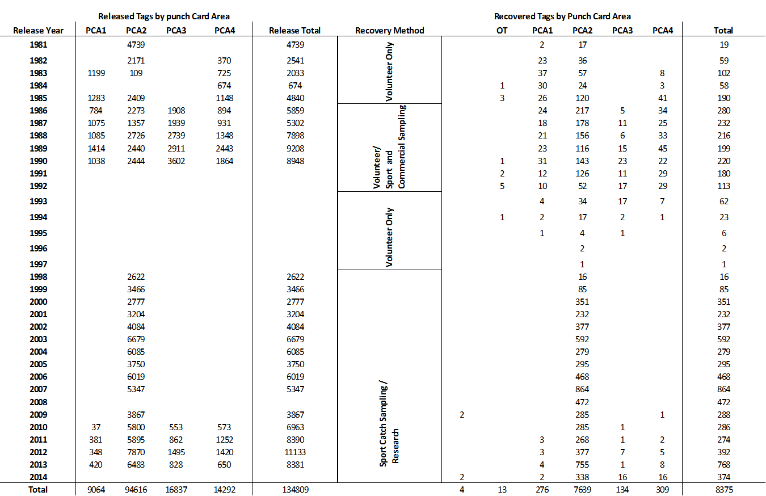

**Table 61. Delta-GLM models and the resultant model selection values for the tagging CPUE data set. Gray bar indicates chosen model.**



Table . Abundance estimates for black rockfish using Petersen method, 1998-2013. No tagging occurred in 2008. The 2007 assessment author did not recommend using 1998-1999 abundance estimates.



Table . Parameterization of the Washington black rockfish model.

|  |  |  |  |  |  |  |
| --- | --- | --- | --- | --- | --- | --- |
|  |  |  | Prior | | | Estimated value |
| Parameter | Bounds | Fixed value | Type | Init/Mean | SD |
| Female |  |  |  |  |  |  |
| Natural mortality (M) | 0.001 to 2 |  | Lognormal | 0.10 | -2.34 | 0.16 |
| Length at age=1 | 5 to 30 |  | No prior | 20.17 |  | 18.21 |
| Length at Linf | 35 to 60 |  | No prior | 53.91 |  | 53.21 |
| VBGF K | 0.01 to 1 |  | No prior | 0.14 |  | 0.18 |
| Length CV at age=1 | 0.03 to 0.2 |  | No prior | 0.12 |  | 0.14 |
| Length CV at age=40 | 0.03 to 0.2 |  | No prior | 0.08 |  | 0.06 |
| Weight-Length a | 0 to 3 | 0.00002 | No prior |  |  |  |
| Weight-Length b | 0 to 4 | 2.90 | No prior |  |  |  |
| Length at 50% maturity | 1 to 1000 | 43.69 | No prior |  |  |  |
| Maturity slope | -3 to 3 | -0.66 | No prior |  |  |  |
| Eggs/kg | -3 to 3 | 0.27 | No prior |  |  |  |
| Eggs/kg slope | -3 to 3 | 0.09 | No prior |  |  |  |
| Male |  |  |  |  |  |  |
| Natural mortality (M) | 0.001 to 2 |  | No prior |  |  | 0.15 |
| Length at age=1 | 5 to 30 |  | No prior |  |  | 18.62 |
| Length at age=40 | 35 to 60 |  | No prior |  |  | 47.04 |
| VBGF K | 0.01 to 1 |  | No prior |  |  | 0.23 |
| Length CV at age=1 | 0.03 to 0.2 |  | No prior |  |  | 0.14 |
| Length CV at age=40 | 0.03 to 0.2 |  | No prior |  |  | 0.06 |
| Weight-Length a | 1 to 20 | 0.00003 | No prior |  |  |  |
| Weight-Length b | -3 to 4 | 2.89 | No prior |  |  |  |
| Stock-recruit |  |  |  |  |  |  |
| ln(R0) | 1 to 31 |  | No prior |  |  | 7.65 |
| steepness (h) | 0.25 to 0.99 | 0.77 | No prior |  |  |  |
| R | 0 to 2 | 0.50 | No prior |  |  |  |

Table . Estimated parameter values for catchability, extra variance on surveys and selectivity curves for the Washington base case model.

|  |  |  |  |  |  |
| --- | --- | --- | --- | --- | --- |
|  |  |  | Prior | | Estimated value |
| Parameter | Bounds | Fixed value | Type | Init |
| Catchability |  |  |  |  |  |
| Dockside CPUE | 0 to 1 |  | no prior | 0.01 | 0.0021 |
| Tagging CPUE | 0 to 1 |  | no prior | 0.01 | 0.0003 |
| Extra survey standard deviation |  |  |  |  |  |
|  | 0 to 5 |  | no prior | 0.01 | 0.08 |
|  | 0 to 5 |  | no prior | 0.01 | 0.46 |
| Length-based selectivity |  |  |  |  |  |
| Trawl |  |  |  |  |  |
|  | 15 to 50 |  | no prior | 40 | 50.00 |
|  | -10 to 10 |  | no prior | -1 | 2.08 |
|  | -4 to 12 |  | no prior | 4 | 3.63 |
|  | -2 to 6 | 2.2 | no prior |  |  |
|  | -15 to 10 | -4 | no prior |  |  |
|  | -5 to 10 | 5 | no prior |  |  |
| non-Trawl |  |  |  |  |  |
|  | 15 to 50 |  | no prior | 40 | 41.29 |
|  | -10 to 10 |  | no prior | -1 | 2.58 |
|  | -4 to 12 |  | no prior | 4 | 3.69 |
|  | -2 to 6 | 2.2 | no prior |  |  |
|  | -15 to 10 | -4 | no prior |  |  |
|  | -5 to 10 | 5 | no prior |  |  |
| Recreational |  |  |  |  |  |
|  | 15 to 50 |  | no prior | 40 | 40.38 |
|  | -10 to 10 |  | no prior | -1 | -4.62 |
|  | -4 to 12 |  | no prior | 4 | 3.52 |
|  | -2 to 6 | 2.2 | no prior |  |  |
|  | -15 to 10 | -4 | no prior |  |  |
|  | -5 to 10 | 5 | no prior |  |  |
| Dockside CPUE |  |  |  |  |  |
|  | -5 to 5 | -1 | no prior |  |  |
|  | -5 to 5 | -1 | no prior |  |  |
| Tagging CPUE |  |  |  |  |  |
|  | 15 to 50 |  | no prior | 40 | 39.73 |
|  | -10 to 10 |  | no prior | -1 | -3.04 |
|  | -4 to 12 |  | no prior | 4 | 3.60 |
|  | -2 to 6 | 2.2 | no prior |  |  |
|  | -15 to 10 | -4 | no prior |  |  |
|  | -5 to 10 | 5 | no prior |  |  |

Table . Sensitivity runs of the main likelihood components of the Washington stock assessment model. Bolded values indicate which components are included in the scenario run. See “supplemental tables” worksheet for a more accessible version.



Table . Sensitivity runs exploring model specification of the Washington black rockfish stock assessment model. See “supplemental tables” worksheet for a more accessible version.



Table . Summary of reference points for black rockfish base case model for Washington.

|  |  |  |
| --- | --- | --- |
| **Quantity** | **Estimate** | **~95% Confidence Interval** |
|
| Unfished Spawning biomass (mt) | 1356 | 1228-1483 |
| Unfished age 3+ biomass (mt) | 9119 | 8467-9772 |
| Unfished recruitment (R0) | 2102 | 1593-2610 |
| Depletion (2015) | 0.43 | 0.36-0.5 |
| ***Reference points based on SB40%*** |  |  |
| Proxy spawning biomass (*B40%*) | 542 | 491-593 |
| SPR resulting in *B40%* (*SPR50%*) | 0.444 | 0.44-0.44 |
| Exploitation rate resulting in *B40%* | 0.086 | 0.08-0.09 |
| Yield with *SPR50%* at *B40%* (mt) | 337 | 298-376 |
| ***Reference points based on SPR proxy for MSY*** |  |  |
| Spawning biomass | 624 | 565-683 |
| *SPRproxy* |  |  |
| Exploitation rate corresponding to *SPRproxy* | 0.072 | 0.07-0.08 |
| Yield with *SPRproxy* at *SBSPR* (mt) | 311 | 275-346 |
| ***Reference points based on estimated MSY values*** |  |  |
| Spawning biomass at *MSY* (*SBMSY*) | 294 | 267-322 |
| *SPRMSY* | 0.274385 | 0.27-0.28 |
| Exploitation rate corresponding to *SPRMSY* | 0.149 | 0.14-0.16 |
| *MSY* (mt) | 383 | 337-430 |

Table . Projection of potential OFL and prescribed removals, summary biomass (age-3 and older), spawning output, and depletion for the Washington base case model projected with total catch equal to the 420 mt for 2015 and 2016. The predicted OFL is the calculated total catch determined by FSPR=50%.

|  |  |  |  |  |  |
| --- | --- | --- | --- | --- | --- |
|  | Predicted OFL | Projected removals | Age 3+ biomass | Spawning output | Depletion (%) |
| Year |
| 2015 | 319 | 283 | 5,645 | 582 | 43% |
| 2016 | 320 | 283 | 5,652 | 610 | 45% |
| 2017 | 319 | 305 | 5,651 | 632 | 47% |
| 2018 | 315 | 301 | 5,629 | 643 | 47% |
| 2019 | 312 | 299 | 5,615 | 646 | 48% |
| 2020 | 311 | 297 | 5,609 | 644 | 48% |
| 2021 | 311 | 297 | 5,610 | 640 | 47% |
| 2022 | 311 | 297 | 5,616 | 636 | 47% |
| 2023 | 311 | 297 | 5,625 | 634 | 47% |
| 2024 | 312 | 298 | 5,635 | 632 | 47% |
| 2025 | 312 | 299 | 5,645 | 632 | 47% |
| 2026 | 313 | 299 | 5,655 | 632 | 47% |

Table . Summary decision table of 12-year projections for the Washington model beginning in 2017 for alternate states of nature based on natural mortality. Columns range over low, mid, and high state of nature, and rows range over different assumptions of total catch levels corresponding to the forecast catches from each state of nature. Catches in 2015 and 2016 are determined from the percentage of landings for each fleet in 2014.

|  |  |  |  |  |  |  |  |  |
| --- | --- | --- | --- | --- | --- | --- | --- | --- |
| Washington | | | **State of nature** | | | | | |
| Low | | Base case | | High | |
| *Mfemale*= 0.133 ; *Mmale* = 0.115 | | *Mfemale*= 0.163 ; *Mmale* = 0.145 | | *Mfemale*= 0.193 ; *Mmale* = 0.175 | |
| **Relative probability of states of nature** | | | 0.25 | | 0.5 | | 0.25 | |
| **Management decision** | Year | Catch (mt) | Spawning output | Stock status | Spawning output | Stock status | Spawning output | Stock status |
| Low catch | 2017 | 193 | 498 | 34% | 632 | 47% | 844 | 59% |
| 2018 | 200 | 525 | 36% | 660 | 49% | 871 | 61% |
| 2019 | 206 | 545 | 38% | 679 | 50% | 886 | 62% |
| 2020 | 210 | 559 | 38% | 692 | 51% | 894 | 63% |
| 2021 | 215 | 569 | 39% | 701 | 52% | 899 | 63% |
| 2022 | 218 | 578 | 40% | 709 | 52% | 905 | 64% |
| 2023 | 221 | 585 | 40% | 716 | 53% | 912 | 64% |
| 2024 | 224 | 593 | 41% | 724 | 53% | 919 | 65% |
| 2025 | 226 | 600 | 41% | 731 | 54% | 927 | 65% |
| 2026 | 228 | 607 | 42% | 737 | 54% | 935 | 66% |
| Base catch | 2017 | 305 | 498 | 34% | 632 | 47% | 844 | 59% |
| 2018 | 301 | 508 | 35% | 643 | 47% | 855 | 60% |
| 2019 | 299 | 511 | 35% | 646 | 48% | 855 | 60% |
| 2020 | 297 | 508 | 35% | 644 | 48% | 849 | 60% |
| 2021 | 297 | 504 | 35% | 640 | 47% | 843 | 59% |
| 2022 | 297 | 499 | 34% | 636 | 47% | 839 | 59% |
| 2023 | 297 | 494 | 34% | 634 | 47% | 837 | 59% |
| 2024 | 298 | 491 | 34% | 632 | 47% | 838 | 59% |
| 2025 | 299 | 489 | 34% | 632 | 47% | 840 | 59% |
| 2026 | 299 | 487 | 34% | 632 | 47% | 843 | 59% |
| High catch | 2017 | 464 | 498 | 34% | 632 | 47% | 844 | 59% |
| 2018 | 448 | 483 | 33% | 619 | 46% | 831 | 58% |
| 2019 | 436 | 461 | 32% | 599 | 44% | 810 | 57% |
| 2020 | 428 | 436 | 30% | 576 | 42% | 785 | 55% |
| 2021 | 423 | 409 | 28% | 553 | 41% | 761 | 53% |
| 2022 | 419 | 385 | 27% | 532 | 39% | 742 | 52% |
| 2023 | 417 | 363 | 25% | 514 | 38% | 728 | 51% |
| 2024 | 415 | 344 | 24% | 500 | 37% | 718 | 50% |
| 2025 | 414 | 327 | 23% | 488 | 36% | 711 | 50% |
| 2026 | 413 | 313 | 22% | 478 | 35% | 706 | 50% |

# Figures

## Figures Common to All Assessments

C:\Users\David Sampson\Dropbox (HMSC - OSU)\2015-07-Black_Rockfish_Assessment\Black_Rockfish_Assessment-Map.wmf

Figure . Map of the black rockfish assessment regions.

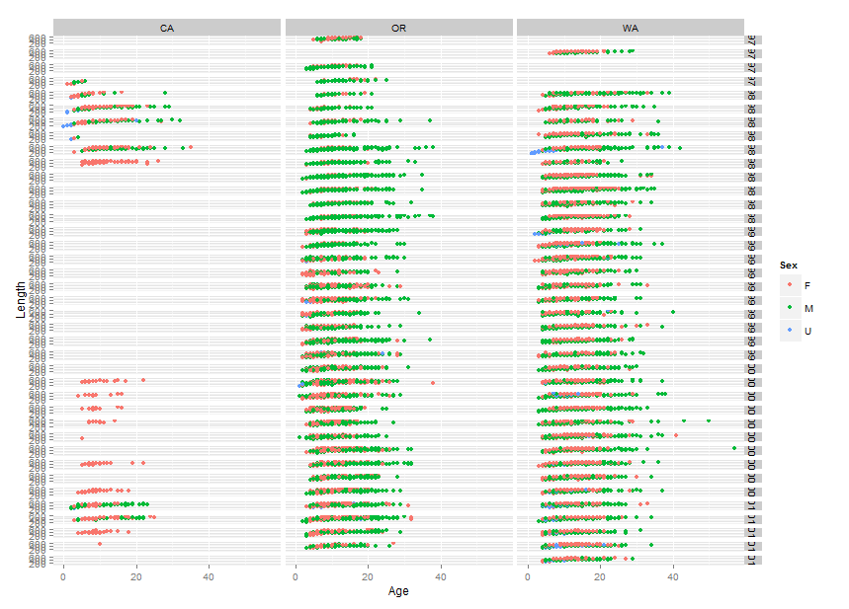

Figure . Sex-specific age and length samples by year available for each assessment area.

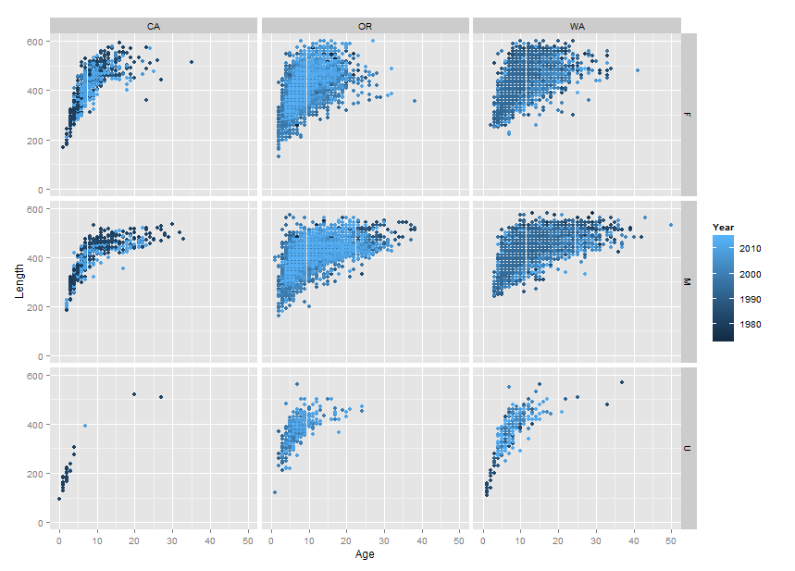

Figure . Sex-specific age and growth samples by state.

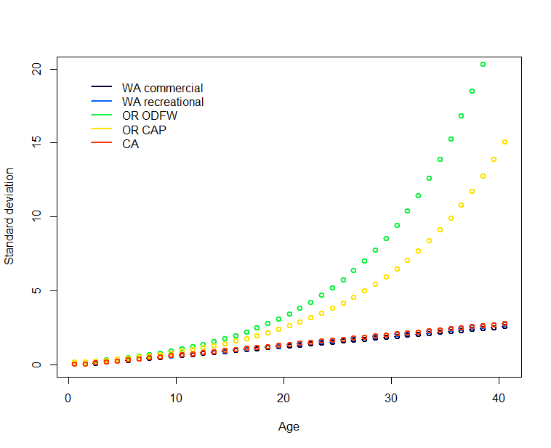

Figure . Ageing error relationships used in the black rockfish base case assessments.

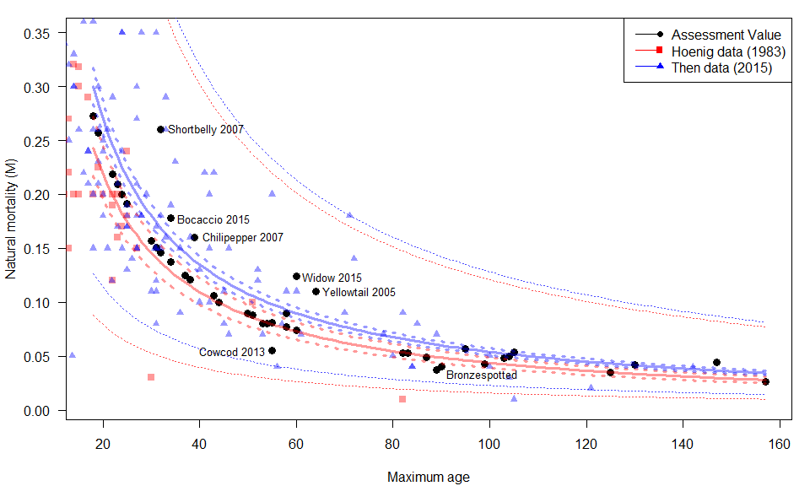

Figure . Natural mortality values used in west coast rockfish assessments compared to values of natural mortality estimated from longevity using two different data sets (Hoenig 1983 and Then 2015). Broken lines indicate the 95% confidence intervals; dotted lines indicate the 95% predictive intervals.

a)



b)



Figure . Female:Male sex ratio a) in two different time periods in Washington waters and b) in Oregon waters.



Figure . The measure of cryptic spawning biomass output compared to spawning output (top left panel), relative cryptic spawning output (top right panel) and the resultant age structure for the Washington black rockfish model that assumes low fixed M and dome-shaped age based selectivity.



Figure . The measure of cryptic spawning biomass output compared to spawning output (top left panel), relative cryptic spawning output (top right panel) and the resultant age structure for the Washington black rockfish model that assumes a fixed ramp in M and logistic length-based selectivity.

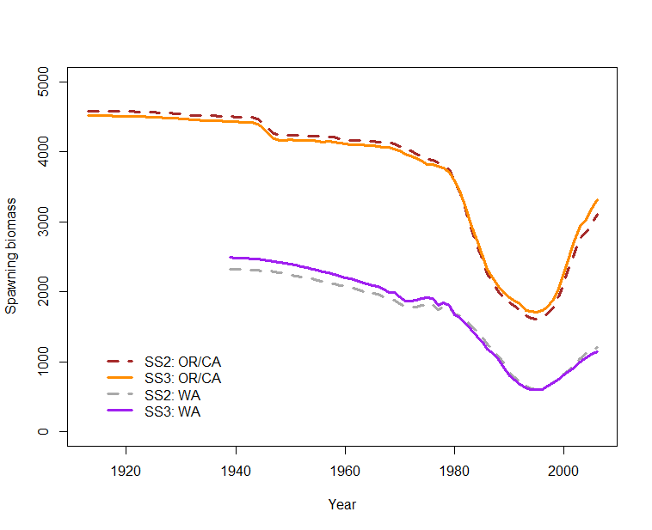

Figure . Comparison of the Stock Synthesis 2 and Stock Synthesis 3 modeling frameworks using the data from the 2007 assessments for the noted areas.

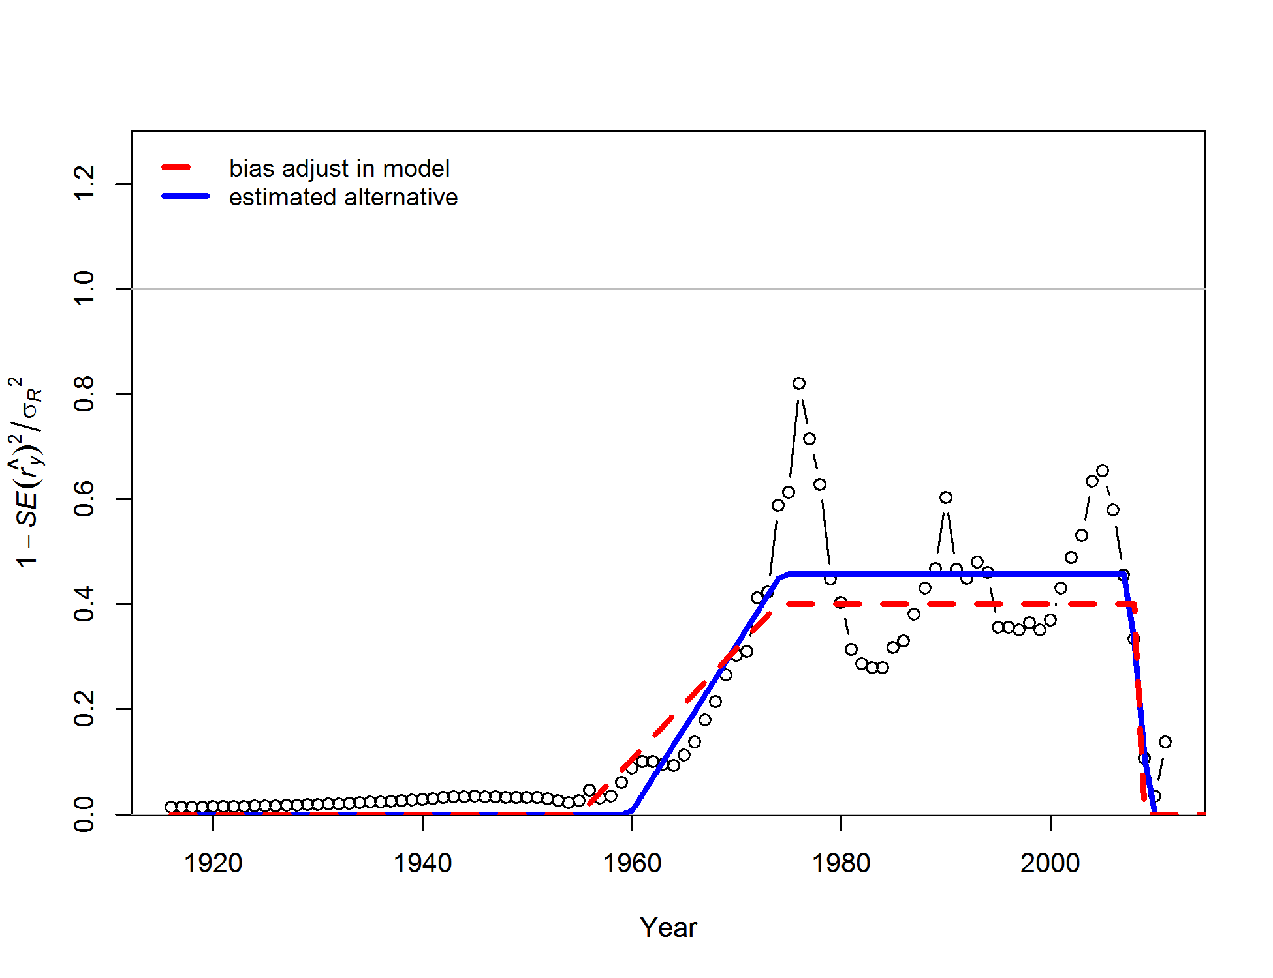

Figure . Recruitment bias-adjustment plot for the California base case model.

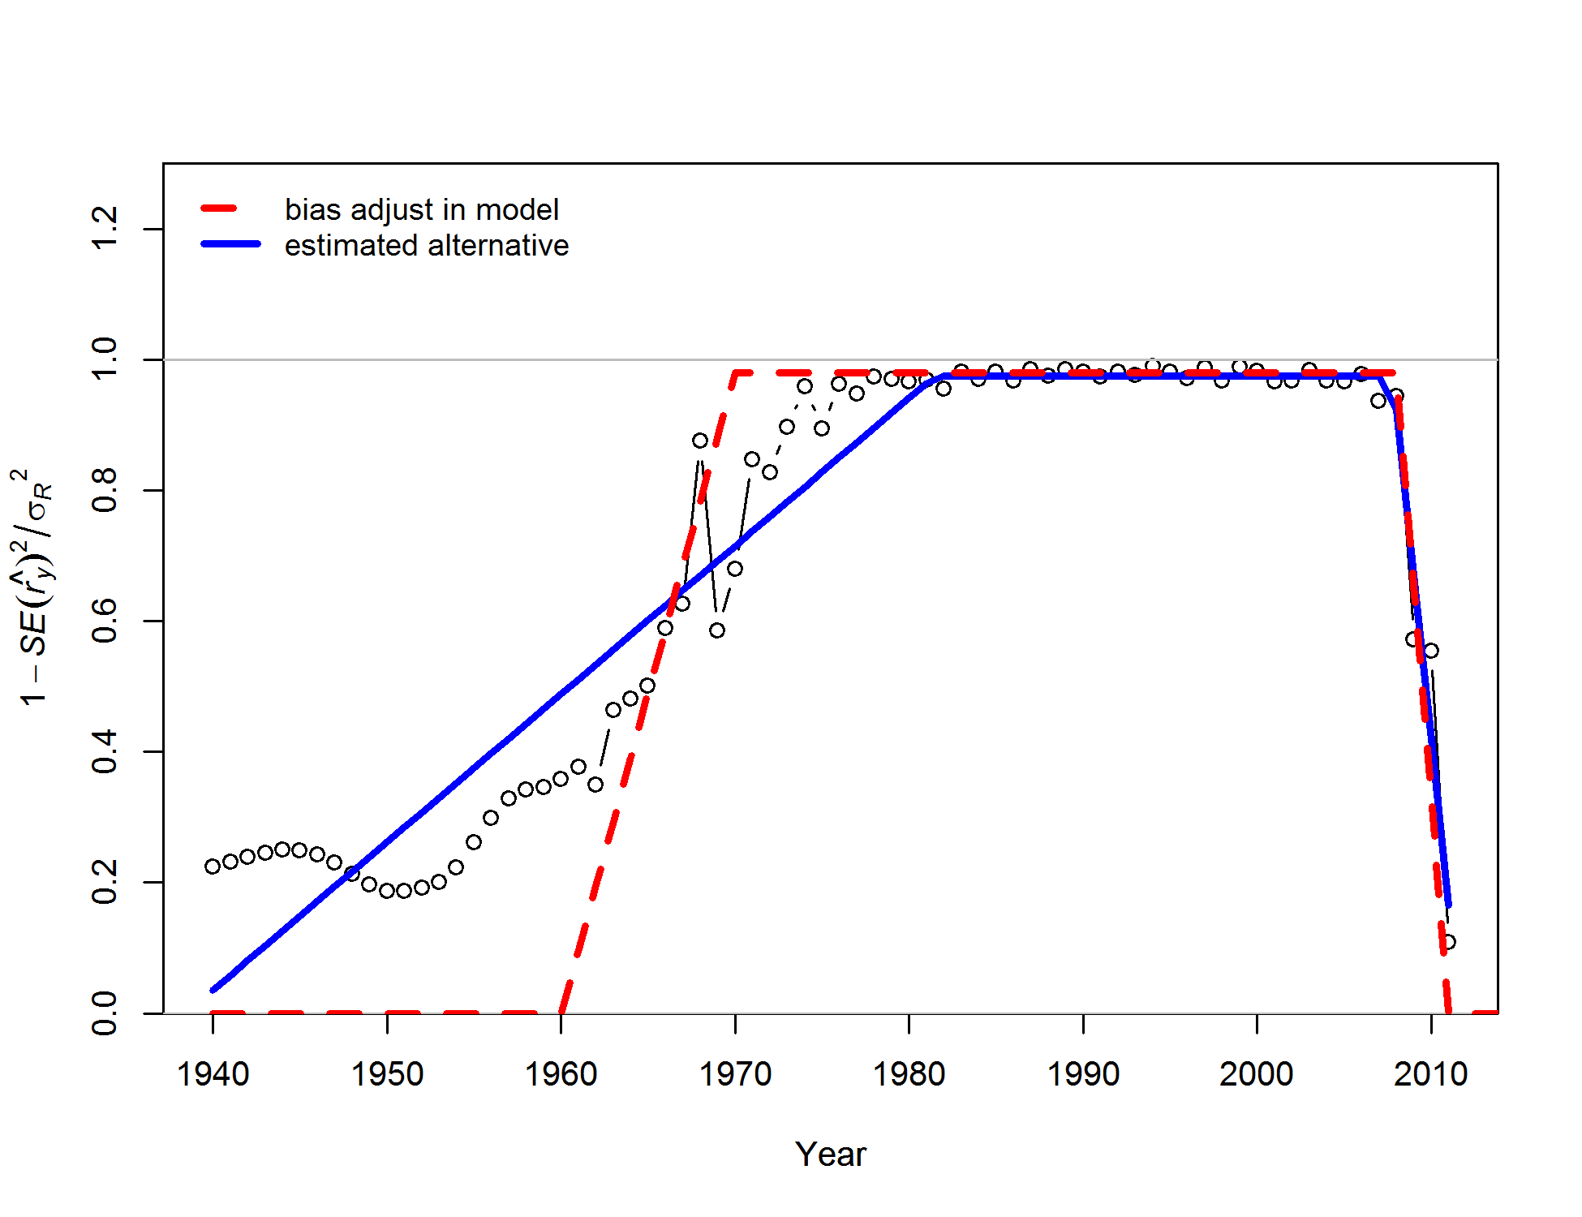

Figure . Recruitment bias-adjustment plot for the Washington base case model.

## CA Data Figures

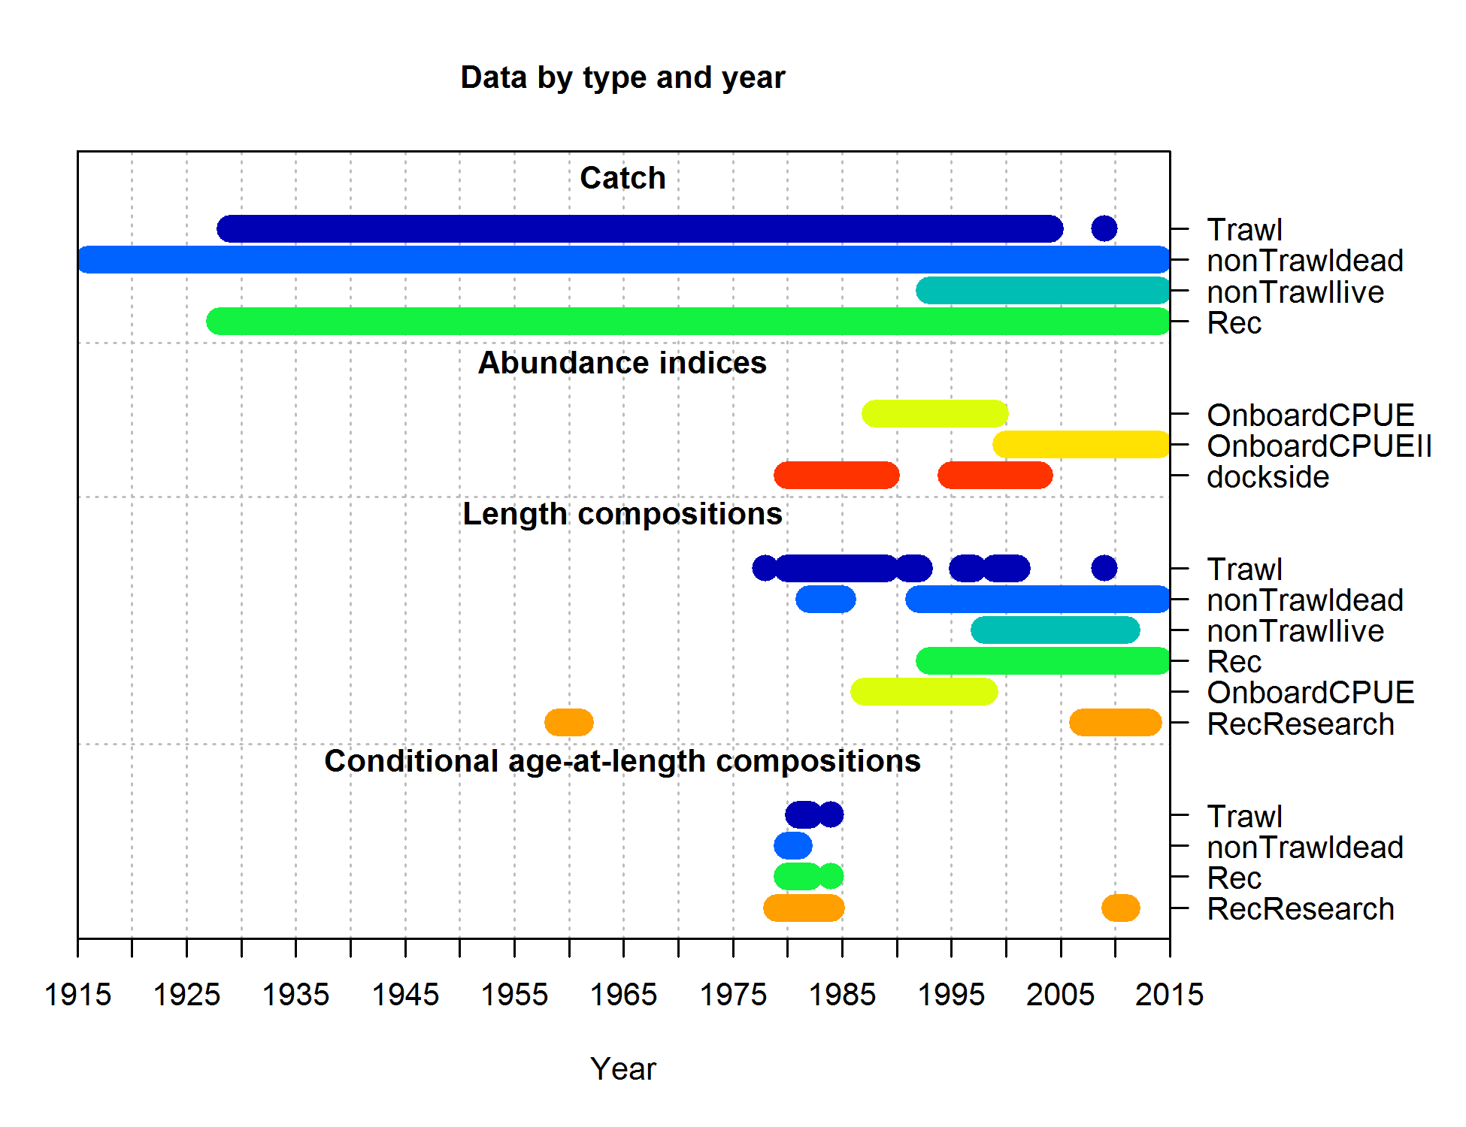

Figure . Data and data types used in the California black rockfish stock assessment model.

Figure : Comparing the California historical commercial landings reconstruction to the 2007 assessment estimates.

Figure : Comparing the California historical recreational landings reconstruction to the 2007 assessment estimates

Figure : Comparison of trawl and non-trawl hook-and-line length compositional data in the California fishery.

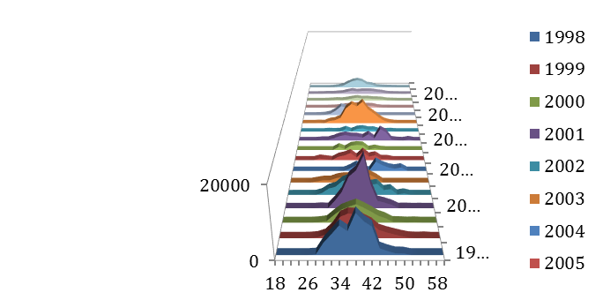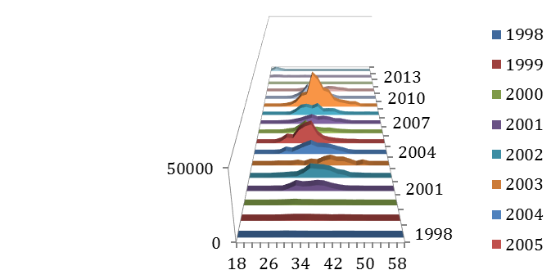

Figure : Comparison of non-live (top) and live (bottom) hook-and-line length compositional data for California. The live-fish fishery appears to catch only slightly smaller fish.

Figure : Comparison of California length compositional data between areas. This is comparing the non-live fishery only. The same pattern is seen even when the trawl gear component is removed.

Figure : Length compositions from California’s CPFV Onboard survey in Central and Northern California, 1987-1998.

Figure : Length compositions from the CCFRP (California), 2007-2013.



Figure . Removal comparison by fishery of the California portion of the previous (Southern California) and current (California) assessment.

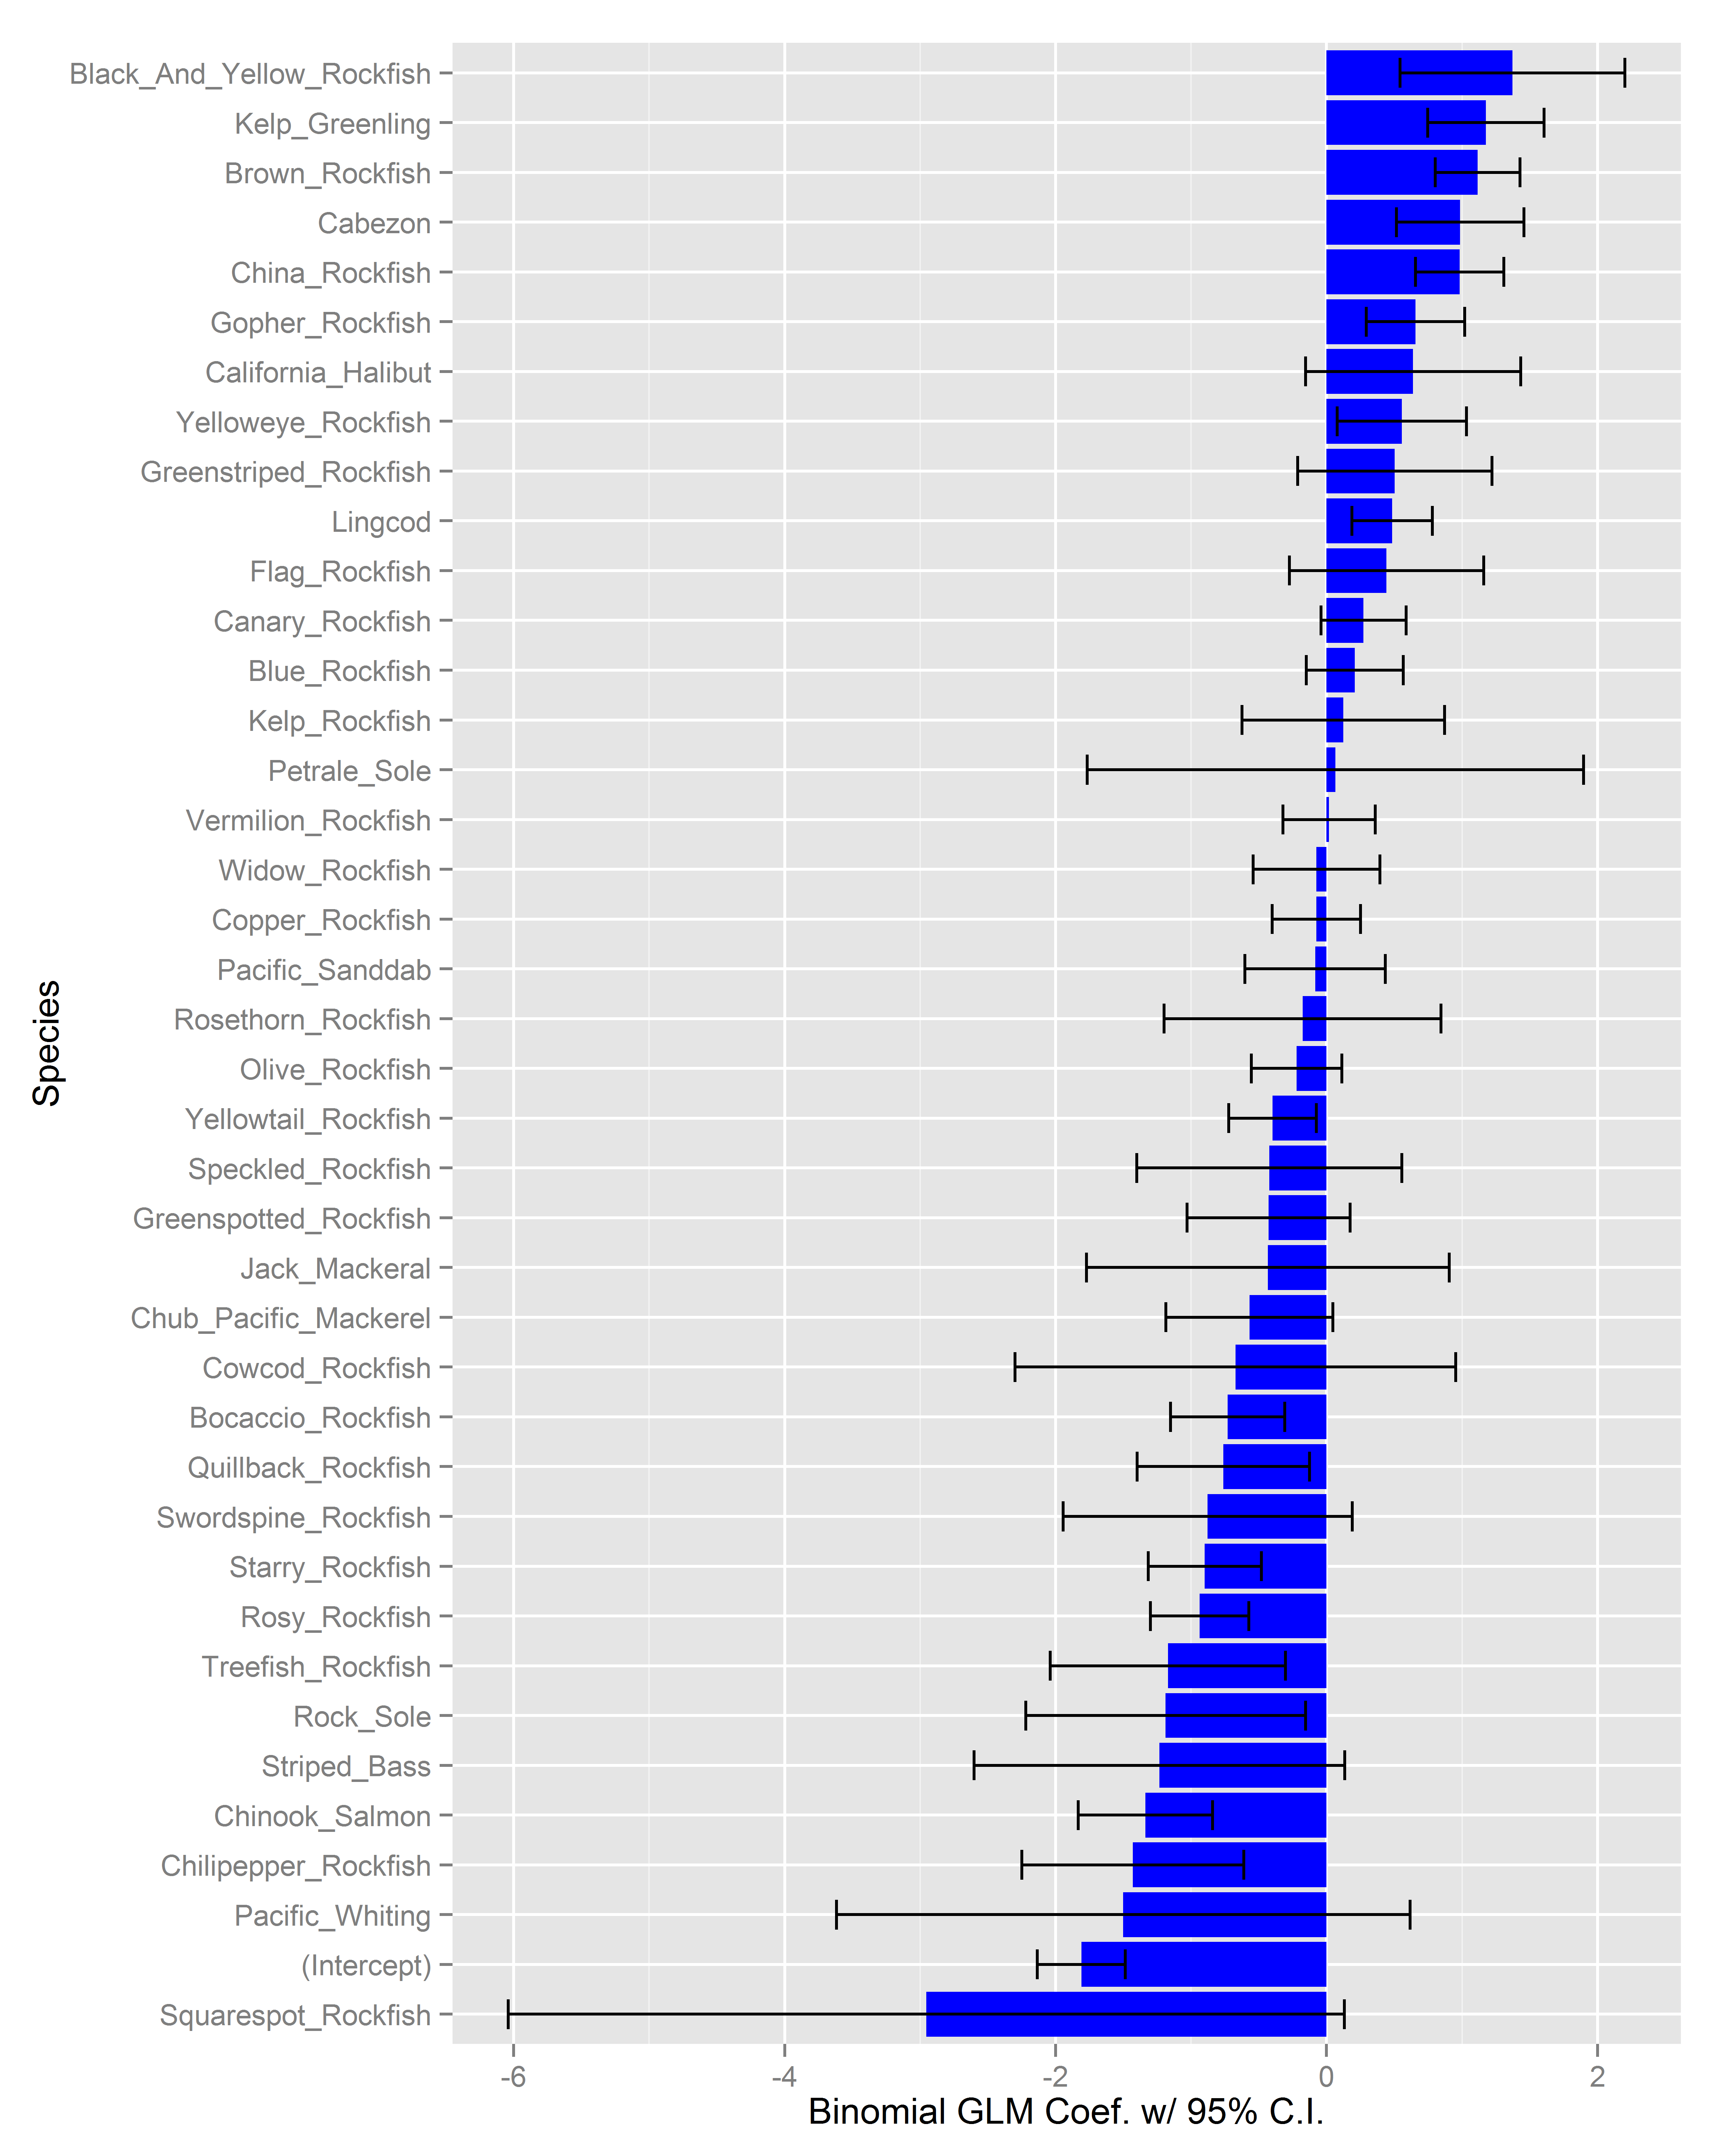

Figure . Species coefficients from the binomial GLM for presence/absence of black rockfish in the California dockside data for years 1980-2003.



Figure . Diagnostic plots for the black rockfish positive catch component gamma delta-GLM model for the California dockside dataset with Stephens-MacCall filtering. These are used to evaluate model fit (top left), assumptions of normality (top right), assumptions of constant variance (bottom left), and the presence of outliers (bottom right).

Figure . Resulting California dockside index from the delta-GLM model.

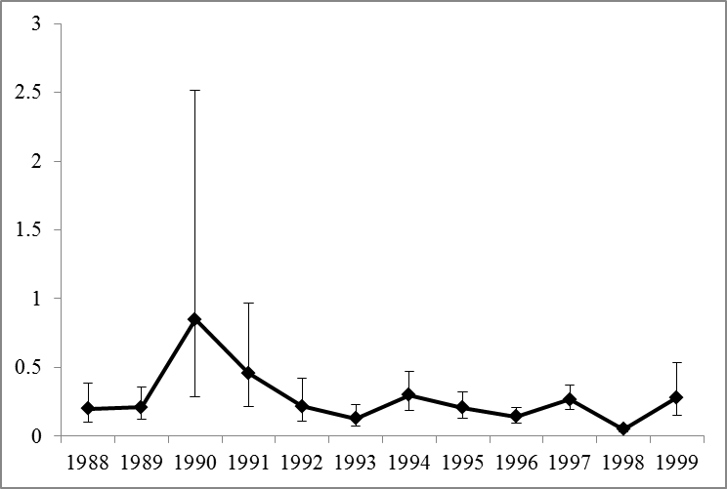

Index value

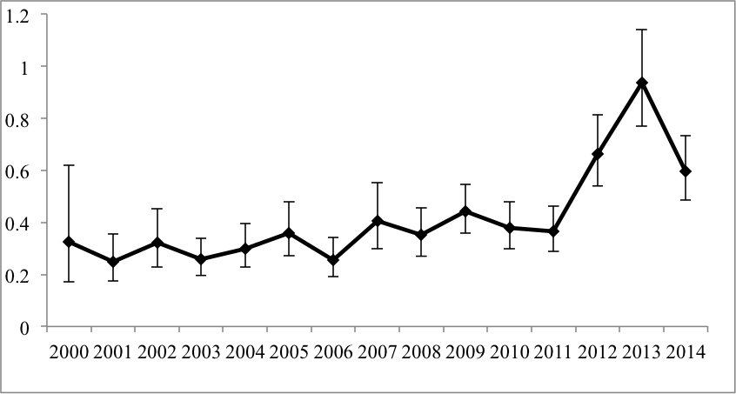

Year

Figure Index of relative abundance for Black rockfish from the central California CDFW 1987- 1998 (top panel) and 1999-2014 (bottom panel) onboard observer program with lognormal 95% confidence intervals.

## CA Model Figures

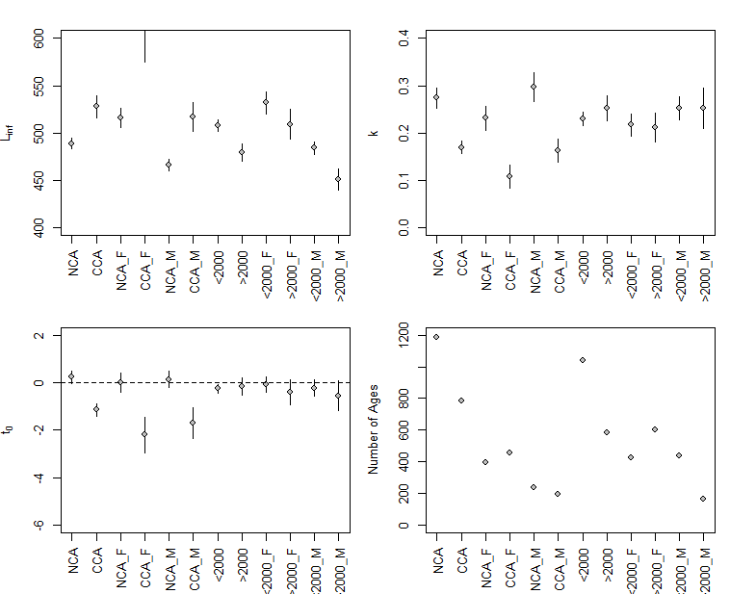

Figure . Temporal (pre and post year 2000) and spatial (North (NCA) and south (CCA) of San Francisco) estimates of the von Bertalanffy growth parameters and sample sizes for females (F) and (M) in California. Vertical lines indicate 95% confidence intervals.

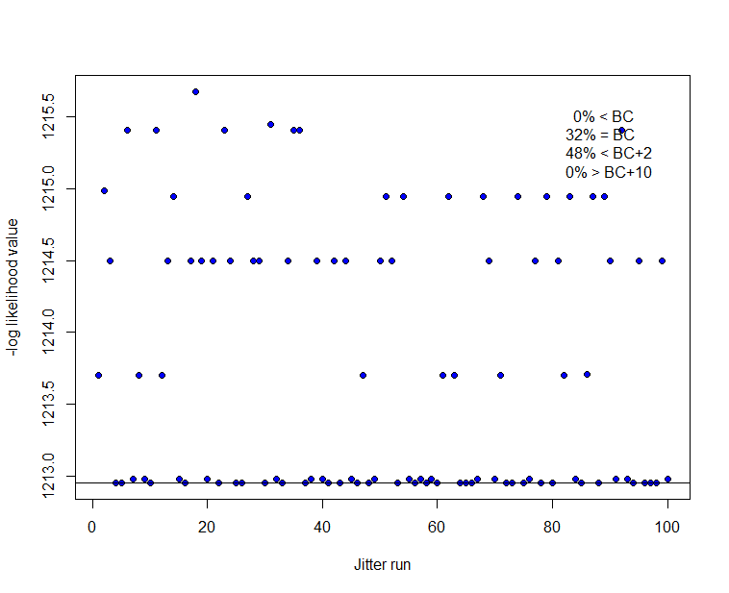

Figure . Results from 100 California model base case runs when starting values are jittered (0.1). Horizontal line indicates base model value.

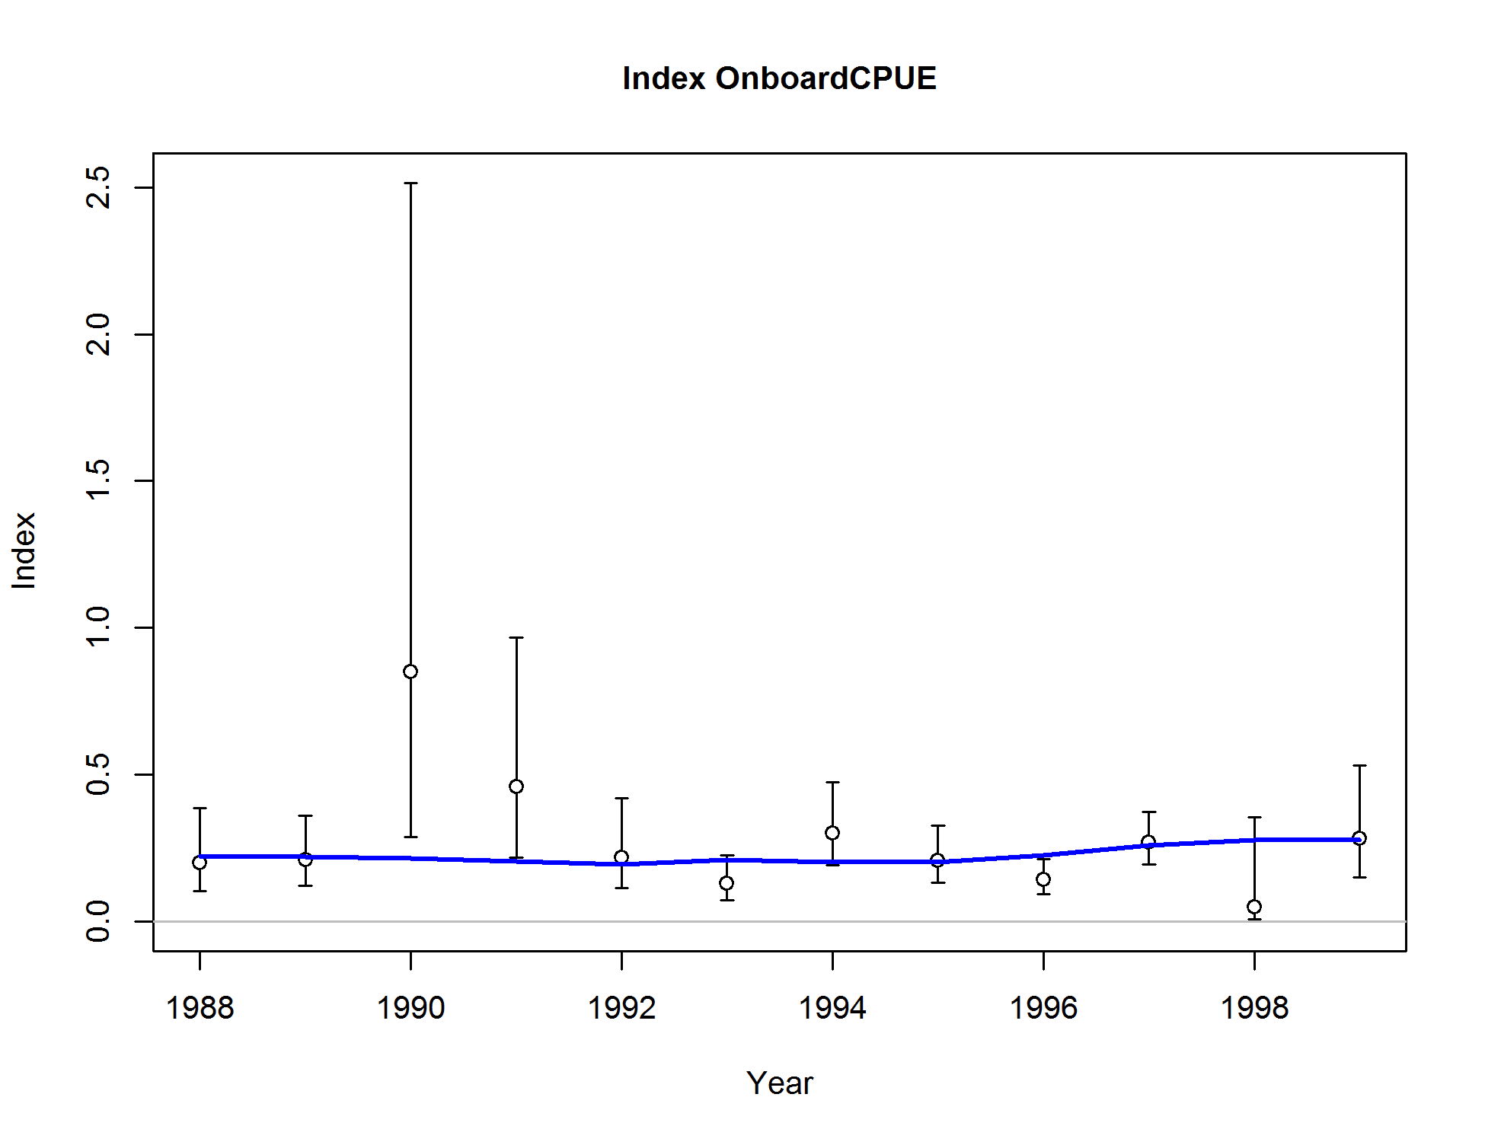

Figure . Base case fit to the California recreational CPFV onboard index (1988-1999). Vertical lines indicate 95% confidence intervals.

**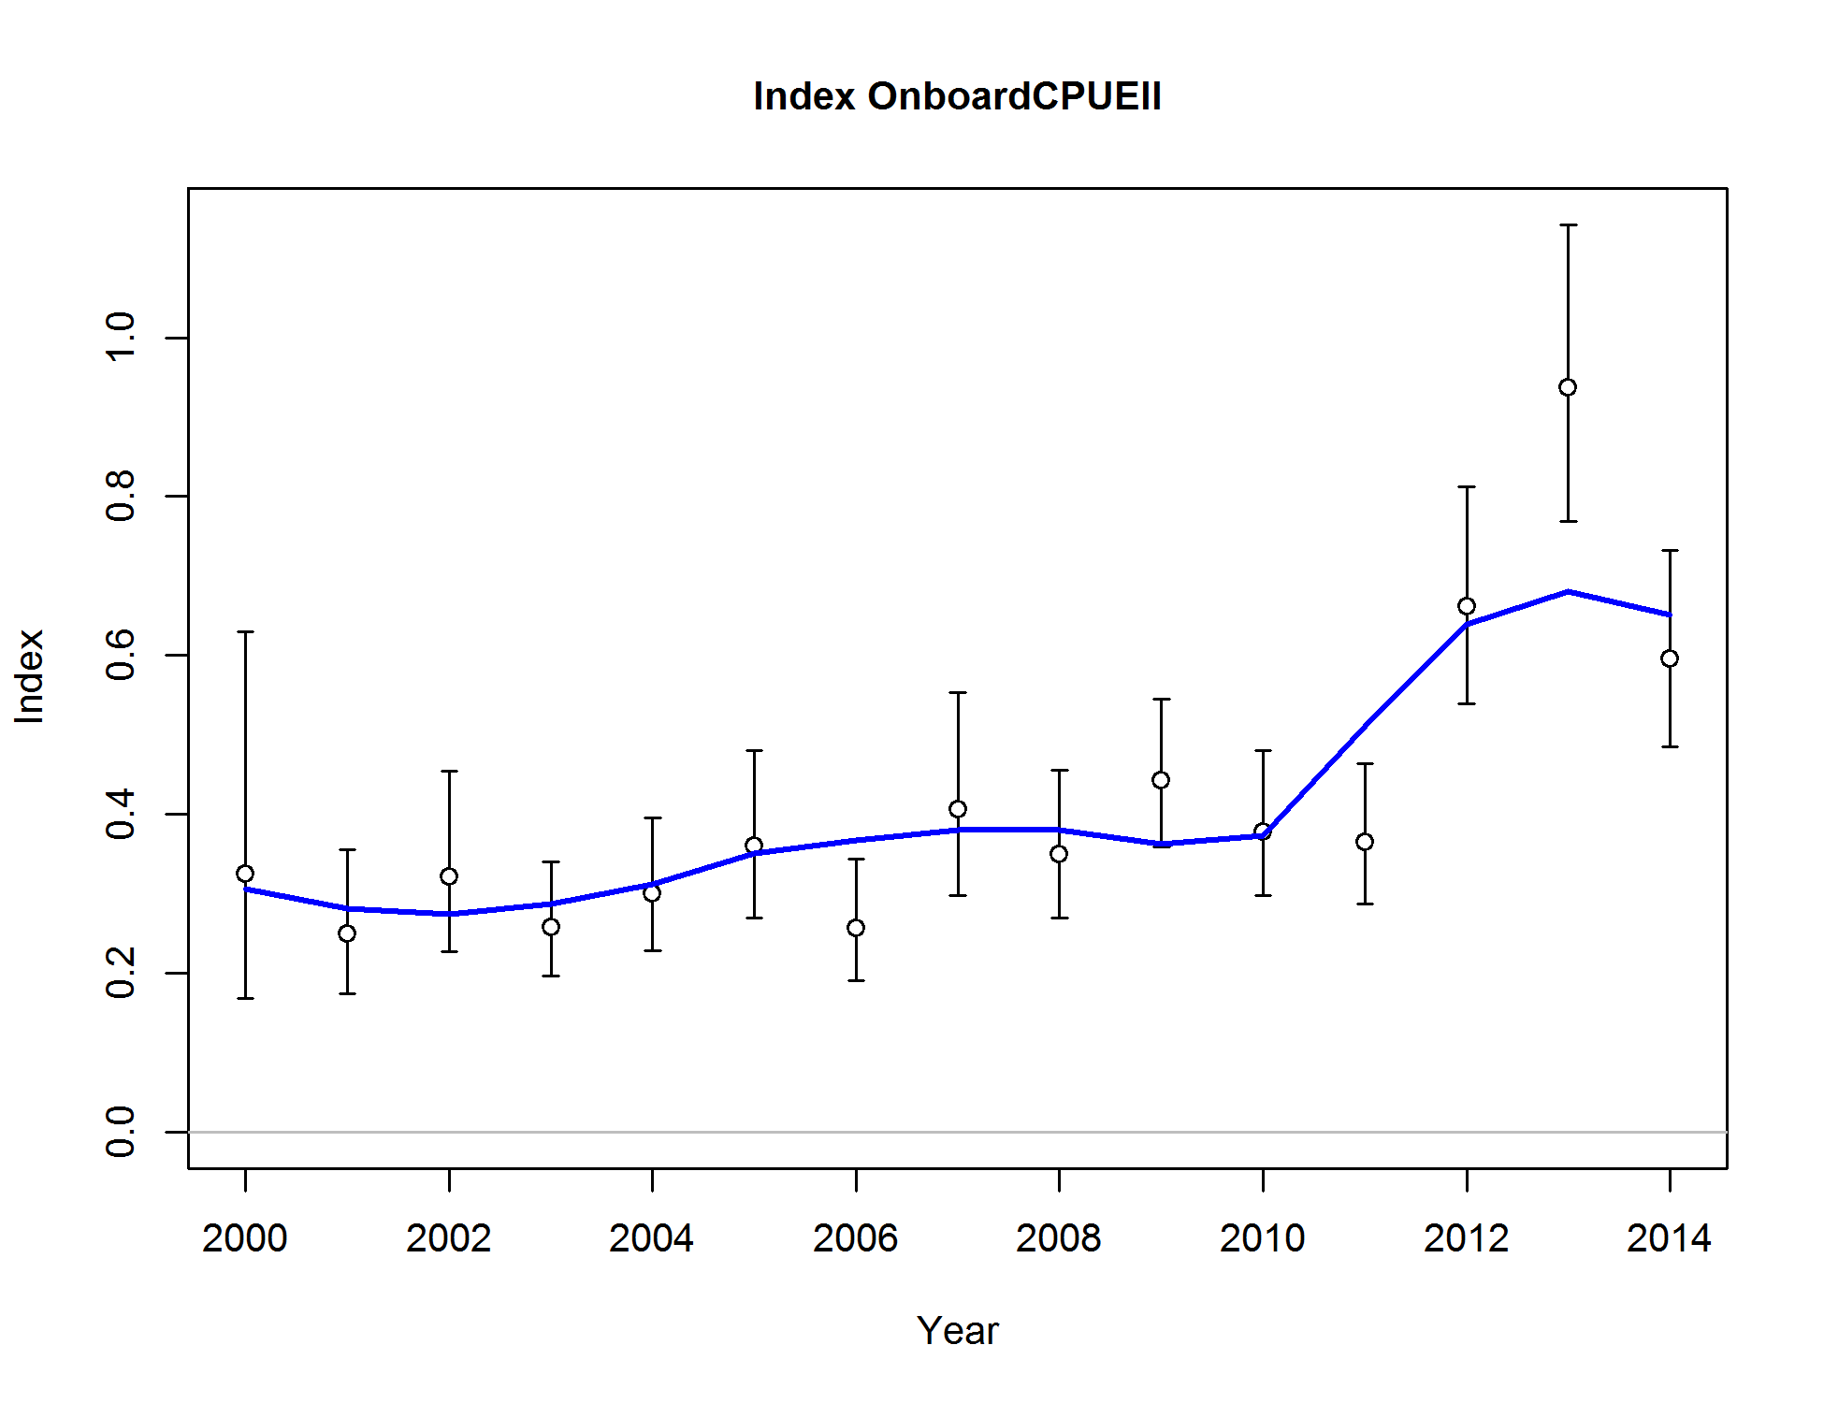**

Figure . Base case fit to the California recreational CPFV onboard index (2000-2014). Vertical lines indicate 95% confidence intervals.

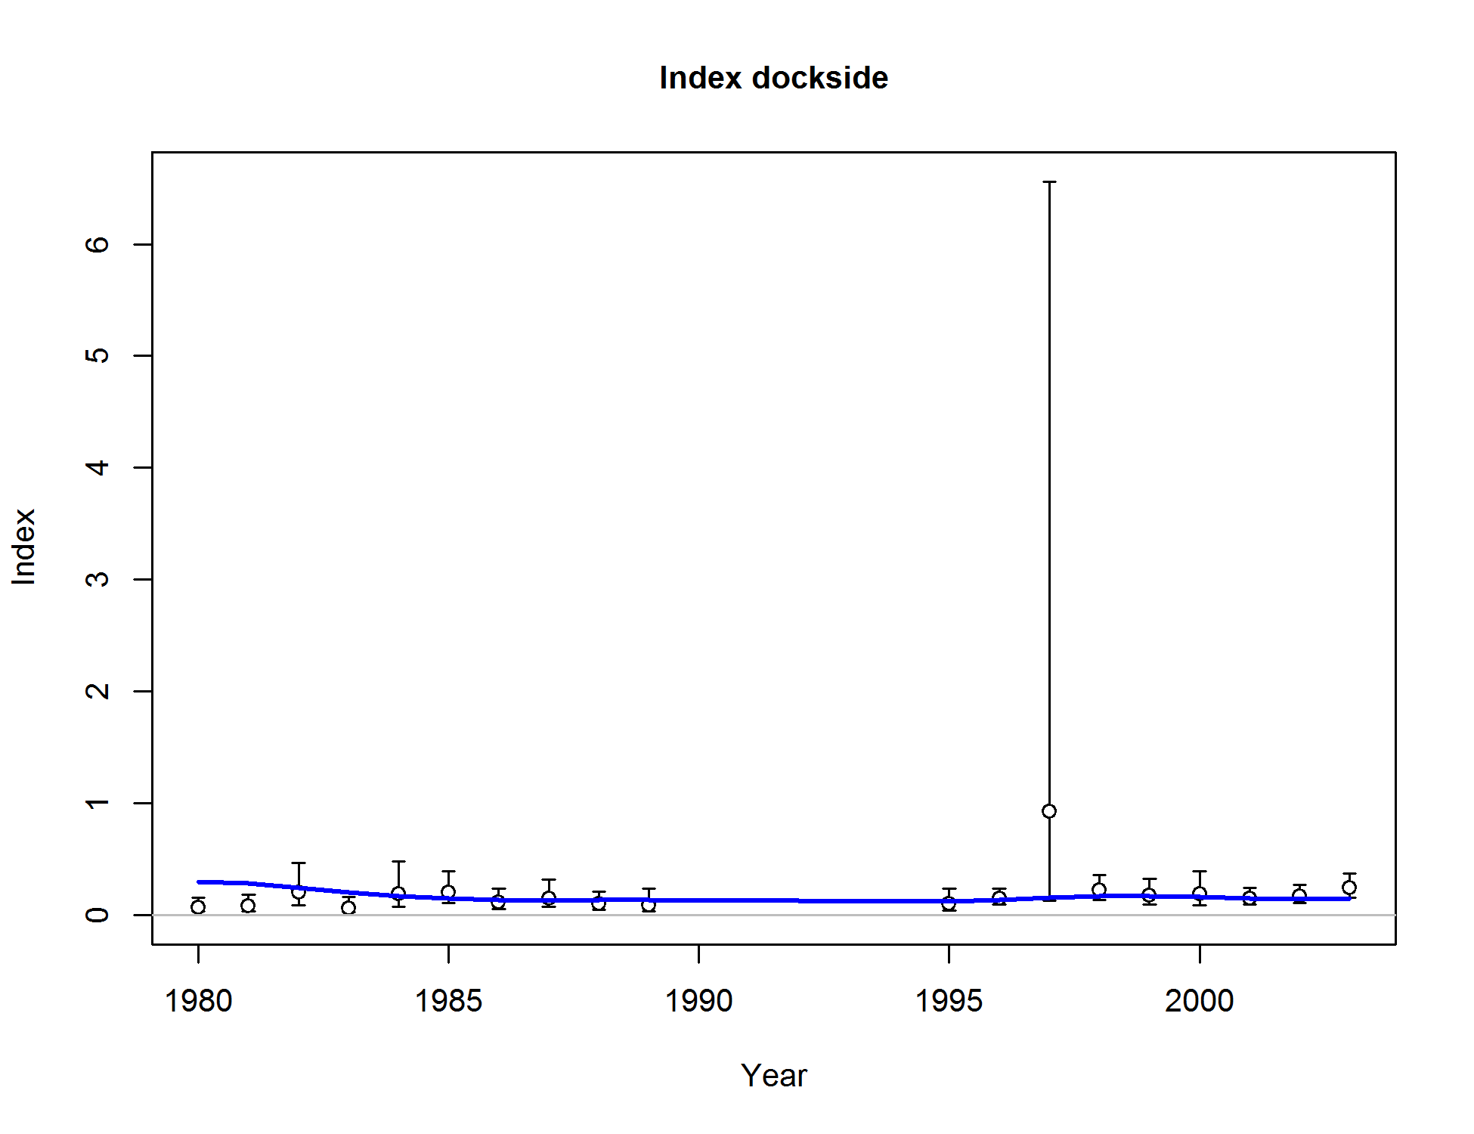

Figure . Base case fit to the California dockside CPUE index. Vertical lines indicate 95% confidence intervals.

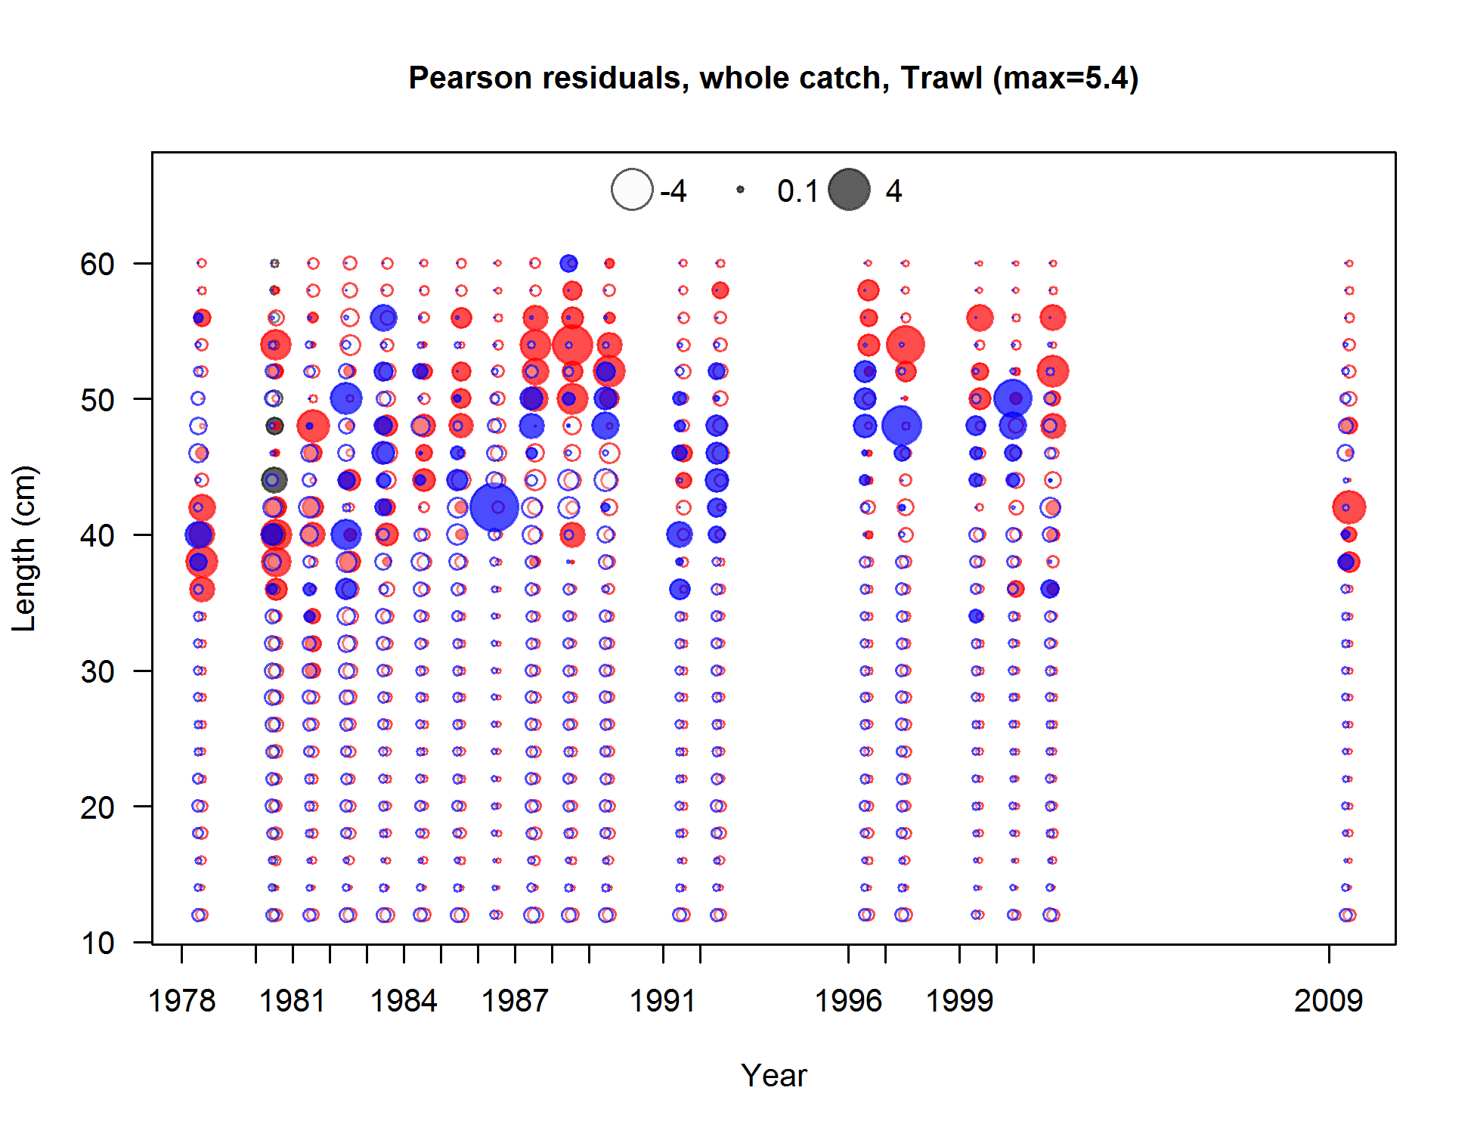

Figure . Pearson residuals plots for male (blue) and female (red) length compositions for the California trawl commercial fleet. Residuals <2 are generally considered non-significant.

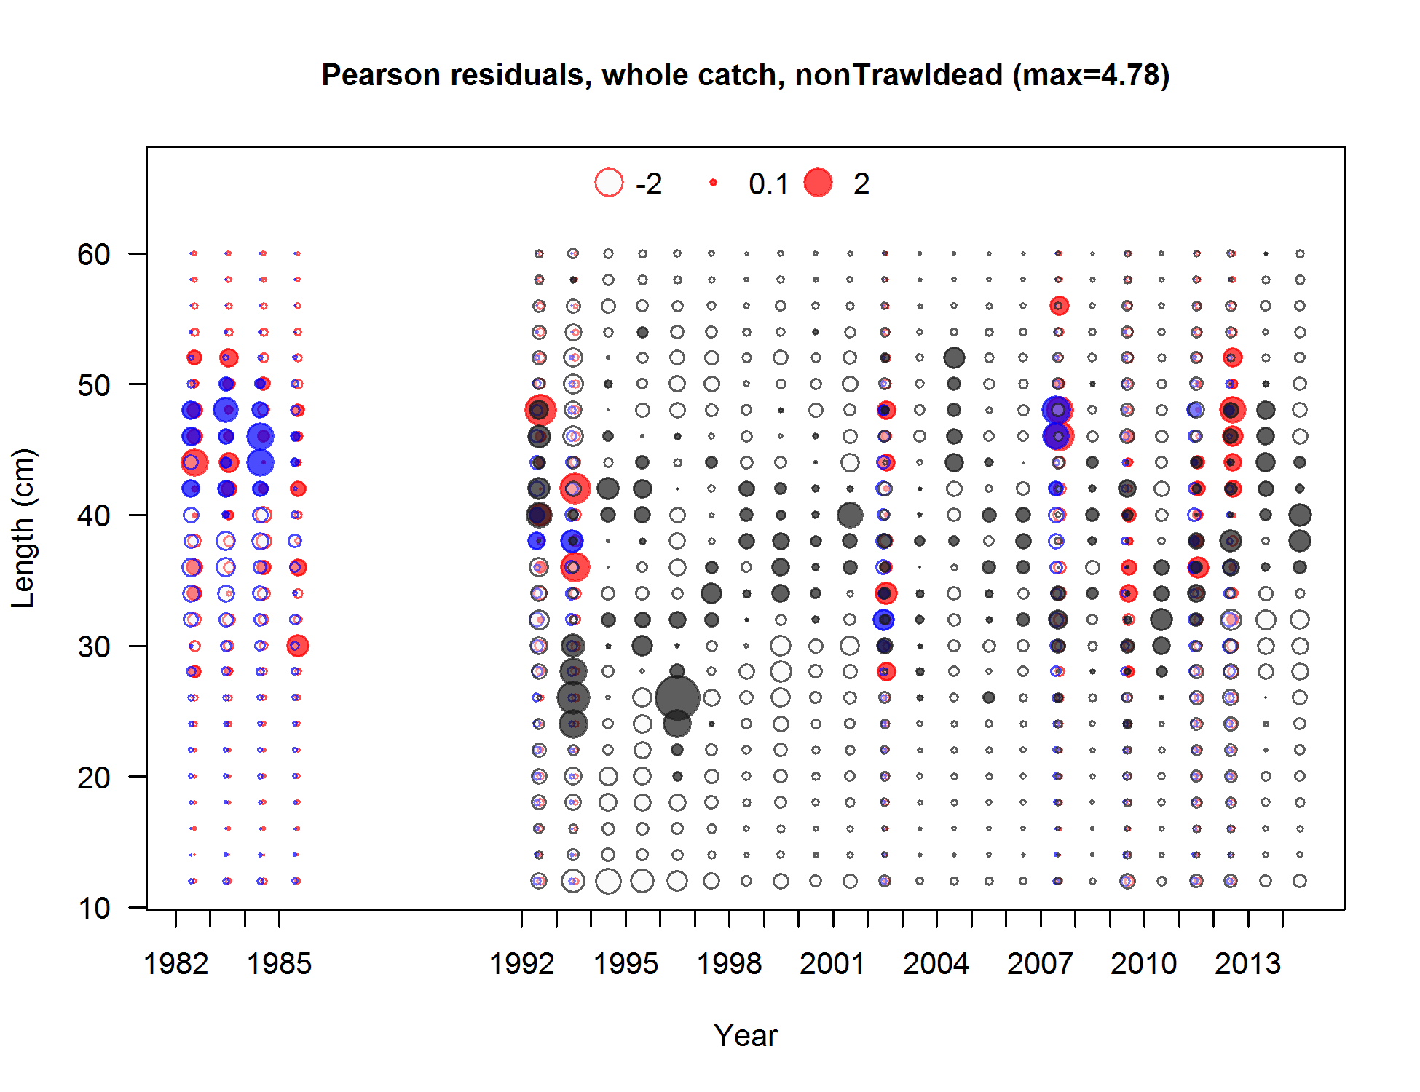

Figure . Pearson residuals plots for male (blue) and female (red) length compositions for the California non-trawl (dead) commercial fleet. Residuals <2 are generally considered non-significant.

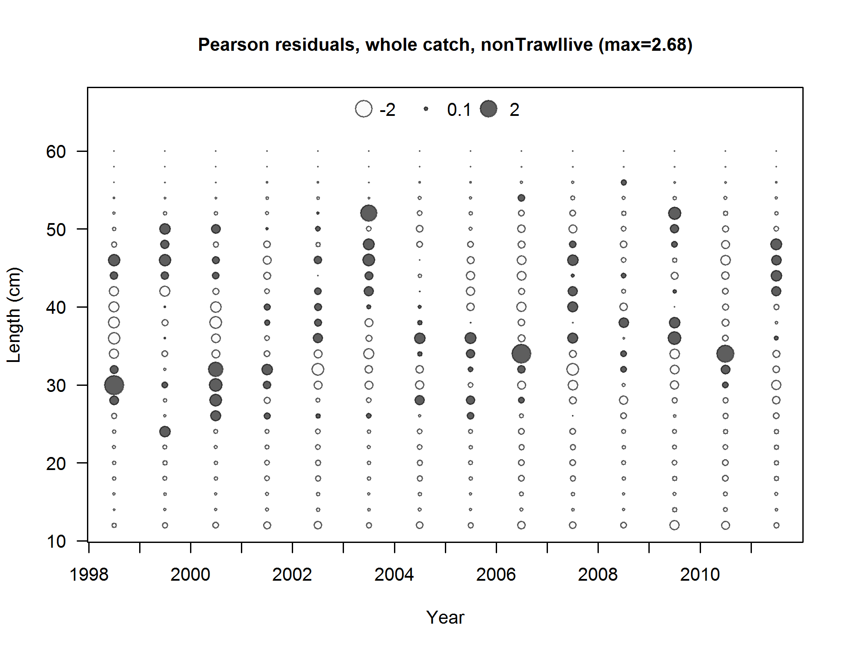

Figure . Pearson residuals plots for male (blue) and female (red) length compositions for the California non-trawl live fish commercial fleet. Residuals <2 are generally considered non-significant.

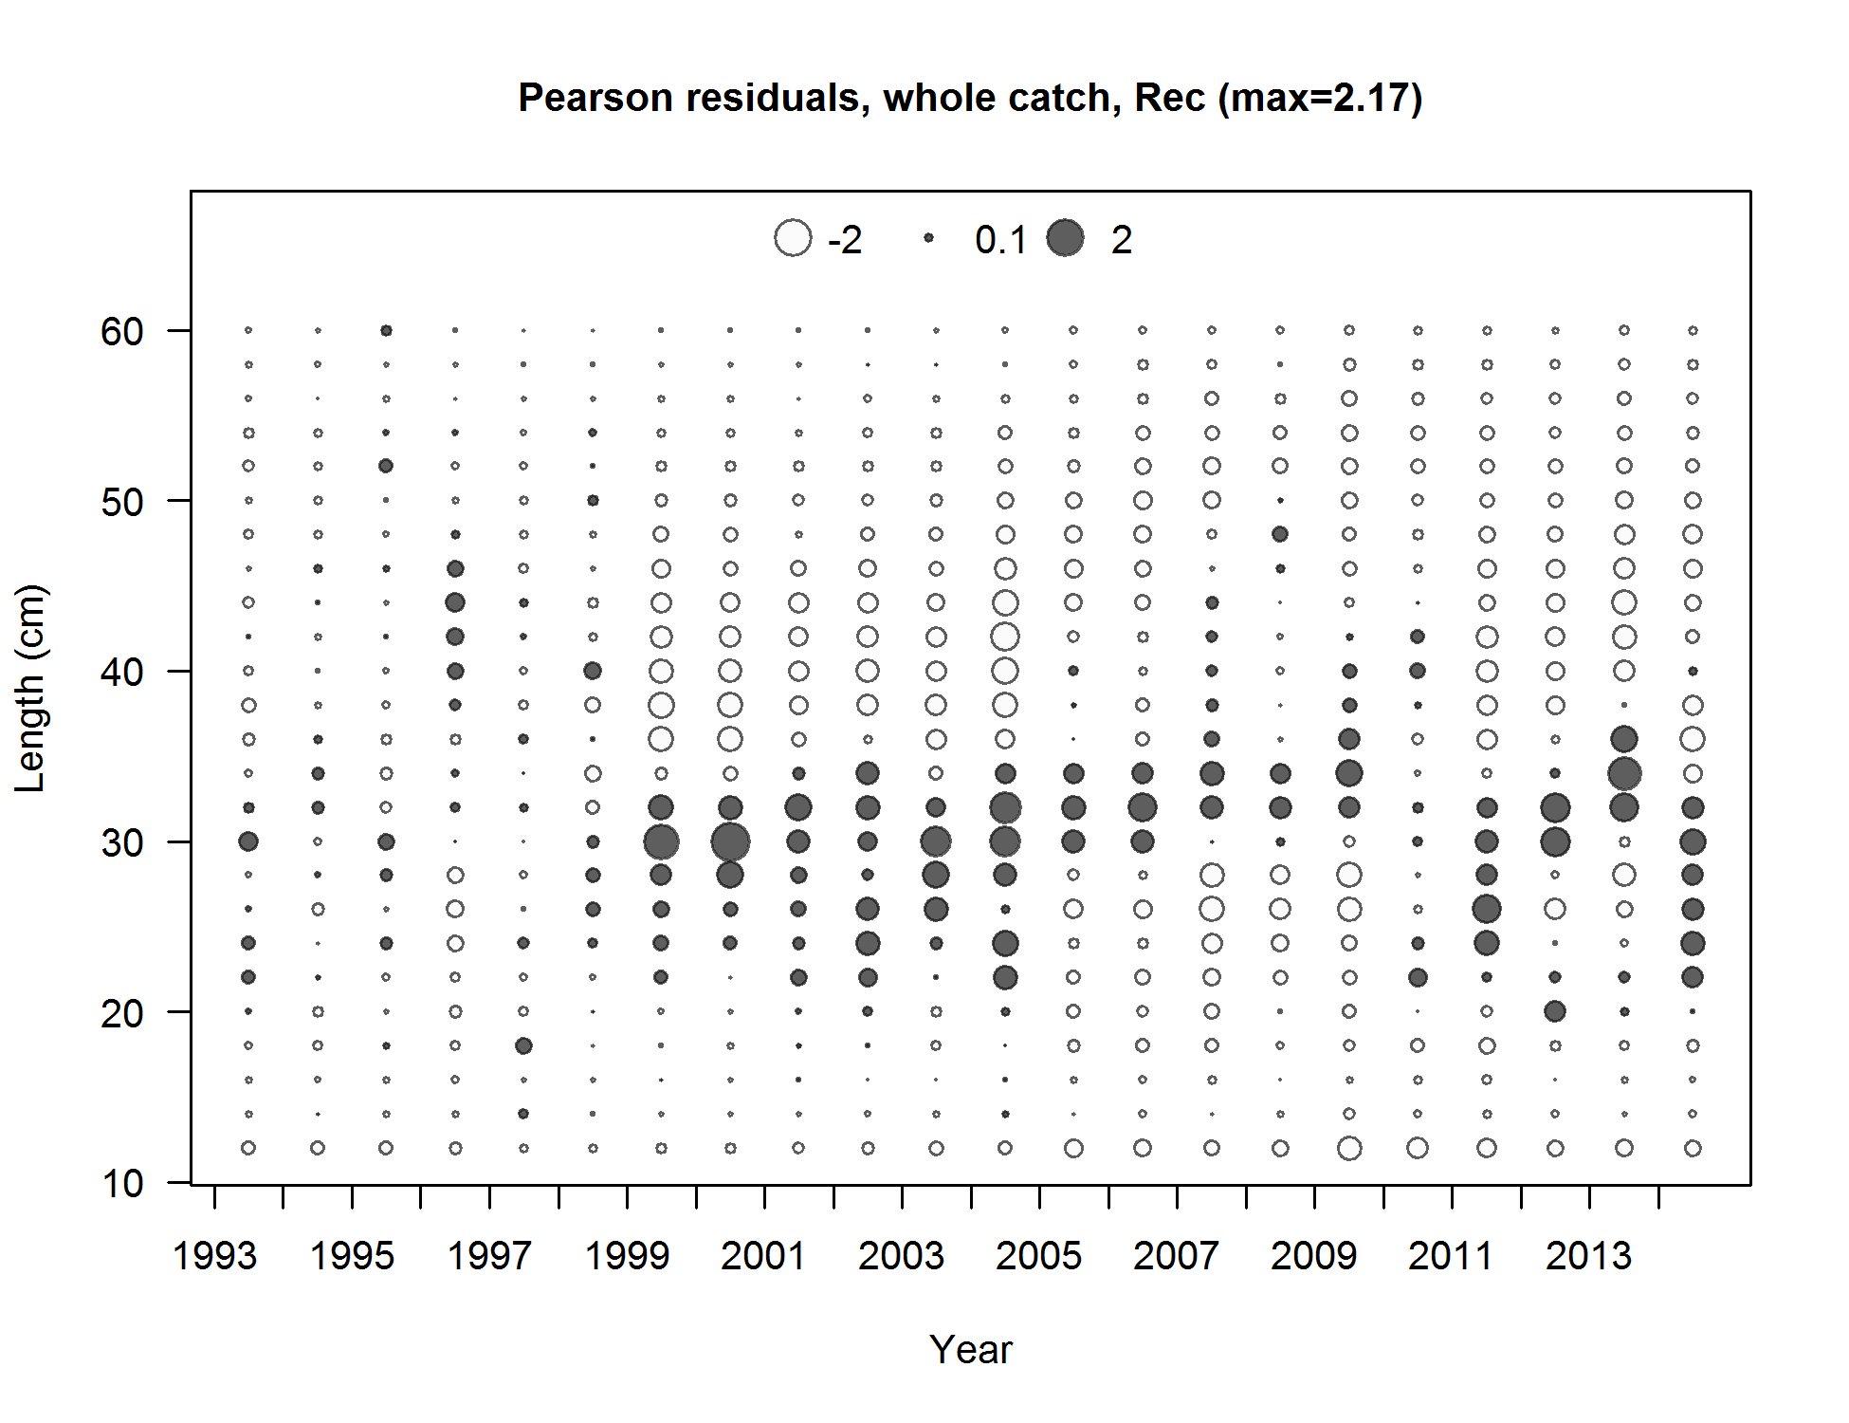

Figure . Pearson residuals plots for unsexed length compositions for the California recreational fleet. Residuals <2 are generally considered non-significant.

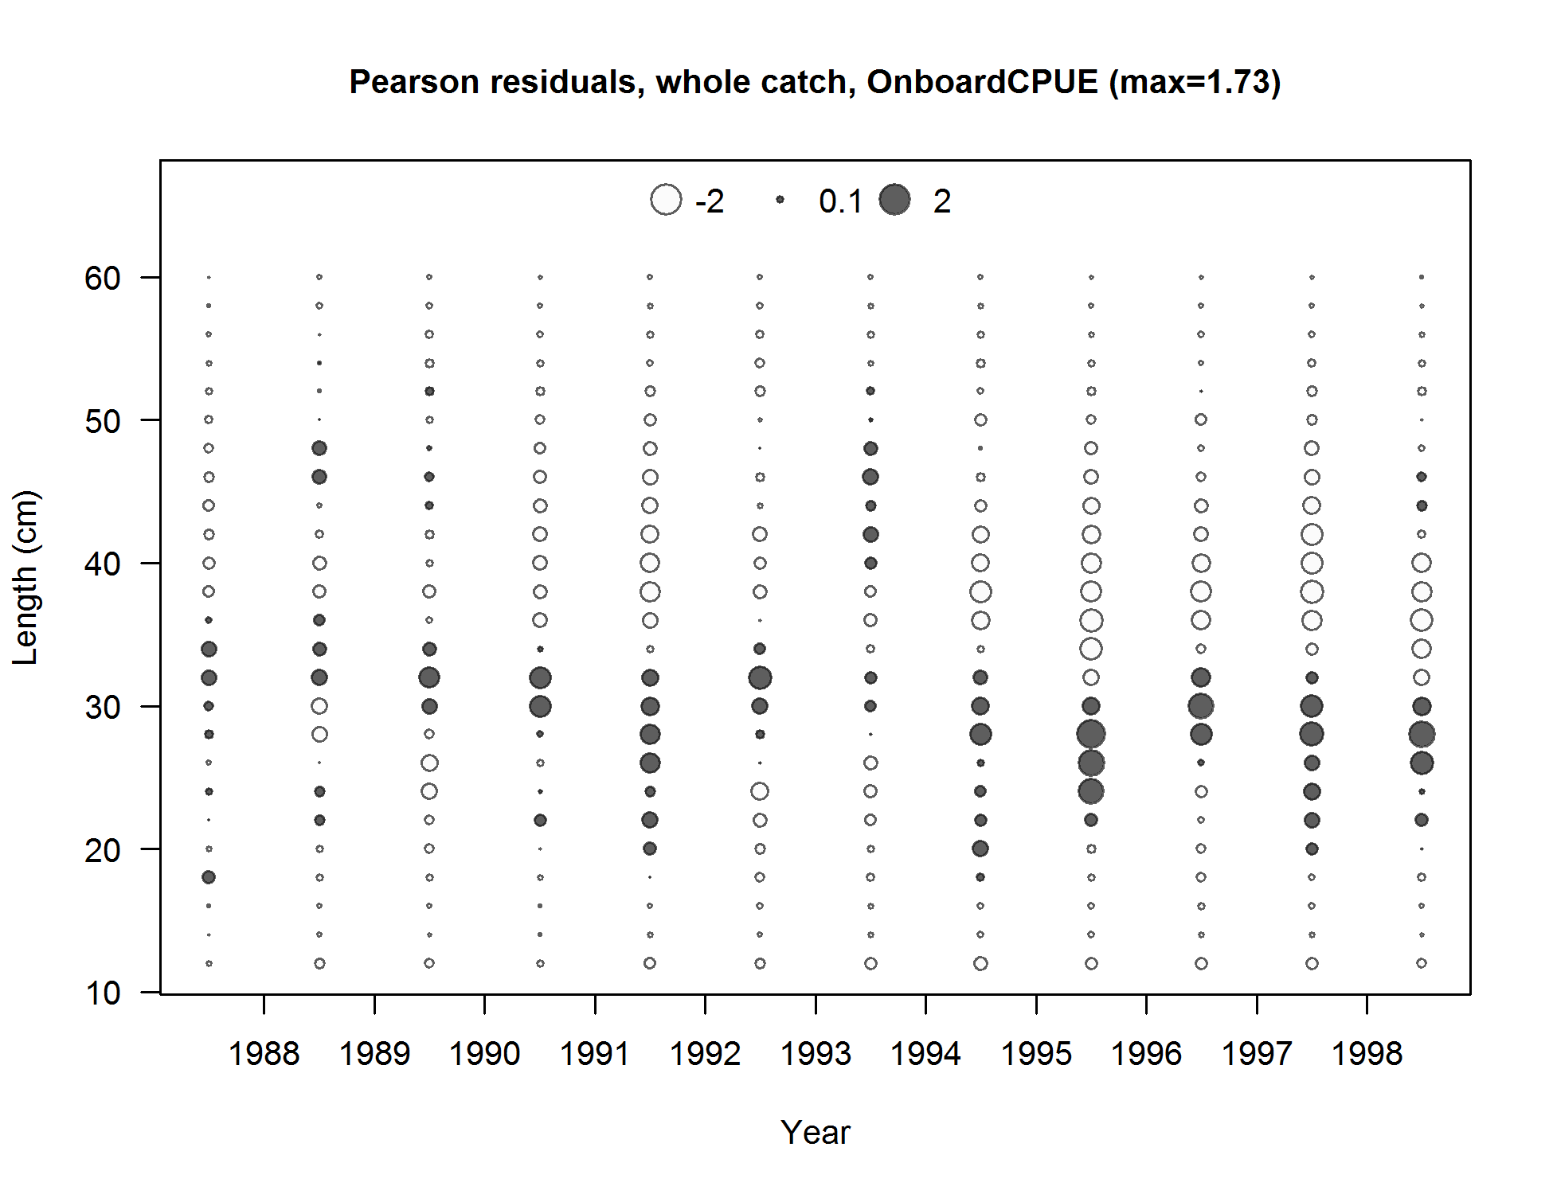

Figure . Pearson residuals plots for male (blue) and female (red) length compositions for the California onboard CPFV CPUE survey. Residuals <2 are generally considered non-significant.

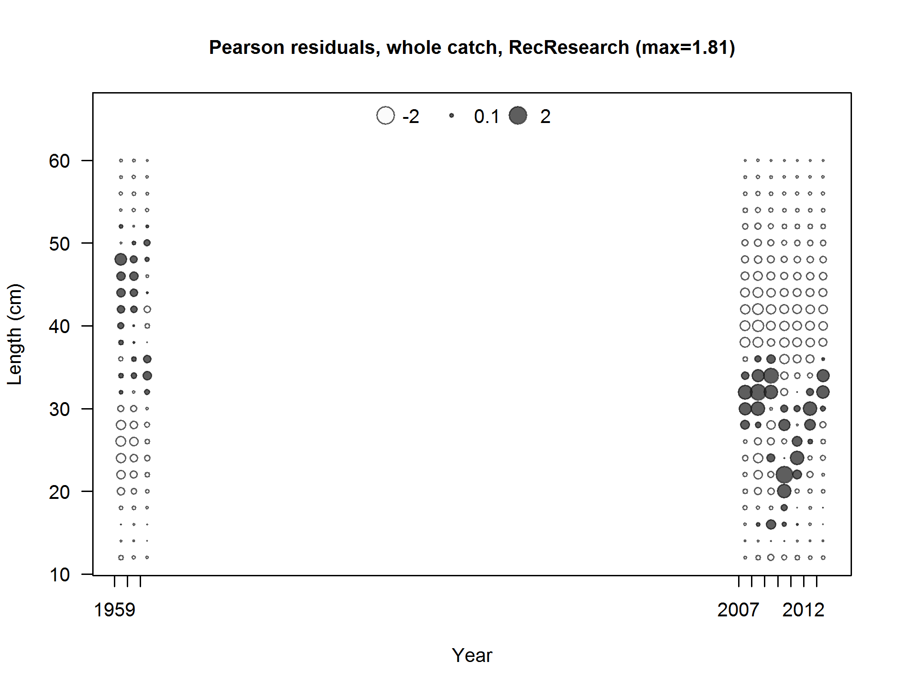

Figure . Pearson residuals plots for male (blue) and female (red) length compositions from California research samples. Residuals <2 are generally considered non-significant.

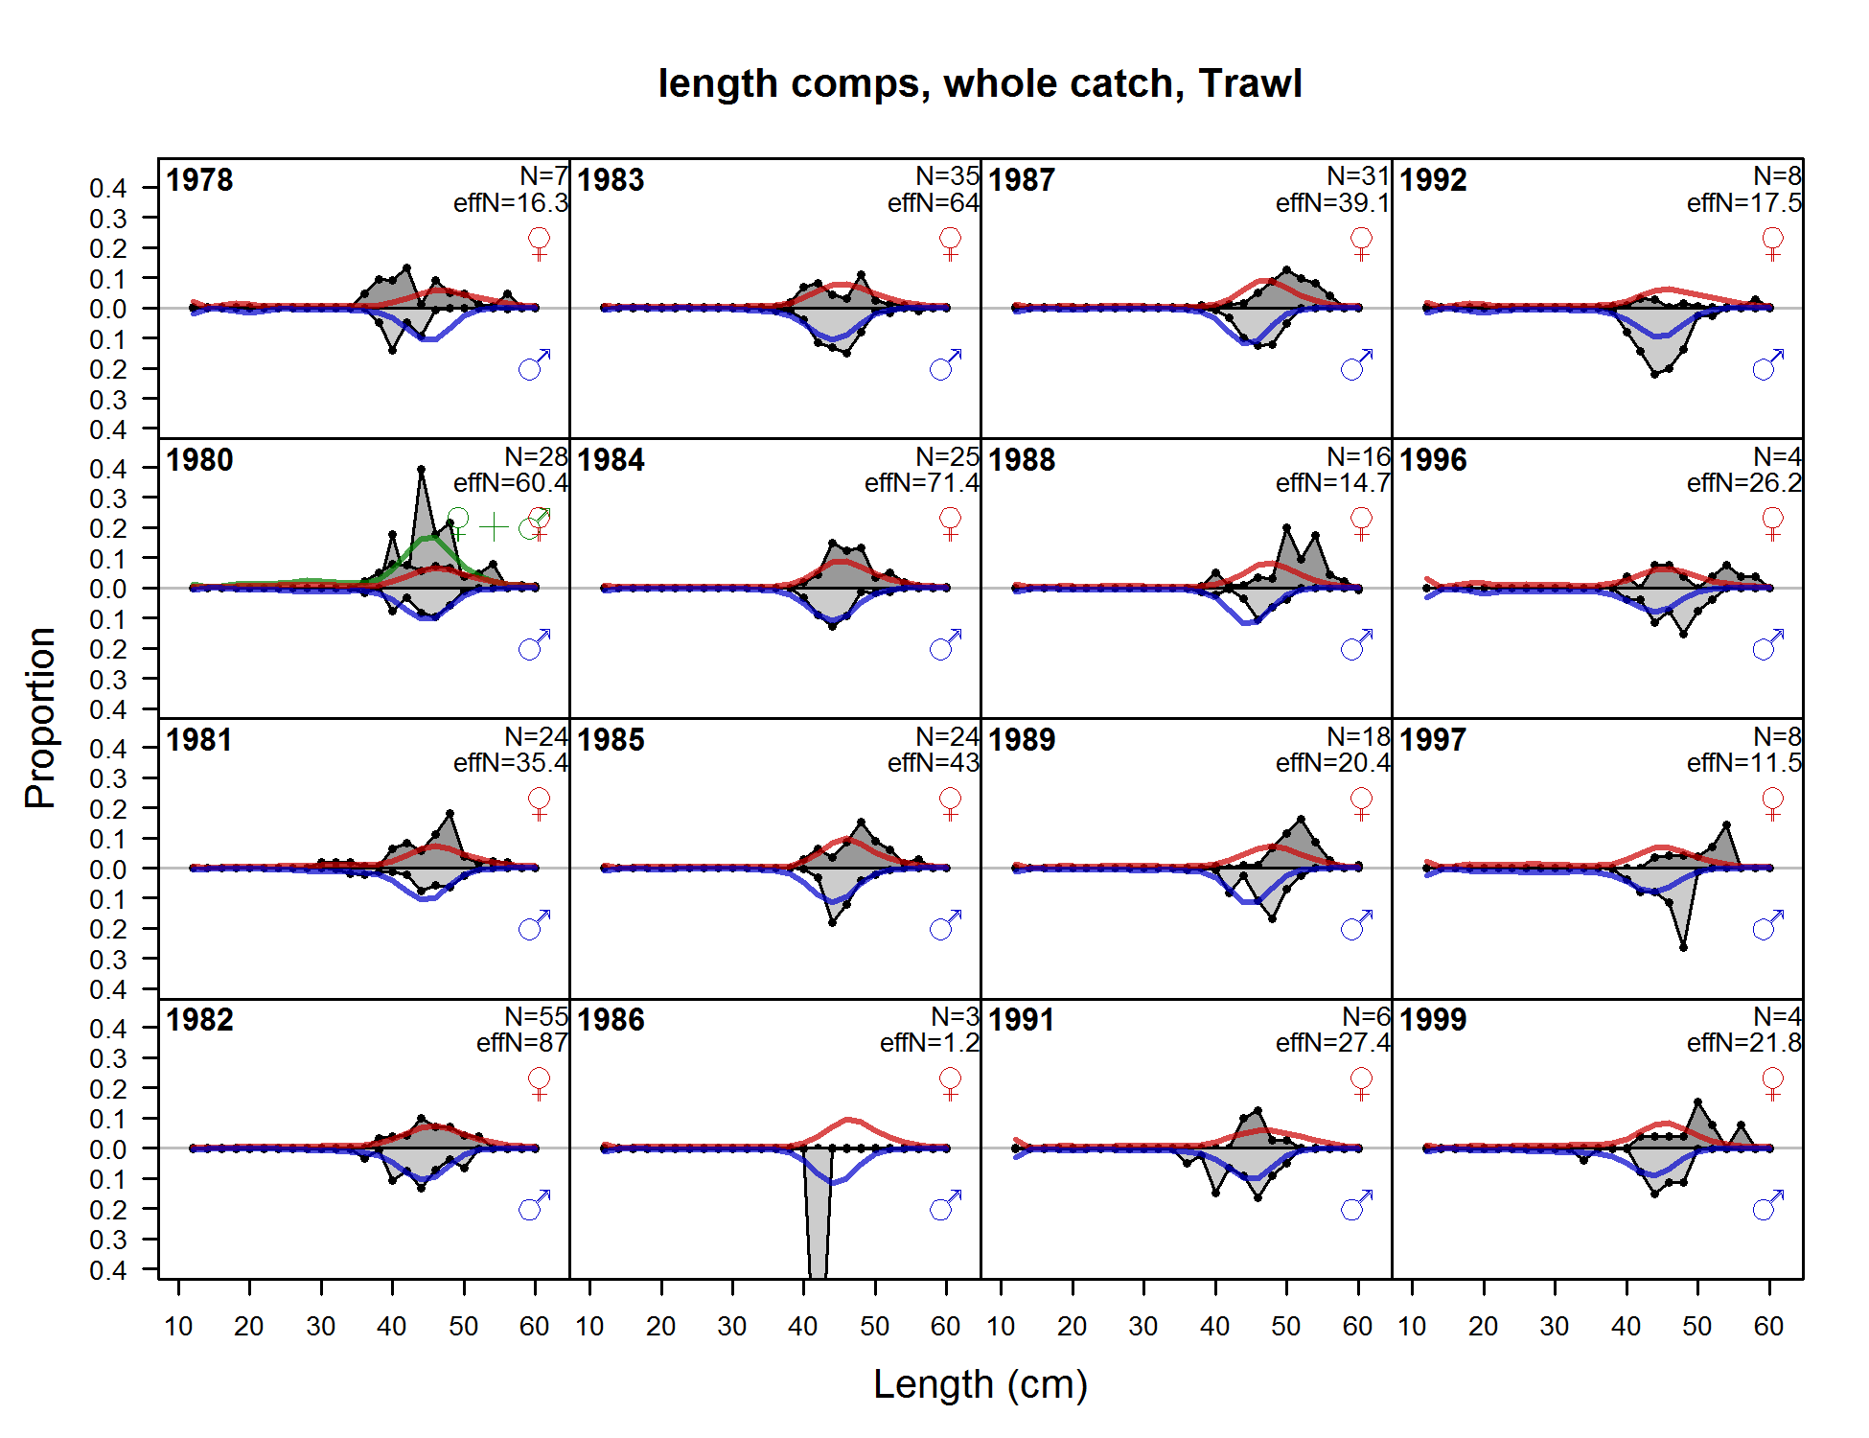

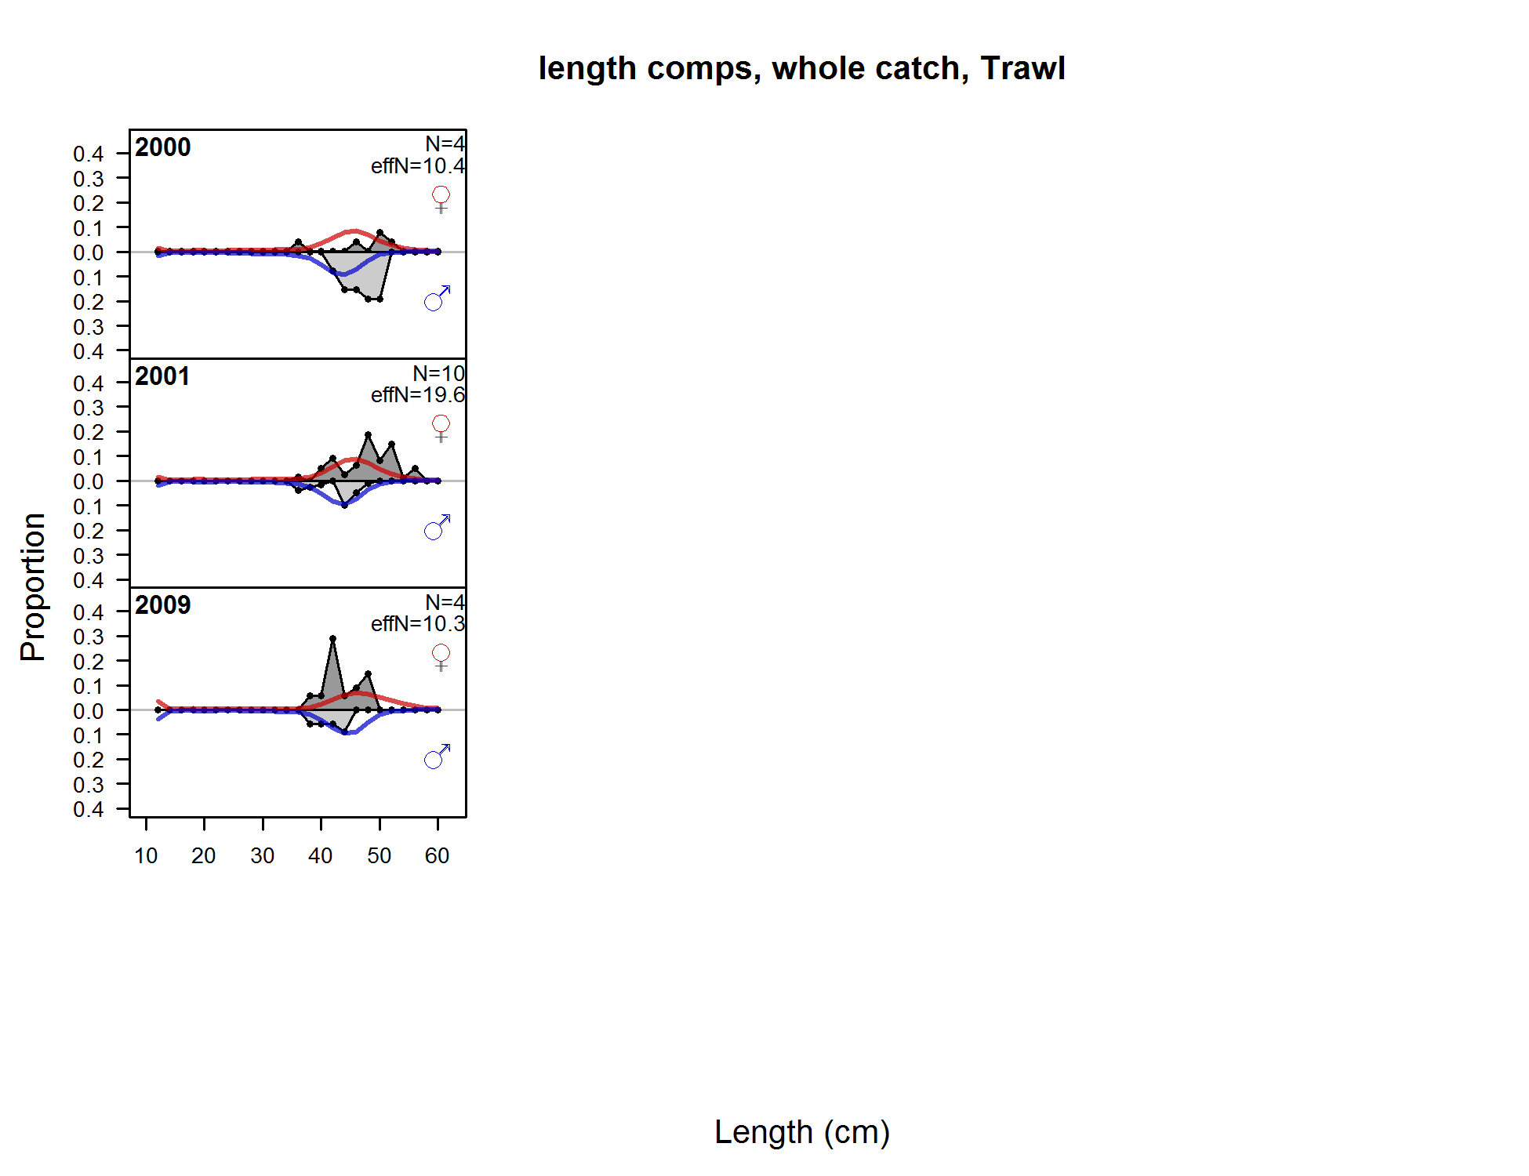

Figure . Fits to the California trawl length compositions by sex and year.

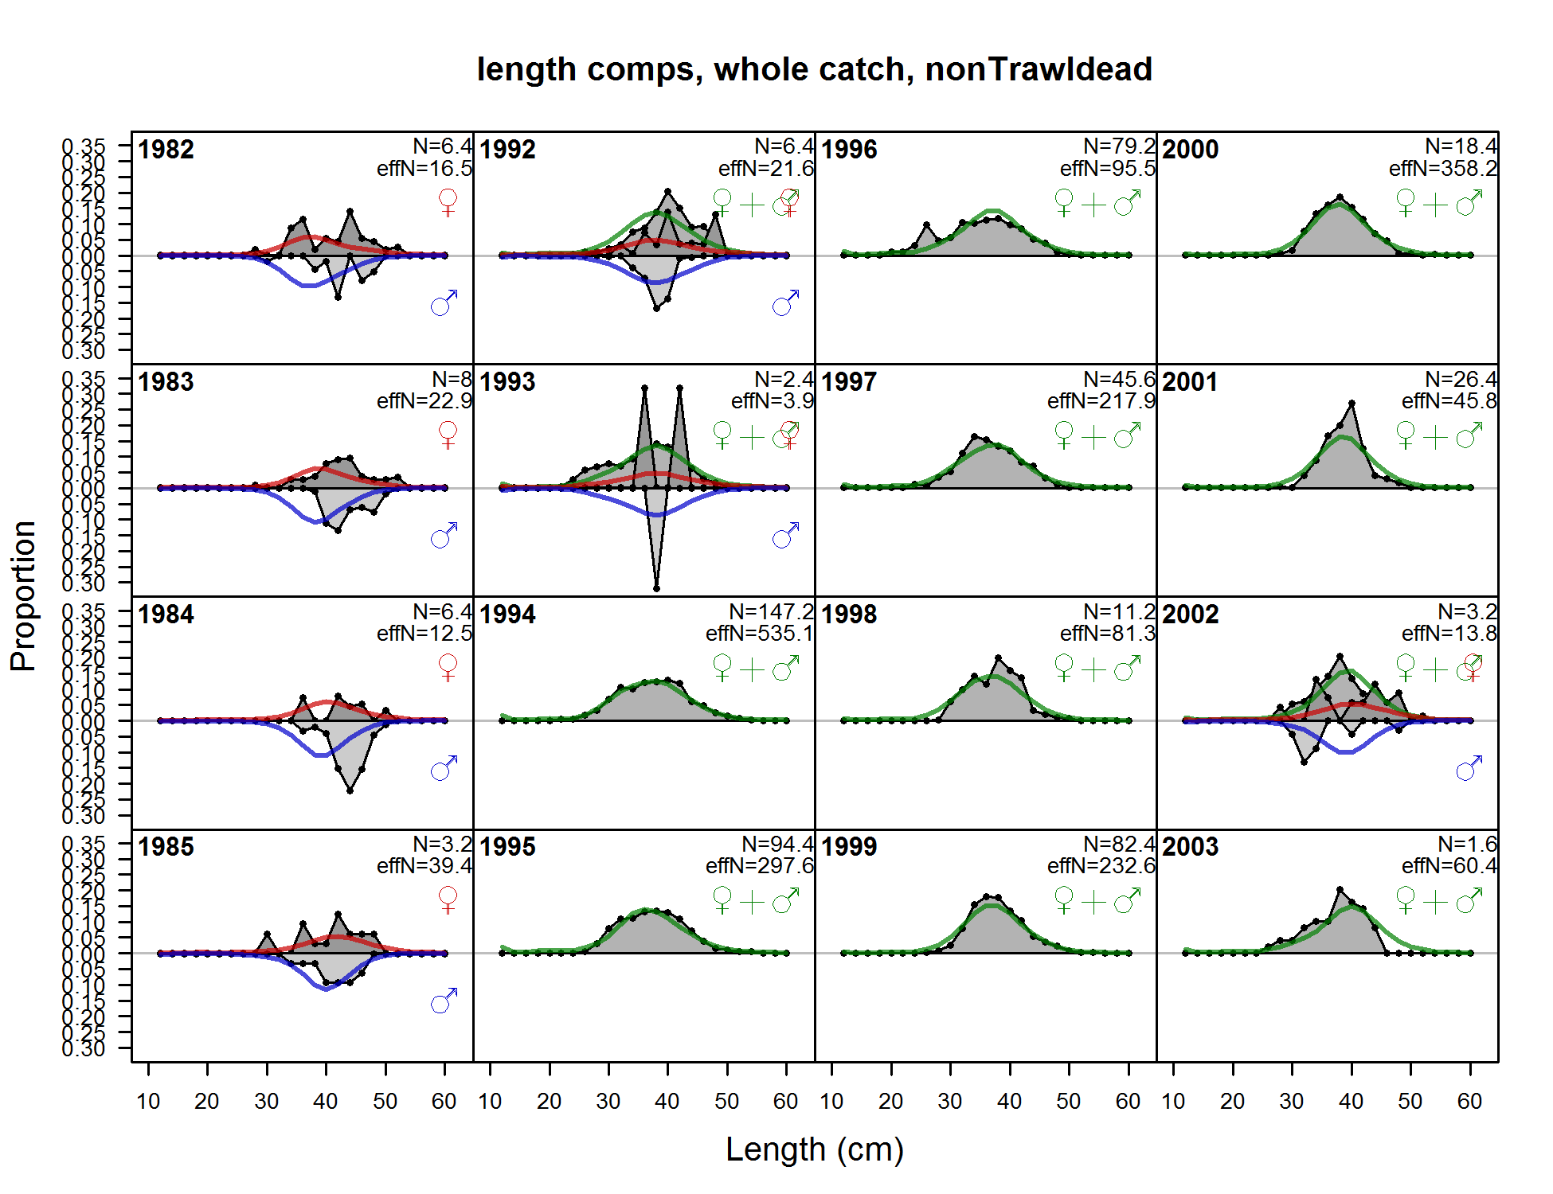

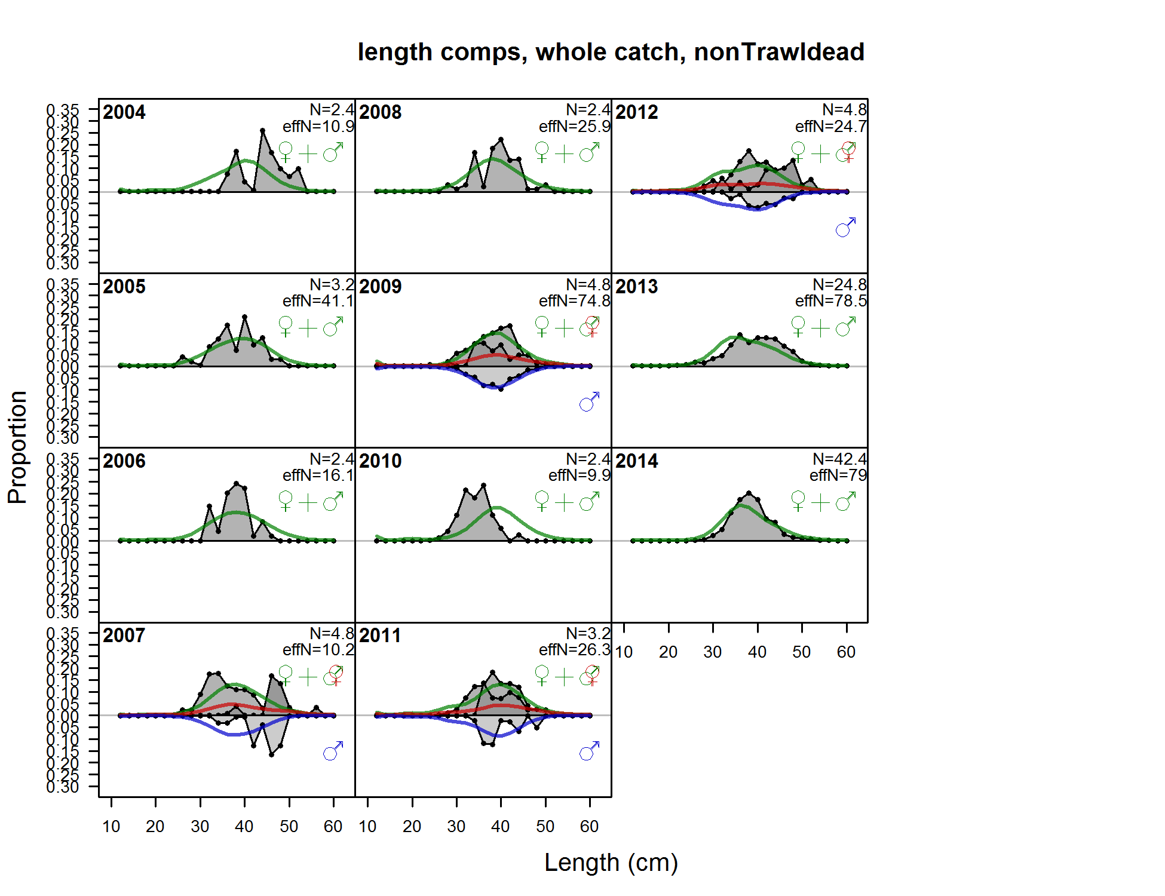

Figure . Fits to the California non-trawl commercial dead length compositions by sex and year.

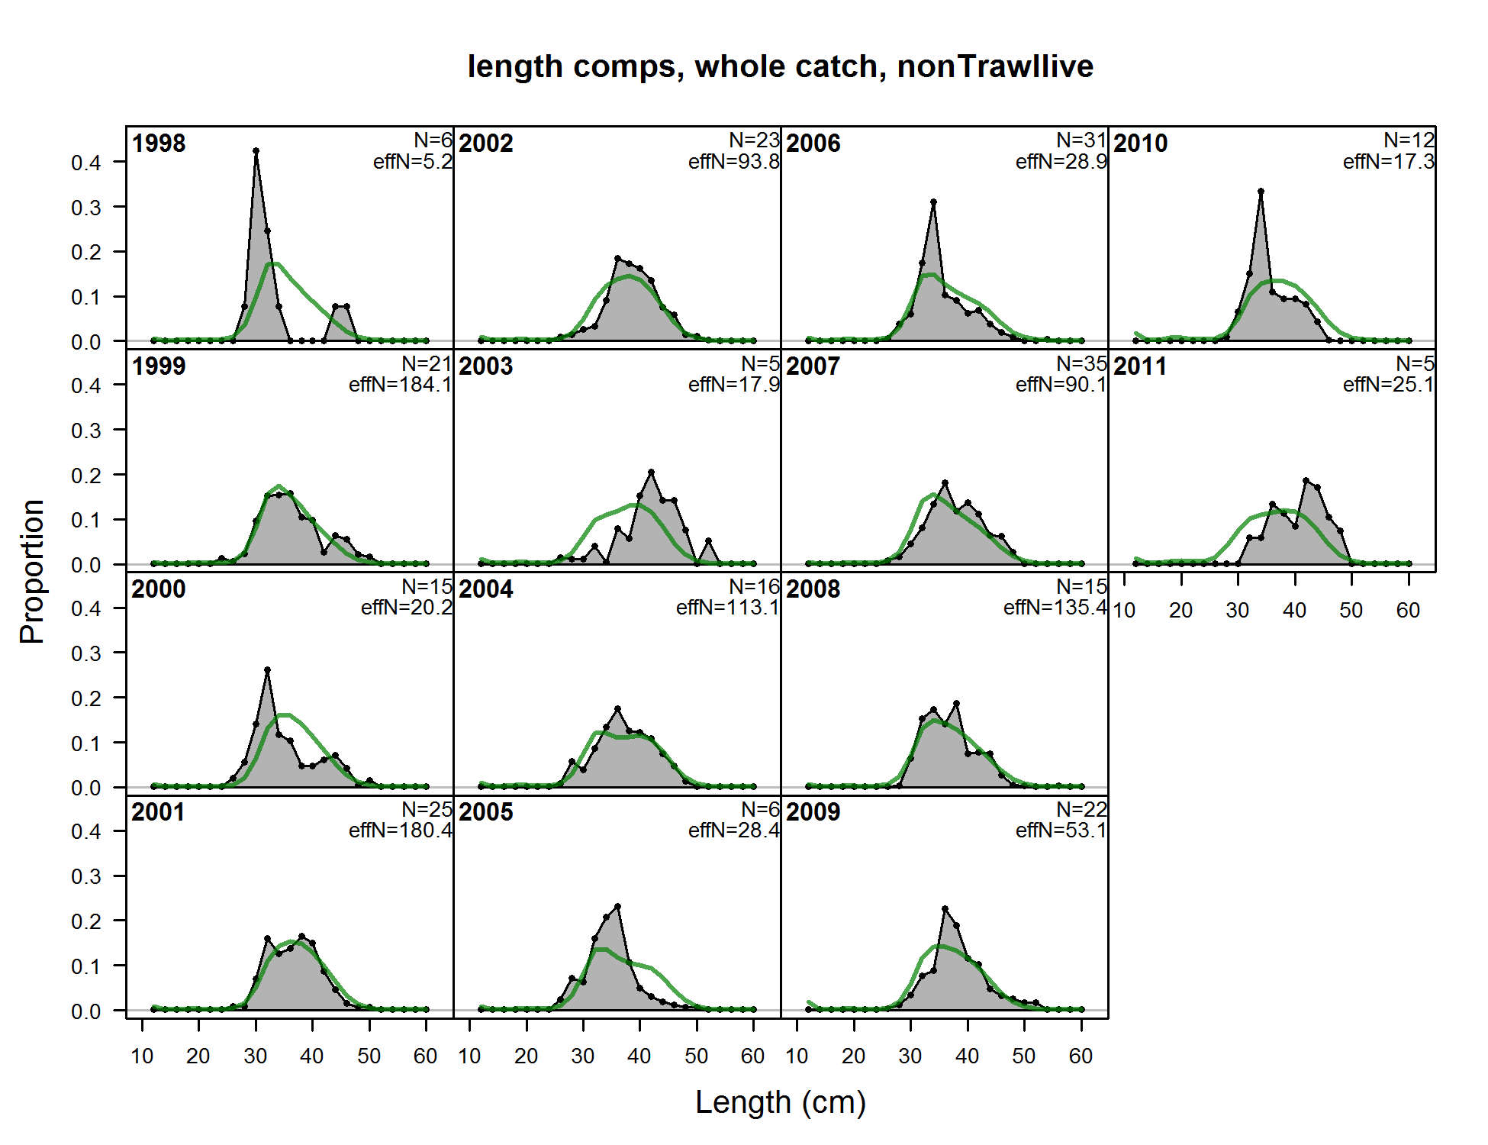

Figure . Fits to the California non-trawl commercial live fish fishery length compositions and year.

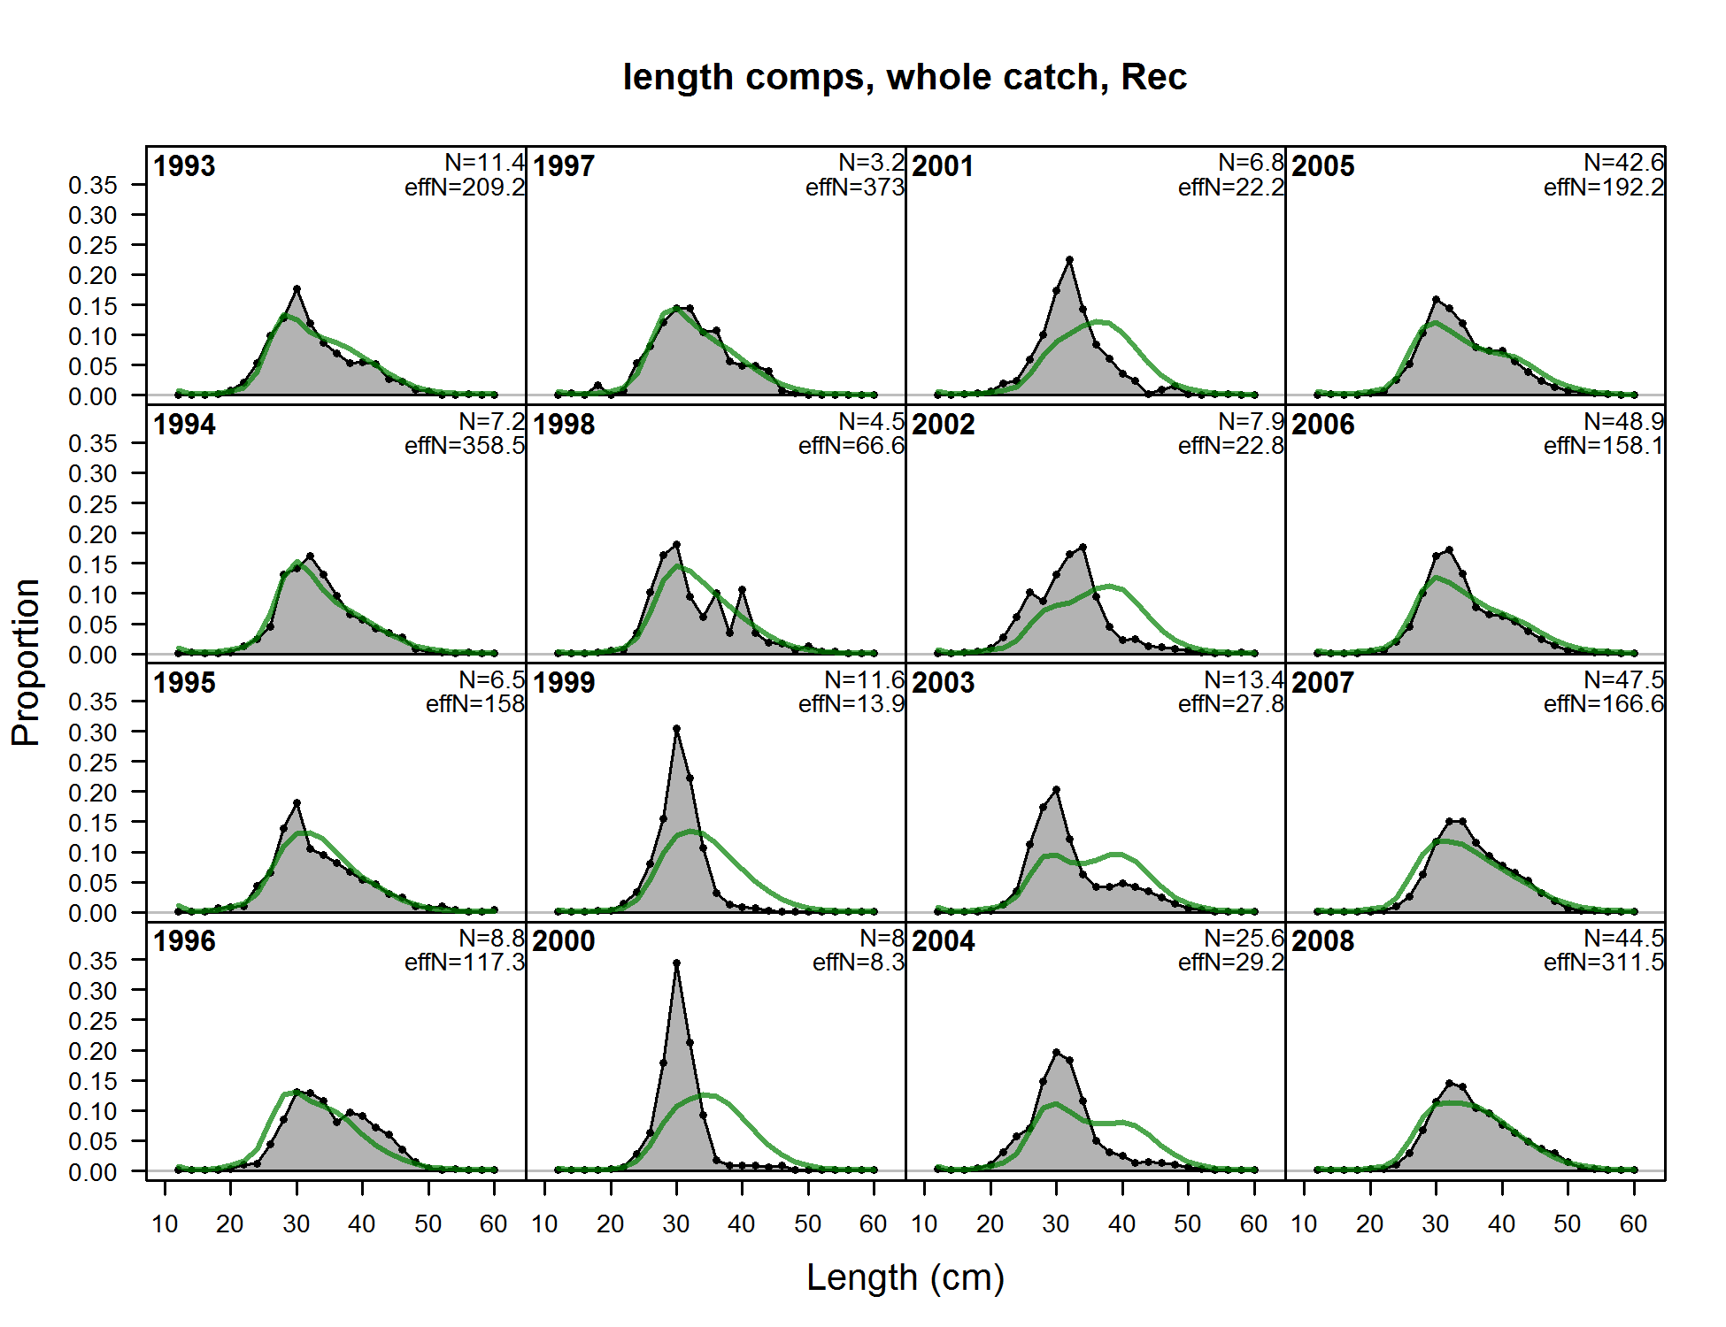

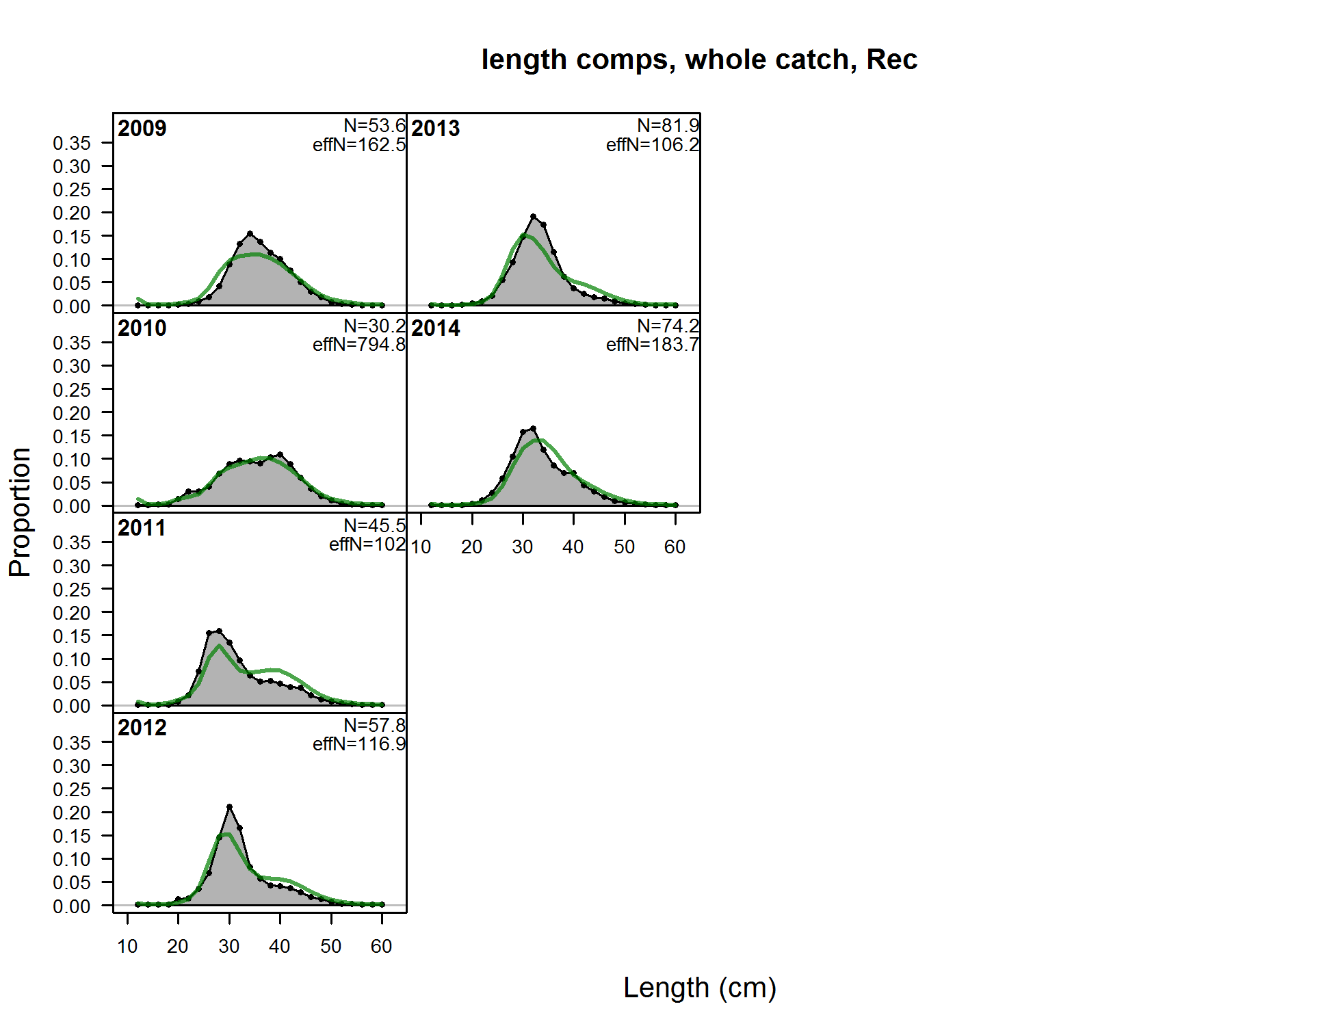

Figure . Fits to the California recreational length compositions and year.

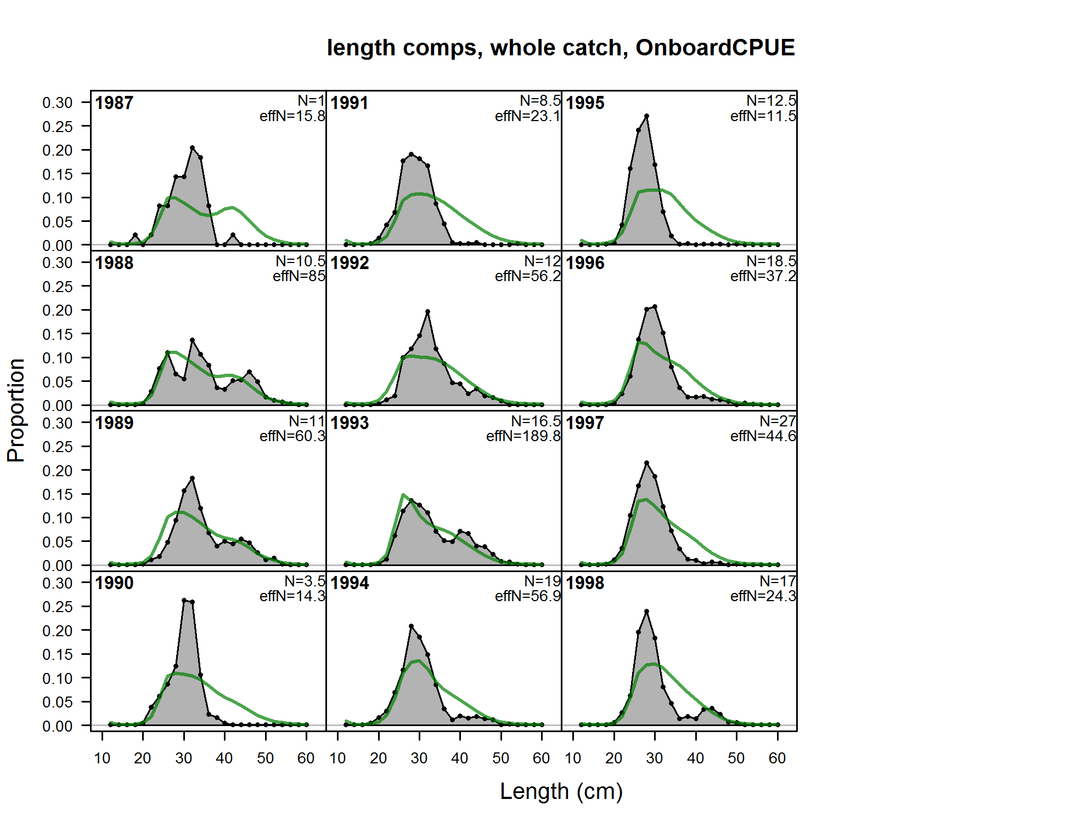

Figure . Fits to the California onboard CPFV CPUE length compositions and year.

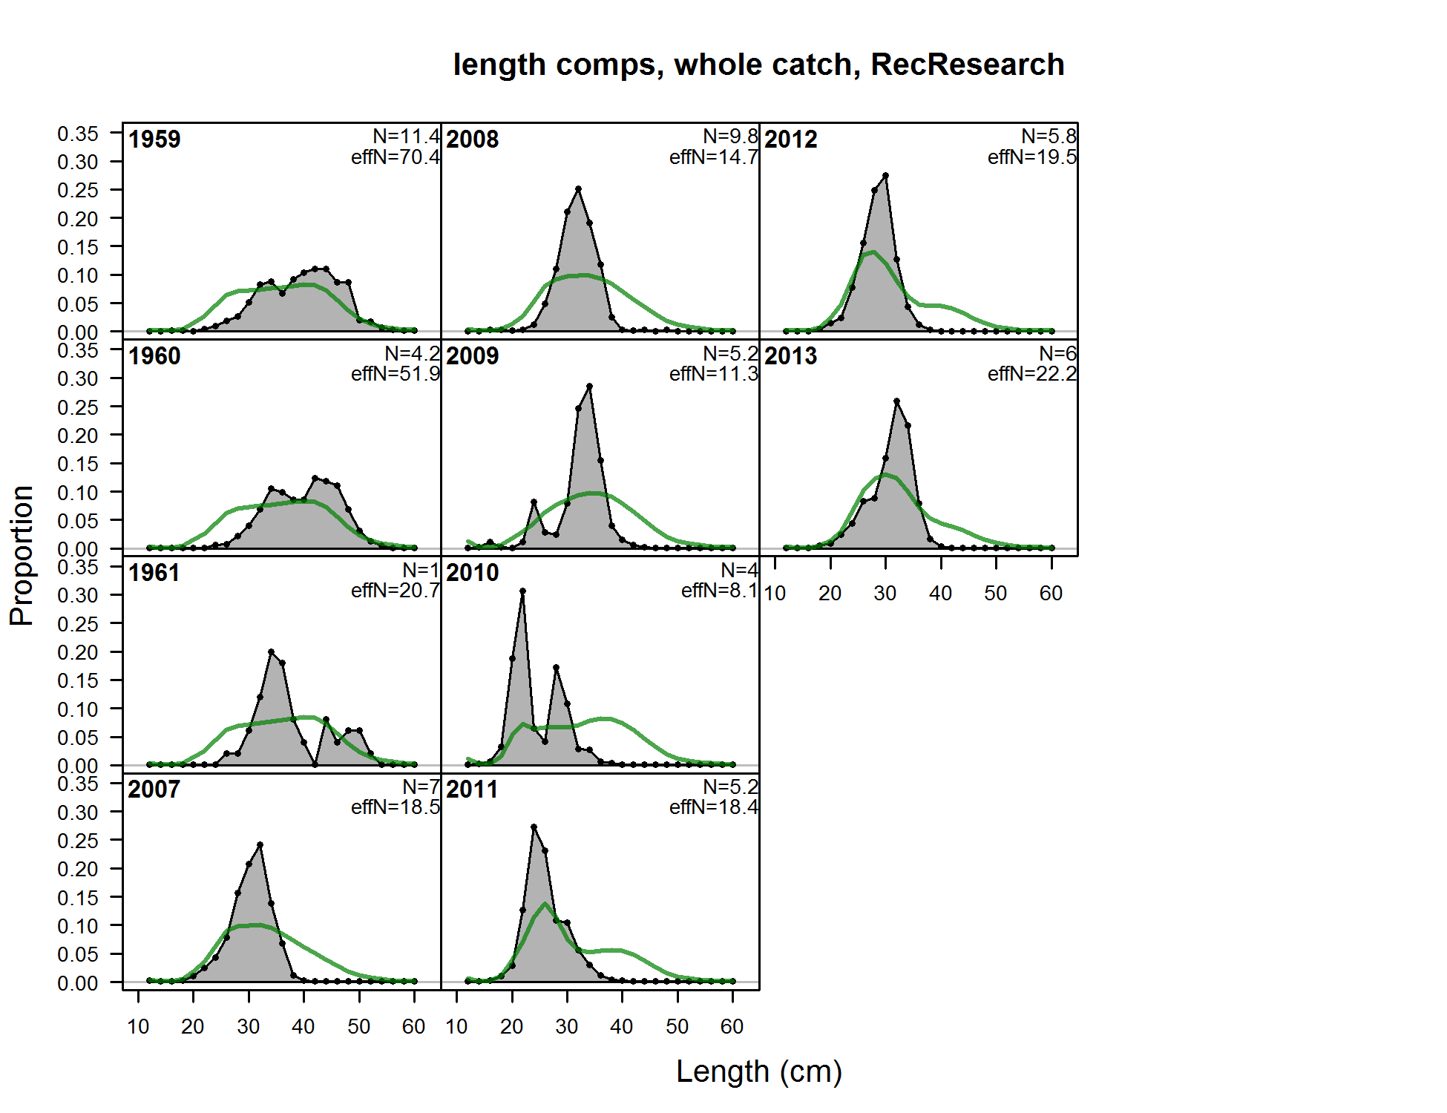

Figure . Fits to the California research sampled length compositions by year.

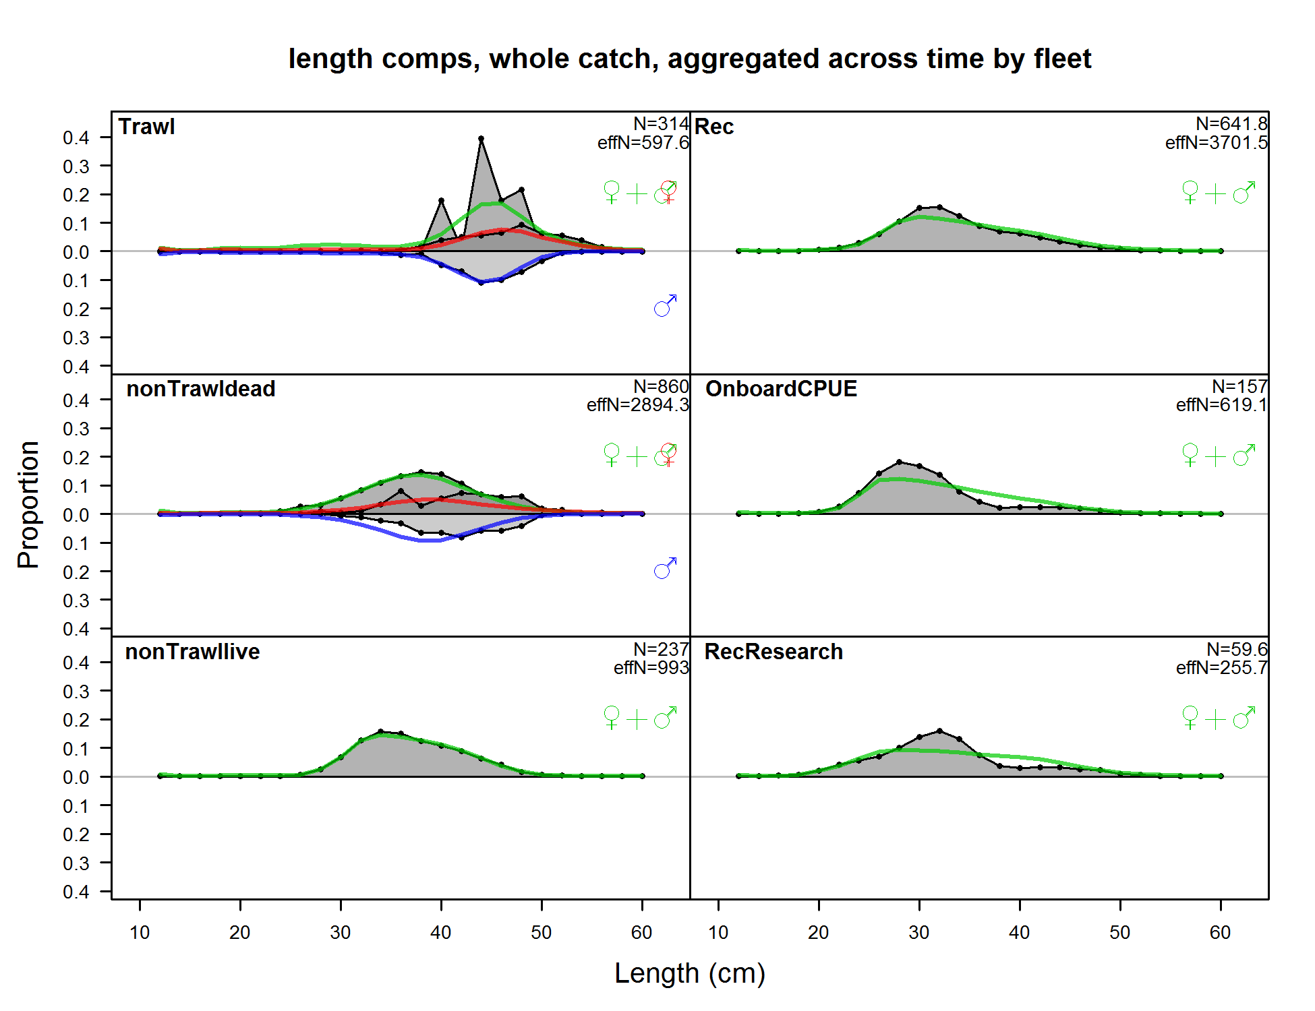

Figure . Composite fits to the length composition by gear and sex for the California base model.

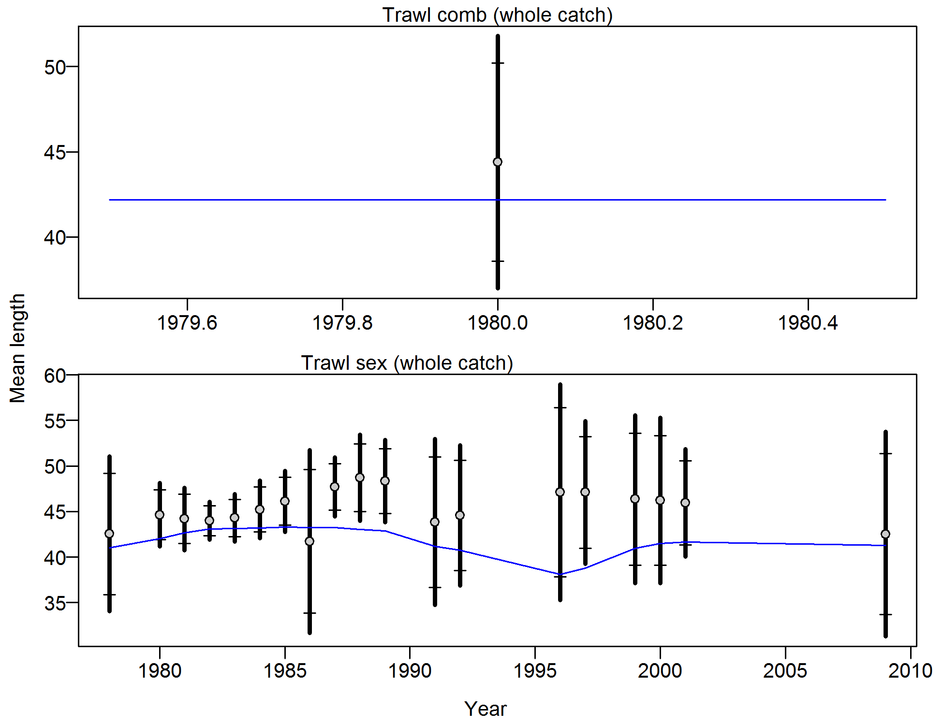

Figure . Francis weighting fits to the mean lengths by year for the California commercial trawl fleet. Vertical lines indicate 95% confidence intervals.

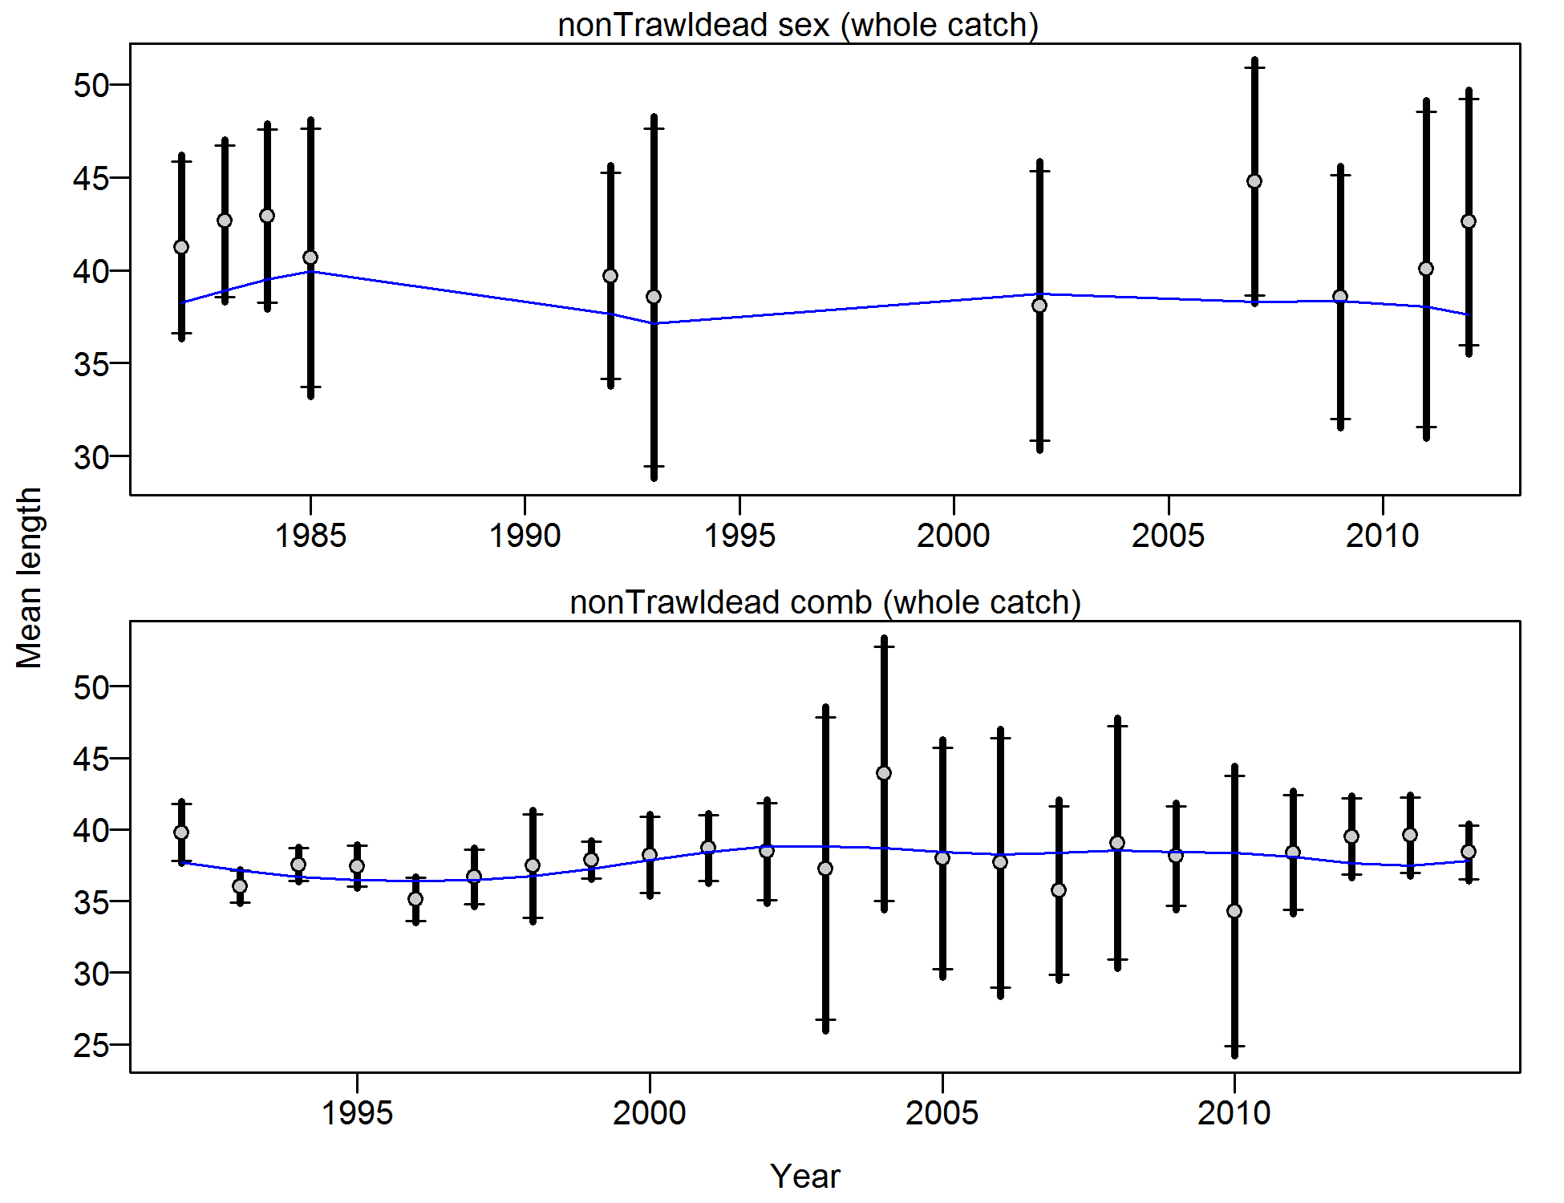

Figure . Francis weighting fits to the mean lengths by year for the California commercial non-trawl dead fish fleet. Vertical lines indicate 95% confidence intervals.

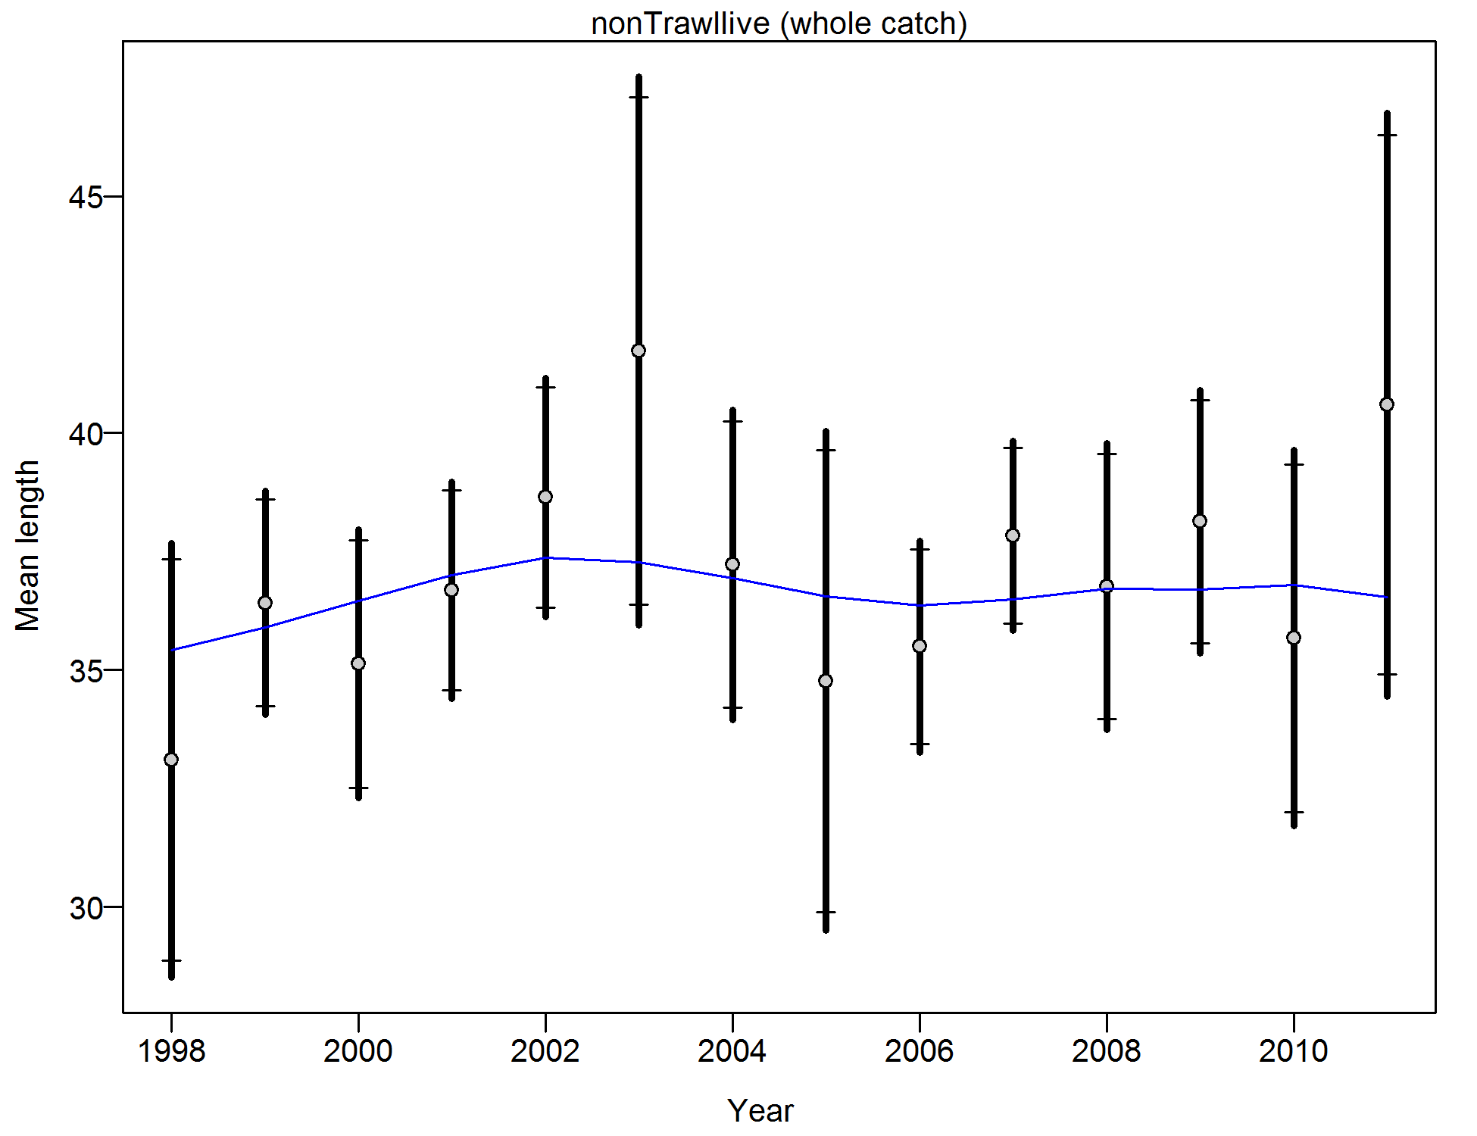

Figure . Francis weighting fits to the mean lengths by year for the California commercial non-trawl live fish fleet. Vertical lines indicate 95% confidence intervals.

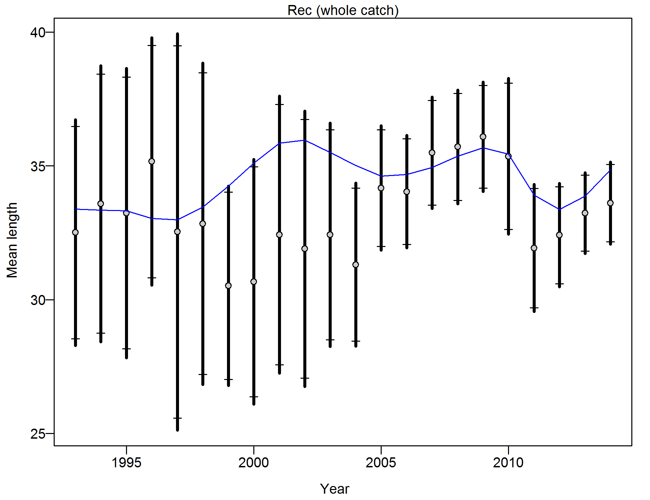

Figure . Francis weighting fits to the mean lengths by year for the California recreational fleet. Vertical lines indicate 95% confidence intervals.

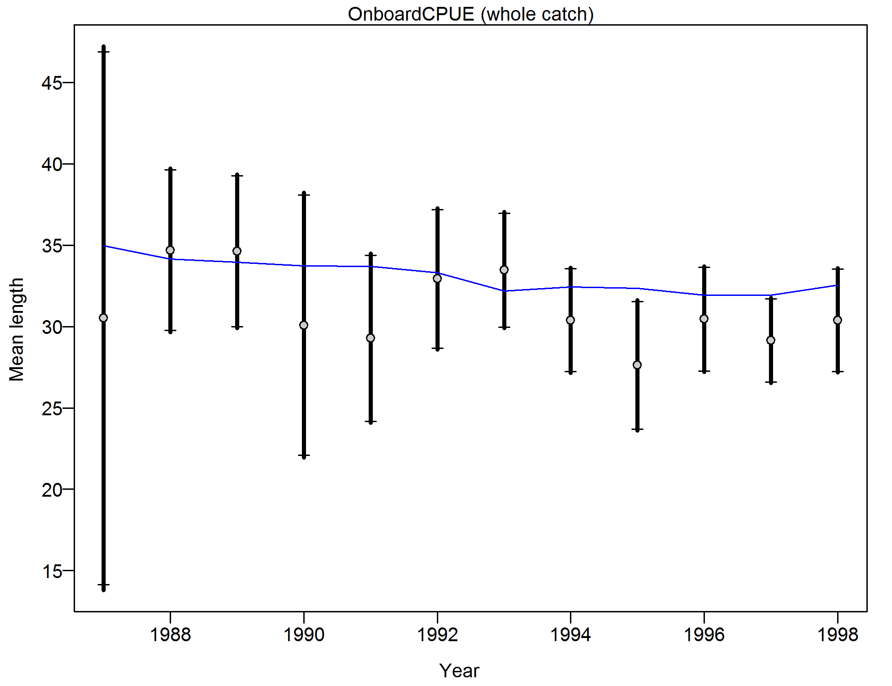

Figure . Francis weighting fits to the mean lengths by year for the California onboard CPFV CPUE survey. Vertical lines indicate 95% confidence intervals.

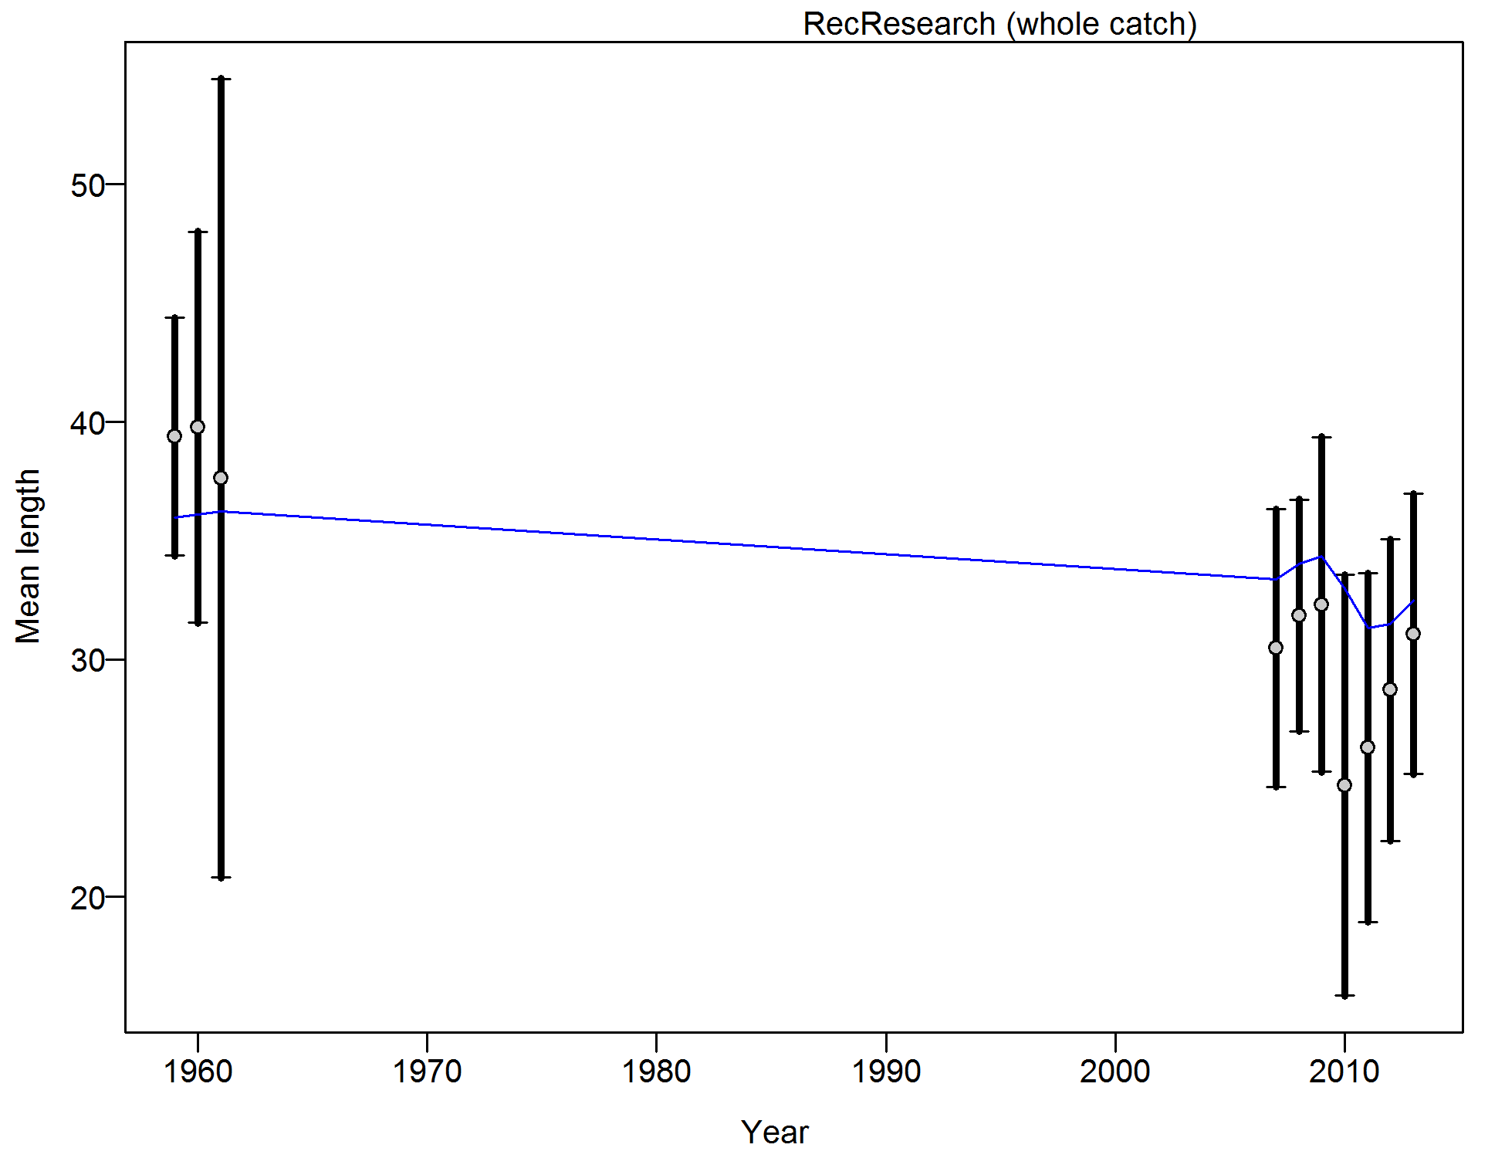

Figure . Francis weighting fits to the mean lengths by year for the California research samples. Vertical lines indicate 95% confidence intervals.

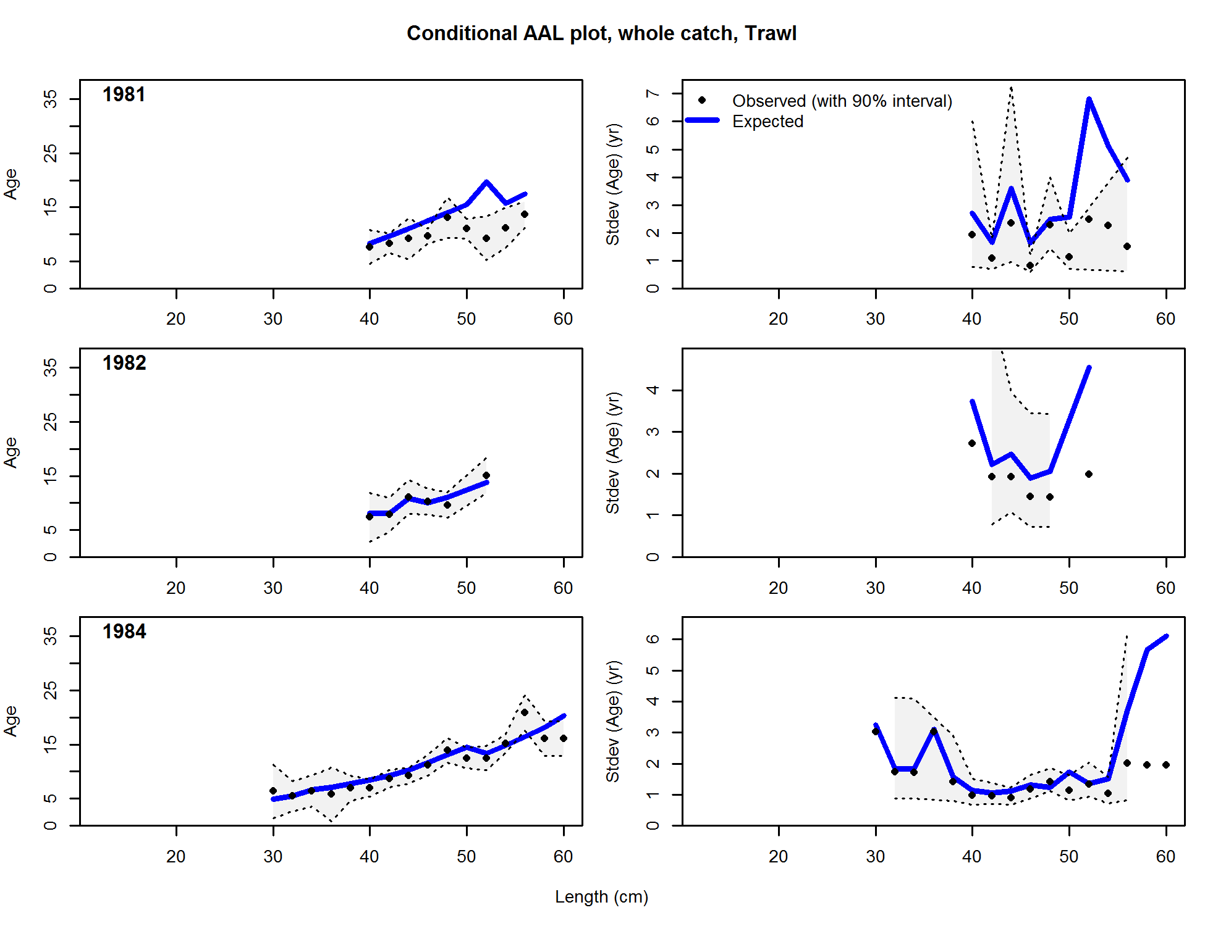

Figure . Conditional age-at-length samples and predictions for the California commercial trawl fleet. Shading indicates 95% confidence intervals.

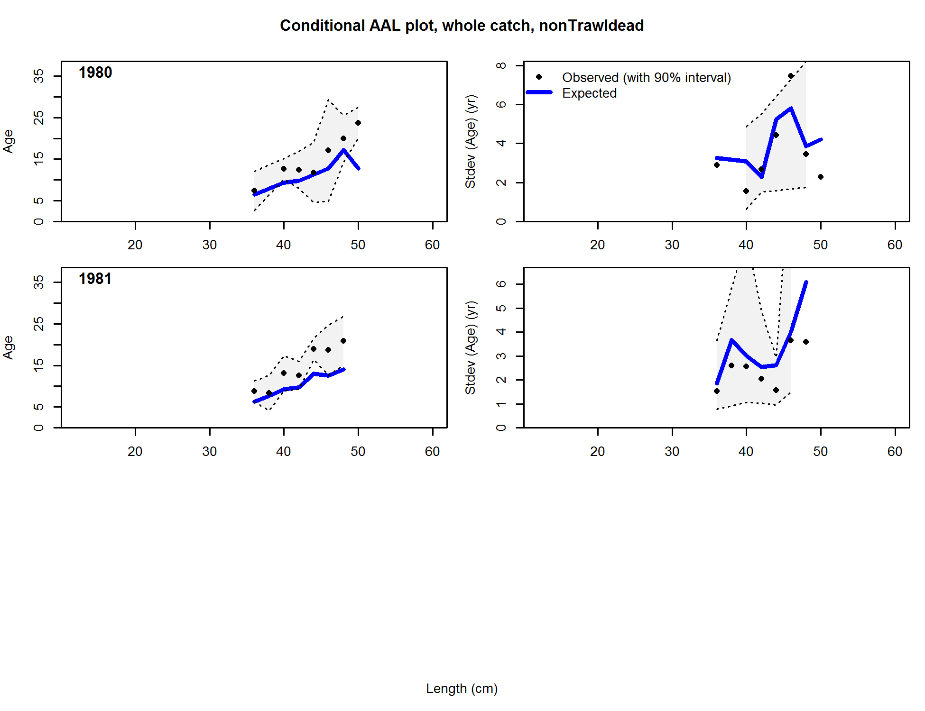



Figure . Conditional age-at-length samples and predictions for the California commercial non-trawl dead fish fleet. Shading indicates 95% confidence intervals.

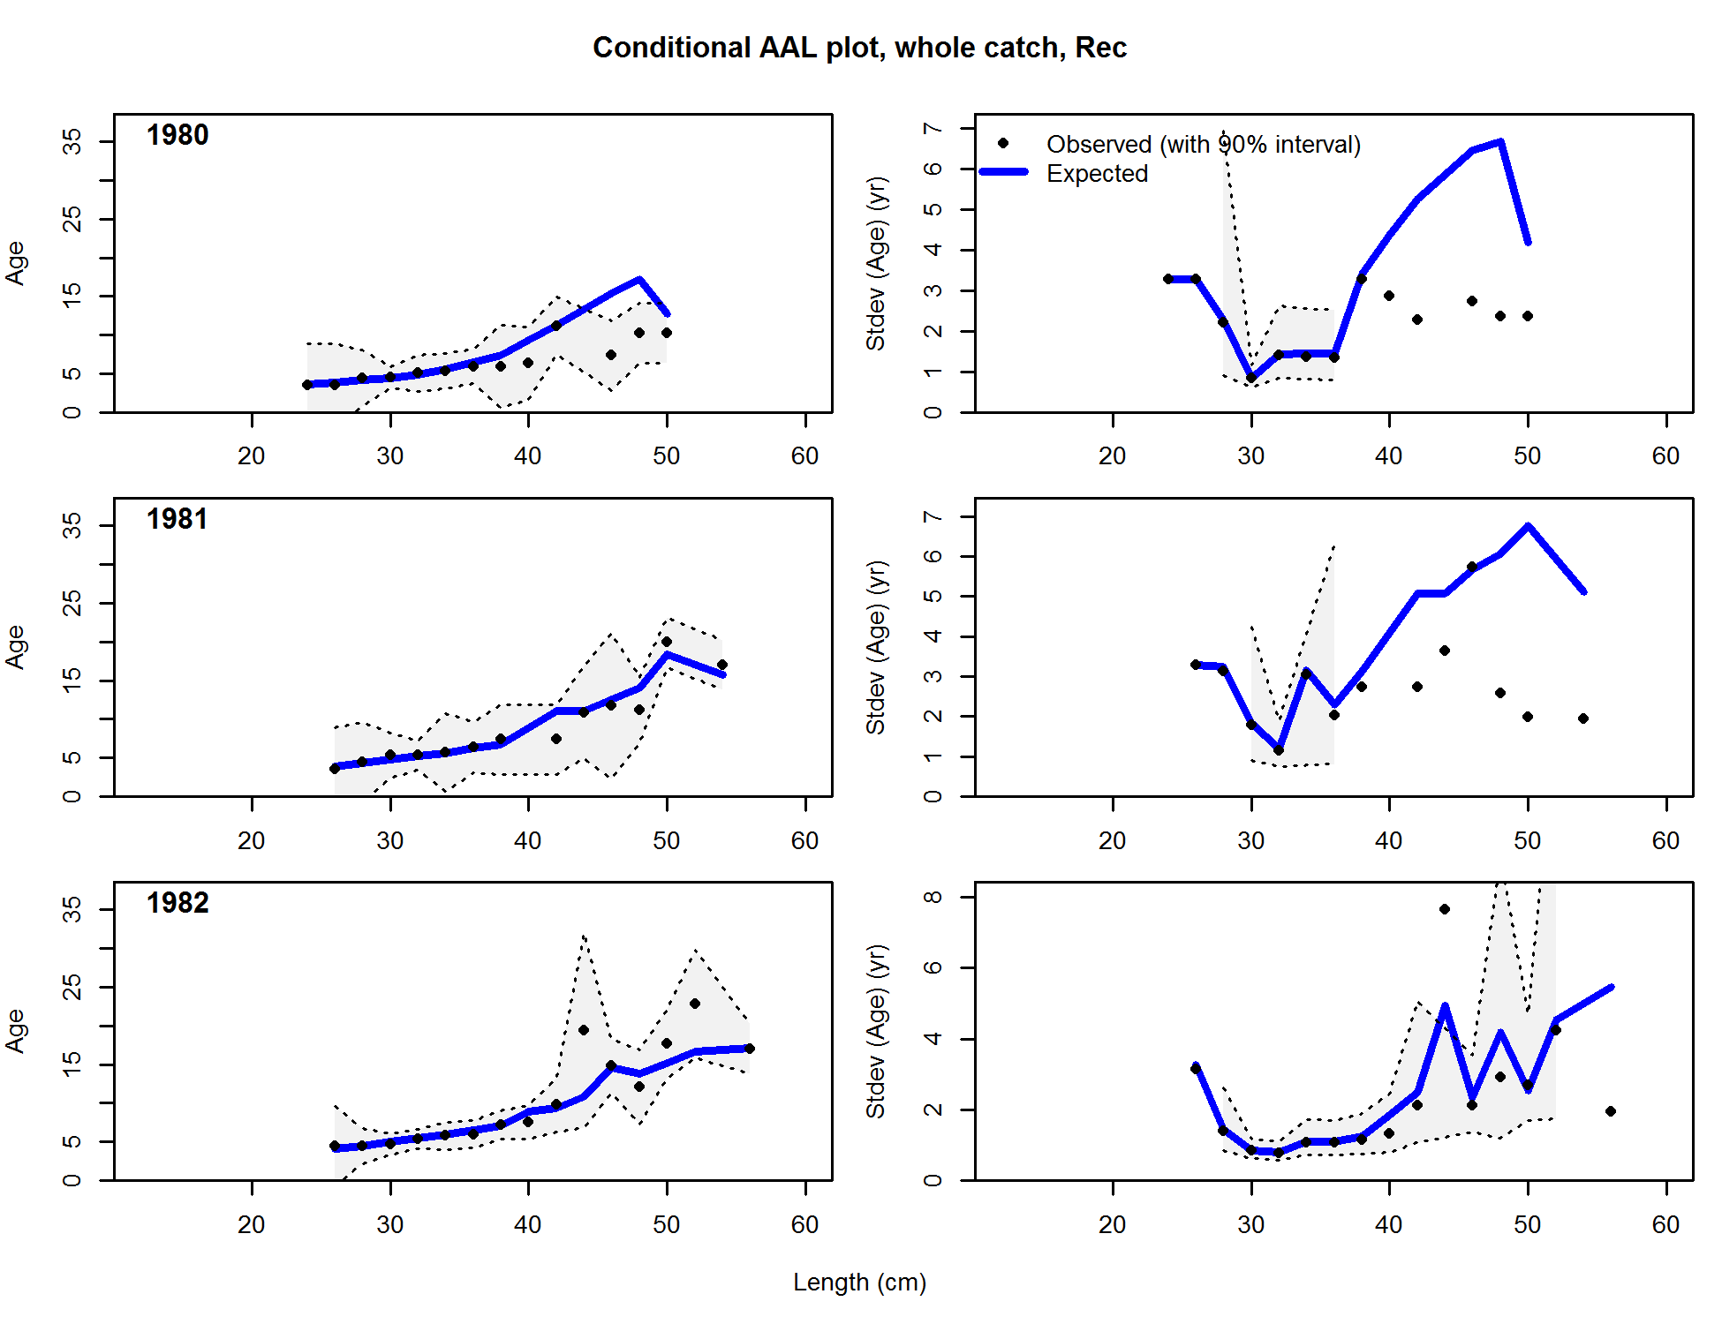

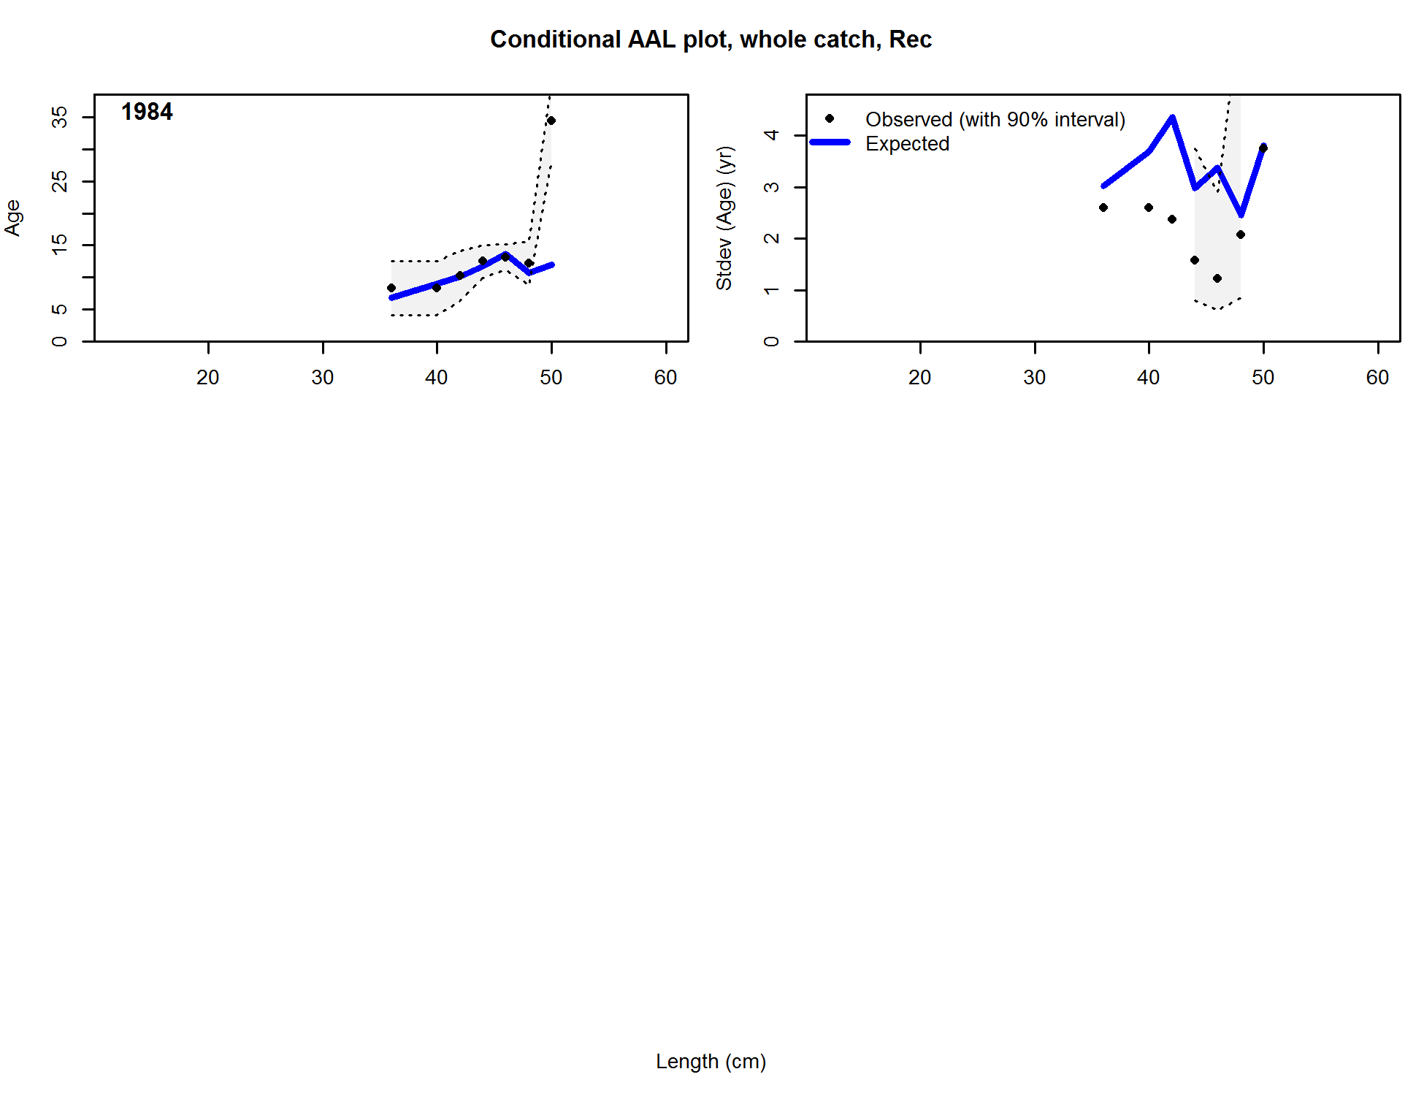

Figure . Conditional age-at-length samples and predictions for the California recreational fleet. Shading indicates 95% confidence intervals.

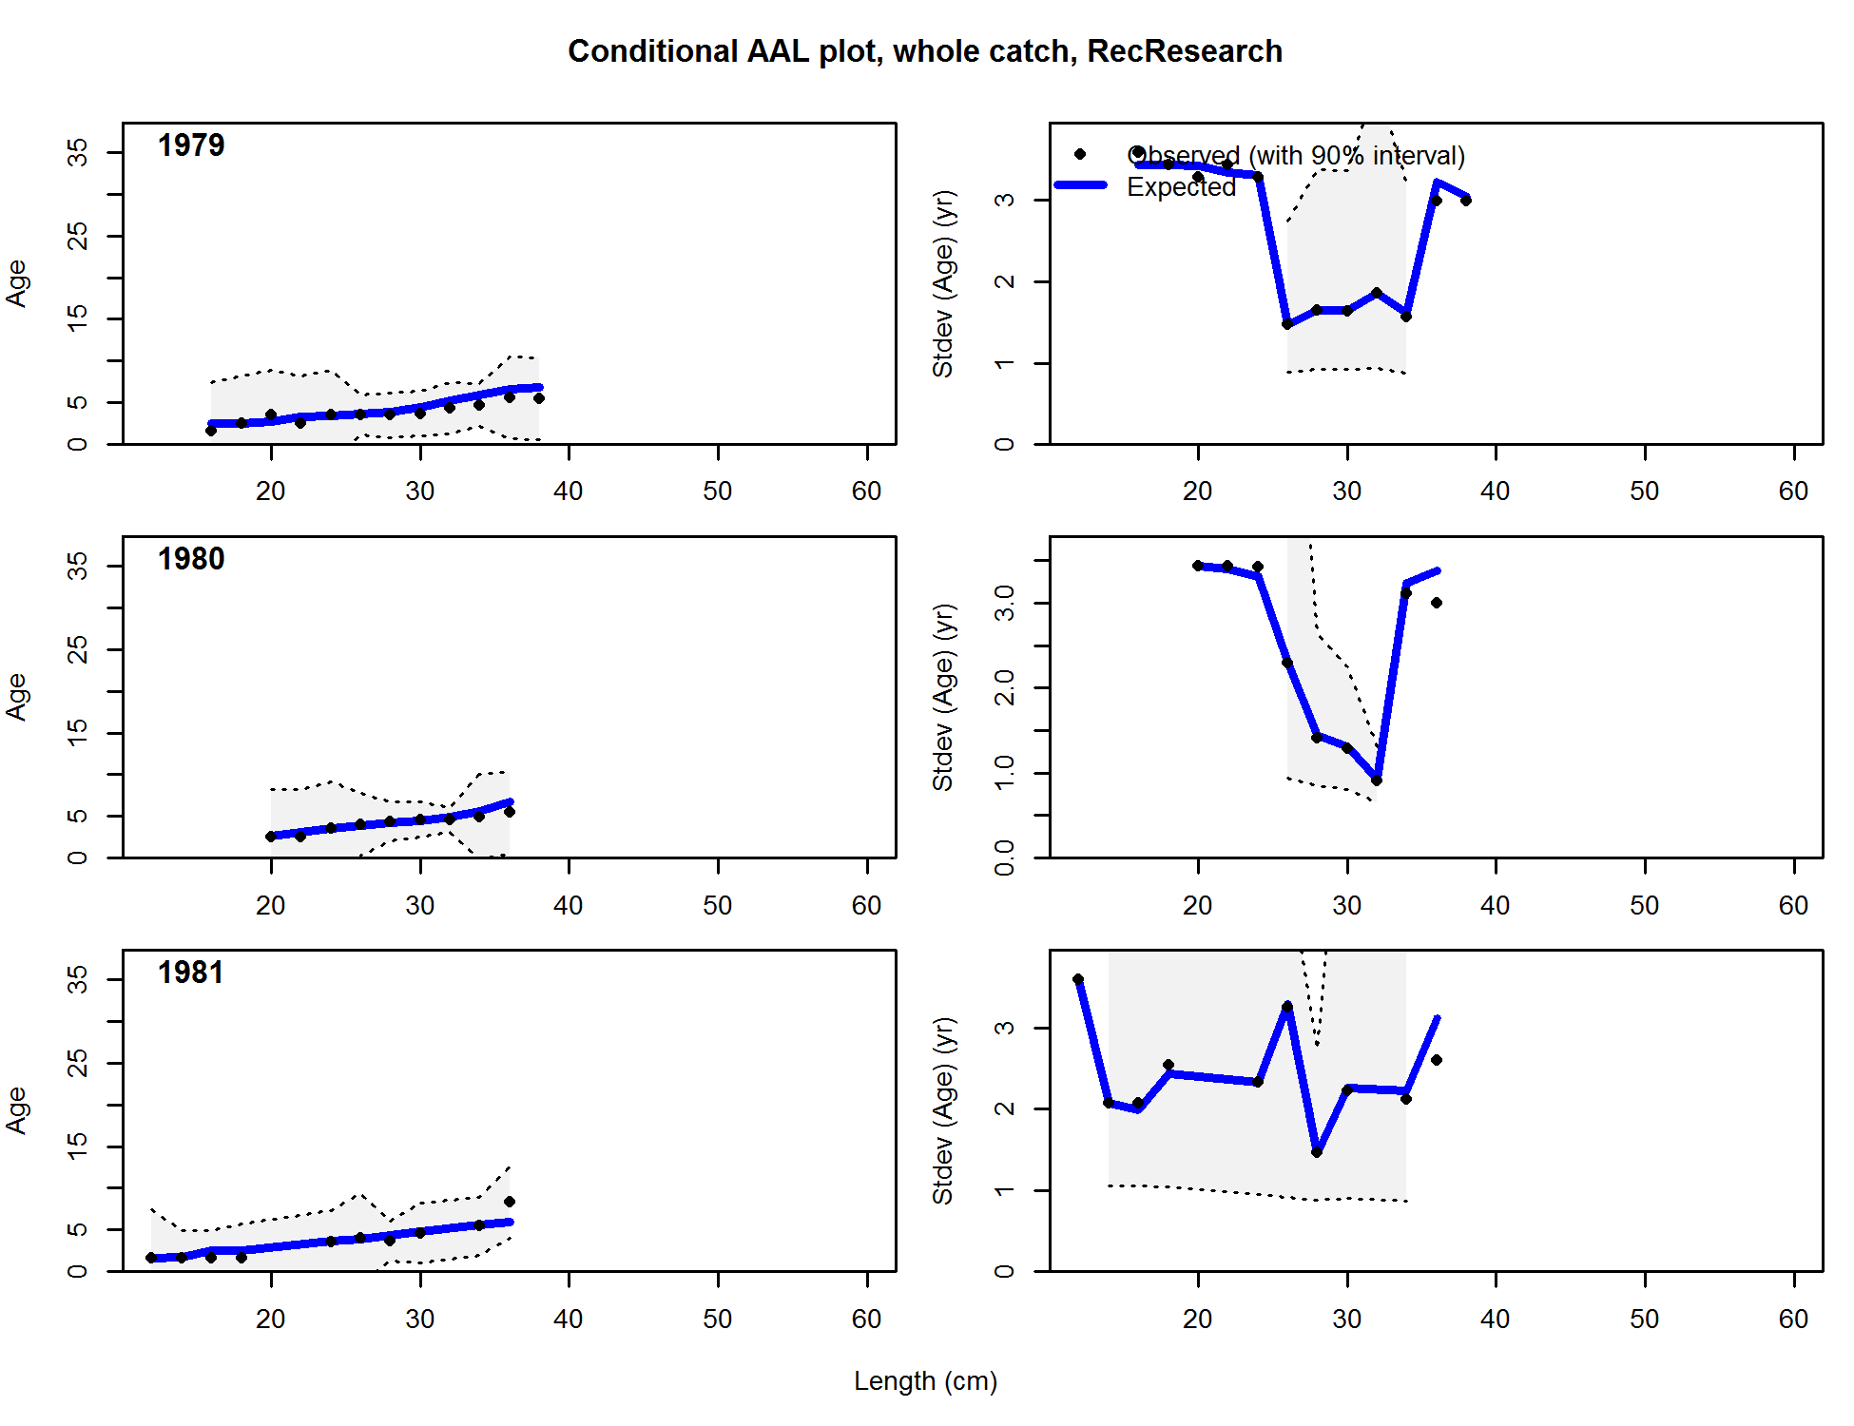

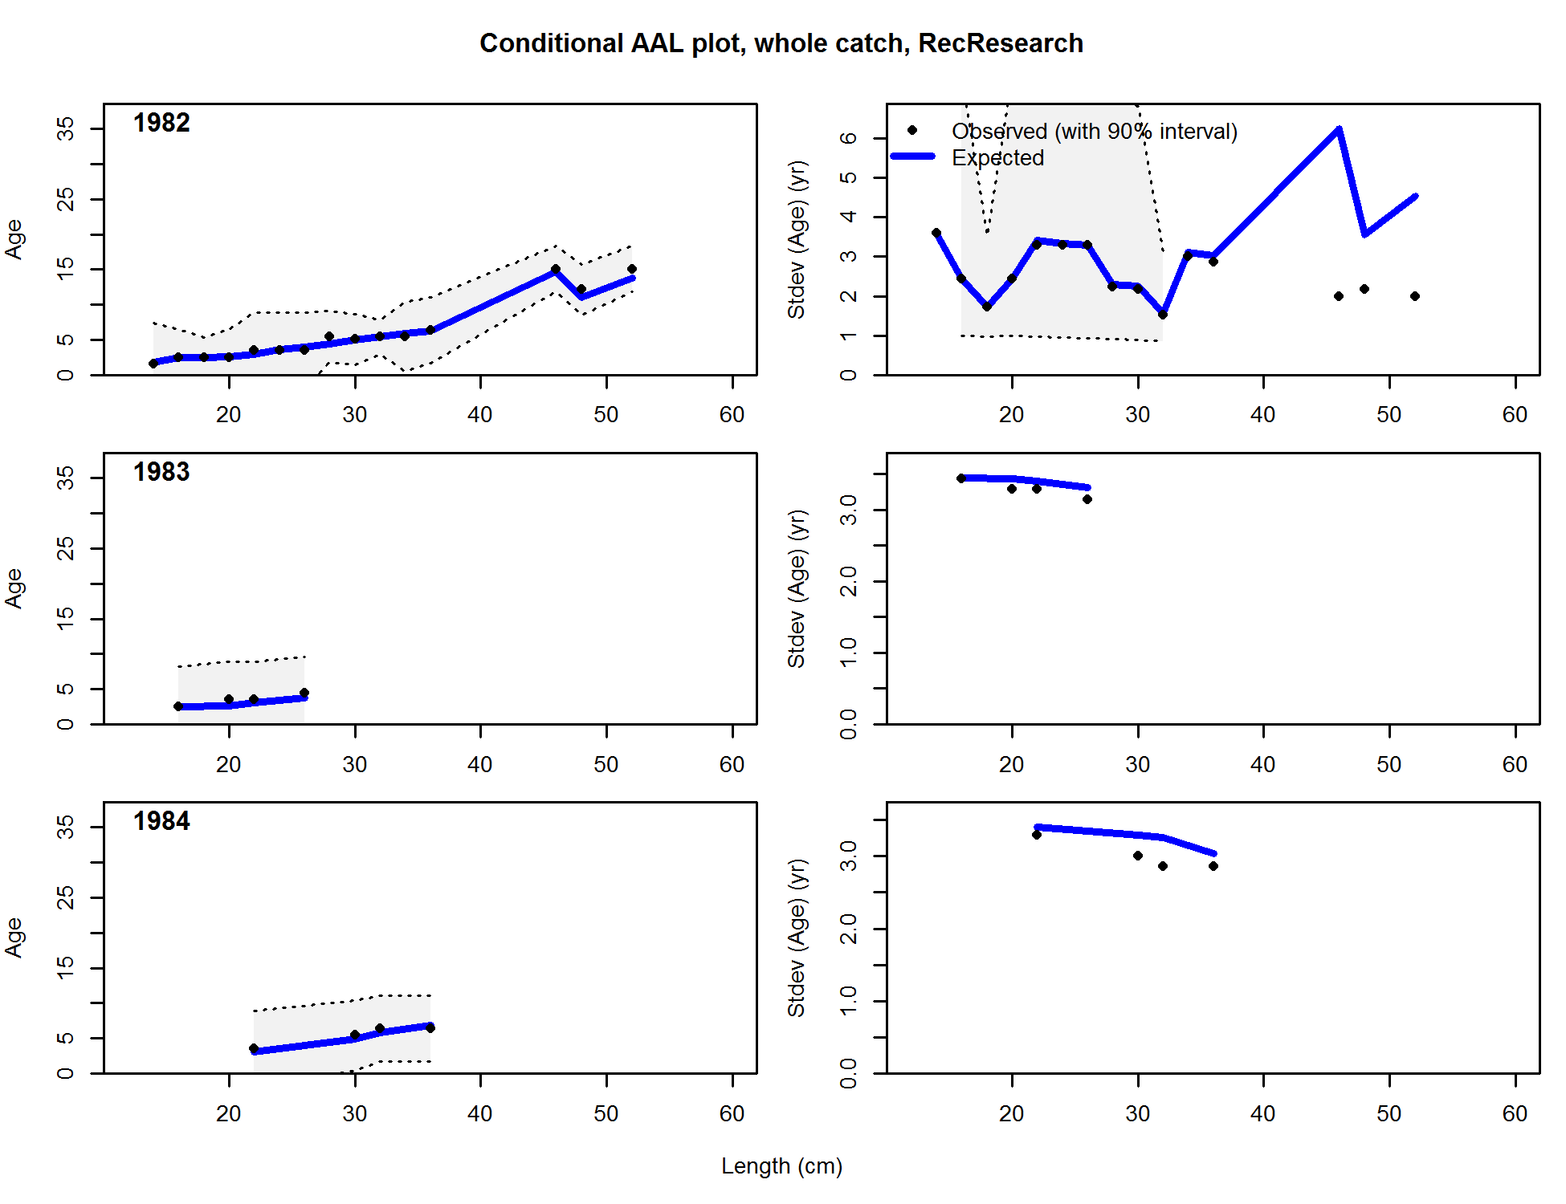

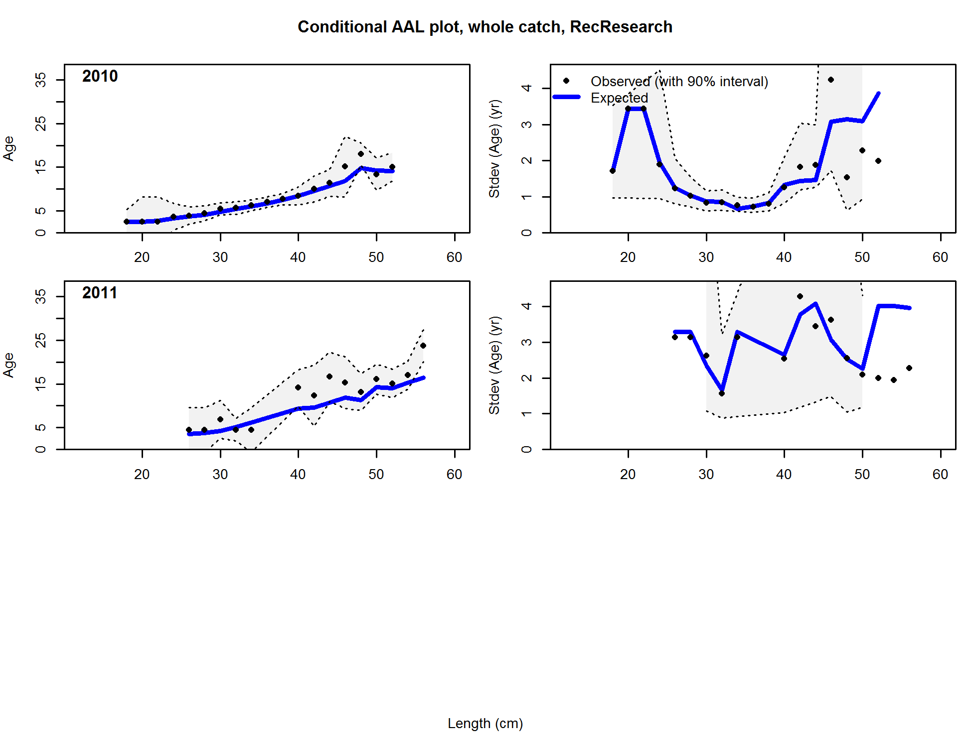

Figure . Conditional age-at-length samples and predictions for the California research samples. Shading indicates 95% confidence intervals.

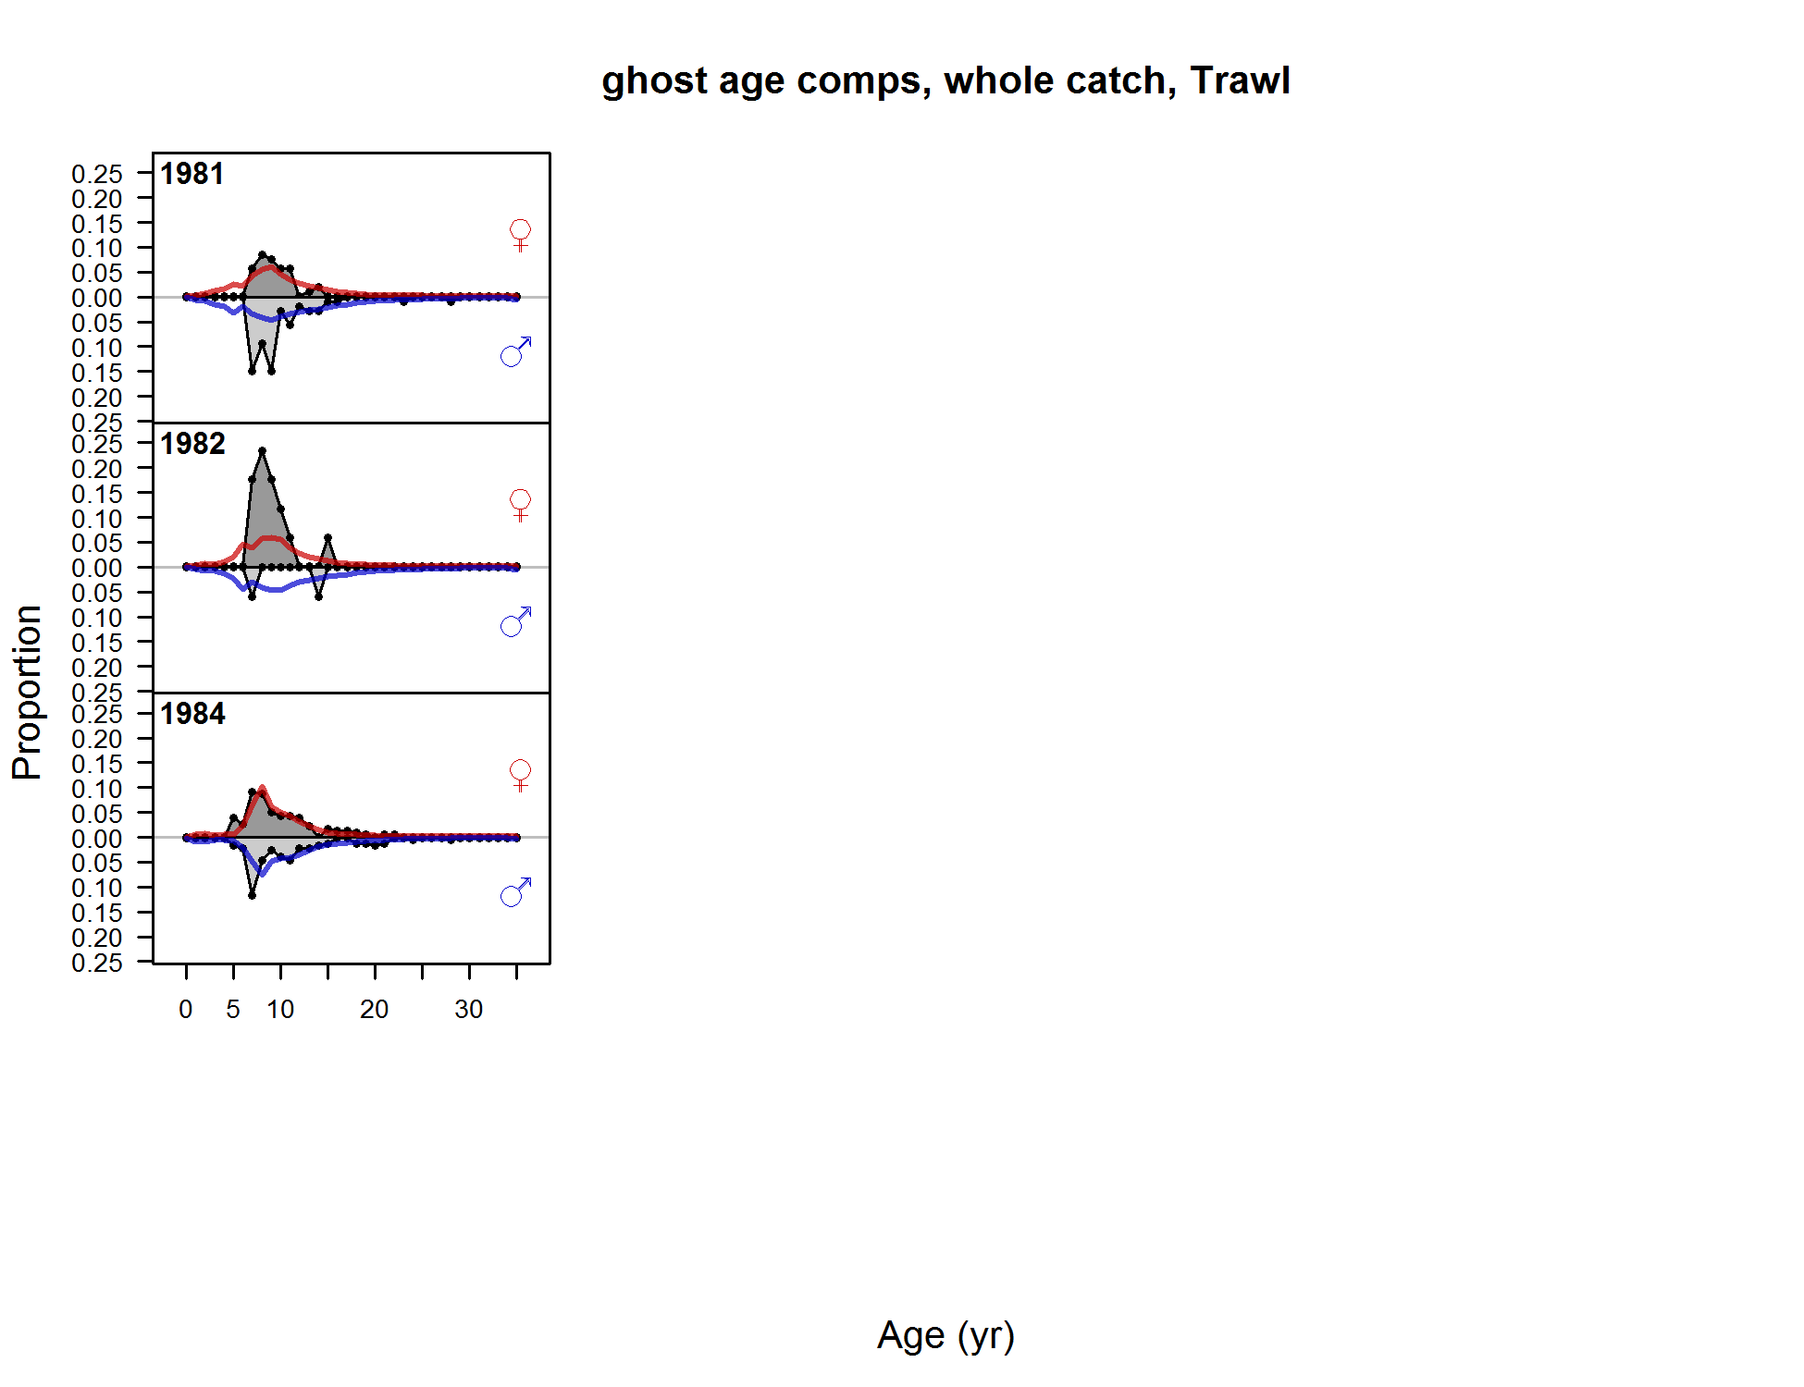



Figure . Age composition samples and predictions for the California trawl fishery.

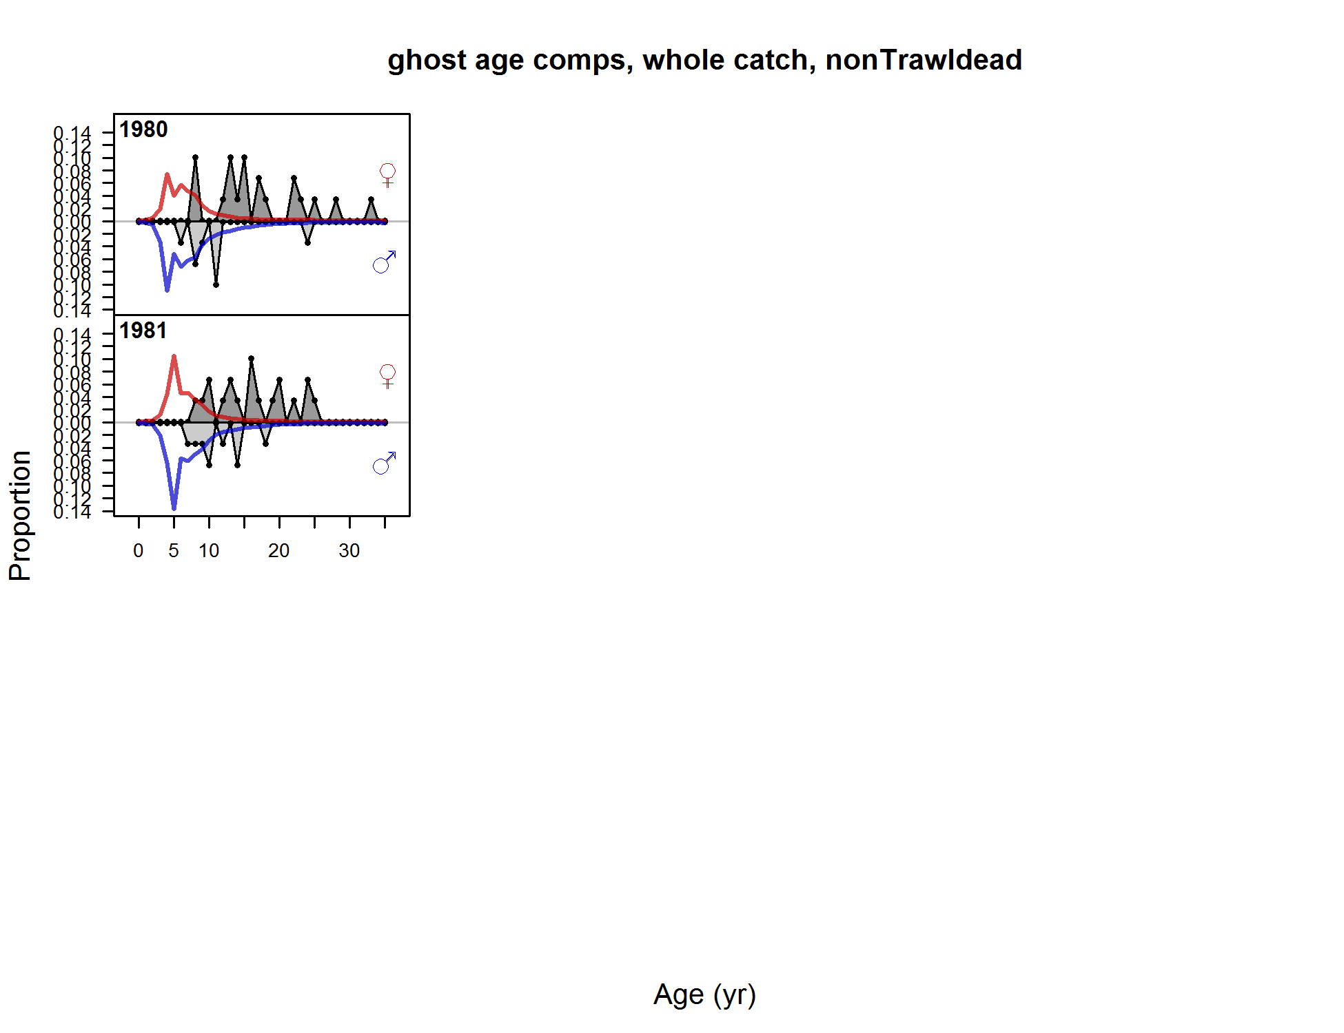



Figure . Age composition samples and predictions for the California commercial non-trawl dead fish fishery.

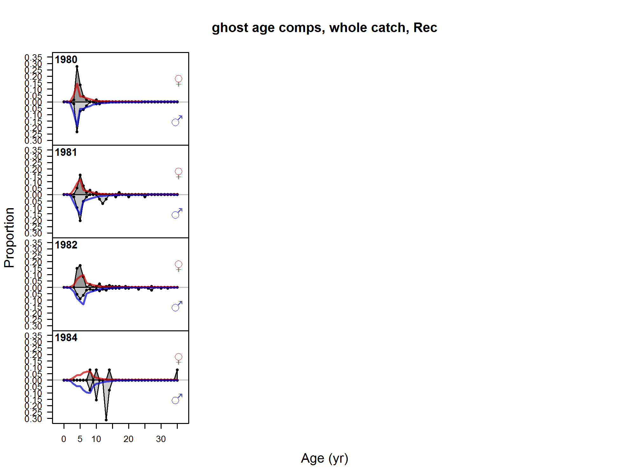

Figure . Age composition samples and predictions for the California recreational fishery.

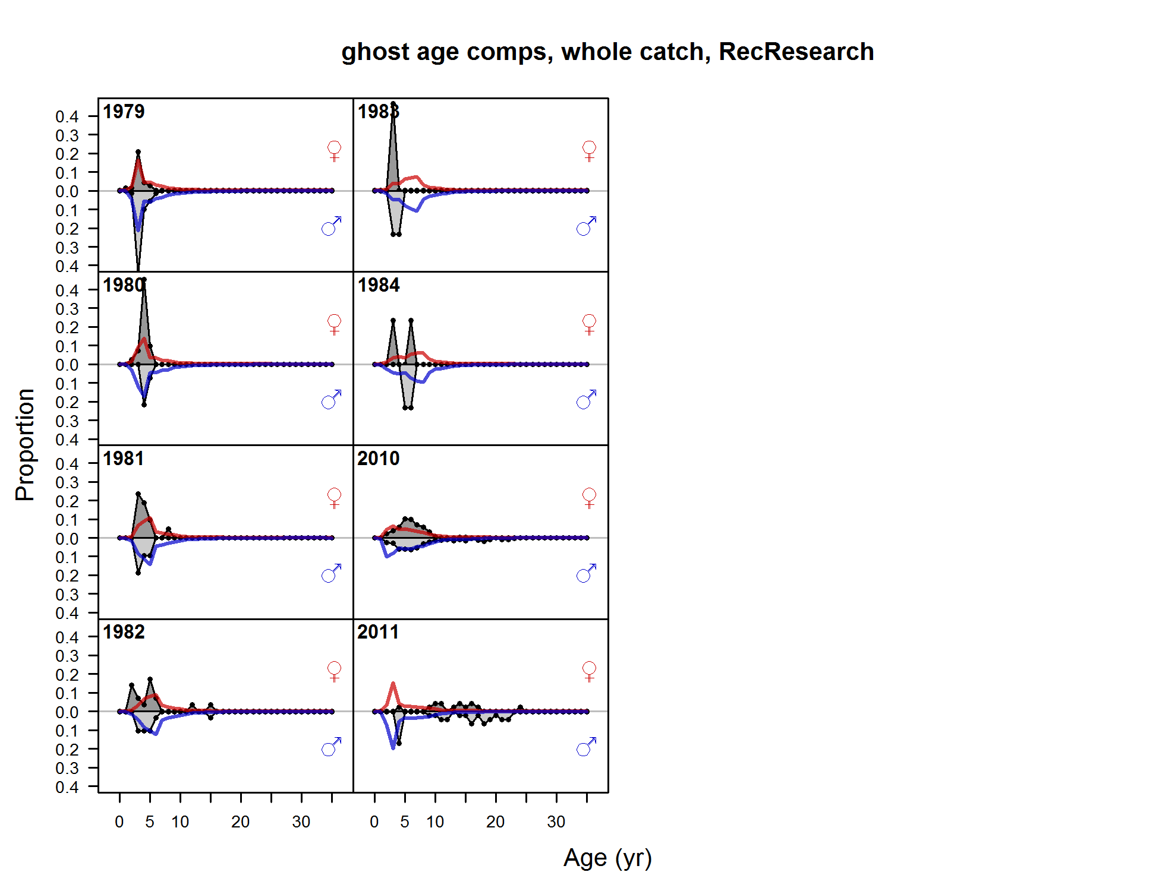

Figure . Age composition samples and predictions for the California research samples.

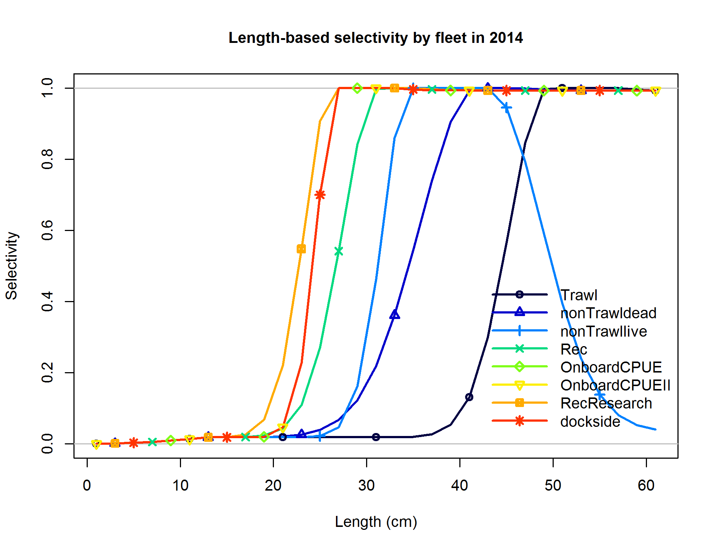

Figure . California base case estimates of length-based selectivity by fleet and survey.

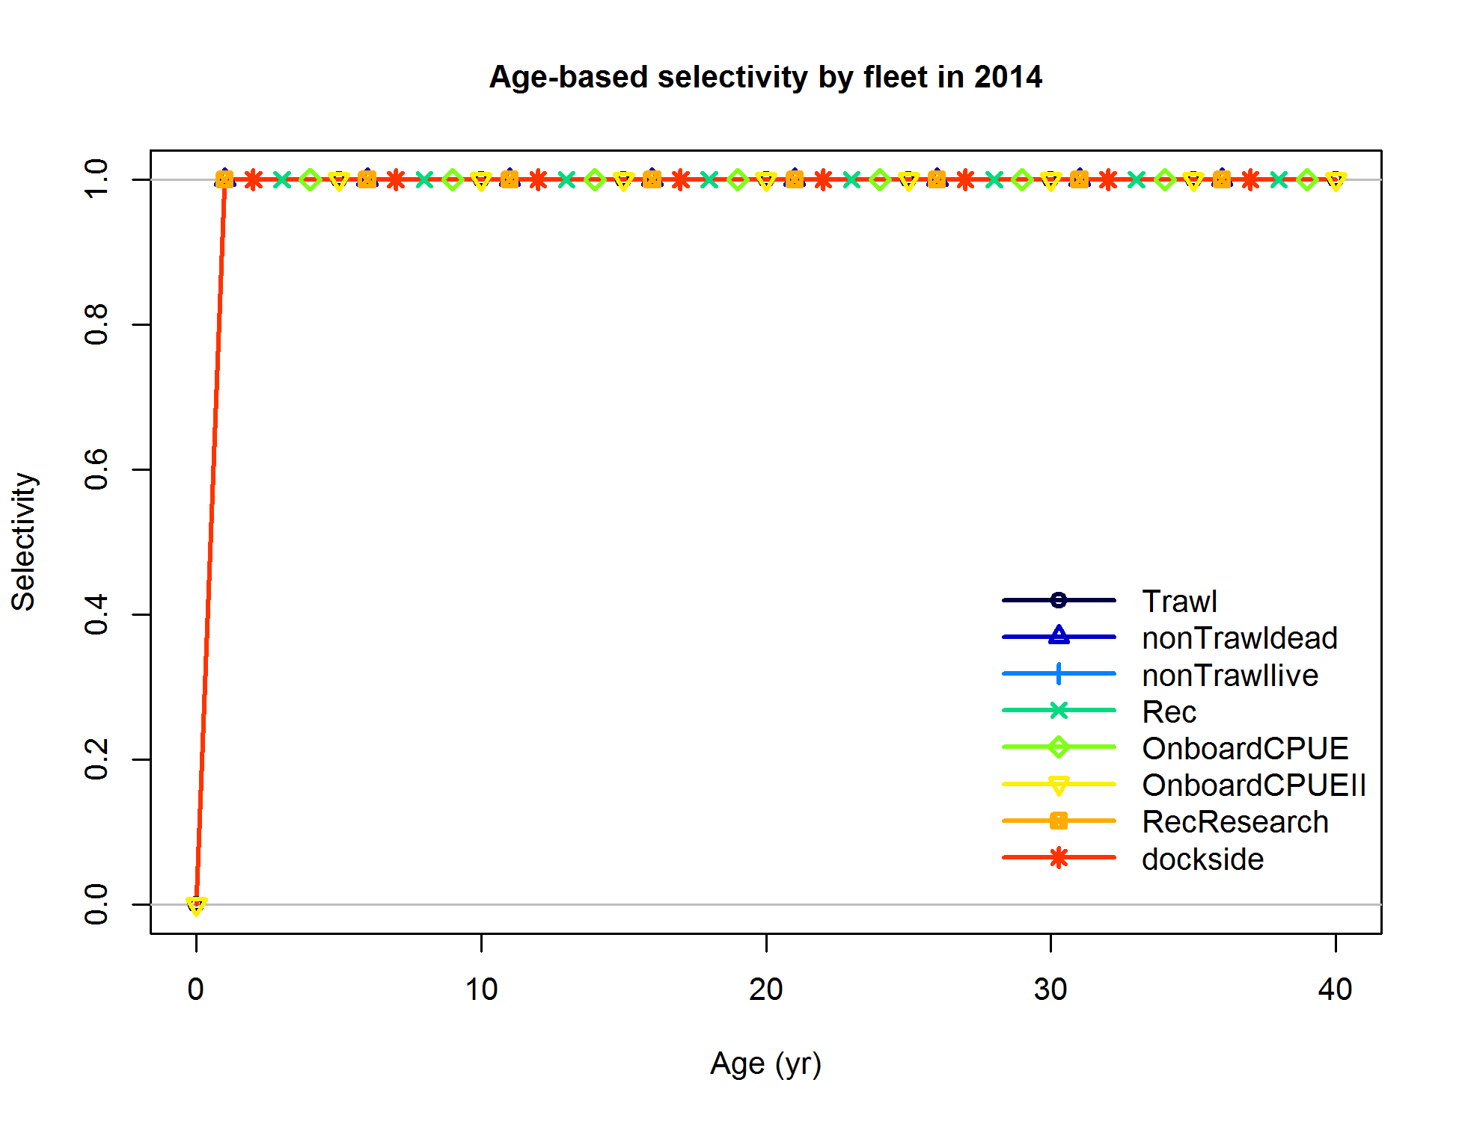

Figure . California base case estimates of age-based selectivity by fleet and survey.

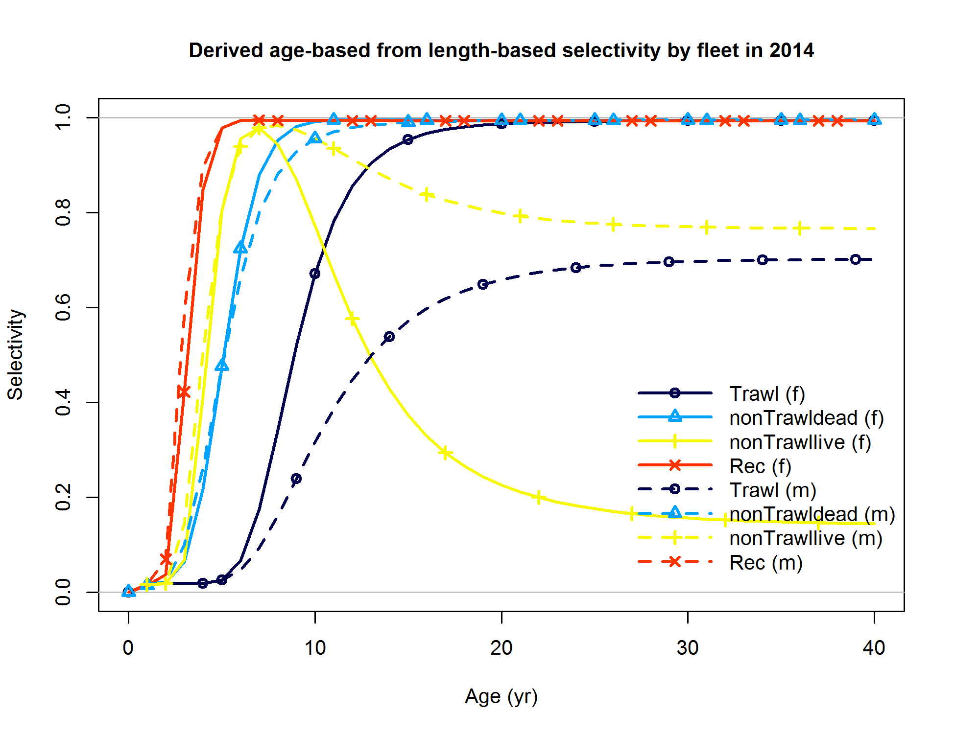

Figure . California base case estimated realized selectivity curves for each gear by sex.

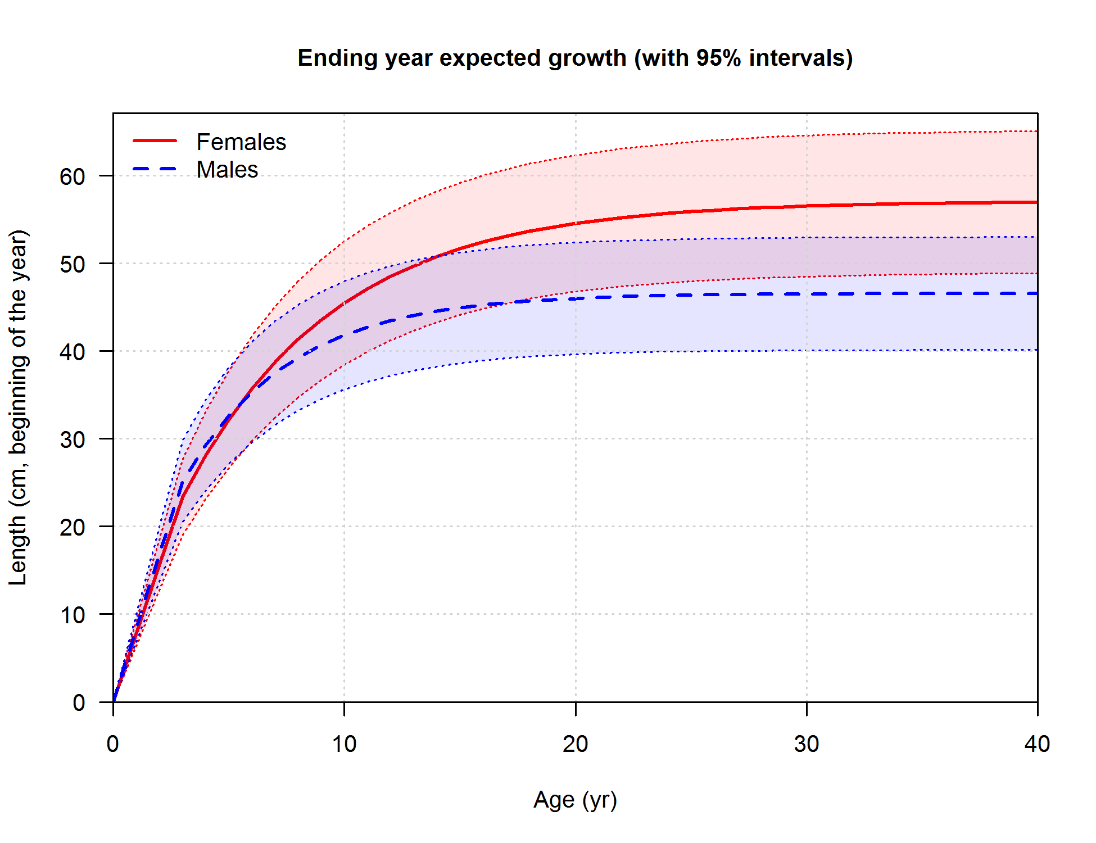

Figure . California base case estimates of sex-specific growth. Only male growth was estimated. Shading indicates 95% confidence intervals.



Figure . California base model estimate of spawning output with 95% confidence intervals.



Figure . California base model estimate of stock status (i.e., spawning depletion) with 95% confidence intervals.



Figure . California base model estimate of age-0 recruits with 95% confidence intervals. Vertical lines indicate 95% confidence intervals.

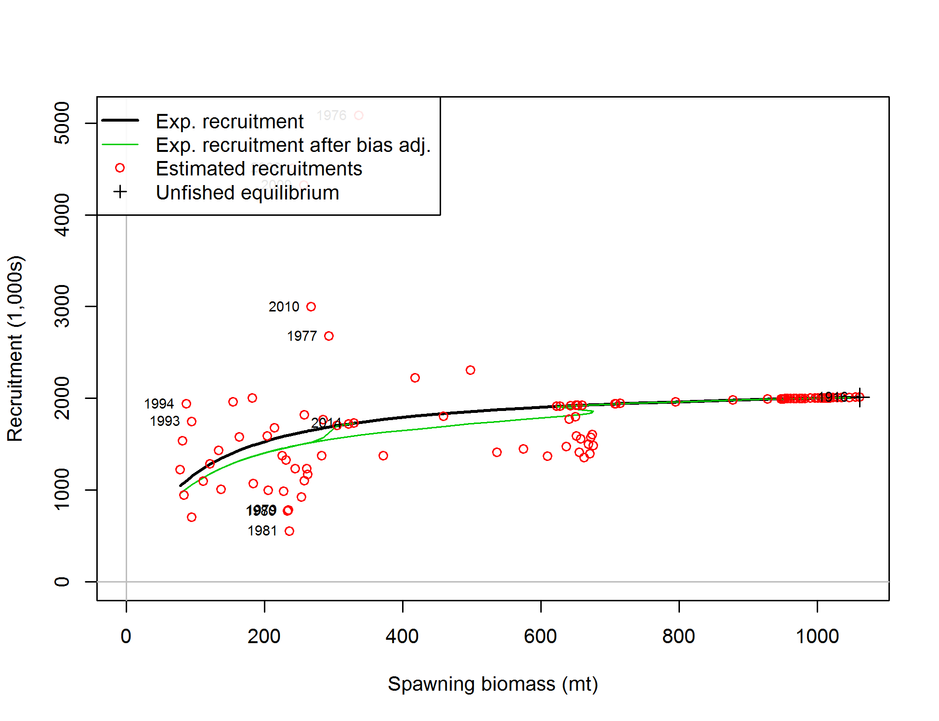

Figure . Stock-recruitment relationship from the California base model.

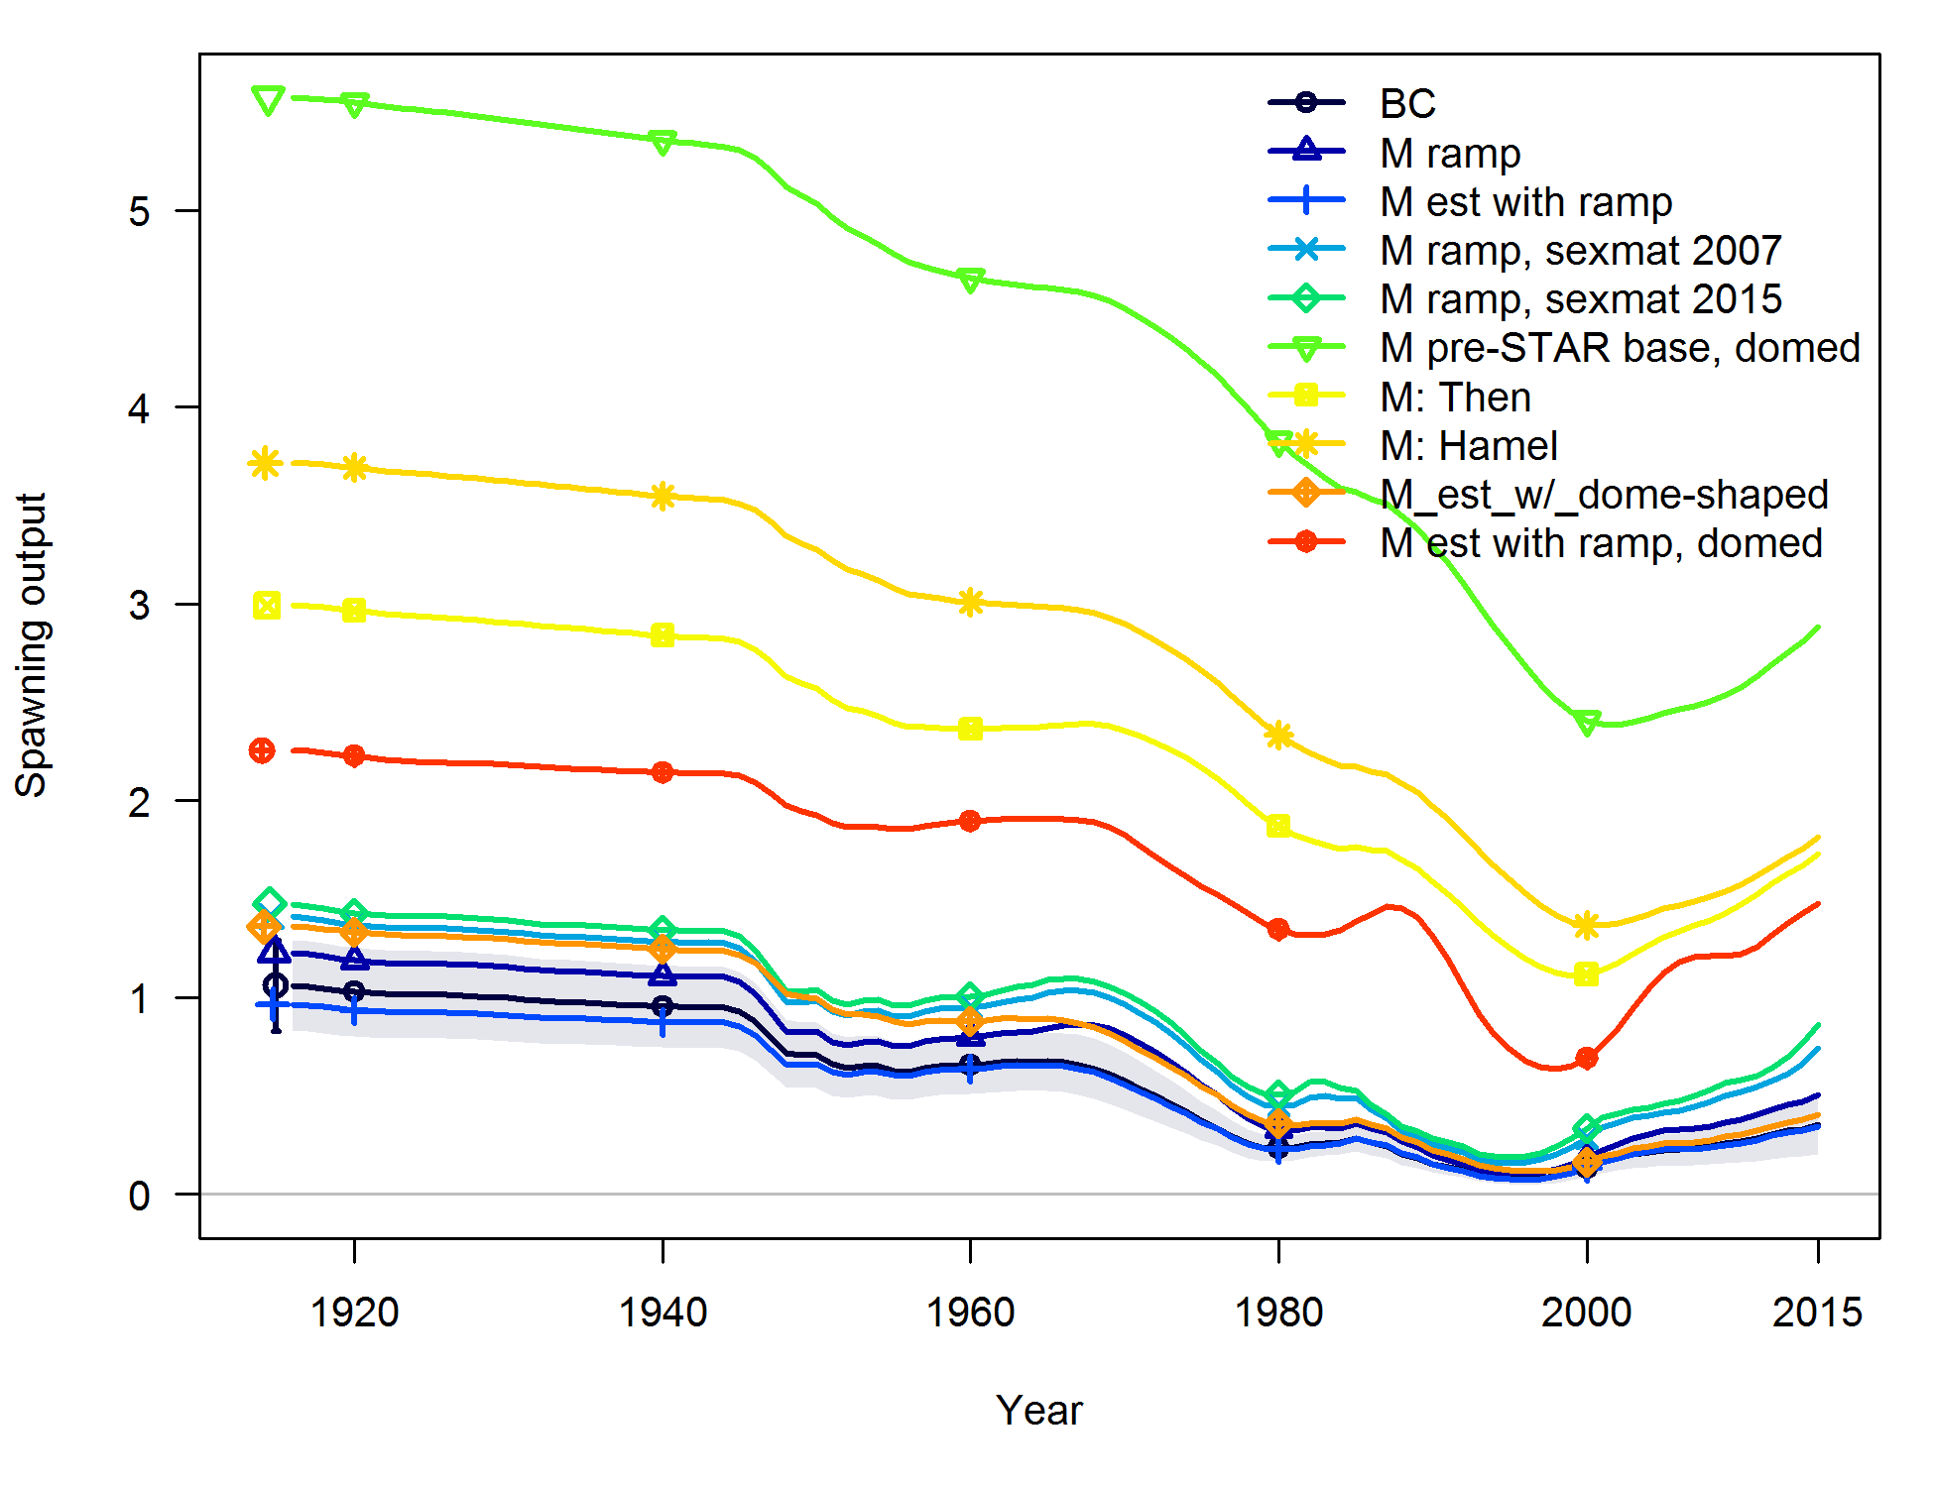

Figure . Comparison of stock output and sensitivity runs that alter natural mortality specification in the California base model. Shading indicates 95% confidence intervals.

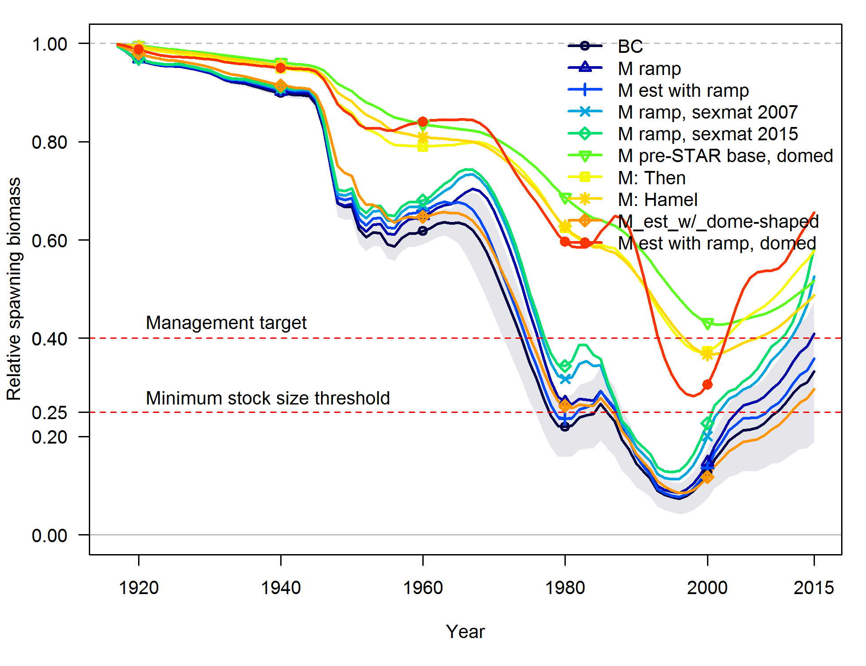

Figure . Comparison of relative stock output and sensitivity runs that alter natural mortality specification in the California base model. Shading indicates 95% confidence intervals.

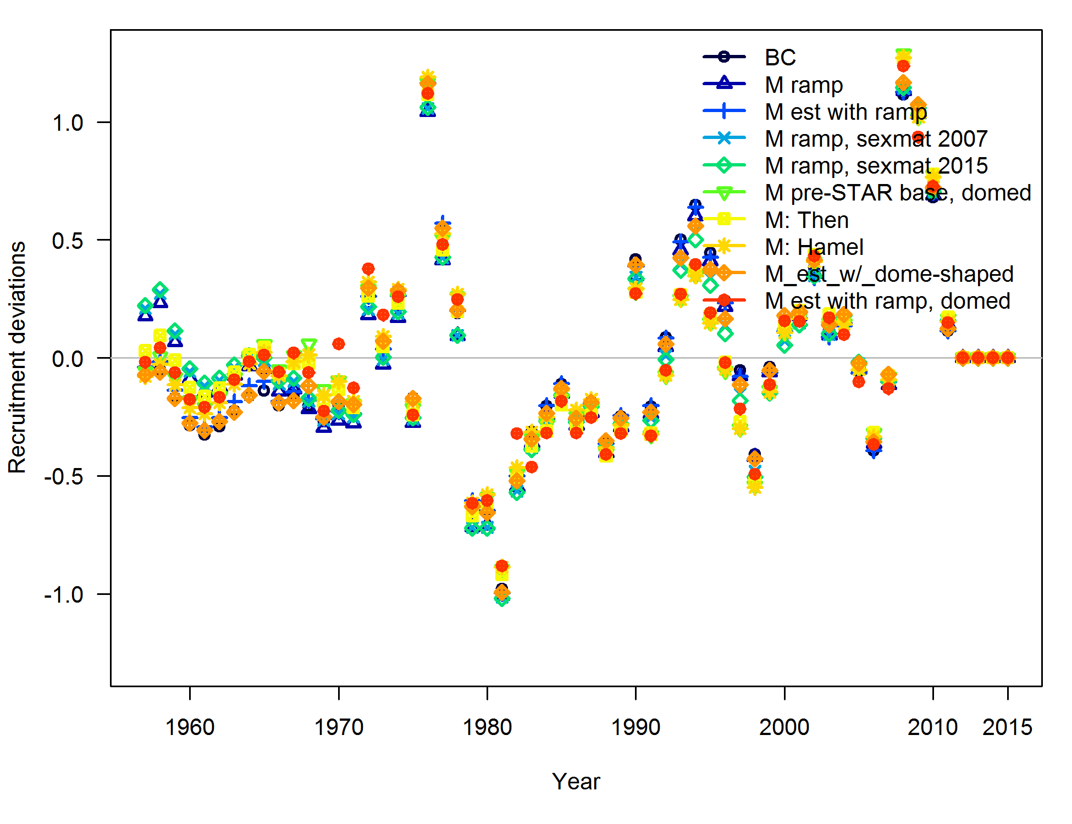

Figure . Comparison of recruitment deviations and sensitivity runs that alter natural mortality specification in the California base model.

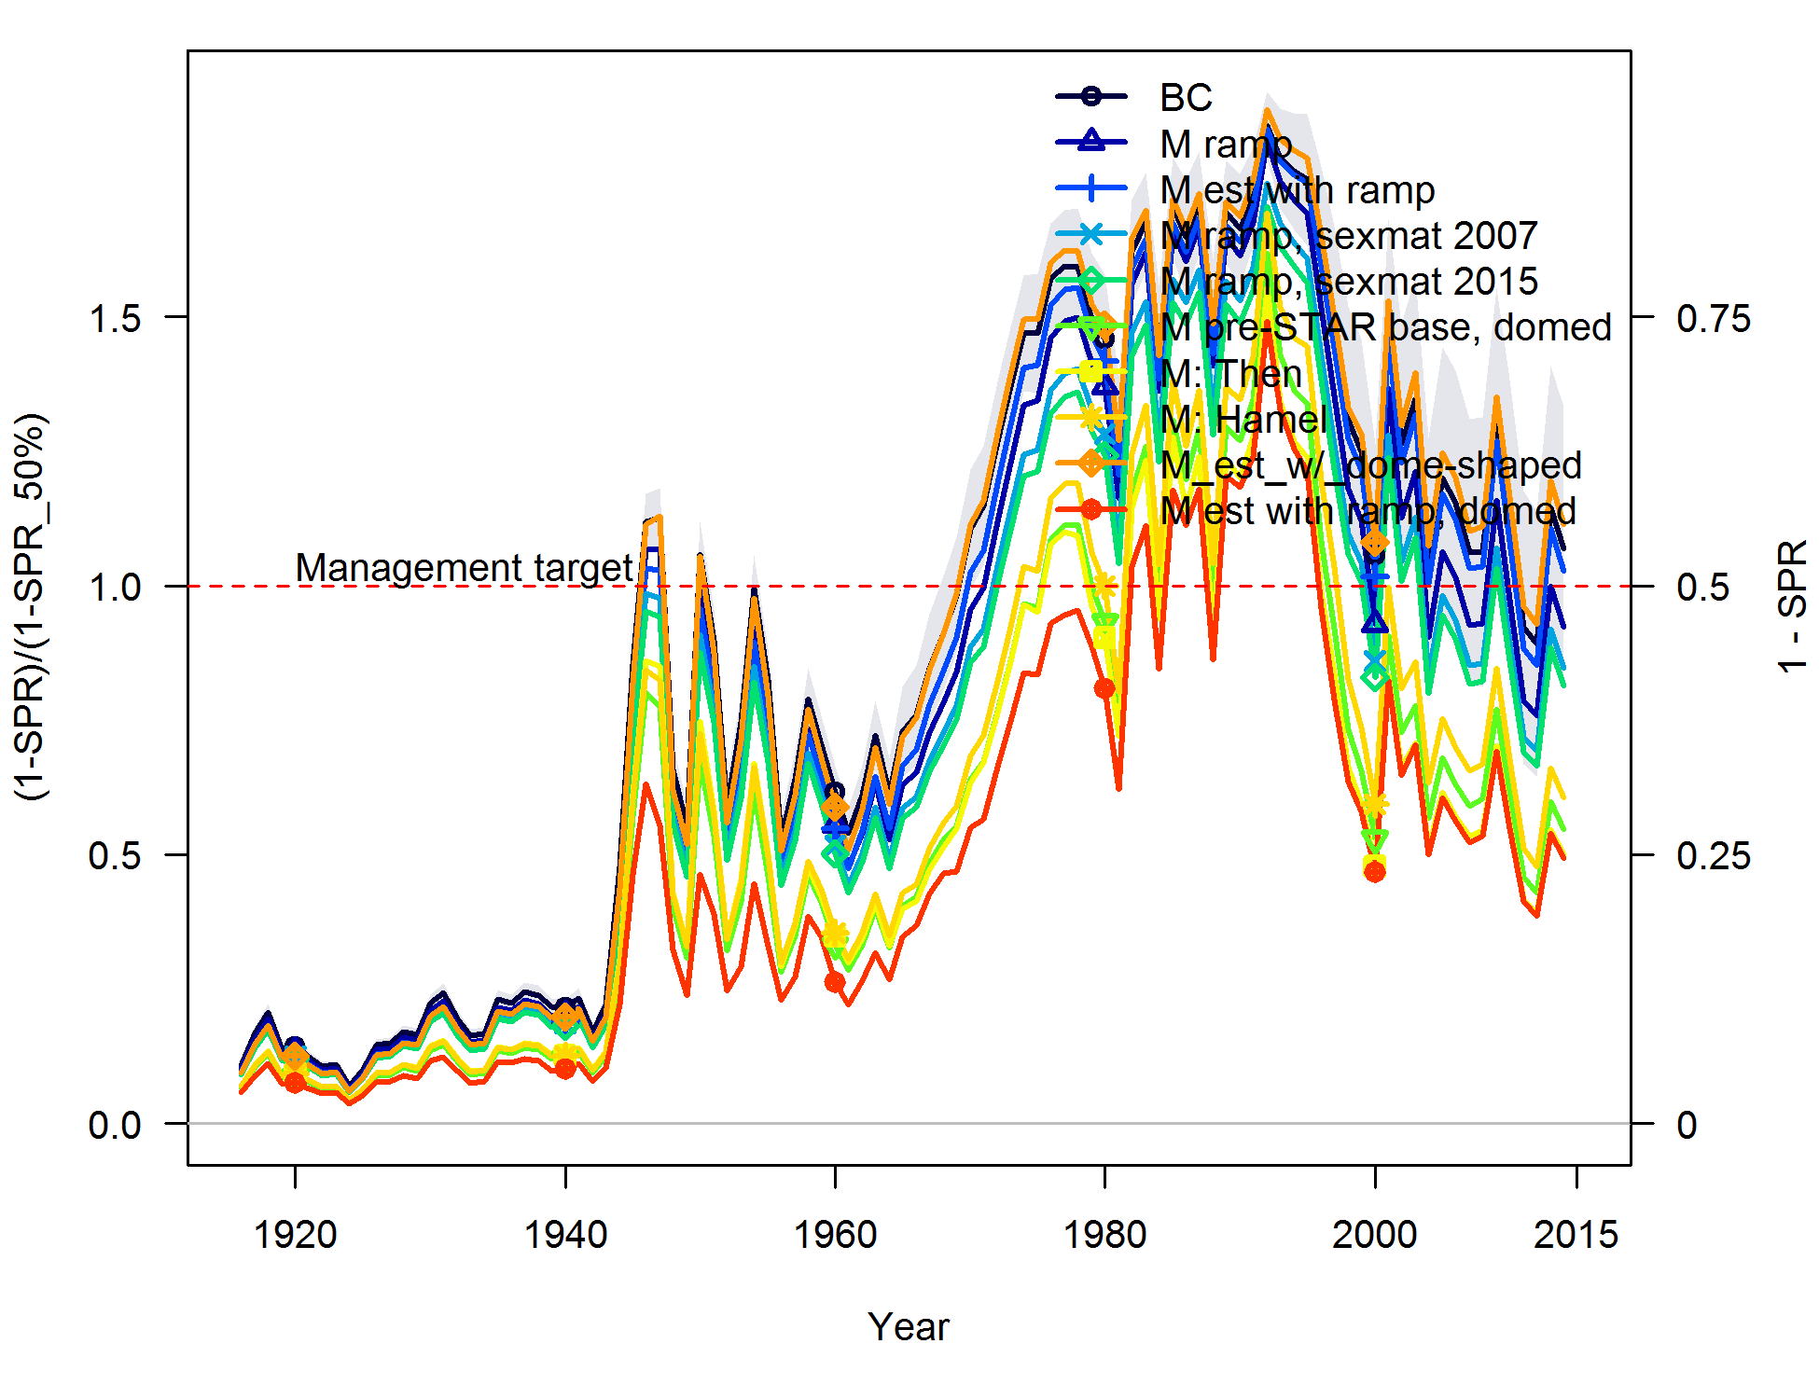

Figure . Comparison of fishing intensity and sensitivity runs that alter natural mortality specification in the California base model. Shading indicates 95% confidence intervals.

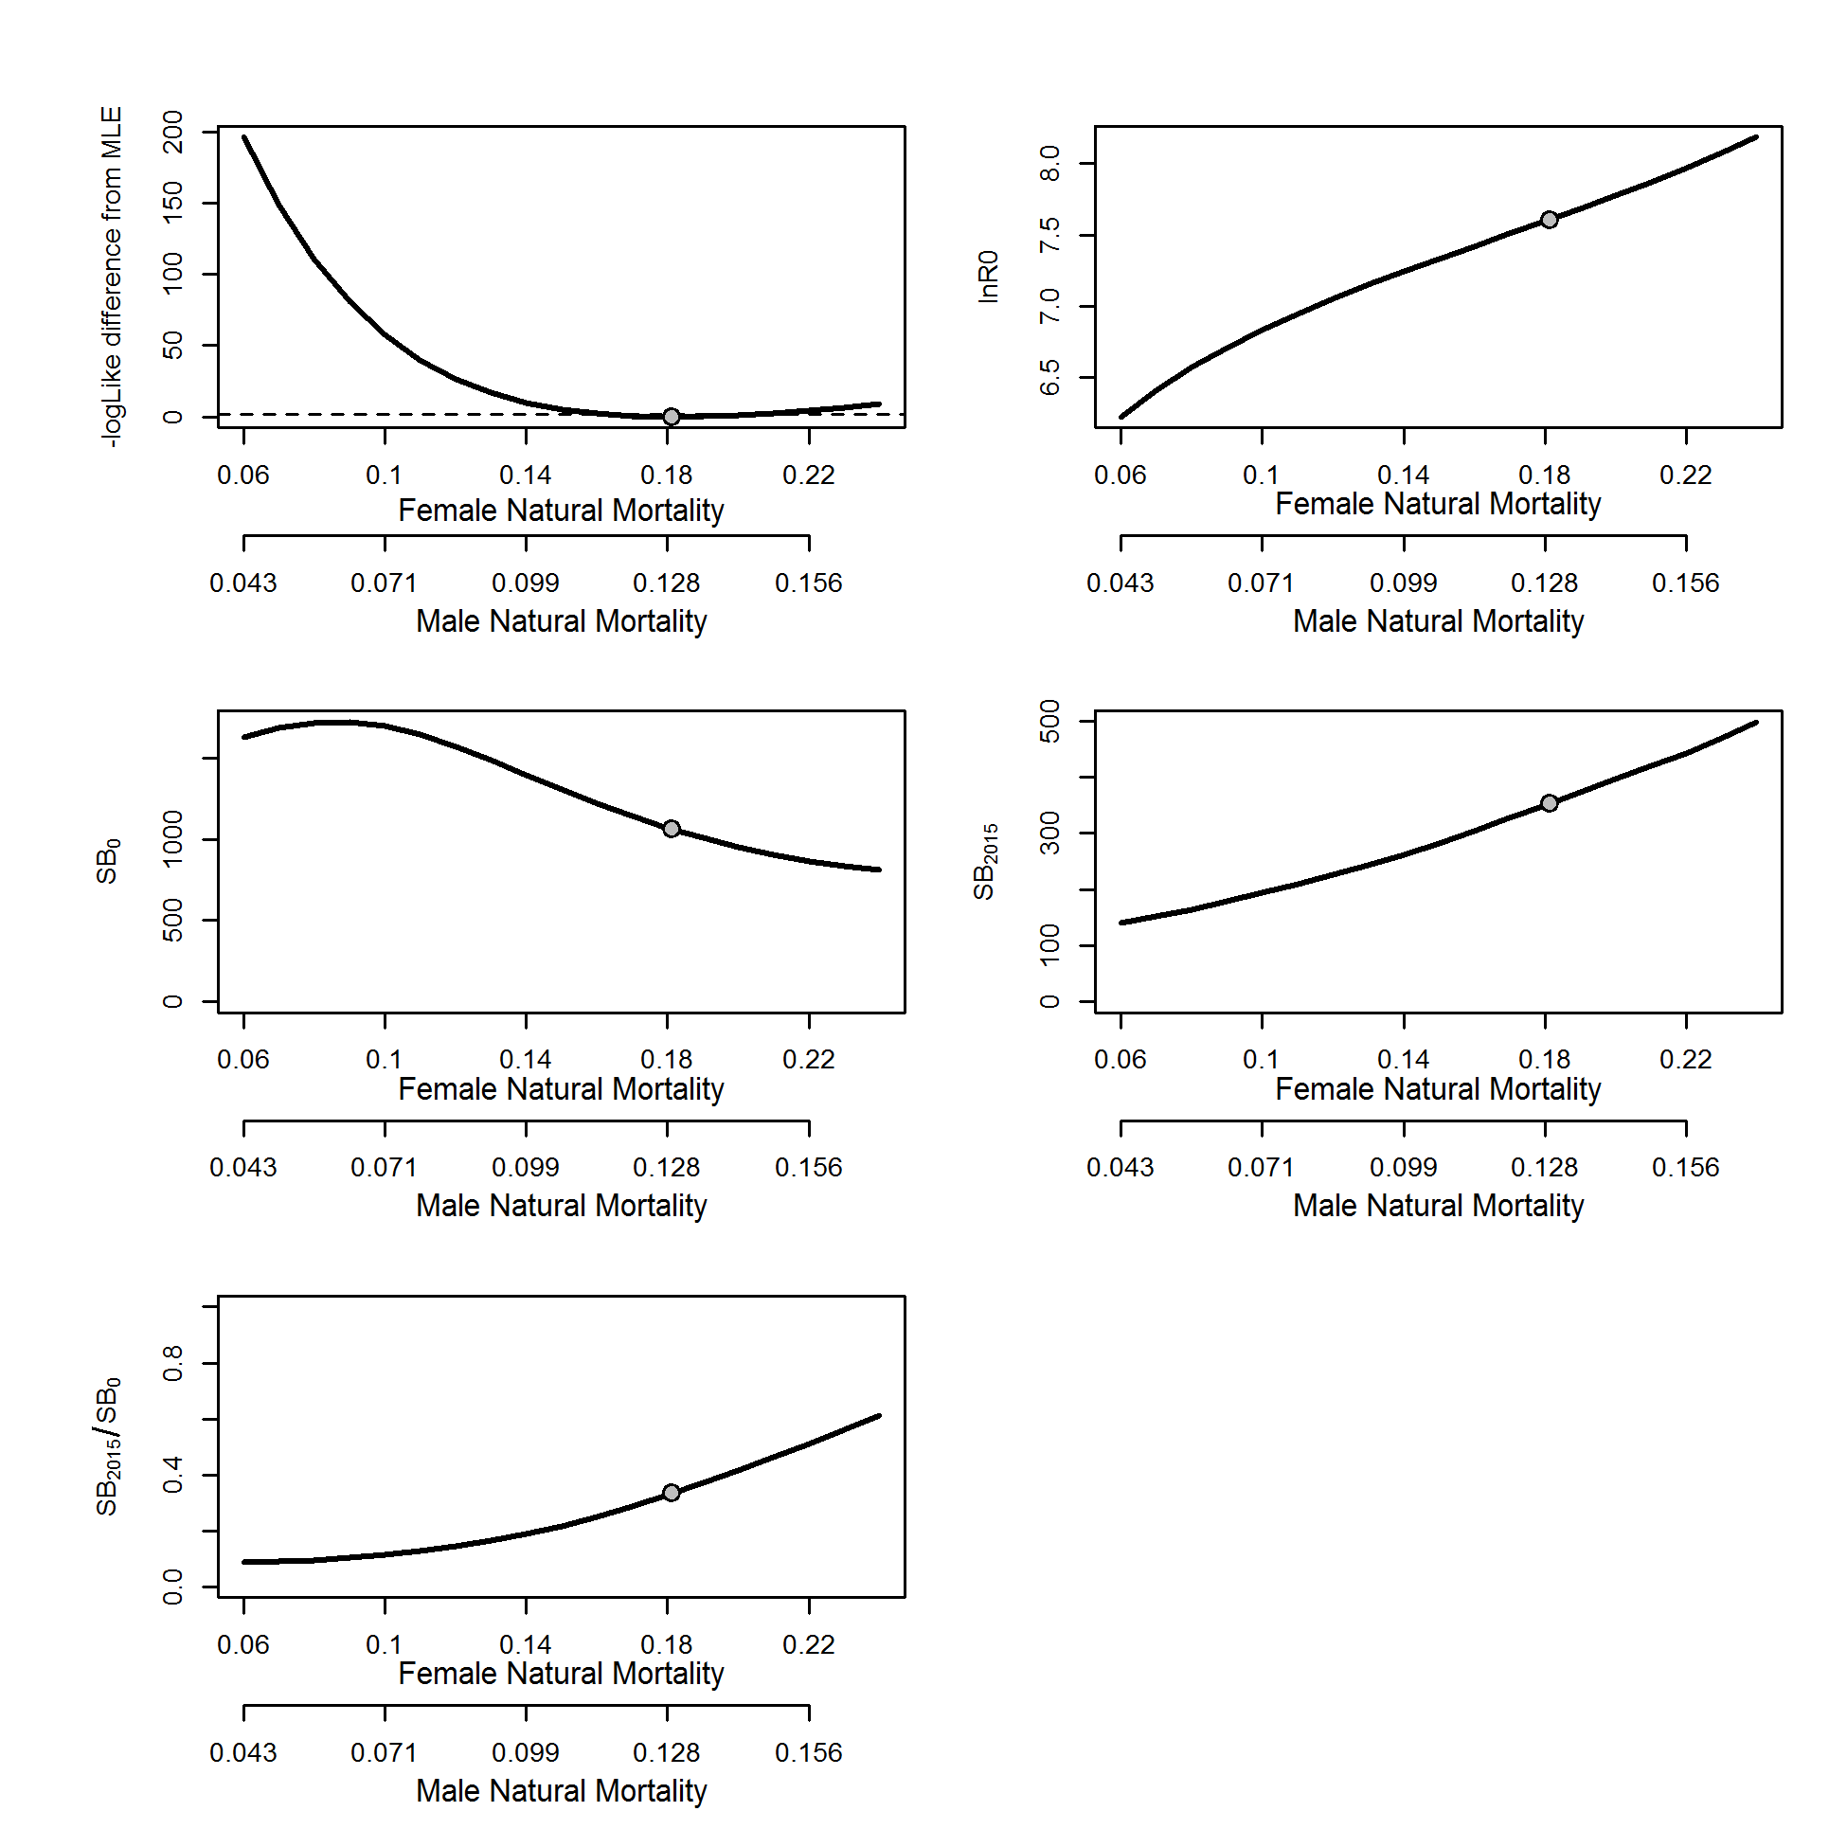

Figure . Likelihood profile in the California model for female and male natural mortality and resultant estimated (lnR0) and derived quantities (initial spawning output (SB0); spawning output in 2015 (SB2015) and stock status (SB2015/SB0)).

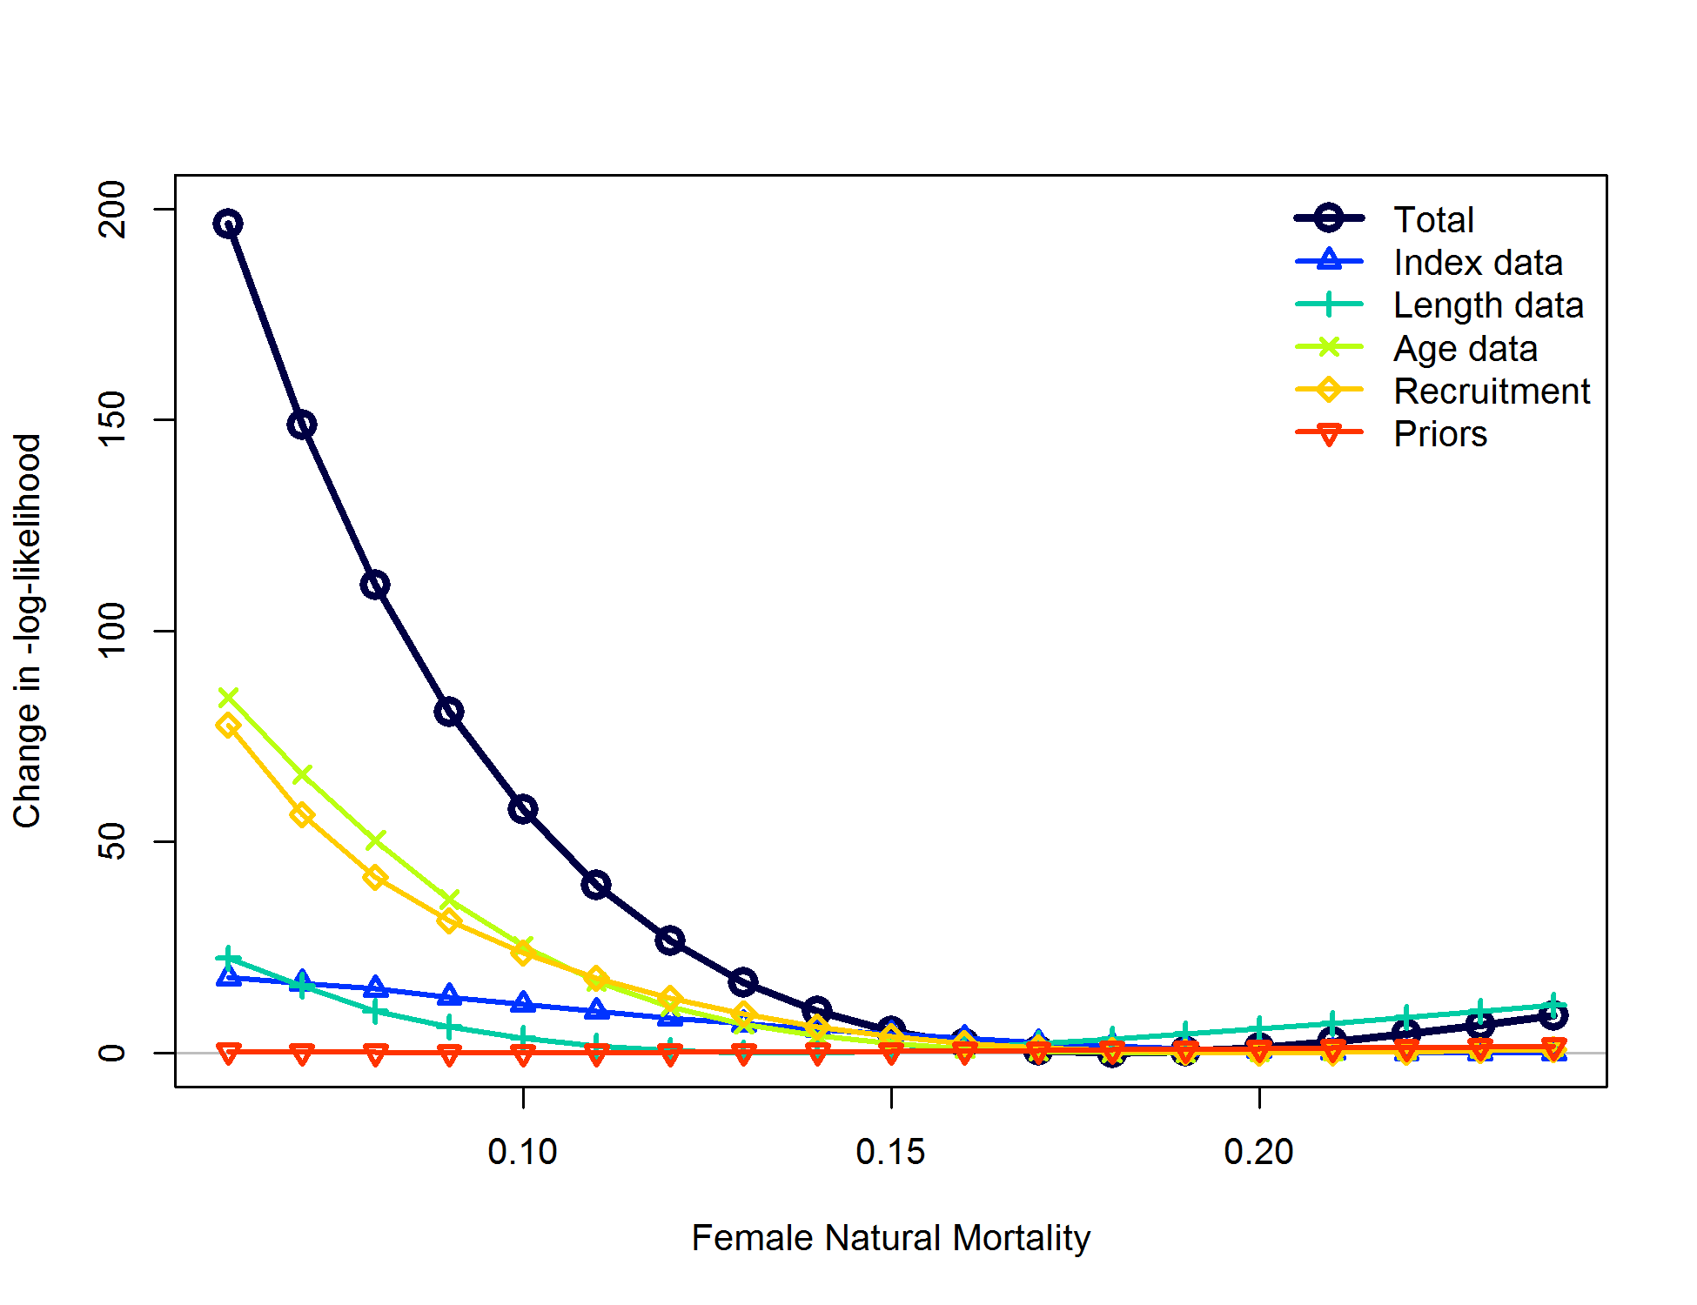

Figure . Likelihood component contributions across profiled values of natural mortality in the California model.

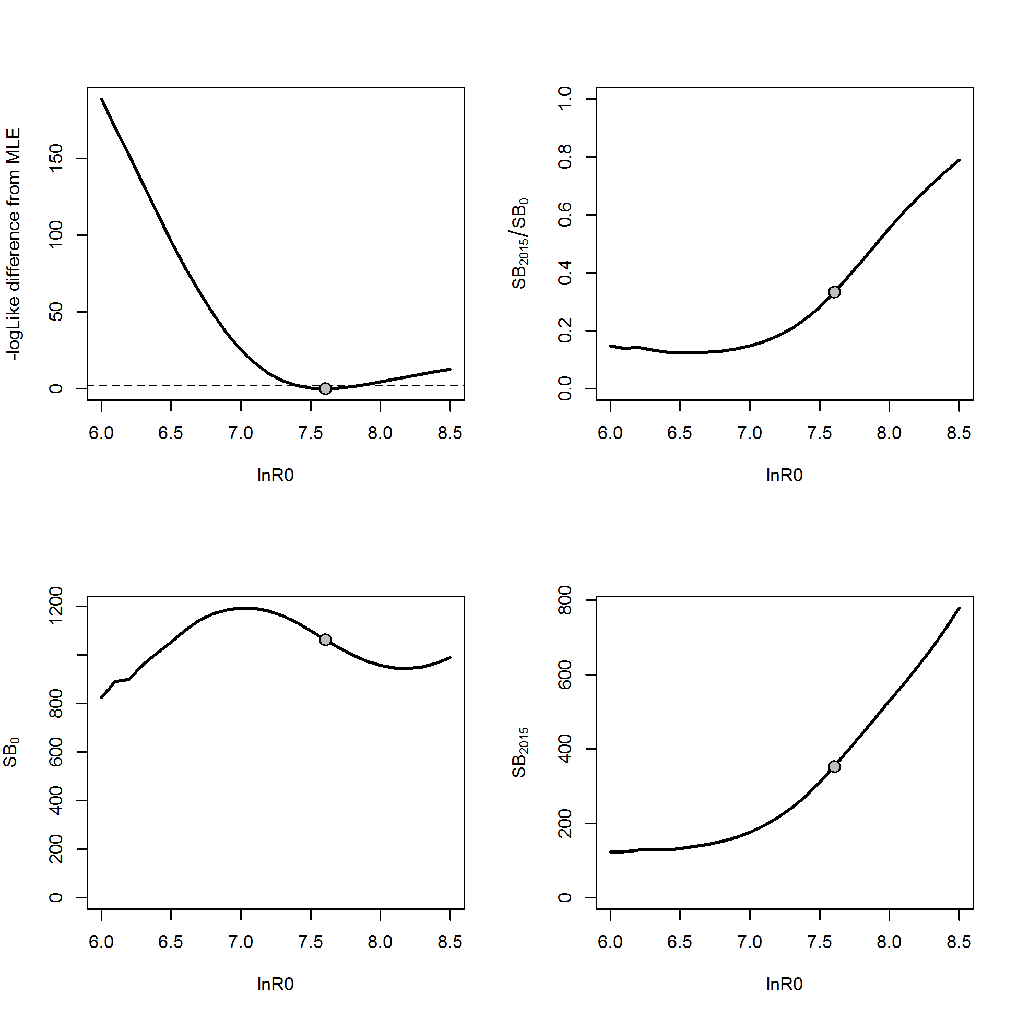

Figure . Likelihood profile in the California model for initial equilibrium recruitment (lnR0) and resultant derived quantities (initial spawning output (SB0); spawning output in 2015 (SB2015) and stock status (SB2015/SB0)).

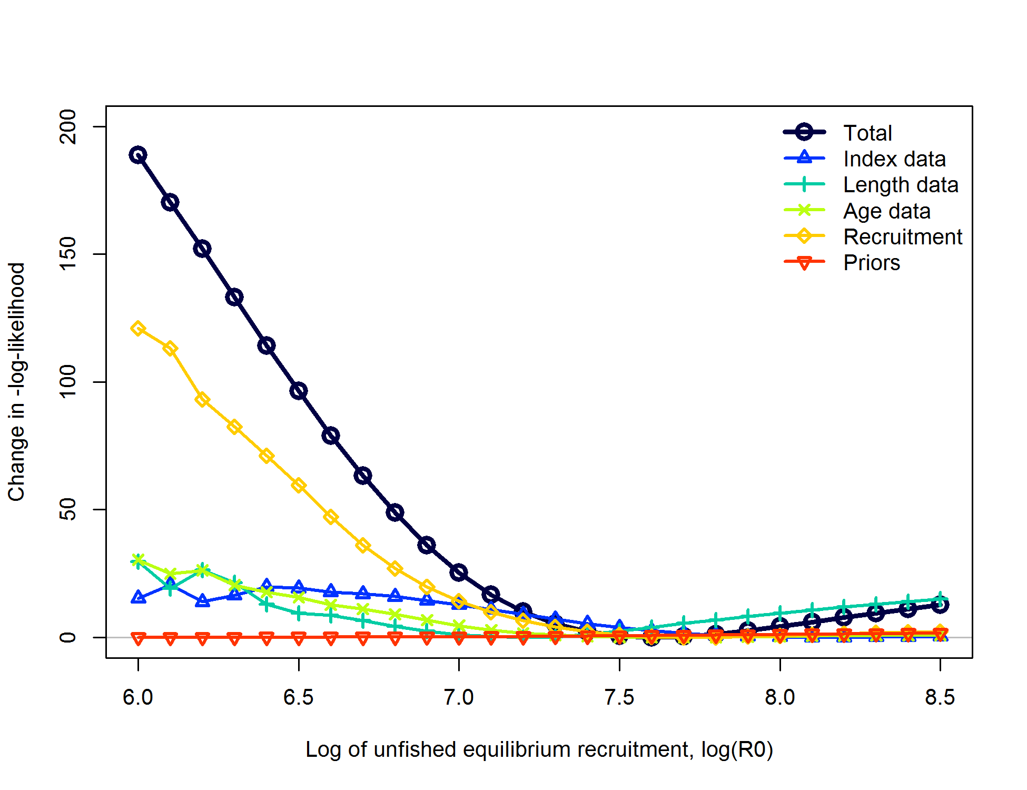

Figure . Likelihood component contributions across profiled values of initial recruitment in the California model.

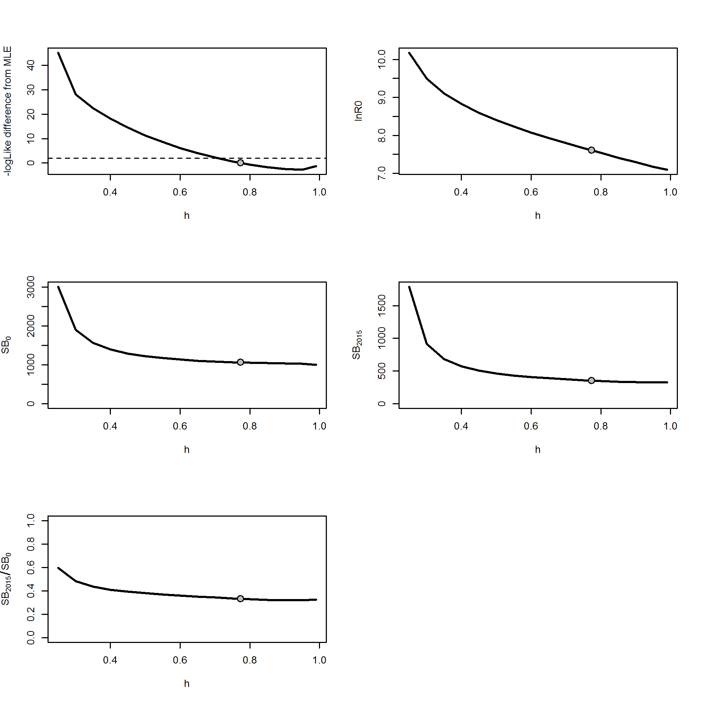

Figure . Likelihood profile in the California model for steepness (*h*) and resultant parameters and derived quantities (initial recruitment (ln*R0*); initial spawning output (SB0); spawning output in 2015 (SB2015) and stock status (SB2015/SB0)).

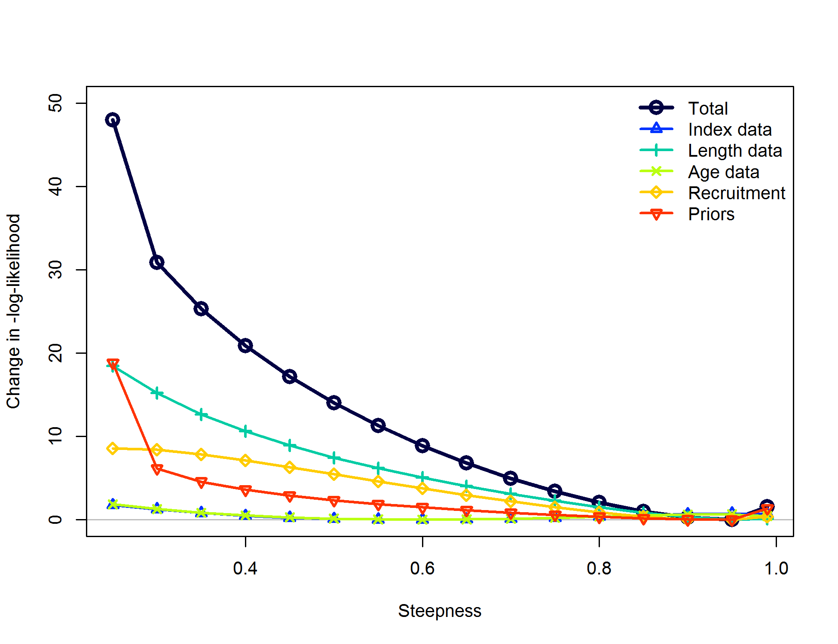

Figure . Likelihood component contributions across profiled values of steepness in the California model.

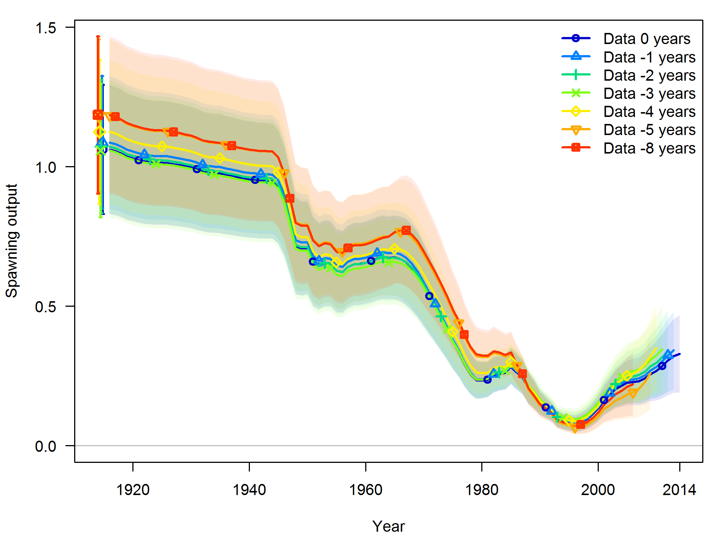

Figure . Retrospective model runs from the base case model of California (“Data 0 years”) for stock spawning output. Shading indicates 95% confidence intervals.

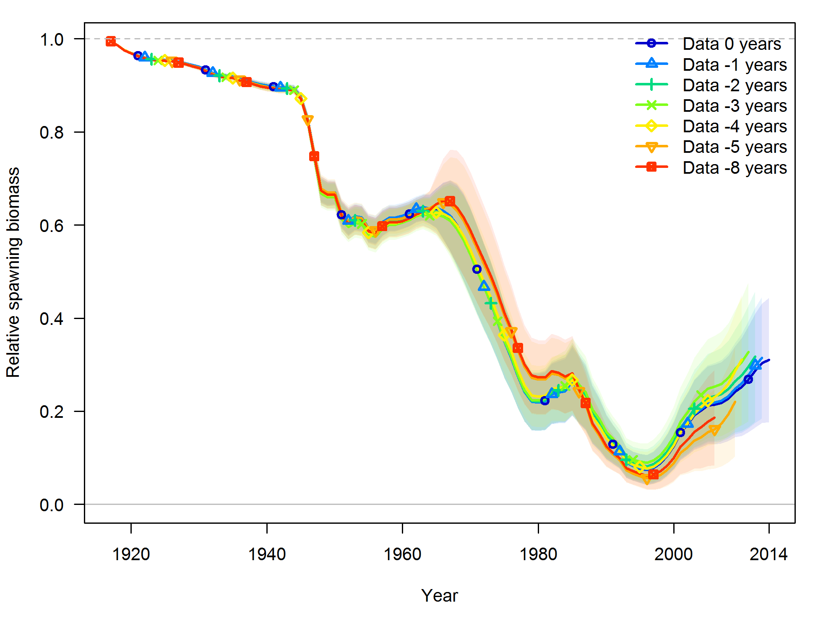

Figure . Retrospective model runs from the base case model of California (“Data 0 years”) for relative stock output (stock status). Shading indicates 95% confidence intervals.



Figure . Estimated spawning potential ratio (SPR) for the California base case model. One minus SPR relative to the MSY proxy SPR value is plotted so that higher exploitation rates occur on the upper portion of the y-axis. The management target is plotted as a red horizontal line and values above this reflect harvests in excess of the overfishing proxy based on the SPR50% harvest rate. The last year in the time series is 2014.



**Figure 78. Phase plot of relative spawning output vs fishing intensity for the California base case model. The relative fishing intensity is (1-SPR) divided by 50% (the SPR target). The vertical red line is the relative spawning output target defined as the annual spawning output divided by the spawning output corresponding to 40% of the unfished spawning output.**



Figure . Equilibrium yield curve for the California base case model. Values are based on 2014 fishery selectivity and distribution with steepness fixed at 0.773. The depletion is relative to unfished spawning biomass.

## OR Data Figures

Figure . Data and data types used in the Oregon black rockfish stock assessment model.

Figure . Catch comparison by fishery for the Oregon portion of the catch in the previous (Southern Oregon) and current (Oregon) assessments.

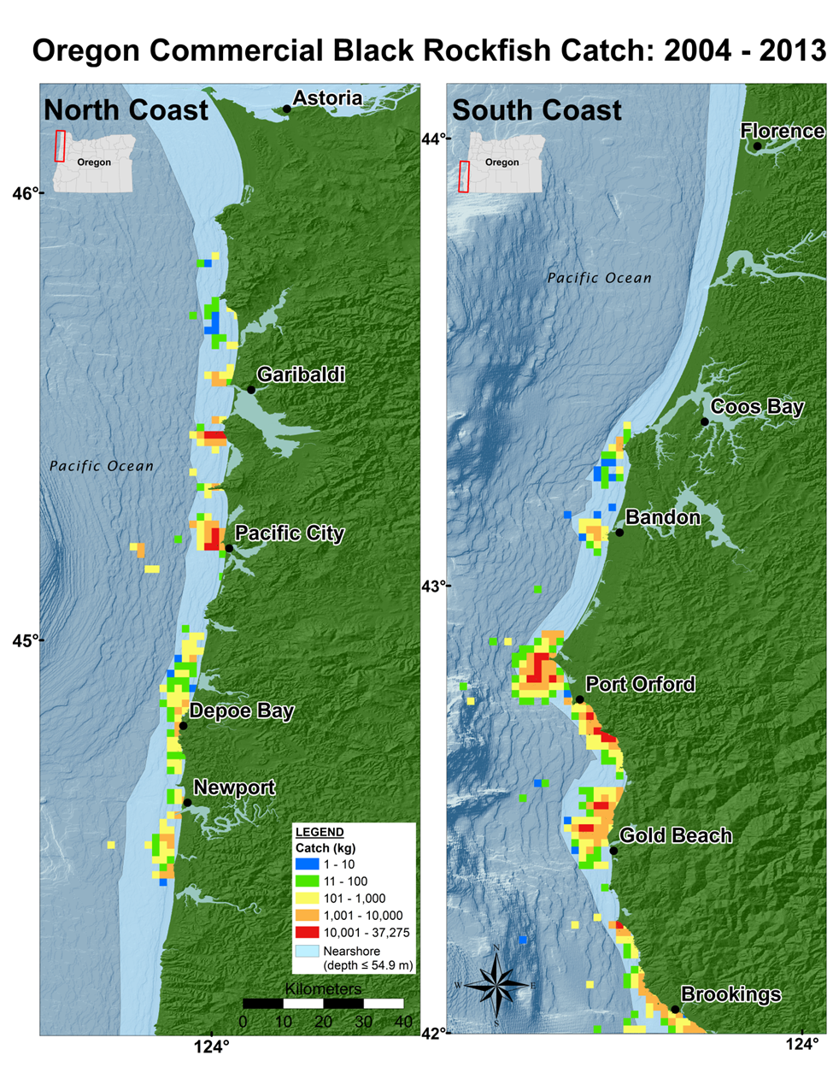

Figure : Distribution of black rockfish catch from logbook reported sets. For confidentiality, these data have been filtered to include only areas where three or more vessels have recorded catch.

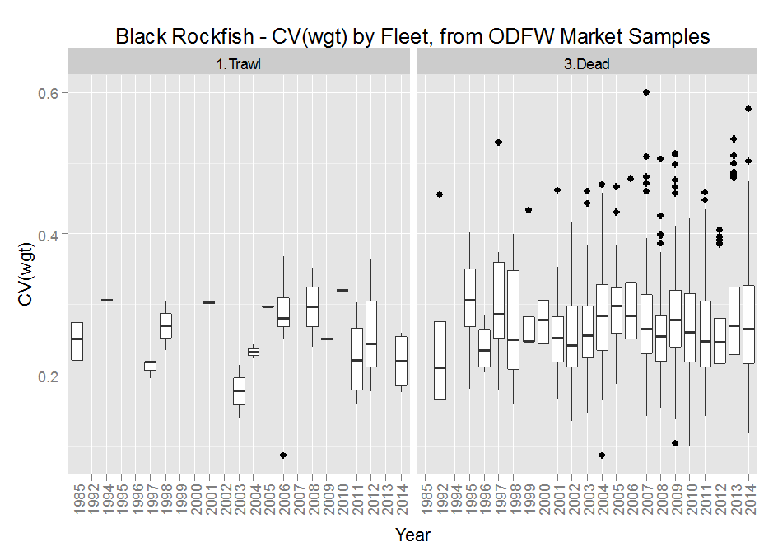

Figure . Box-plots by year and gear-type of sample-level estimates of the coefficient of variation in black rockfish weights, based on commercial fishery market samples of observed lengths that were transformed to estimated weights.

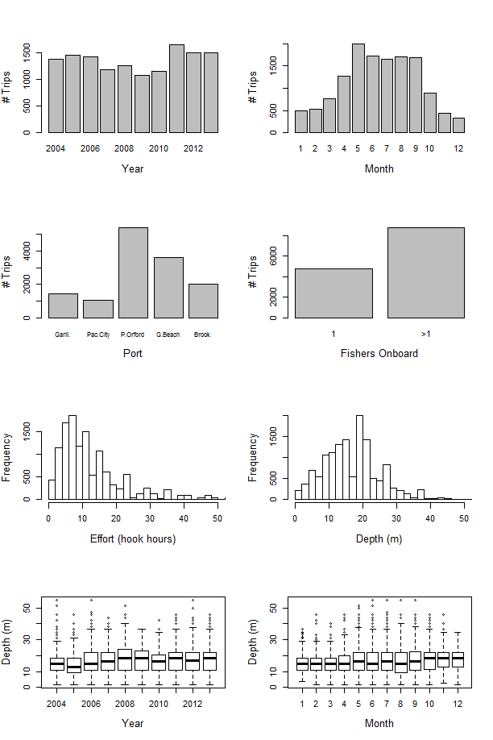

Figure . Characterization of the final subset of logbook data used in delta-GLM analyses for Oregon black rockfish

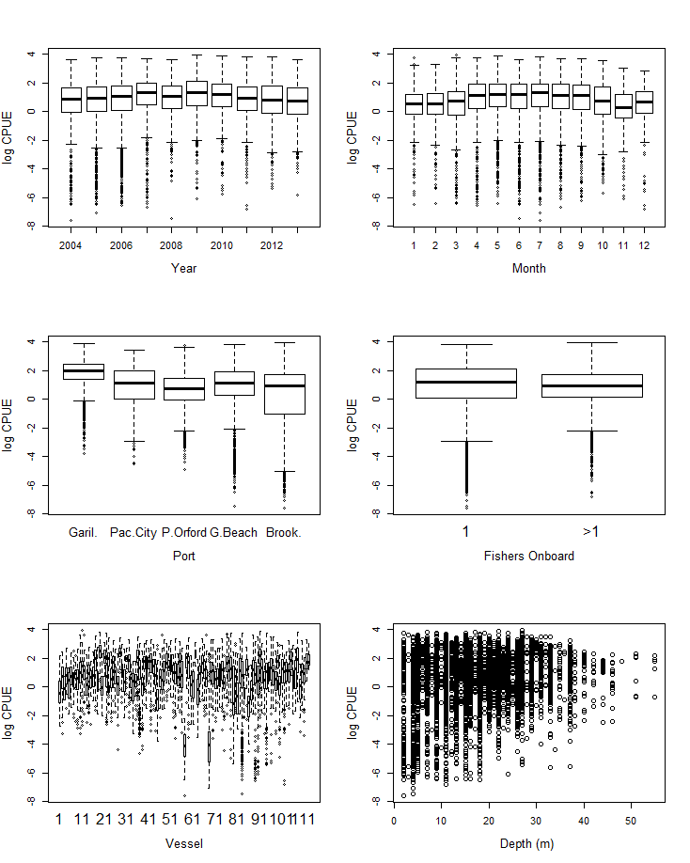

Figure . The distribution of set-level raw positive catch CPUE data relative to potential covariates evaluated in the black rockfish delta-GLM analysis for the Oregon commercial logbook index.

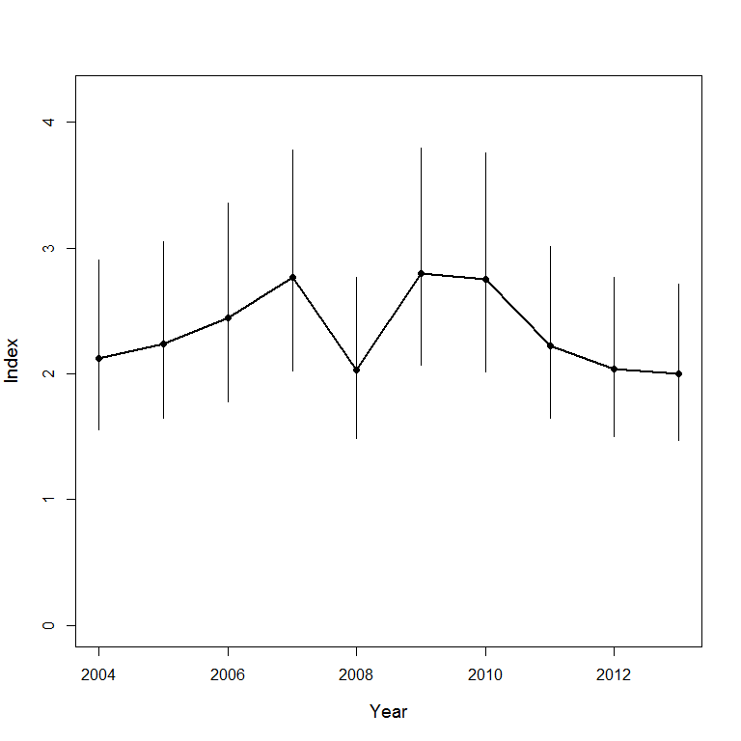

Figure . Oregon nearshore commercial logbook abundance index for black rockfish 2004 – 2013.

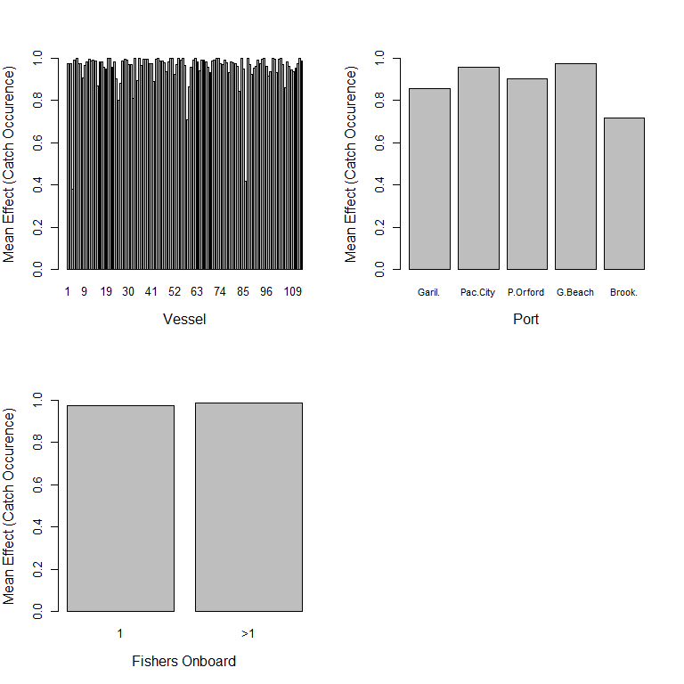

Figure . Summary of the relative effects of each covariate in the catch occurrence model component for the black rockfish commercial logbook index in Oregon.

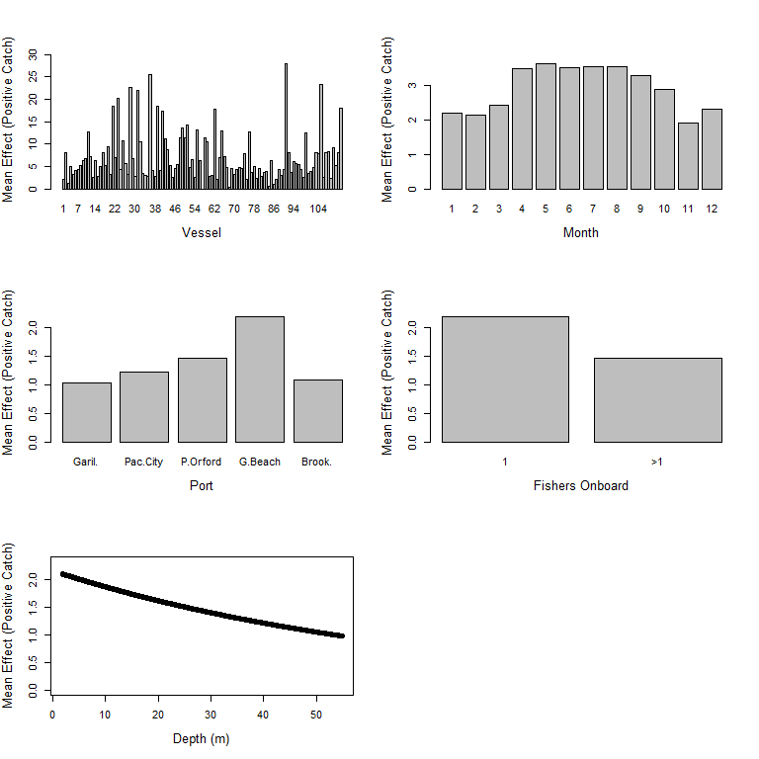

Figure . Summary of the relative effects of each covariate in the positive catch model component for the black rockfish commercial logbook index in Oregon.

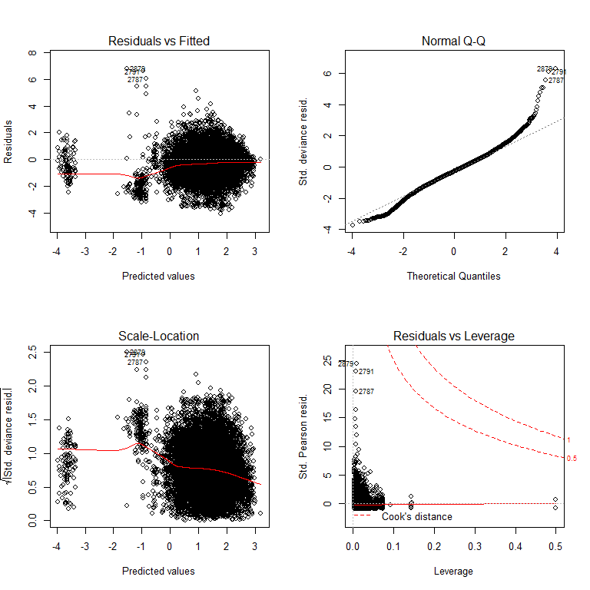

Figure . Diagnostic plots for the Oregon onboard black rockfish positive catch component delta-GLM model. These are used to evaluate model fit (top left), assumptions of normality (top right), assumptions of constant variance (bottom left), and the presence of outliers (bottom right).

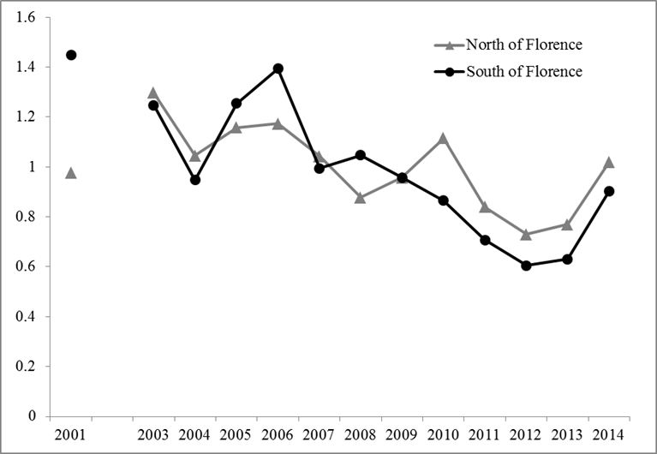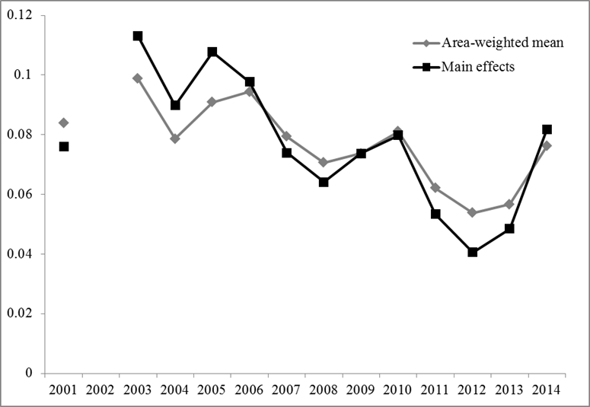

Figure . Onboard observer CPUE index for Oregon by area (top panel) and coastwide (bottom panel).



Figure . Species coefficients for the Stephens-MacCall filter of the ODFW ORBS dockside data.

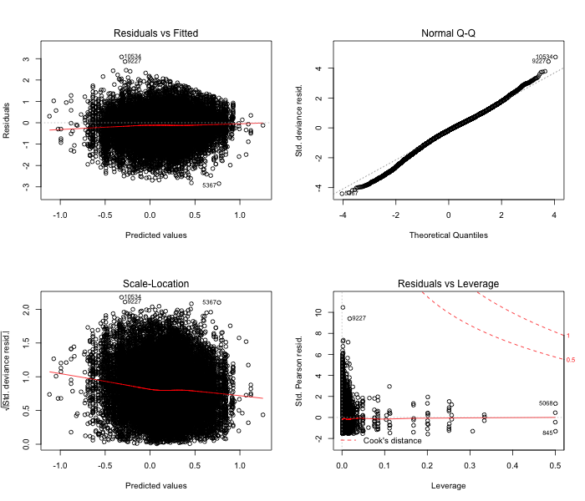

Figure . Diagnostic plots for the black rockfish positive catch component gamma delta-GLM model for the ORBS dockside dataset. These are used to evaluate model fit (top left), assumptions of normality (top right), assumptions of constant variance (bottom left), and the presence of outliers (bottom right).

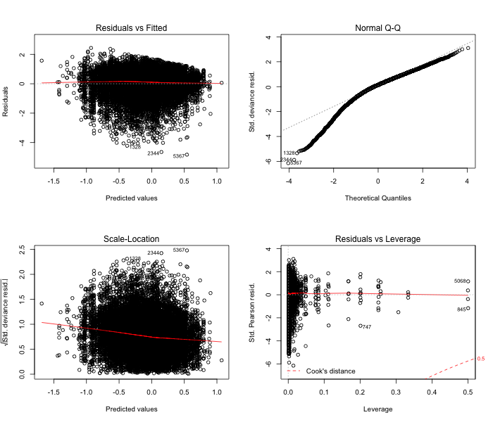

Figure . Diagnostic plots for the black rockfish positive catch component lognormal delta-GLM model for the ORBS dockside dataset. These are used to evaluate model fit (top left), assumptions of normality (top right), assumptions of constant variance (bottom left), and the presence of outliers (bottom right).



Figure . ODFW ORBS dockside CPUE with CV interval.

Figure . Abundance indices for Oregon, normalized to mean and sd. The MRFSS index begins in 1981; it is truncated here so that the detail in recent years is evident.

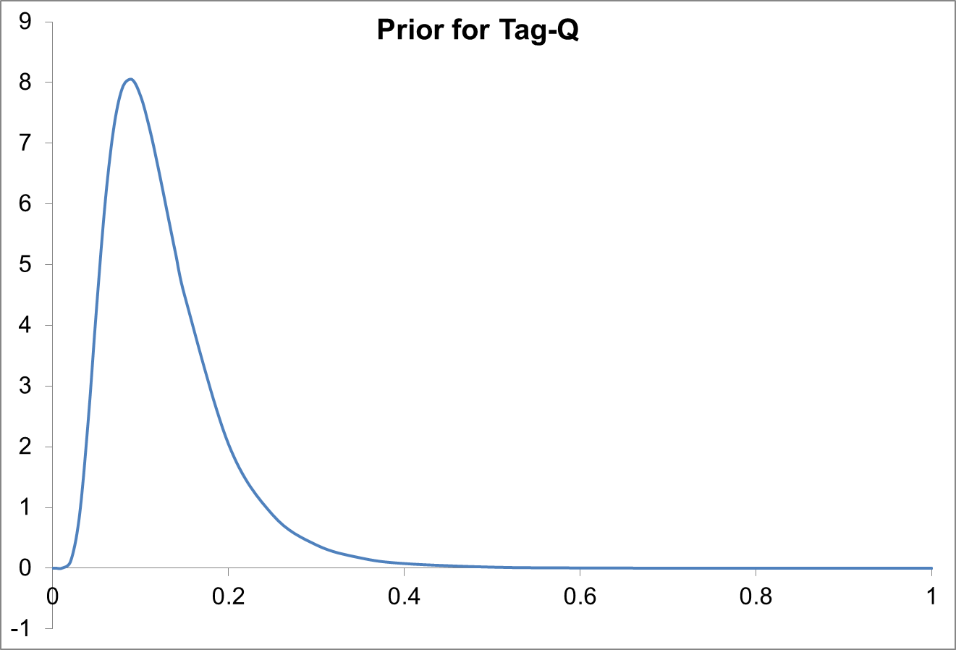

Figure . Lognormal prior probability distribution for parameter *Tag-Q*, the catchability coefficient for the series of ODFW tagging study annual estimates of the abundance of exploitable black rockfish off Newport, OR. The lognormal distribution parameters are mu = ‑2.1885 and sigma = 0.5, corresponding to a mean value of 0.1270 for *Tag-Q*.

## OR Model Figures

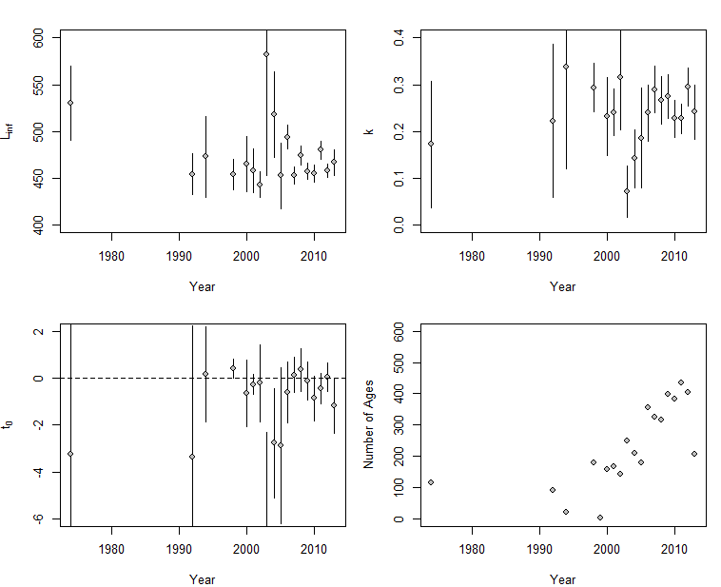

Figure . Temporal estimates of the von Bertalanffy growth parameters and sample sizes for females in Oregon.

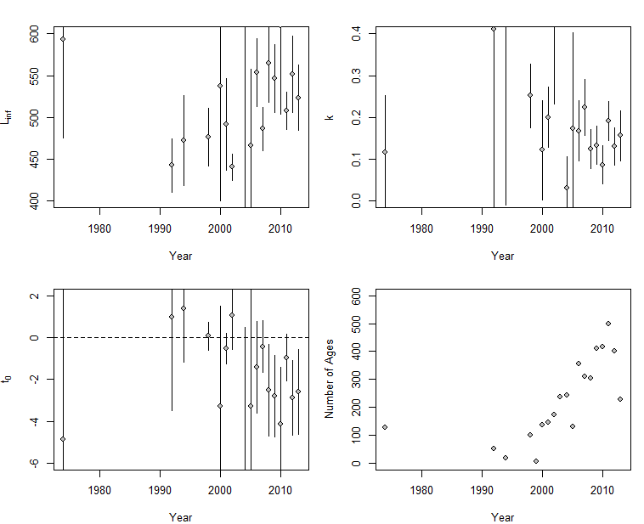

Figure . Temporal estimates of the von Bertalanffy growth parameters and sample sizes for females in Oregon

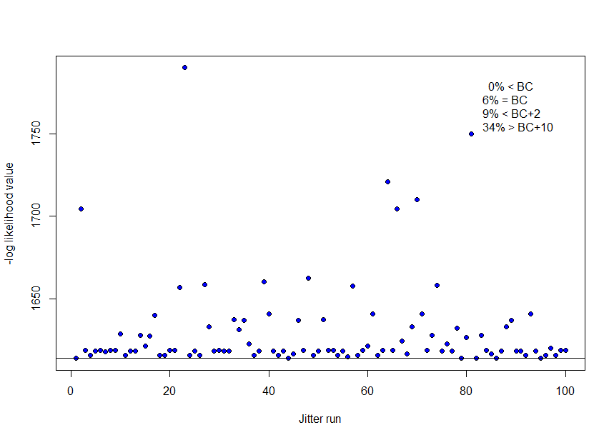

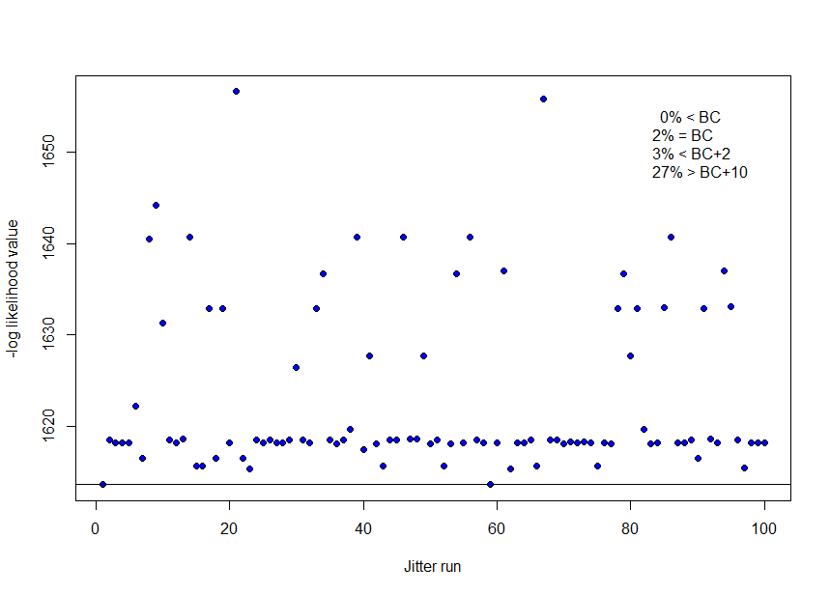

Figure . Results from 100 Oregon model base case runs when starting values are jittered at 0.1 (top panel) and 0.05 (bottom panel). Horizontal line indicates base model value.

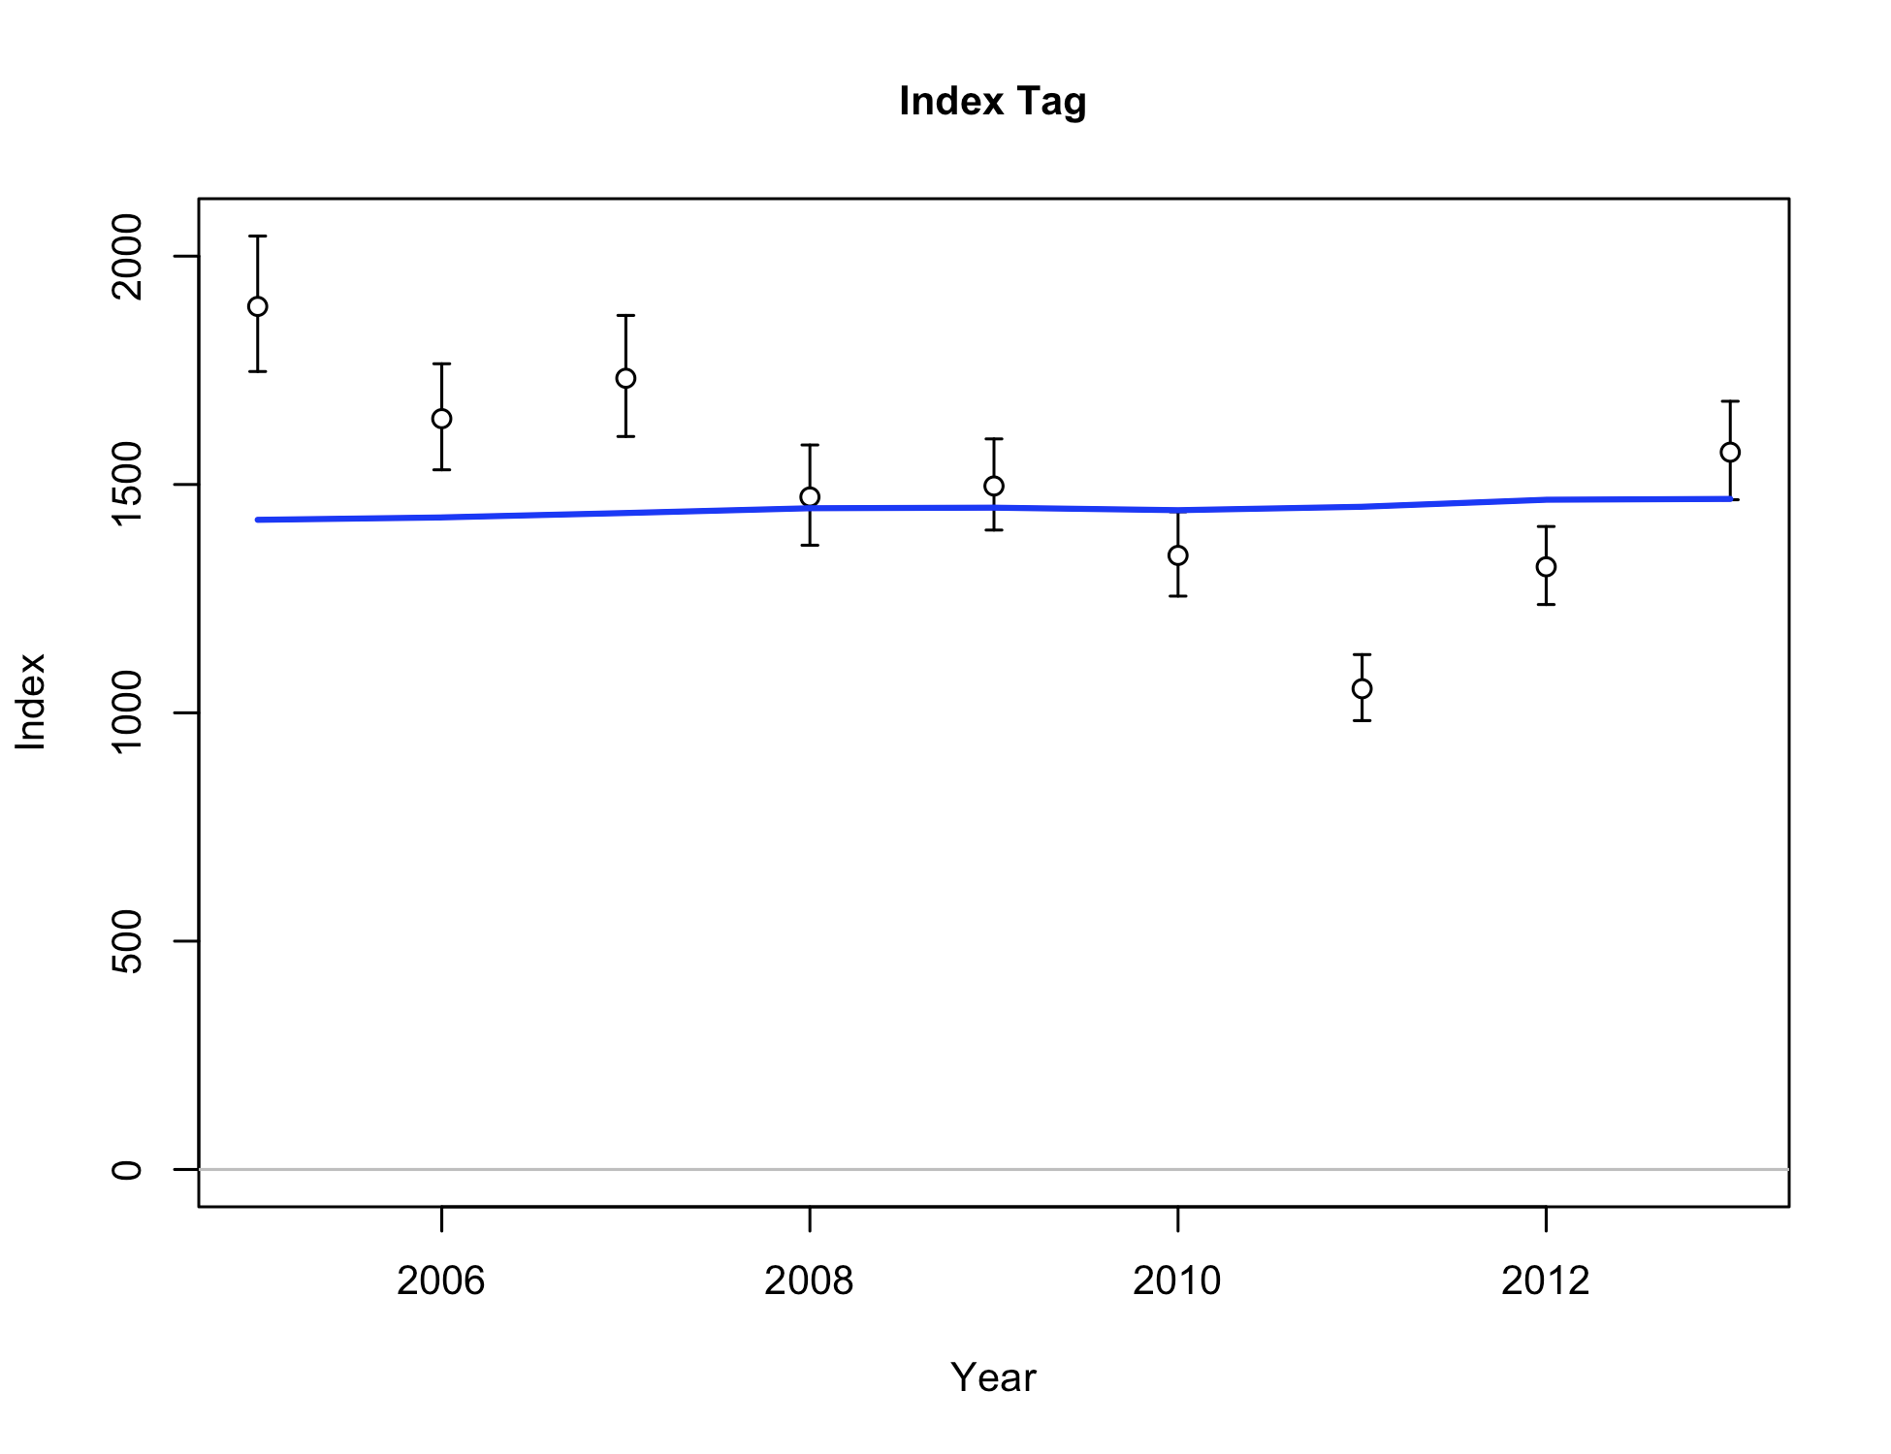

Figure . Base case fit to the Oregon tagging abundance index.

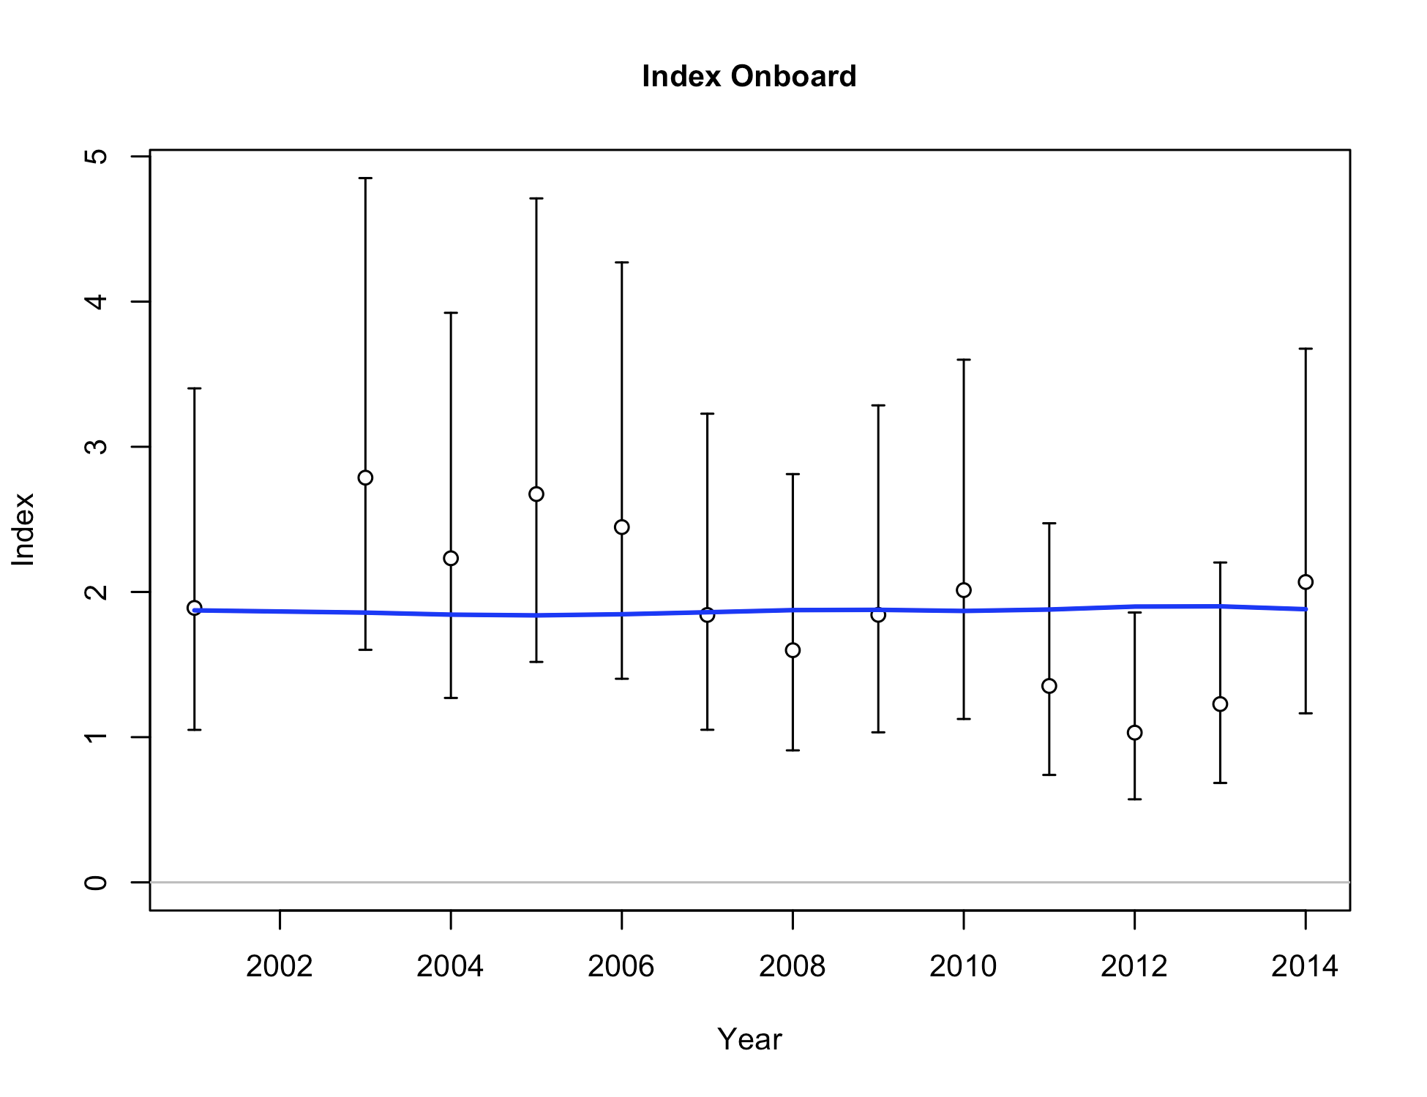

Figure . Base case fit to the Oregon onboard observer CPUE index.

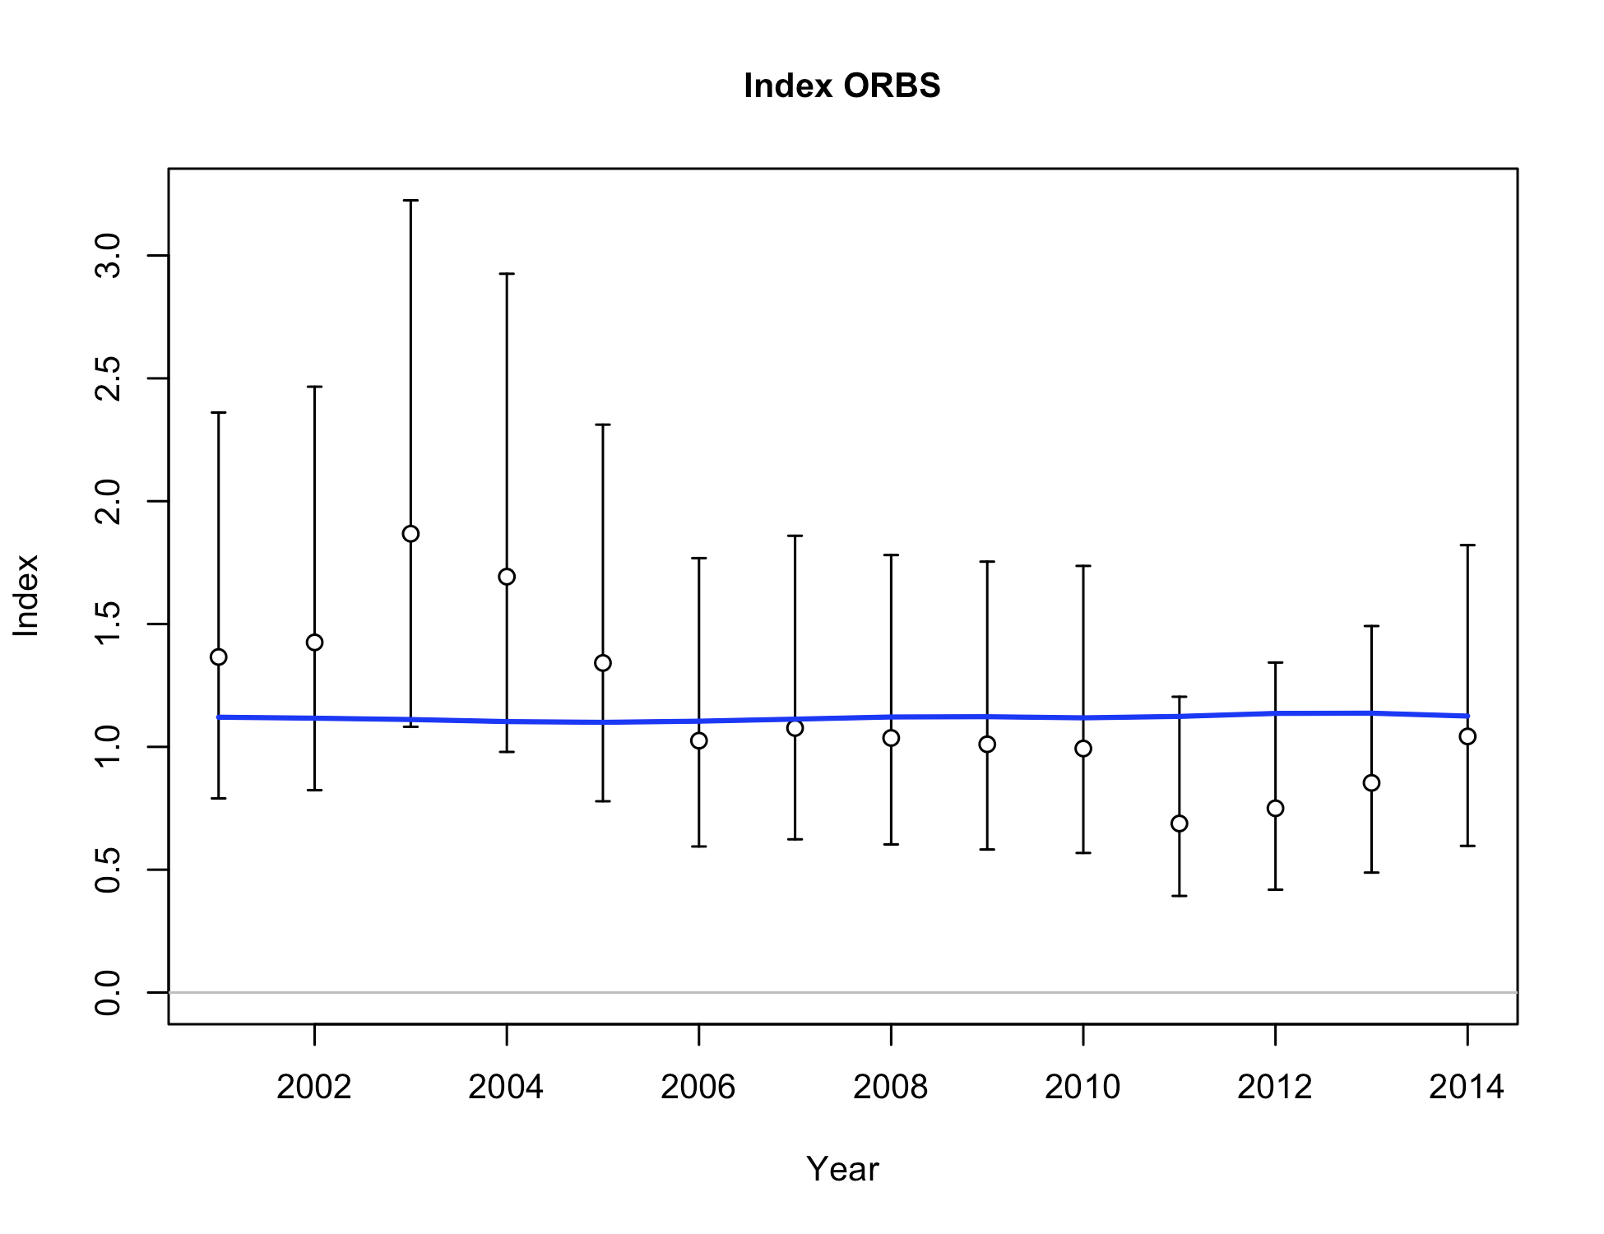

Figure . Base case fit to the Oregon recreational dockside ORBS CPUE index.

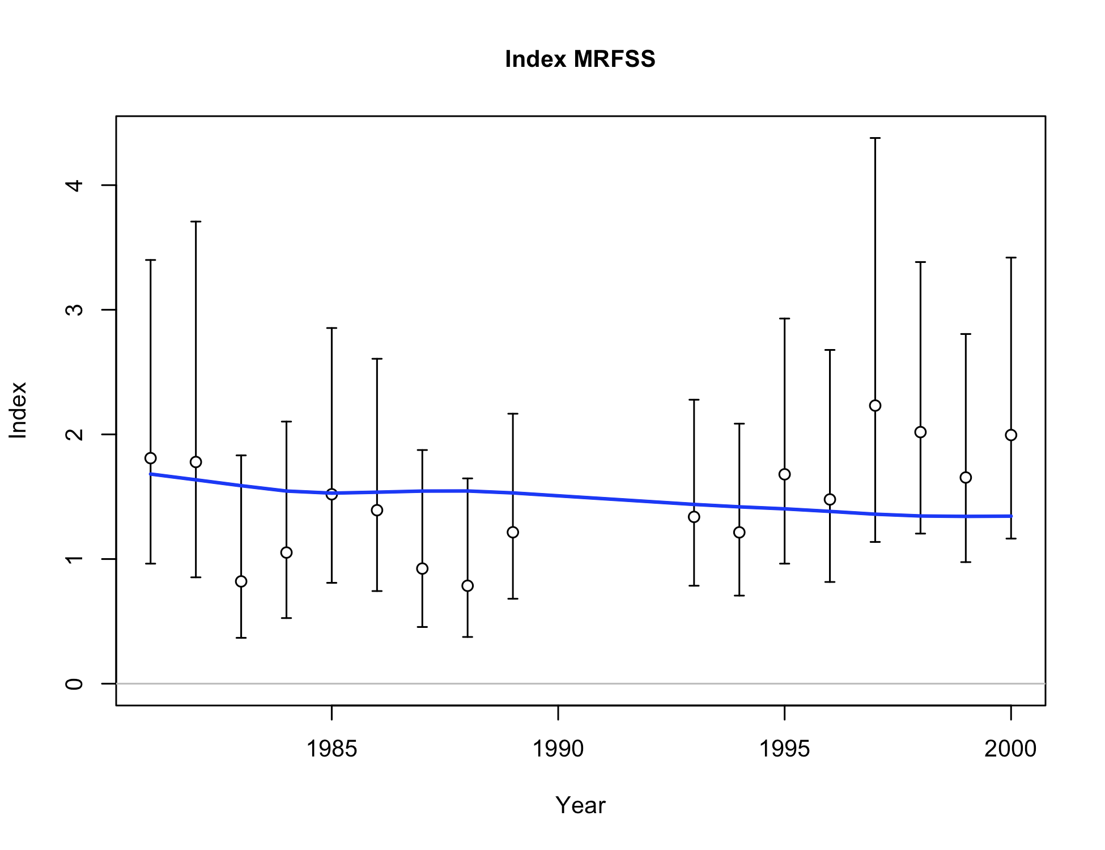

Figure . Base case fit to the Oregon recreational MRFSS dockside CPUE index.

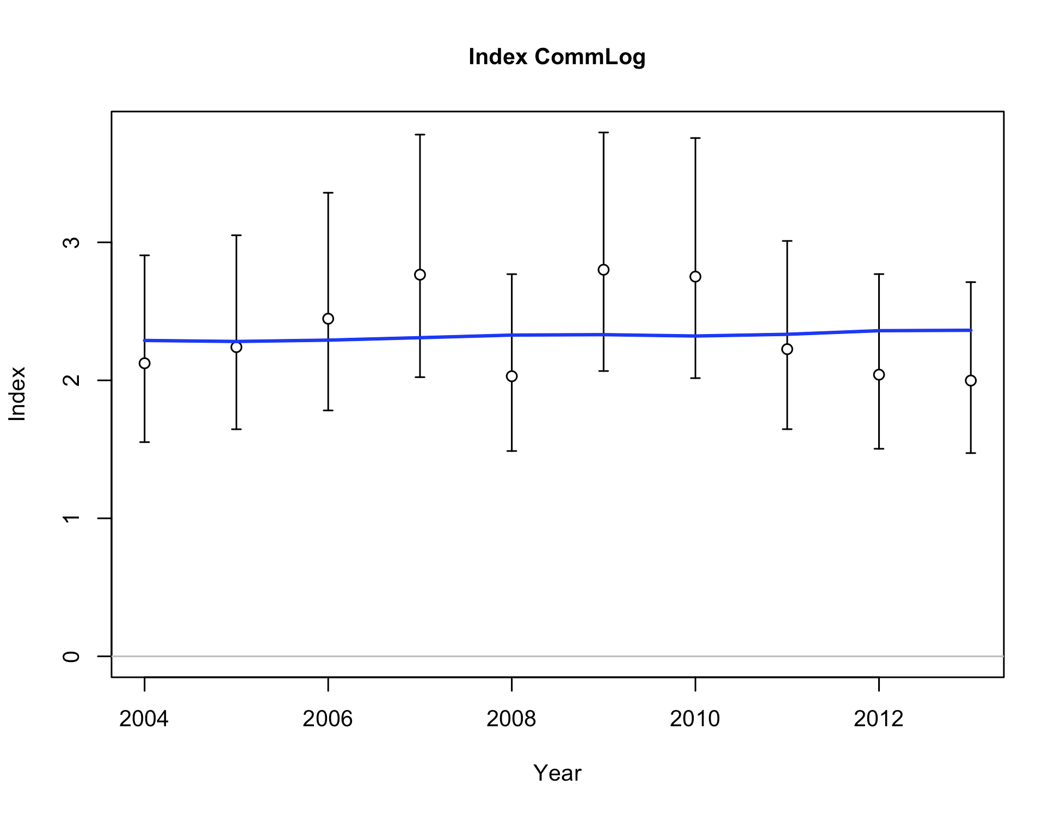

Figure . Base case fit to the Oregon Commercial Logbook CPUE index.

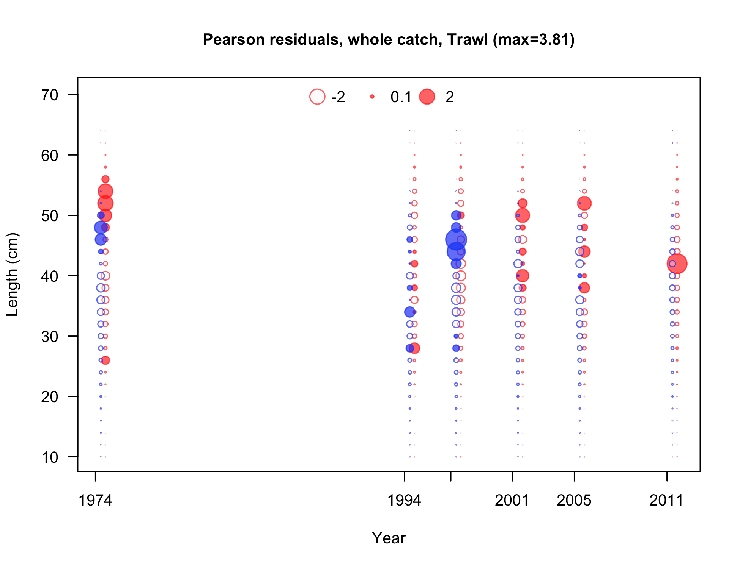

Figure . Pearson residuals plots for male (blue) and female (red) length compositions for the Oregon trawl commercial fleet. Residuals <2 are generally considered non-significant.

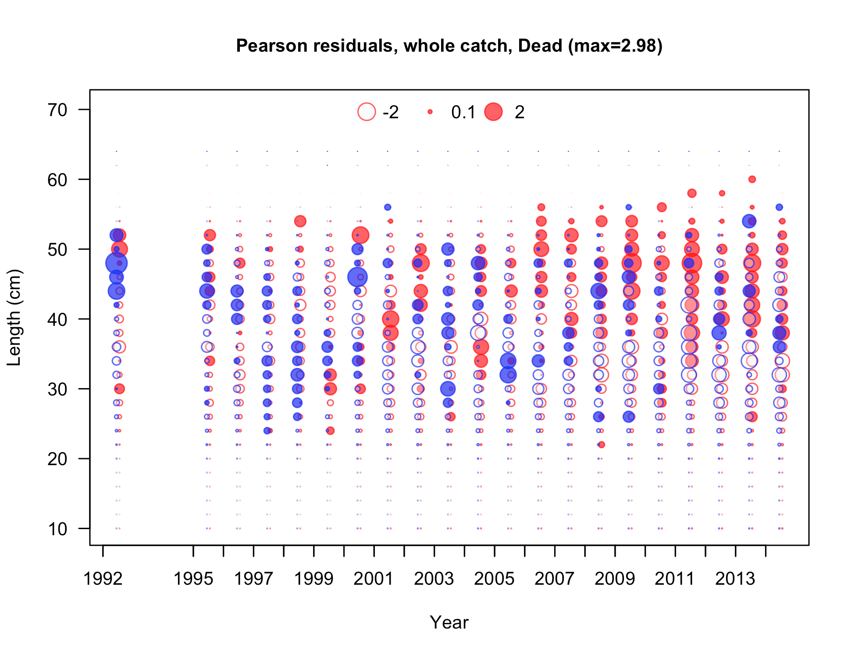

Figure . Pearson residuals plots for male (blue) and female (red) length compositions for the Oregon non-trawl-dead commercial fleet. Residuals <2 are generally considered non-significant.

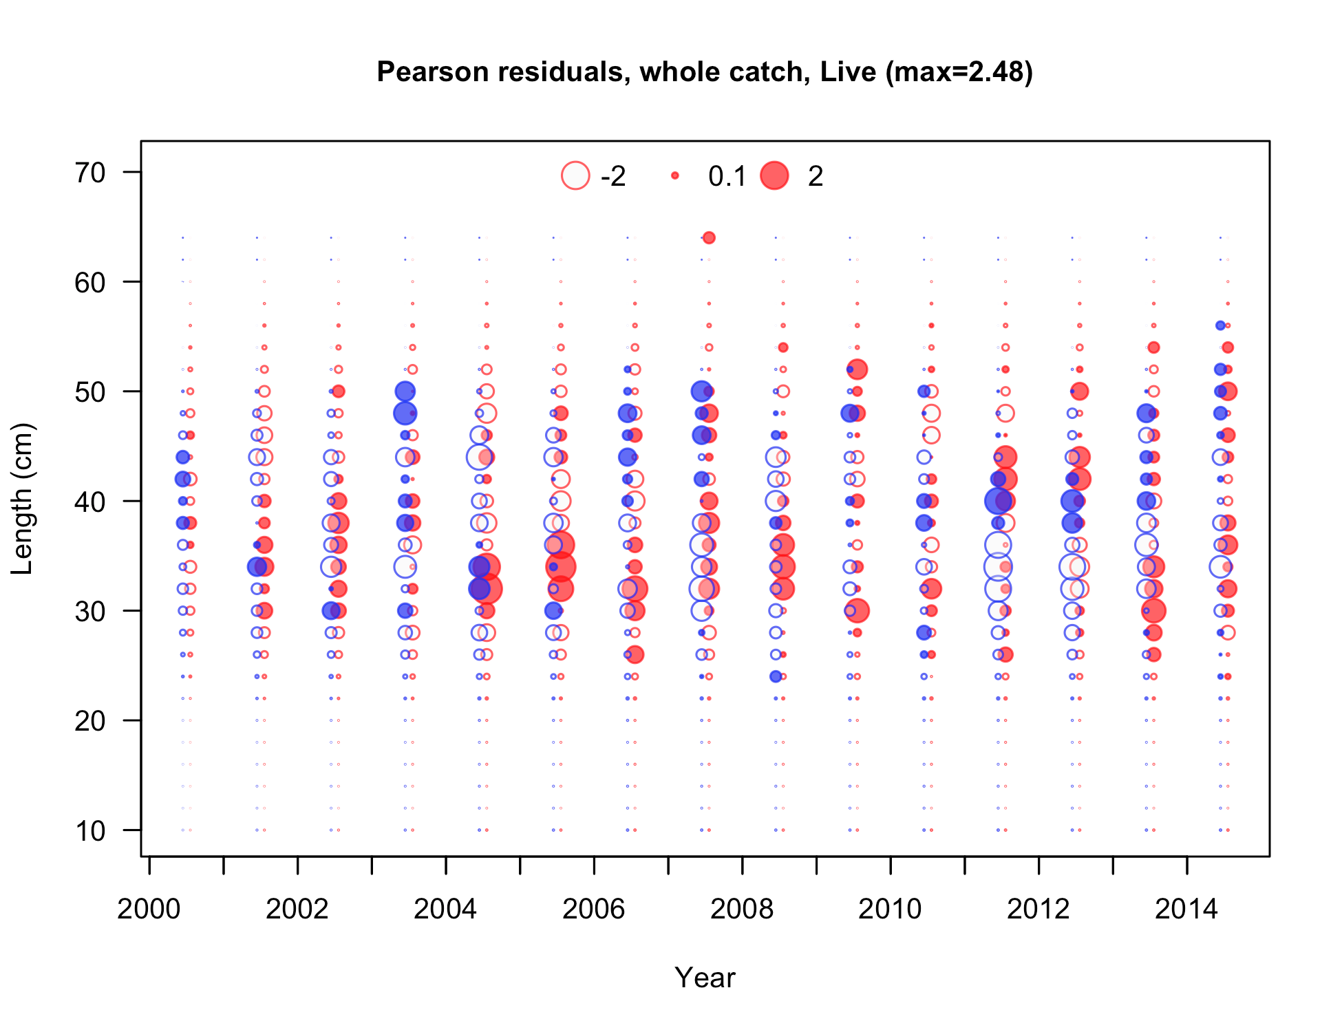

Figure . Pearson residuals plots for male (blue) and female (red) length compositions for the Oregon non-trawl-live commercial fleet. Residuals <2 are generally considered non-significant.

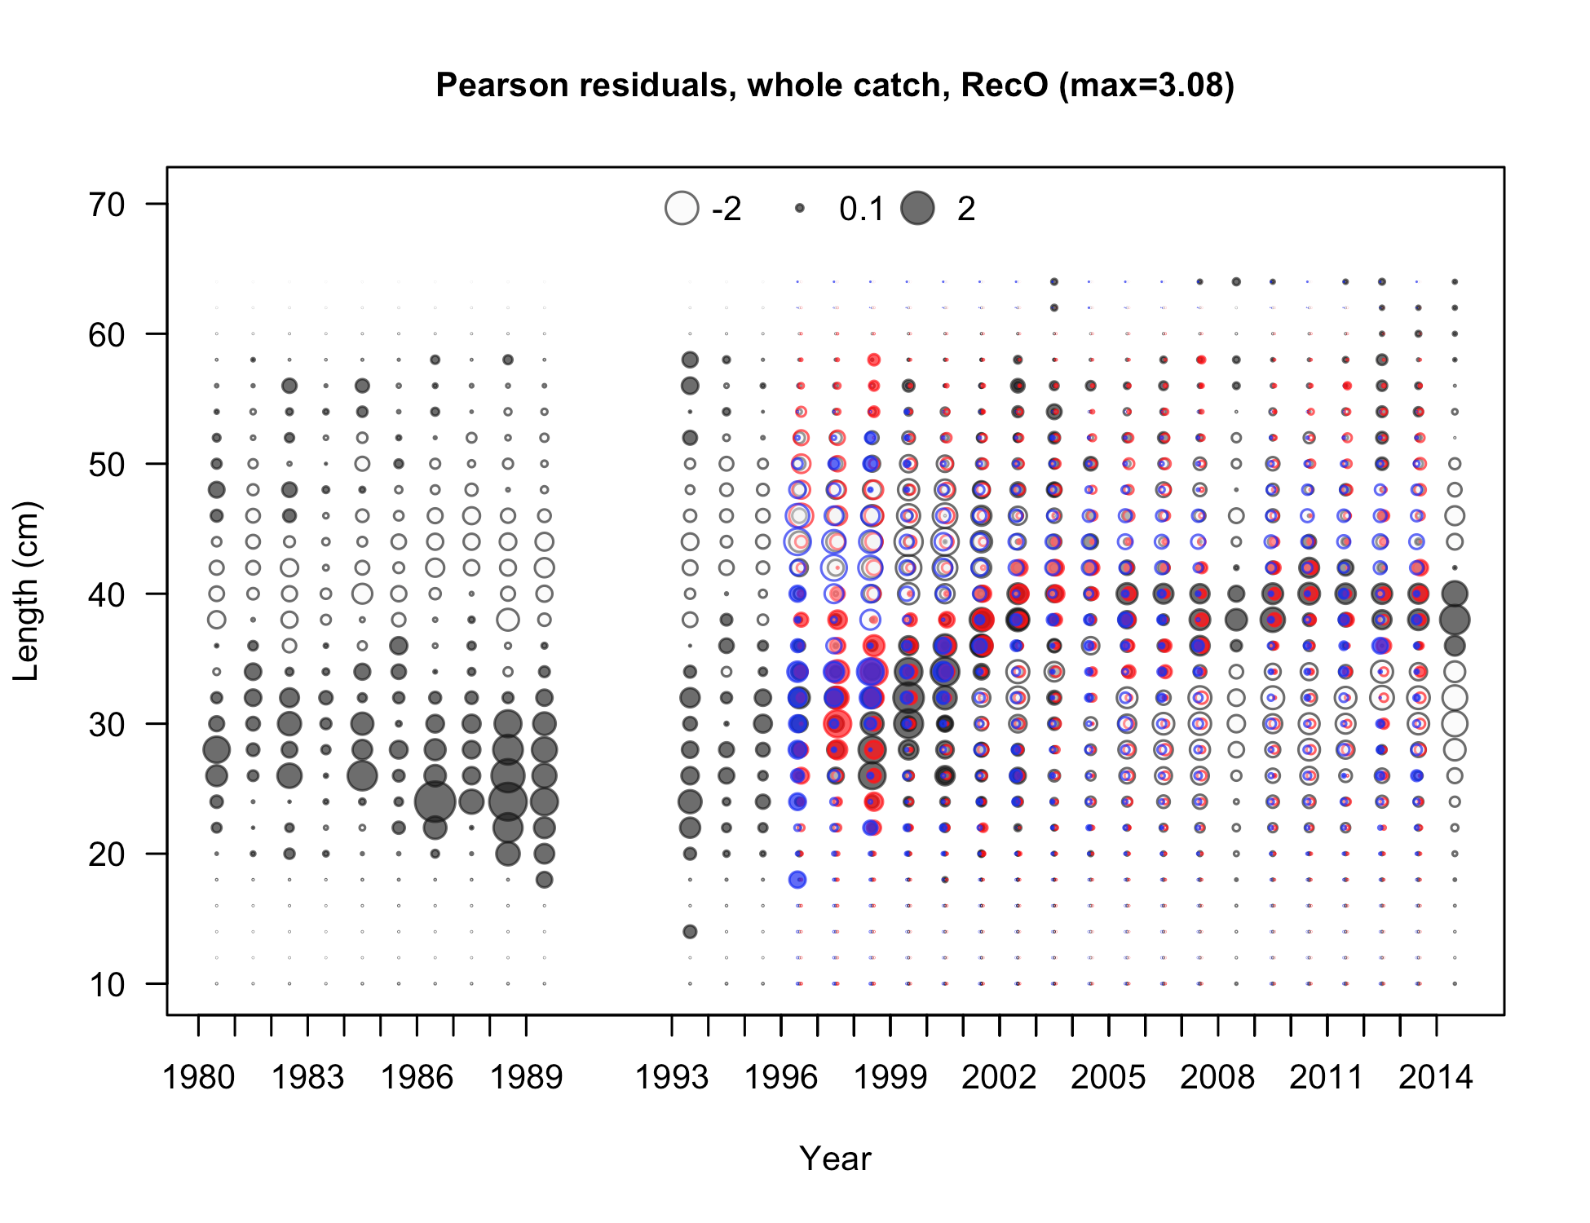

Figure . Pearson residuals plots for male (blue) and female (red) length compositions for the Oregon Ocean boat recreational fleet. Residuals <2 are generally considered non-significant.

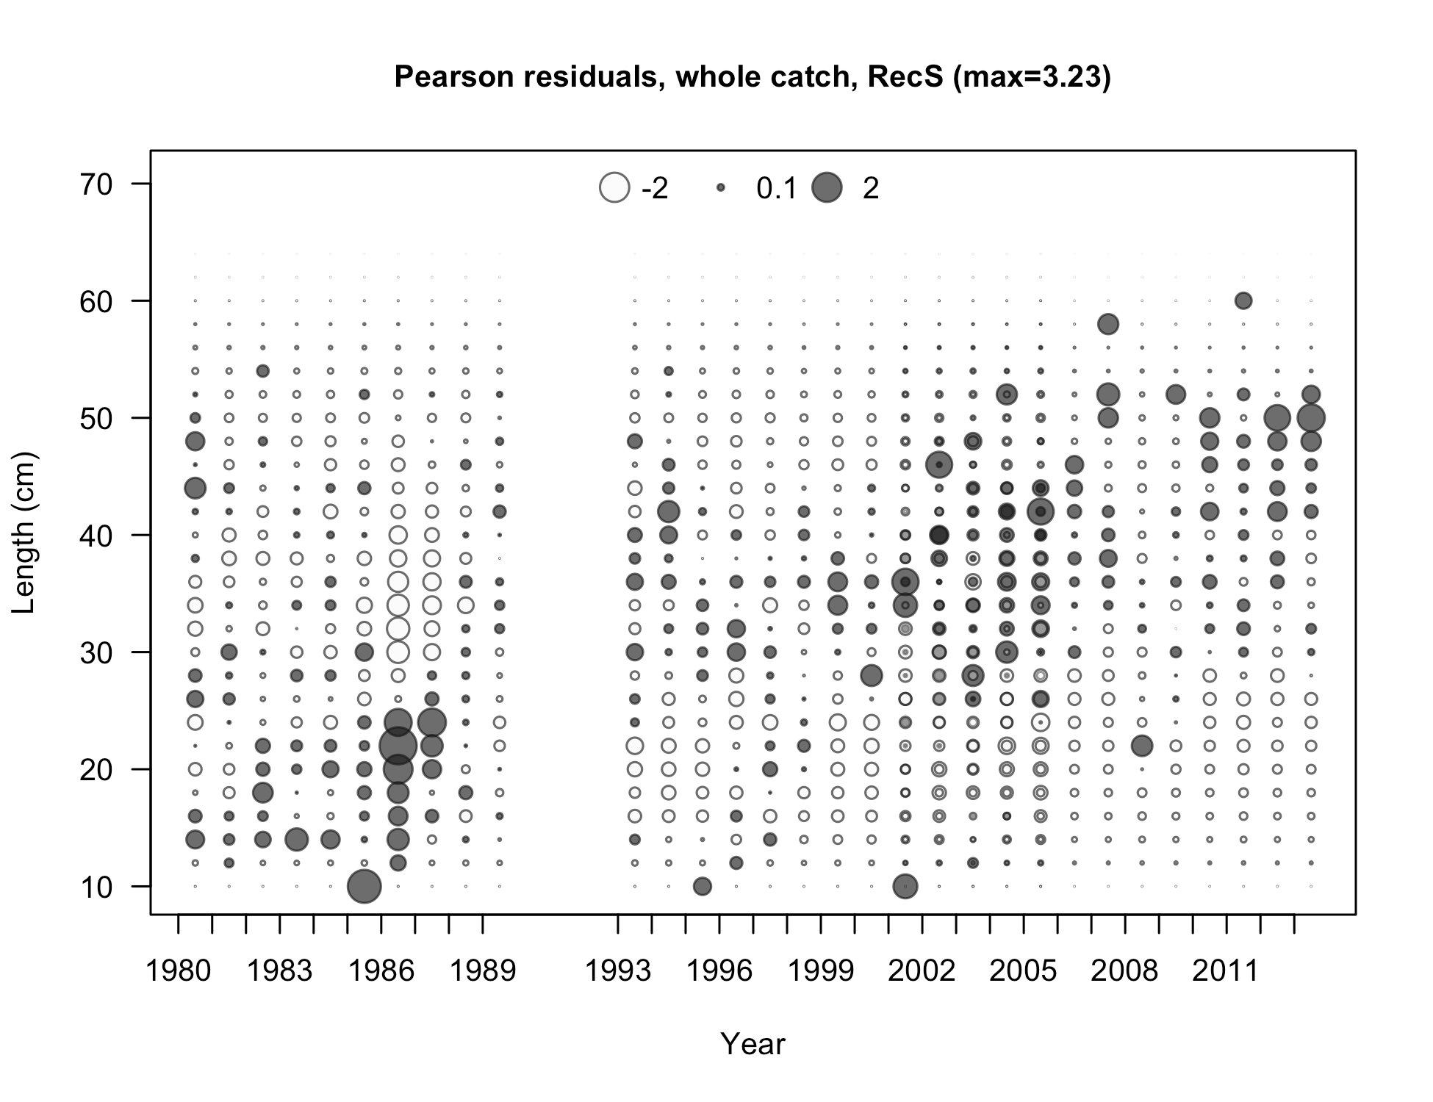

Figure . Pearson residuals plots for male (blue) and female (red) length compositions for the Oregon Shore/Estuary recreational catch. Residuals <2 are generally considered non-significant.

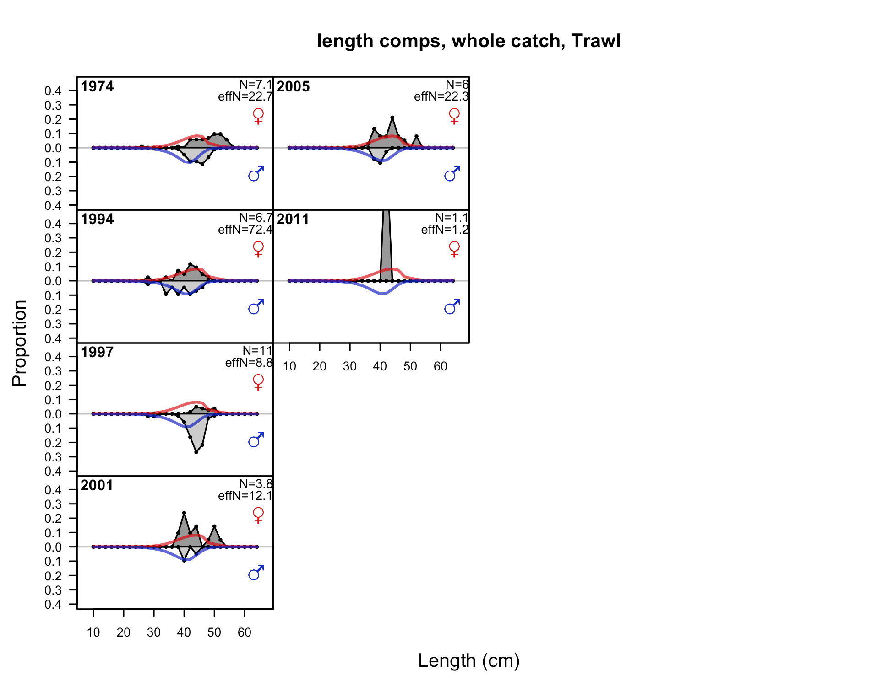

Figure . Fits to the Oregon trawl length compositions by sex and year.

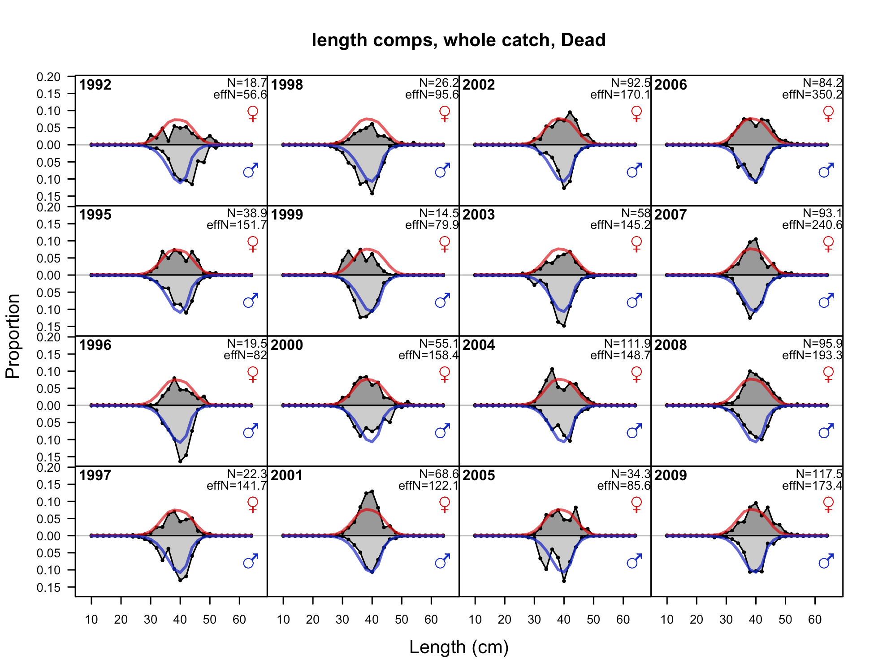

Figure . Fits to the Oregon non-trawl-dead length compositions by sex and year, 1 of 2.

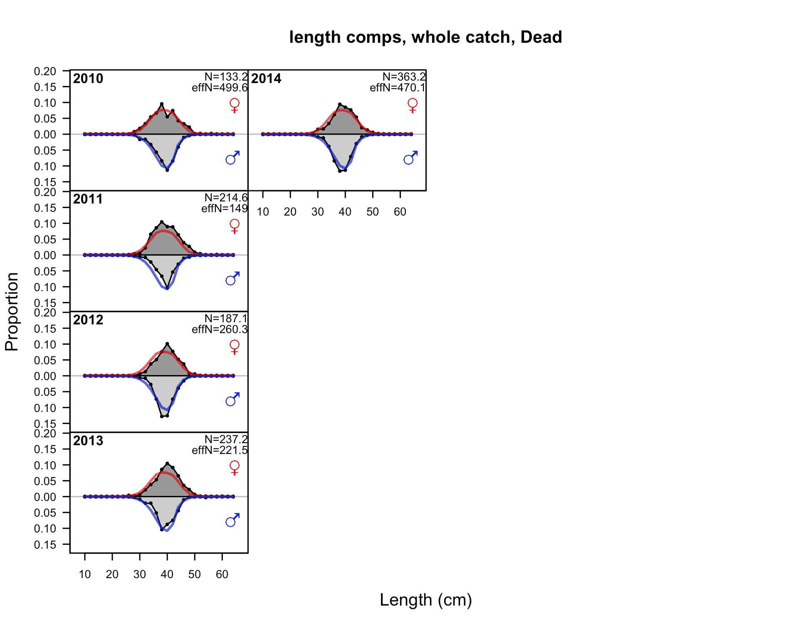

Figure . Fits to the Oregon non-trawl-dead length compositions by sex and year, 2 of 2.

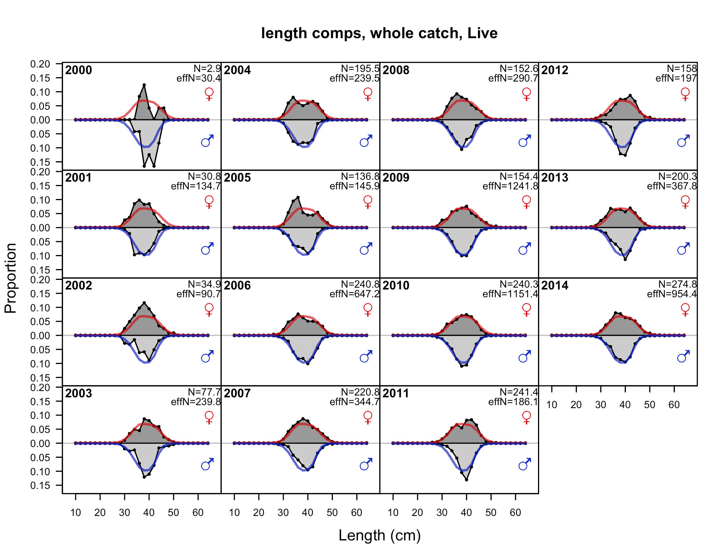

Figure . Fits to the Oregon non-trawl-live length compositions by sex and year.

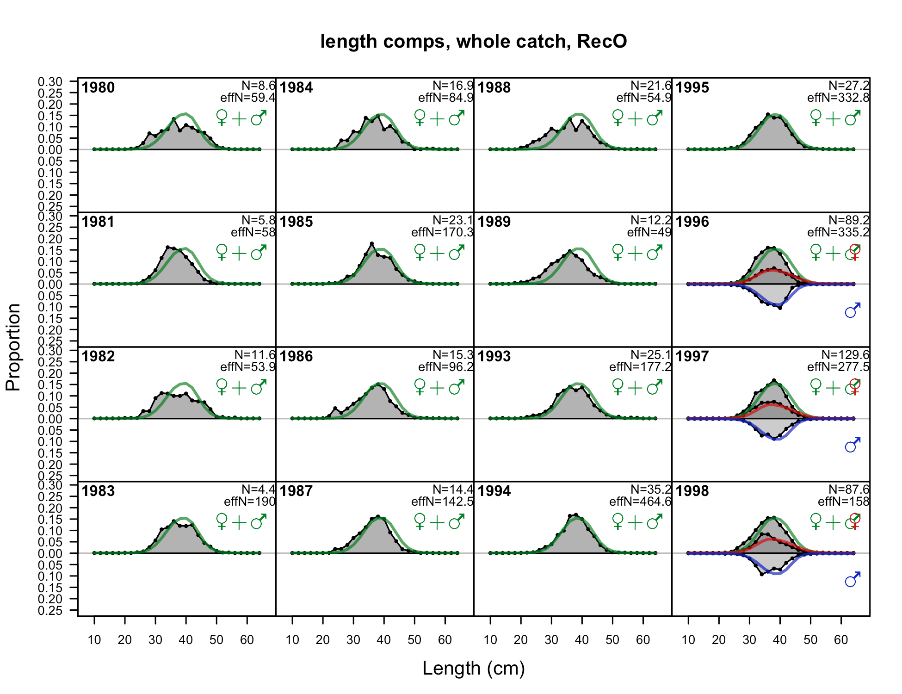

Figure . Fits to the Oregon Ocean boat recreational length compositions by sex and year, 1 of 2.

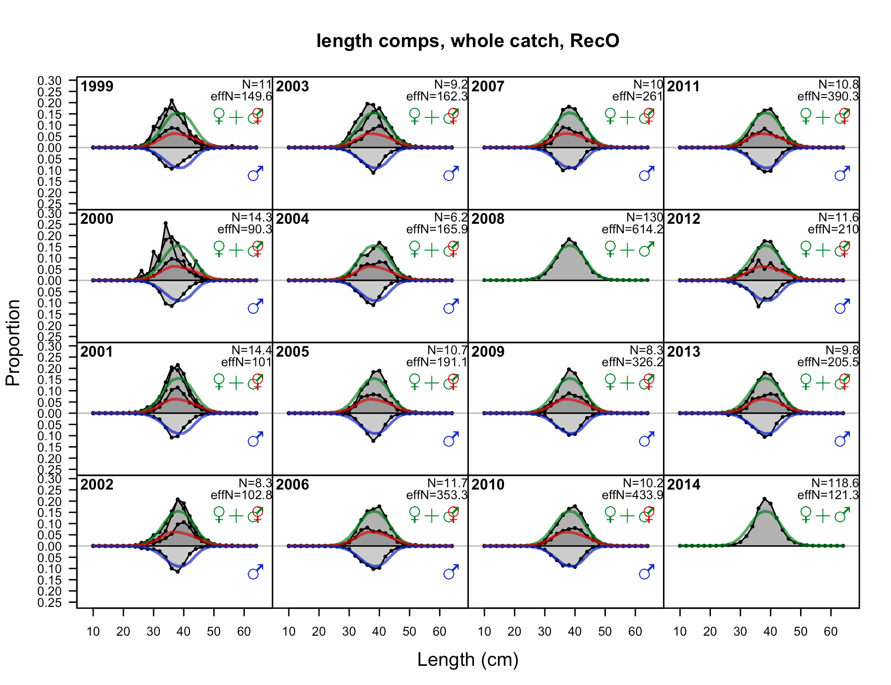

Figure . Fits to the Oregon Ocean boat recreational length compositions by sex and year, 2 of 2.

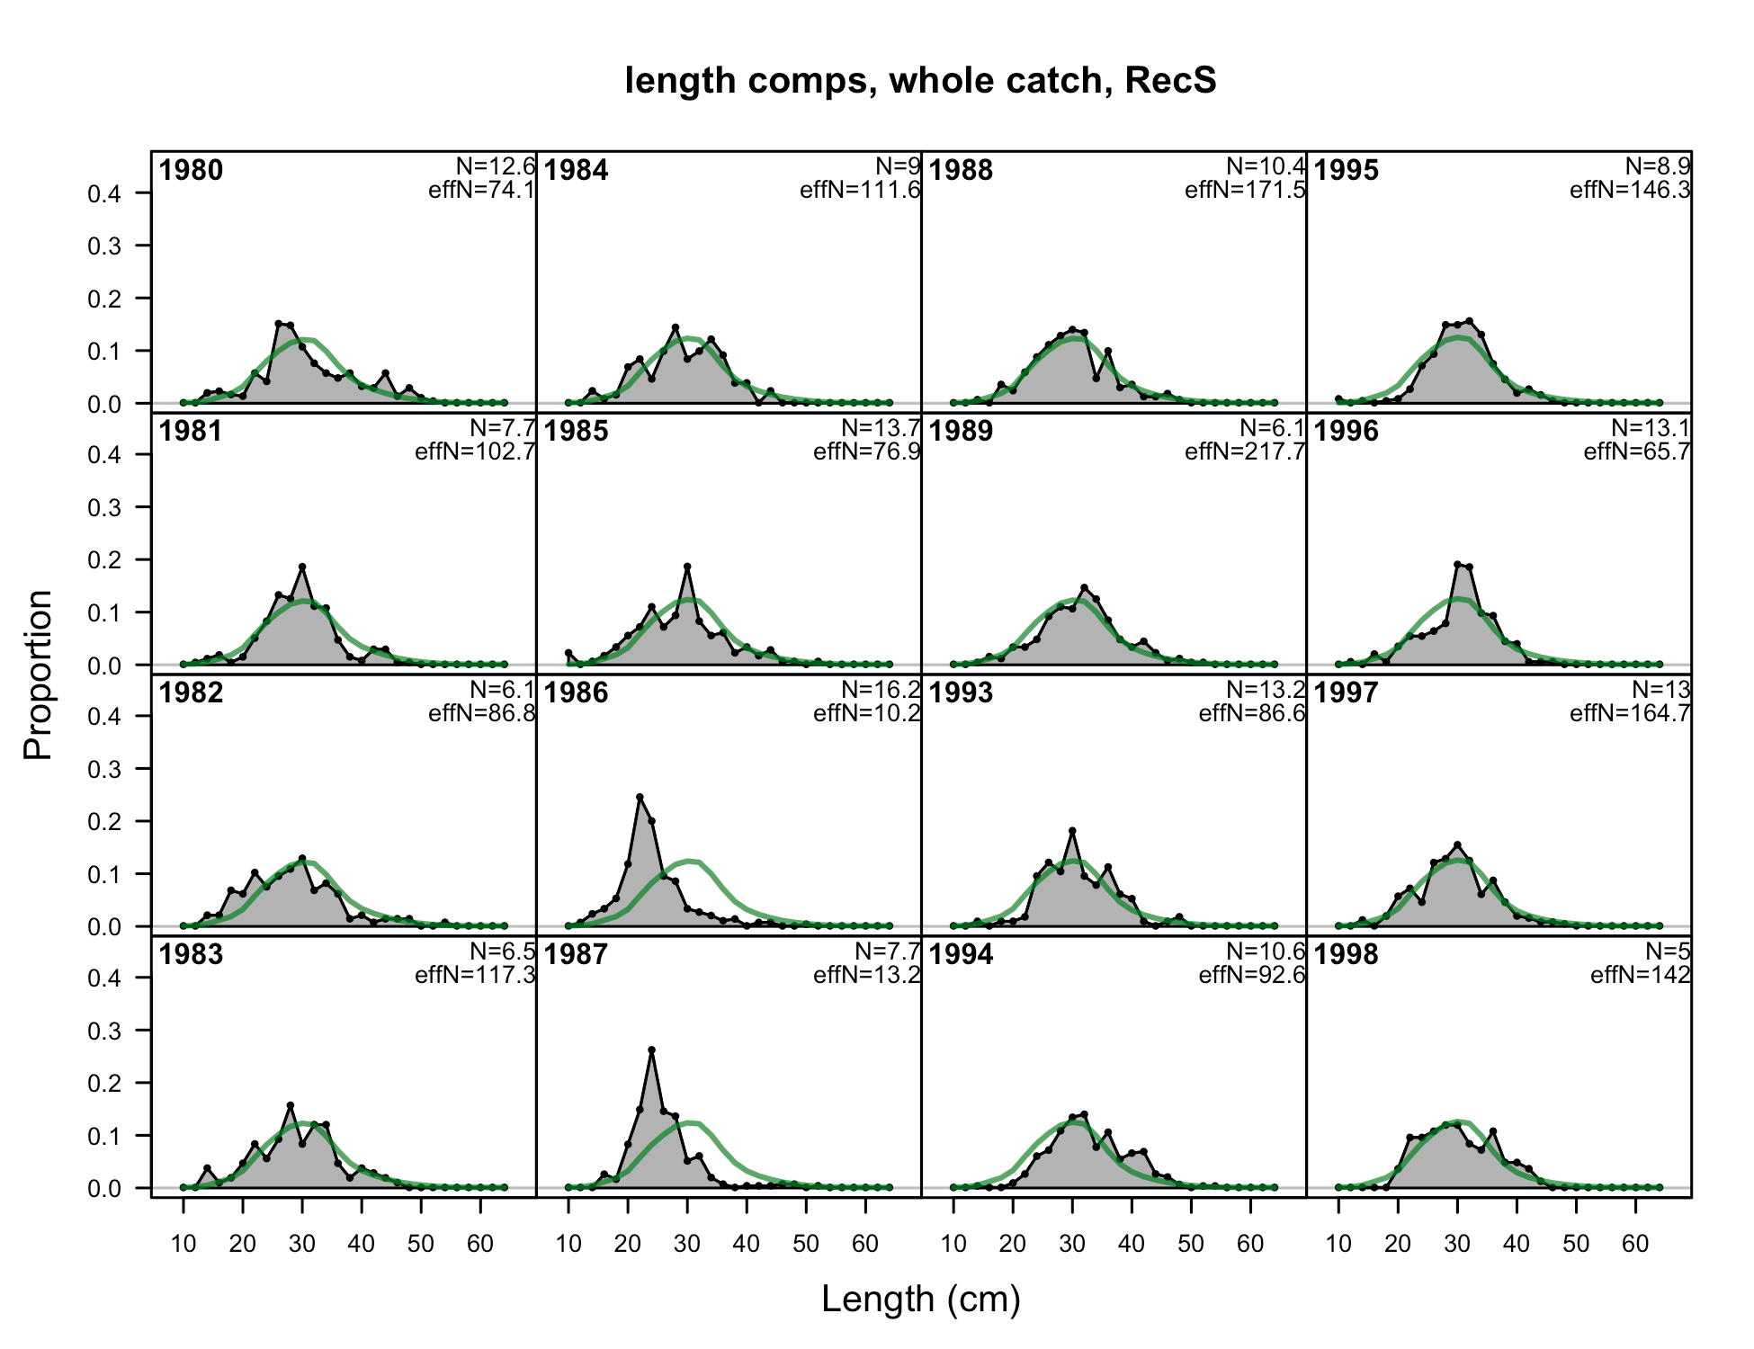

Figure . Fits to the Oregon Shore/Estuary recreational length compositions by sex and year, 1 of 2.

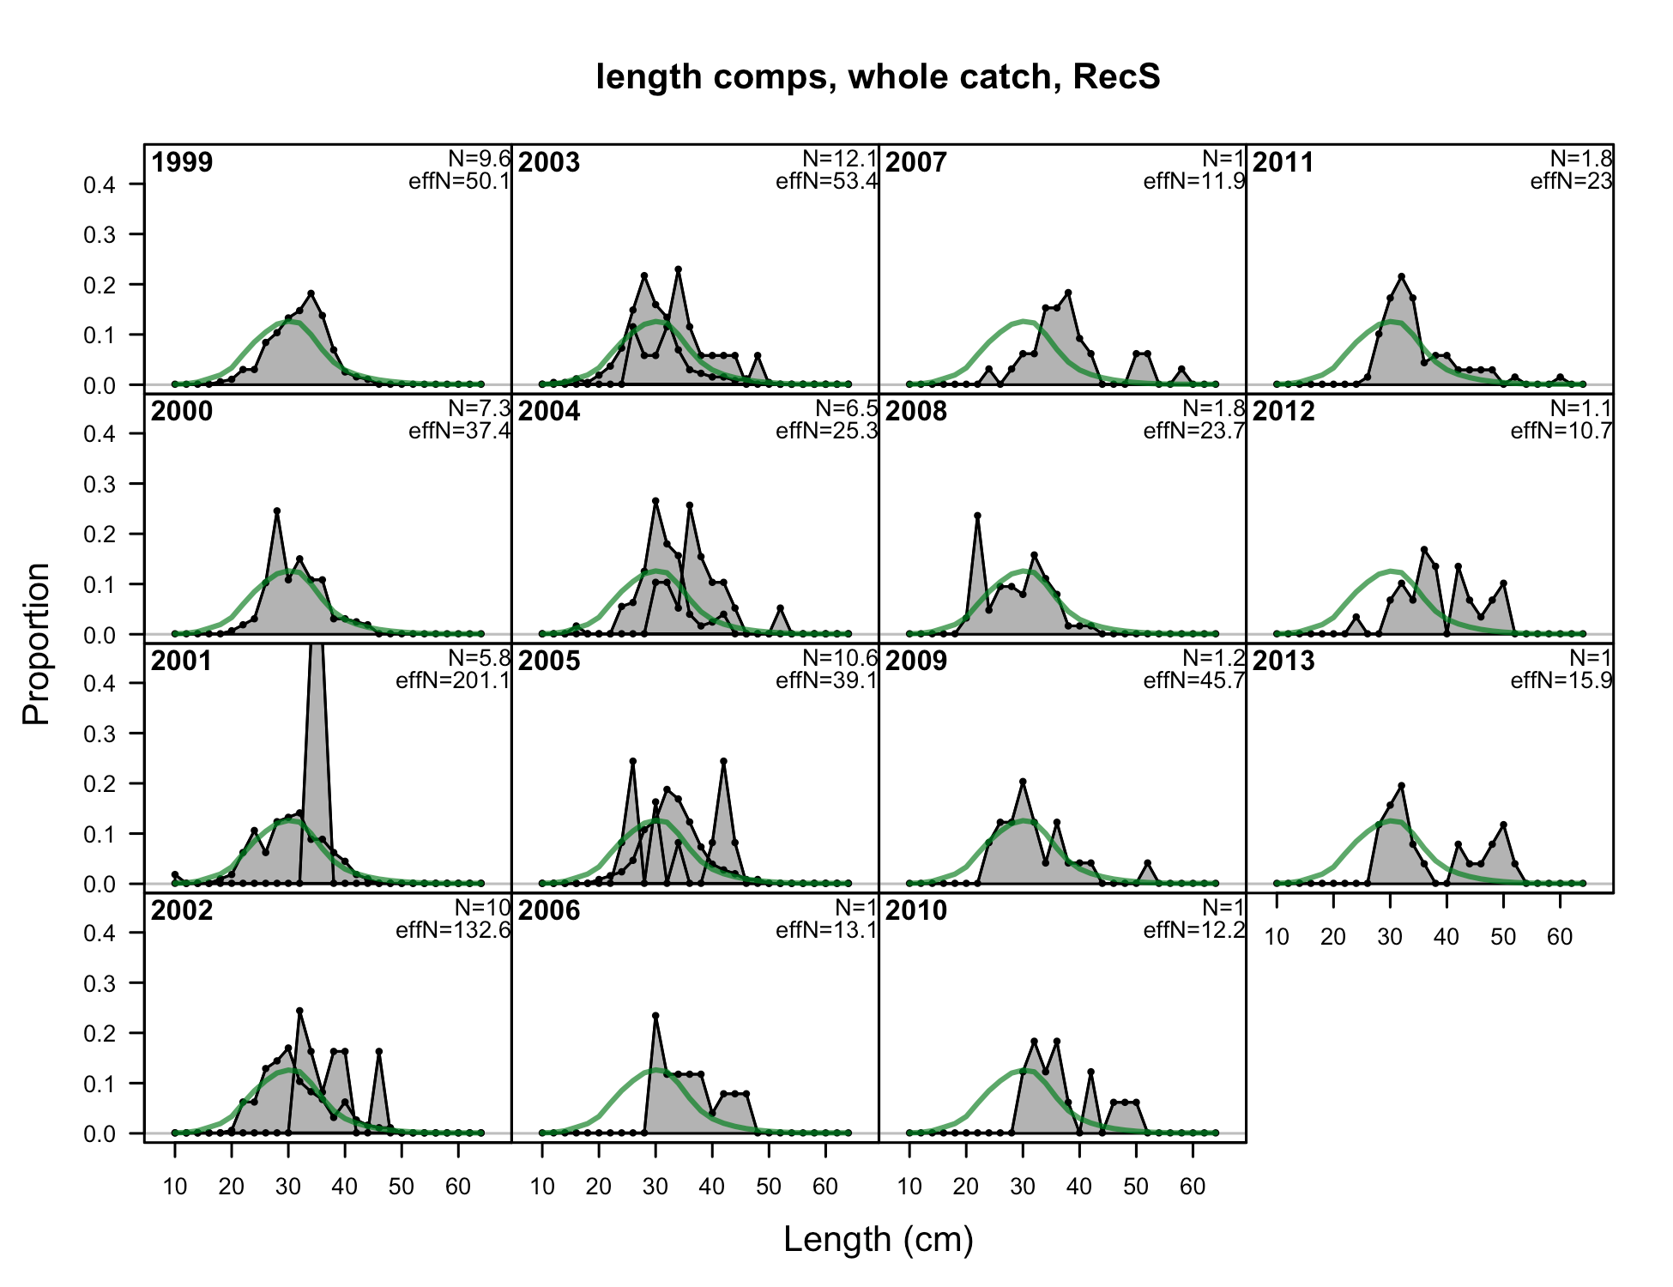

Figure . Fits to the Oregon Shore/Estuary recreational length compositions by sex and year, 2 of 2.

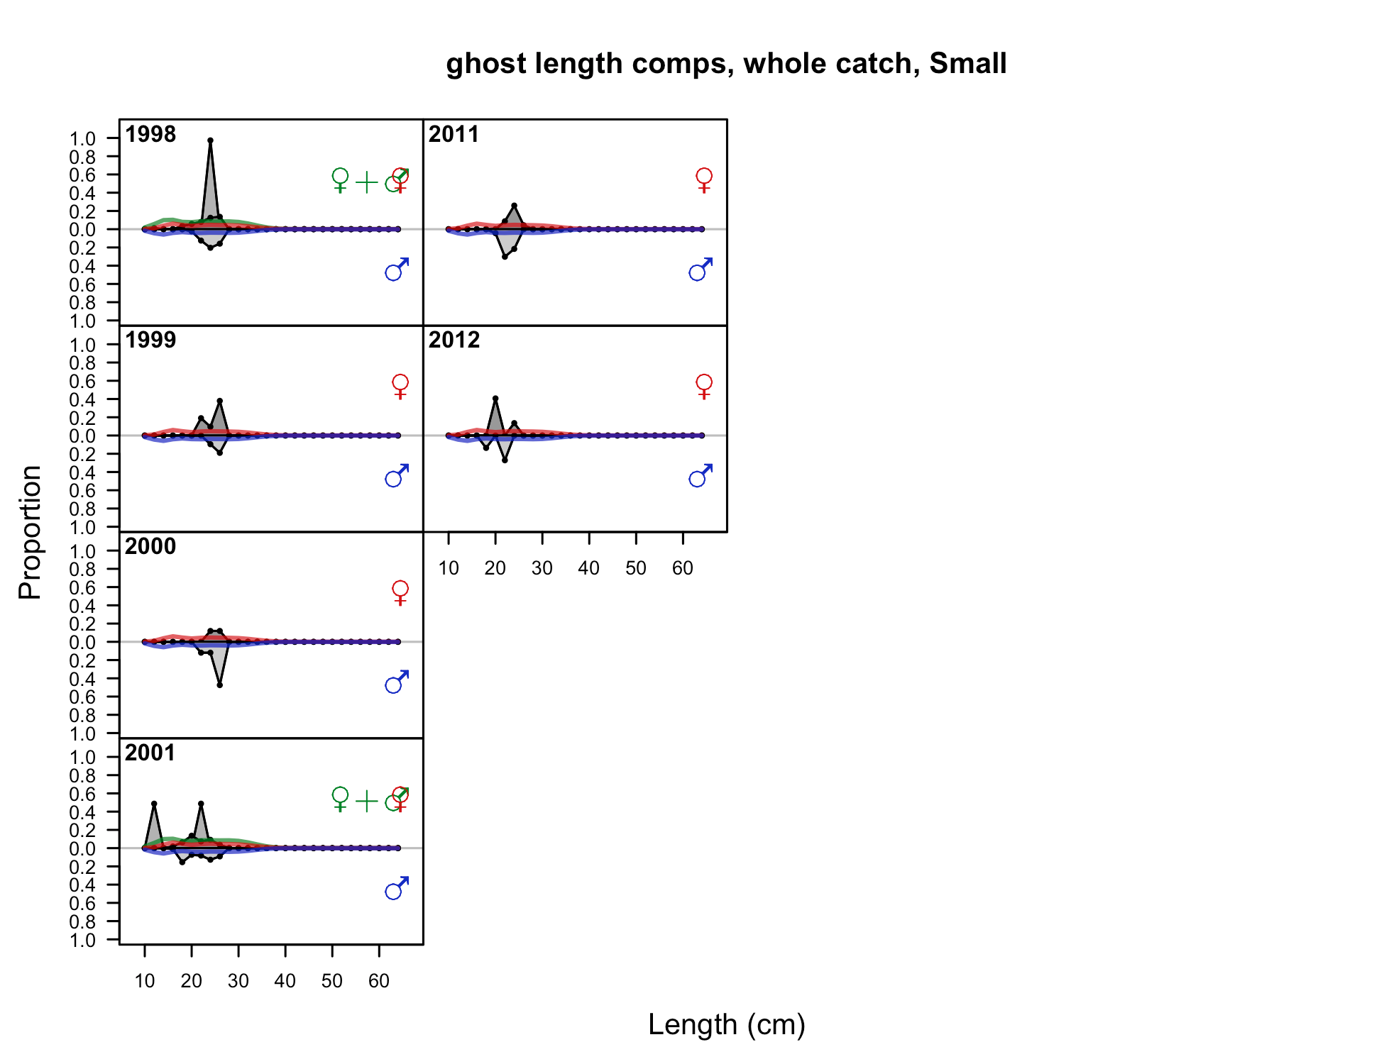

Figure . Fits to the Oregon “small” fish length compositions by sex and year.

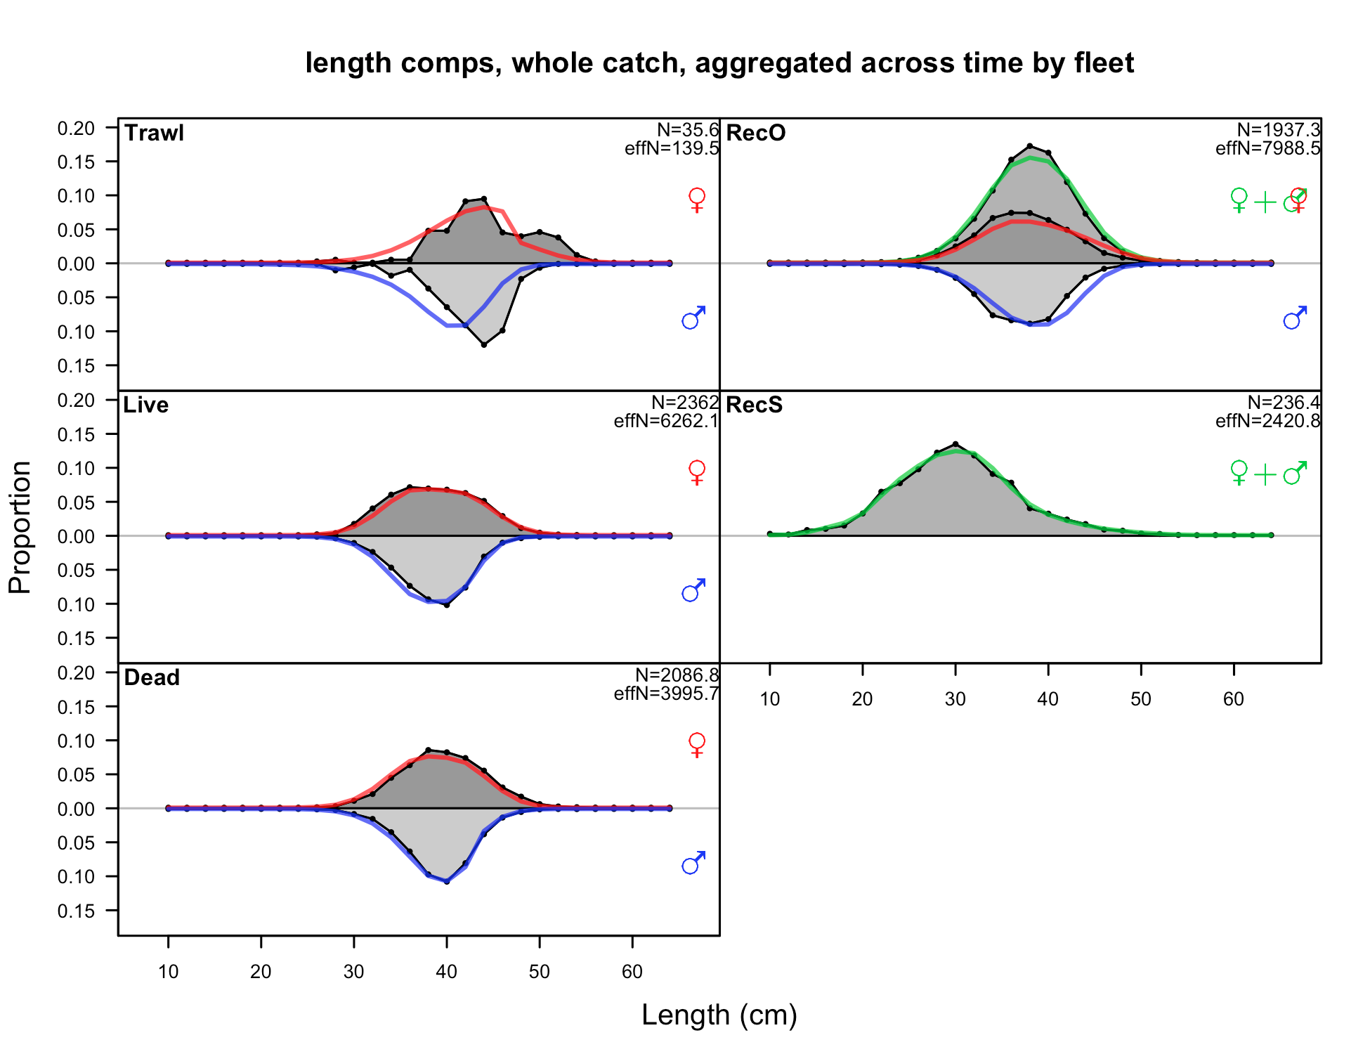

Figure . Composite fits to the length composition by fleet and sex for the Oregon base model.

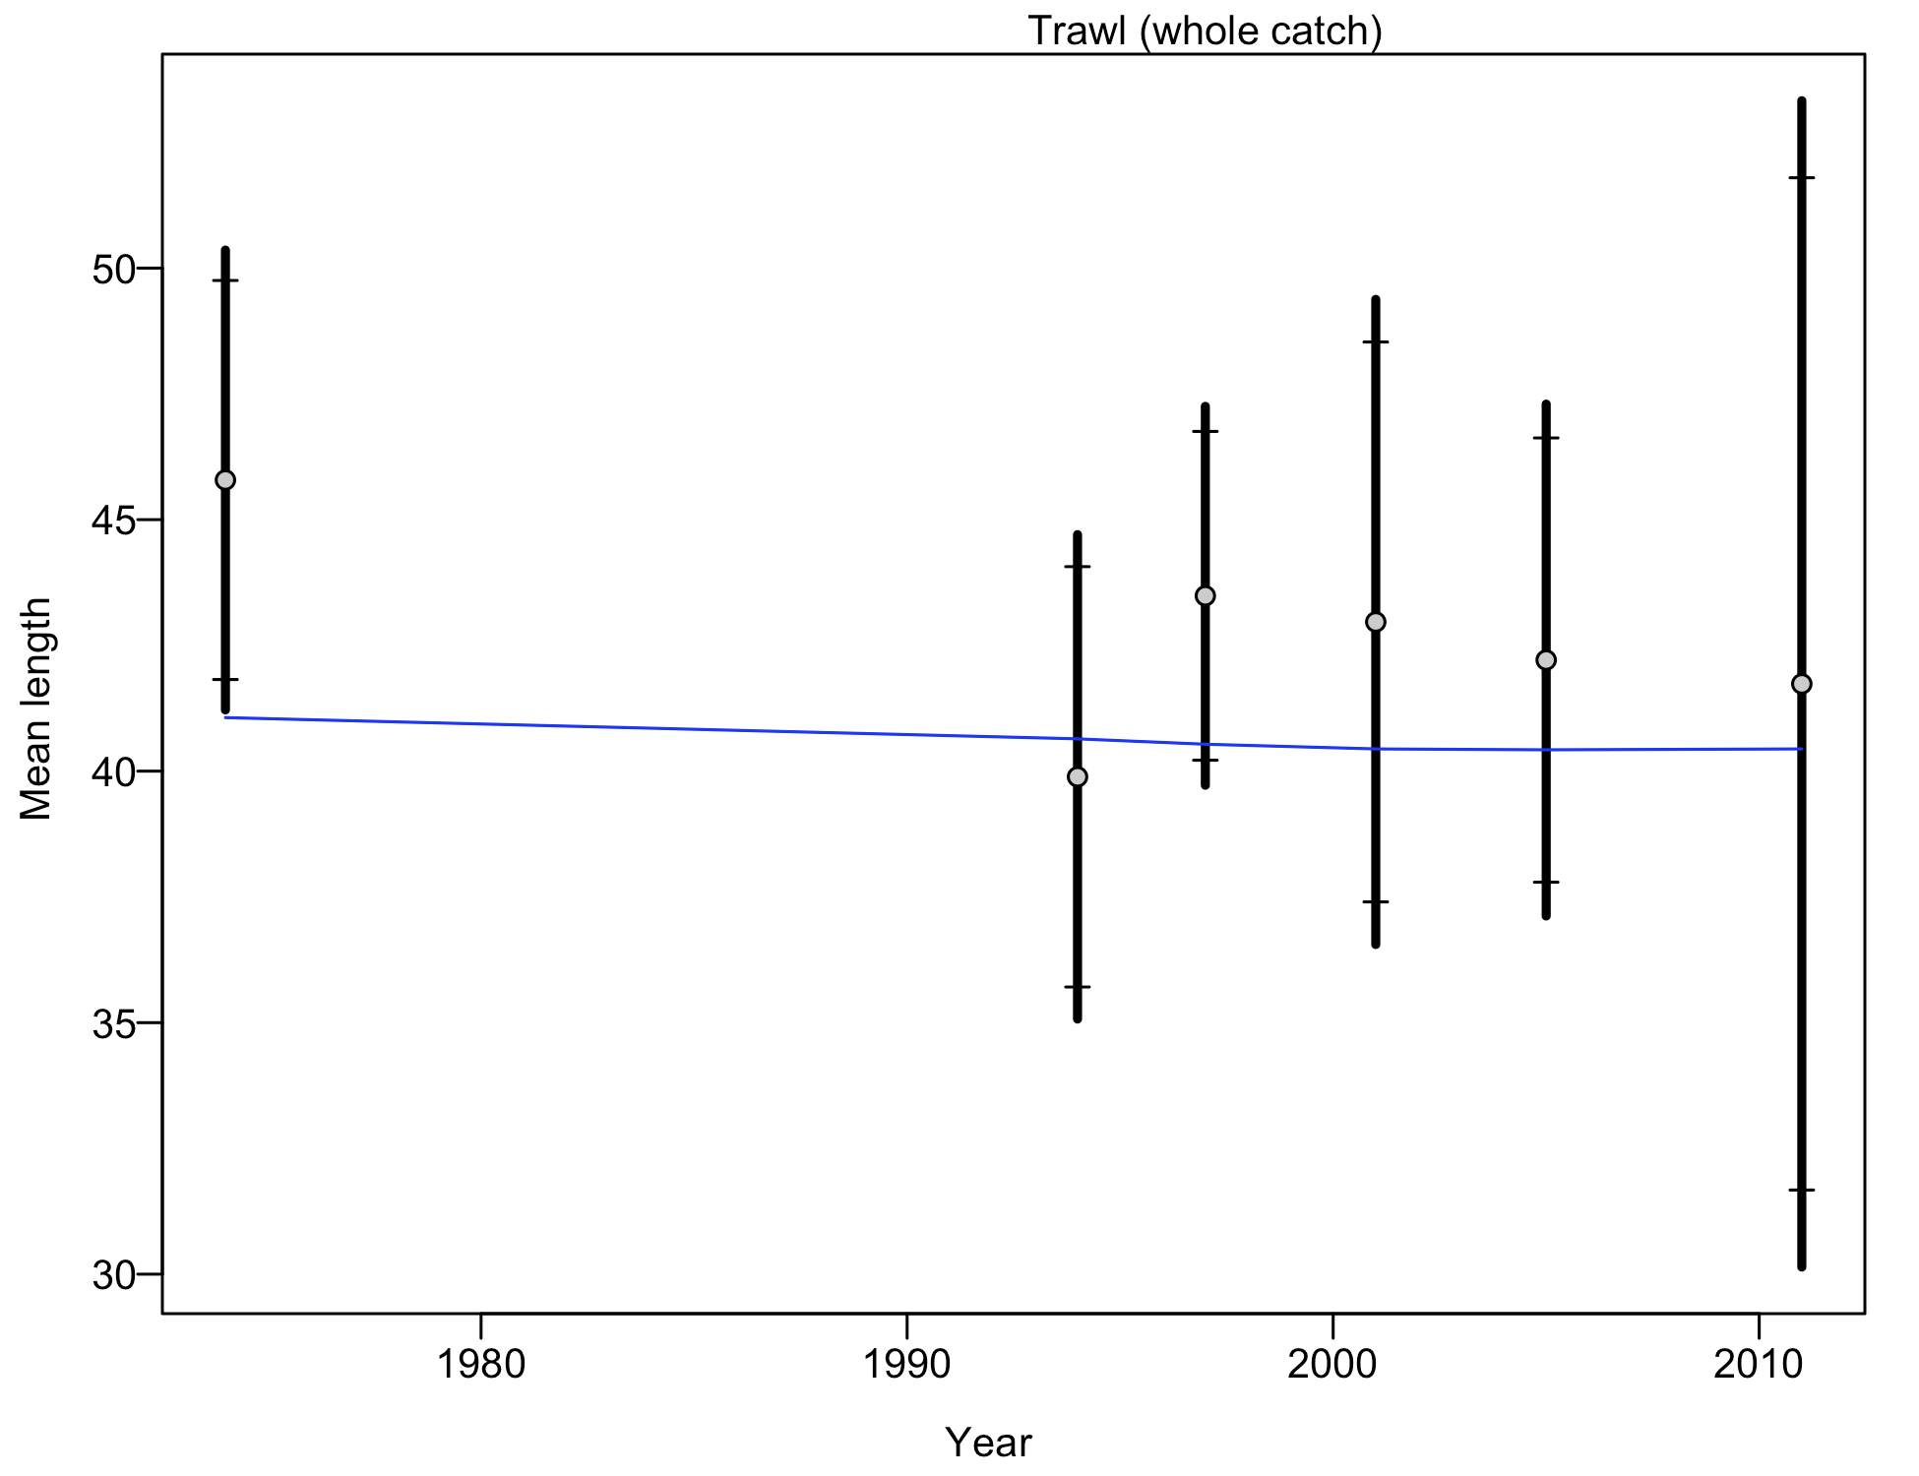

Figure . Francis weighting fits to the mean lengths by year for the Oregon trawl commercial fleet.

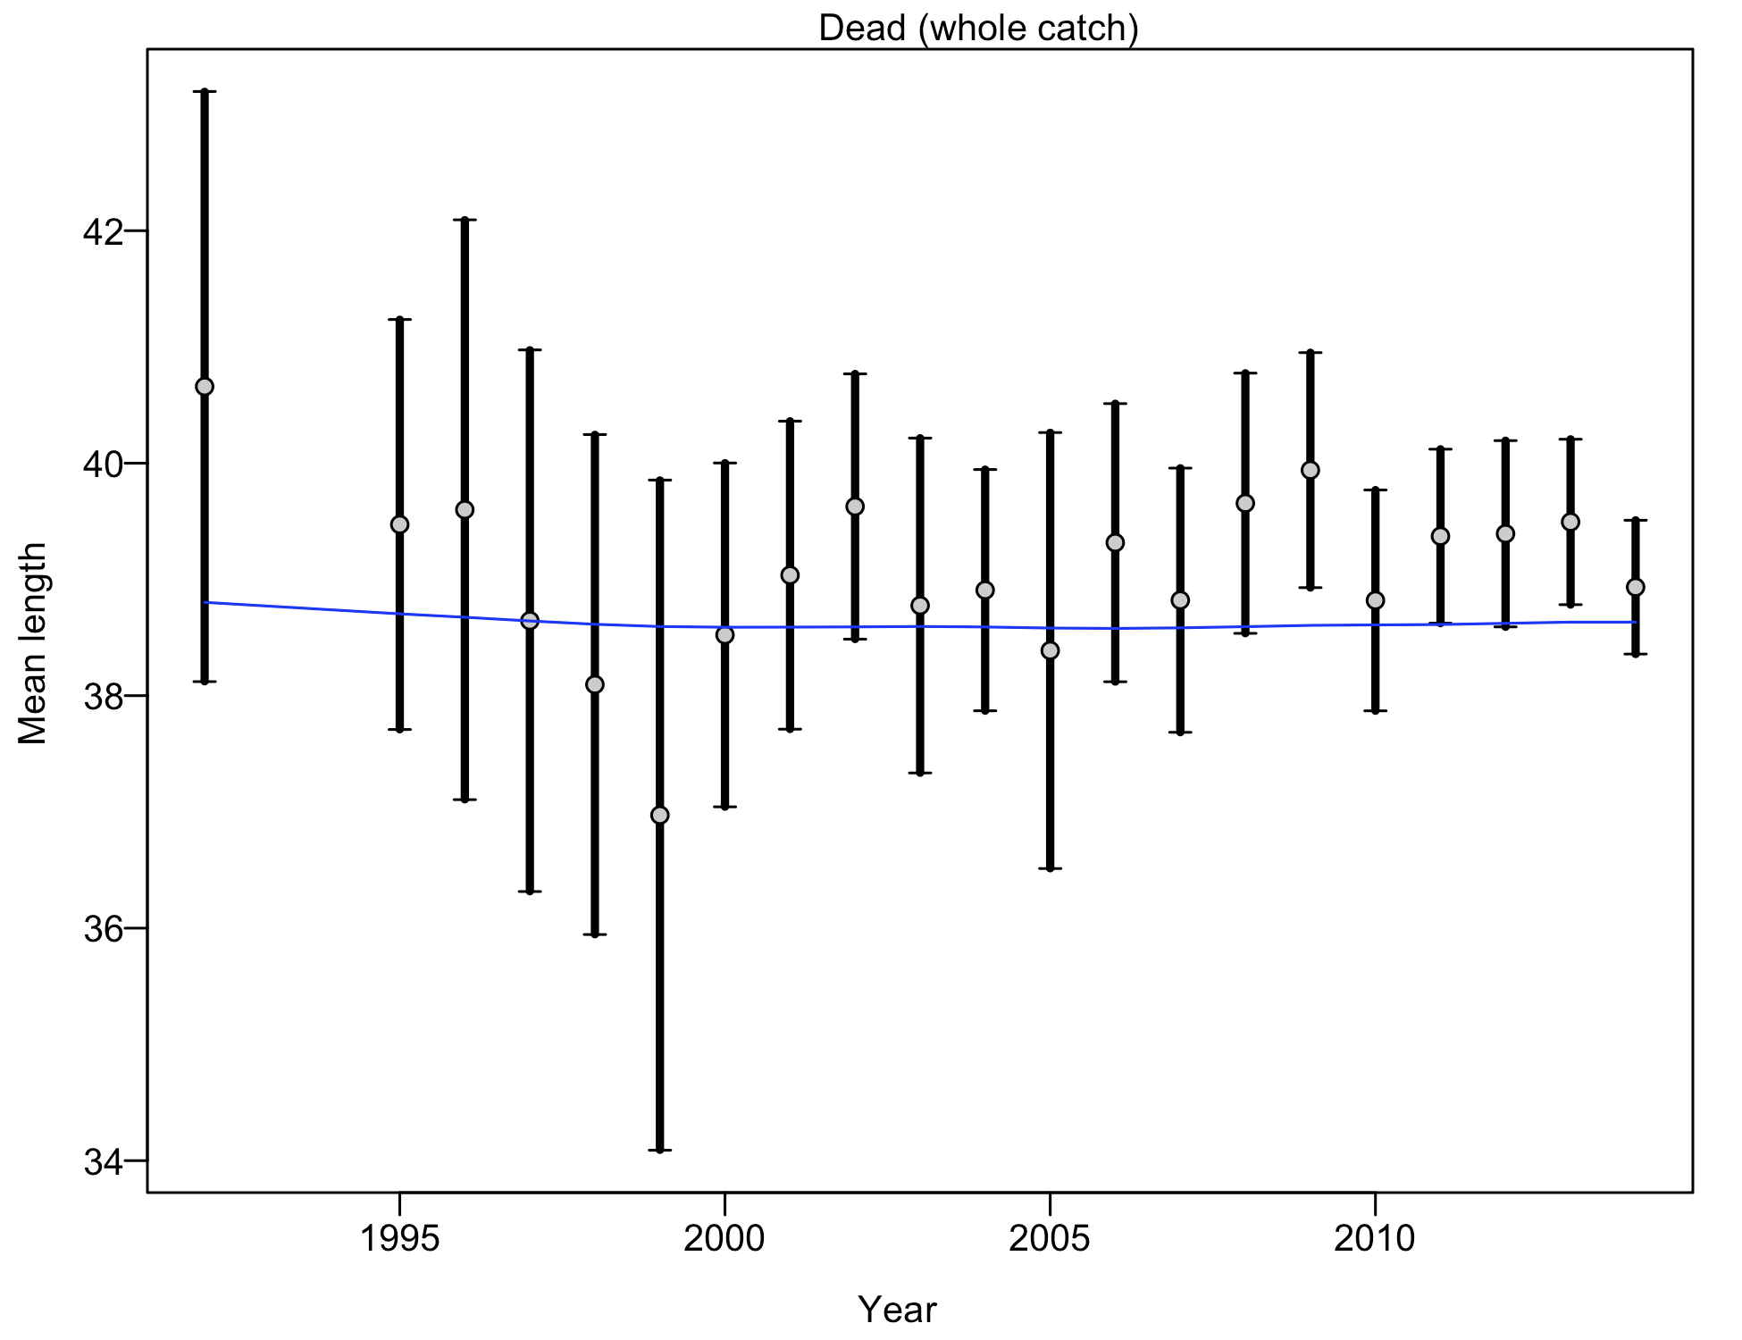

Figure . Francis weighting fits to the mean lengths by year for the Oregon non-trawl-dead commercial fleet.

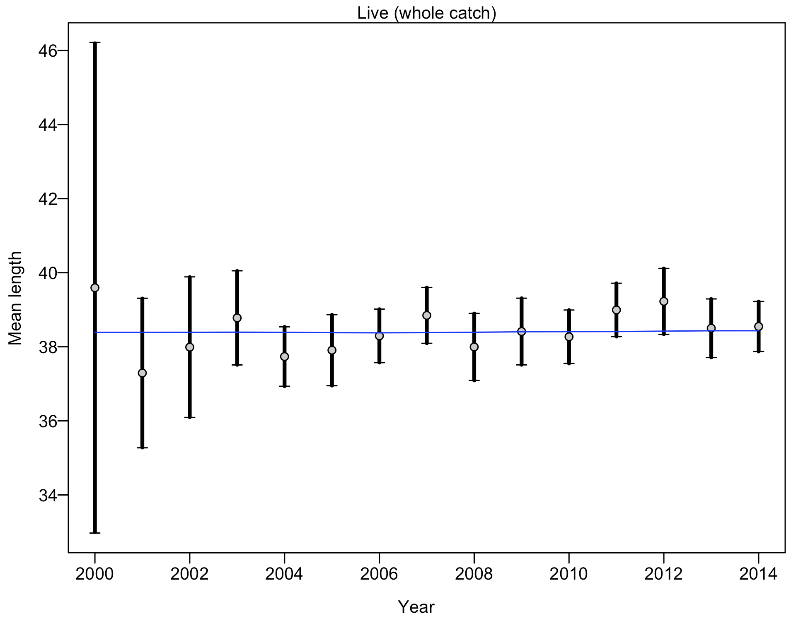

Figure . Francis weighting fits to the mean lengths by year for the Oregon non-trawl-live commercial fleet.

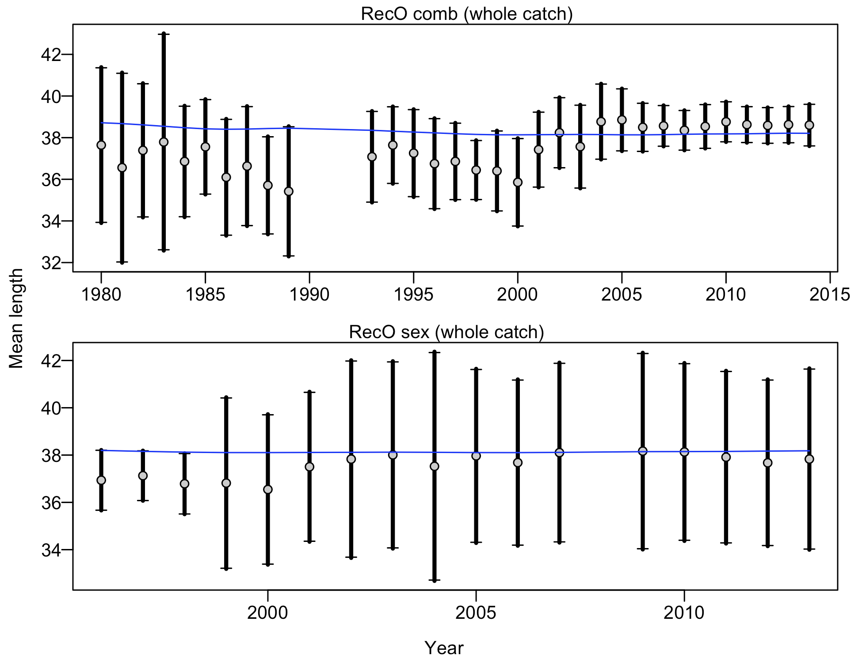

Figure . Francis weighting fits to the mean lengths by year for the Oregon Ocean boat recreational fleet.

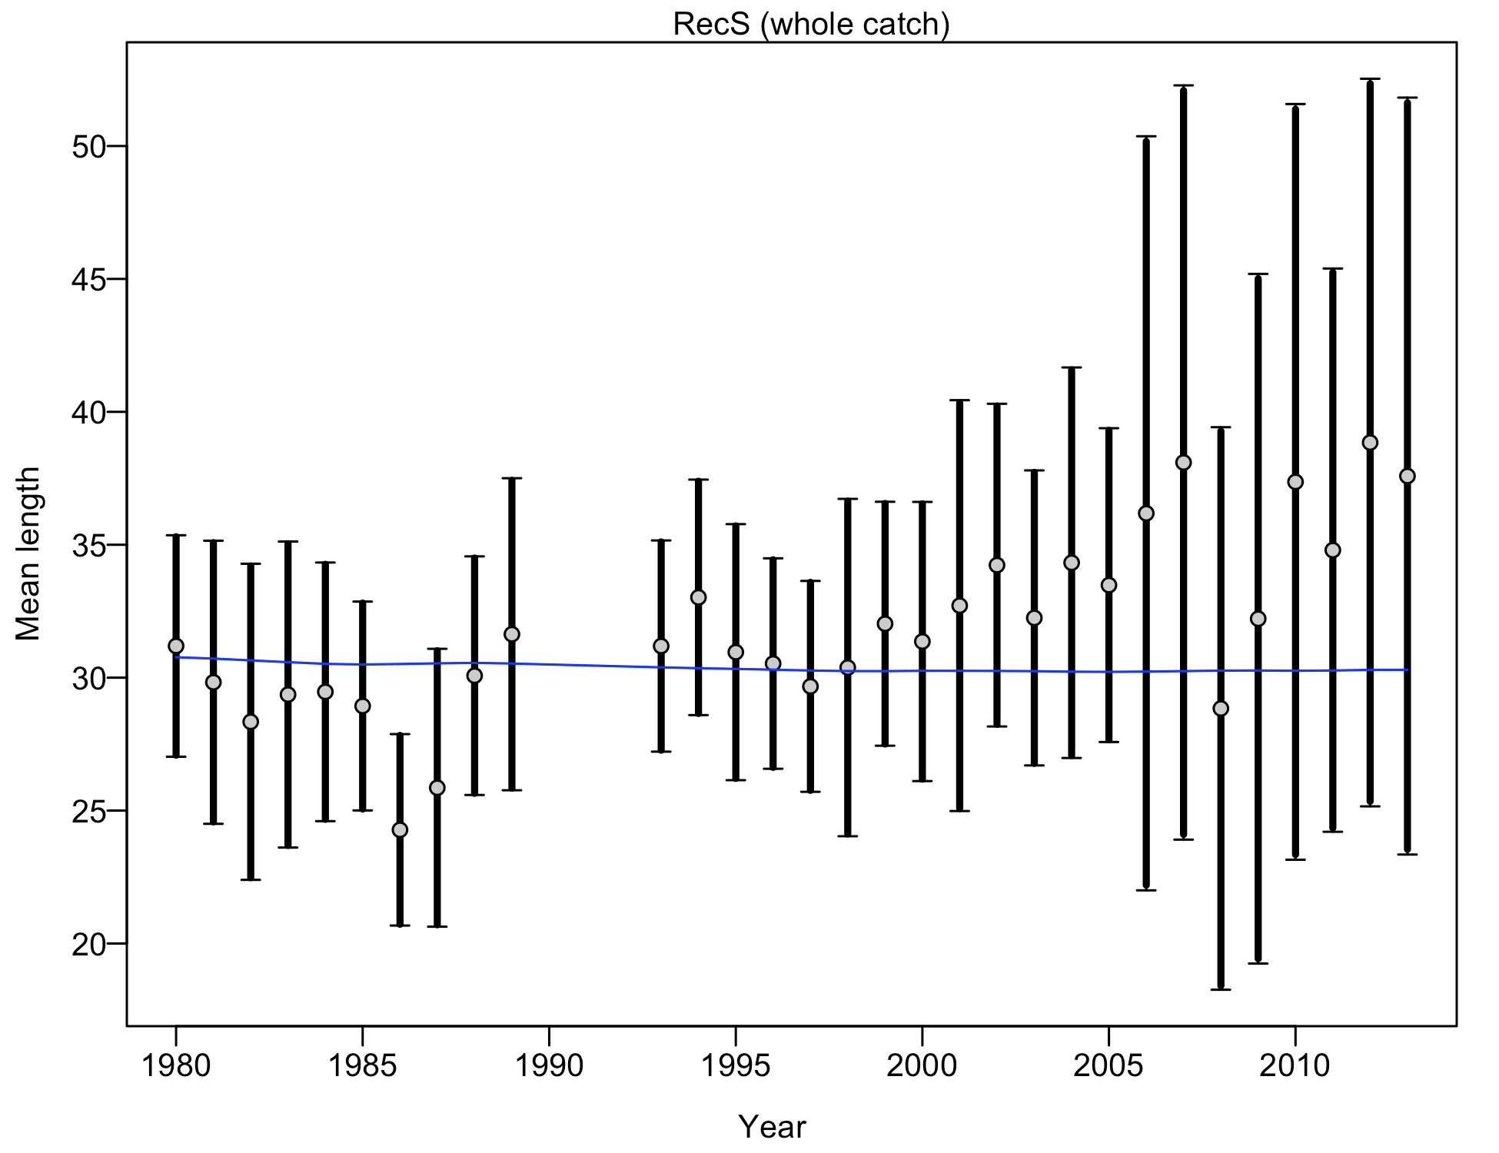

Figure . Francis weighting fits to the mean lengths by year for the Oregon Shore/Estuary recreational fleet.

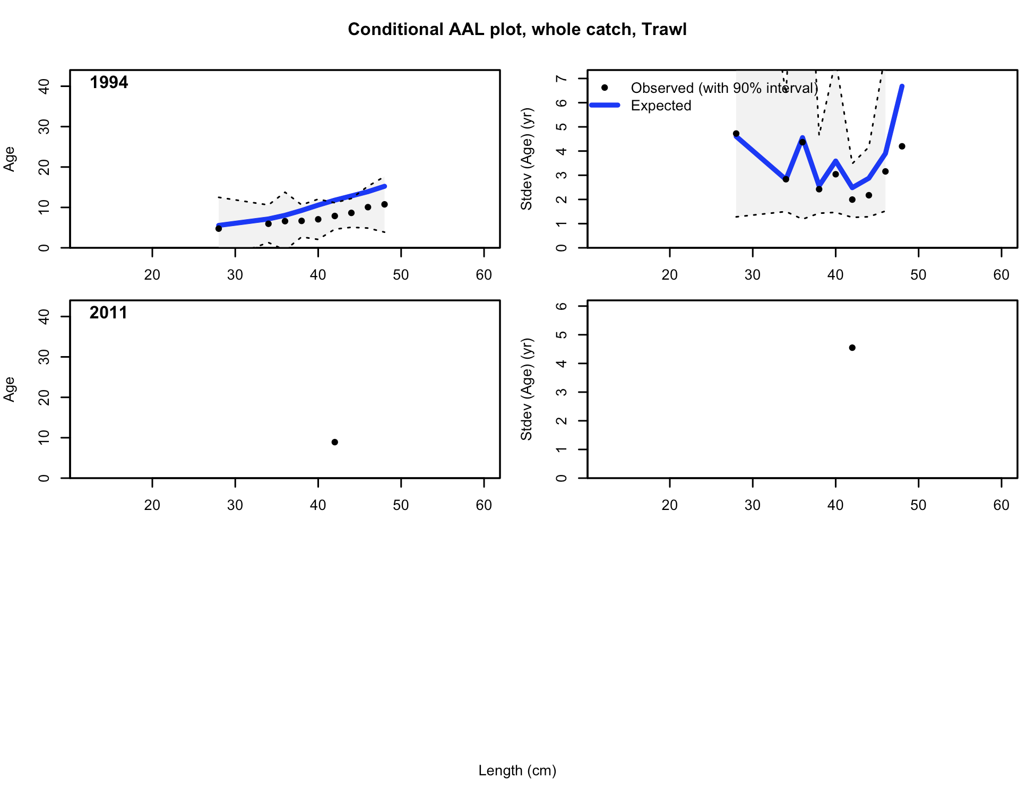

Figure . Conditional age-at-length samples and predictions for the Oregon trawl fleet.

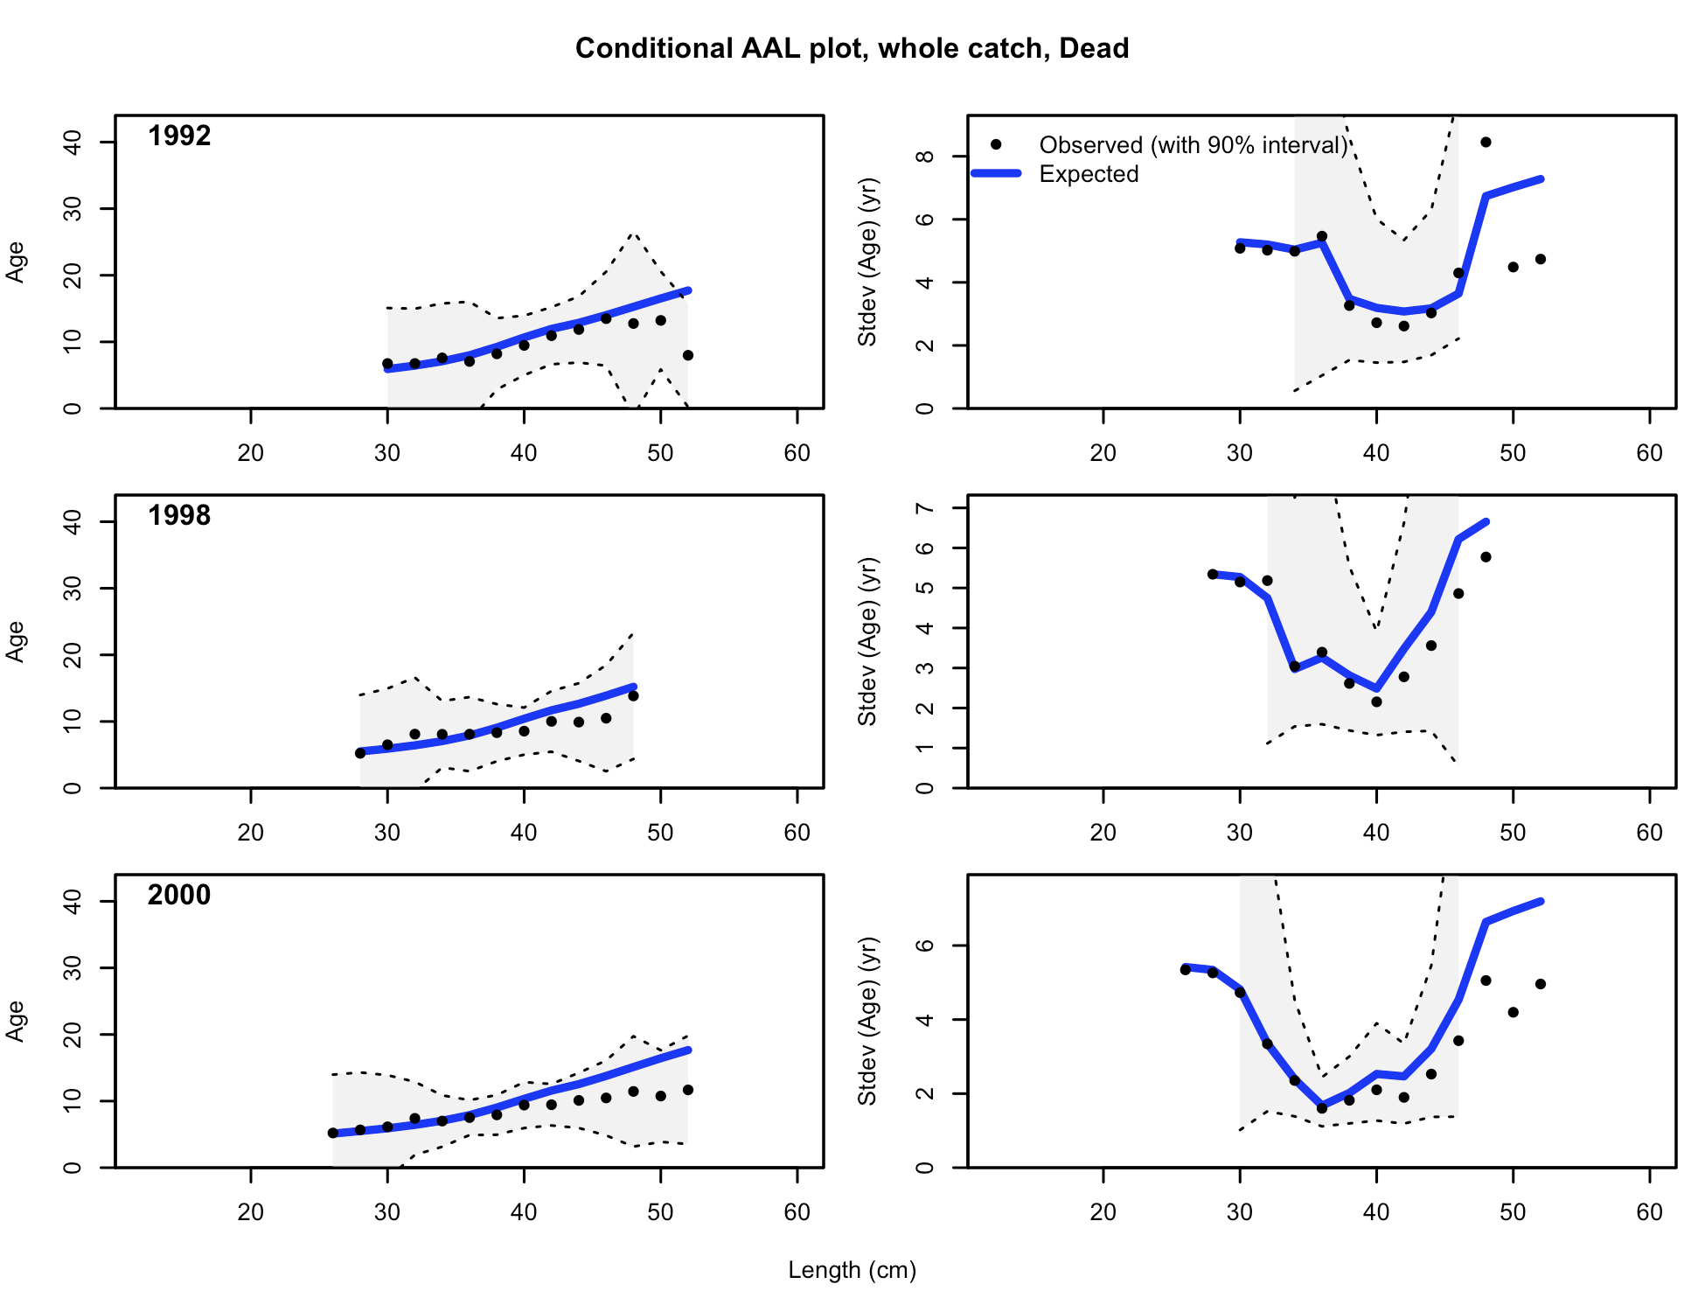

Figure . Conditional age-at-length samples and predictions for the Oregon non-trawl-dead fleet, 1 of 6.

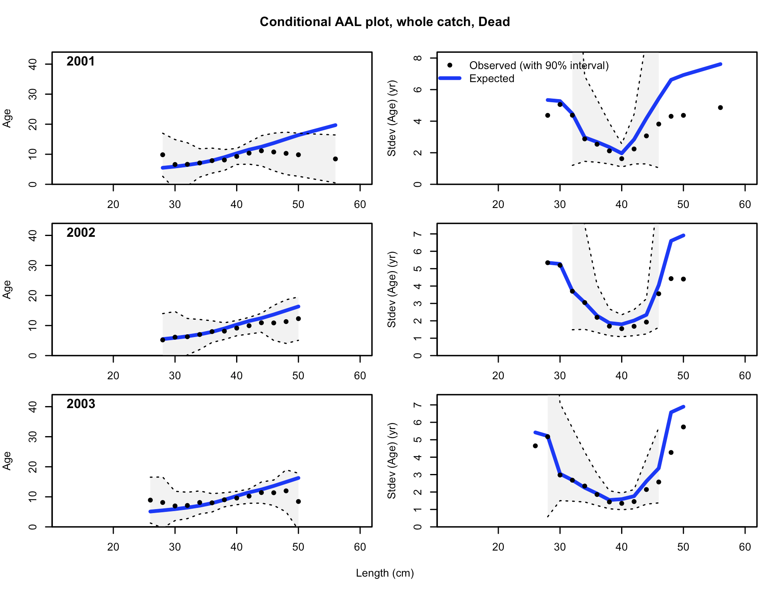

Figure . Conditional age-at-length samples and predictions for the Oregon non-trawl-dead fleet, 2 of 6.

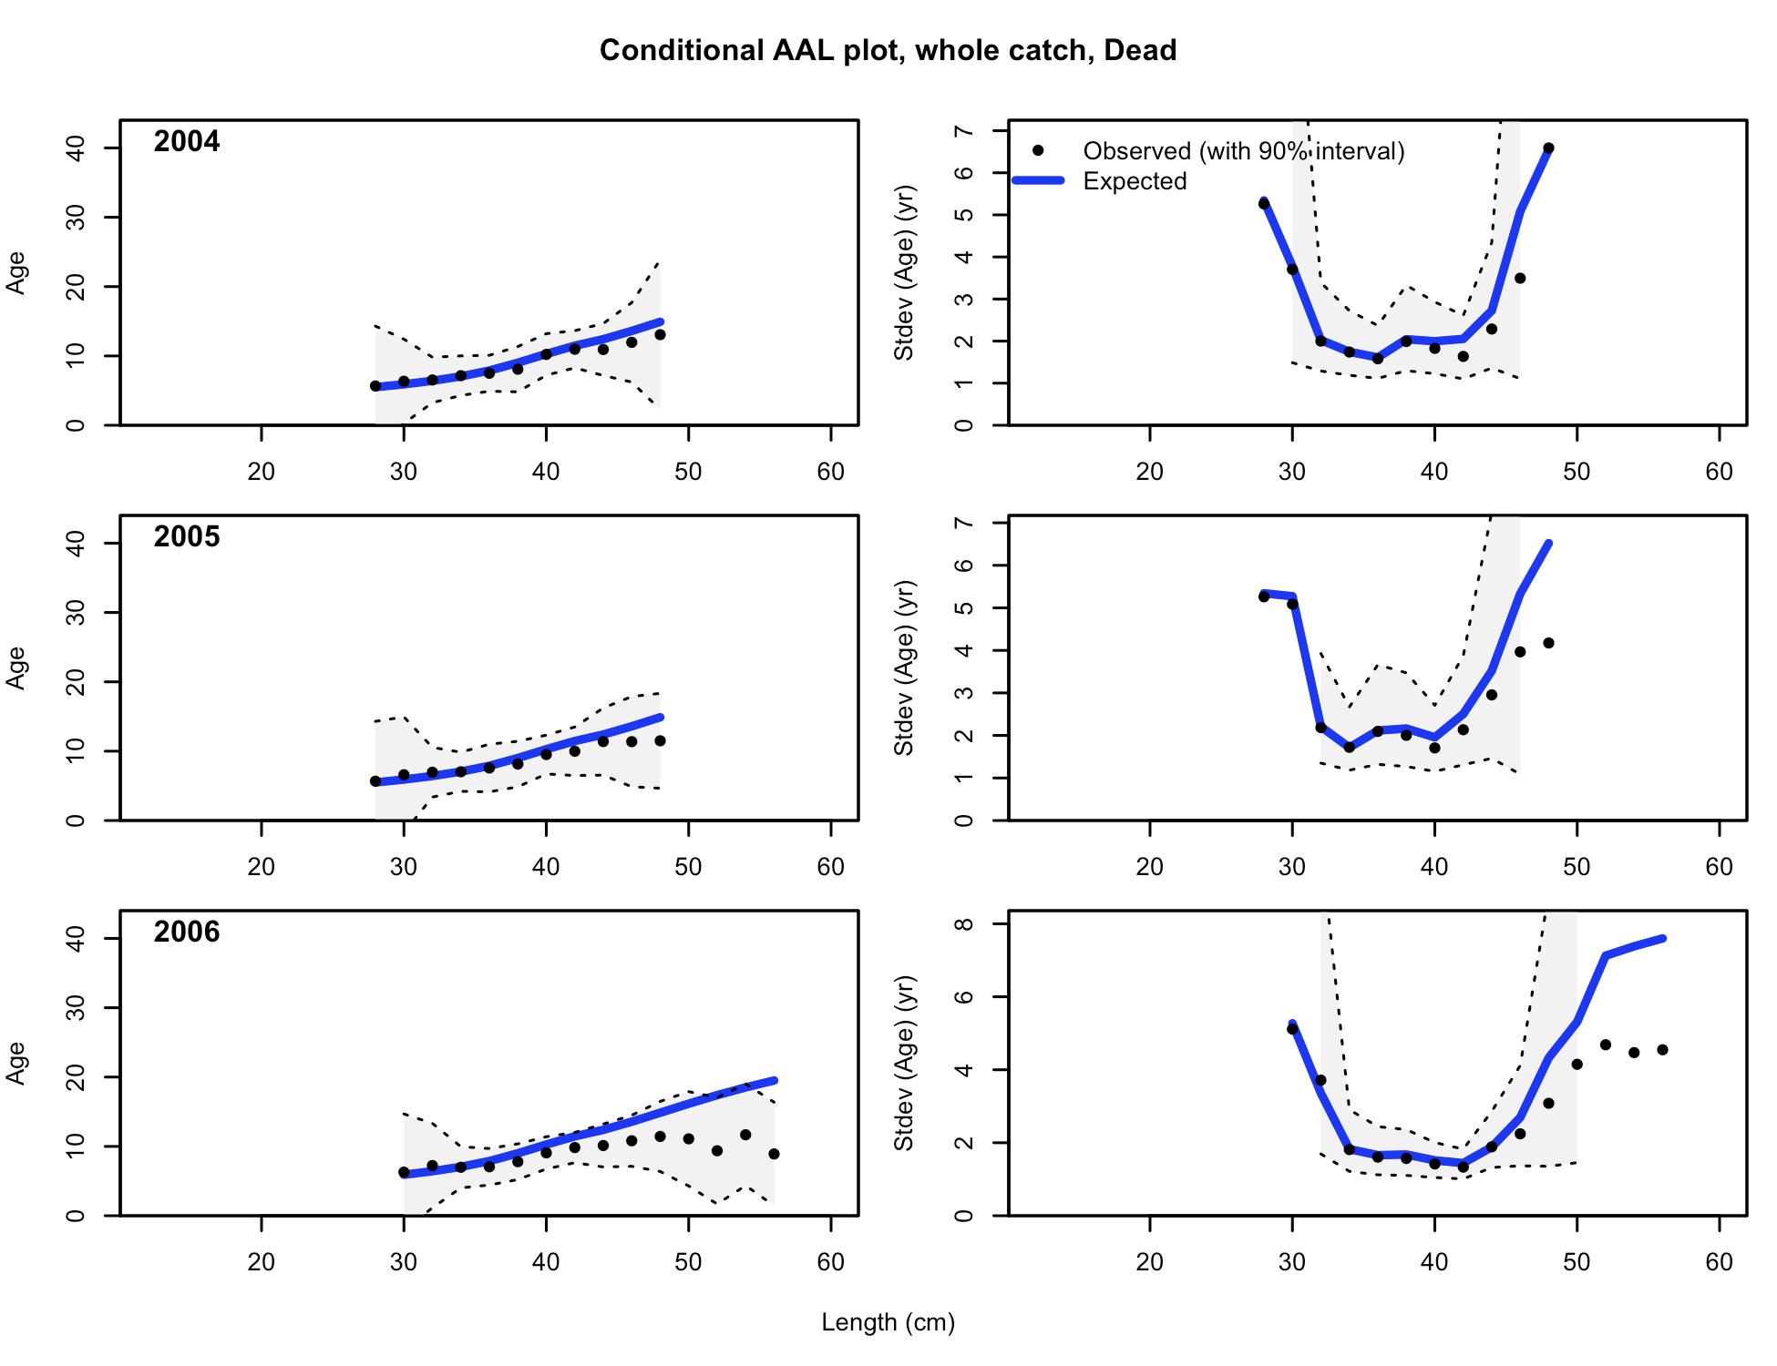

Figure . Conditional age-at-length samples and predictions for the Oregon non-trawl-dead fleet, 3 of 6.

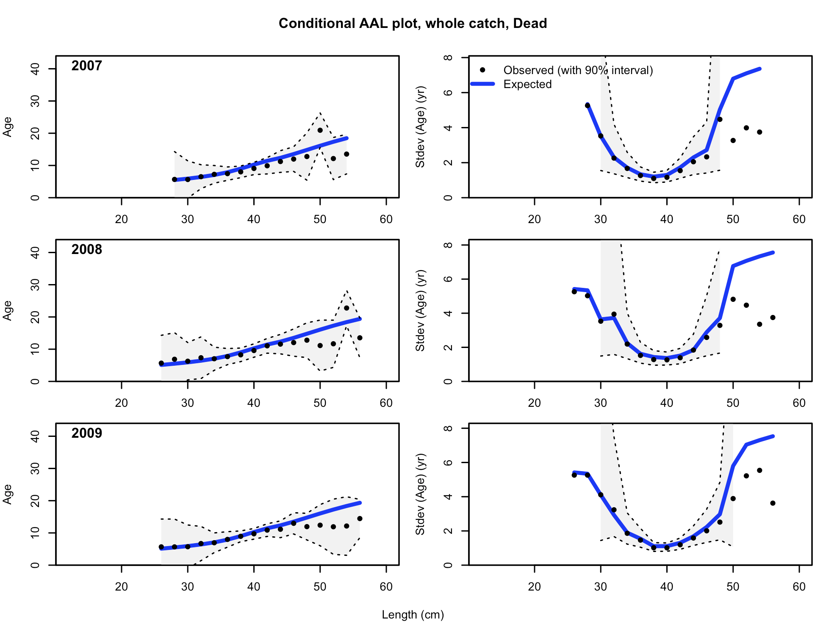

Figure . Conditional age-at-length samples and predictions for the Oregon non-trawl-dead fleet, 4 of 6.

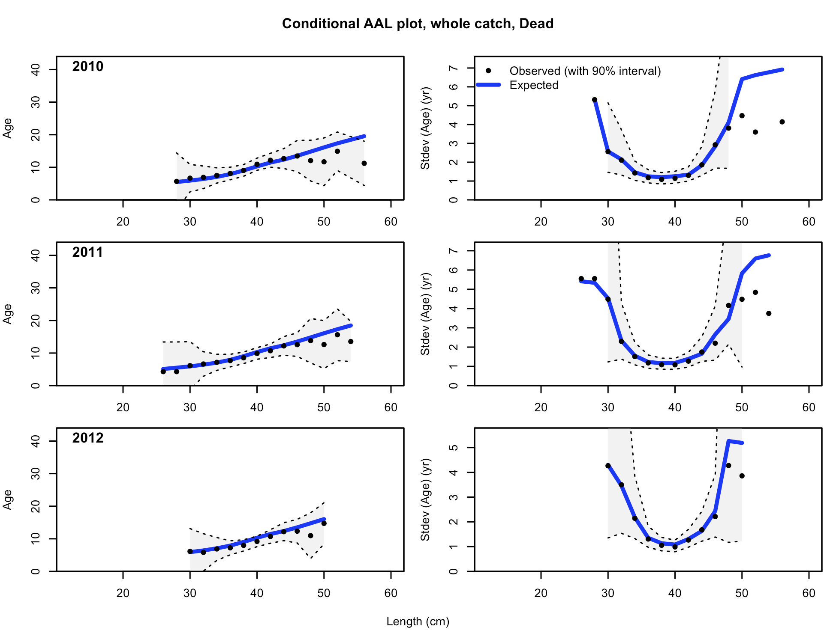

Figure . Conditional age-at-length samples and predictions for the Oregon non-trawl-dead fleet, 5 of 6.

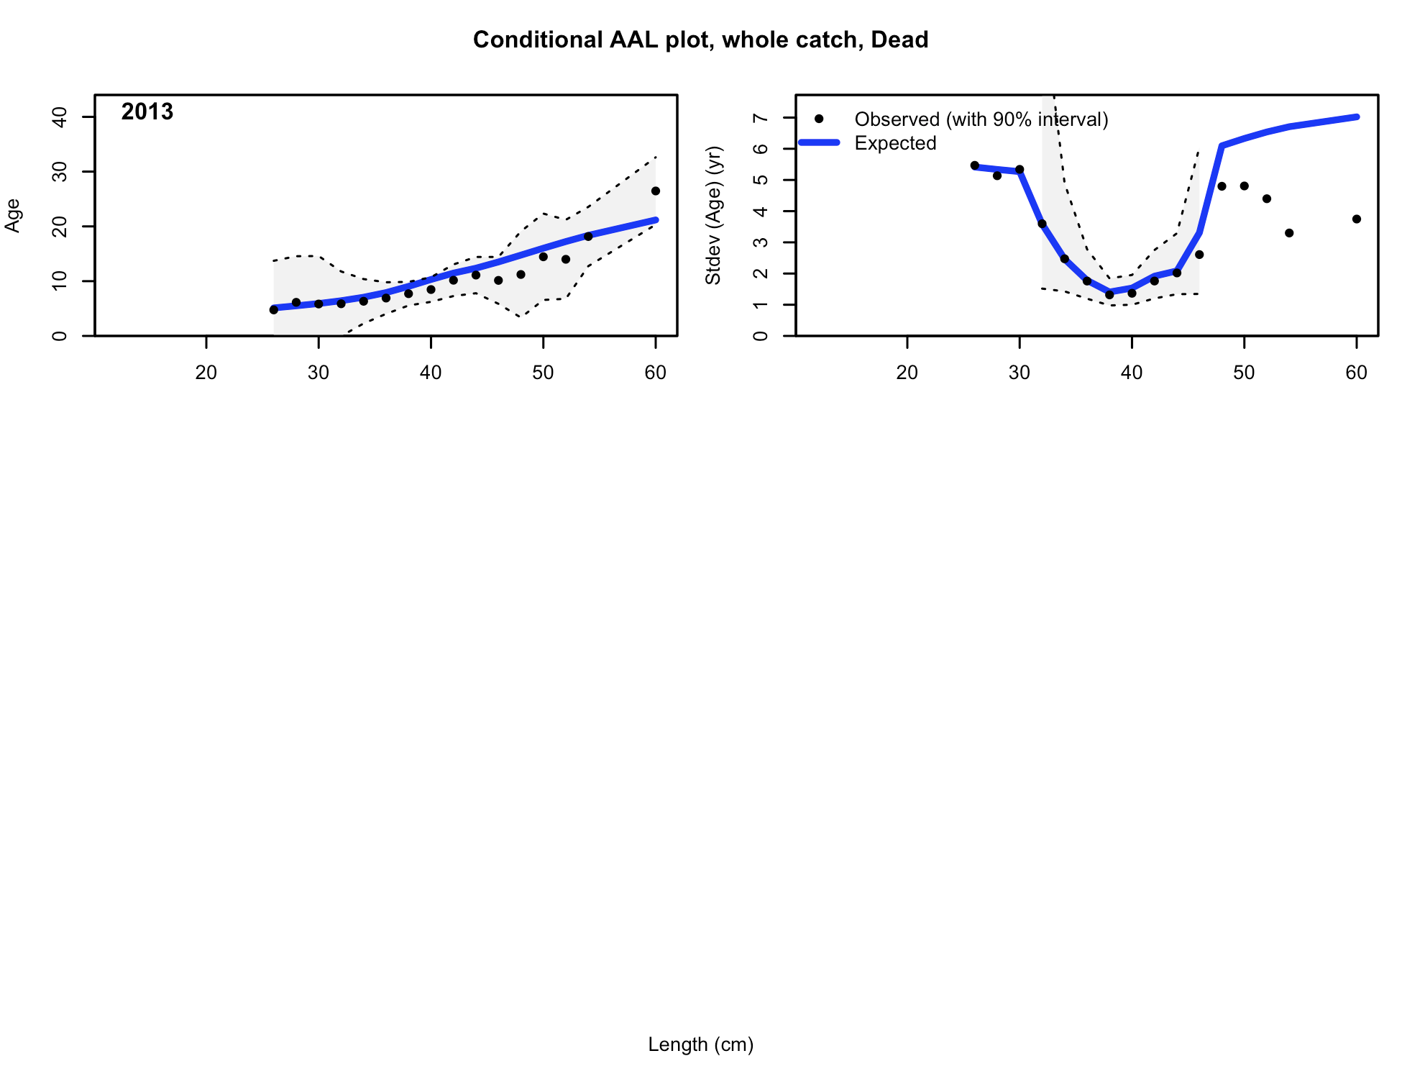

Figure . Conditional age-at-length samples and predictions for the Oregon non-trawl-dead fleet, 6 of 6.

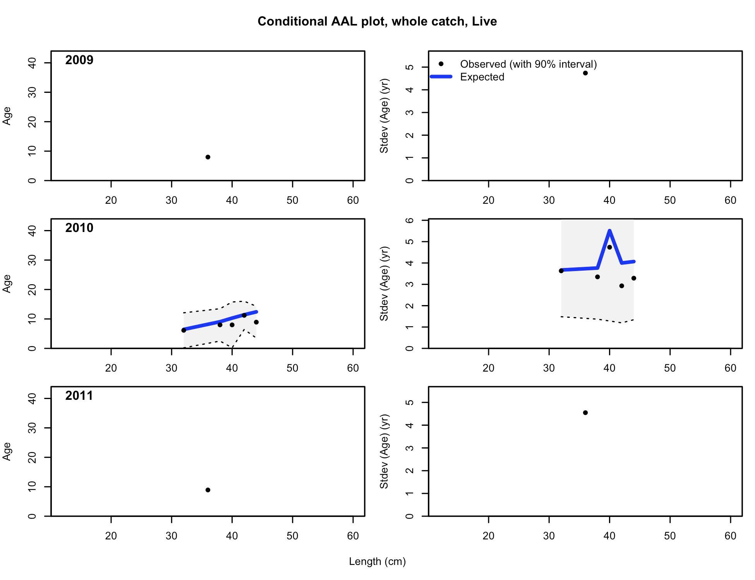

Figure . Conditional age-at-length samples and predictions for the Oregon non-trawl-live fleet.

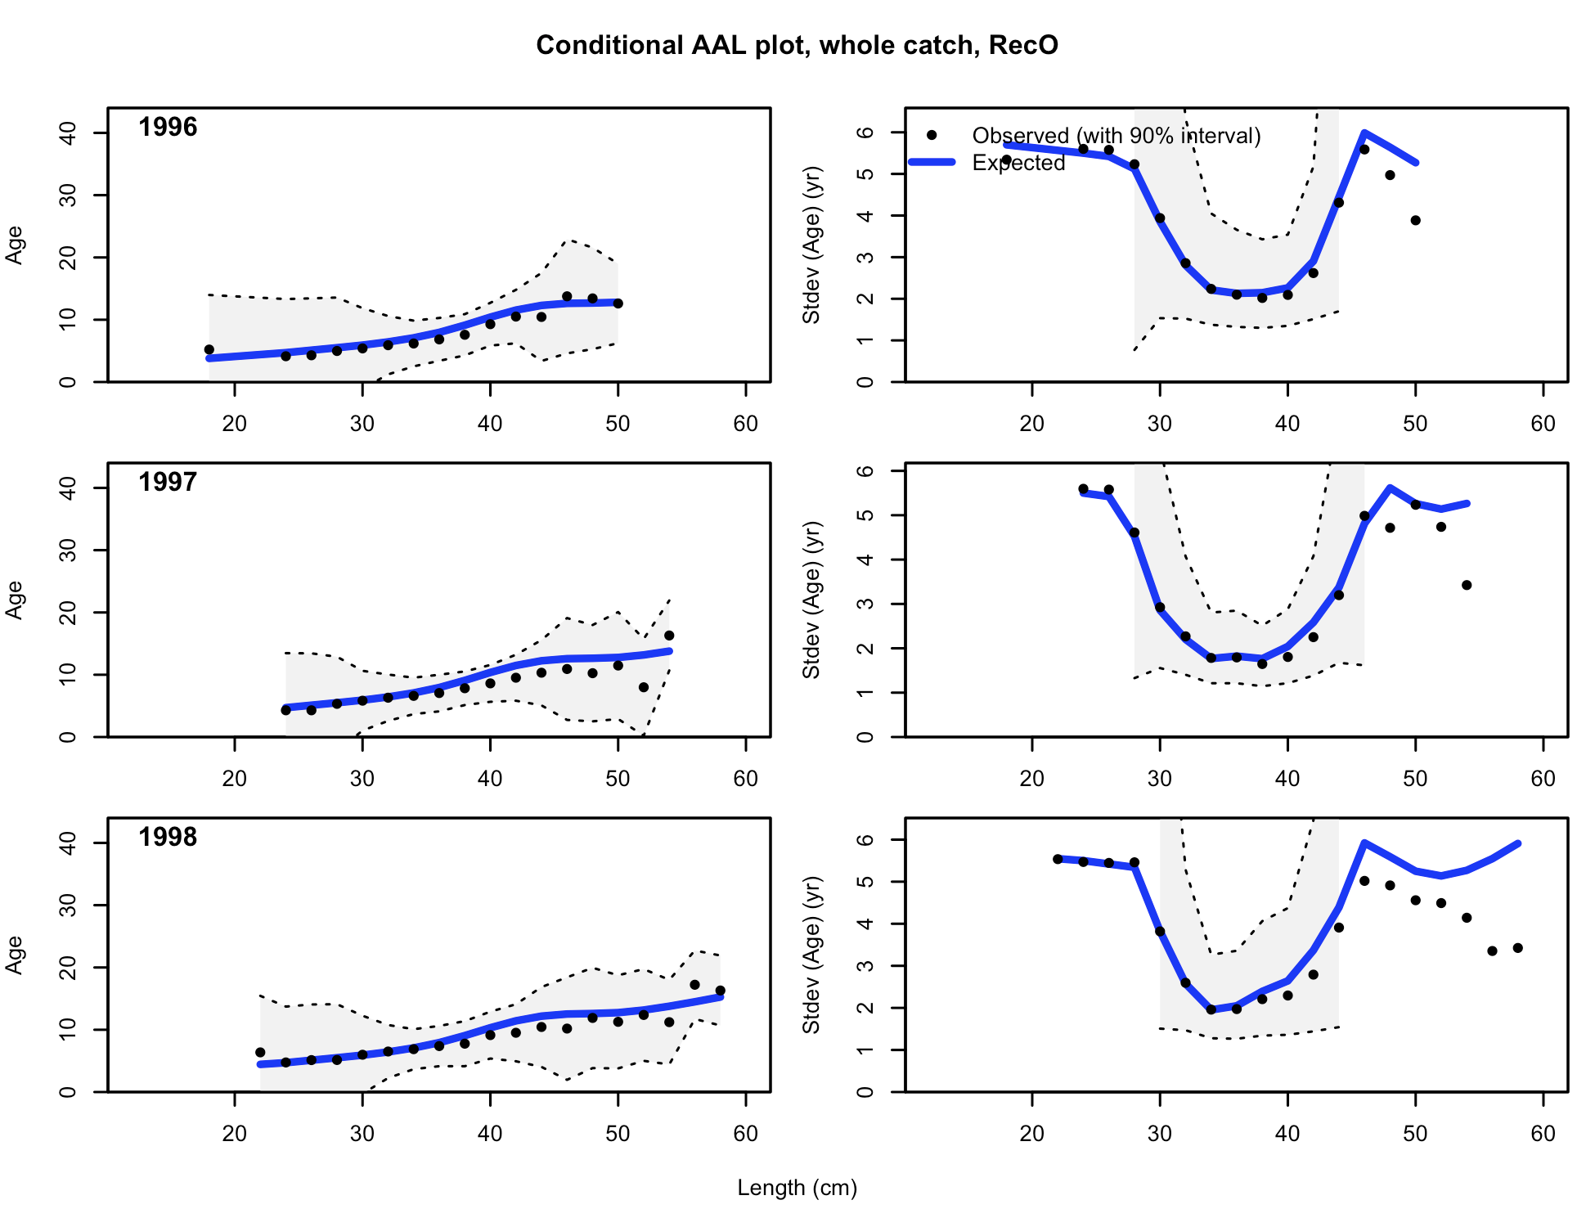

Figure . Age composition samples and predictions for the Oregon Ocean boat recreational fishery, 1 of 6.

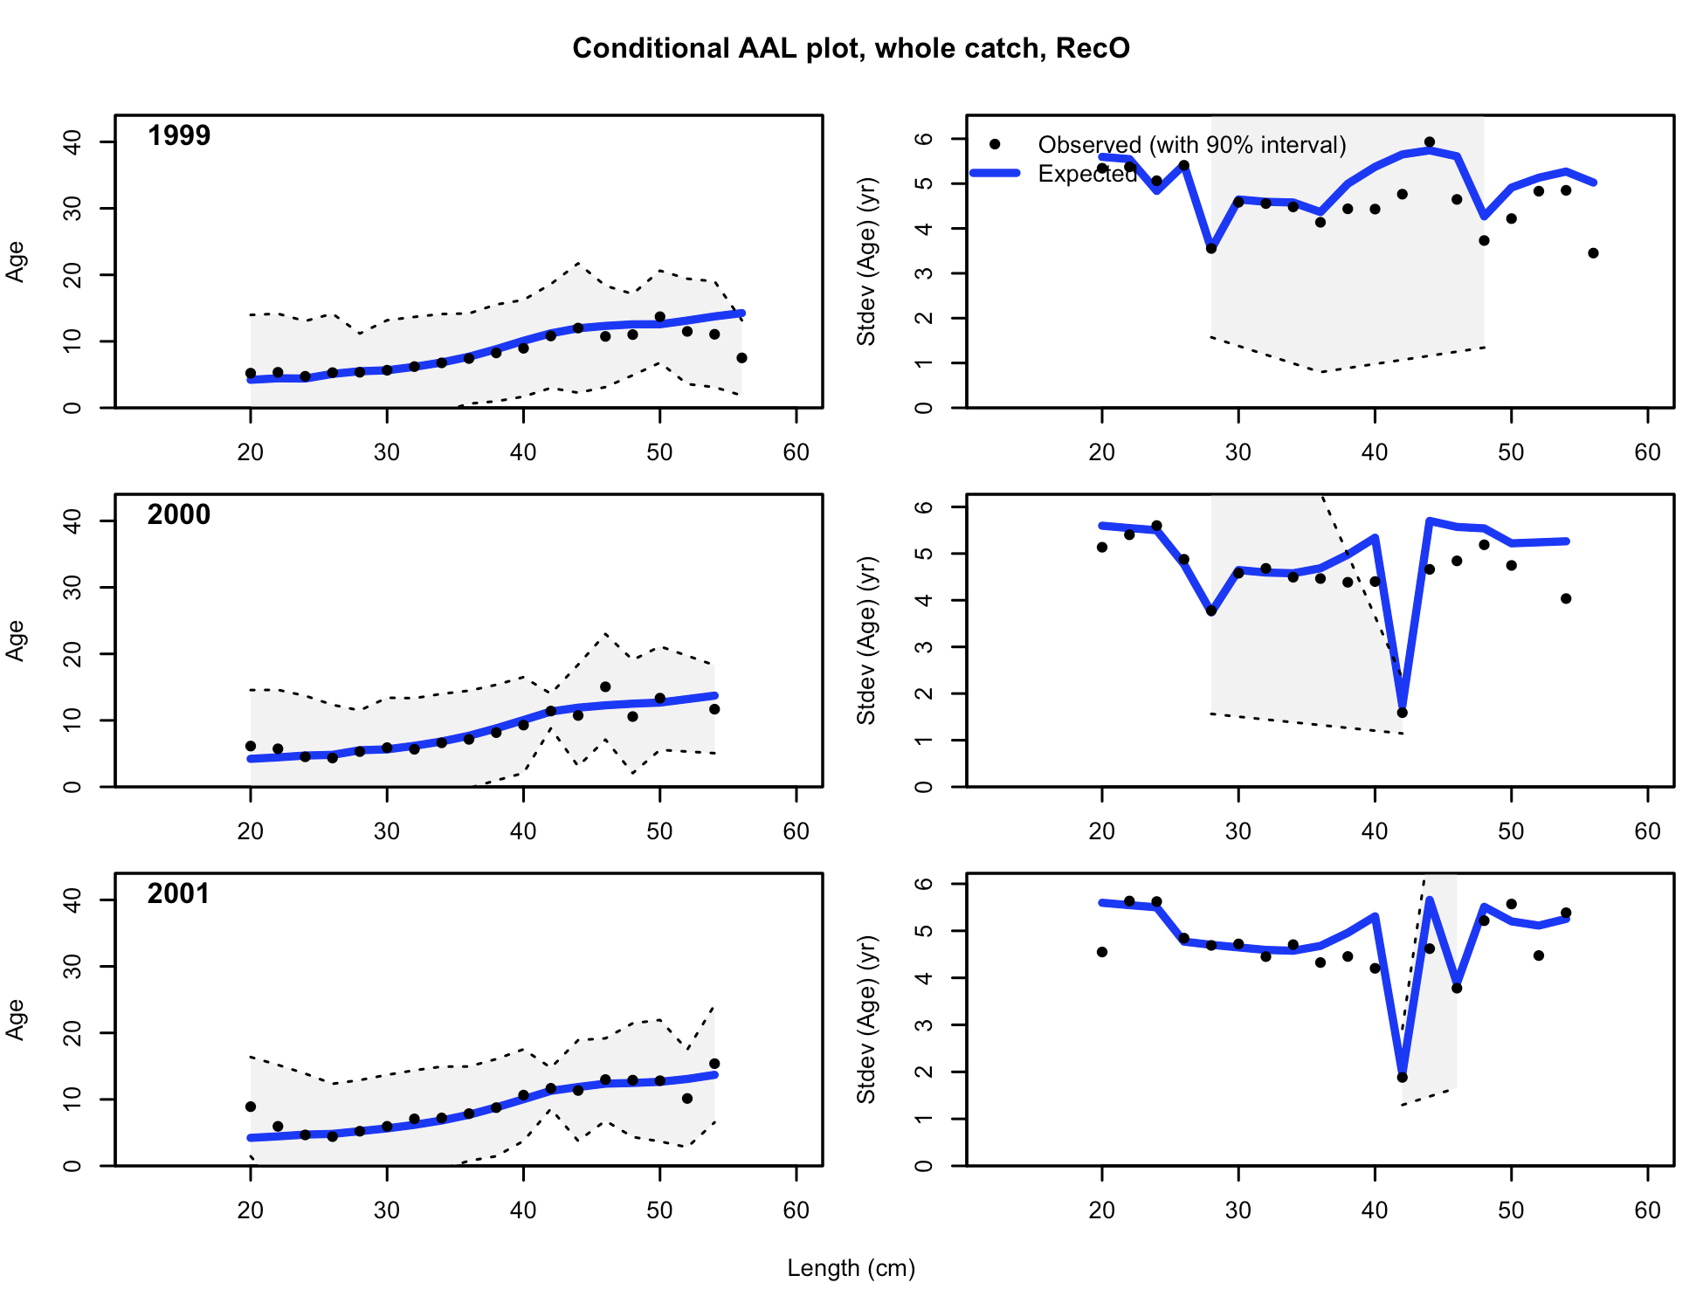

Figure . Age composition samples and predictions for the Oregon Ocean boat recreational fishery, 2 of 6.

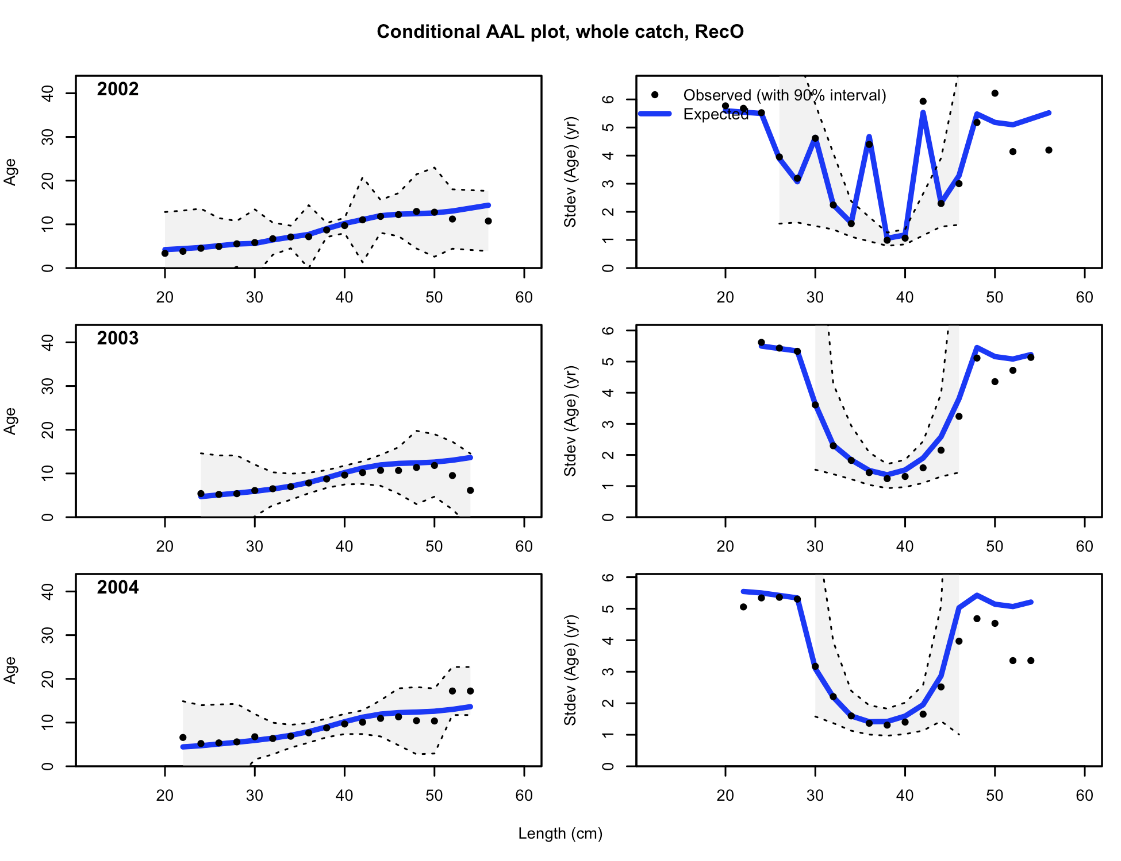

Figure . Age composition samples and predictions for the Oregon Ocean boat recreational fishery, 3 of 6.

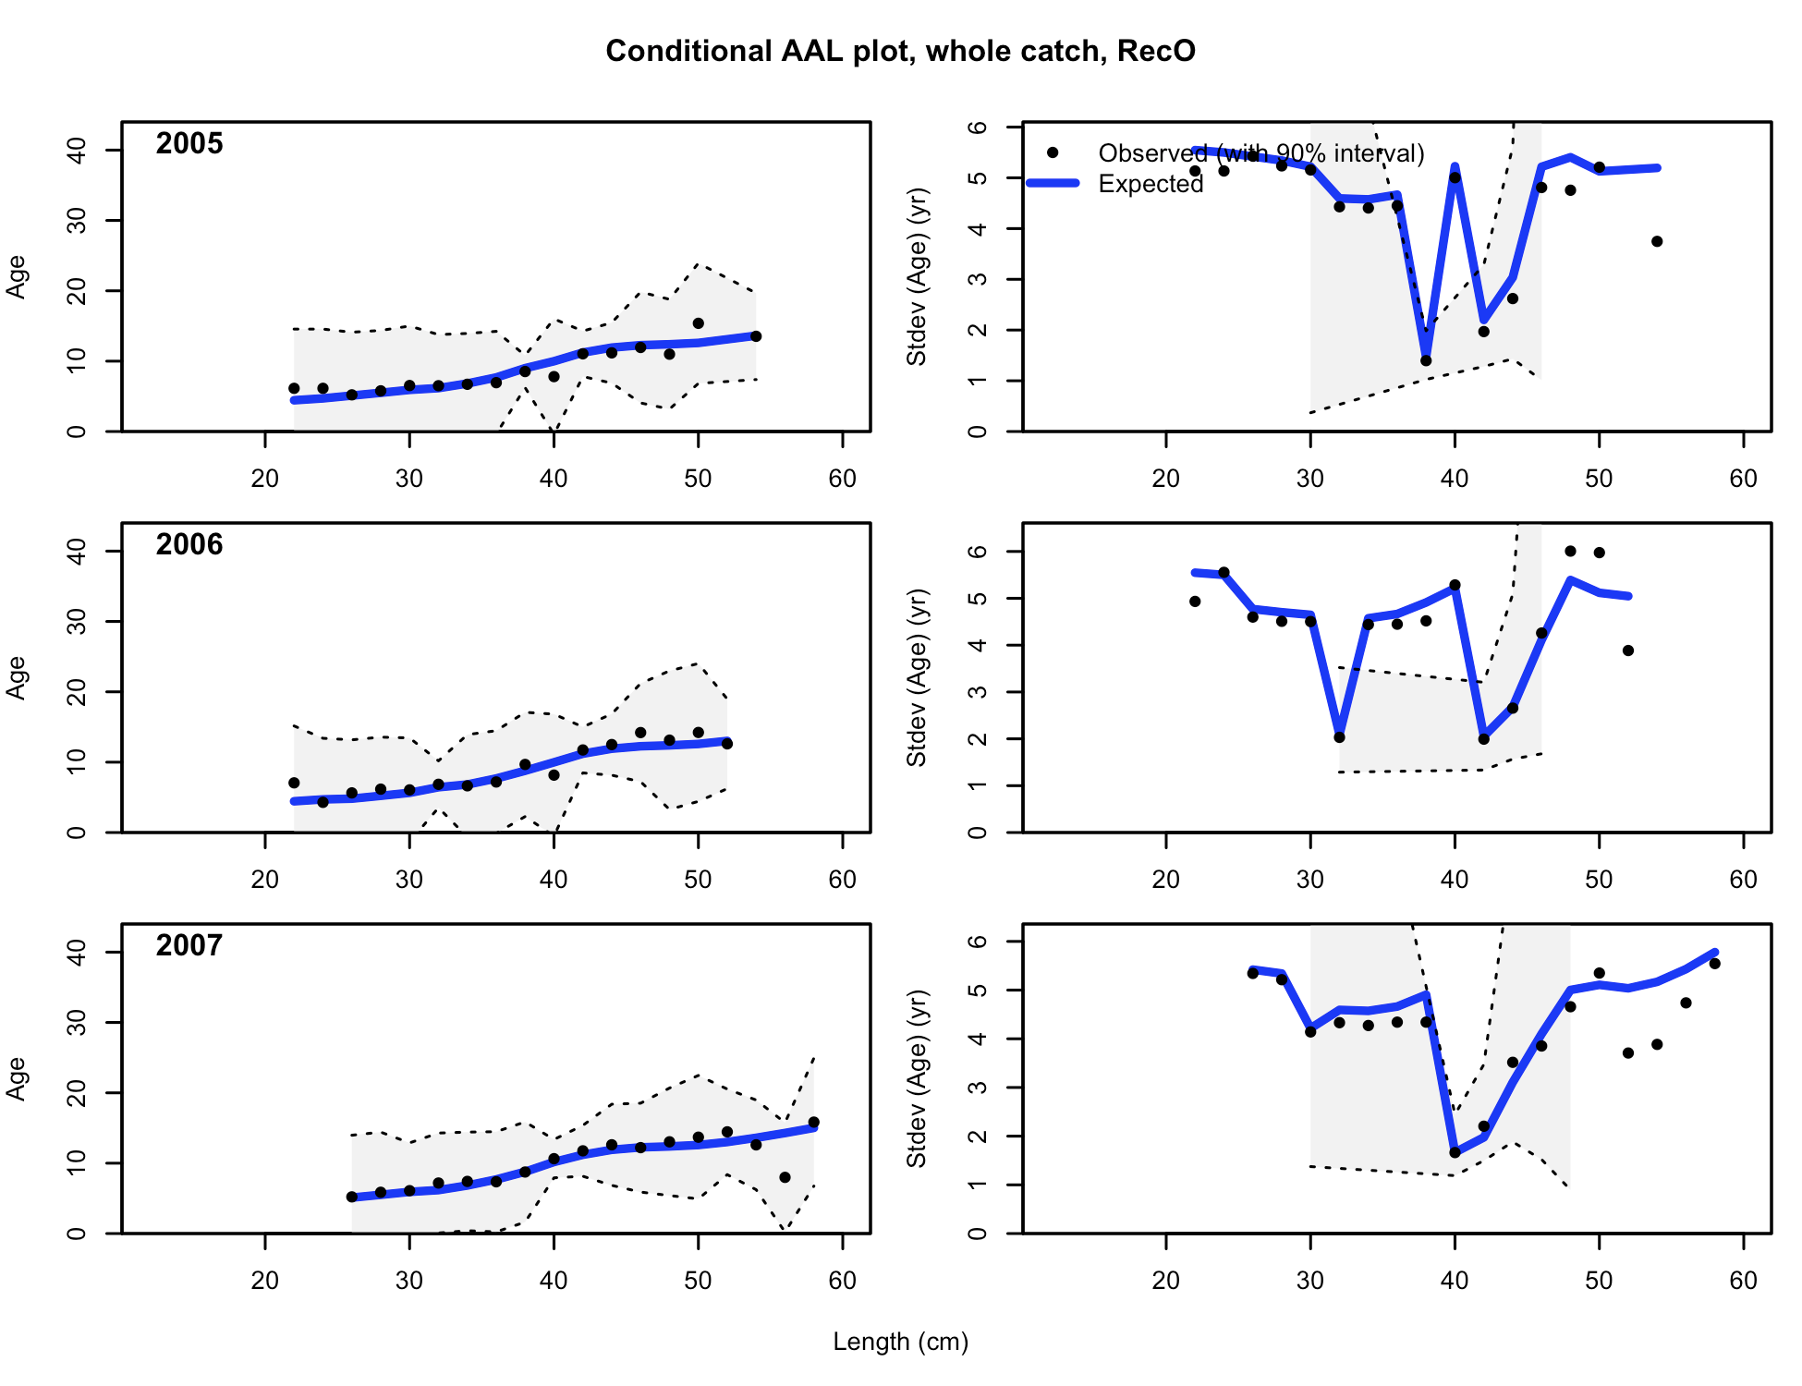

Figure . Age composition samples and predictions for the Oregon Ocean boat recreational fishery, 4 of 6.

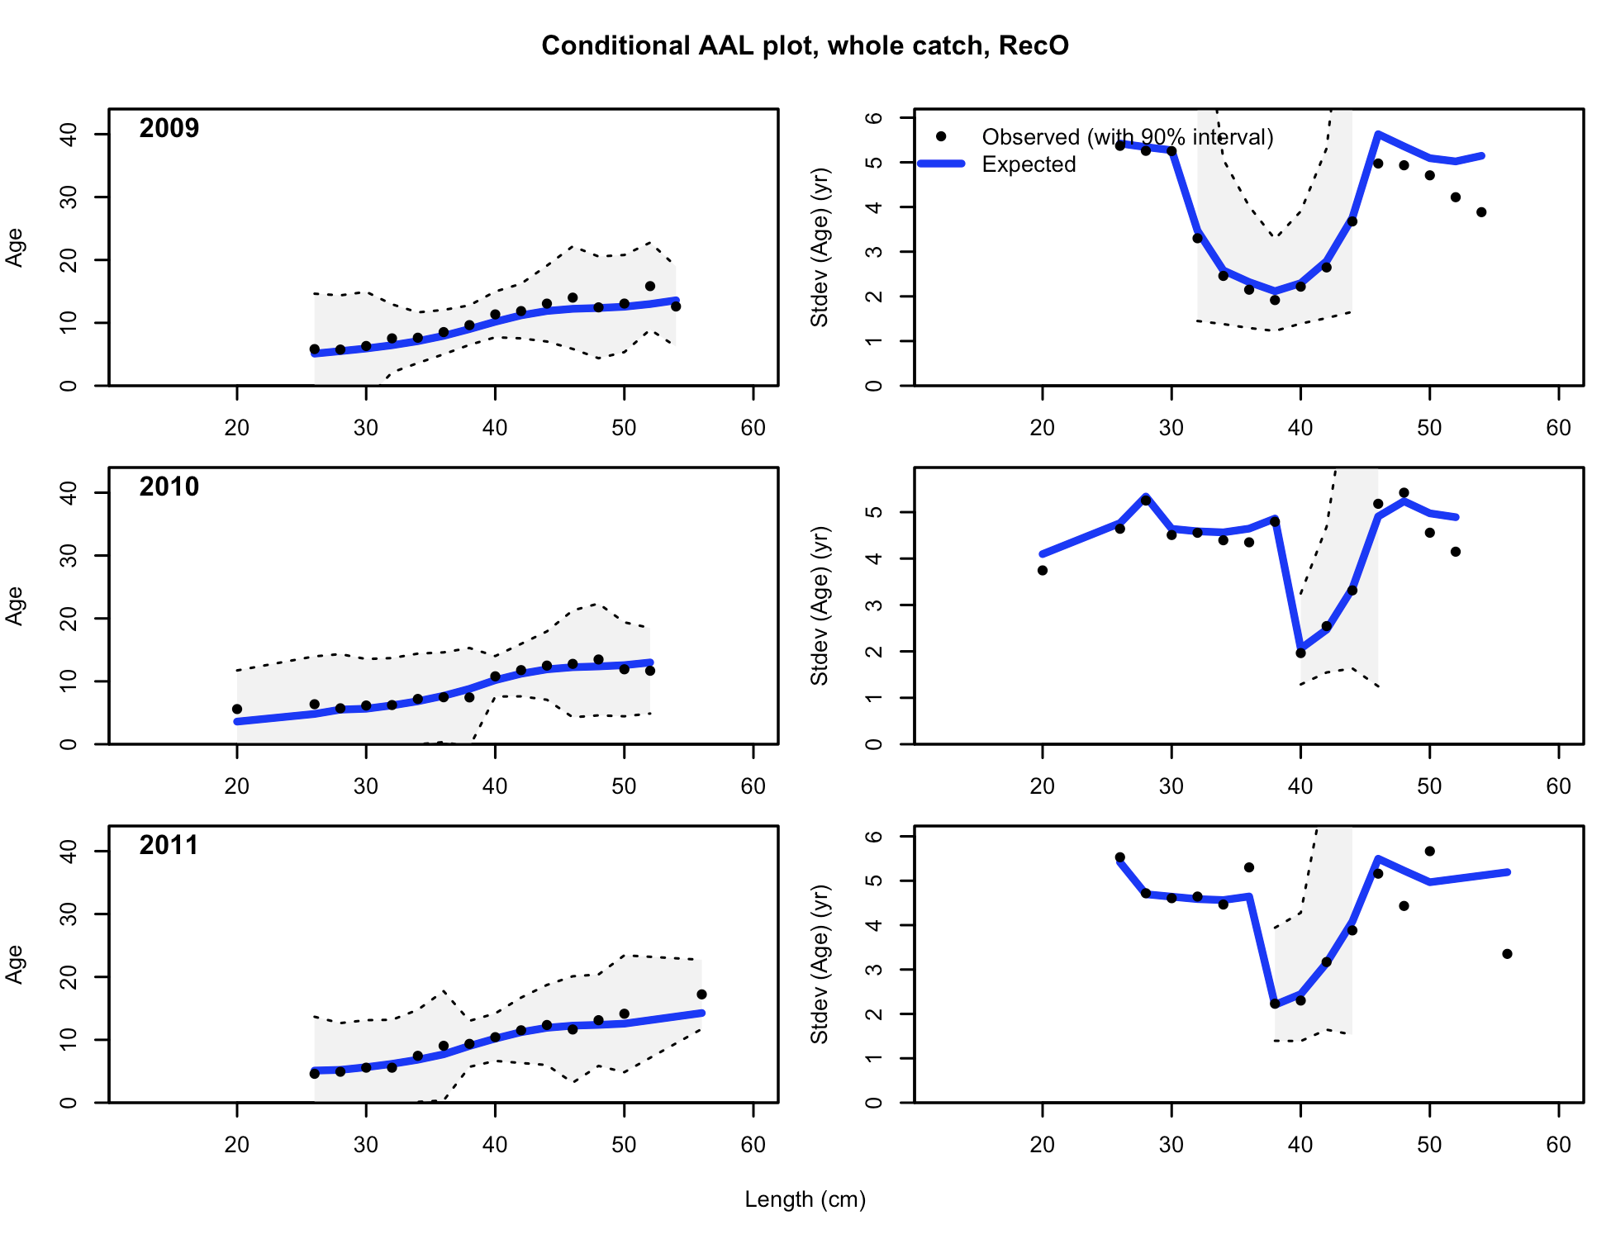

Figure . Age composition samples and predictions for the Oregon Ocean boat recreational fishery, 5 of 6.

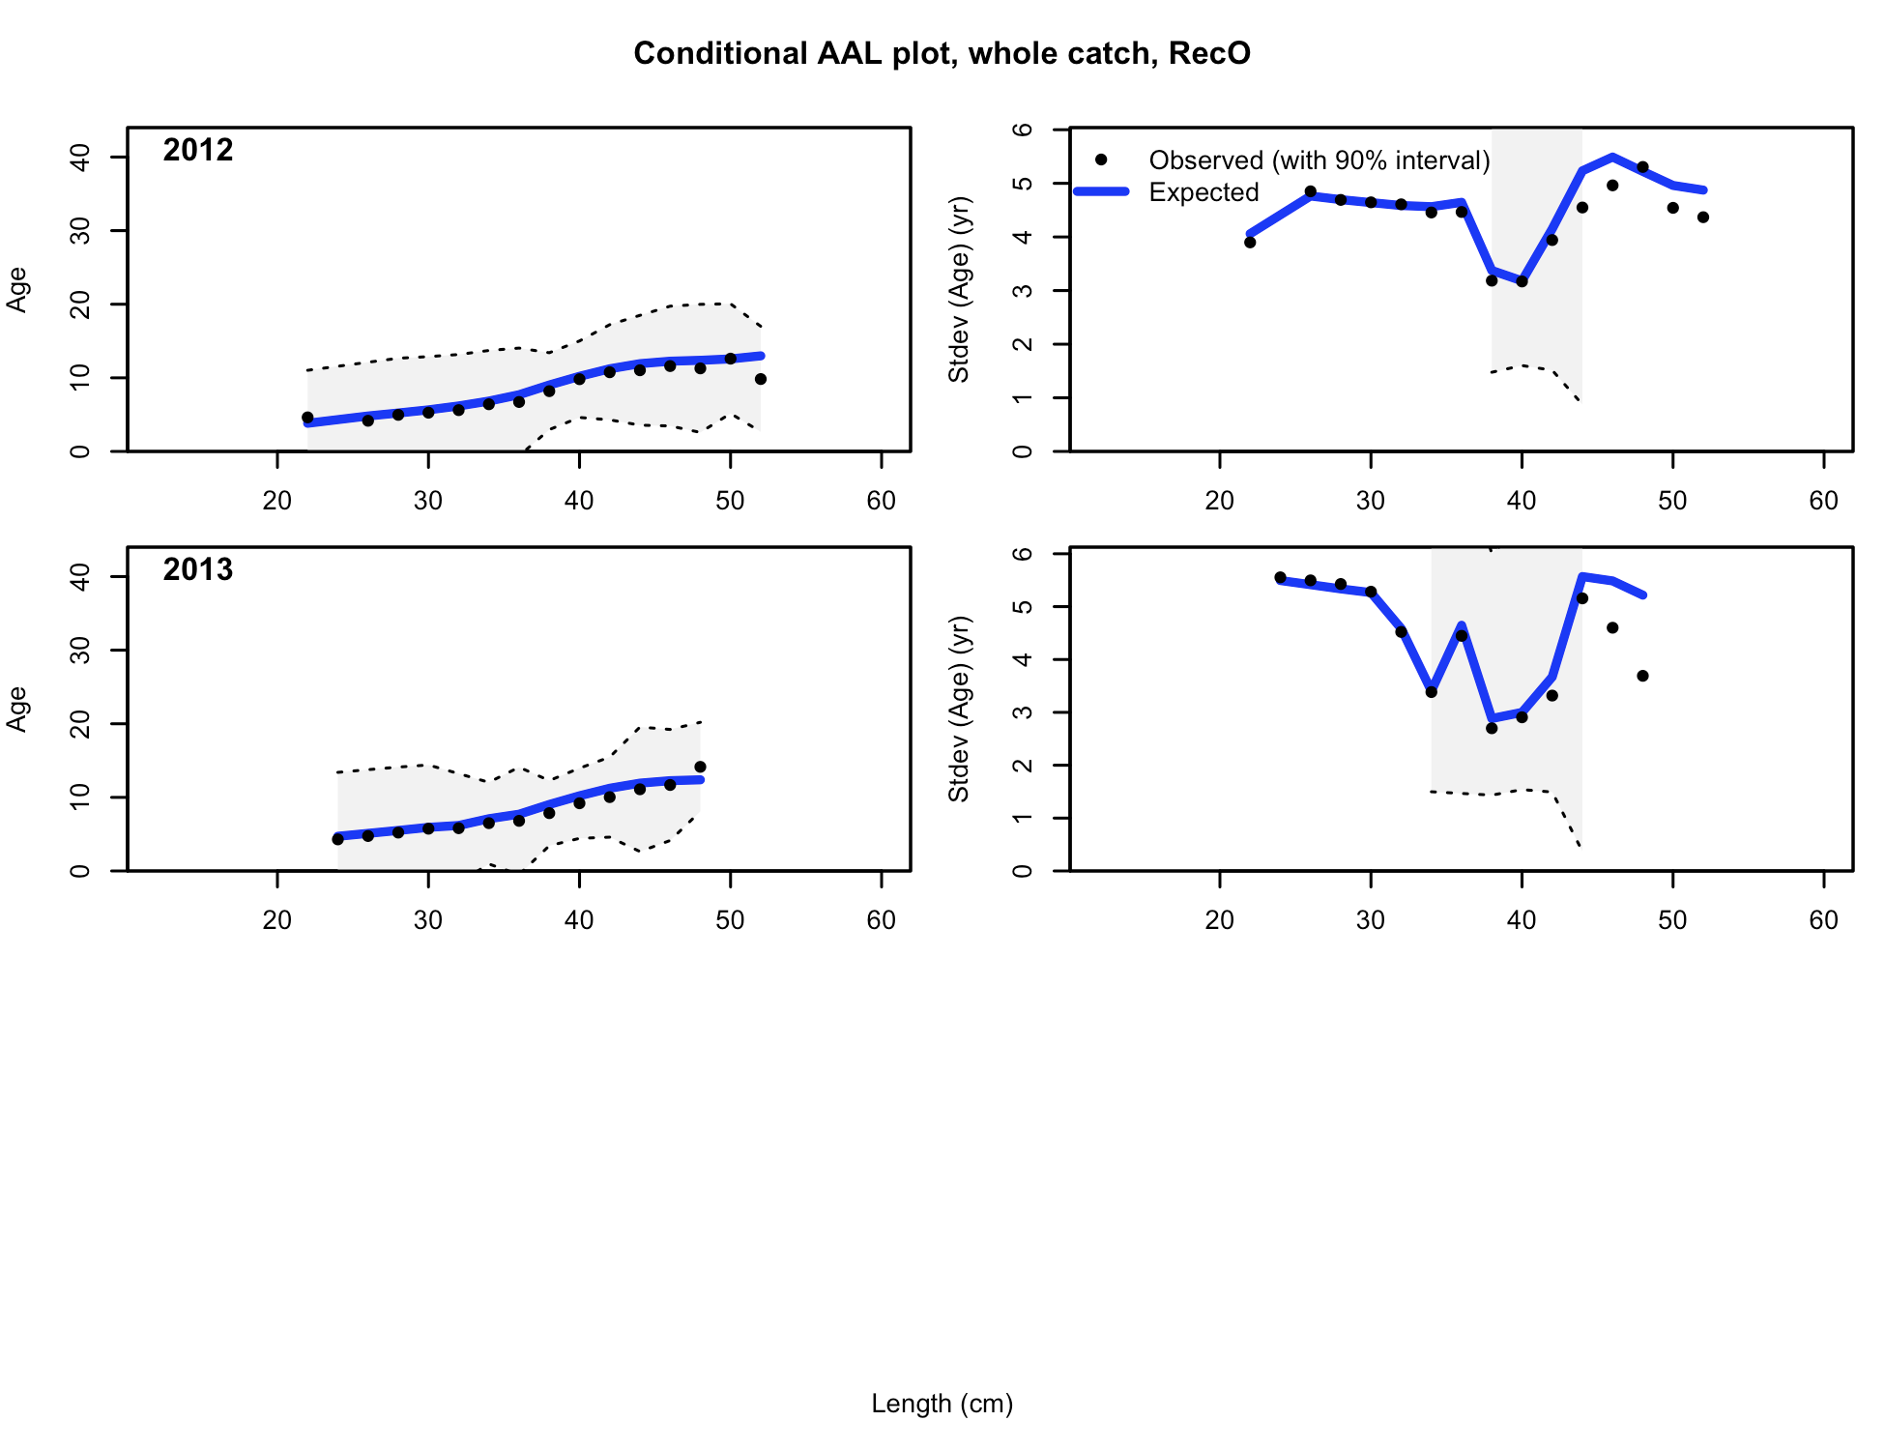

Figure . Age composition samples and predictions for the Oregon Ocean boat recreational fishery, 6 of 6.

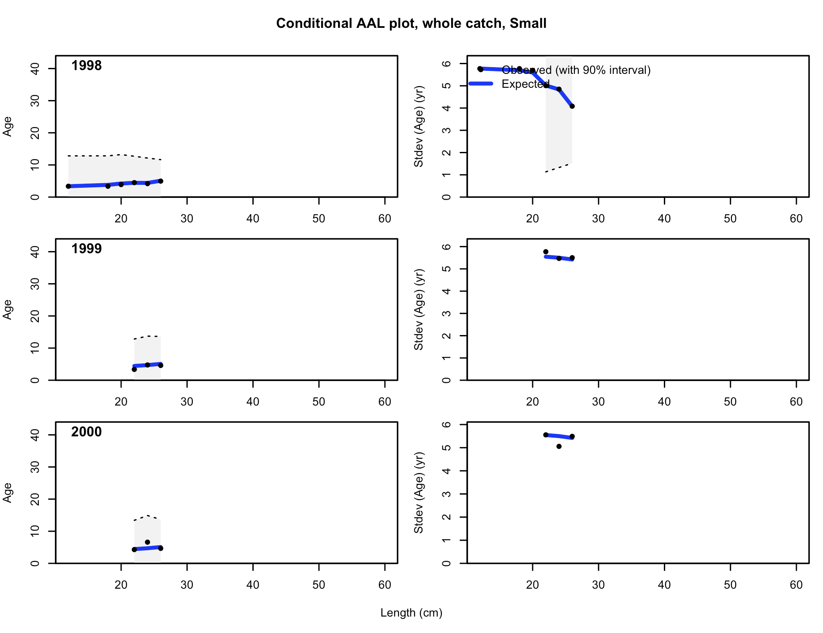

Figure . Age composition samples and predictions for the Oregon Small-fish survey, 1 of 2.

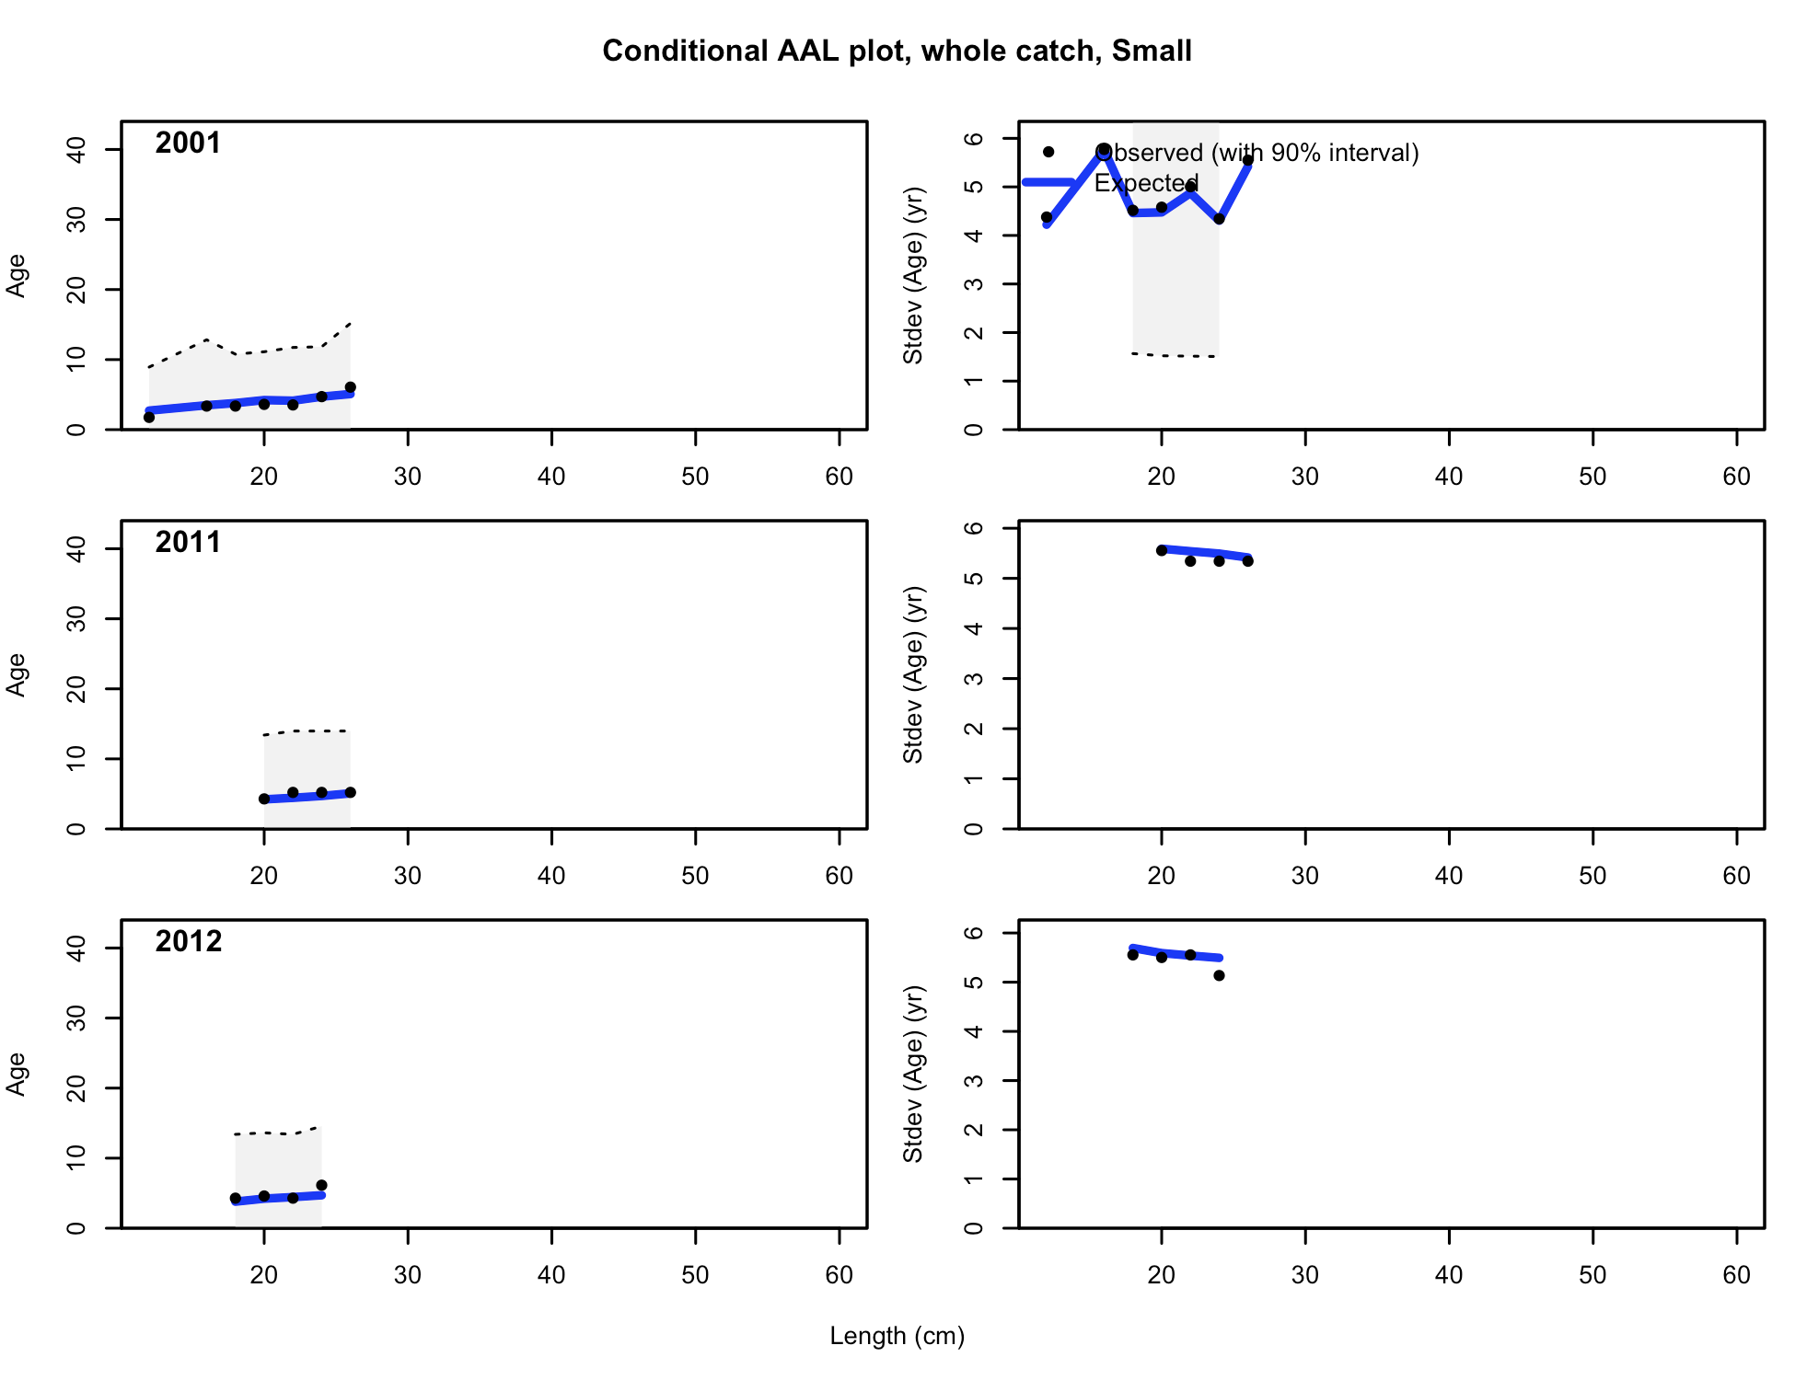

Figure . Age composition samples and predictions for the Oregon Small-fish survey, 2 of 2.

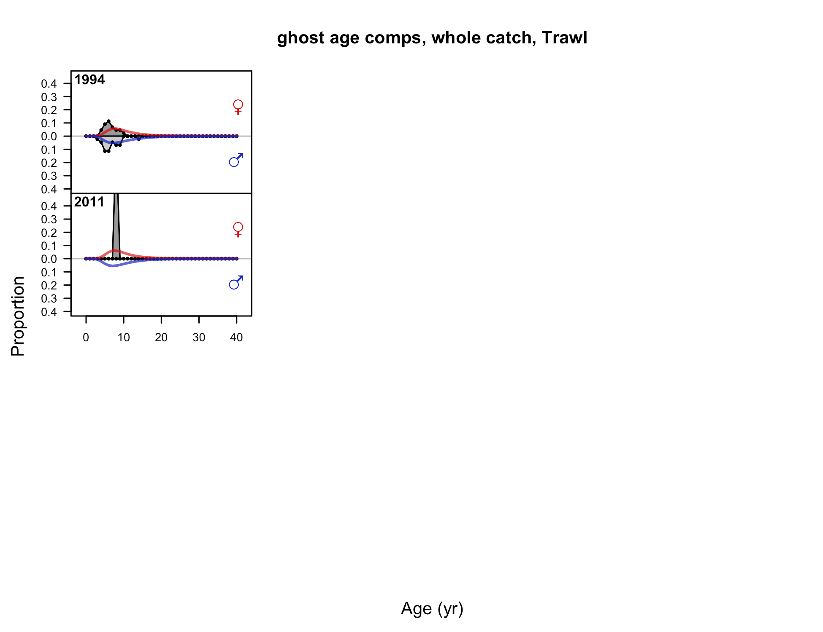

Figure . Age composition samples and predictions for the Oregon trawl fishery.

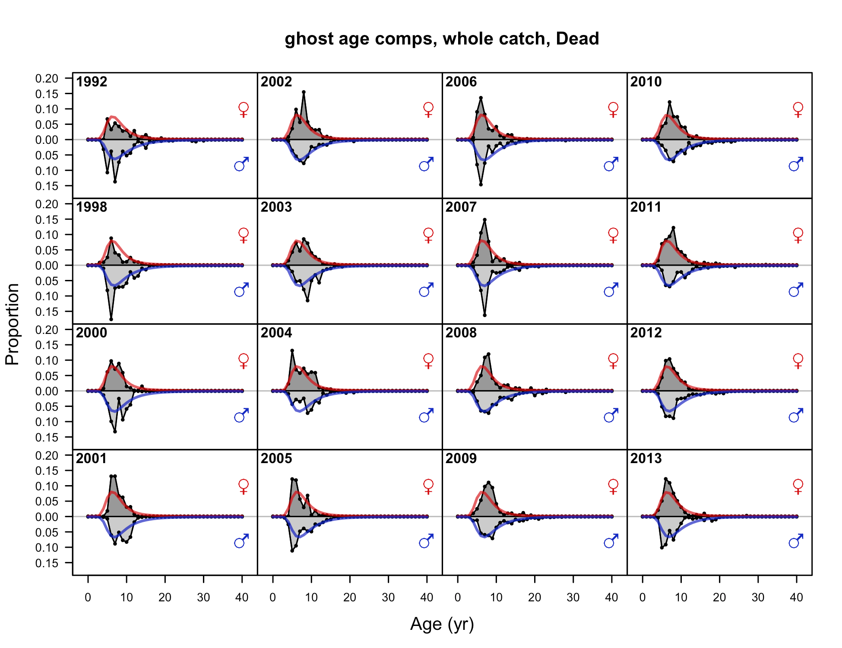

Figure . Age composition samples and predictions for the Oregon non-trawl dead fishery.

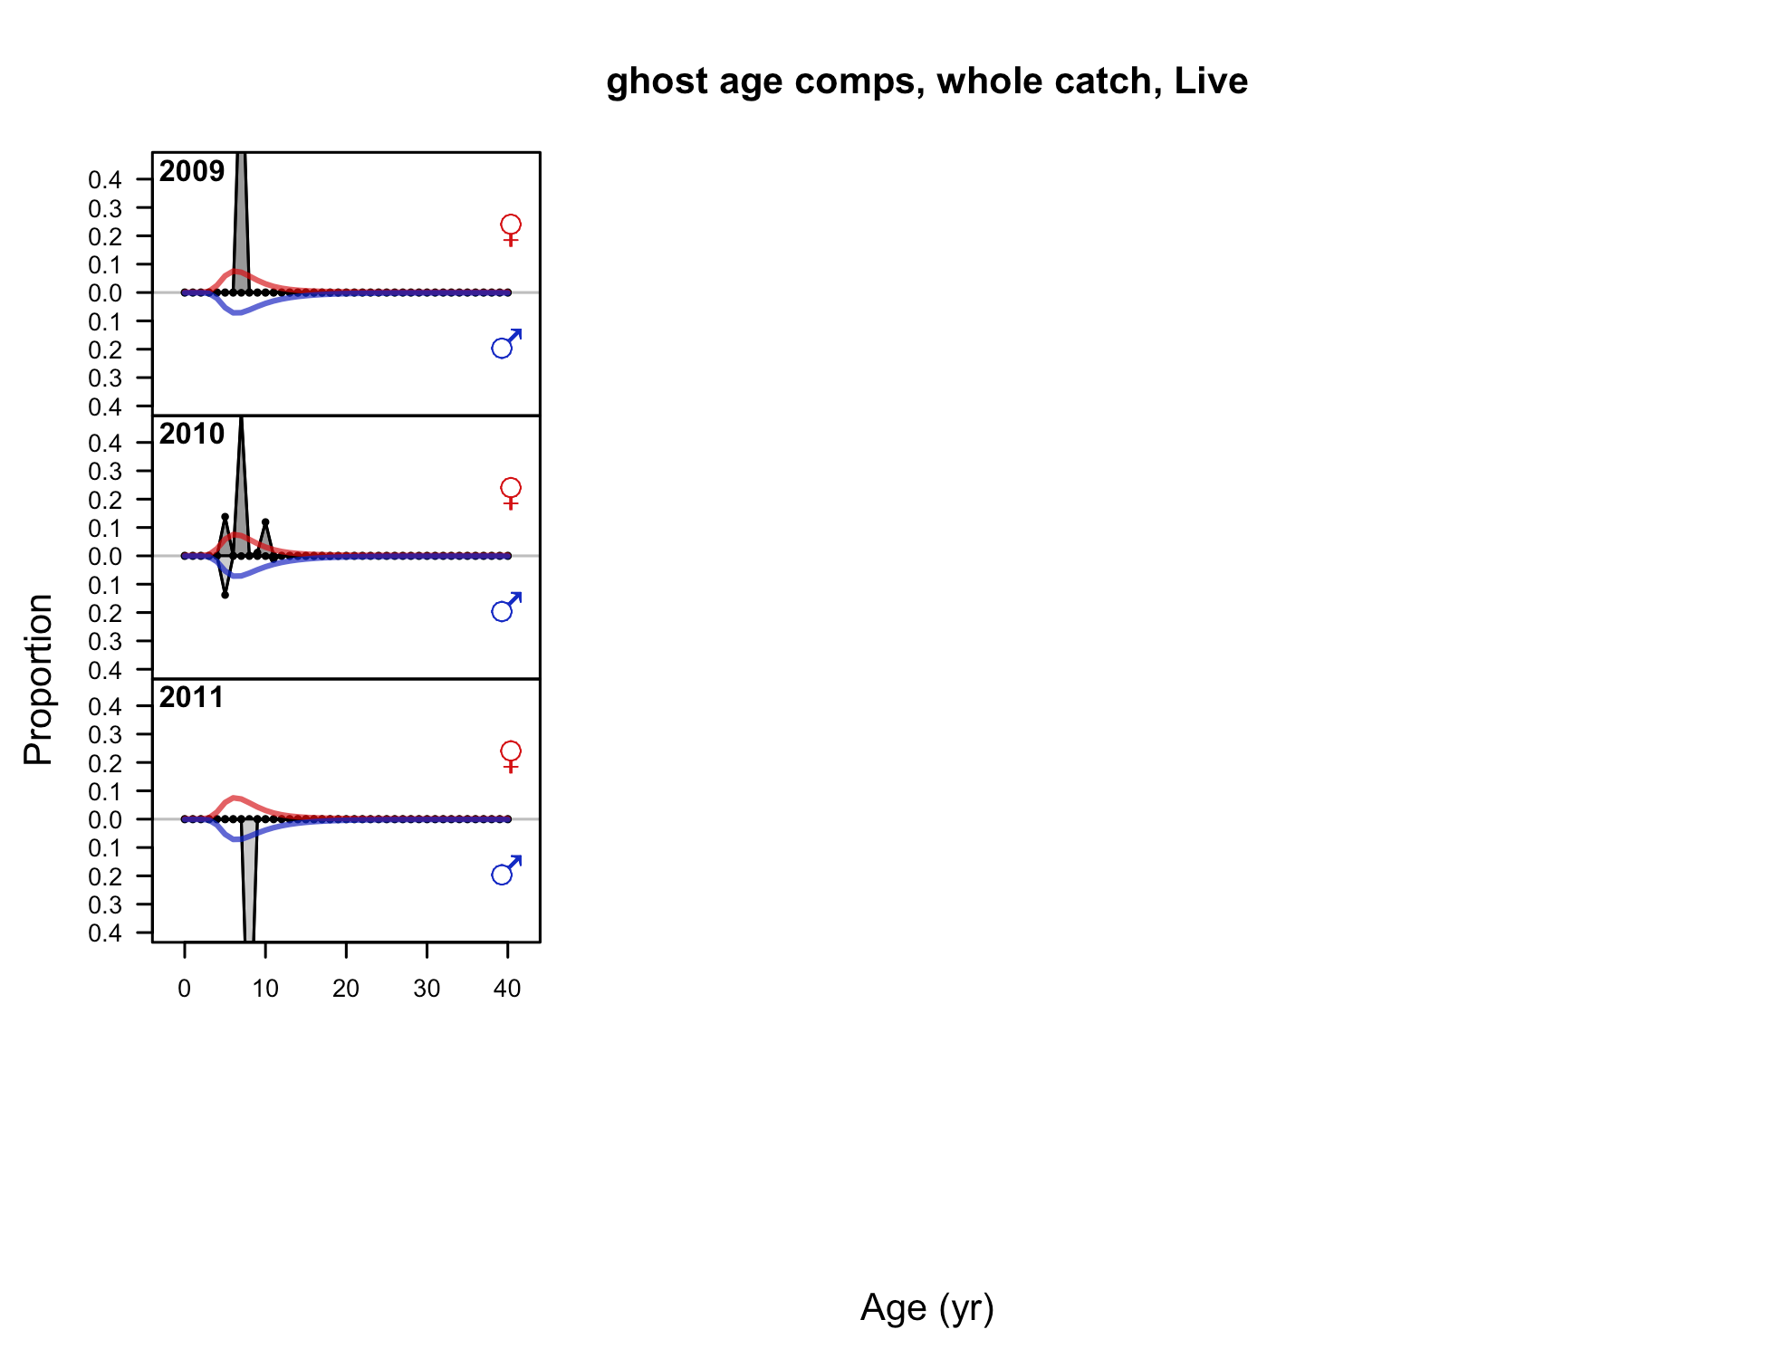

Figure . Age composition samples and predictions for the Oregon non-trawl live fishery.

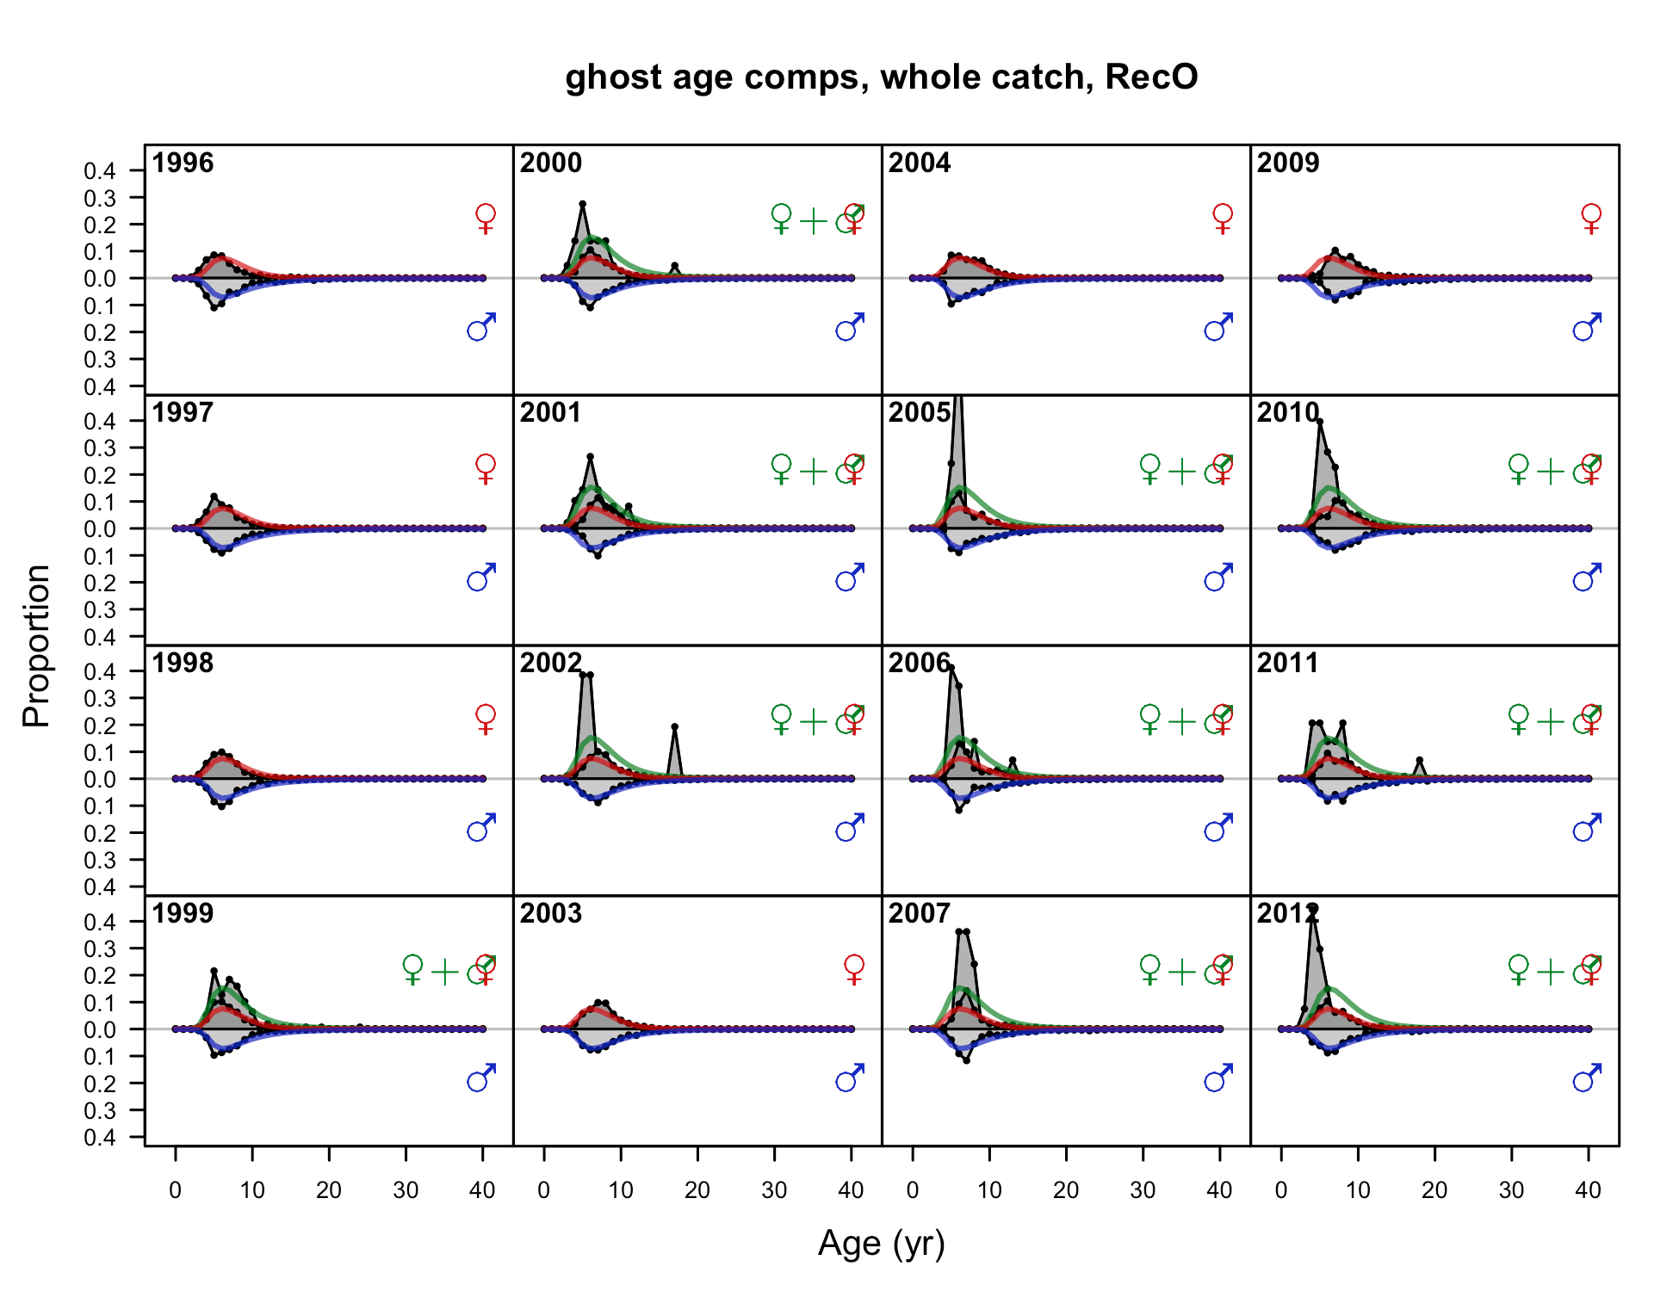

Figure . Age composition samples and predictions for the Oregon recreation Ocean boat fishery, 1 of 2.

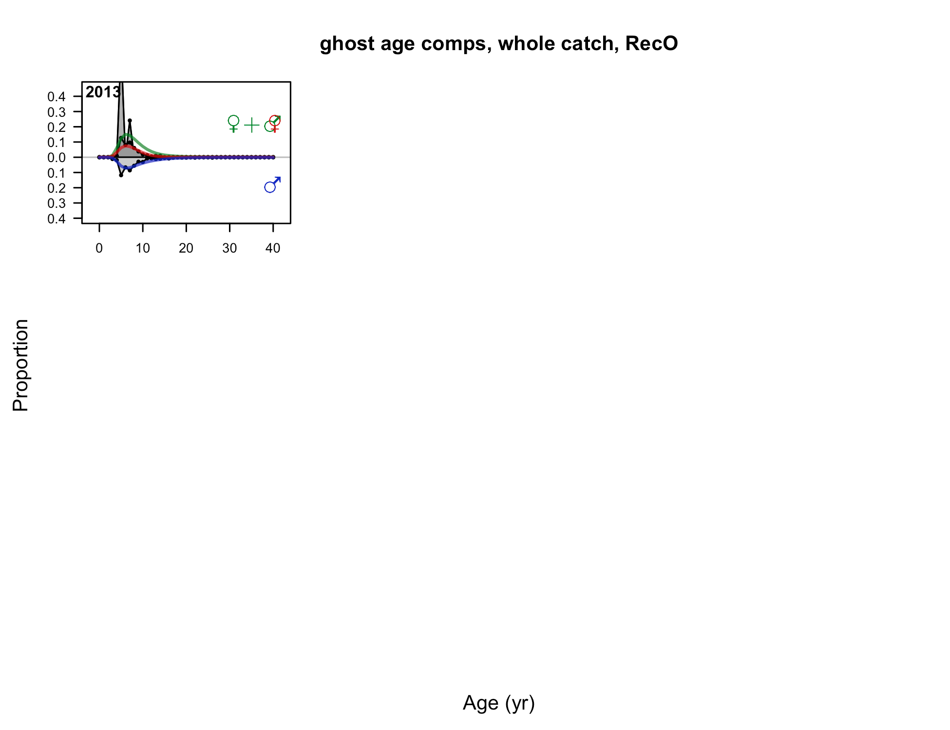

Figure . Age composition samples and predictions for the Oregon Ocean boat fishery, 2 of 2.

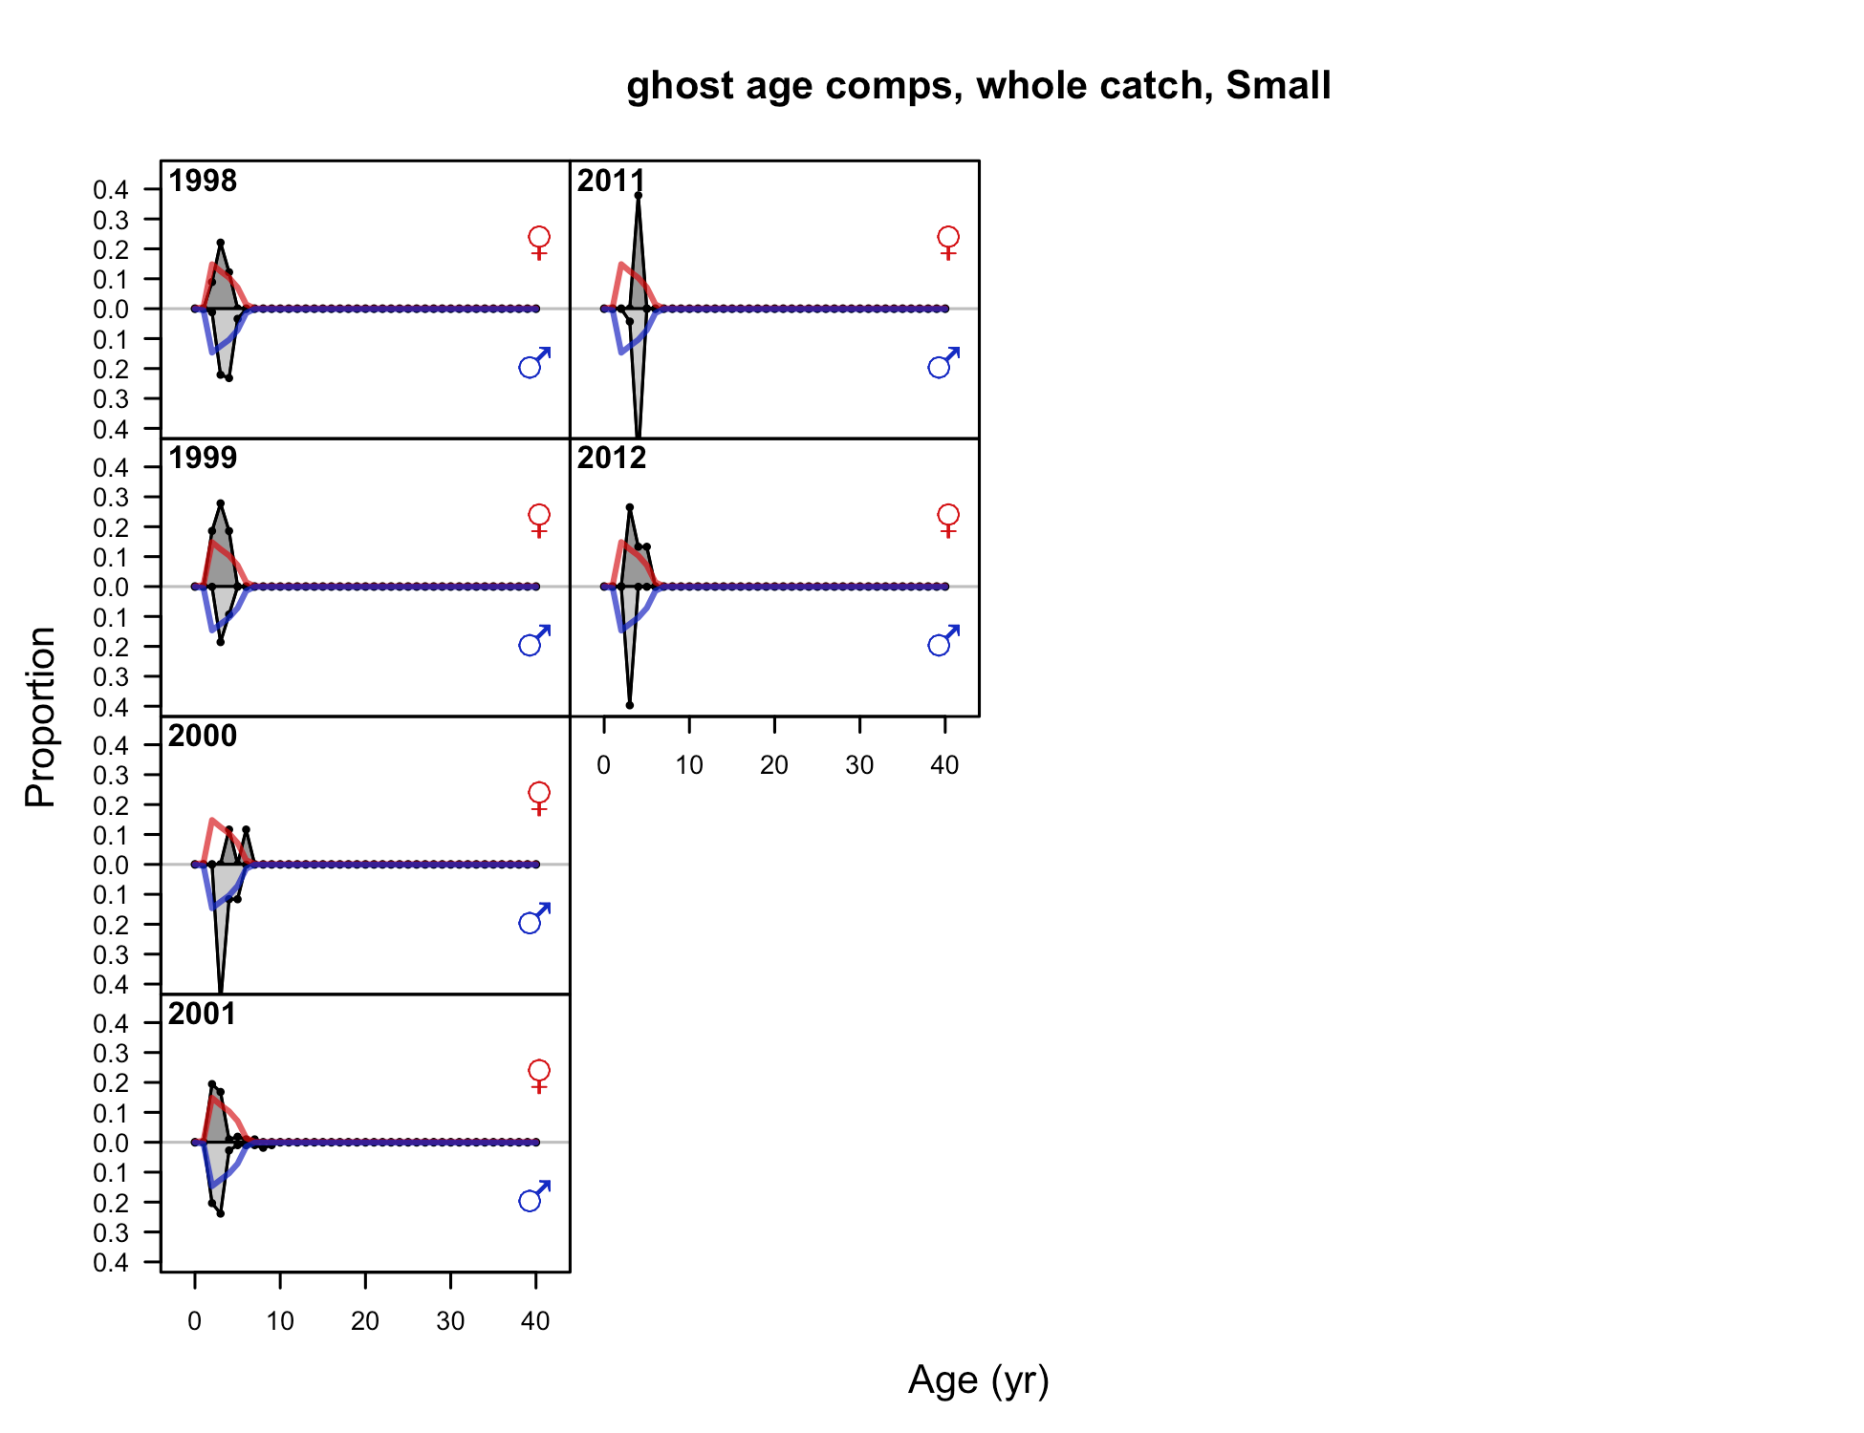

Figure . Age composition samples and predictions for the Oregon small-fish survey.

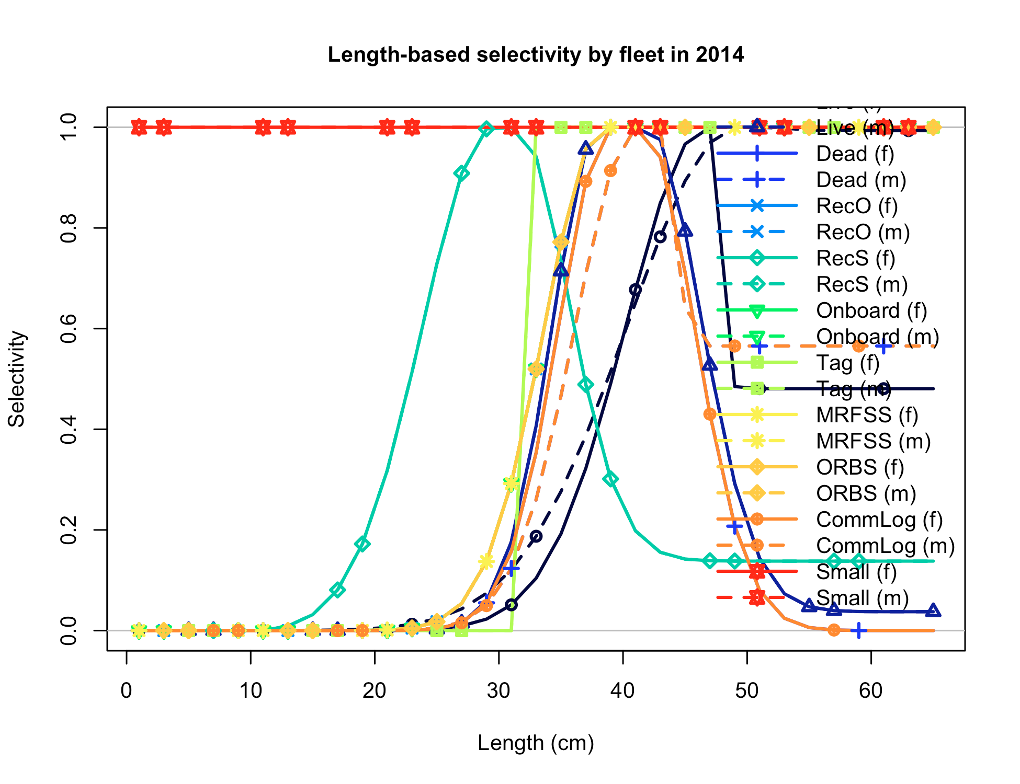

Figure . Oregon base case estimates of length-based selectivity by fleet and survey.

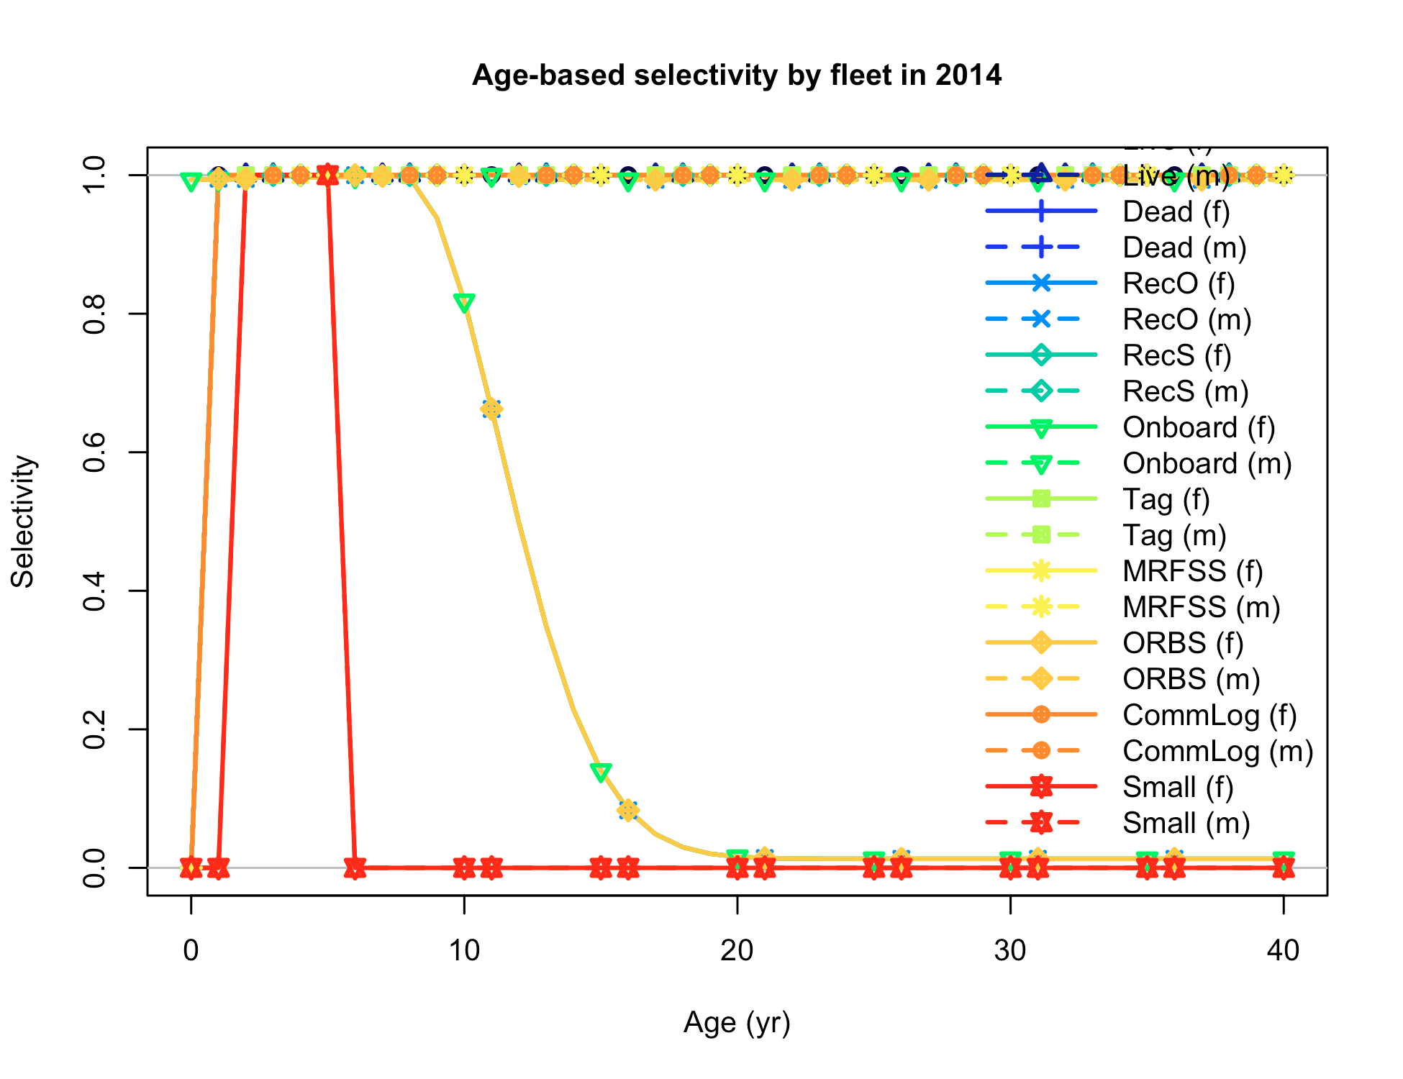

Figure . Oregon base case estimates of age-based selectivity by fleet and survey.

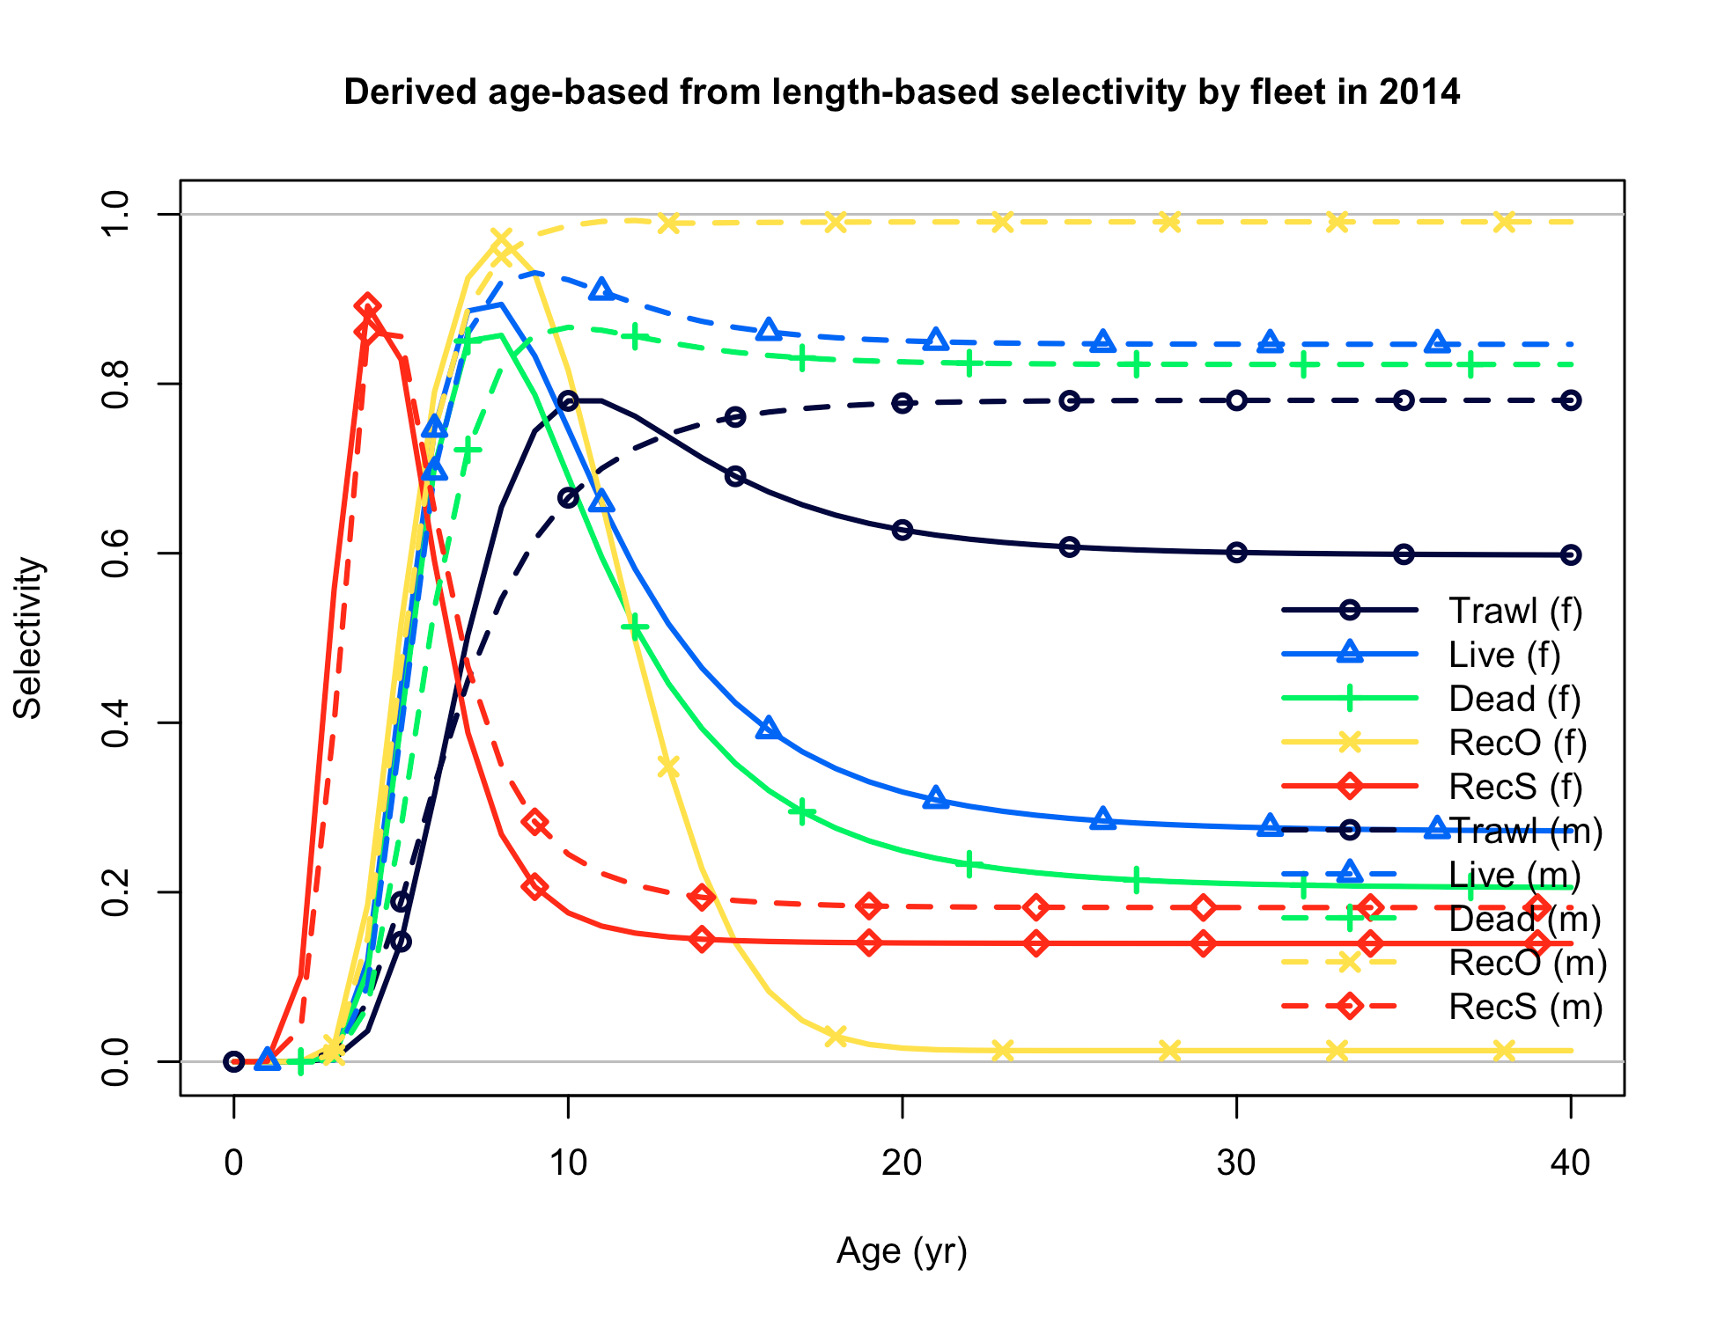

Figure . Oregon base case estimated realized selectivity curves by fleet and survey by gender.

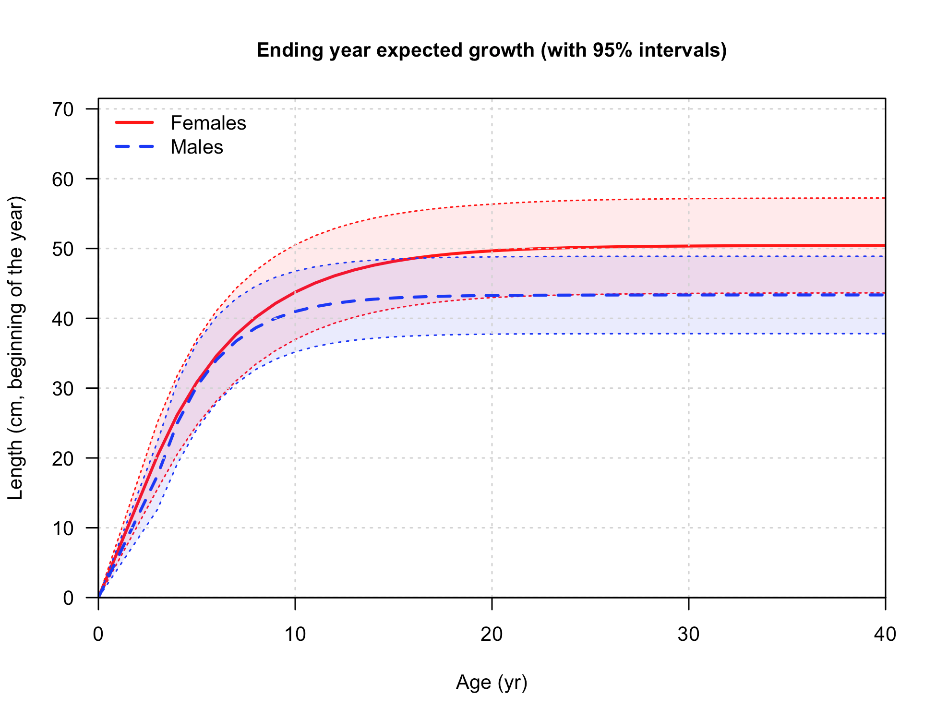

Figure . Base case estimates of sex-specific growth for the Oregon model.

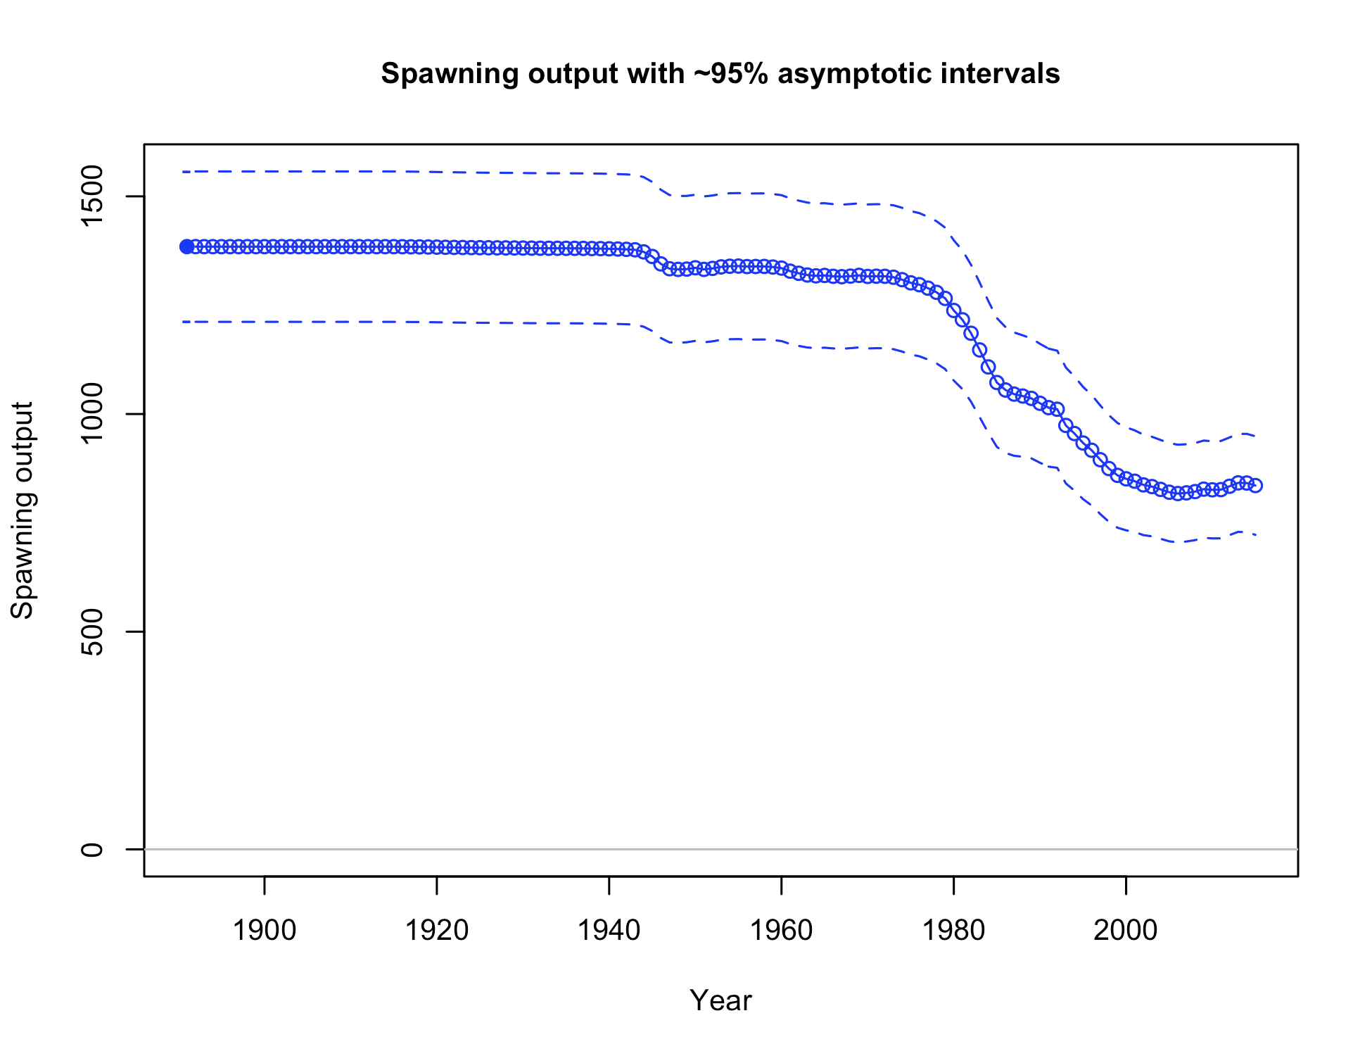

Figure . Oregon base case estimate of spawning biomass with 95% confidence intervals.

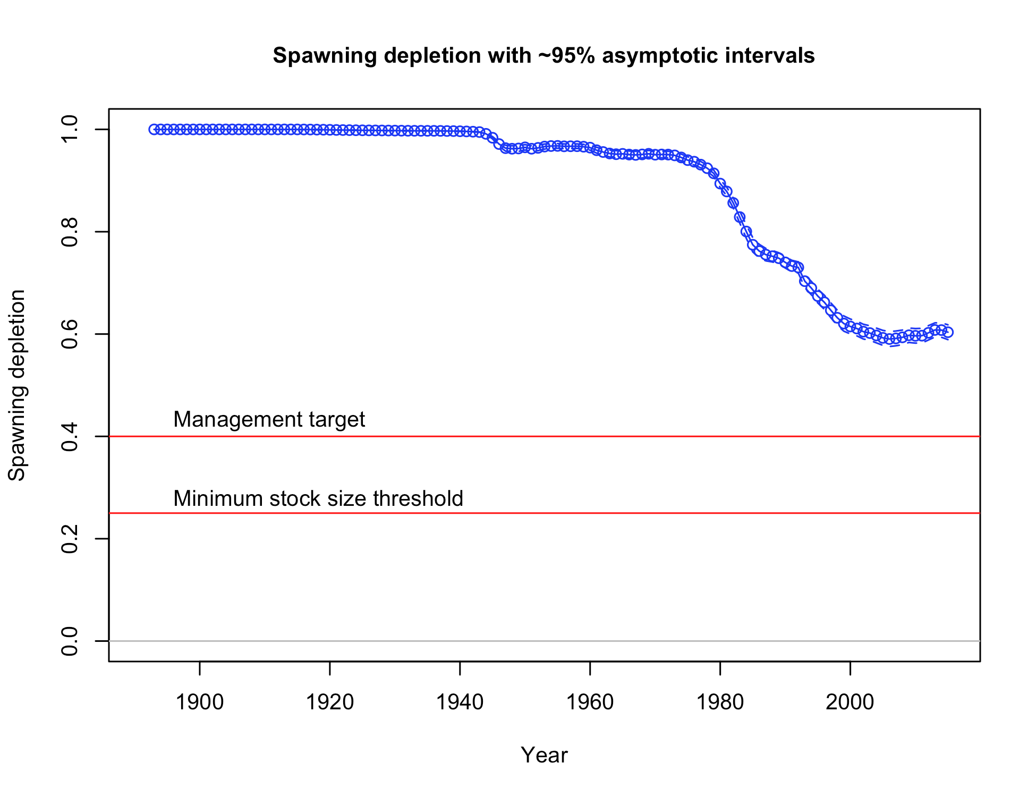

Figure . Oregon base case estimate of stock status (i.e., spawning depletion) with 95% confidence intervals.

Qvars.Spawn.Comparison.pdf

Figure . Sensitivity runs comparing spawning output for different model treatments of the tagging index catchability (Q) in the Oregon model. Shading indicates 95% confidence intervals. BC = base case model. More details for these runs can be found in the supplemental tables.

Qvars.Relative.Bio.Comparison.pdf

Figure . Sensitivity runs comparing stock status for different model treatments of the tagging index catchability (Q) in the Oregon model. Shading indicates 95% confidence intervals. BC = base case model. More details for these runs can be found in the supplemental tables.

M.Spawn.Comparisons.pdf

Figure . Sensitivity runs comparing spawning output for several model treatments of natural mortality in the Oregon model. Shading indicates 95% confidence intervals. BC = base case model. More details for these runs can be found in the supplemental tables.

M.Rel.Bio.Comparisons.pdf

Figure . Sensitivity runs comparing stock status for several model treatments of natural mortality in the Oregon model. Shading indicates 95% confidence intervals. BC = base case model. More details for these runs can be found in the supplemental tables.

Config.Spawn.Comparions.pdf

Figure . Sensitivity runs comparing spawning output for several model specifications in the Oregon model. Shading indicates 95% confidence intervals. BC = base case model. More details for these runs can be found in the supplemental tables.

Relative.Bio.Config.Comparisons.pdf

Figure . Sensitivity runs comparing stock status for several model specifications in the Oregon model. Shading indicates 95% confidence intervals. BC = base case model. More details for these runs can be found in the supplemental tables.



Figure . Explorations of cryptic biomass for the Oregon model when tag Q =0.25 (base model). Panels are a) amount of spawning output that is cryptic (top left); b) time series of percent biomass that is cryptic (top right); c) mean age over time (bottom left); and d) mean selectivity of all fleets over time (bottom right).



Figure . Explorations of cryptic biomass for the Oregon model when tag Q =0.125 (base model). Panels are a) amount of spawning output that is cryptic (top left); b) time series of percent biomass that is cryptic (top right); c) mean age over time (bottom left); and d) mean selectivity of all fleets over time (bottom right).



Figure . Explorations of cryptic biomass for the Oregon model when tag Q is estimated (base model). Panels are a) amount of spawning output that is cryptic (top left); b) time series of percent biomass that is cryptic (top right); c) mean age over time (bottom left); and d) mean selectivity of all fleets over time (bottom right).

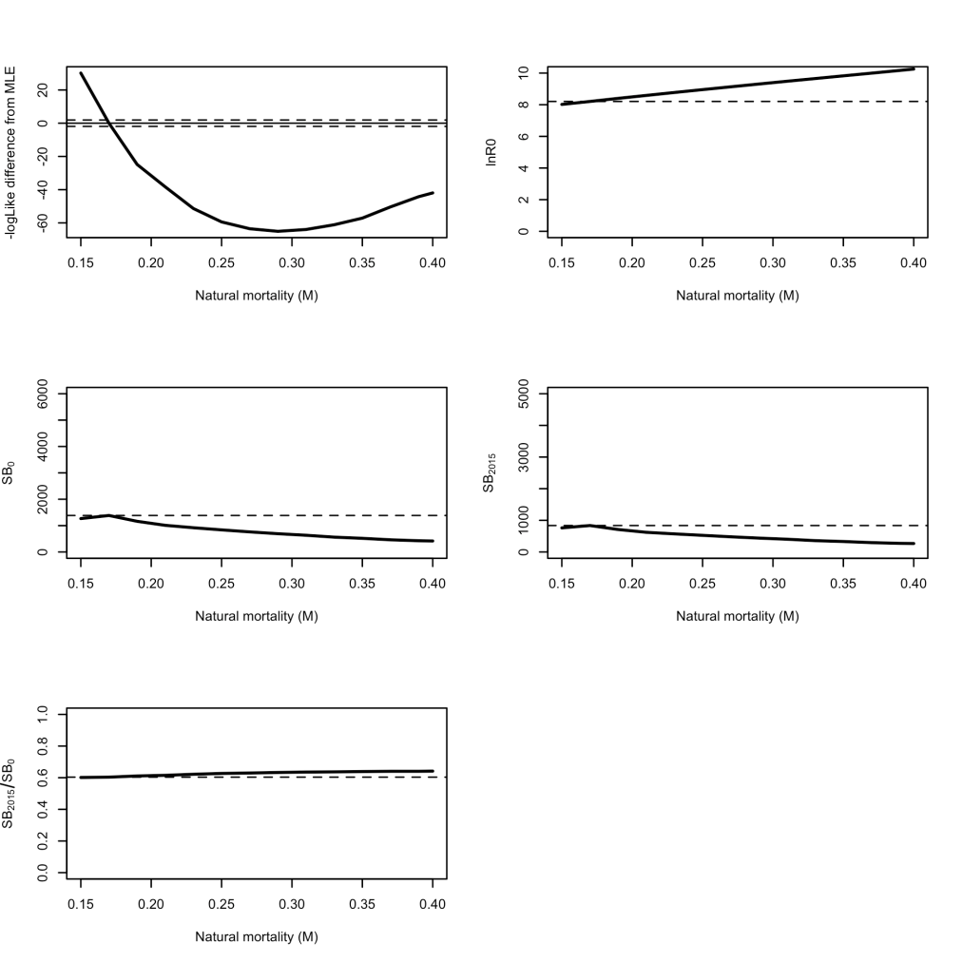

Figure . Likelihood analysis for the Oregon model for parameter estimates in response to changes in natural mortality with a step at age 10 to a value + 0.112 higher for females only (male mortality at all ages equal to the initial female mortality).

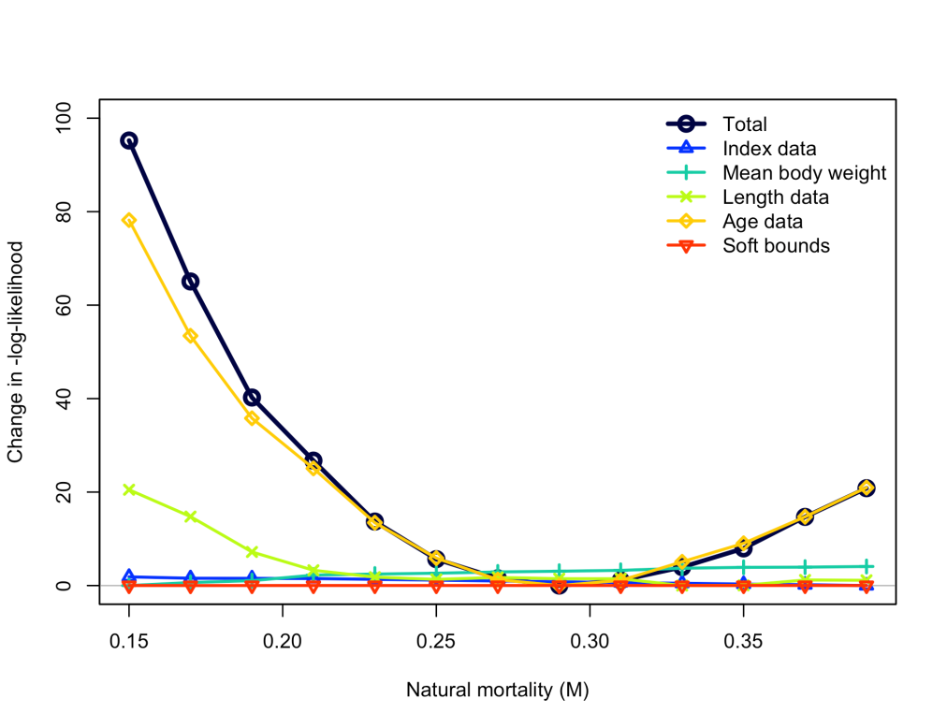

Figure . Likelihood component contributions across profiled values of female natural mortality with a step at age 10 to a value 0.2/1.7 higher for females only (male mortality at all ages equal to the initial female mortality) in the Oregon model.

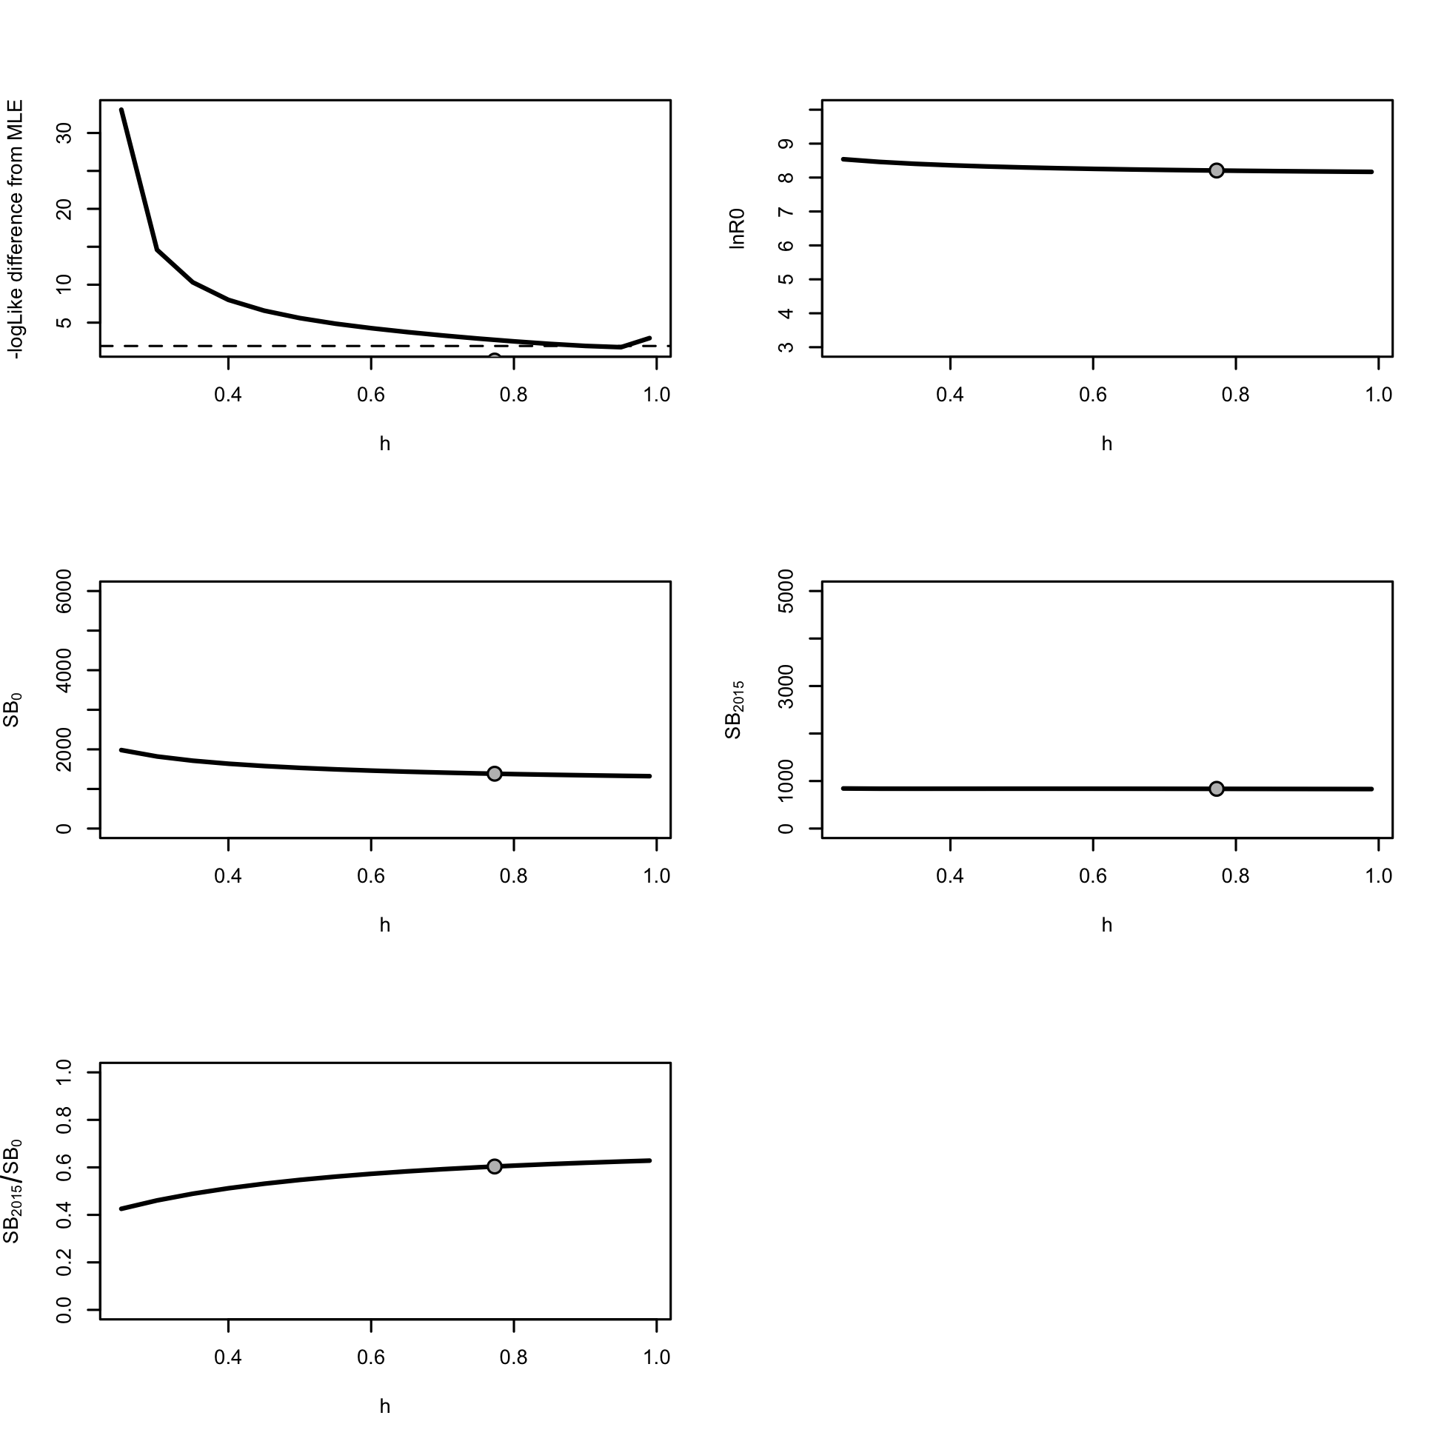

Figure . Likelihood analysis for the Oregon model for parameter estimates in response to changes in steepness.

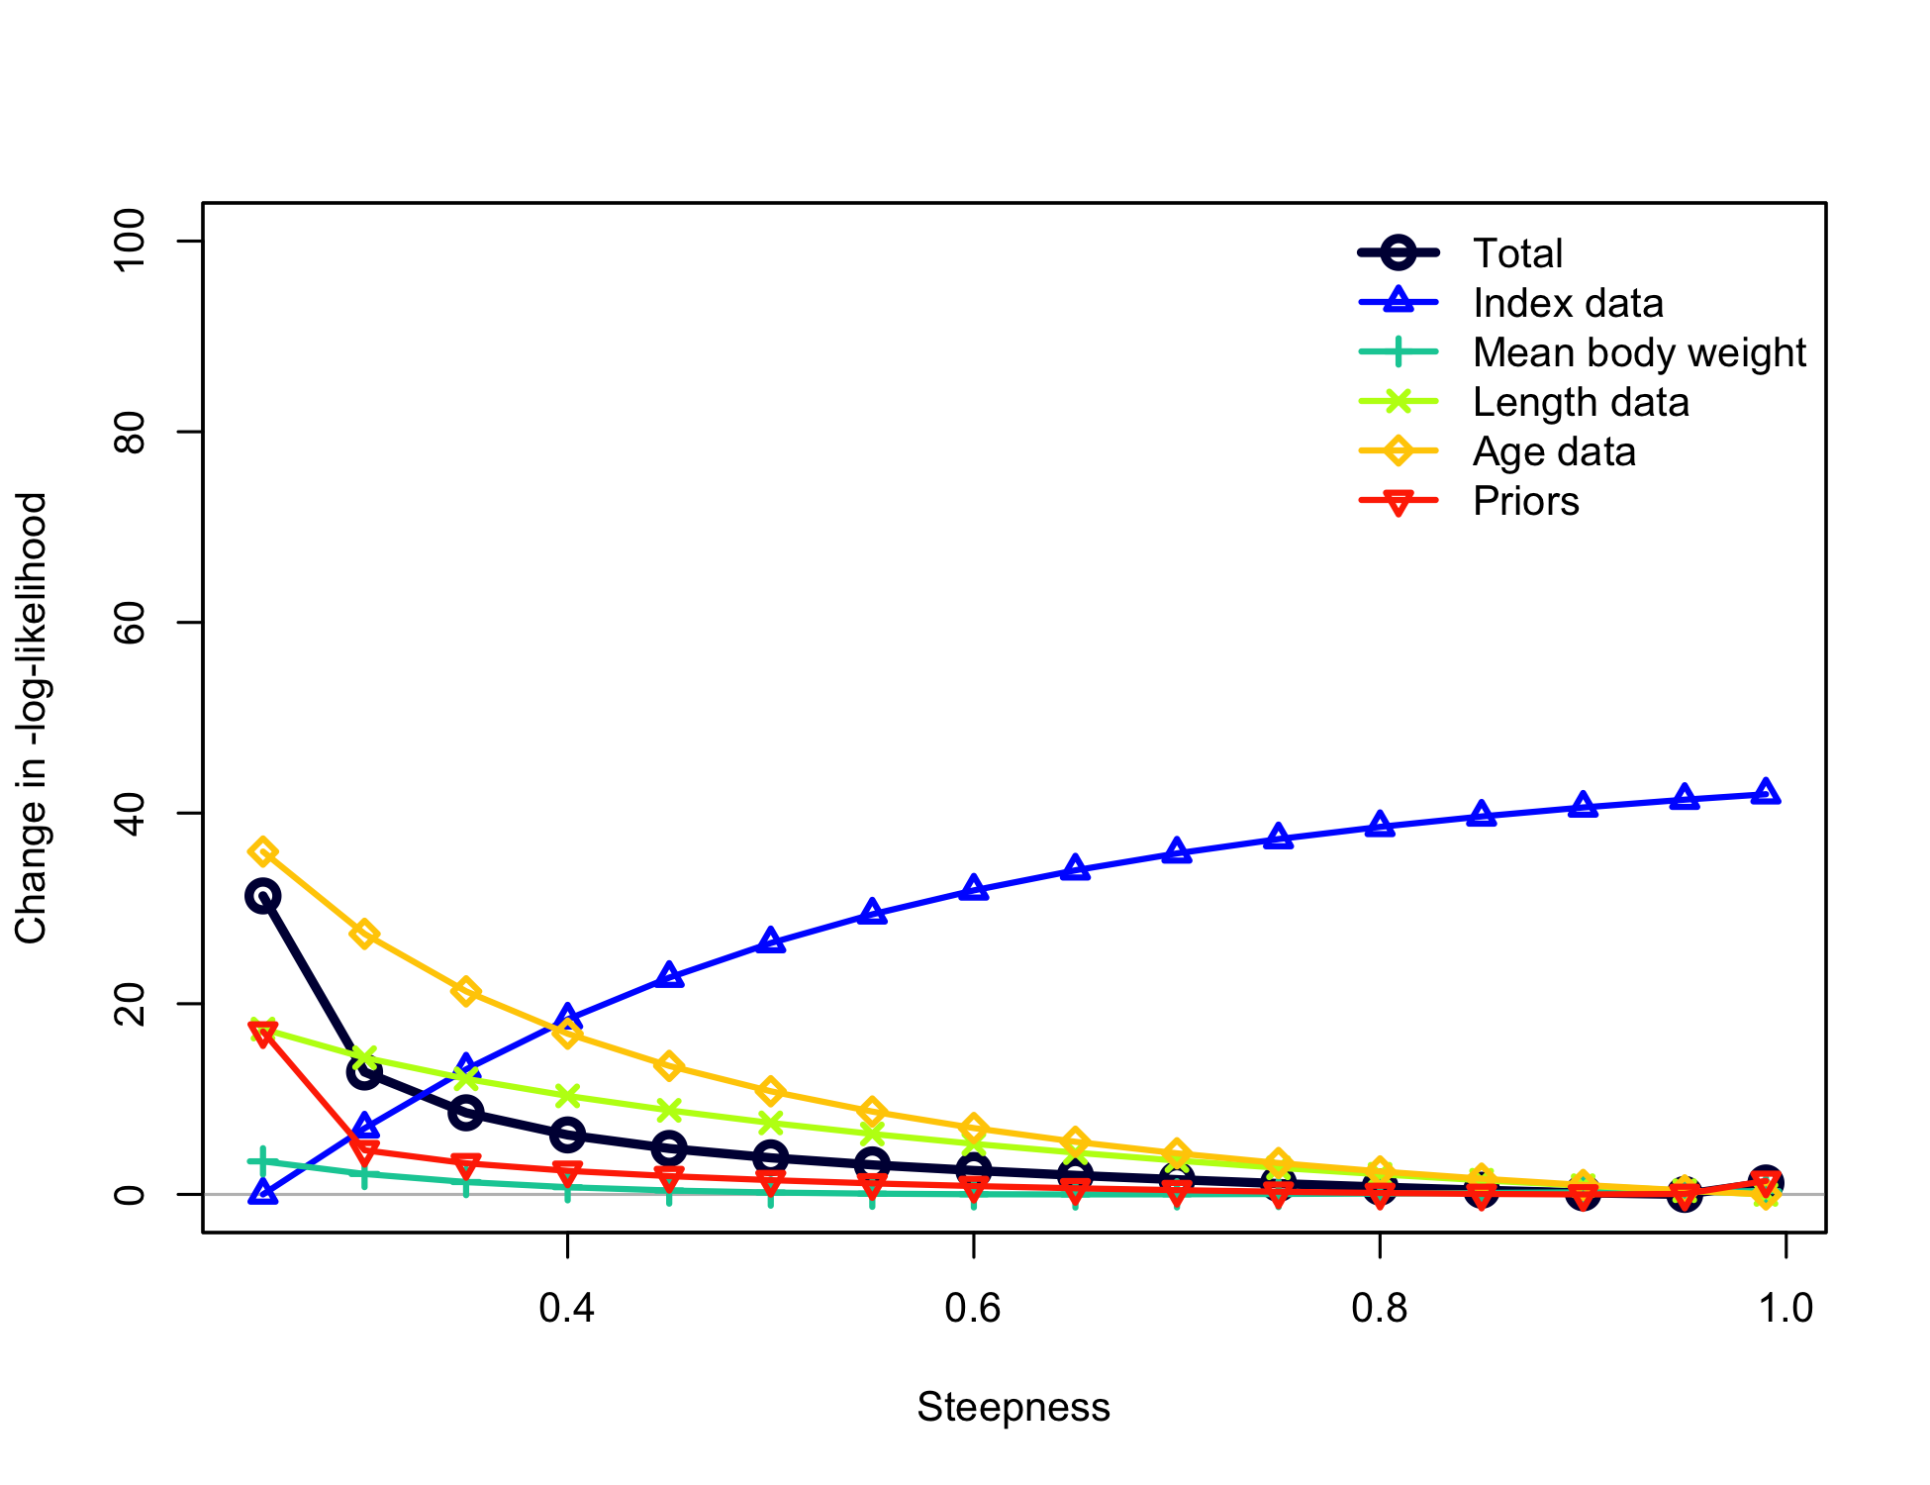

Figure . Likelihood component contributions across profiled values of the steepness parameter in the Oregon model.

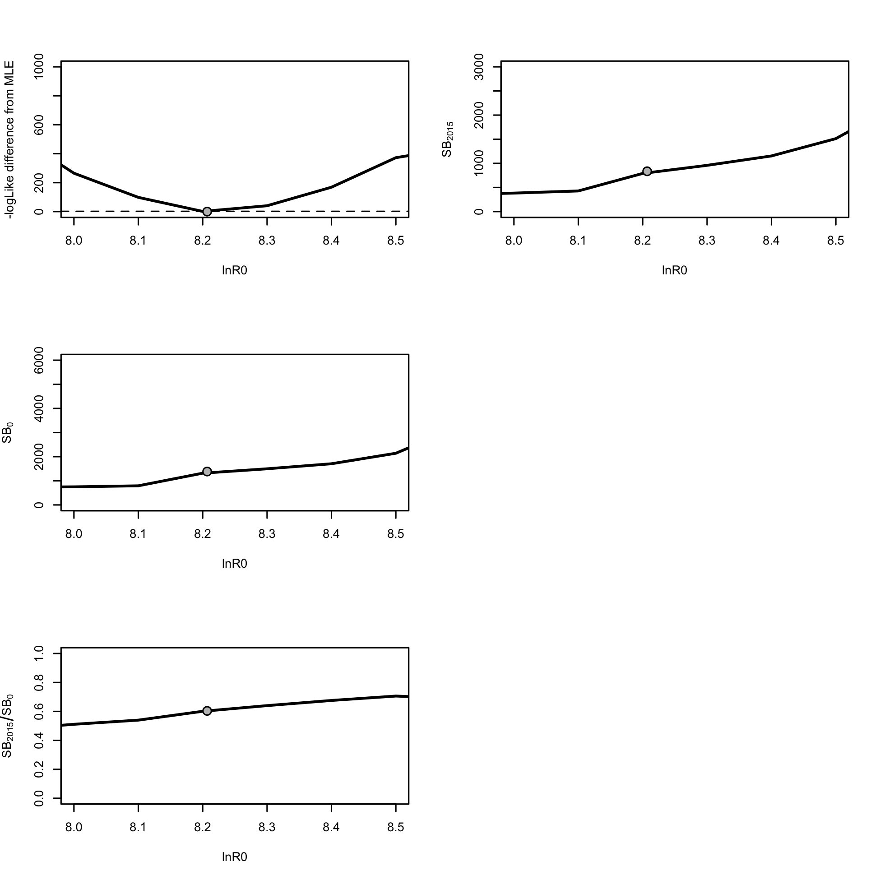

Figure . Likelihood analysis for the Oregon model for parameter estimates in response to changes in unfished recruitment ln(R0).

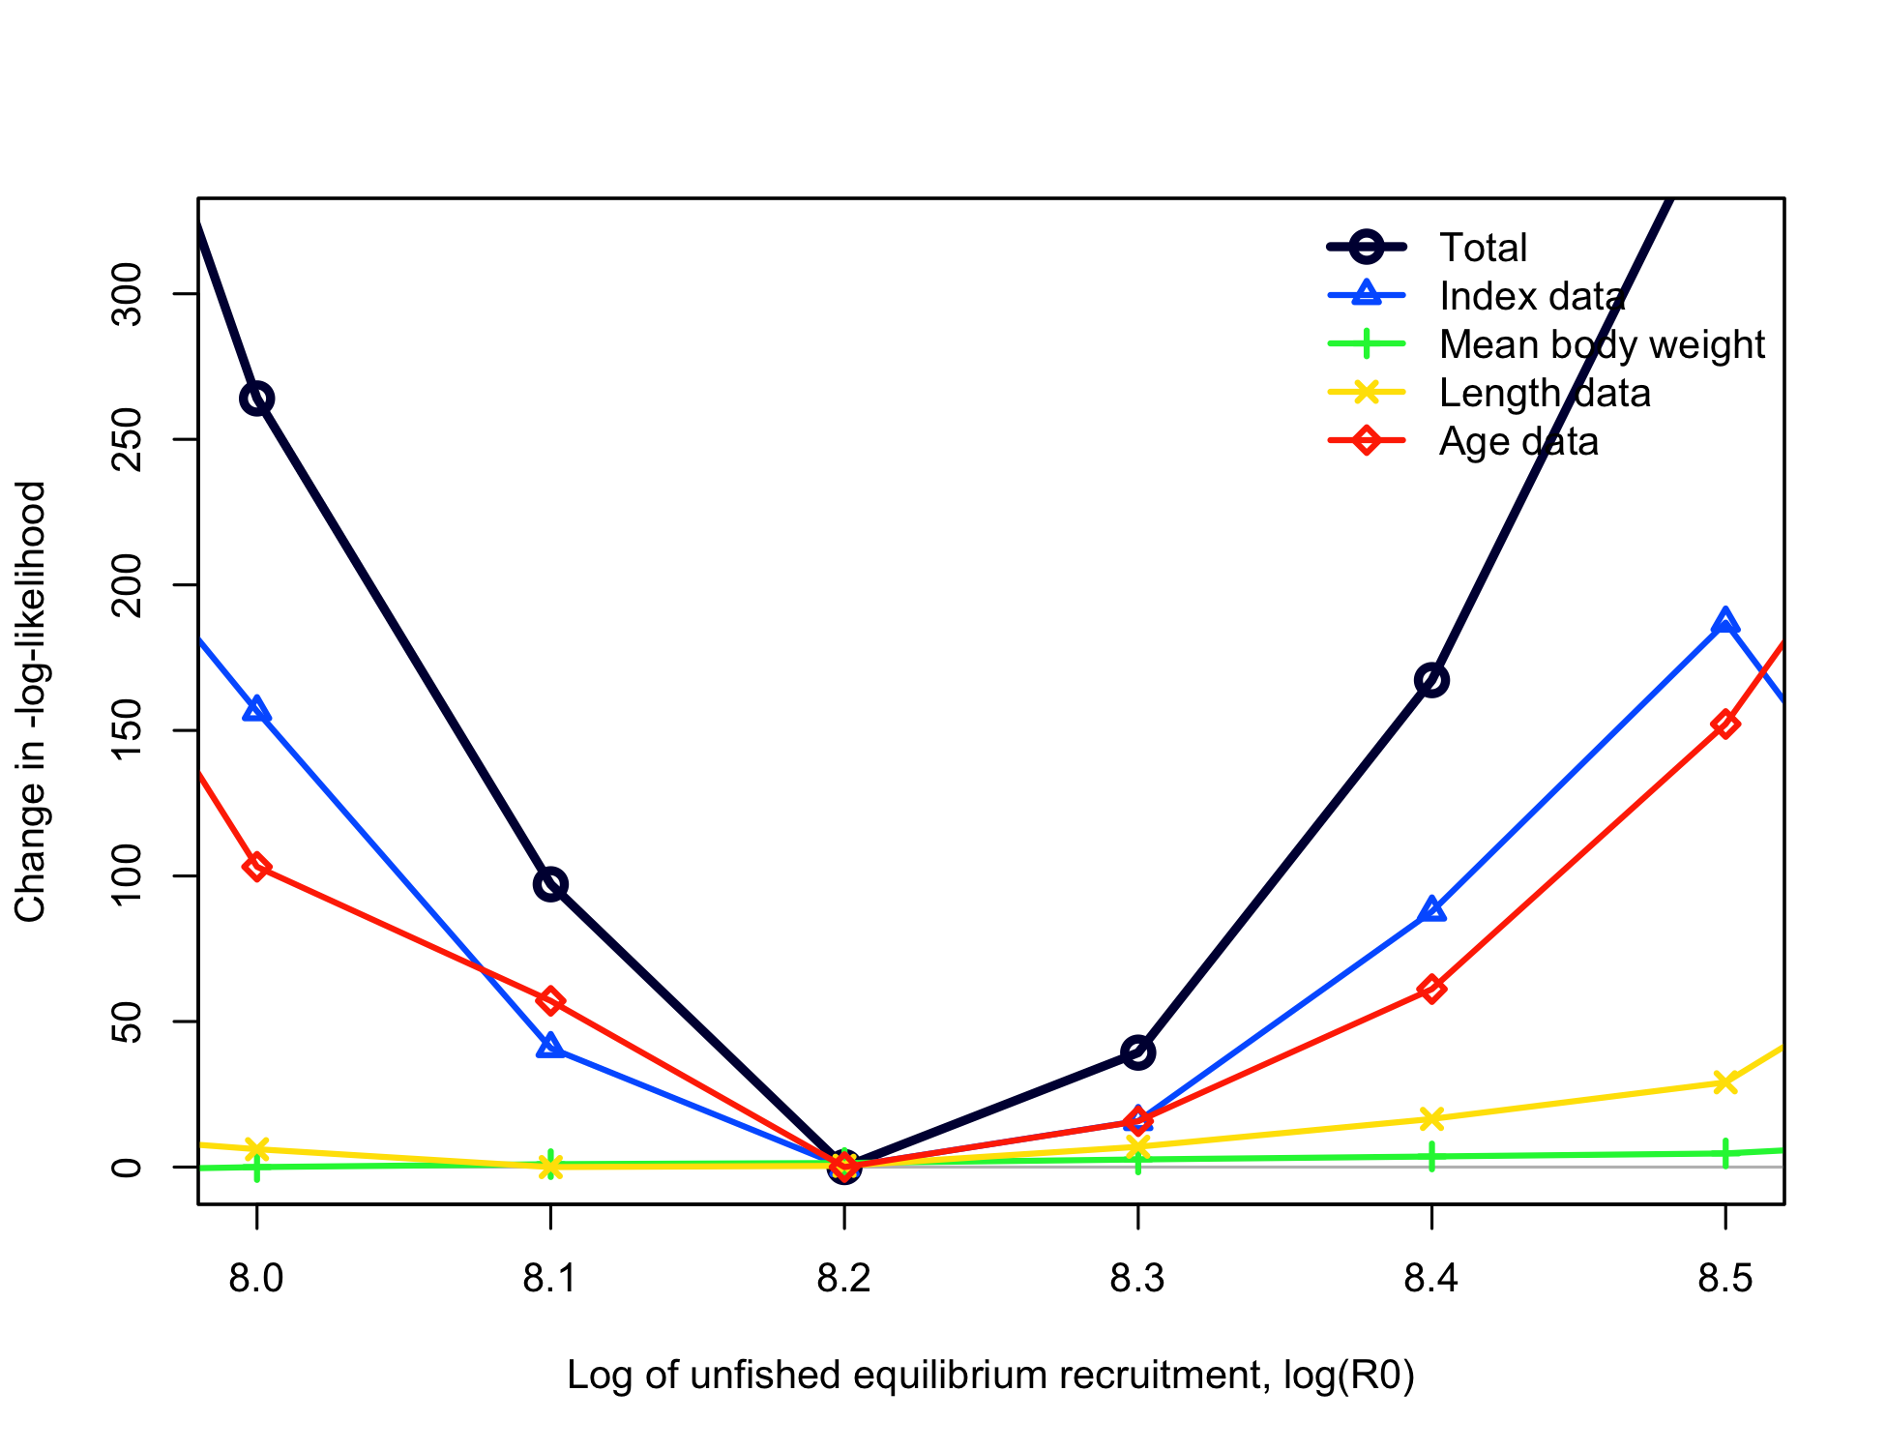

Figure . Likelihood component contributions across profiled values of ln*R0* in the Oregon model.

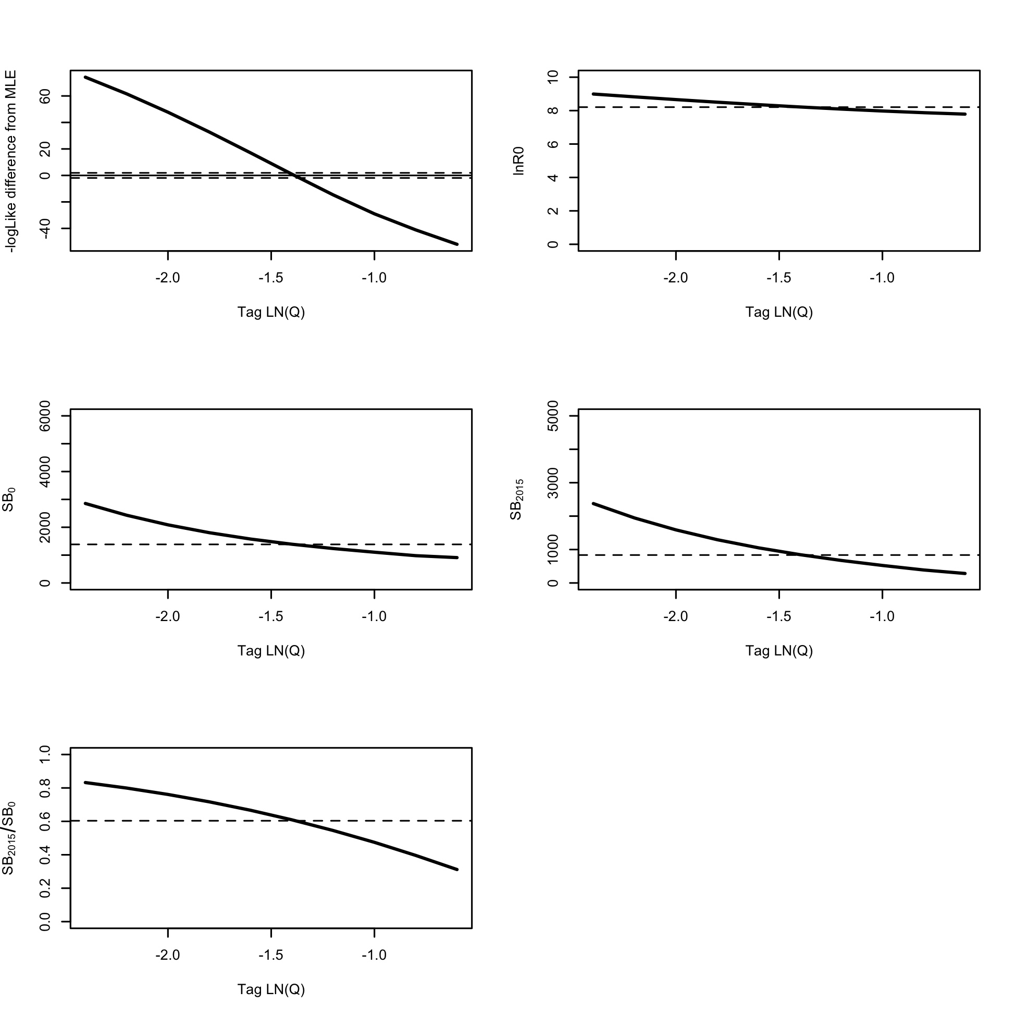

Figure . Likelihood profile in the Oregon model across values of lnQ for the tag study. Horizontal line indicates base case.

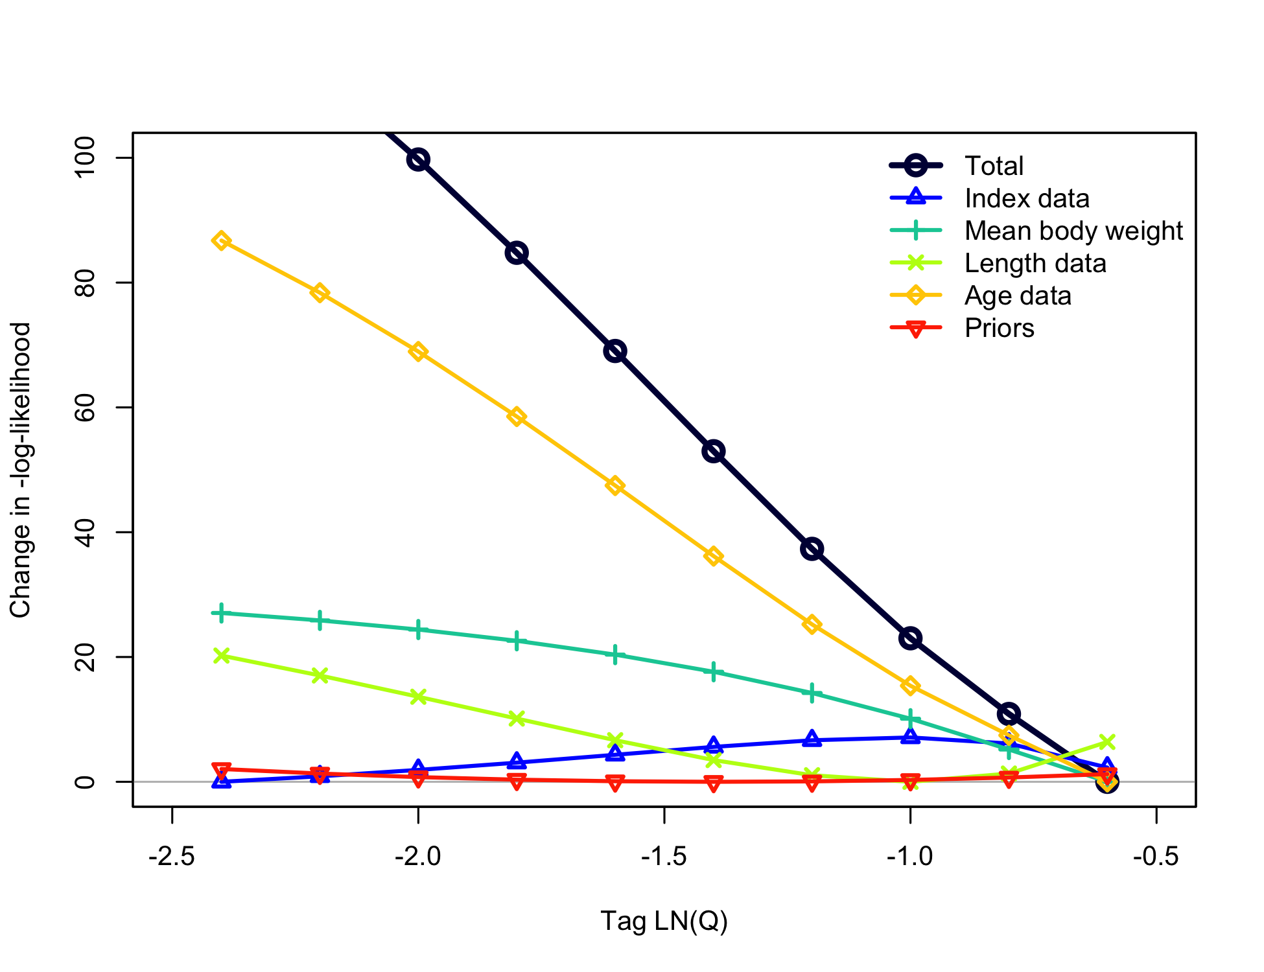

Figure . Likelihood component contributions across profiled values of the tagging study lnQ in the Oregon model.

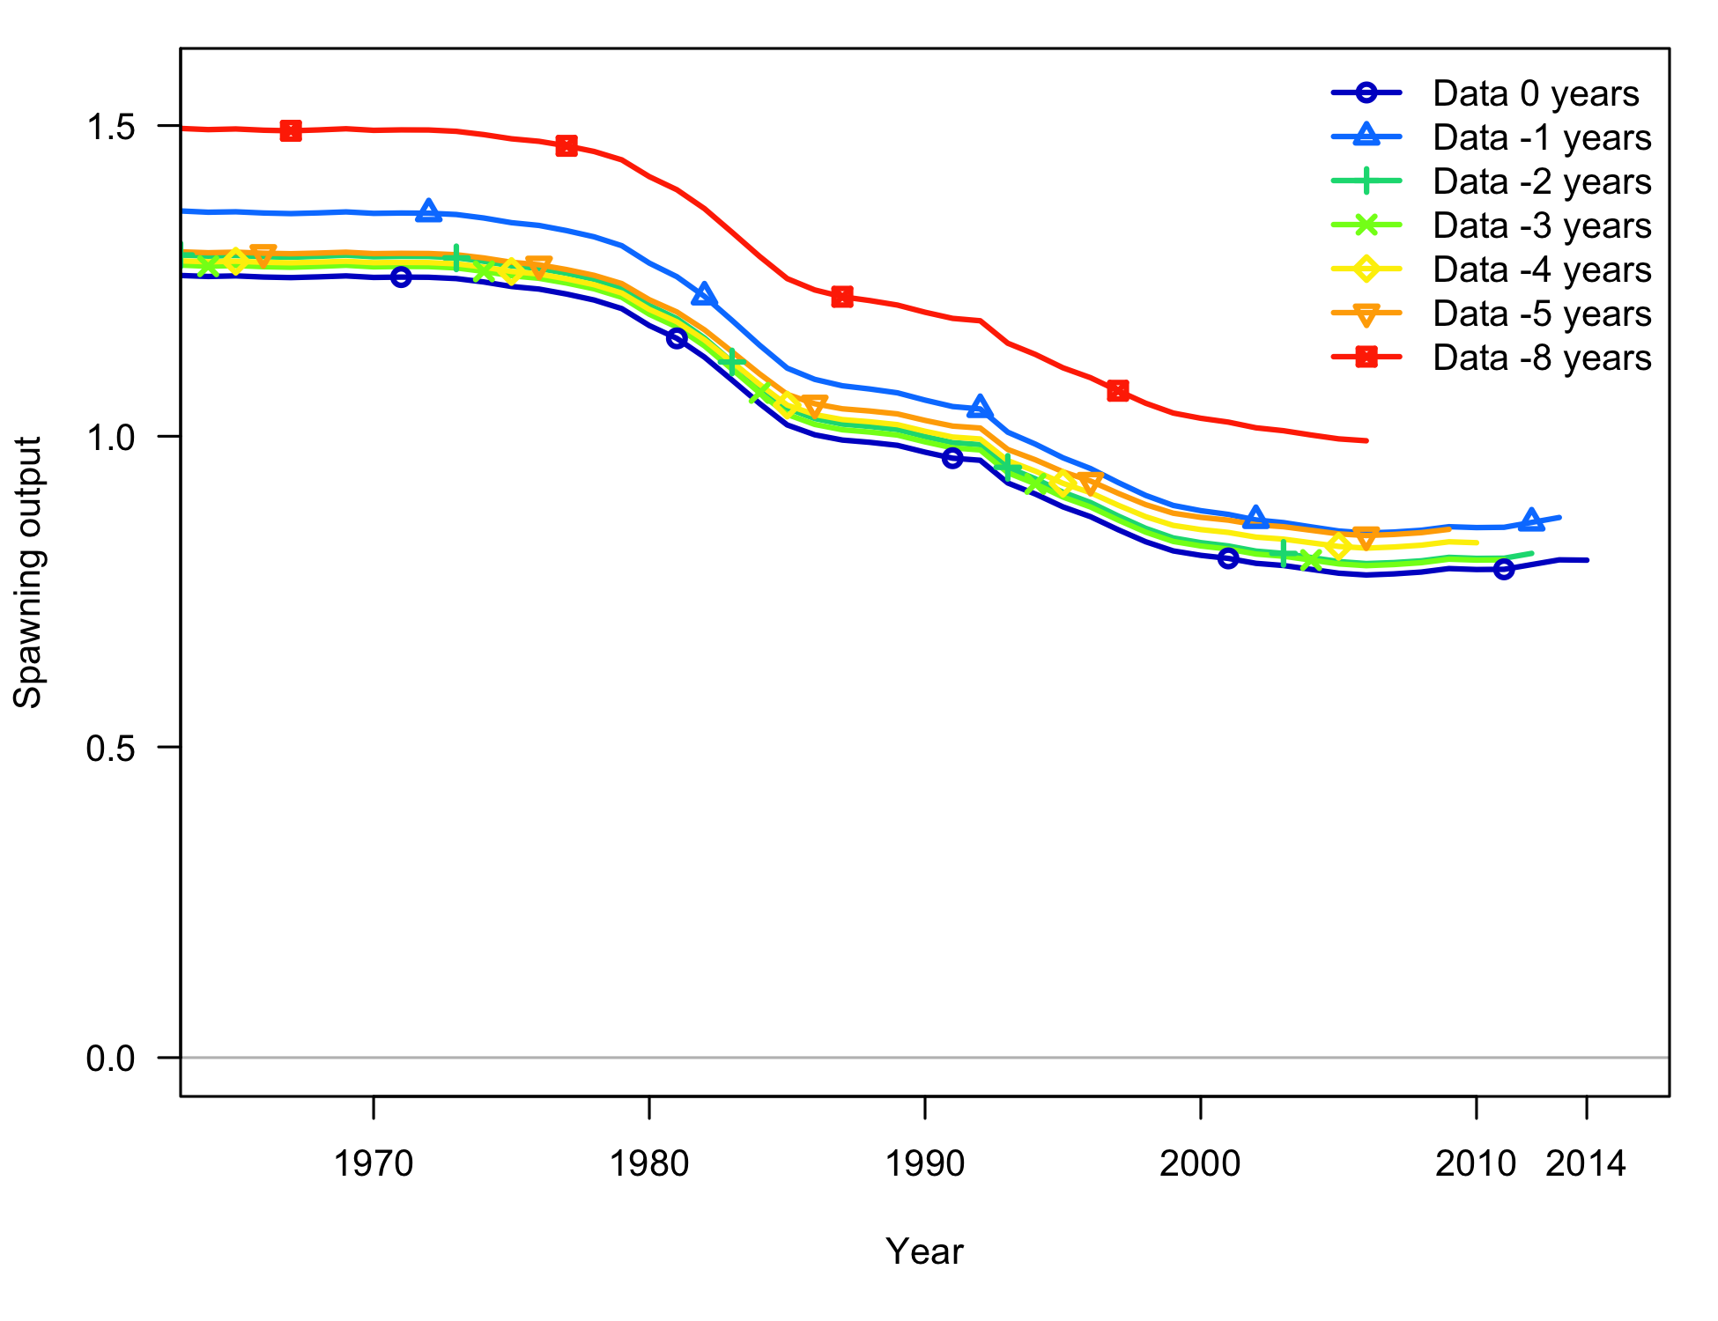

Figure . Retrospective model runs from the base case model of Oregon (“Data 0 years”) for stock spawning output.

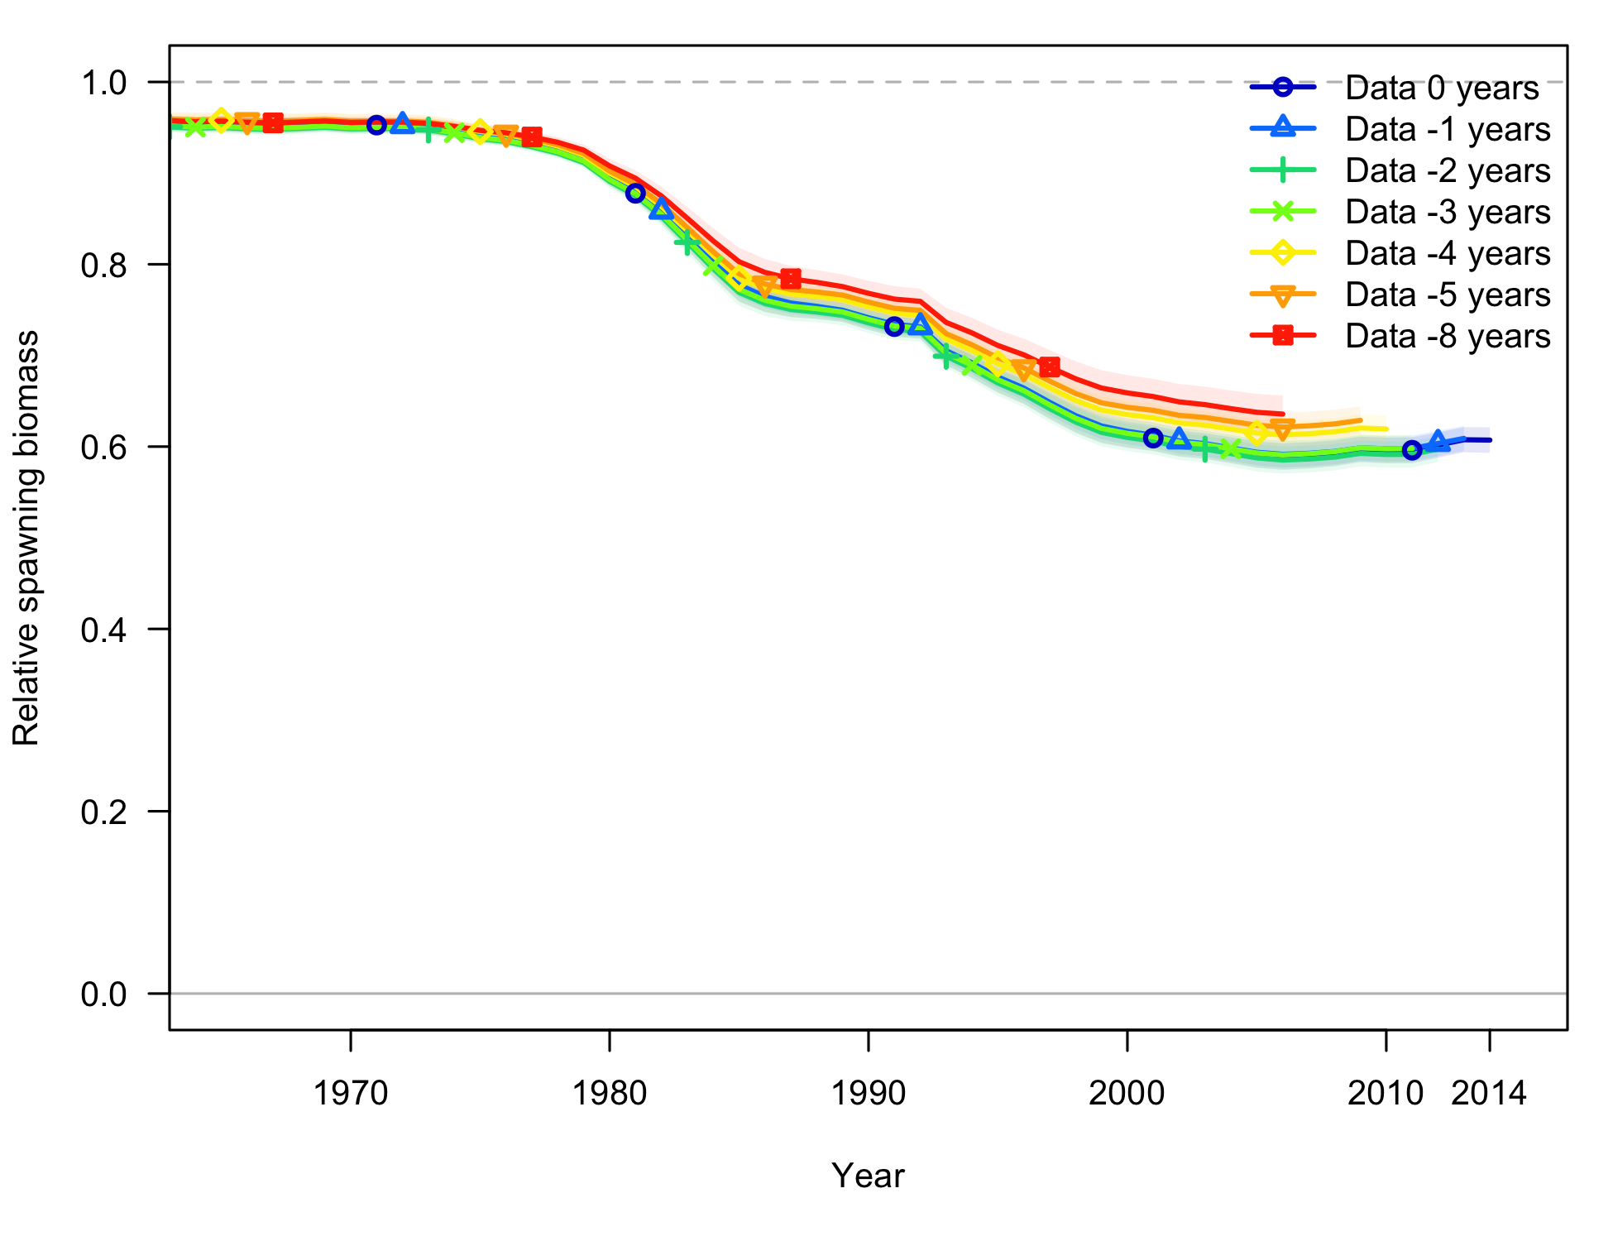

Figure . Retrospective model runs from the base case model of Oregon (“Data 0 years”) for relative stock output (stock status). Shading indicates 95% confidence intervals.

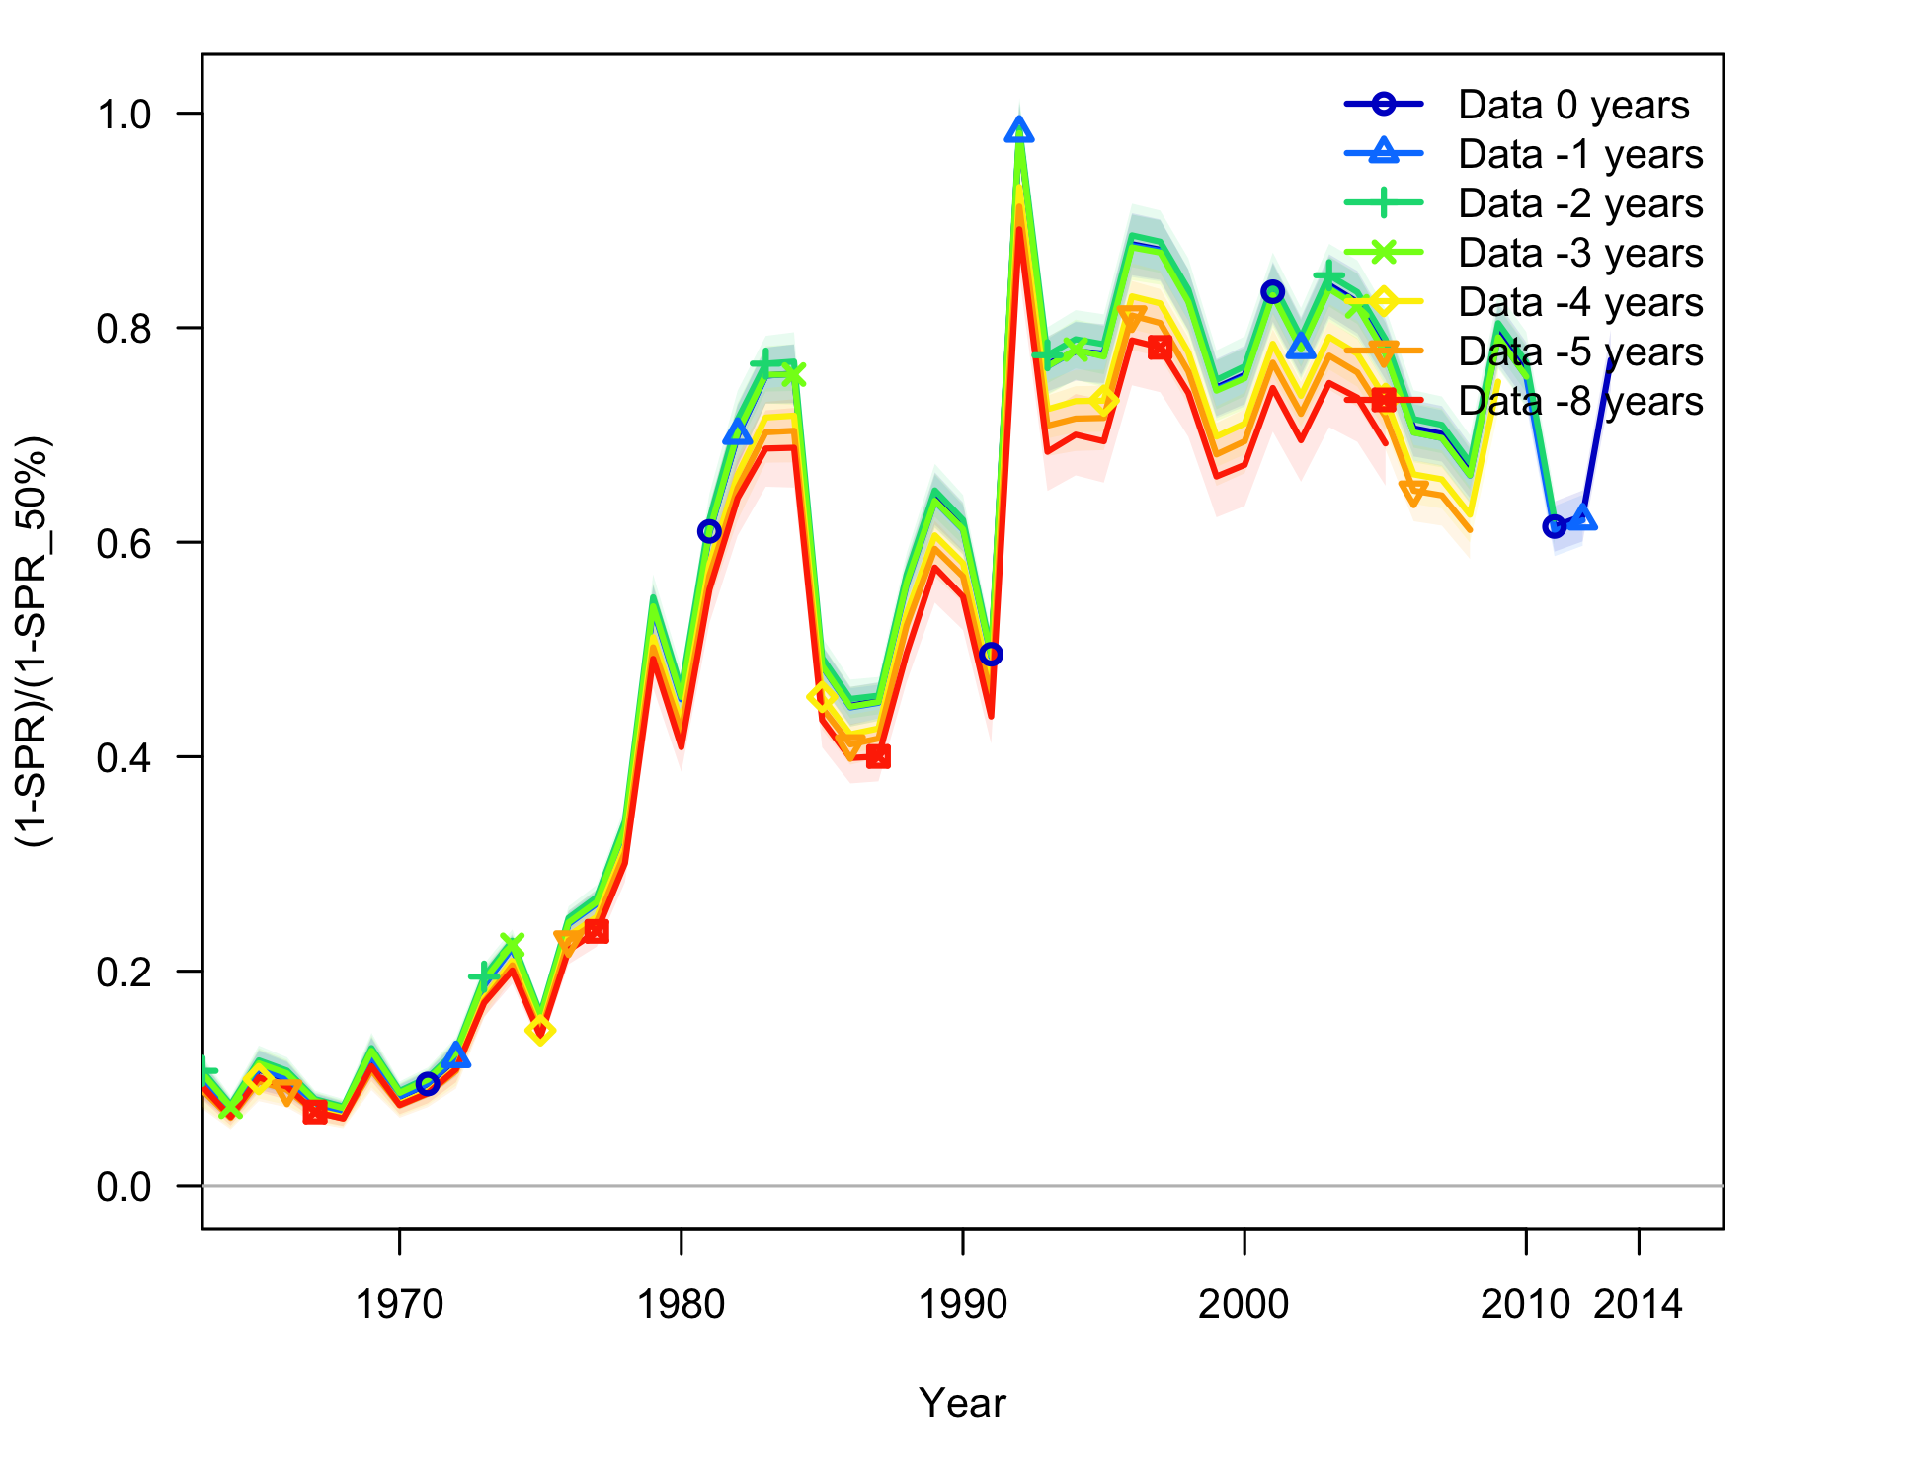

Figure . Retrospective model runs from the base case model of Oregon (“Data 0 years”) for fishing intensity in terms of SPR. Shading indicates 95% confidence intervals.

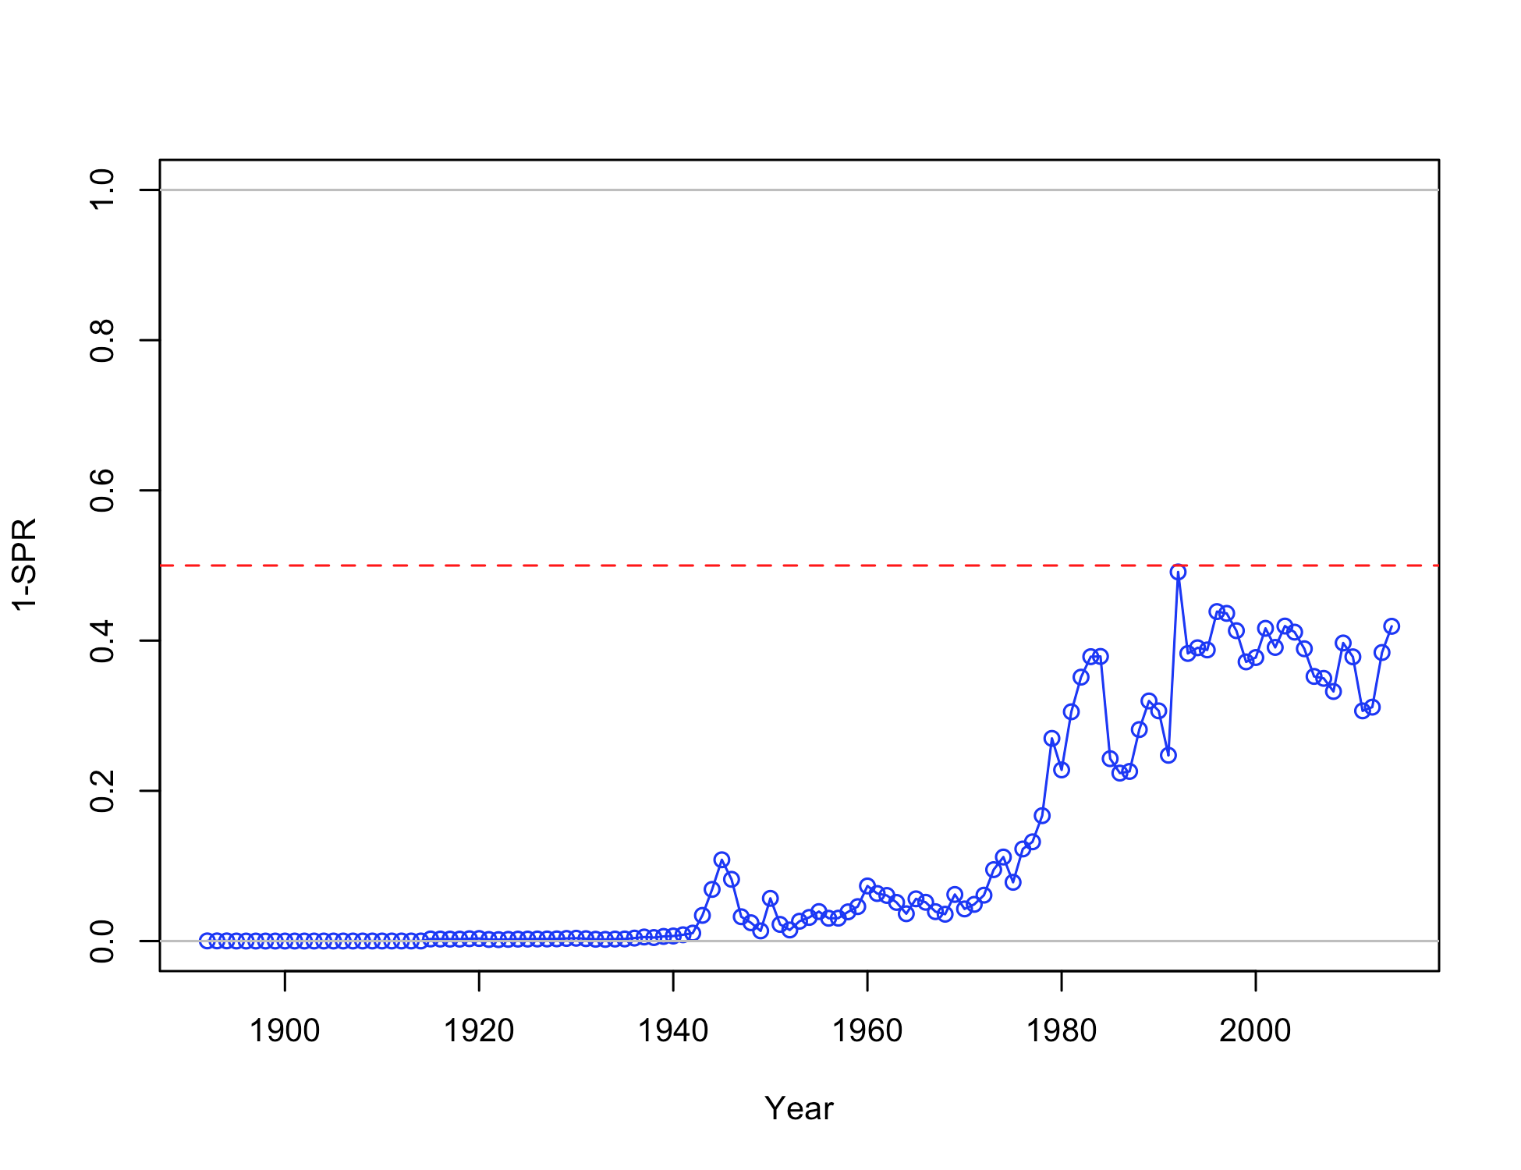

Figure . Estimated spawning potential ratio (SPR) for the Oregon base case model. One minus SPR is plotted so that higher exploitation rates occur on the upper portion of the y-axis. The management target is plotted as a red horizontal line and values above this reflect harvests in excess of the overfishing proxy based on the SPR50% harvest rate. The last year in the time series is 2014.

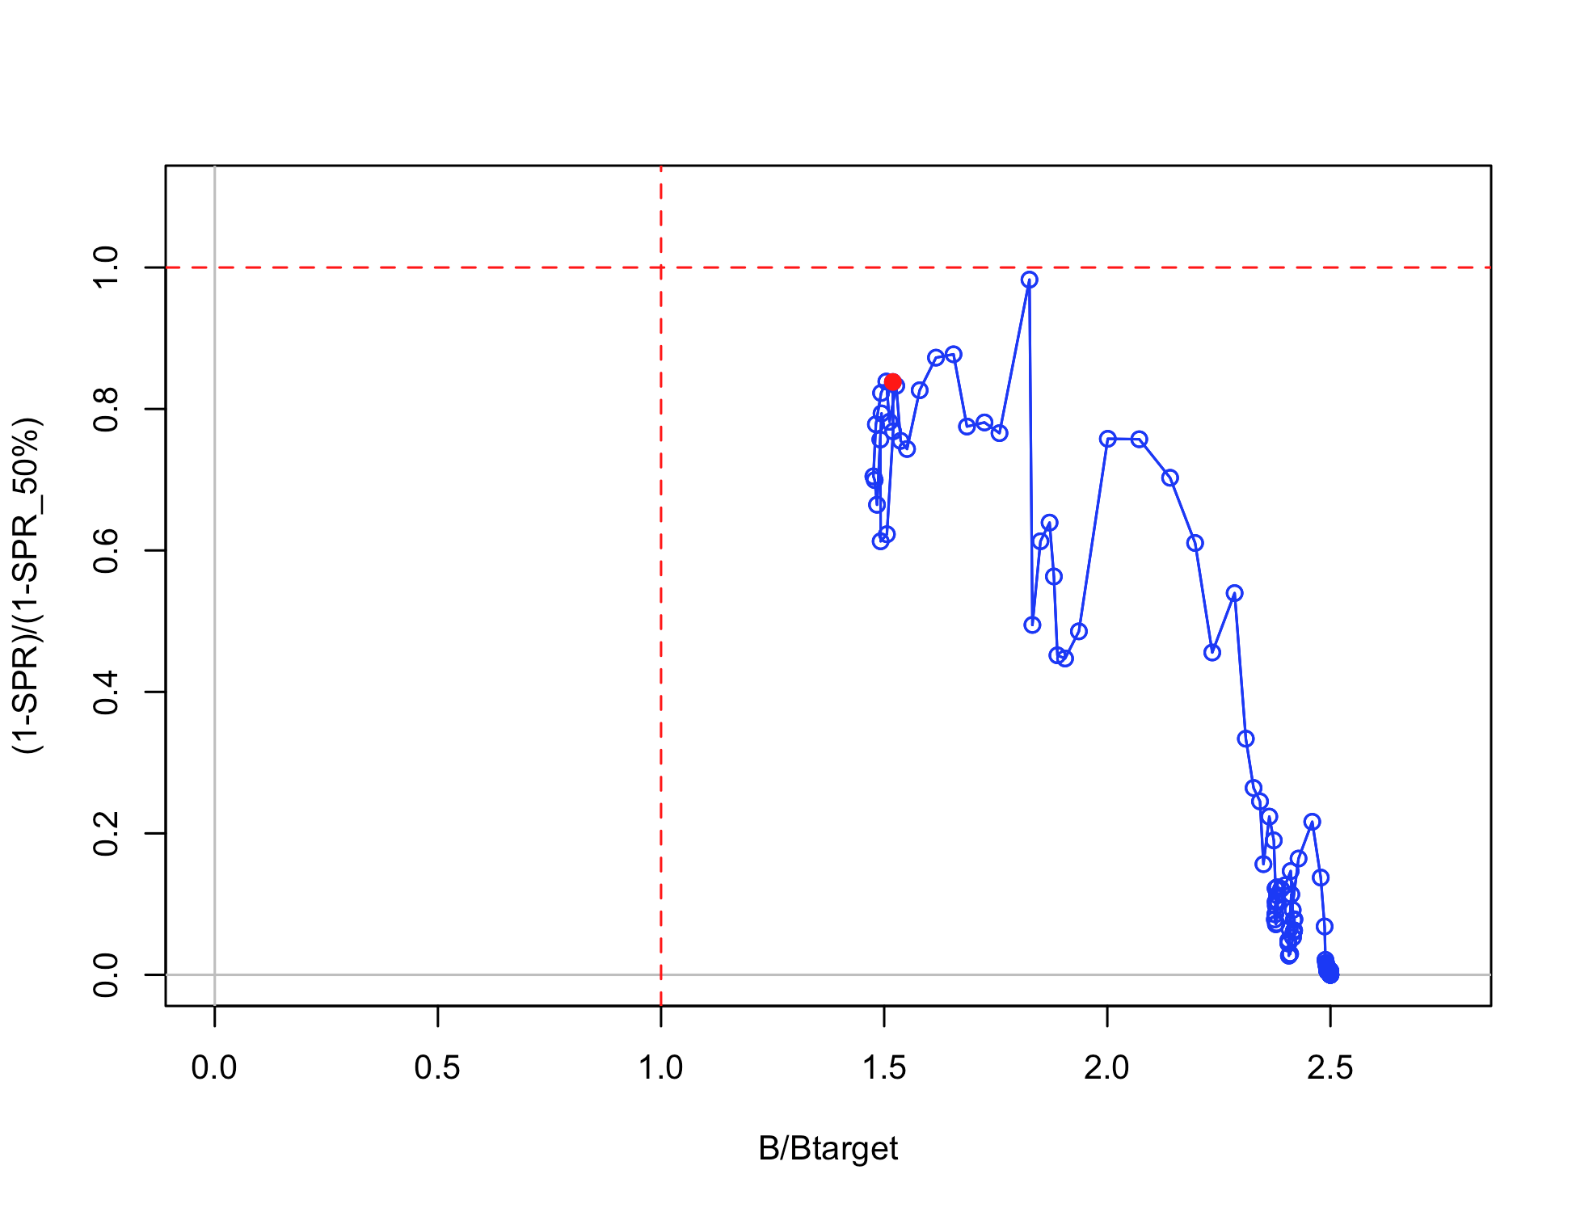

Figure . Phase plot of relative spawning biomass vs fishing intensity for the Oregon base case model. The relative fishing intensity is (1-SPR) divided by 50% (the SPR target). The vertical red line is the relative spawning biomass target defined as the annual spawning biomass divided by the spawning biomass corresponding to 40% of the unfished spawning biomass.

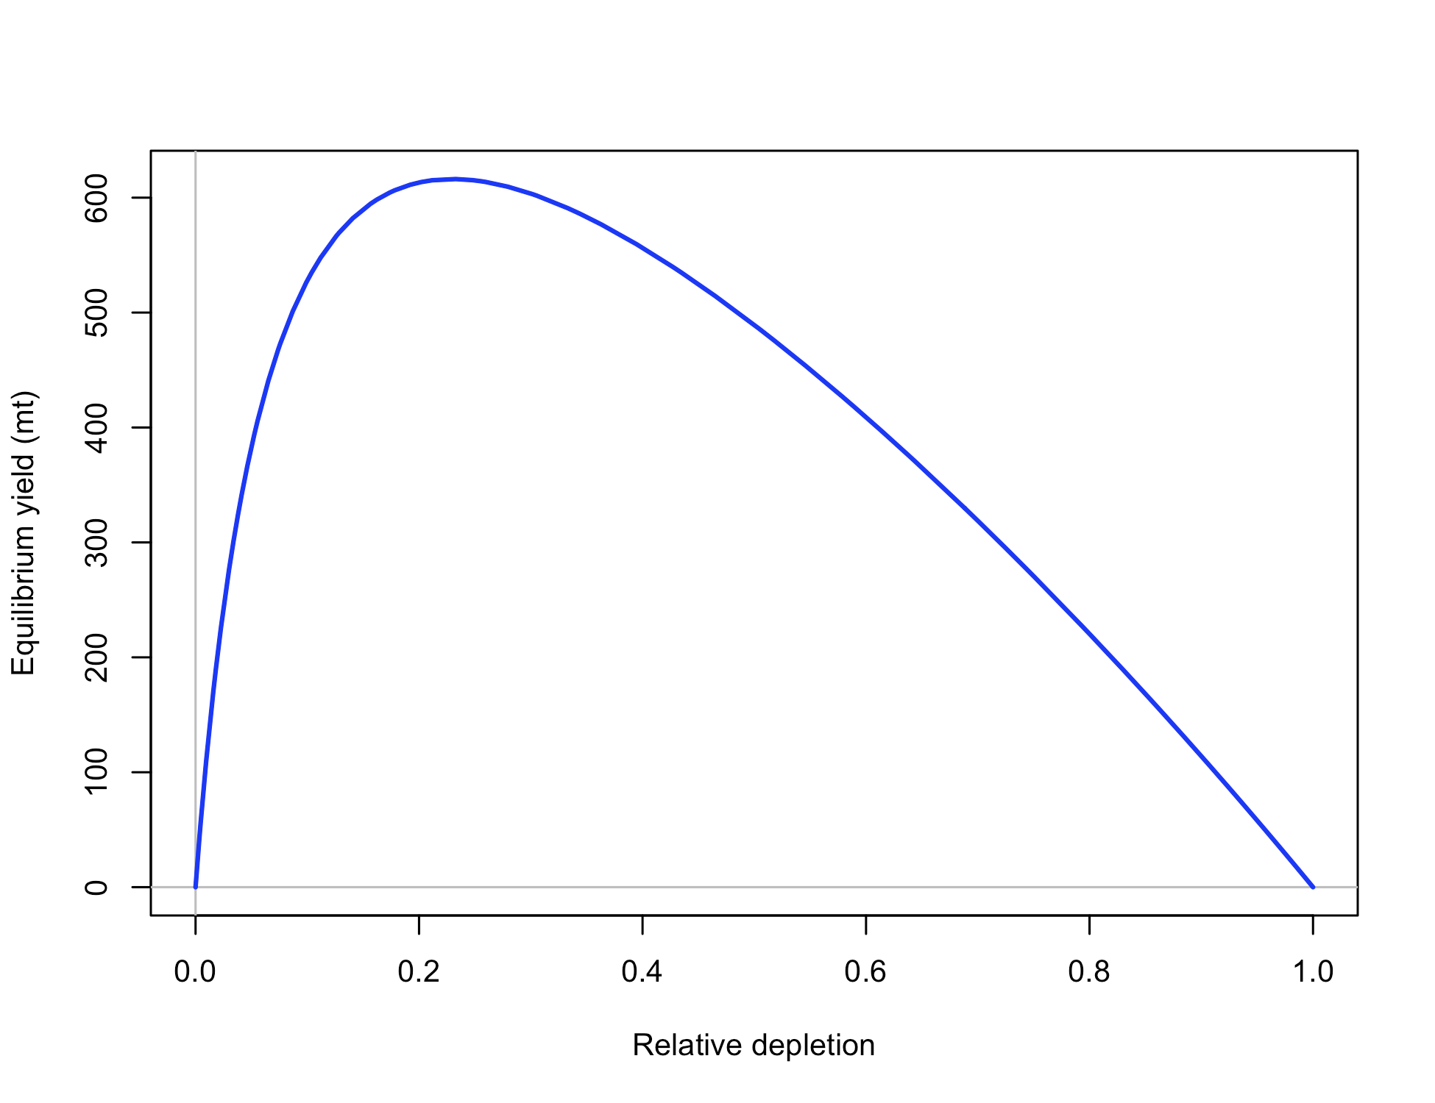

Figure . Equilibrium yield curve for the Oregon base case model. Values are based on 2014 fishery selectivity and distribution with steepness fixed at 0.773. The depletion is relative to unfished spawning biomass.

## WA Data Figures

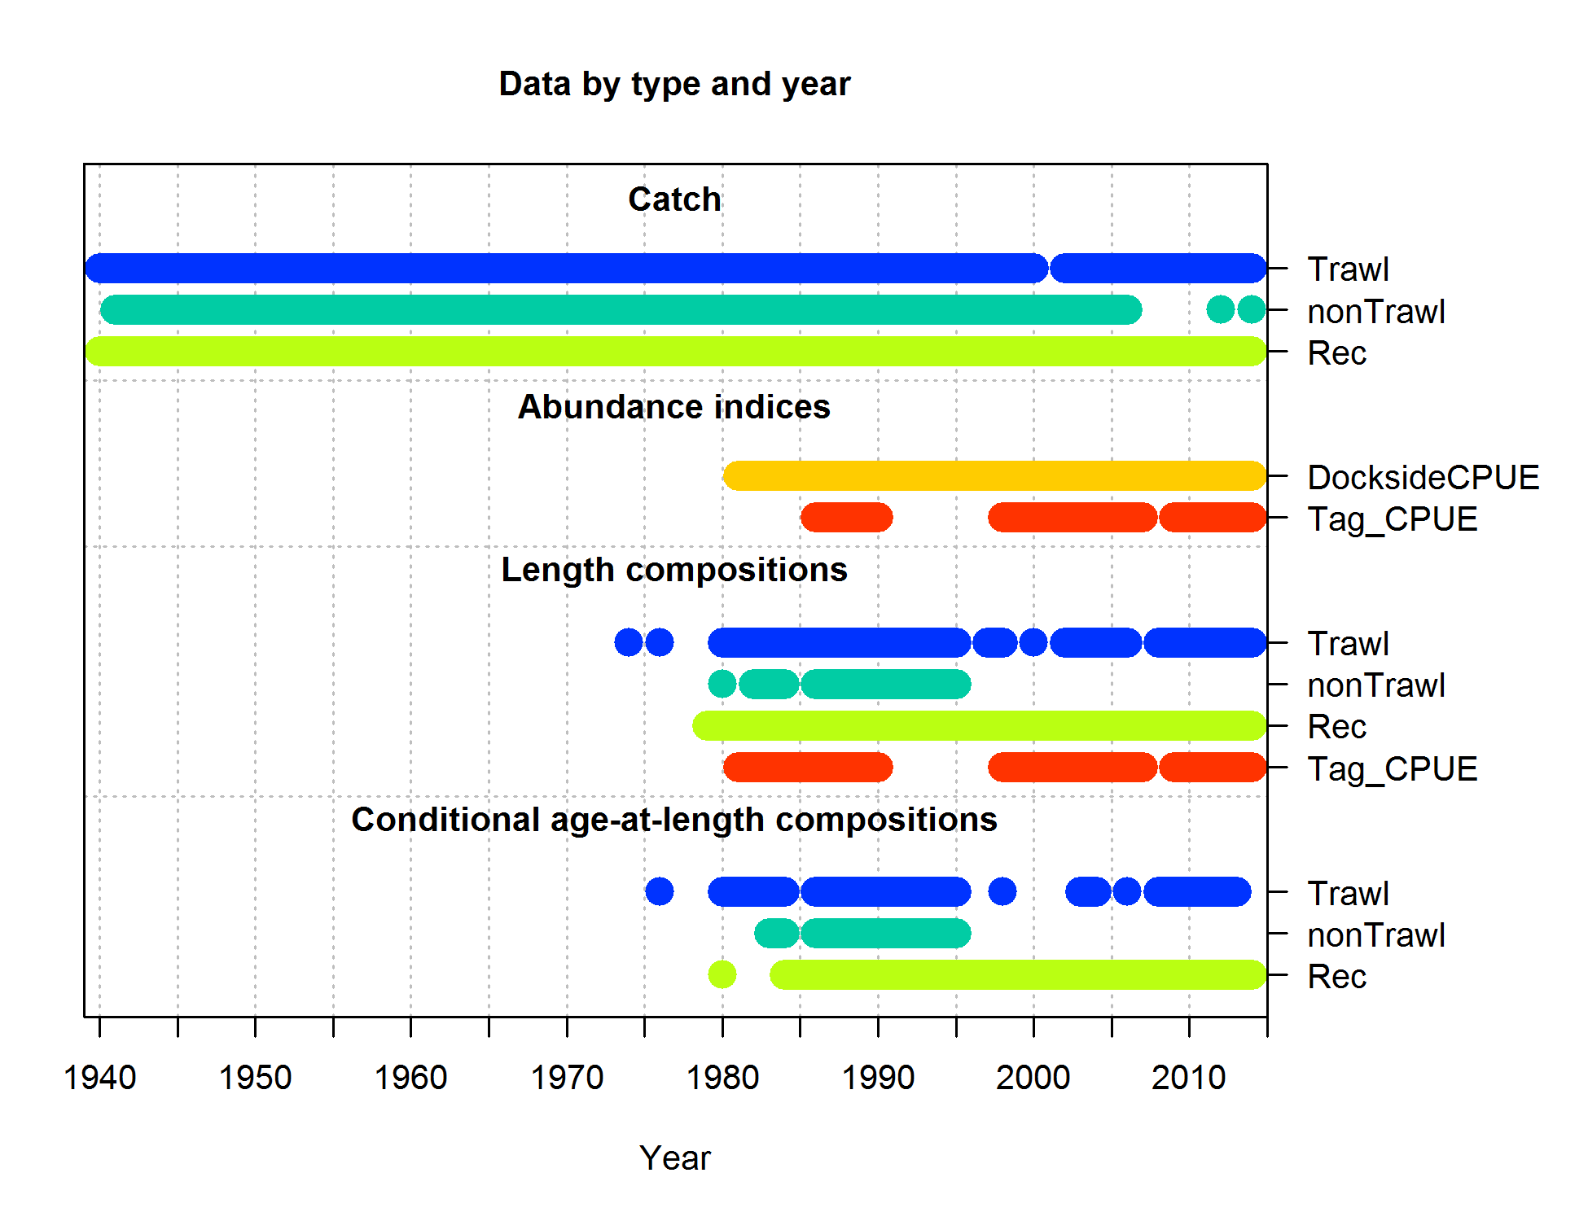

Figure . Data and data types used in the Washington black rockfish stock assessment model.

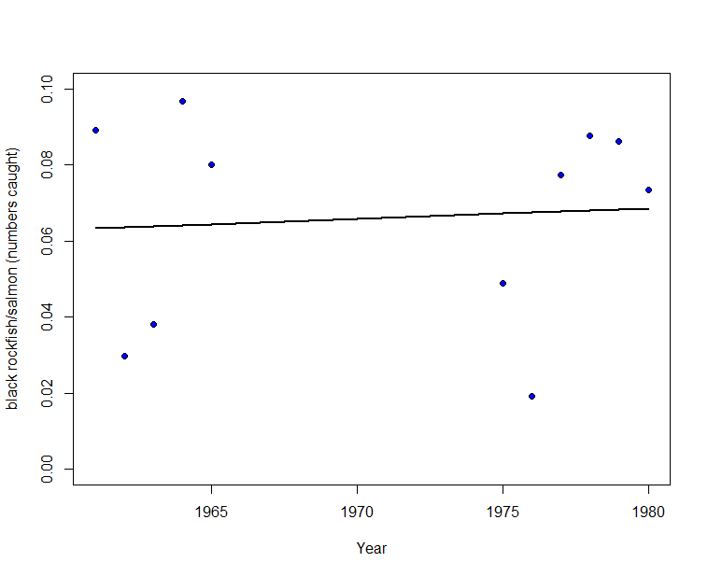

Figure . Ratio of total rockfish to salmon catches over time in Washington used to build the predicting relationship for the missing catch years of black rockfish removals 1950-1966 and 1968-1974.

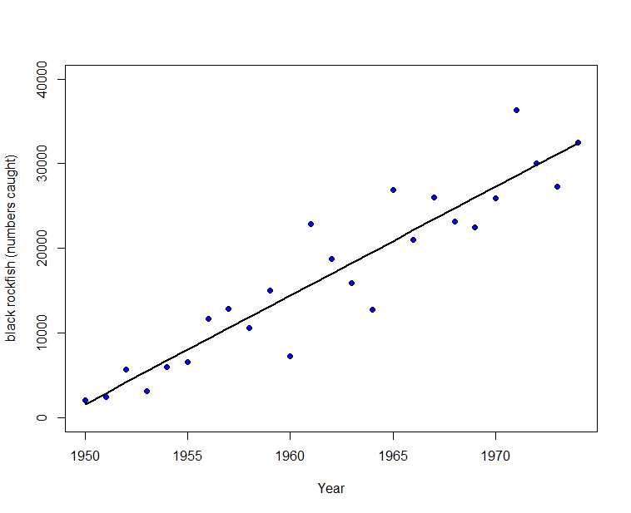

Figure . Numbers of landed black rockfish in Washington relative to year used to calculate pre-1950 catch estimates.



Figure . Comparison of catch by fishery from the current (Washington) and previous (Northern) assessments.

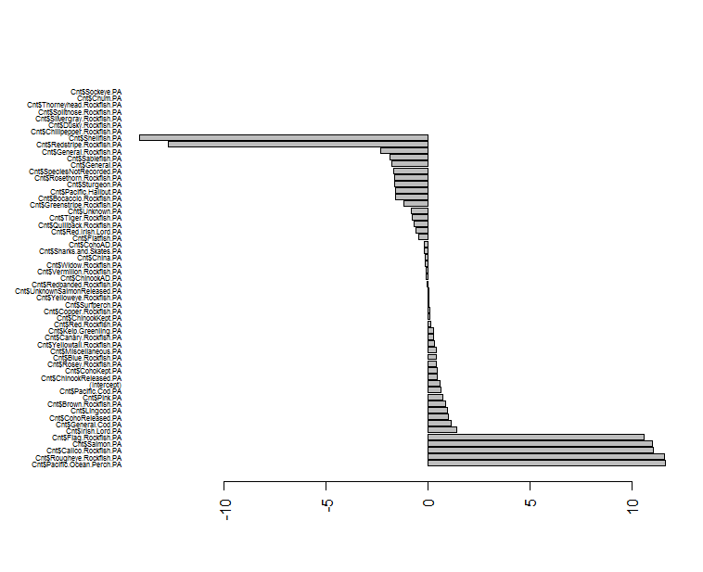

Figure . Species coefficients from the binomial GLM for presence/absence of black rockfish in the WDFW dockside data for years 1980-1989.

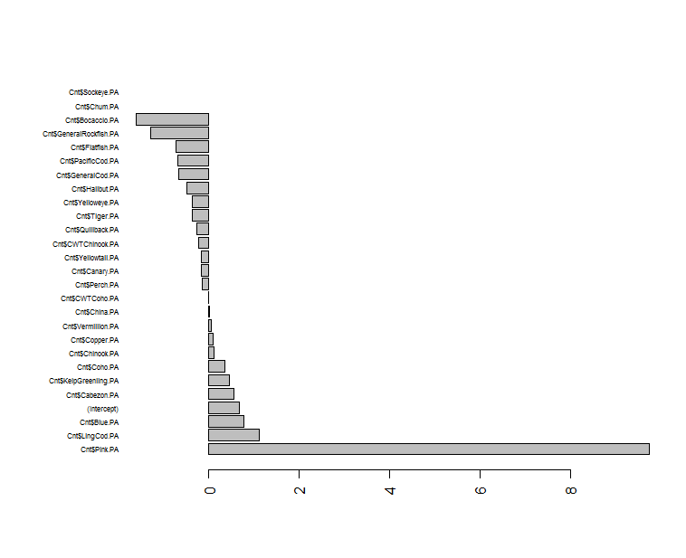

Figure . Species coefficients from the binomial GLM for presence/absence of black rockfish in the WDFW dockside data for years 1990-2014.

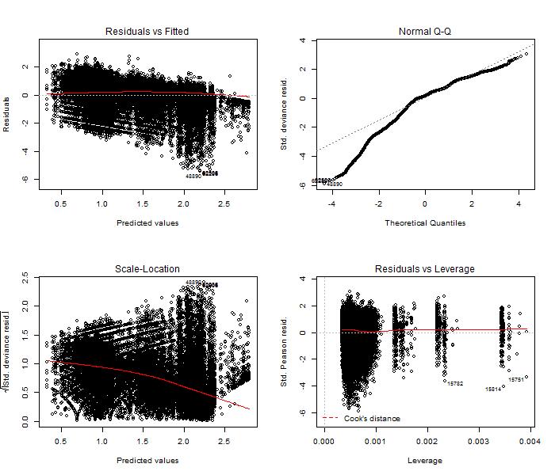

Figure . Diagnostic plots for the black rockfish positive catch component lognormal delta-GLM model for the Washington dockside dataset without Stephens-MacCall filtering. These are used to evaluate model fit (top left), assumptions of normality (top right), assumptions of constant variance (bottom left), and the presence of outliers (bottom right).

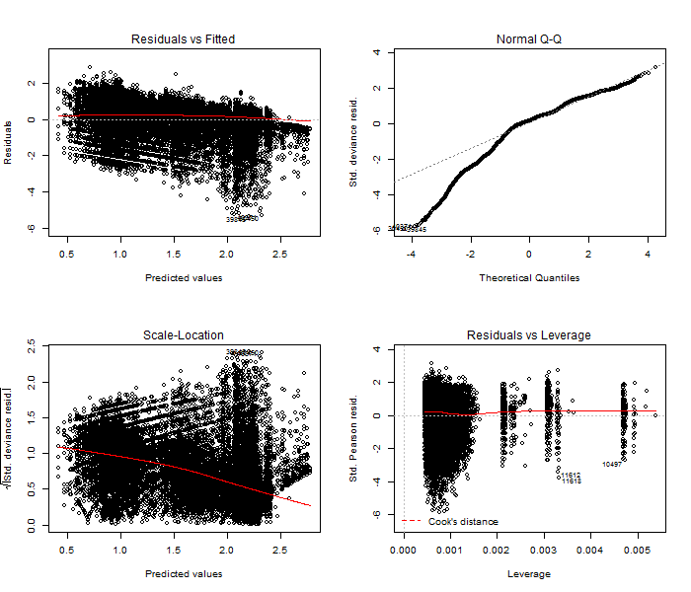

Figure . Diagnostic plots for the black rockfish positive catch component lognormal delta-GLM model for the Washington dockside dataset with Stephens-MacCall filtering. These are used to evaluate model fit (top left), assumptions of normality (top right), assumptions of constant variance (bottom left), and the presence of outliers (bottom right).

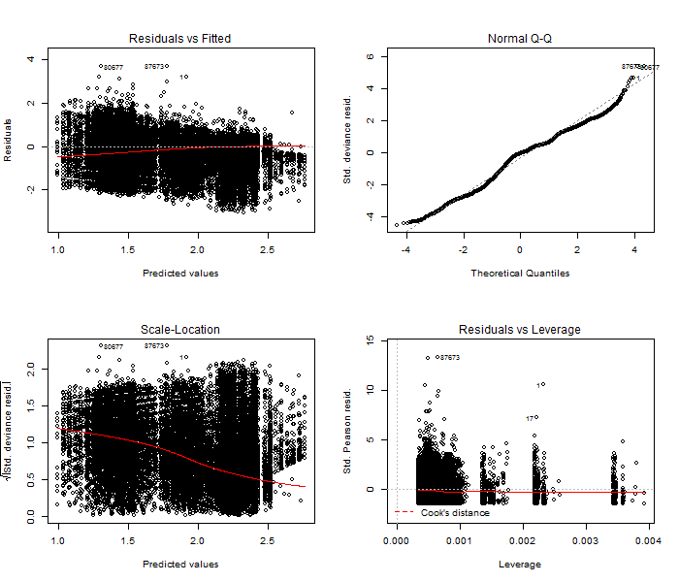

Figure . Diagnostic plots for the black rockfish positive catch component gamma delta-GLM model for the Washington dockside dataset without Stephens-MacCall filtering. These are used to evaluate model fit (top left), assumptions of normality (top right), assumptions of constant variance (bottom left), and the presence of outliers (bottom right).

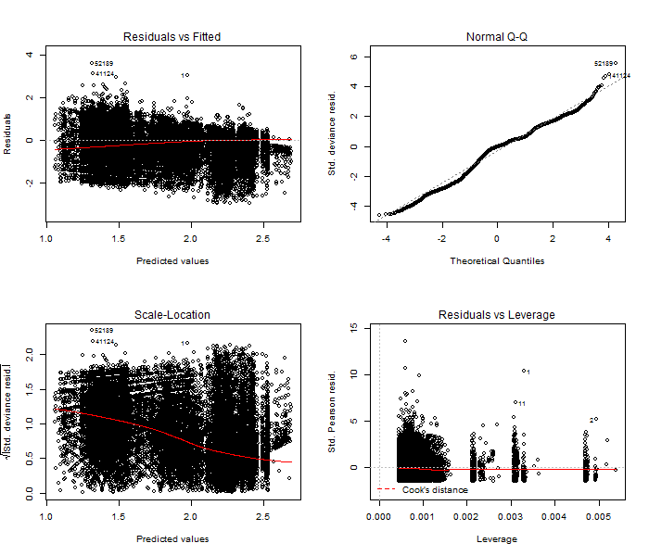

Figure . Diagnostic plots for the black rockfish positive catch component gamma delta-GLM model for the Washington dockside dataset with Stephens-MacCall filtering. These are used to evaluate model fit (top left), assumptions of normality (top right), assumptions of constant variance (bottom left), and the presence of outliers (bottom right).

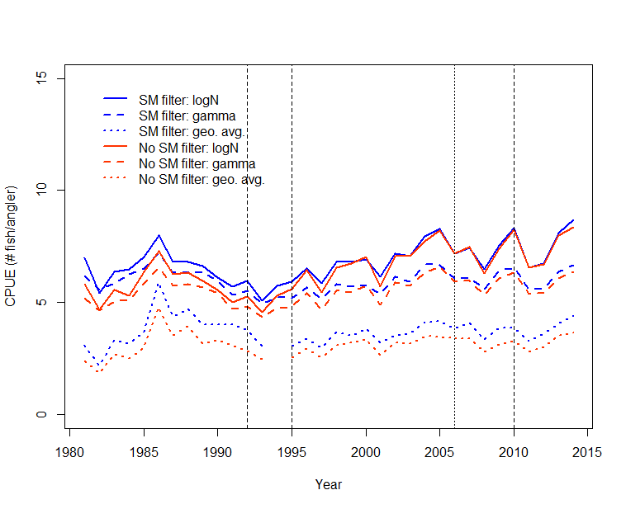

Figure . Abundance indices for the WDFW dockside CPUE analysis. Vertical lines are management actions. Colors indicate different filtered data sets. Line type indicates different realizations of the index.

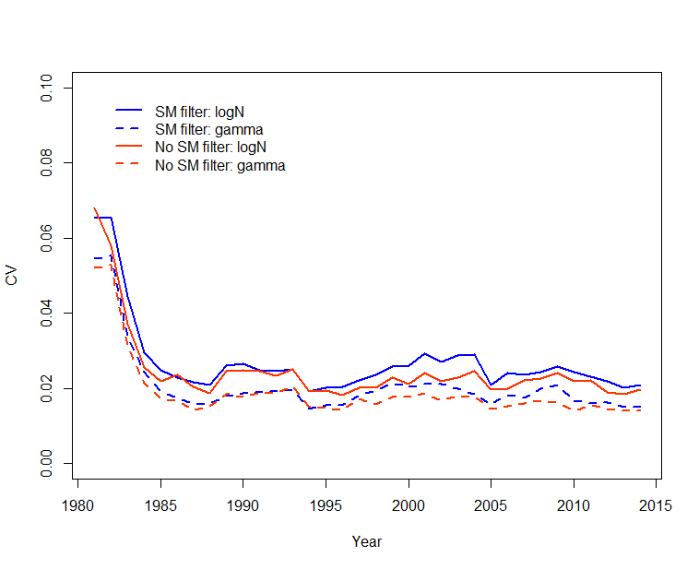

Figure . Bootstrapped estimates of variation for each model of the Washington dockside index.

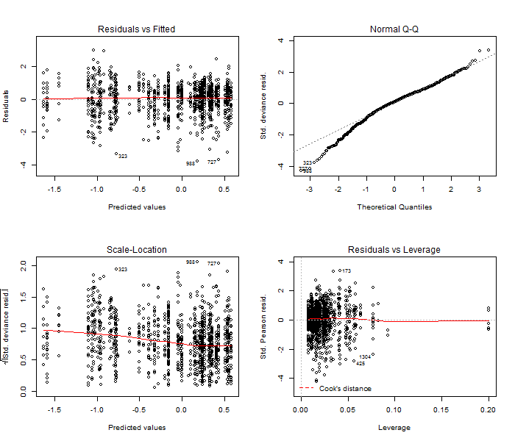

Figure . Diagnostic plots for the black rockfish positive catch component lognormal delta-GLM model for the Washington tagging dataset. These are used to evaluate model fit (top left), assumptions of normality (top right), assumptions of constant variance (bottom left), and the presence of outliers (bottom right).

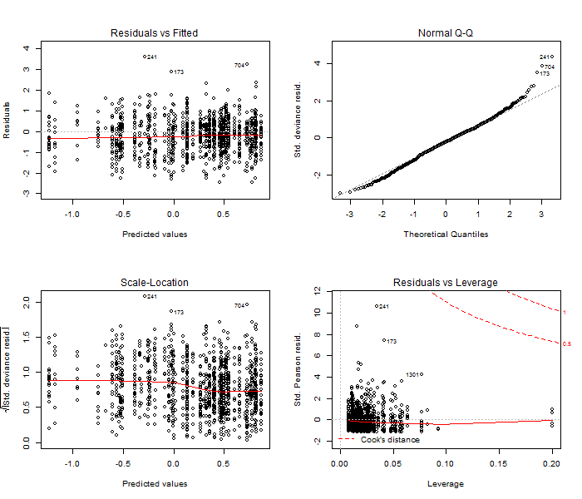

Figure . Diagnostic plots for the black rockfish positive catch component gamma delta-GLM model for the Washington tagging dataset. These are used to evaluate model fit (top left), assumptions of normality (top right), assumptions of constant variance (bottom left), and the presence of outliers (bottom right).

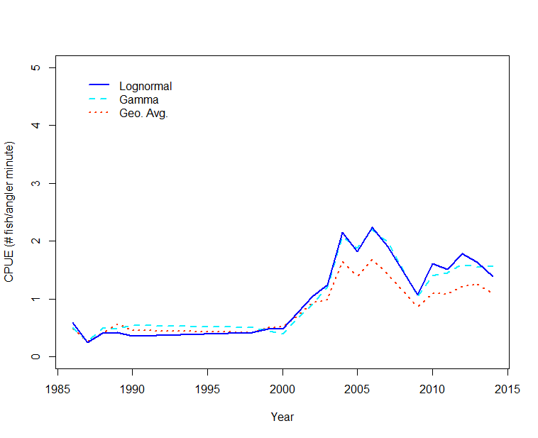

Figure . Abundance indices for the WDFW tagging CPUE analysis.

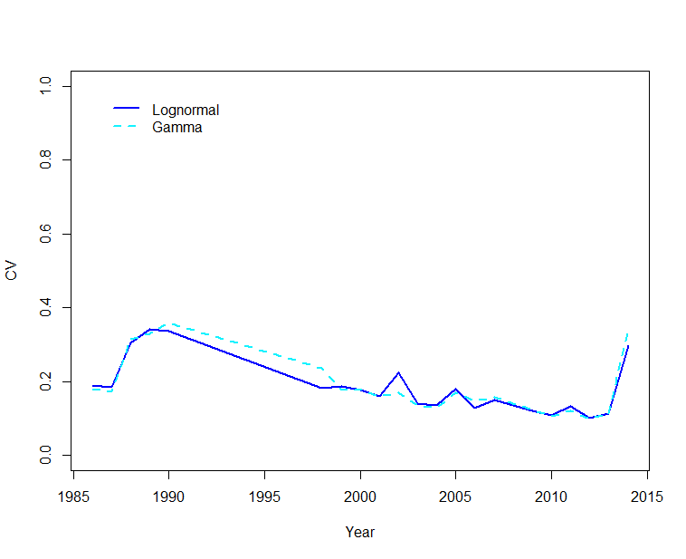

Figure . Jackknifed estimates of variation for each model of the Washington tagging CPUE index.

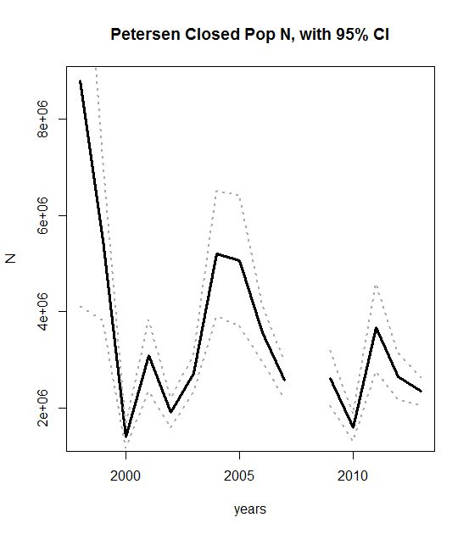

Figure . Abundance estimates for Washington black rockfish using Petersen method, with 95% upper and lower confidence intervals.

## WA Model Figures

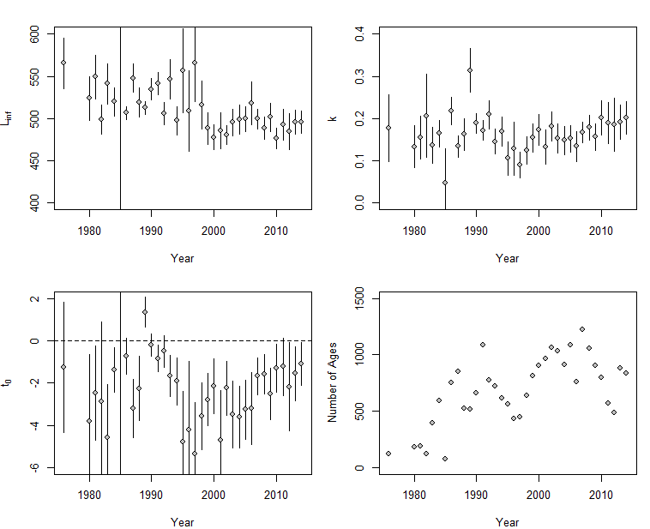

Figure . Temporal estimates of the von Bertalanffy growth parameters and sample sizes for females in Washington state. Vertical lines are 95% confidence intervals.

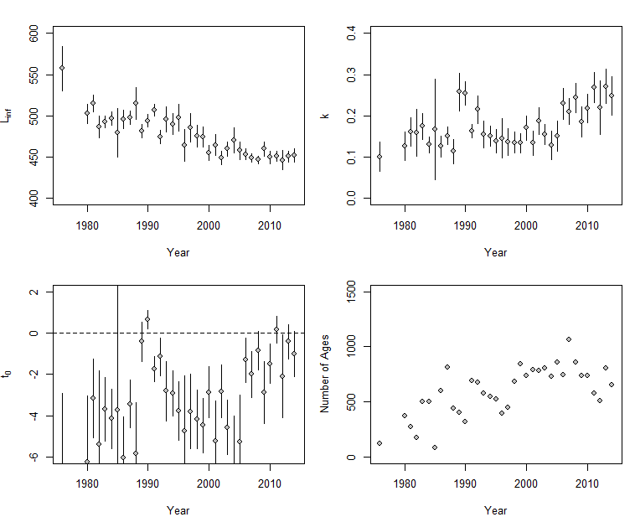

Figure . Temporal estimates of the von Bertalanffy growth parameters and sample sizes for males in Washington state. Vertical lines are 95% confidence intervals.

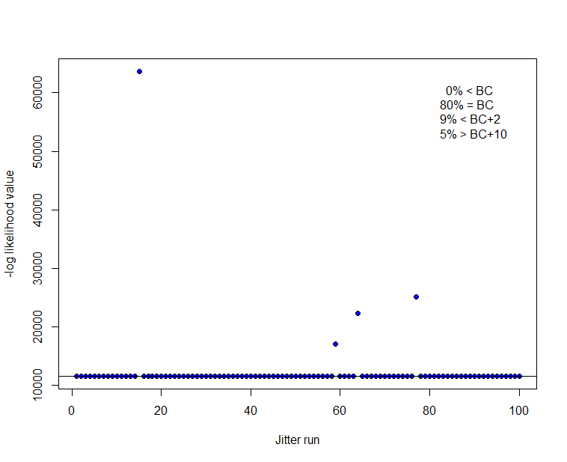

Figure . Results from 100 Washington model base case runs when starting values are jittered (0.1). Horizontal line indicates base model value.

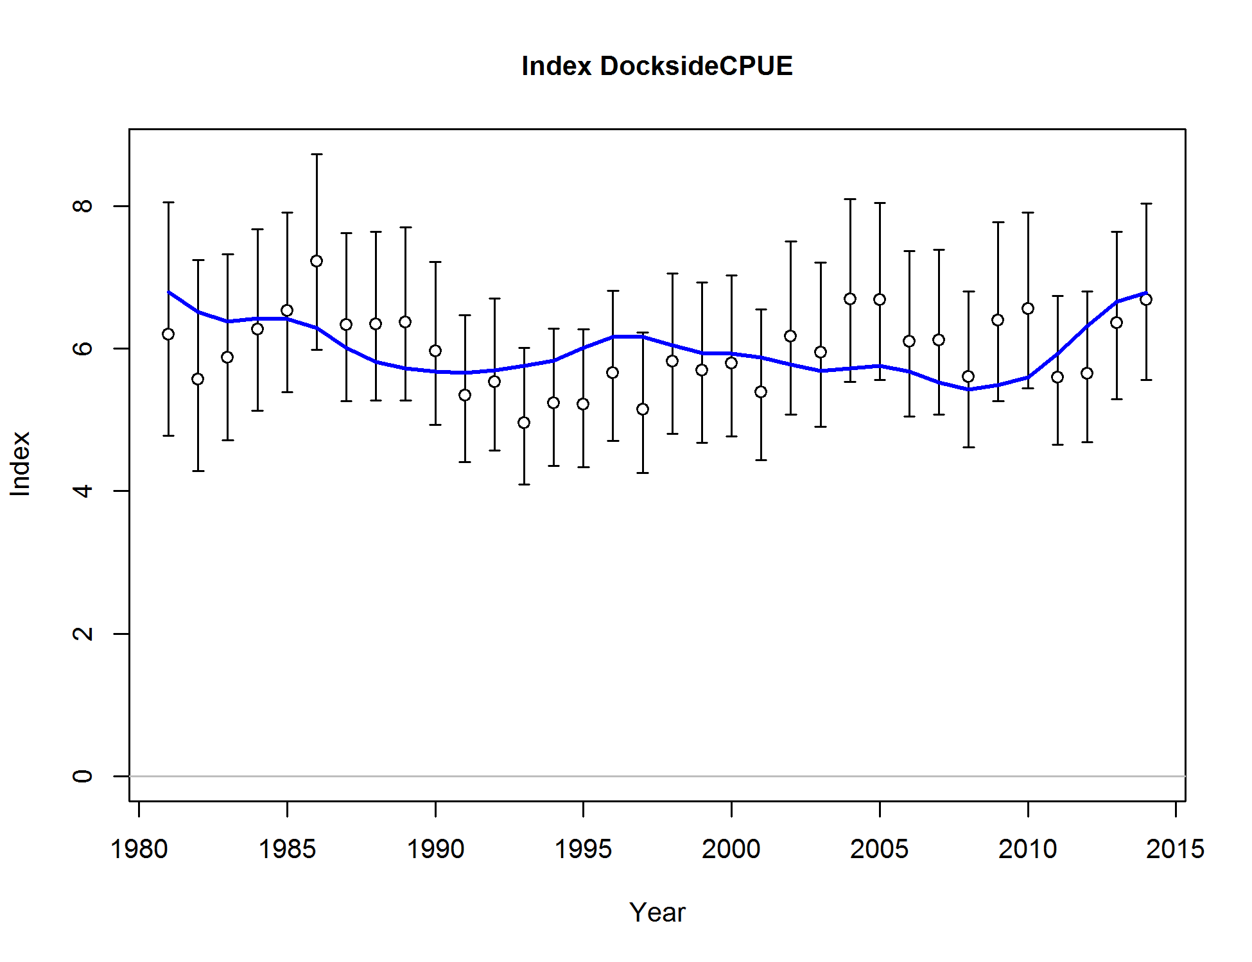

Figure . Base model fit to the Washington recreational dockside index.

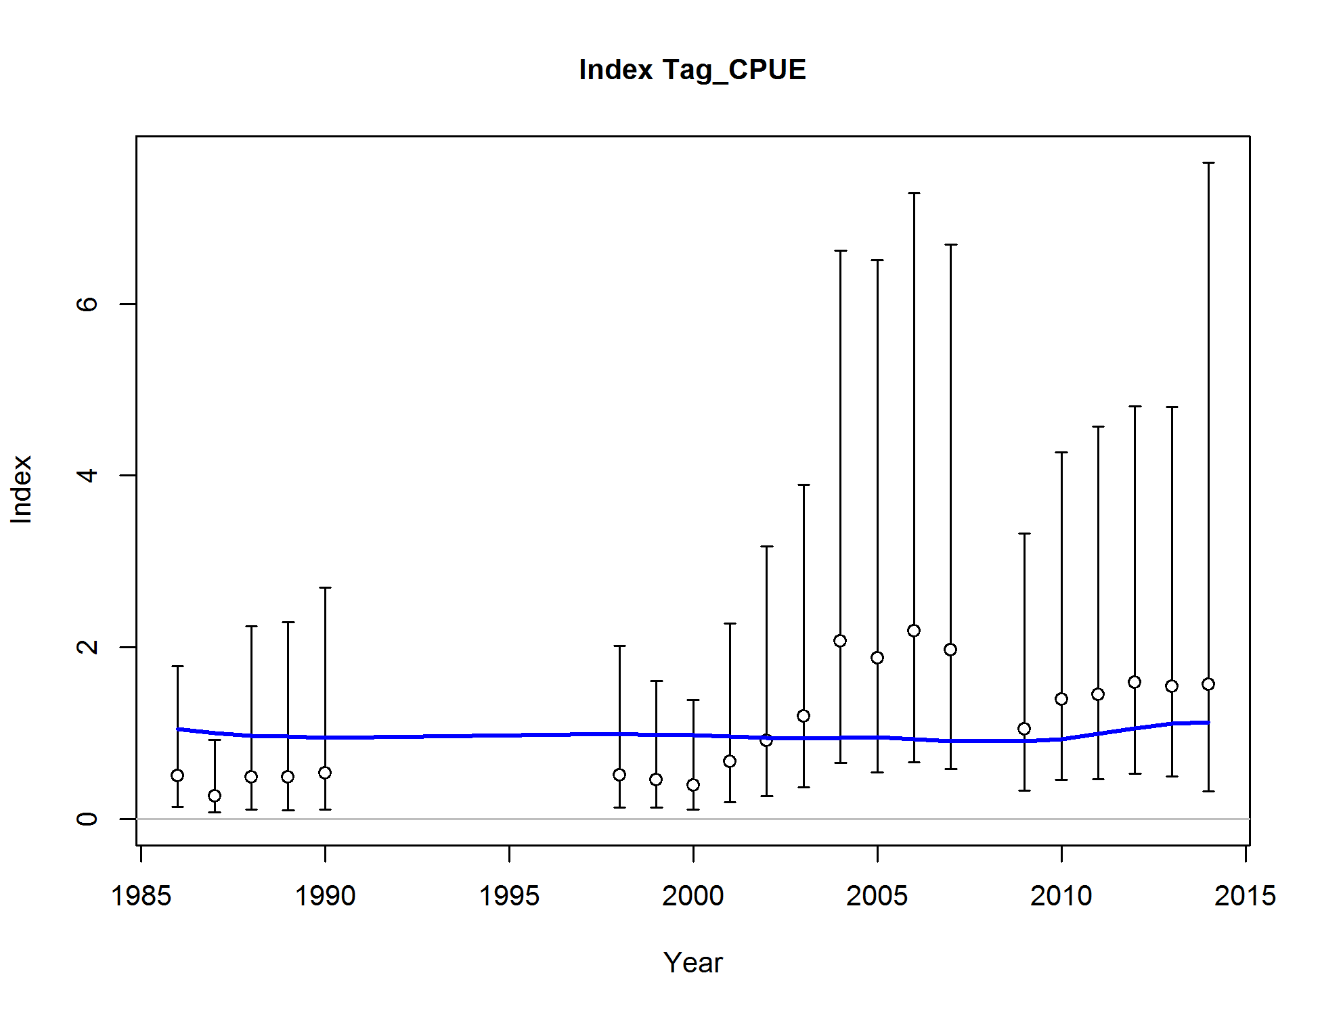

Figure . Base model fit to the Washington tagging CPUE index.

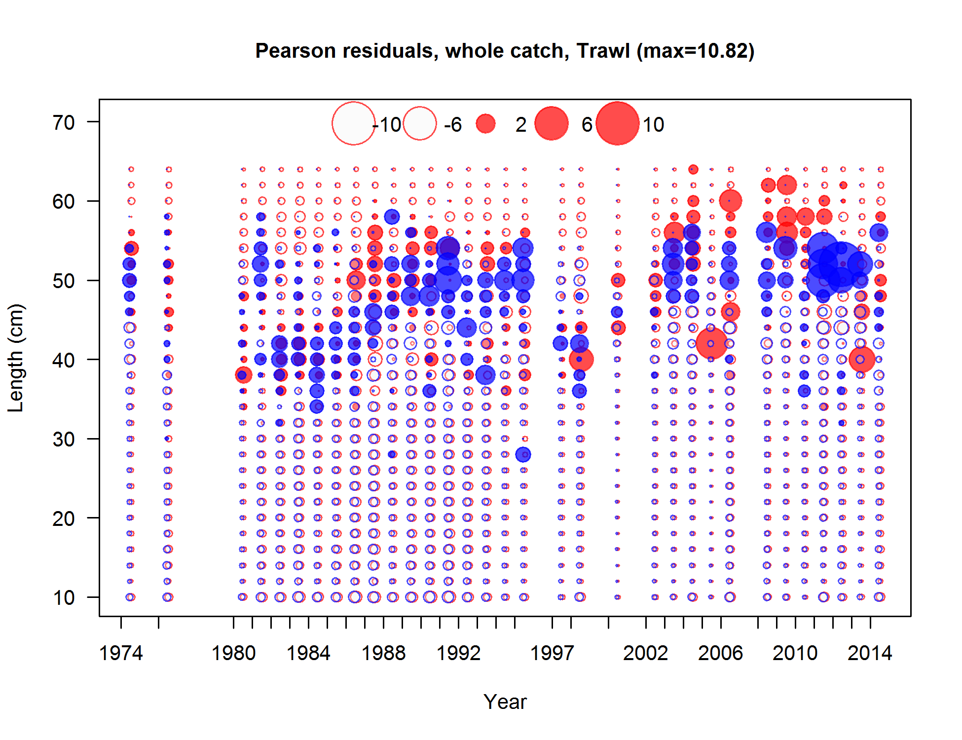

Figure . Pearson residuals plots for male (blue) and female (red) length compositions for the Washington trawl commercial fleet. Residuals <2 are generally considered non-significant.

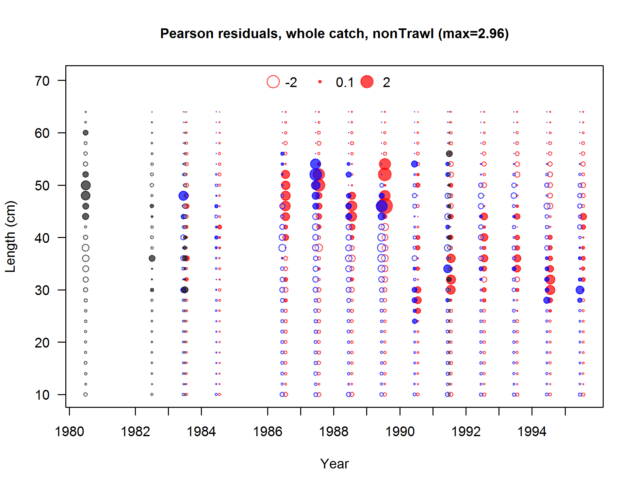

Figure . Pearson residuals plots for male (blue) and female (red) length compositions for the Washington non-trawl commercial fleet. Residuals <2 are generally considered non-significant.

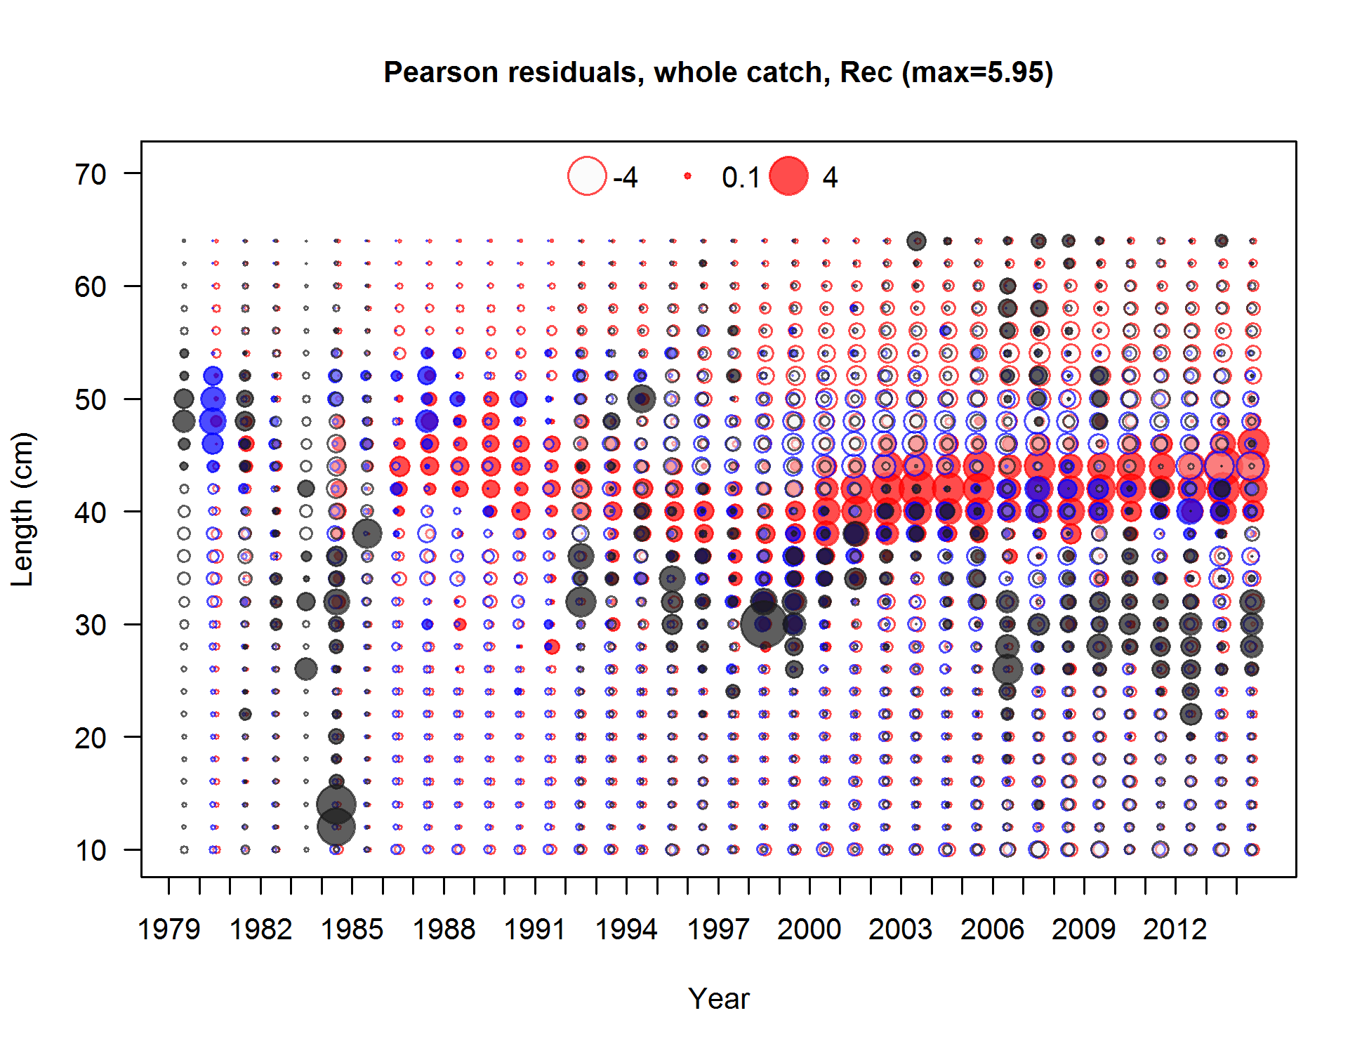

Figure . Pearson residuals plots for male (blue) and female (red) length compositions for the Washington recreational fleet. Residuals <2 are generally considered non-significant.

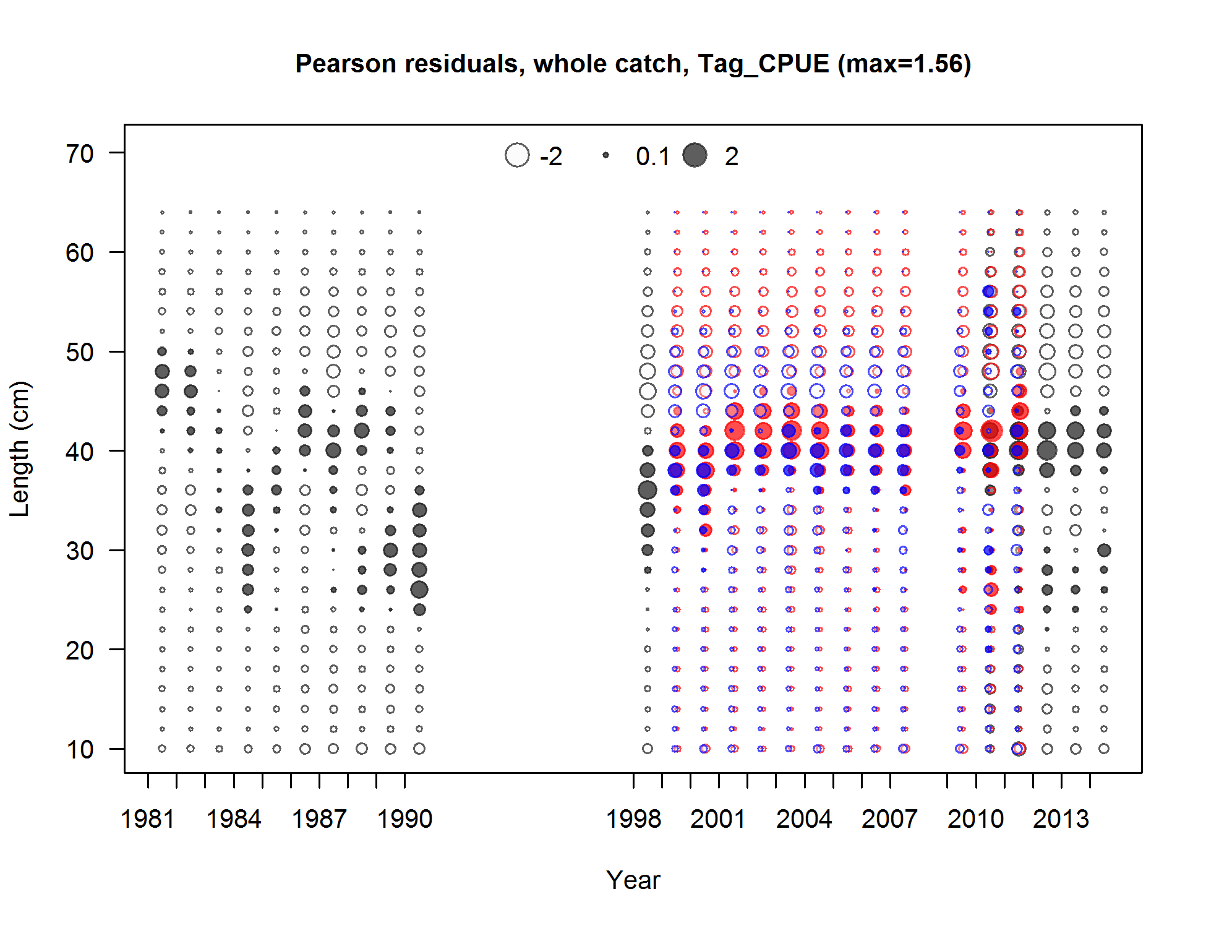

Figure . Pearson residuals plots for male (blue) and female (red) length compositions for the Washington tagging CPUE survey. Residuals <2 are generally considered non-significant.

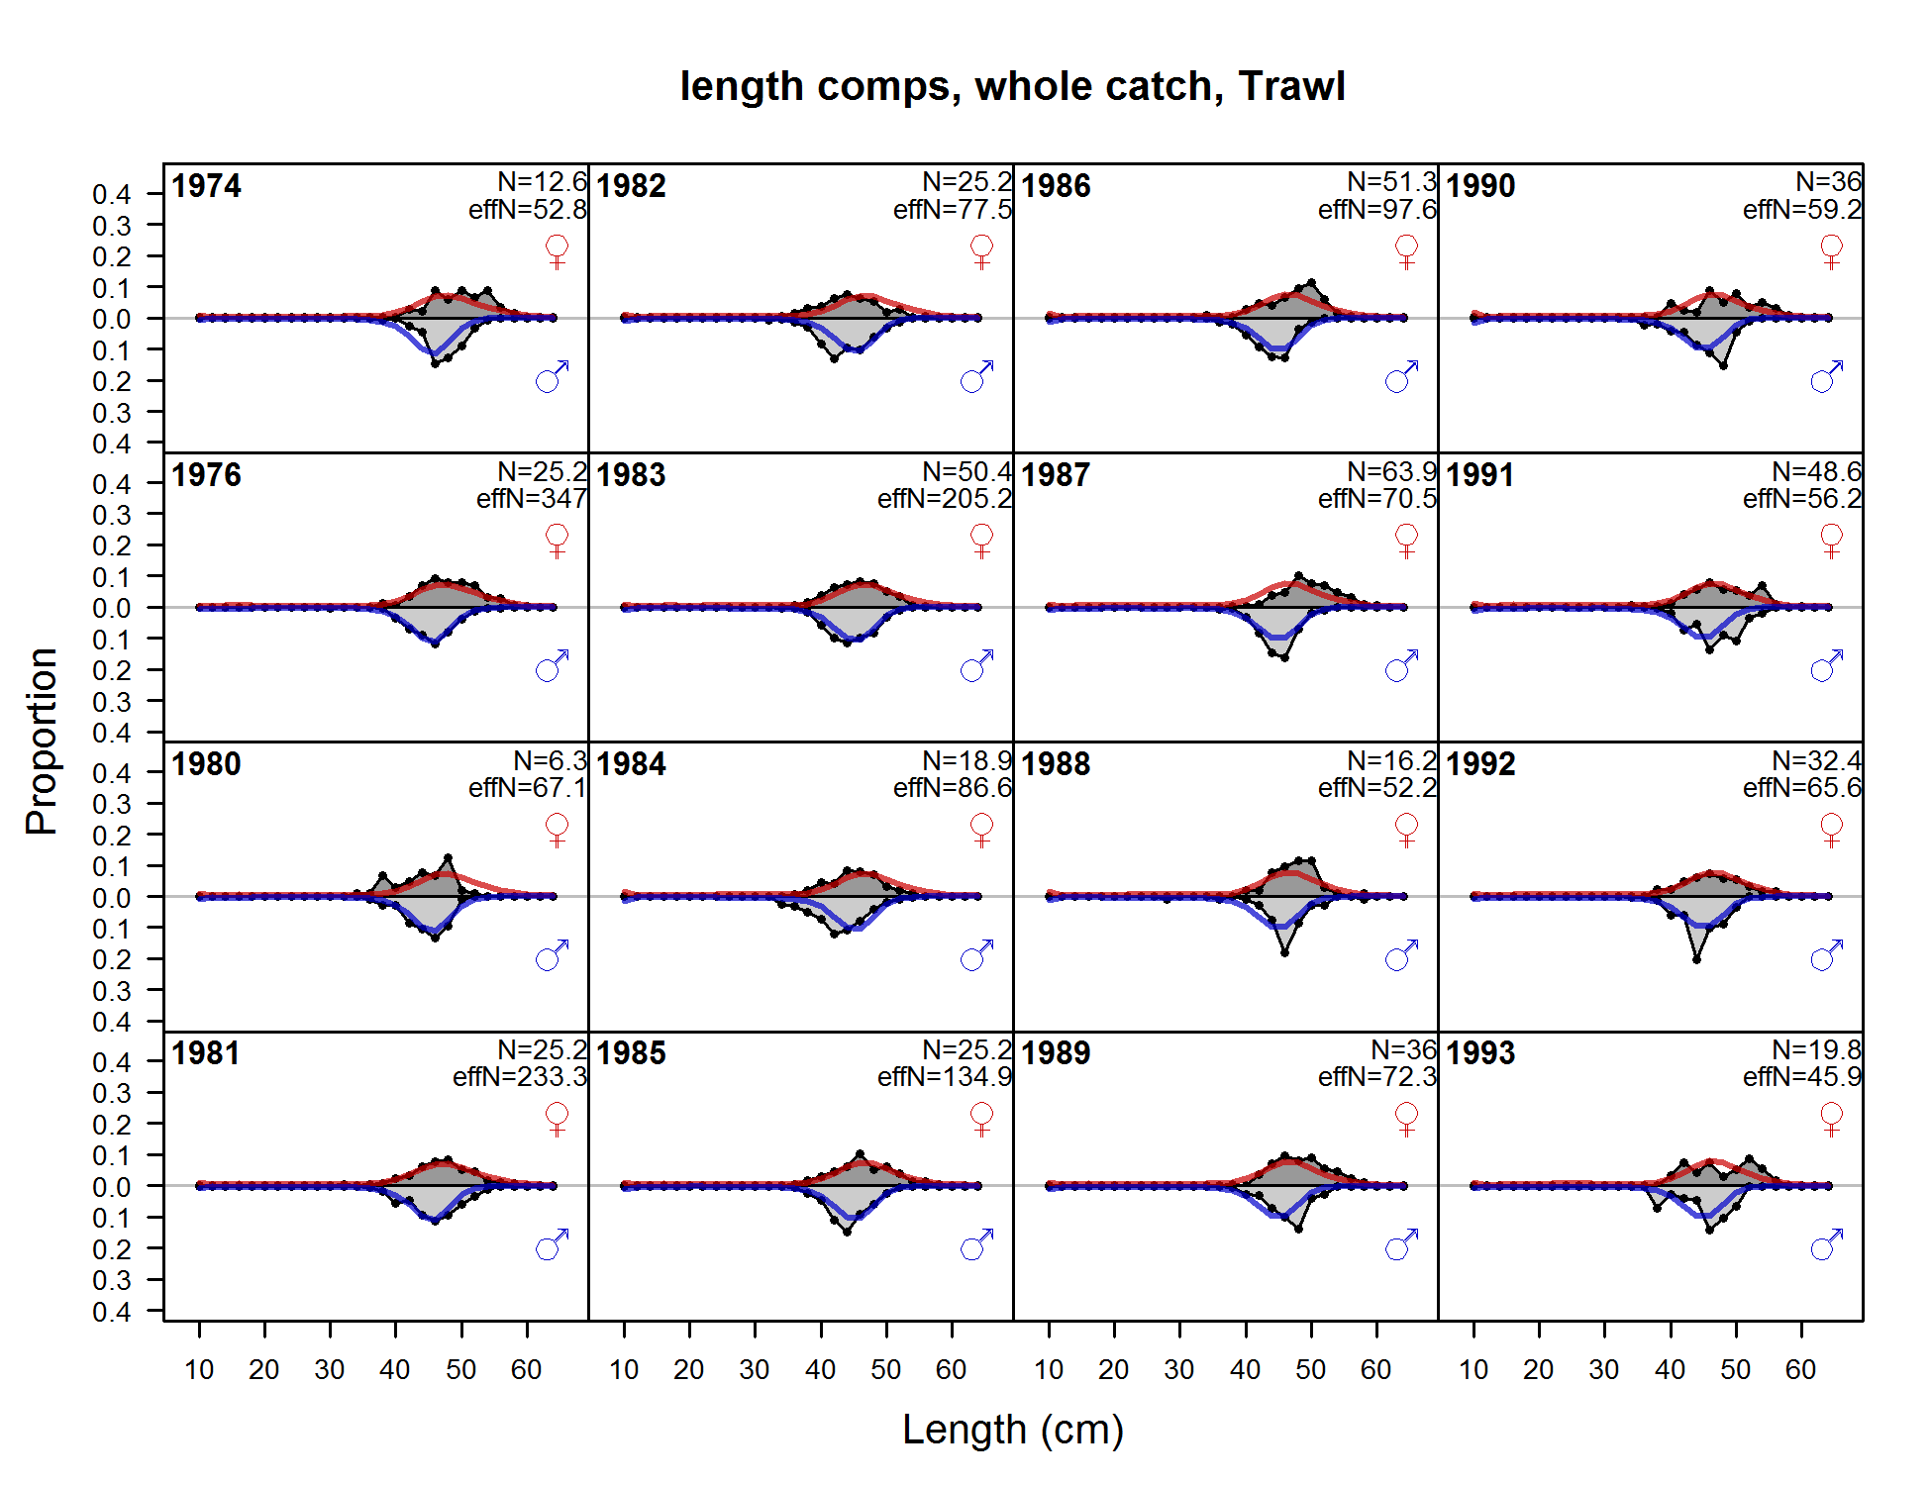

Figure . Fits to the Washington trawl length compositions by sex and year.

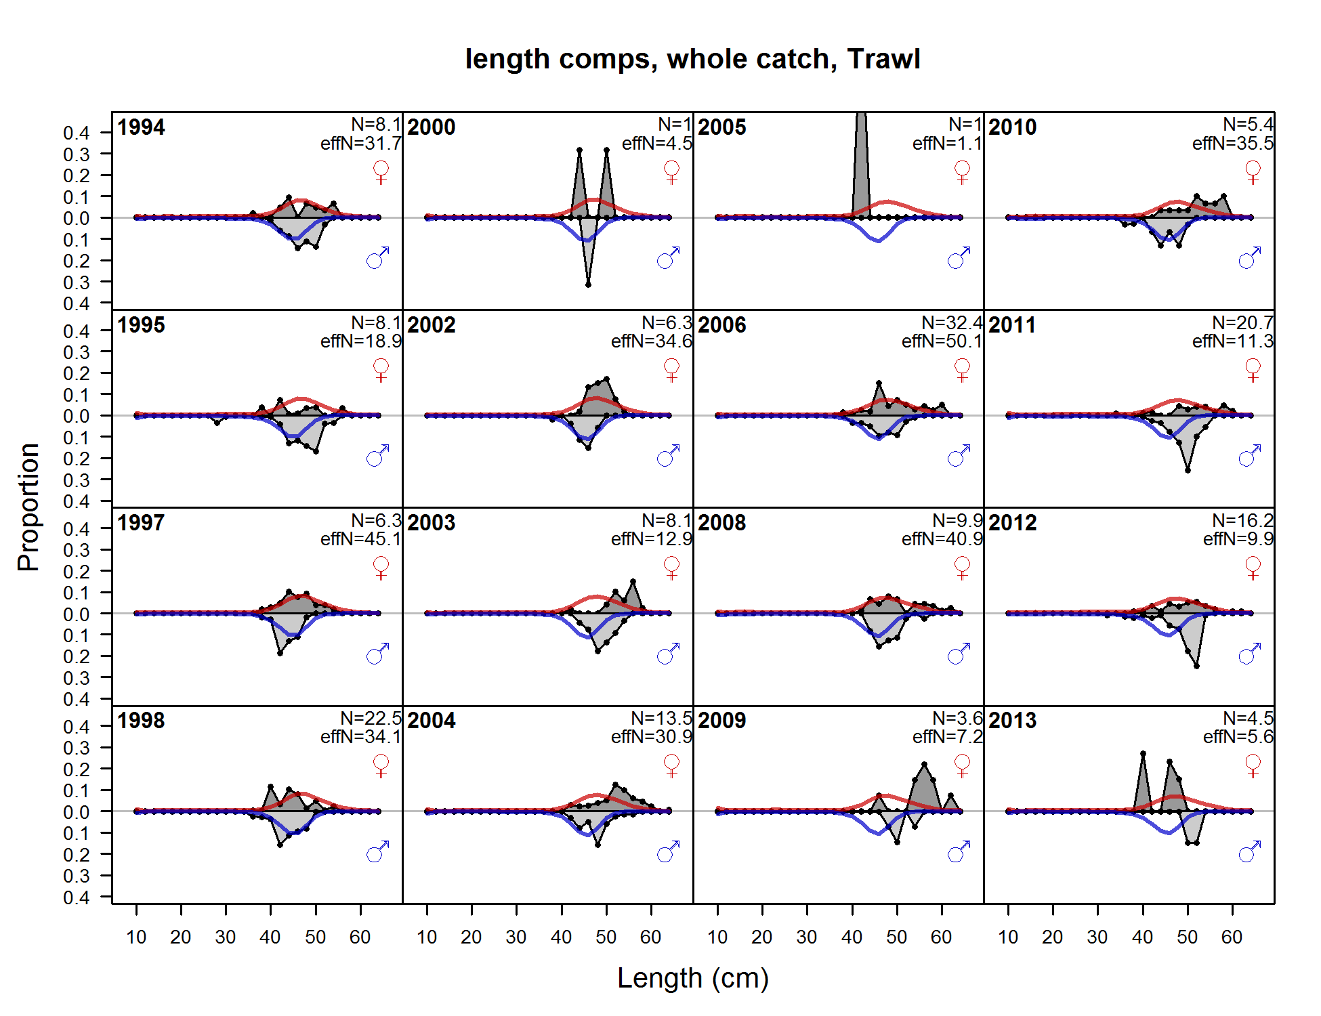

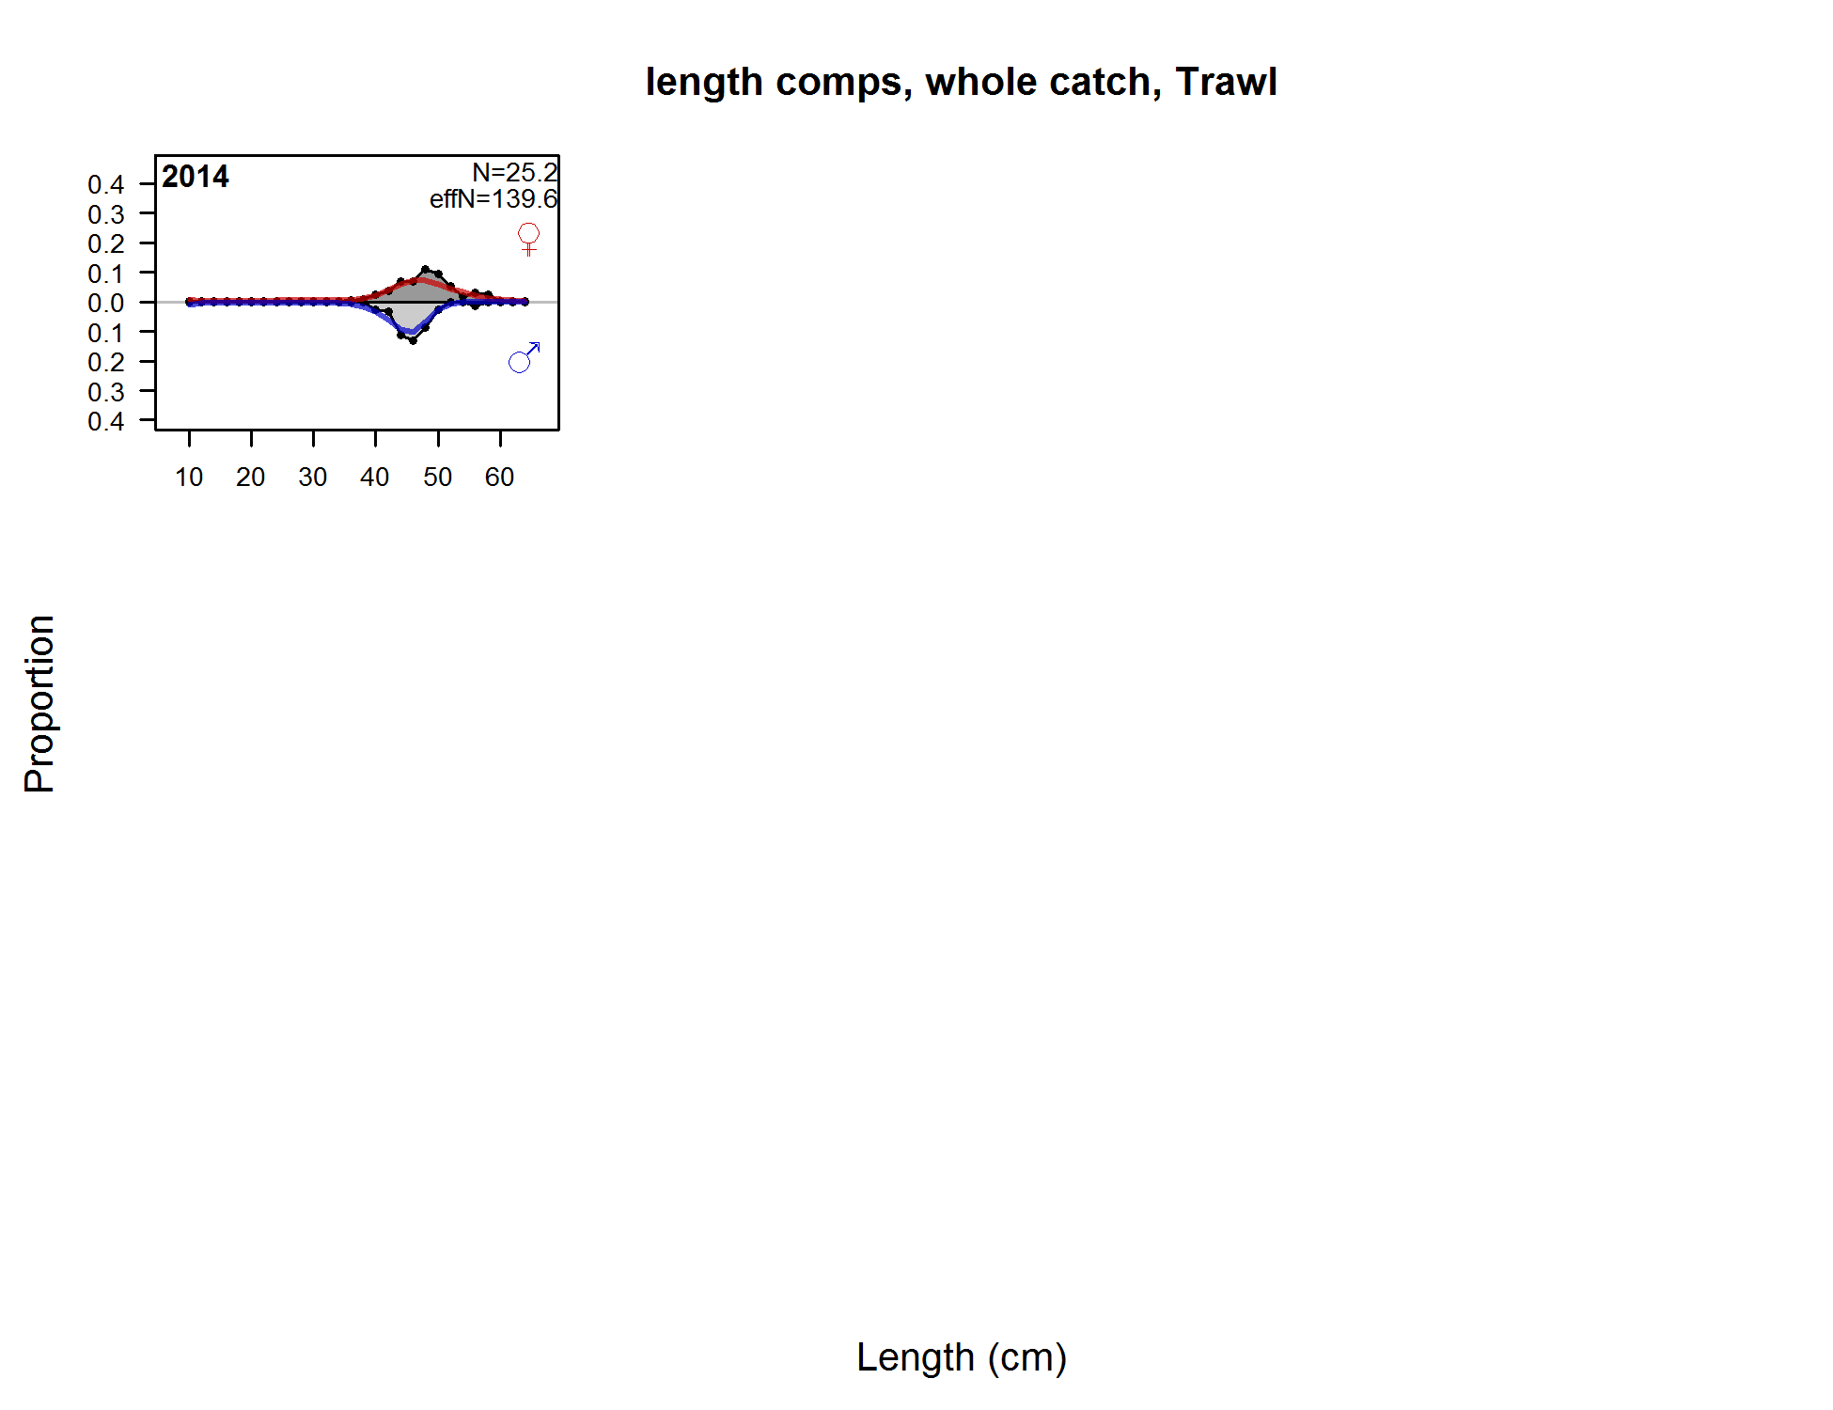

Figure 175 (continued).

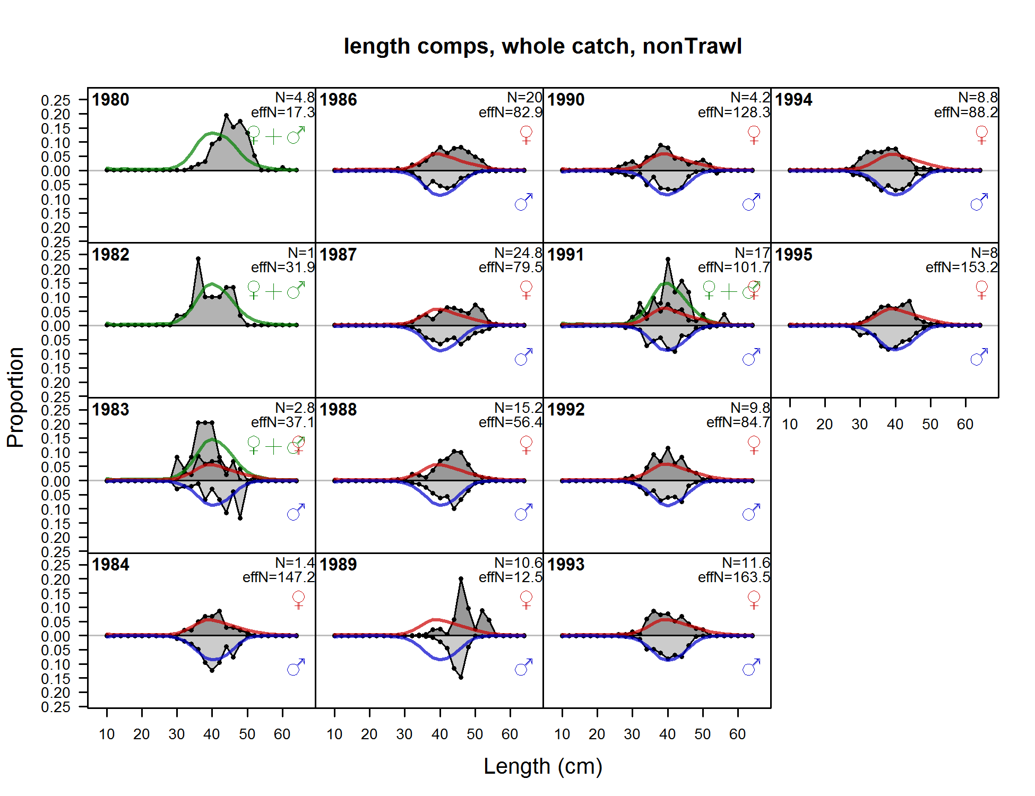

Figure . Fits to the Washington non-trawl length compositions by sex and year.

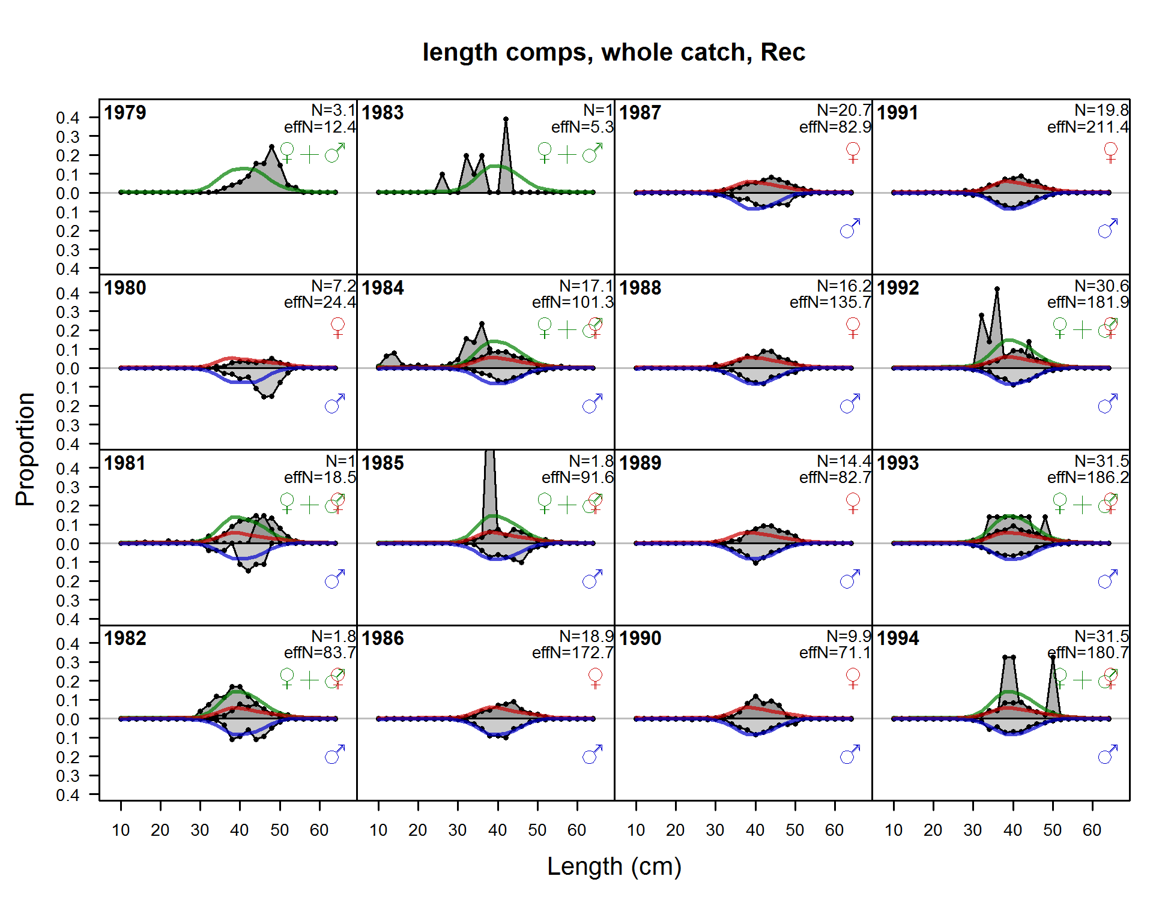

Figure . Fits to the Washington recreational length compositions by sex and year.

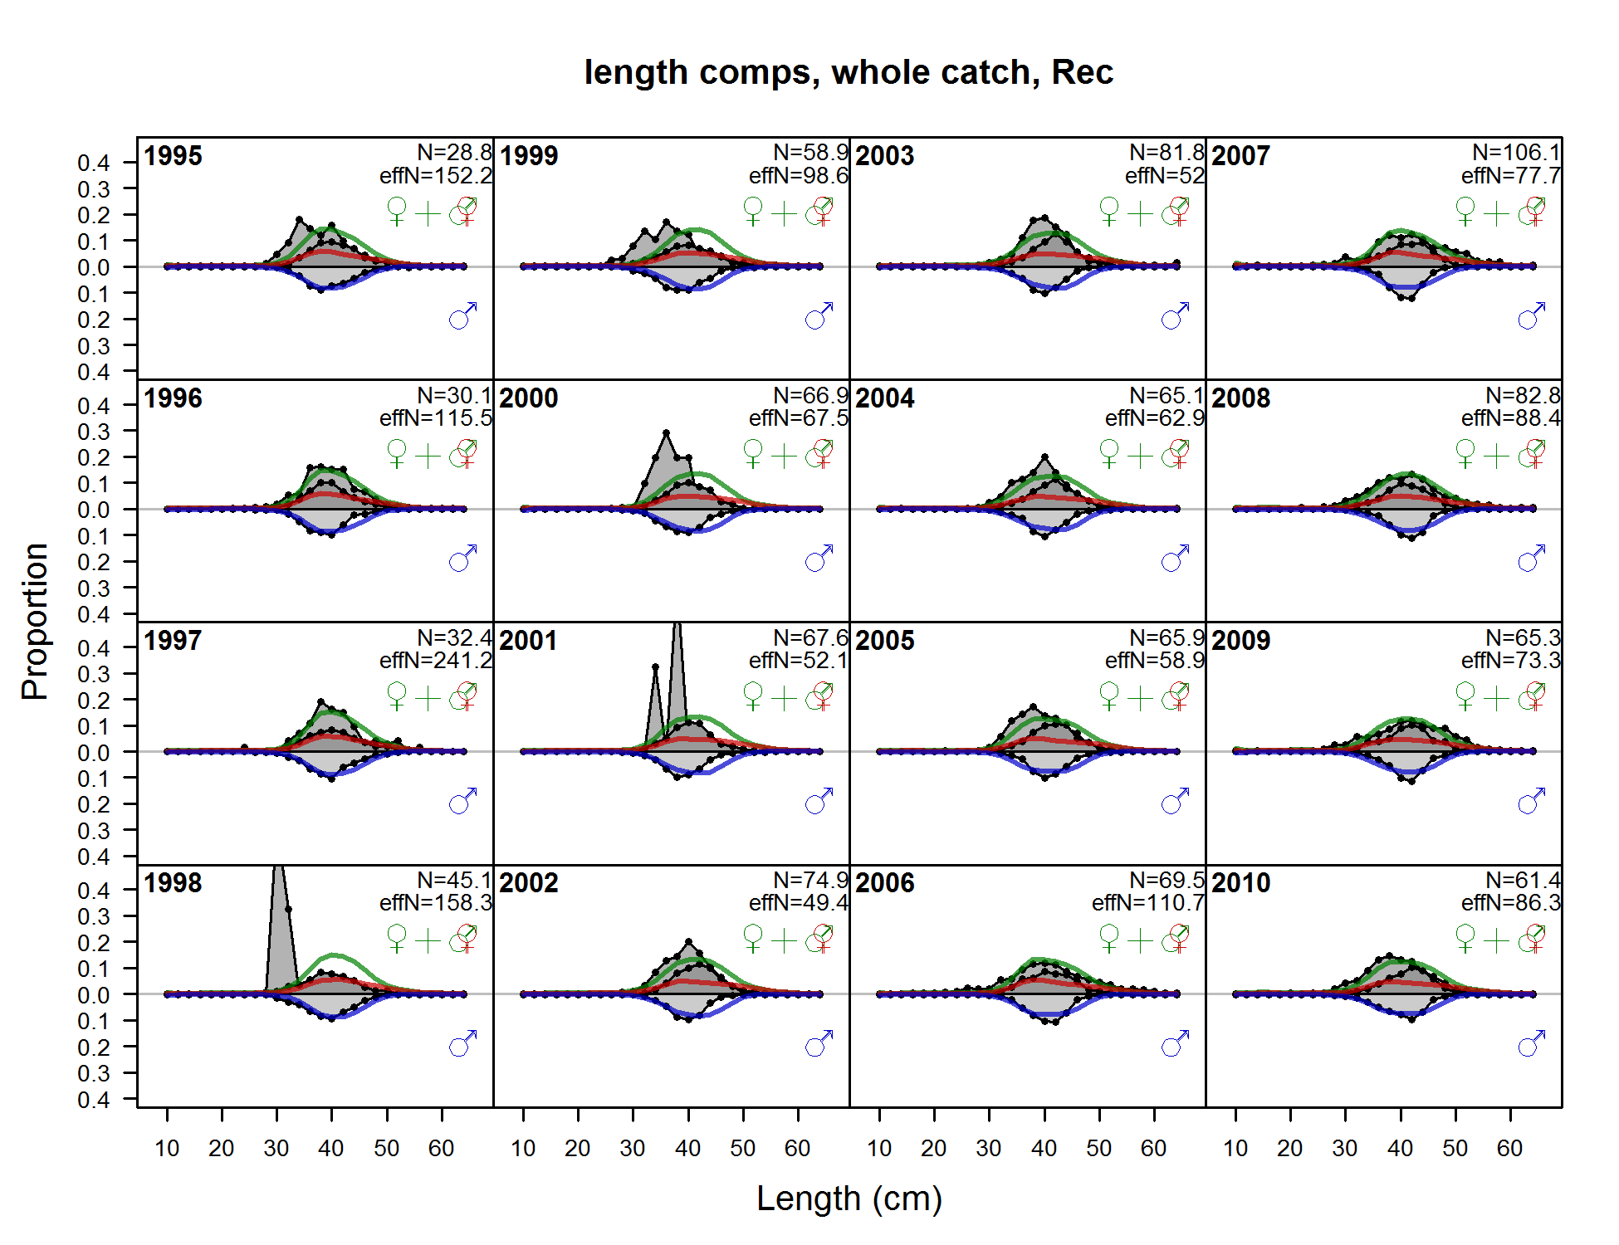

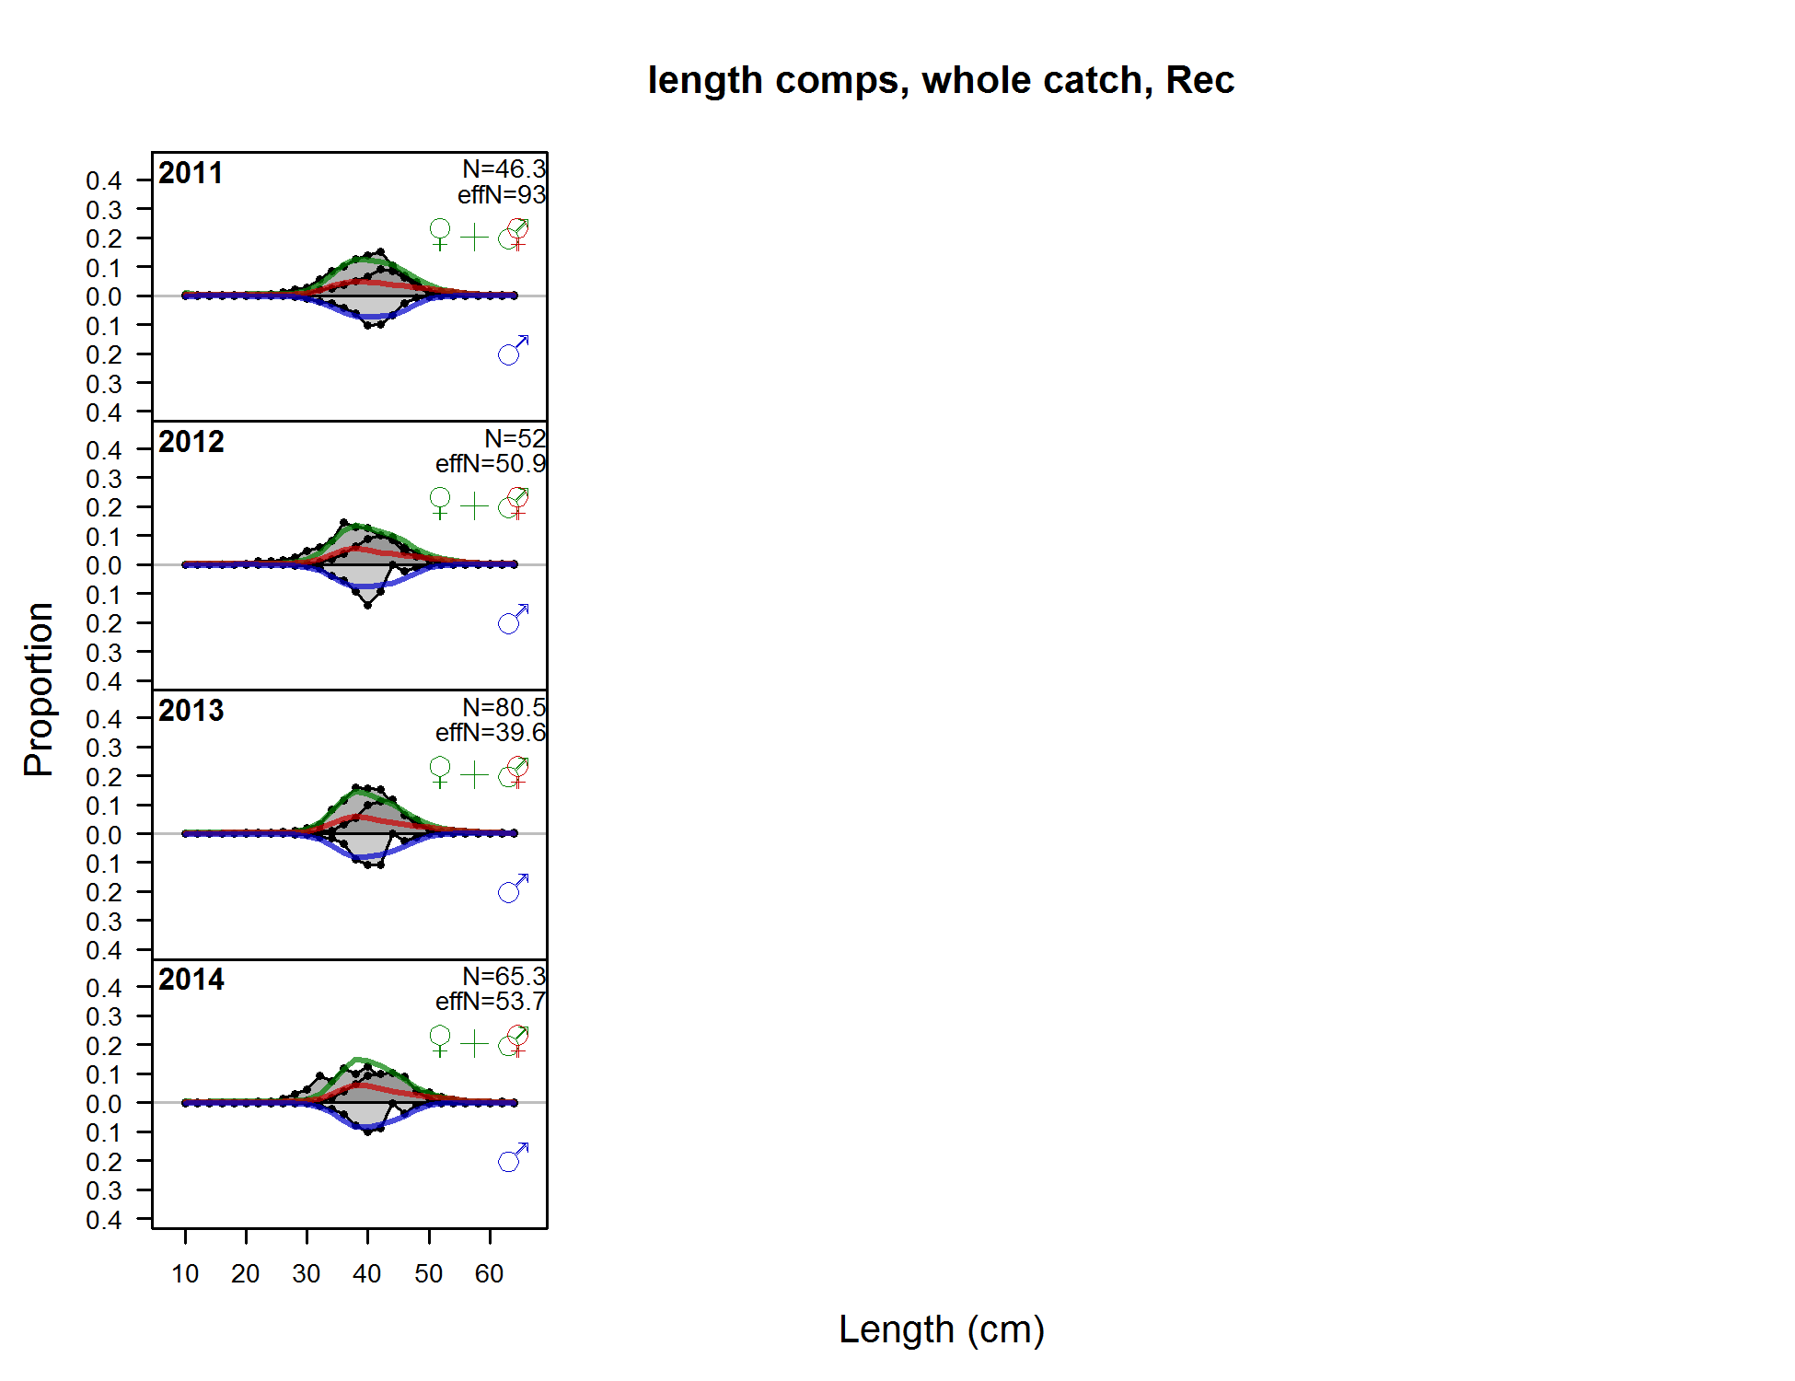

**Figure 204 (continued).**

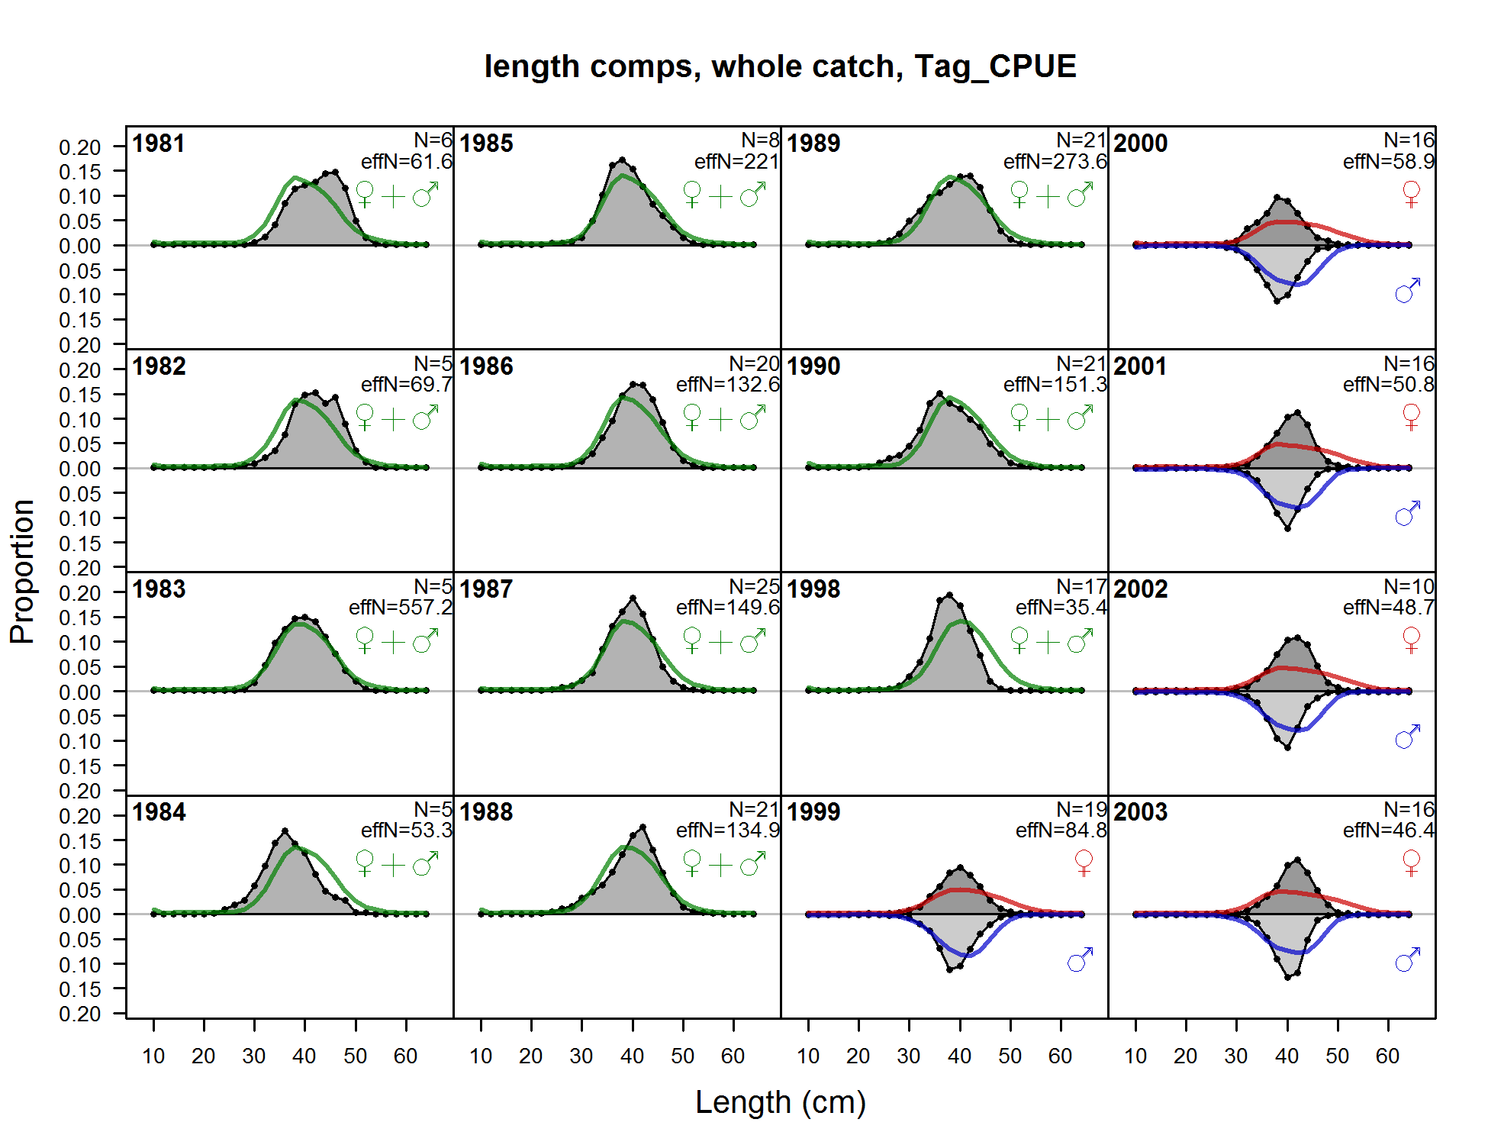

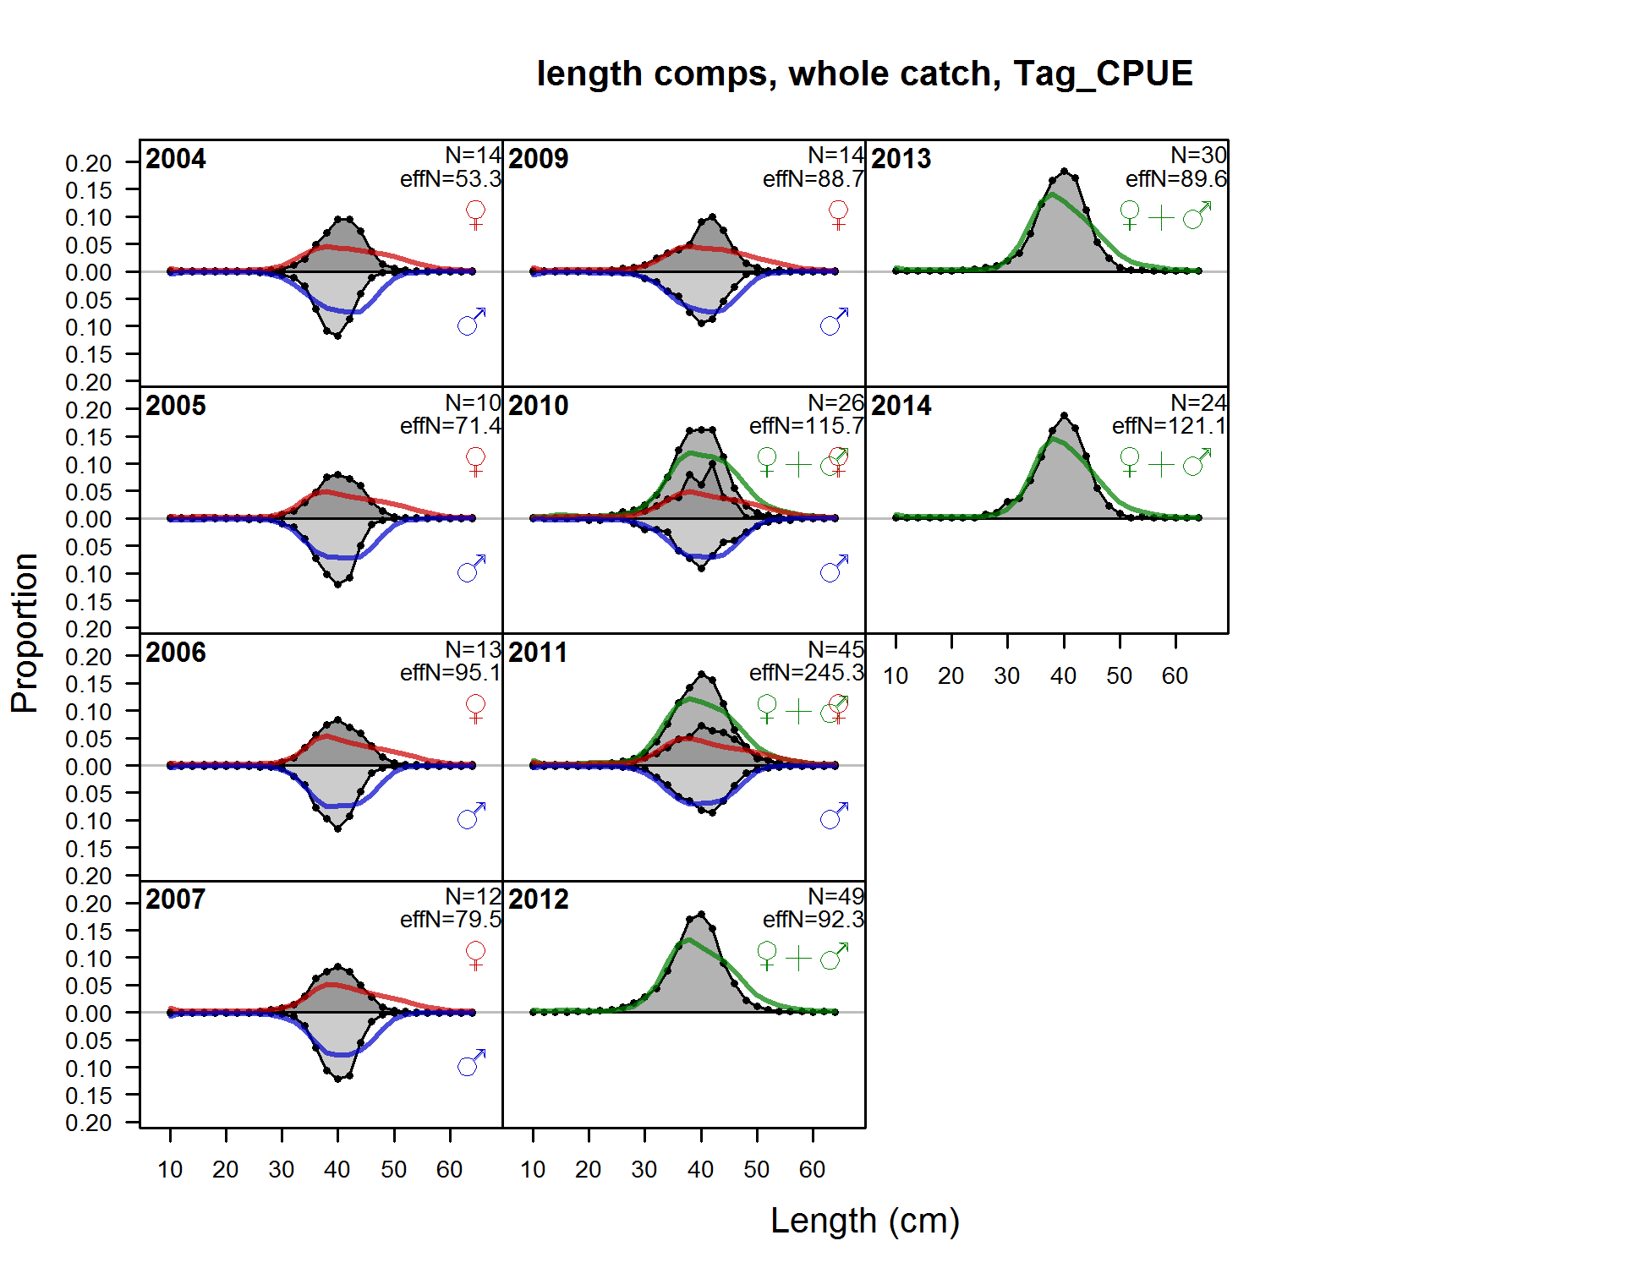

Figure . Fits to the Washington tagging CPUE length compositions by sex and year.

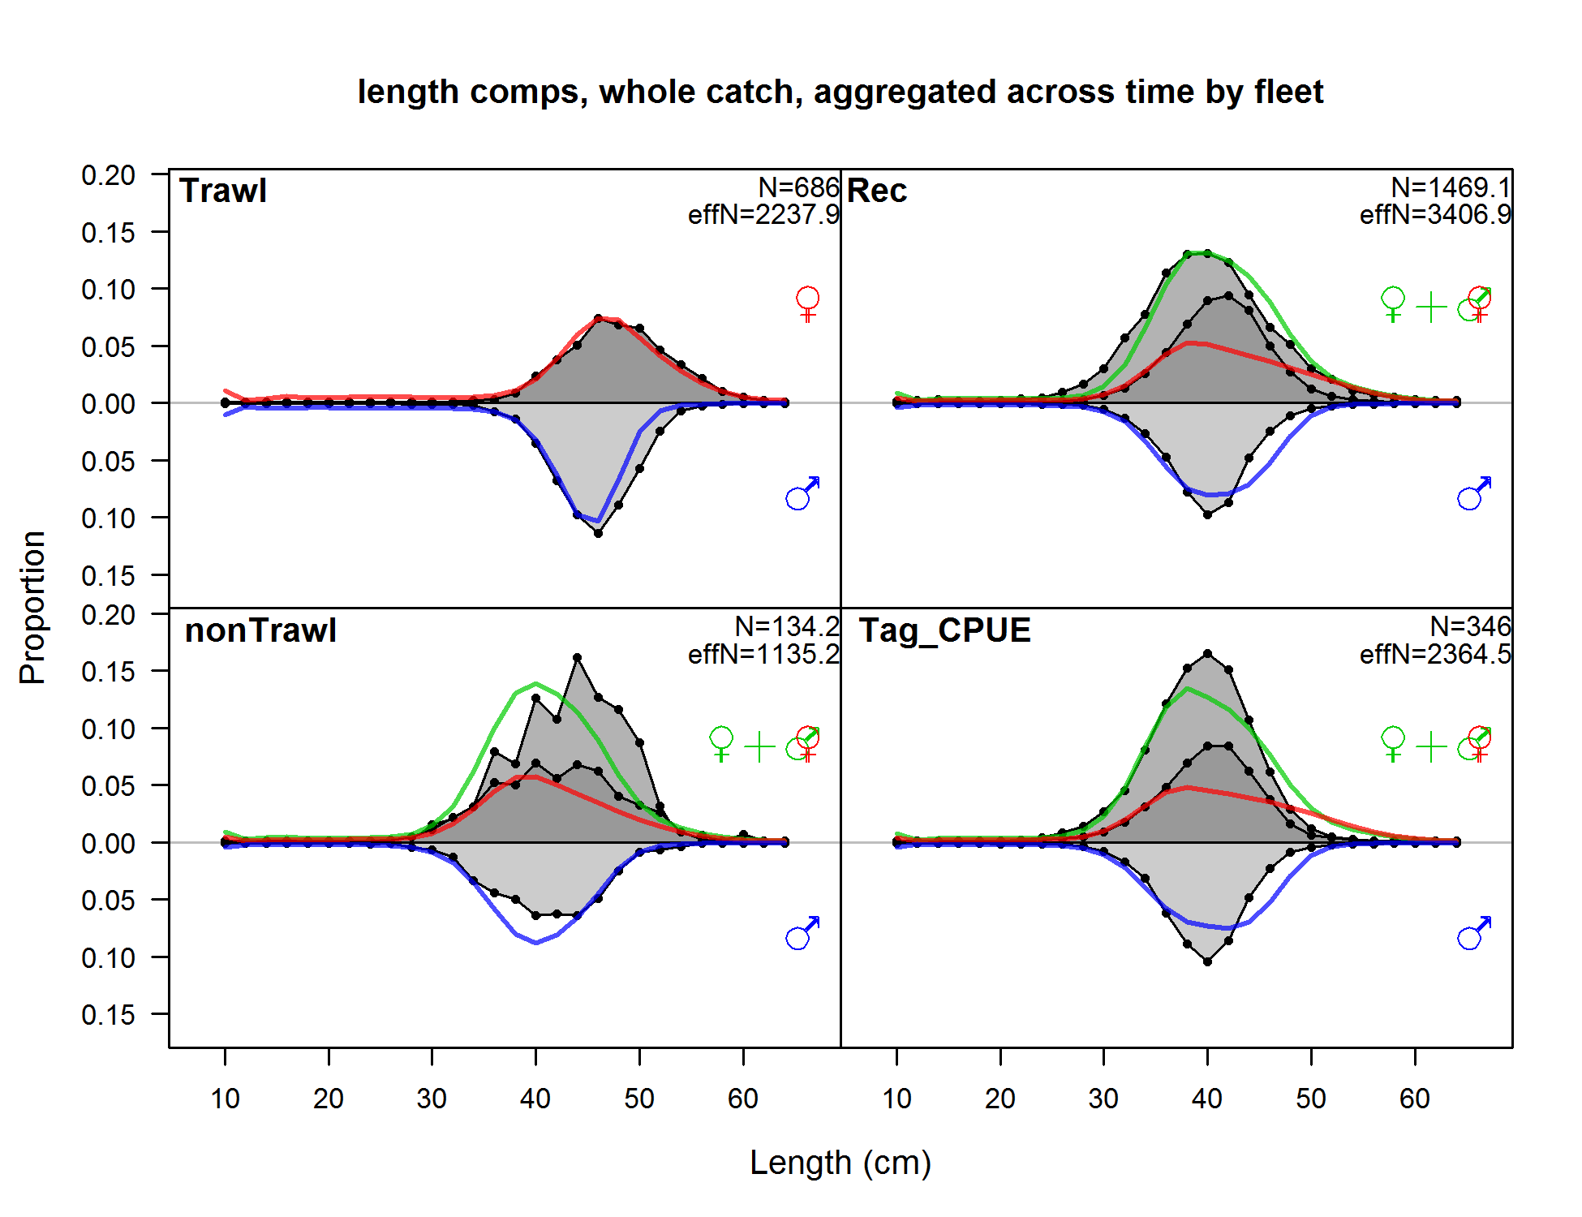

Figure . Composite fits to the length composition by gear and sex for the Washington base model.

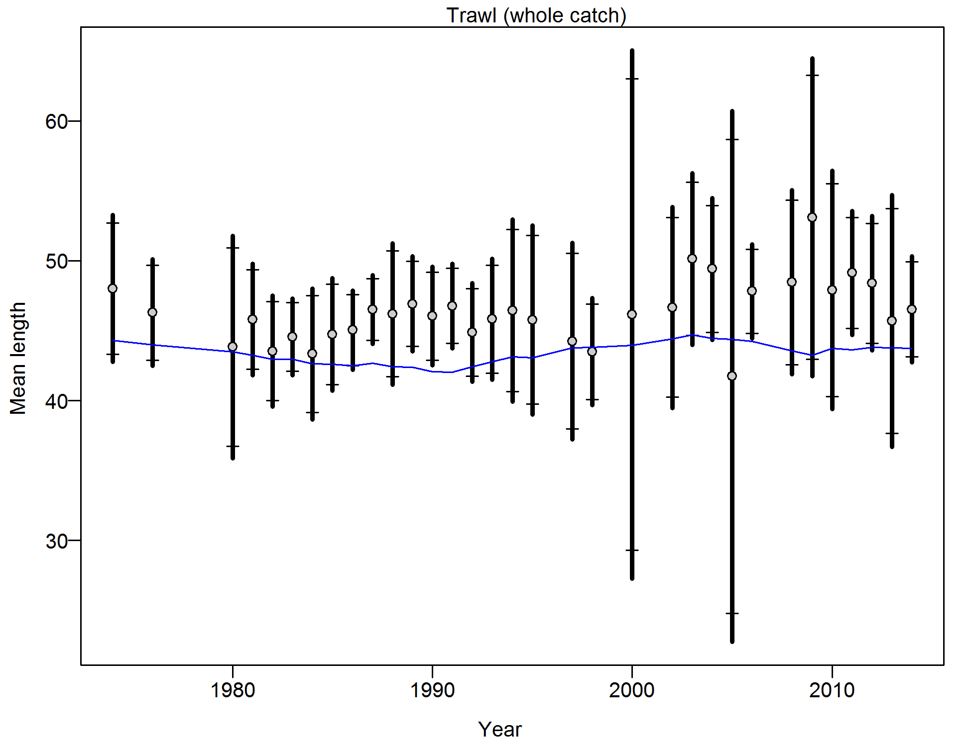

Figure . Francis weighting fits to the mean lengths by year for the Washington trawl commercial fleet. Vertical lines are 95% confidence intervals.

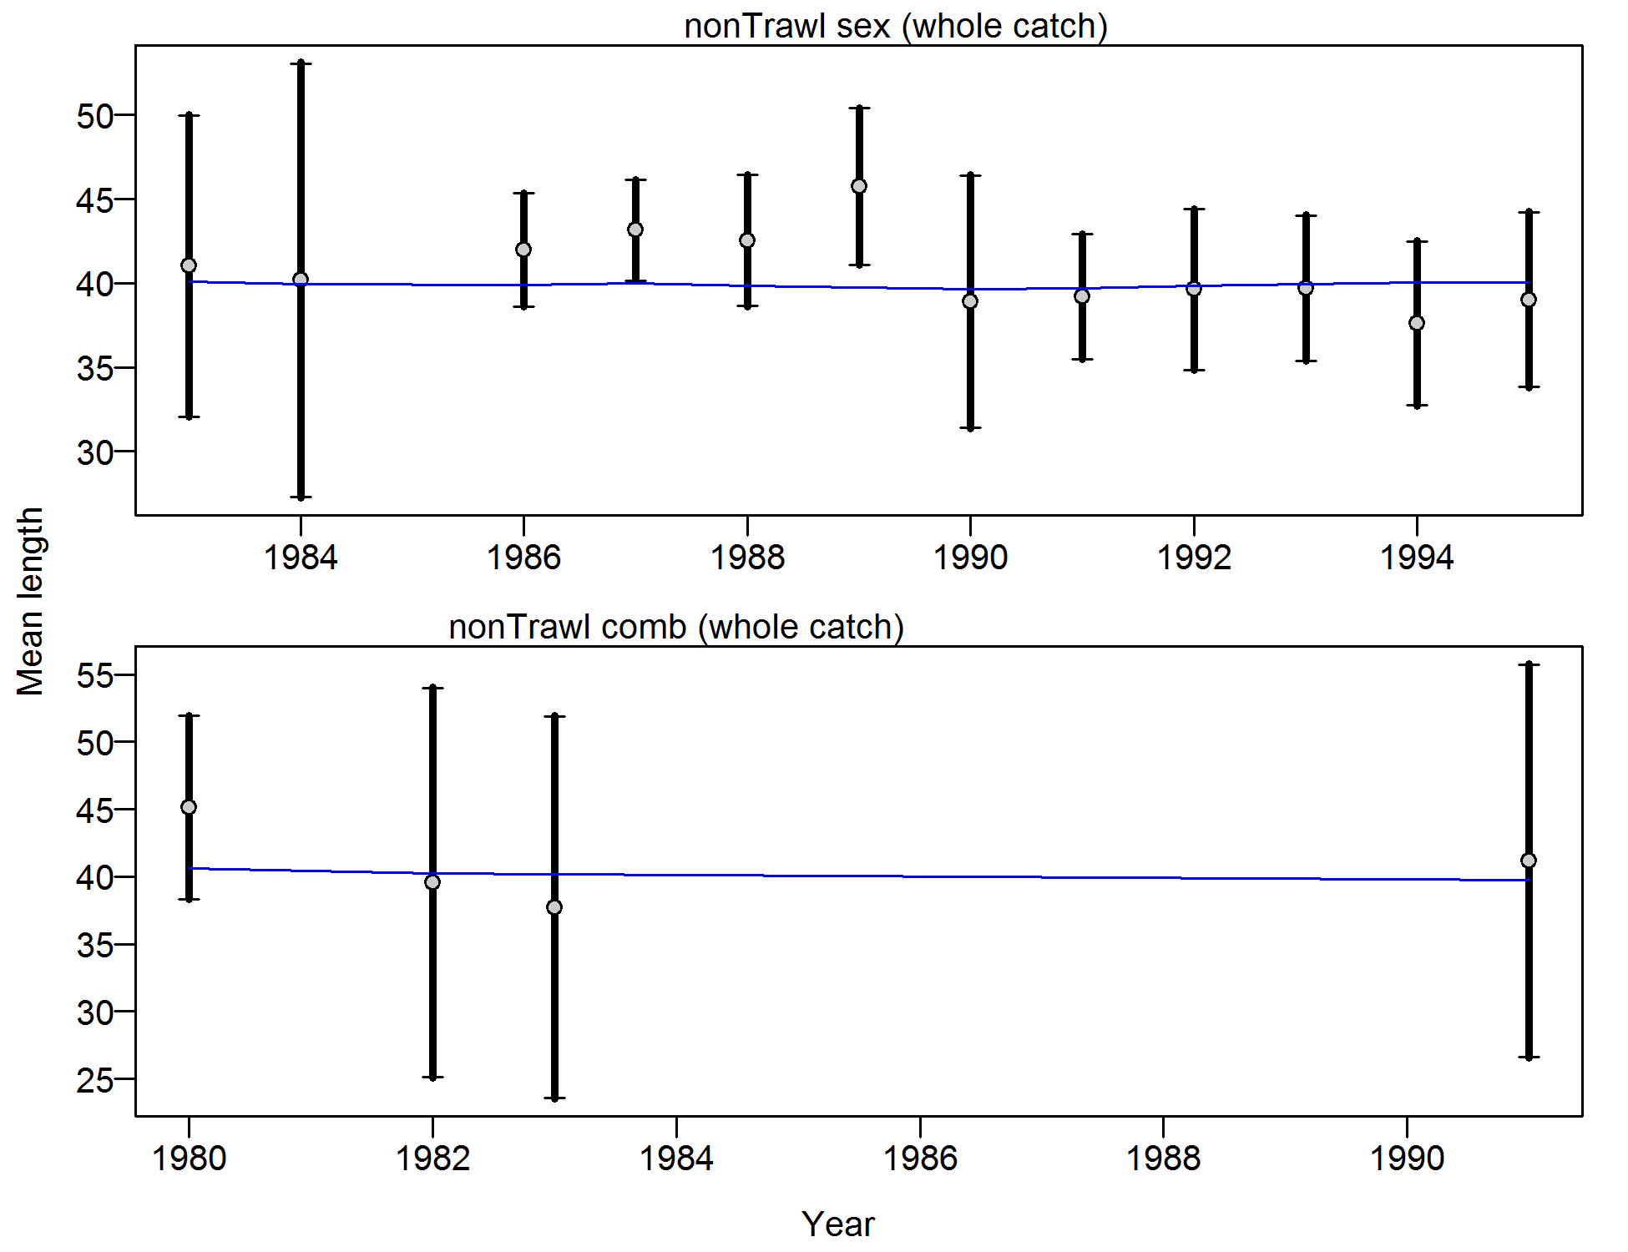

Figure . Francis weighting fits to the mean lengths by year for the Washington non-trawl commercial fleet. Vertical lines are 95% confidence intervals.

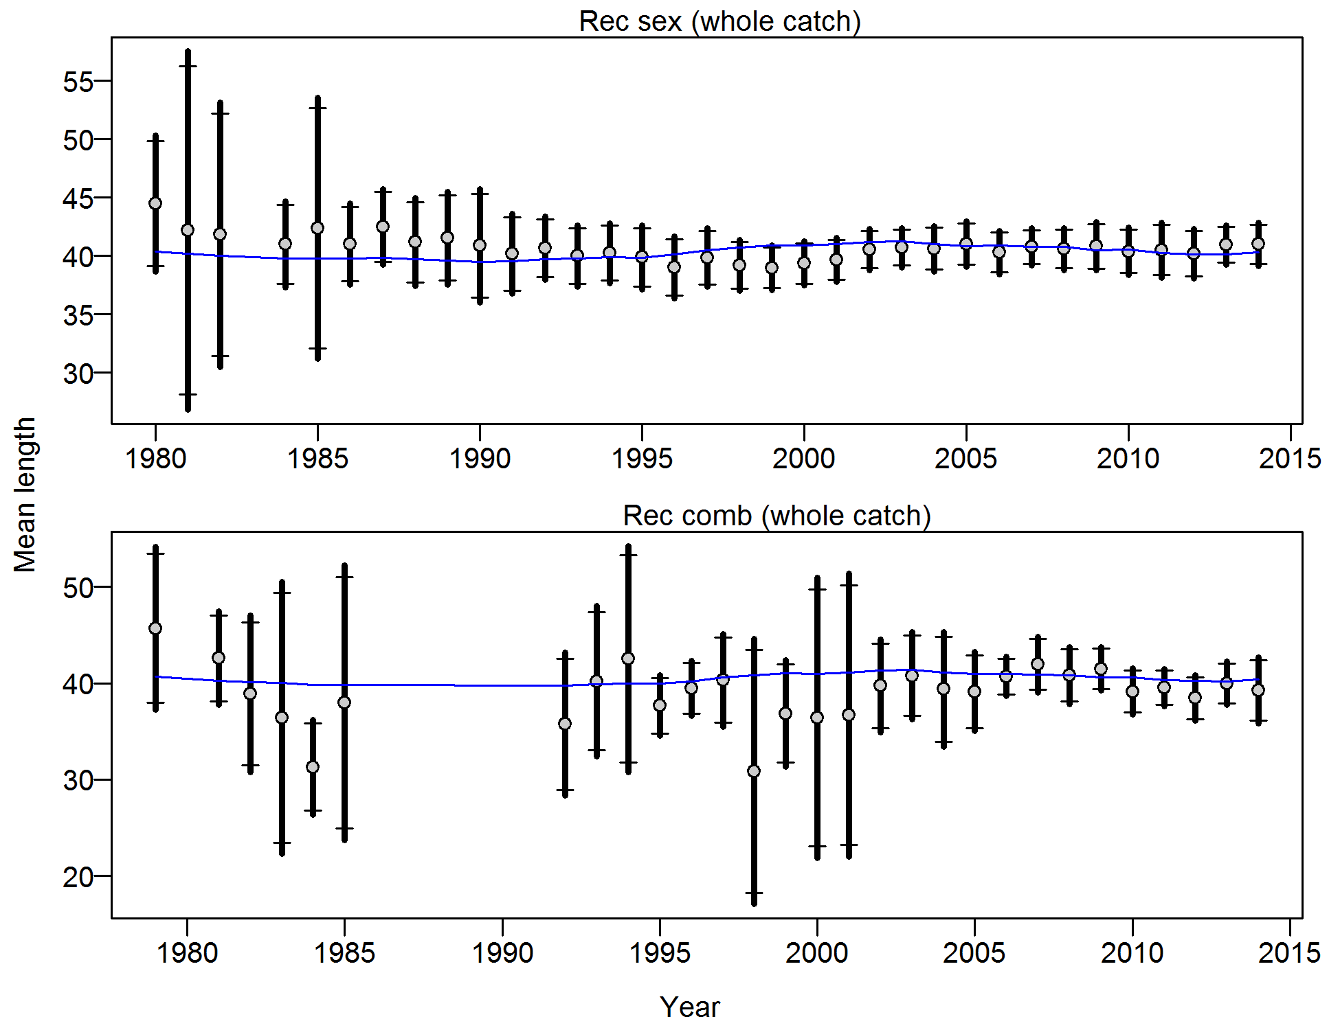

Figure . Francis weighting fits to the mean lengths by year for the Washington recreational fleet. Vertical lines are 95% confidence intervals.

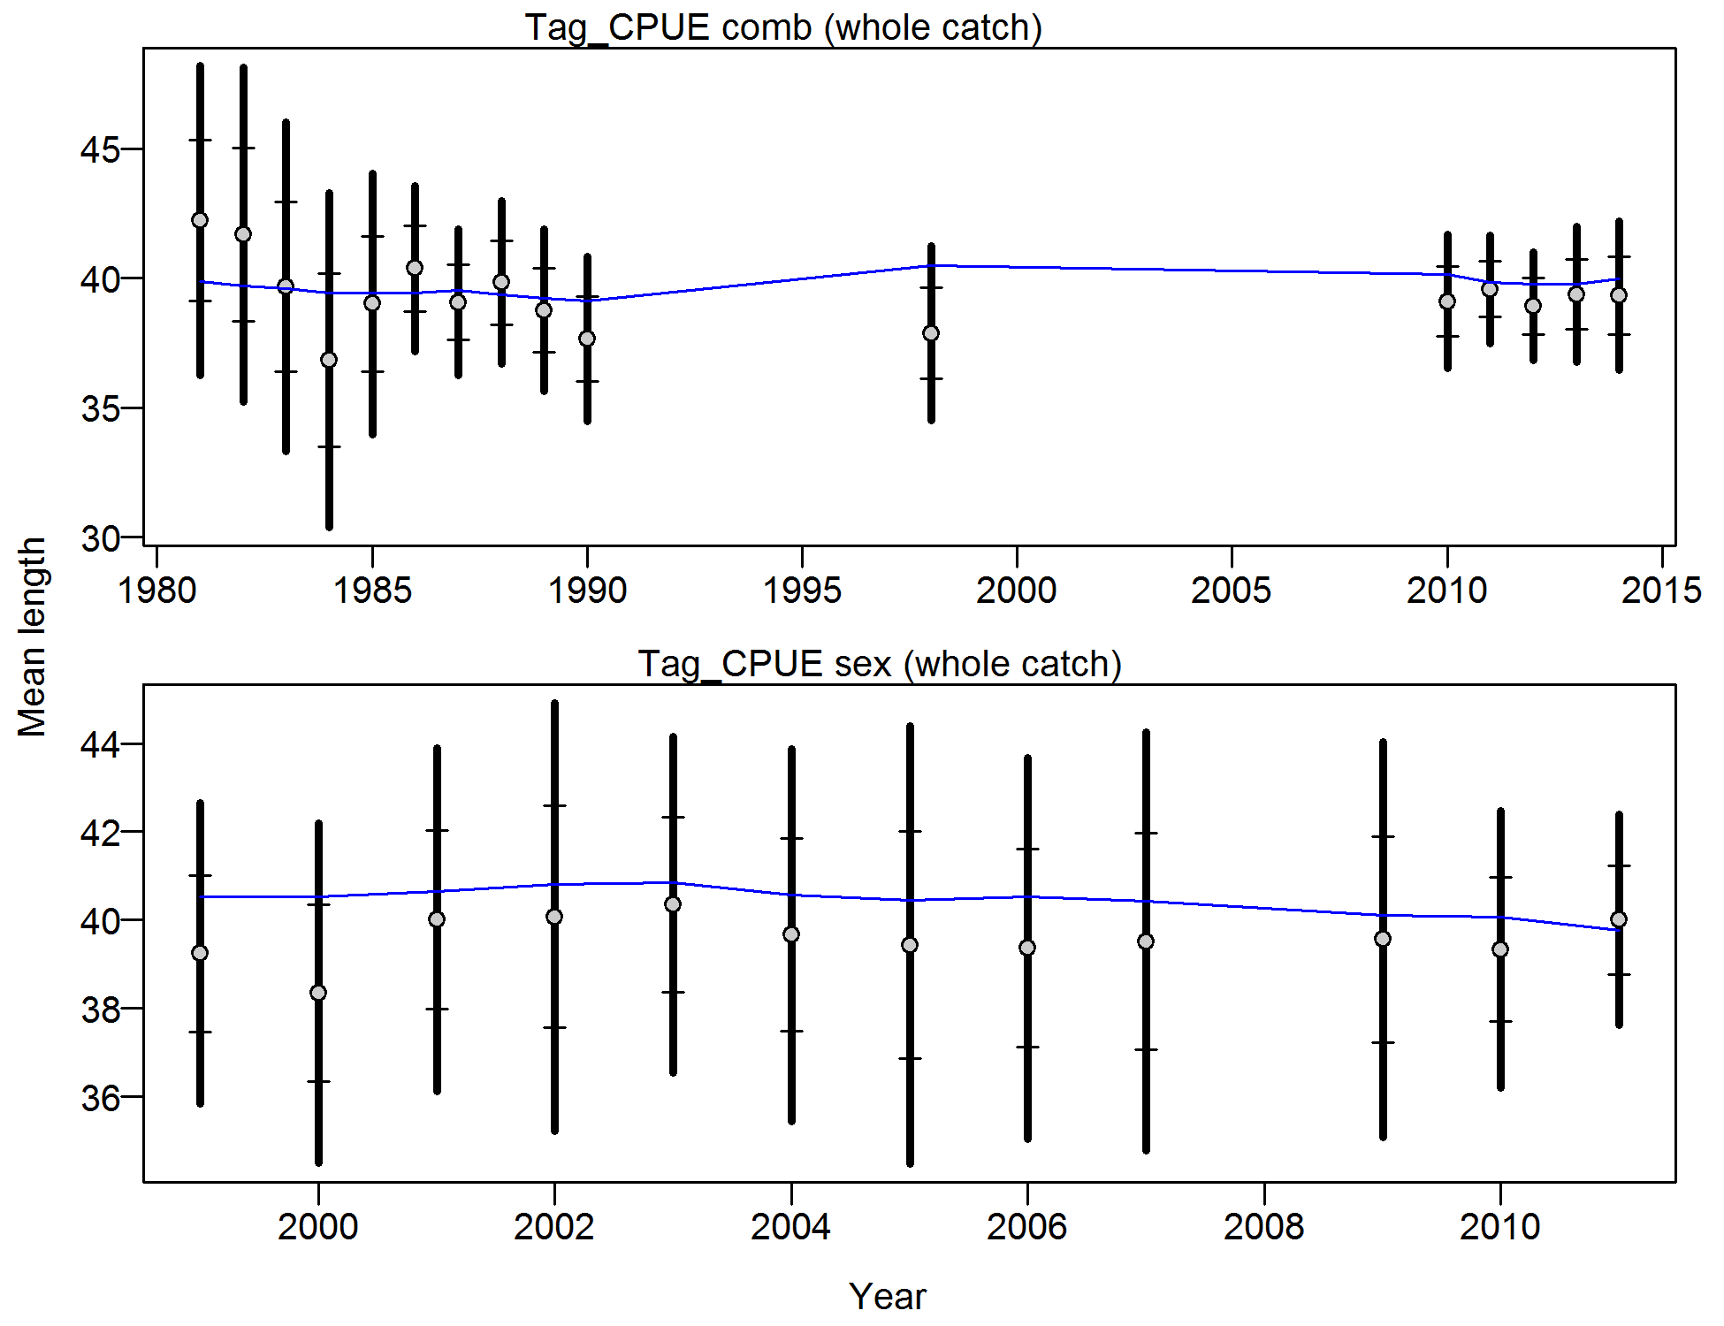

Figure . Francis weighting fits to the mean lengths by year for the Washington tagging CPUE survey. Vertical lines are 95% confidence intervals.

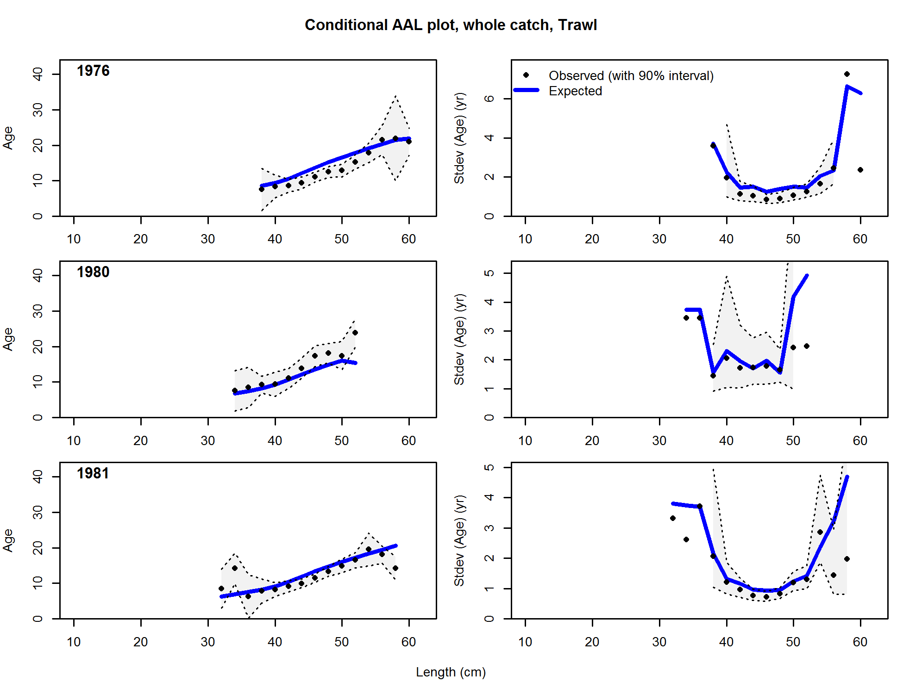

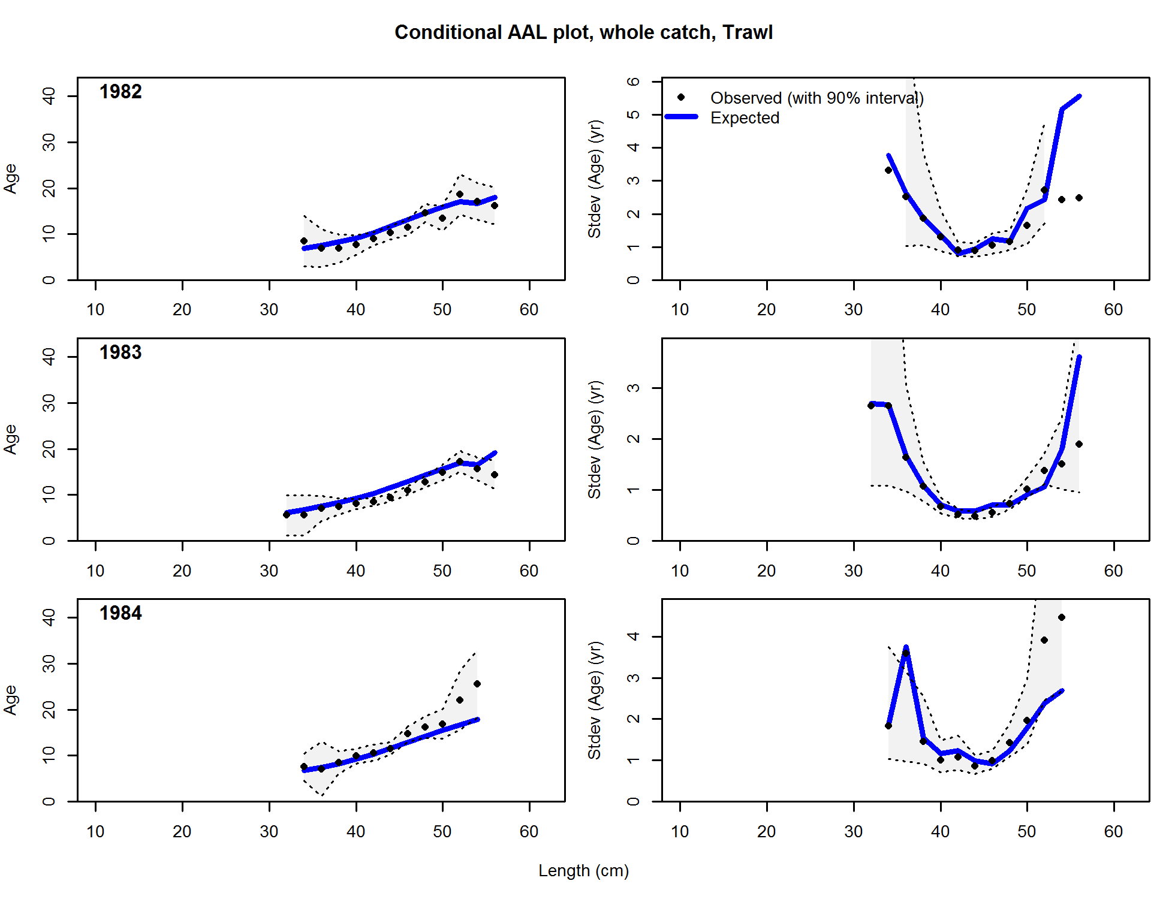

Figure . Conditional age-at-length samples and predictions for the Washington Trawl fleet. Shading indicates 95% confidence intervals.

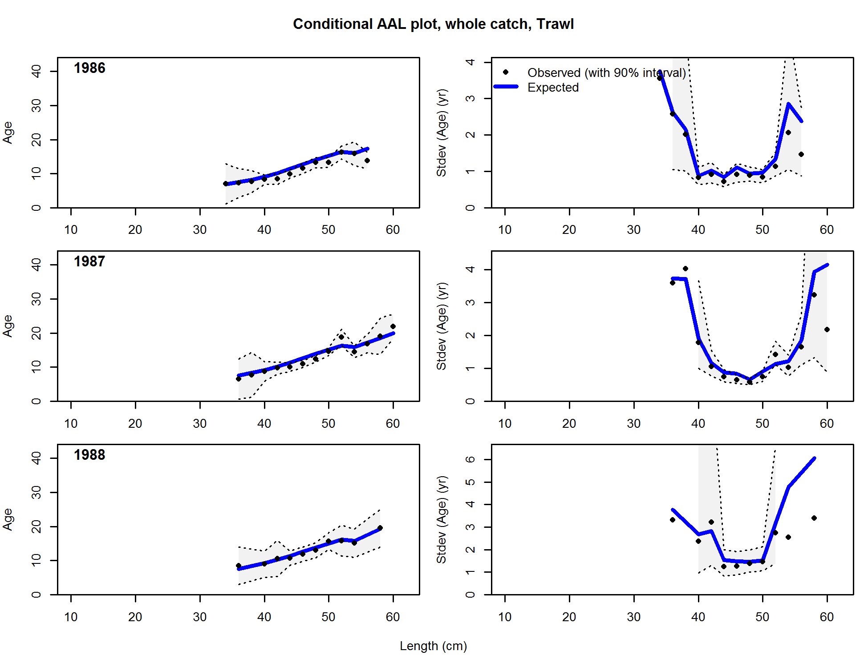

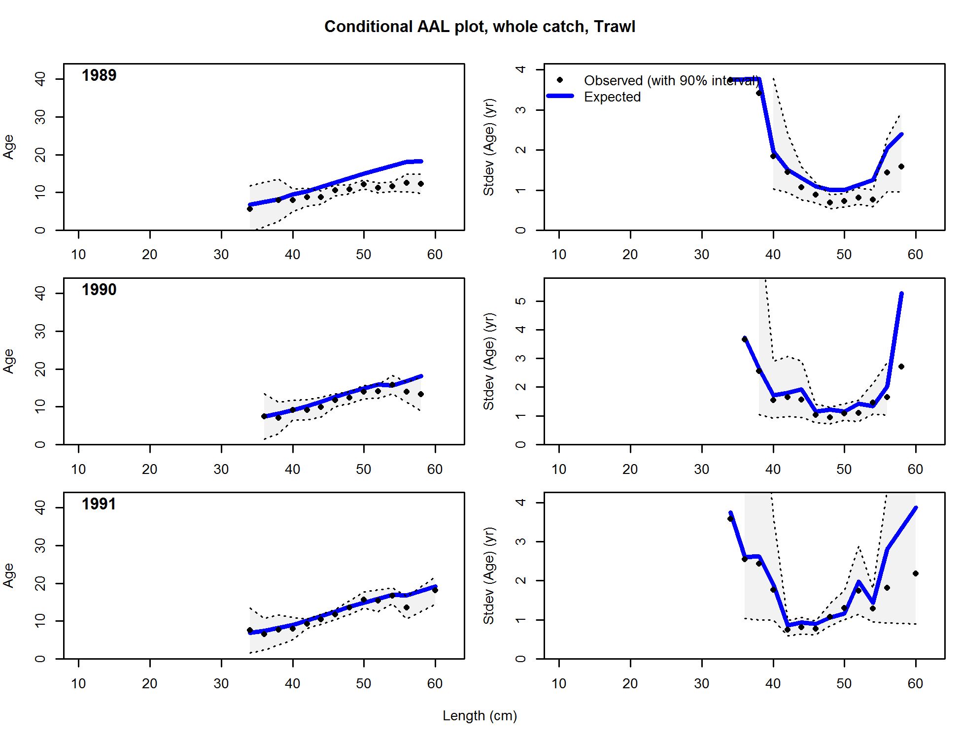

Figure 184 (continued).

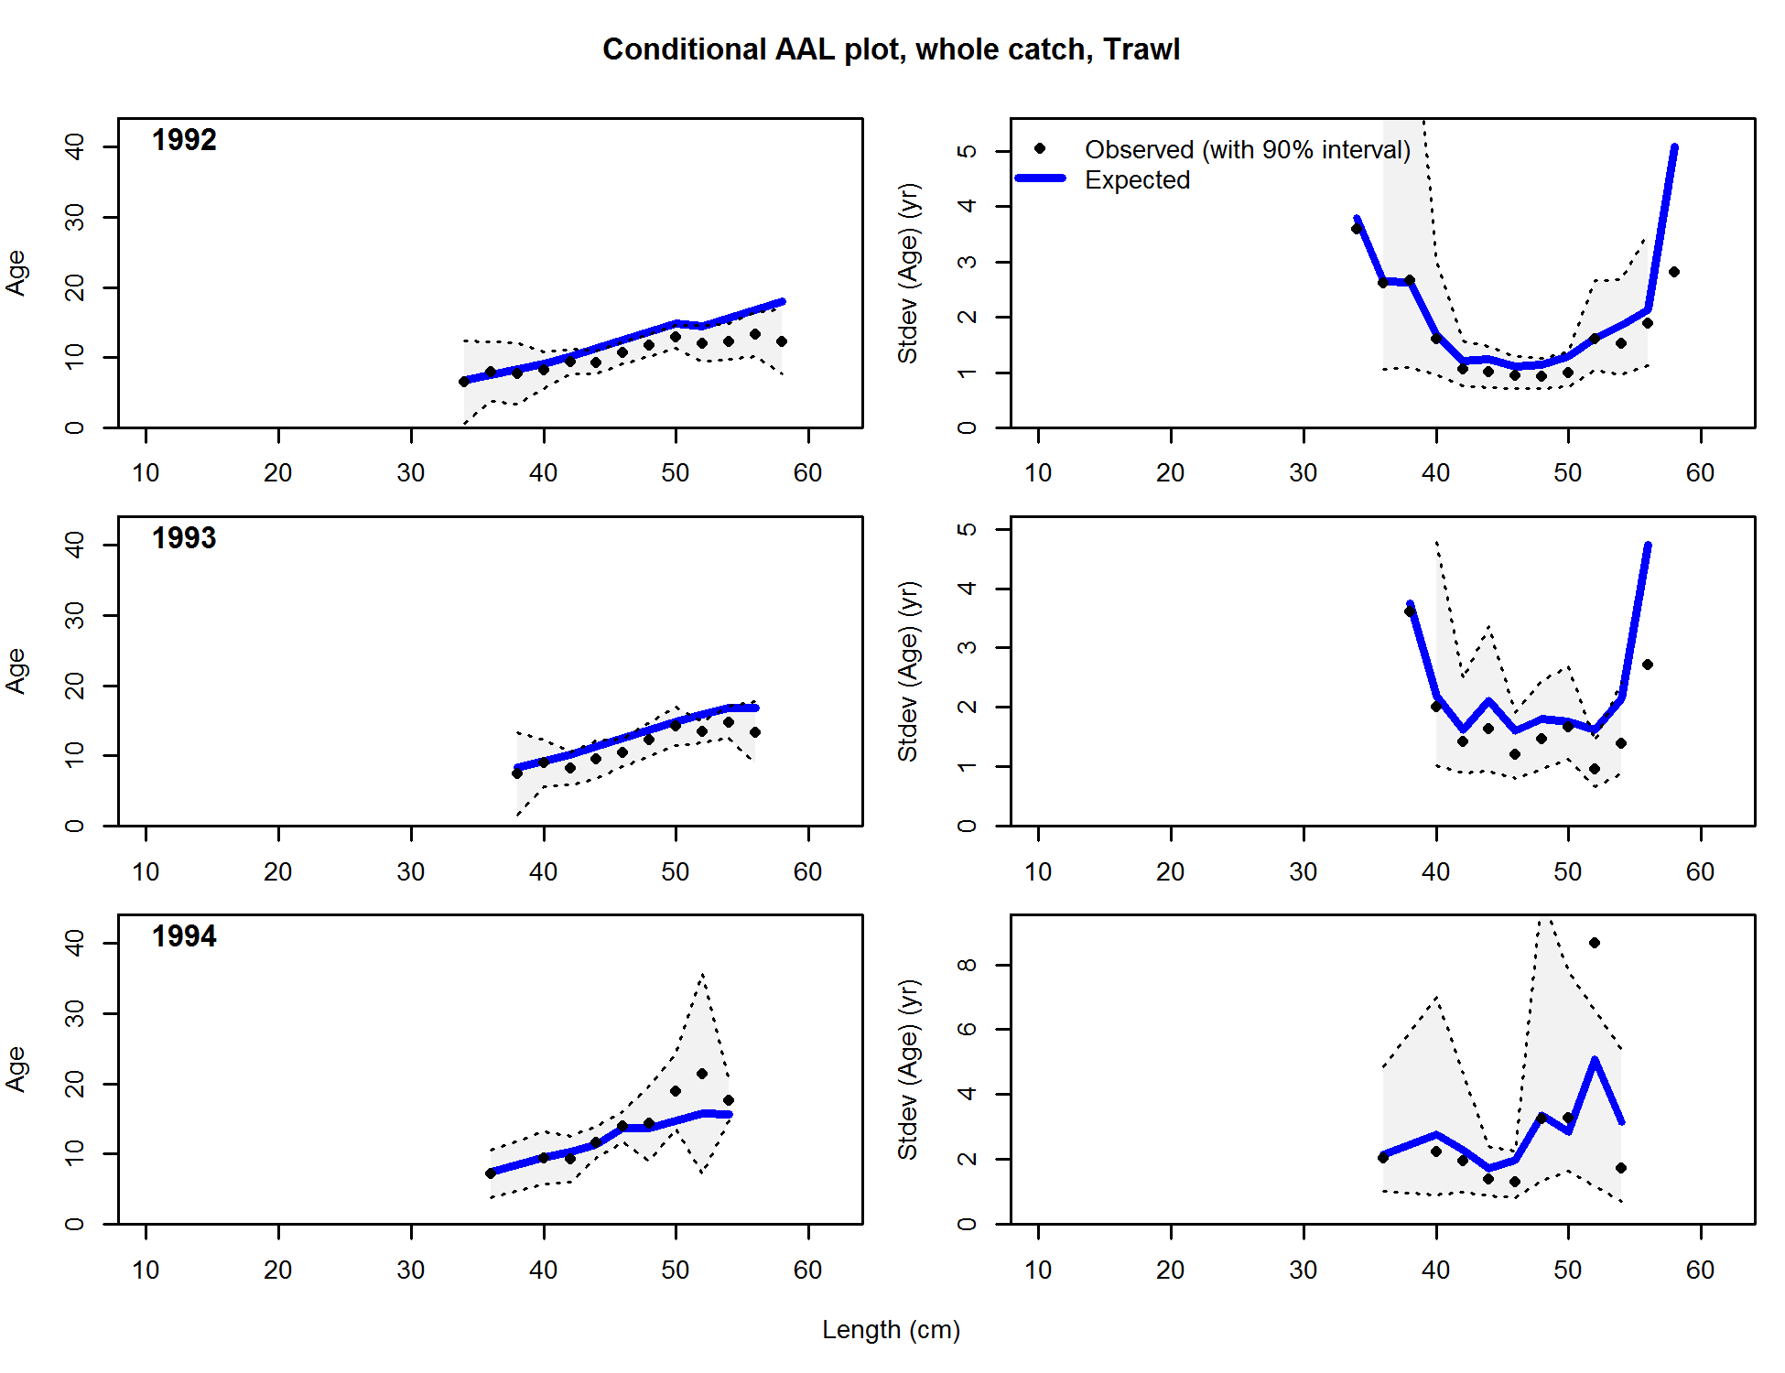

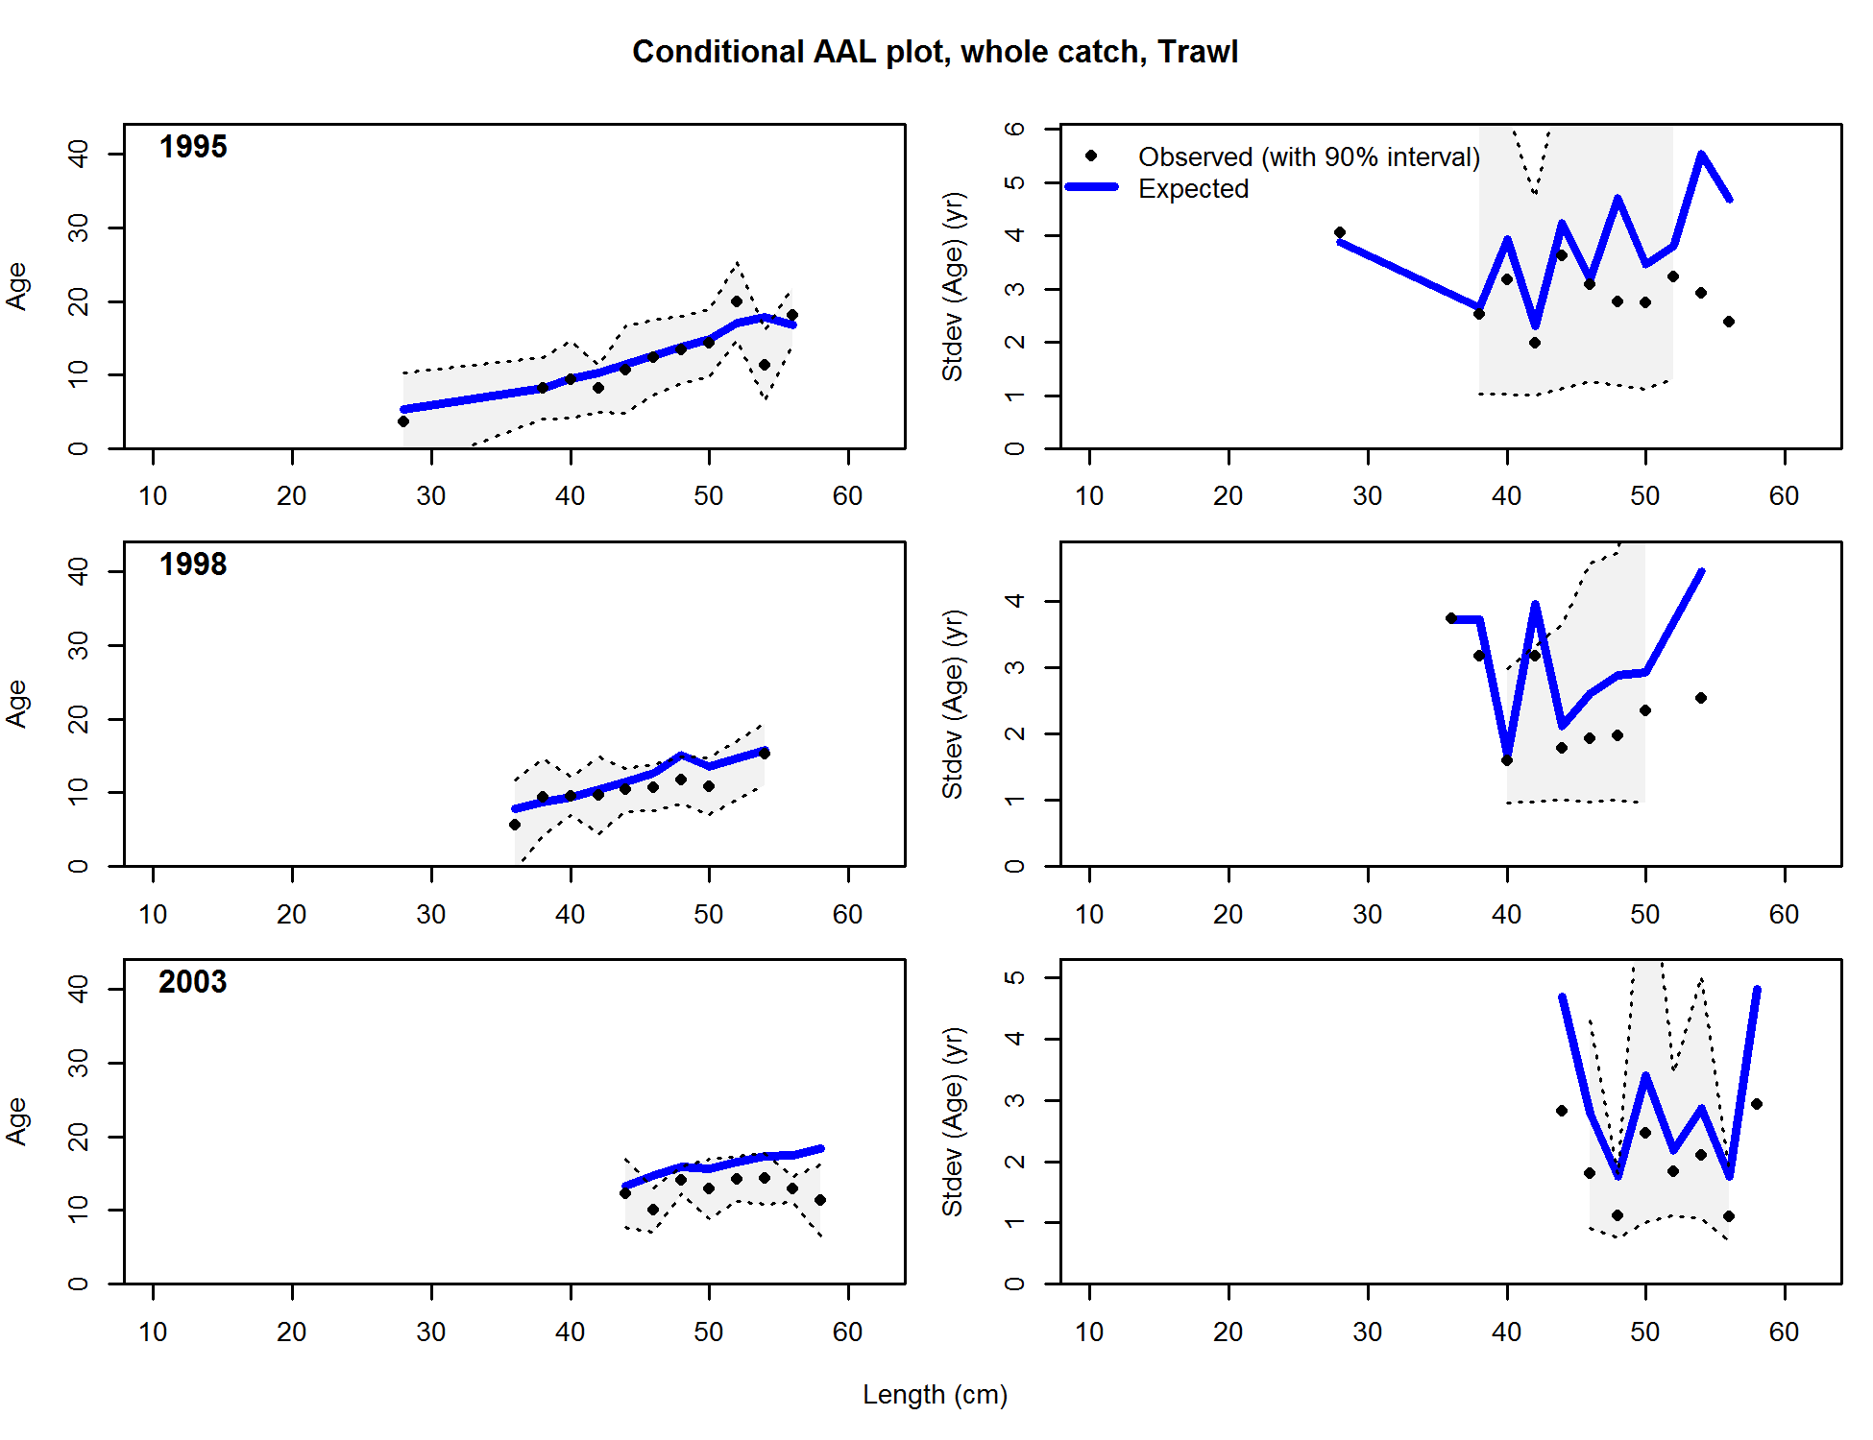

**Figure 211. (continued)**

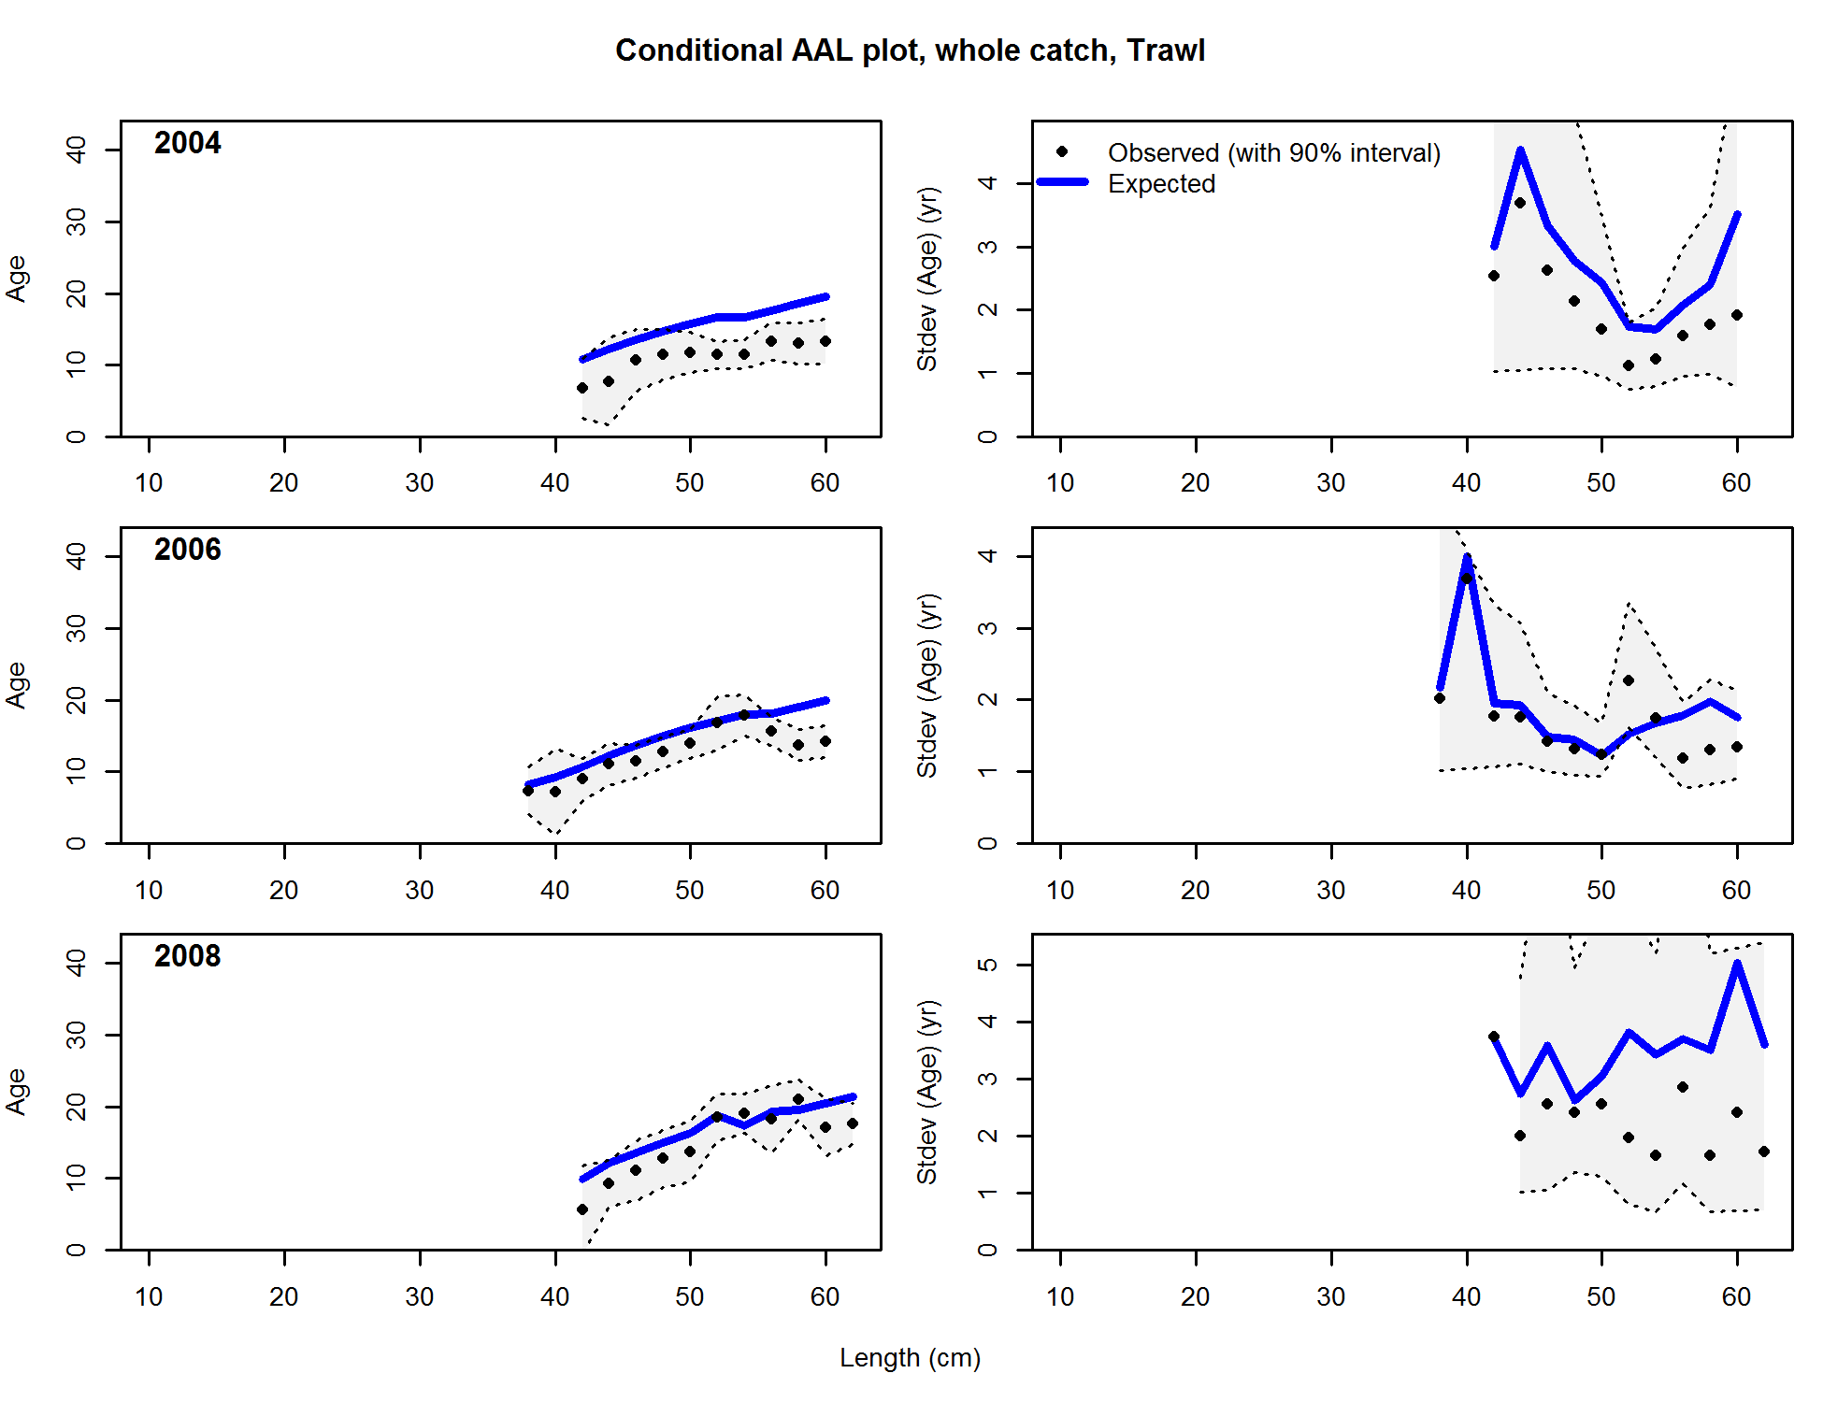

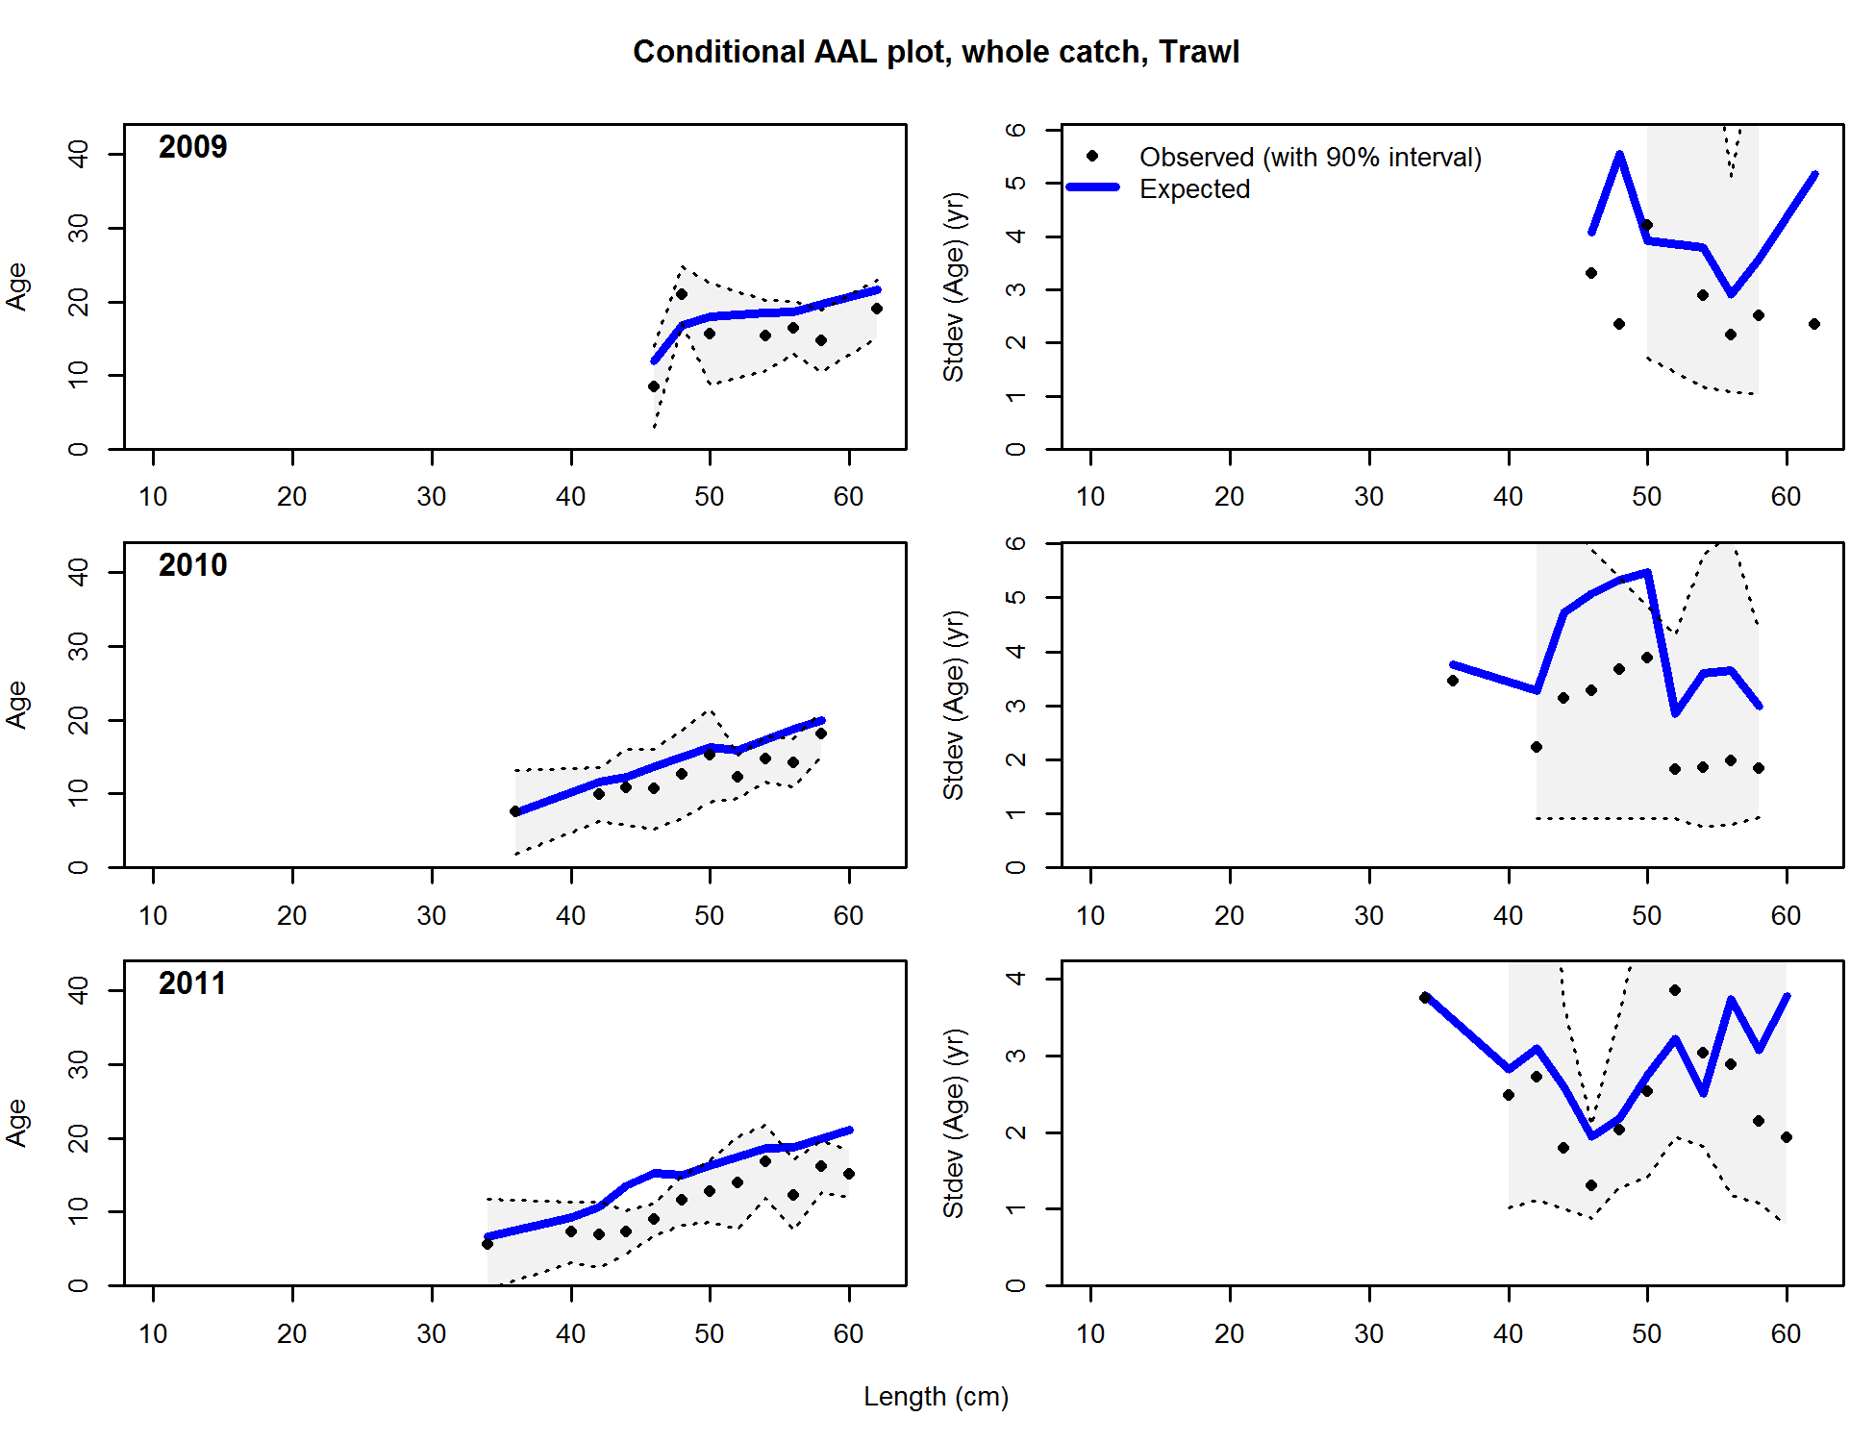

**Figure 211. (continued)**

**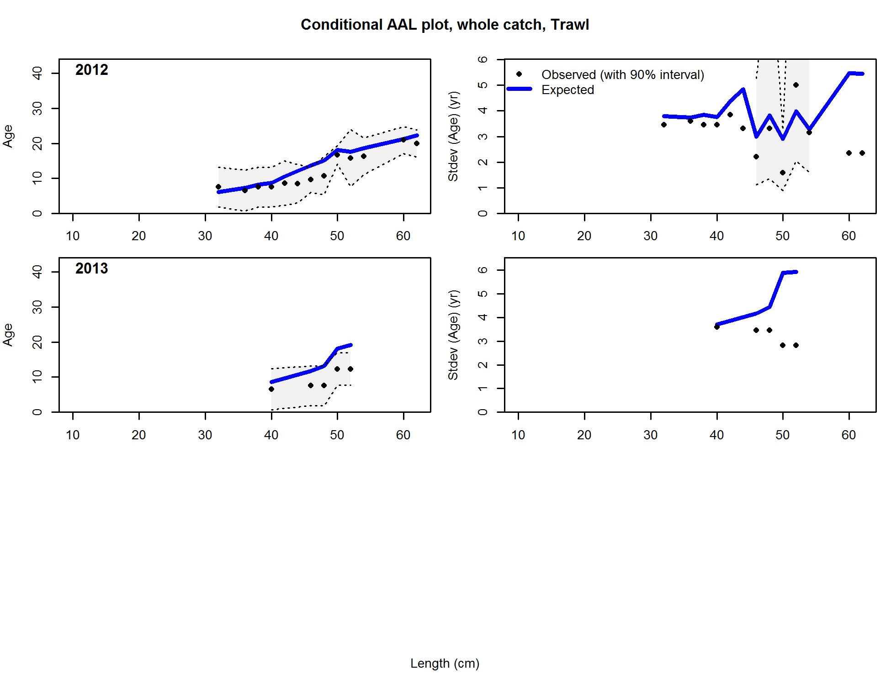**

****

**Figure 211. (continued)**

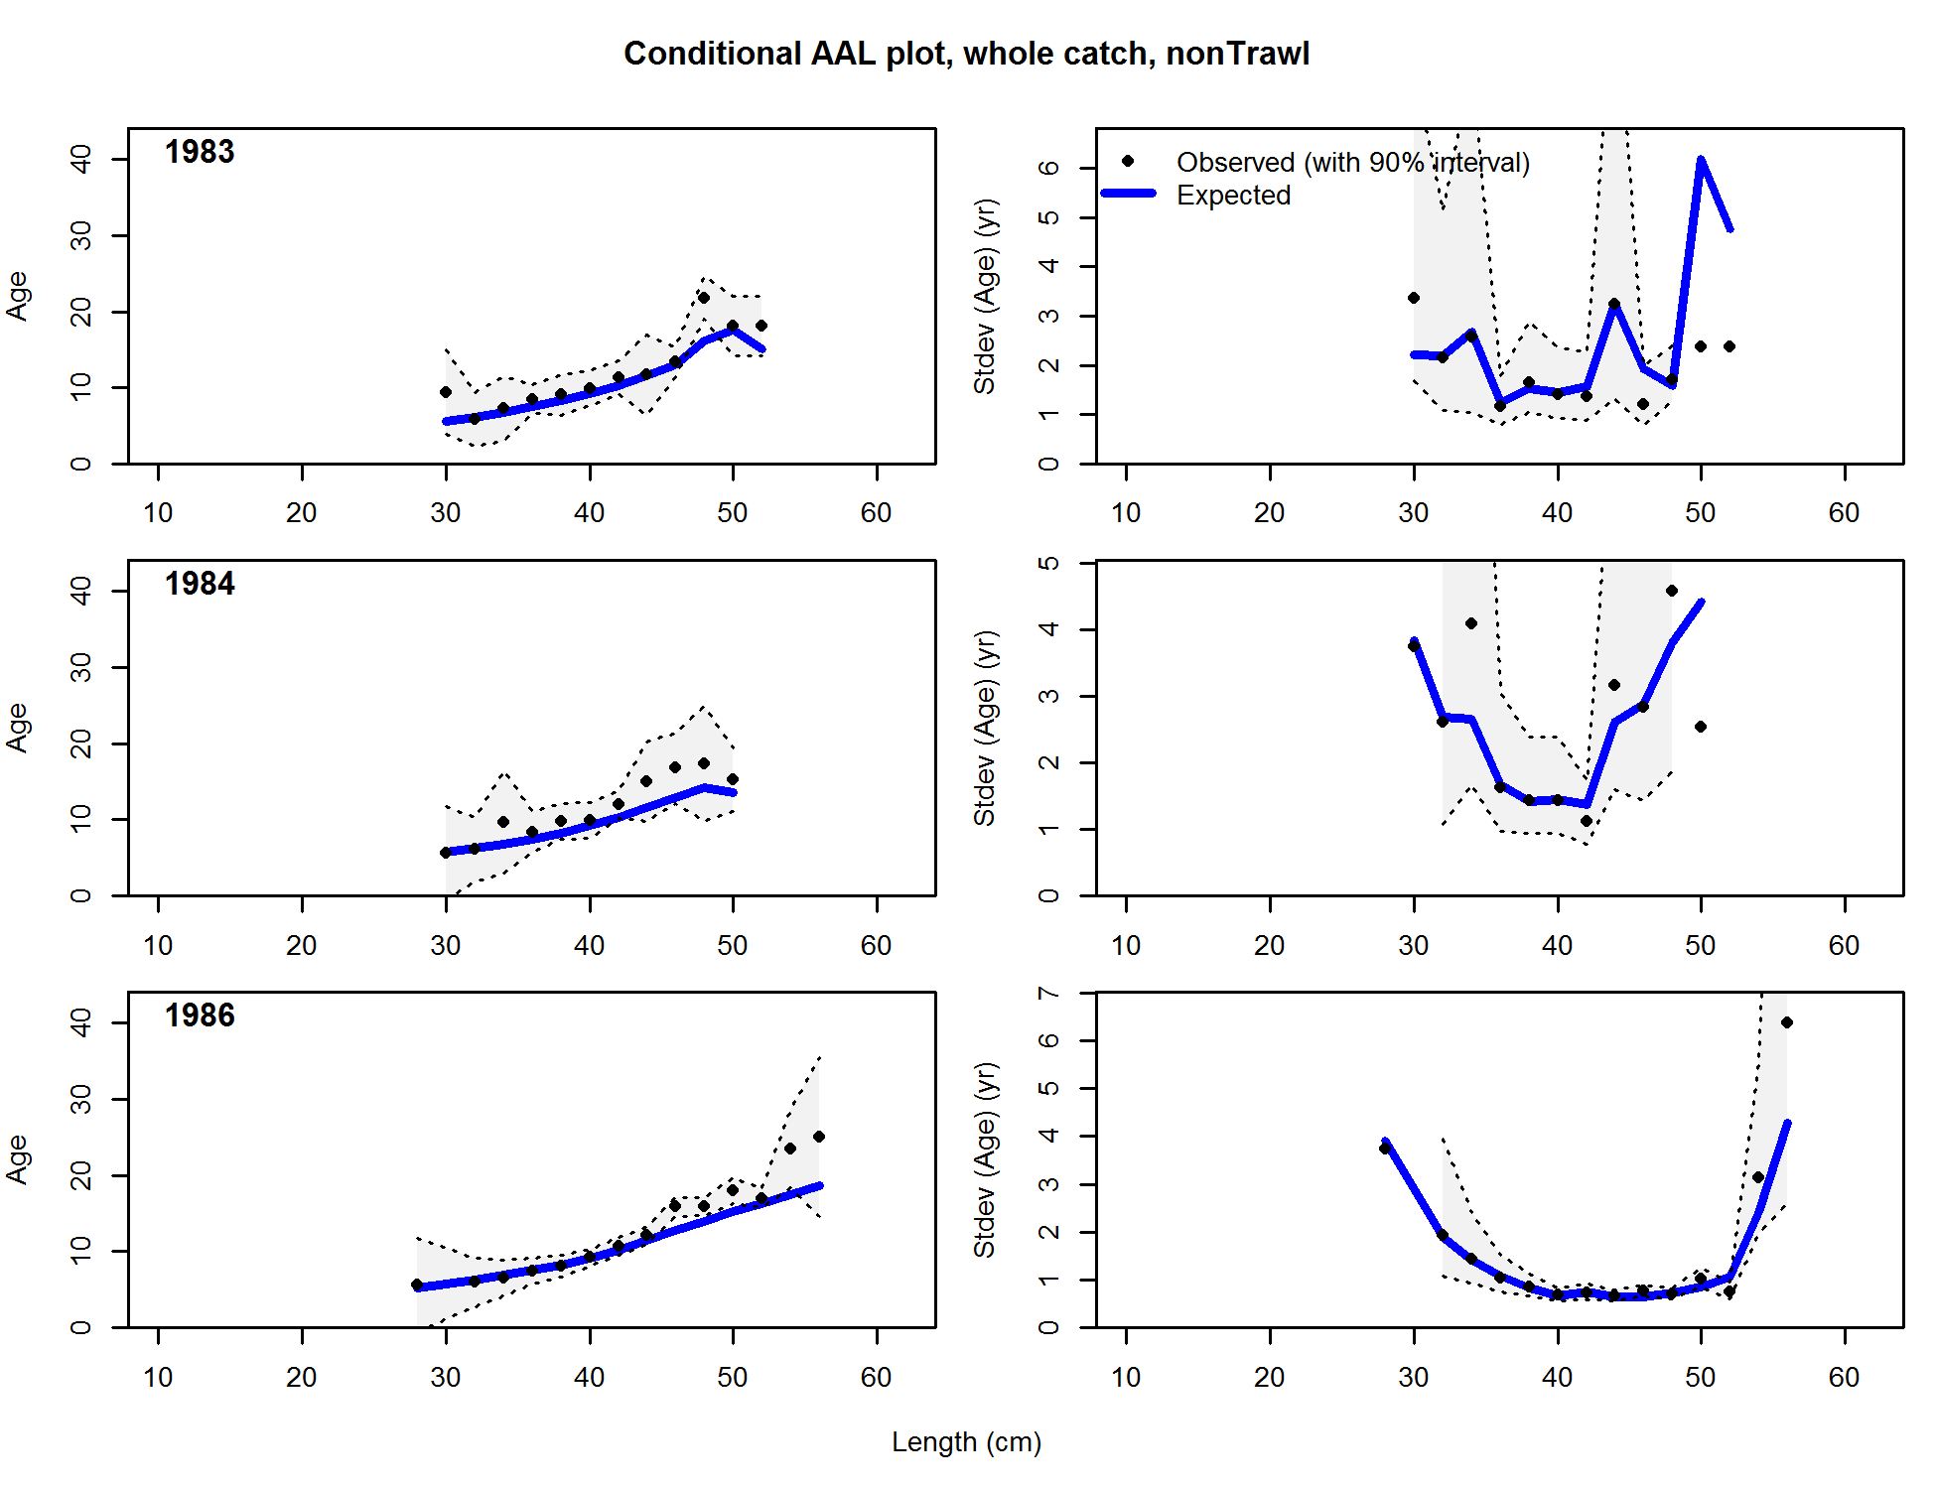

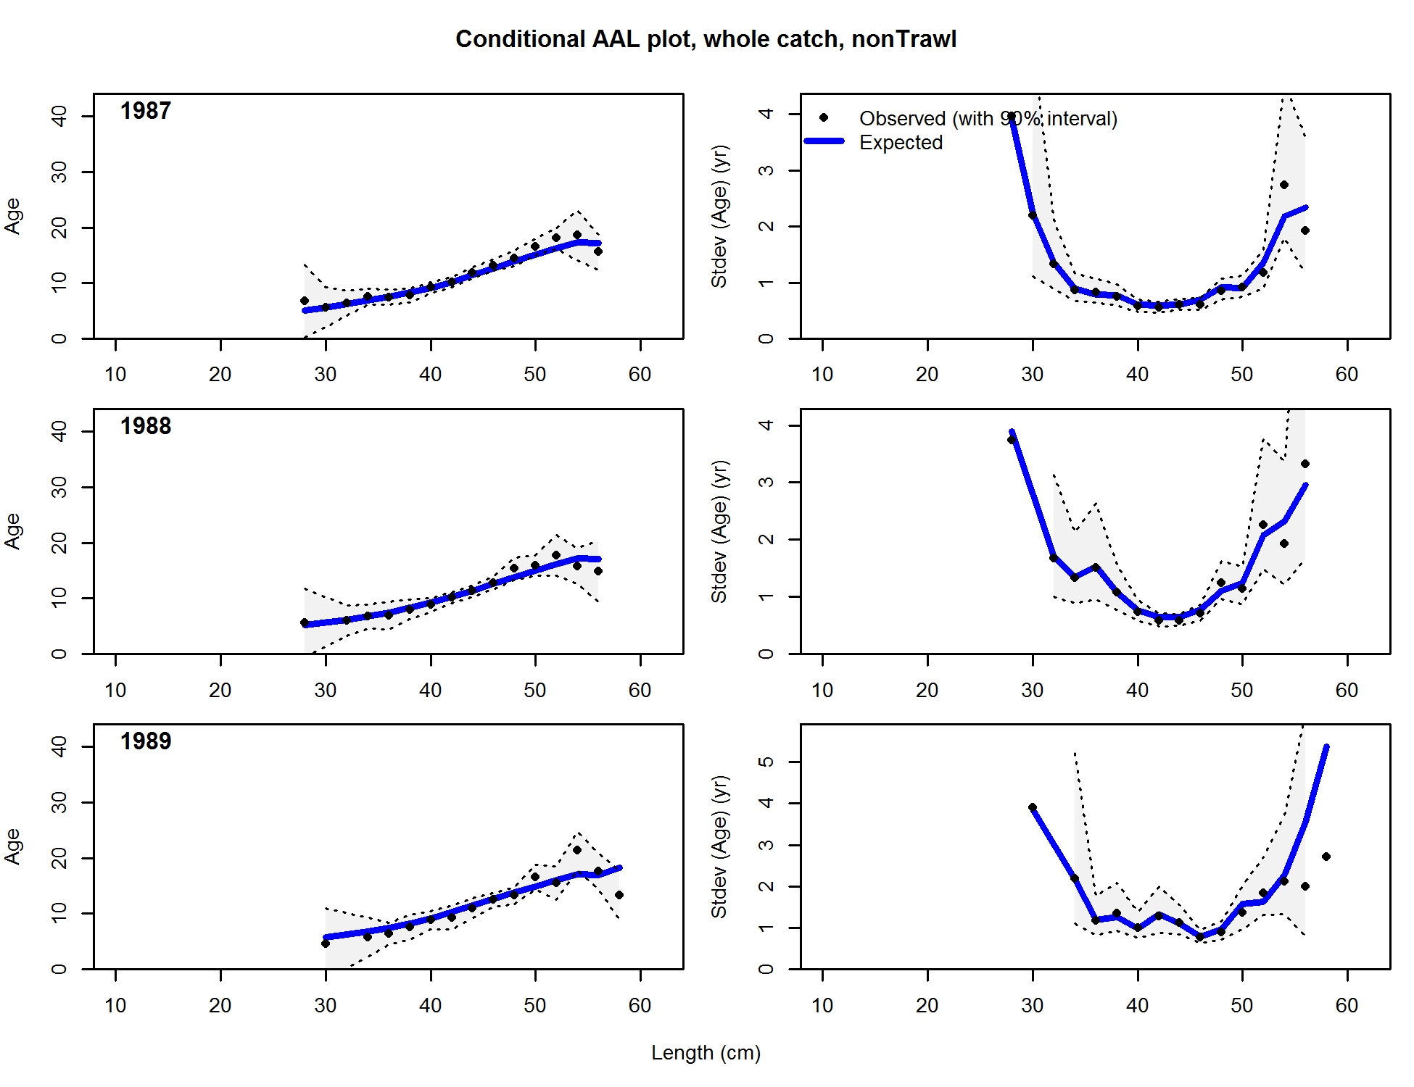

Figure . Conditional age-at-length samples and predictions for the Washington non-trawl commercial fleet. Shading indicates 95% confidence intervals.

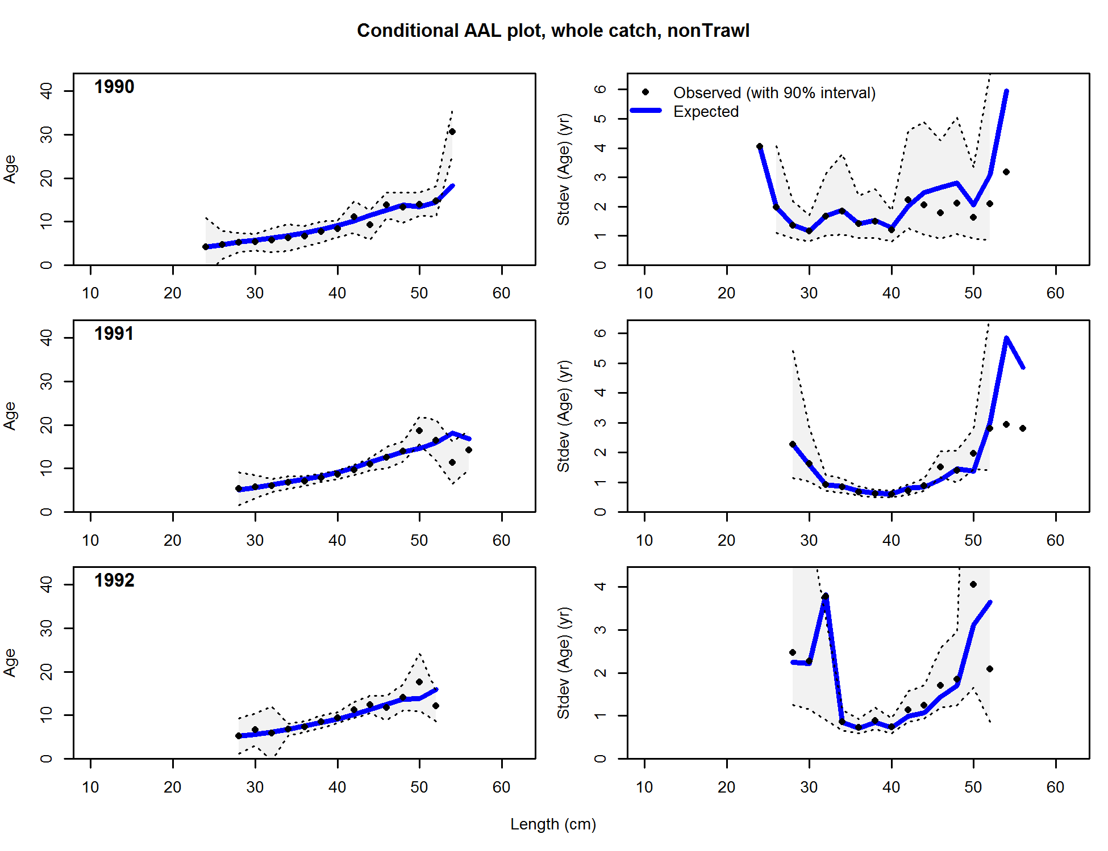

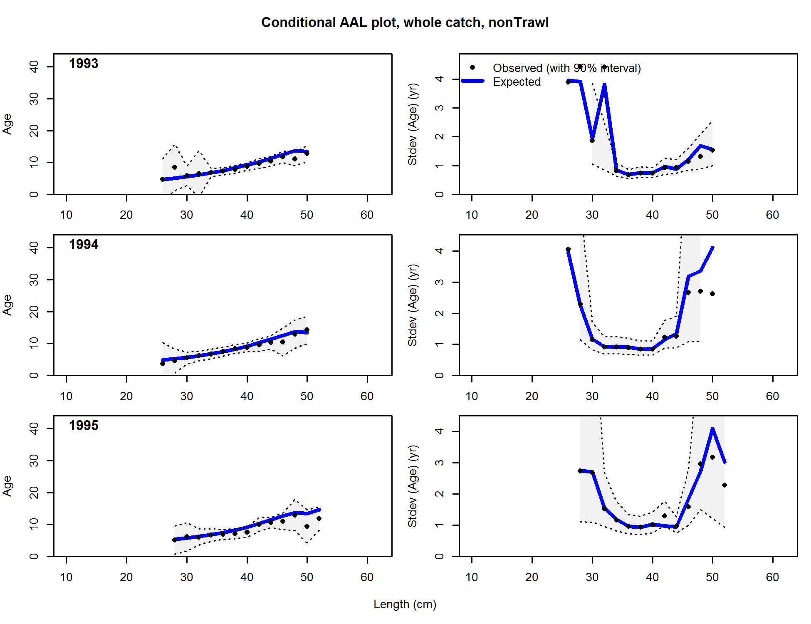

**Figure 185 (continued).**

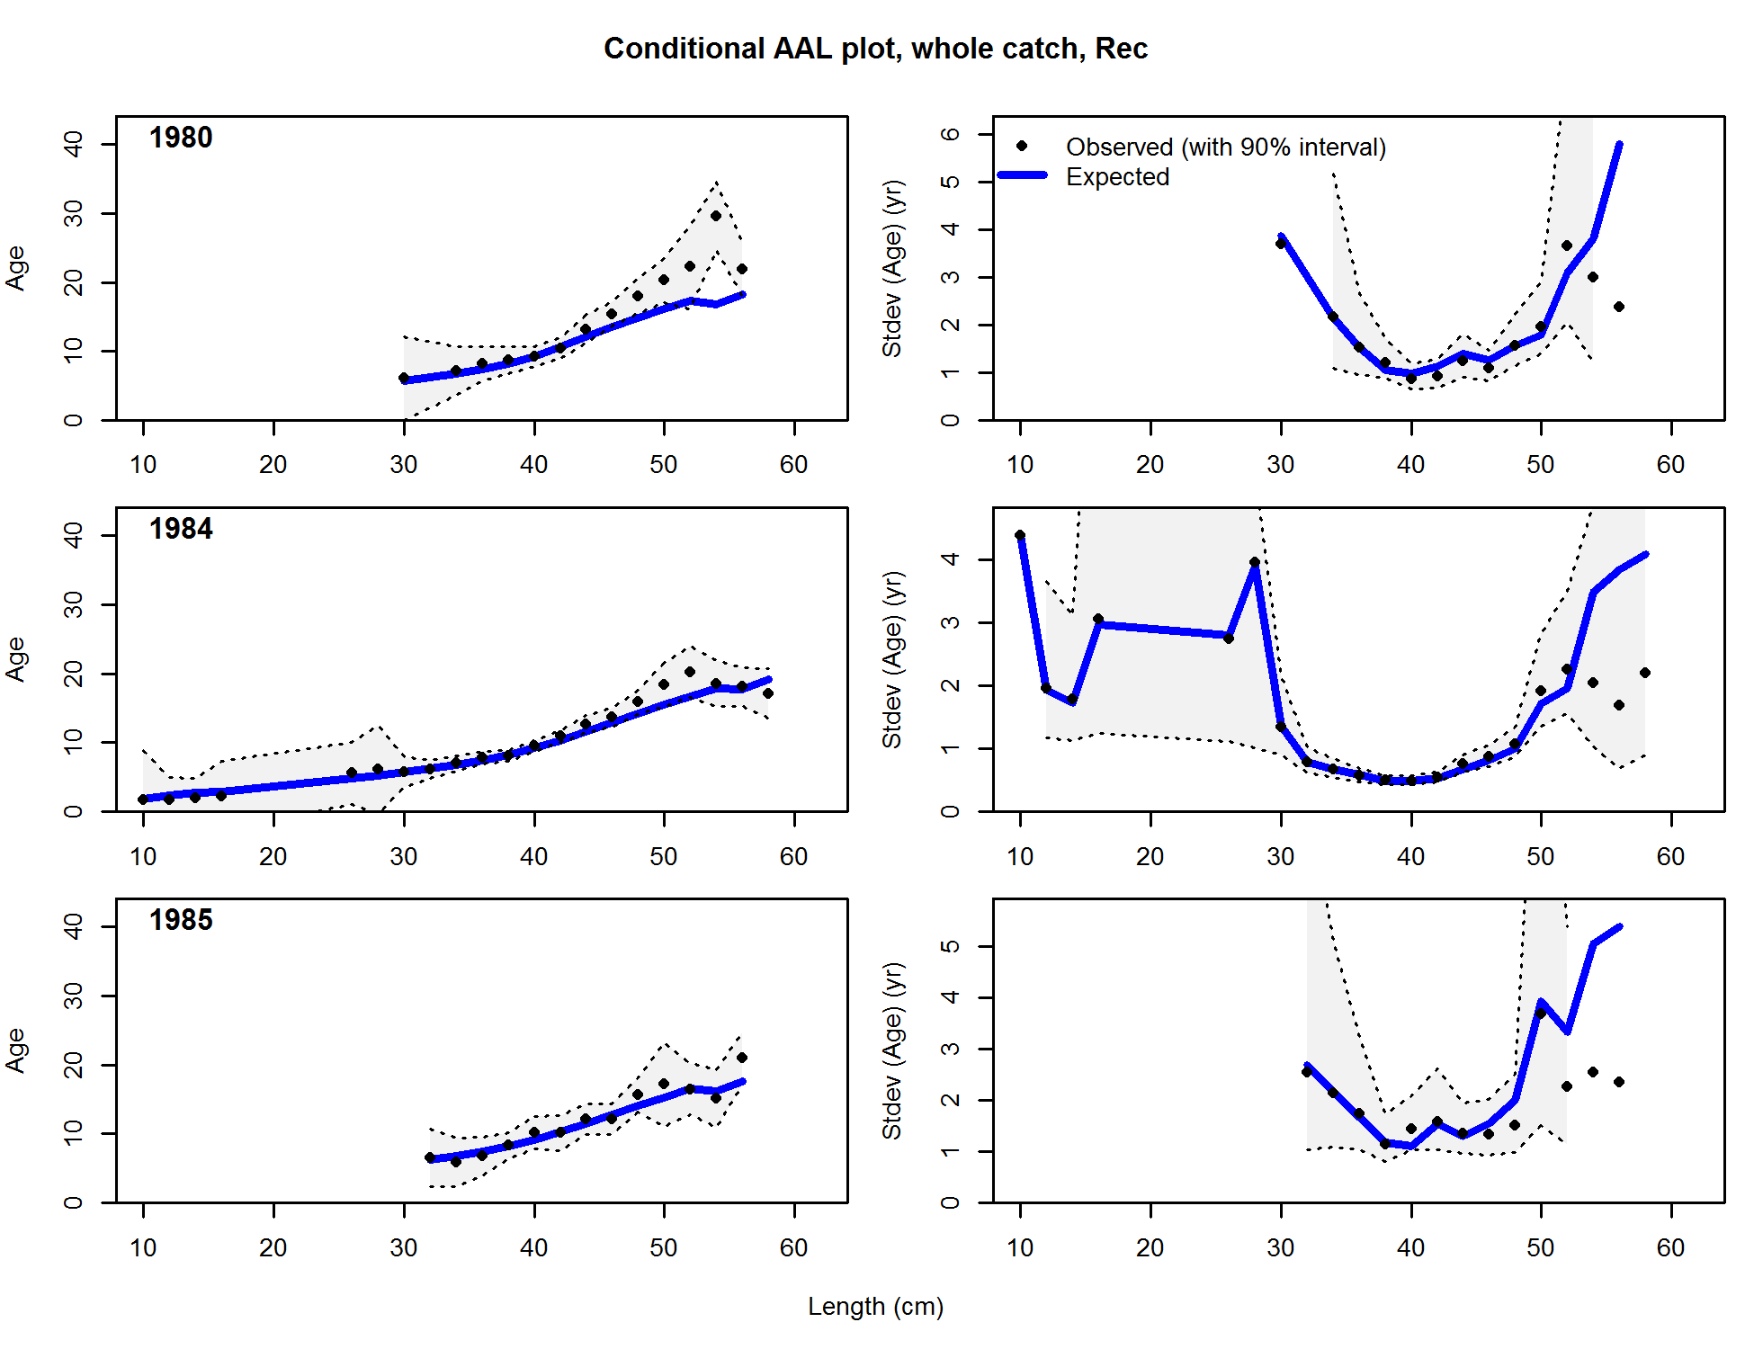

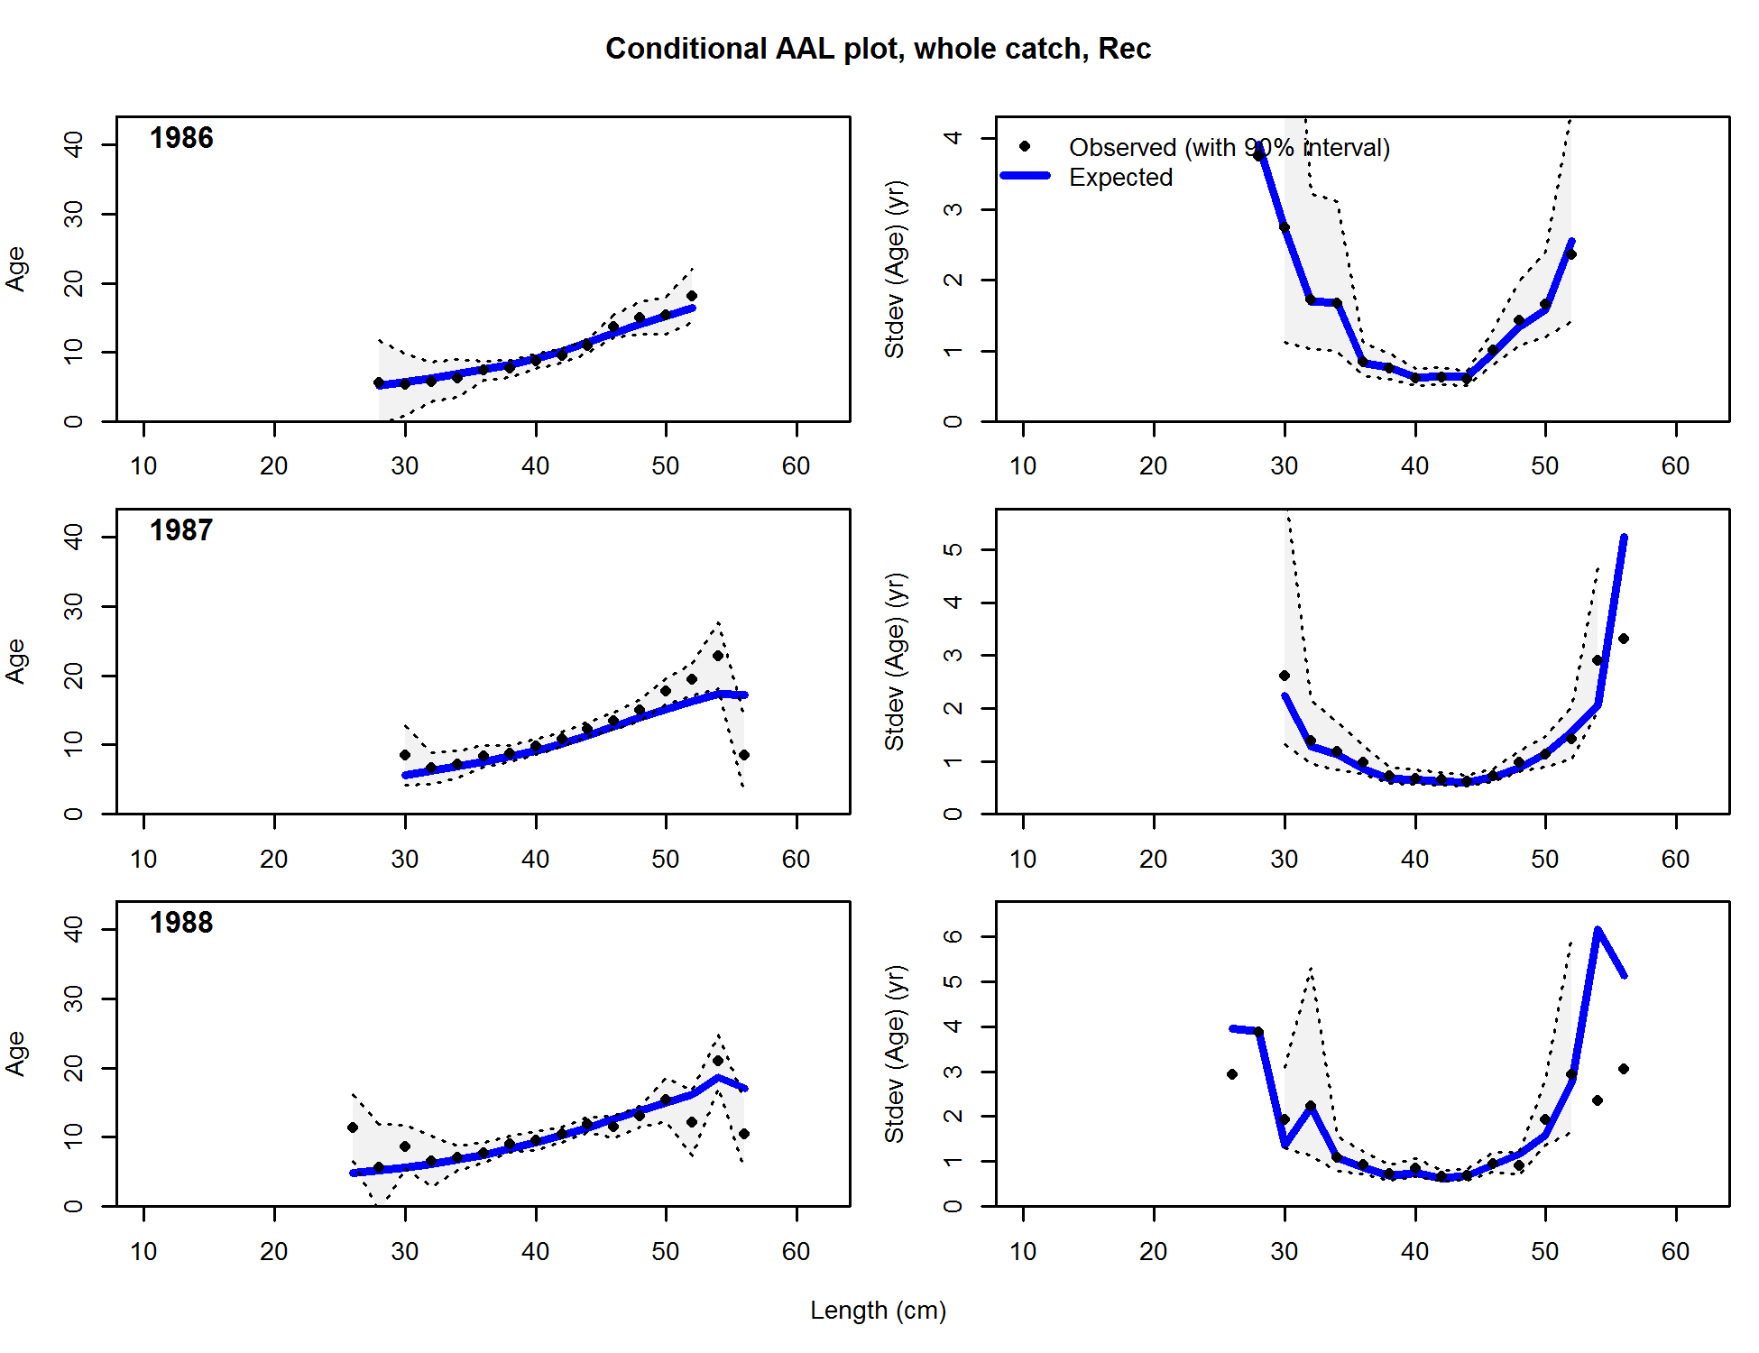

Figure . Conditional age-at-length samples and predictions for the Washington recreational fleet. Shading indicates 95% confidence intervals.

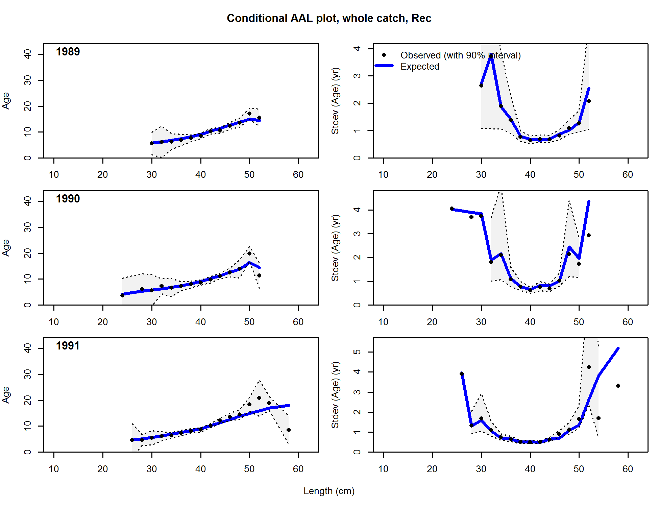

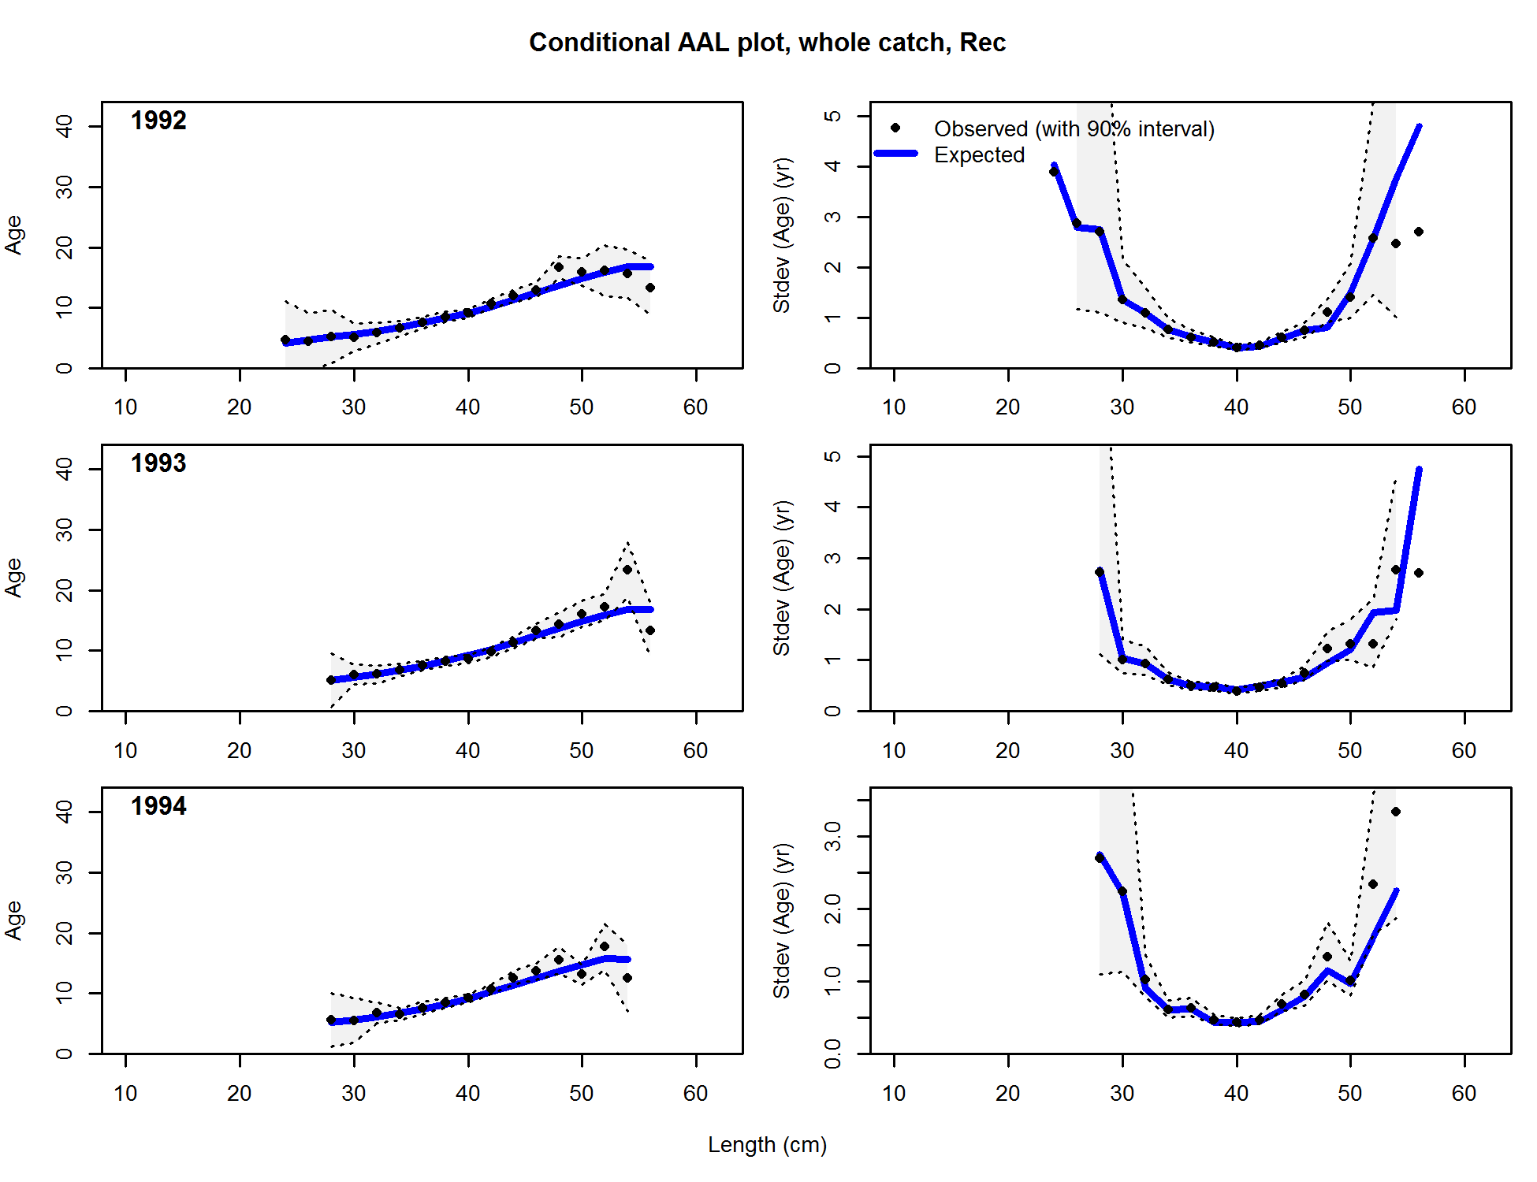

**Figure 186. (continued).**

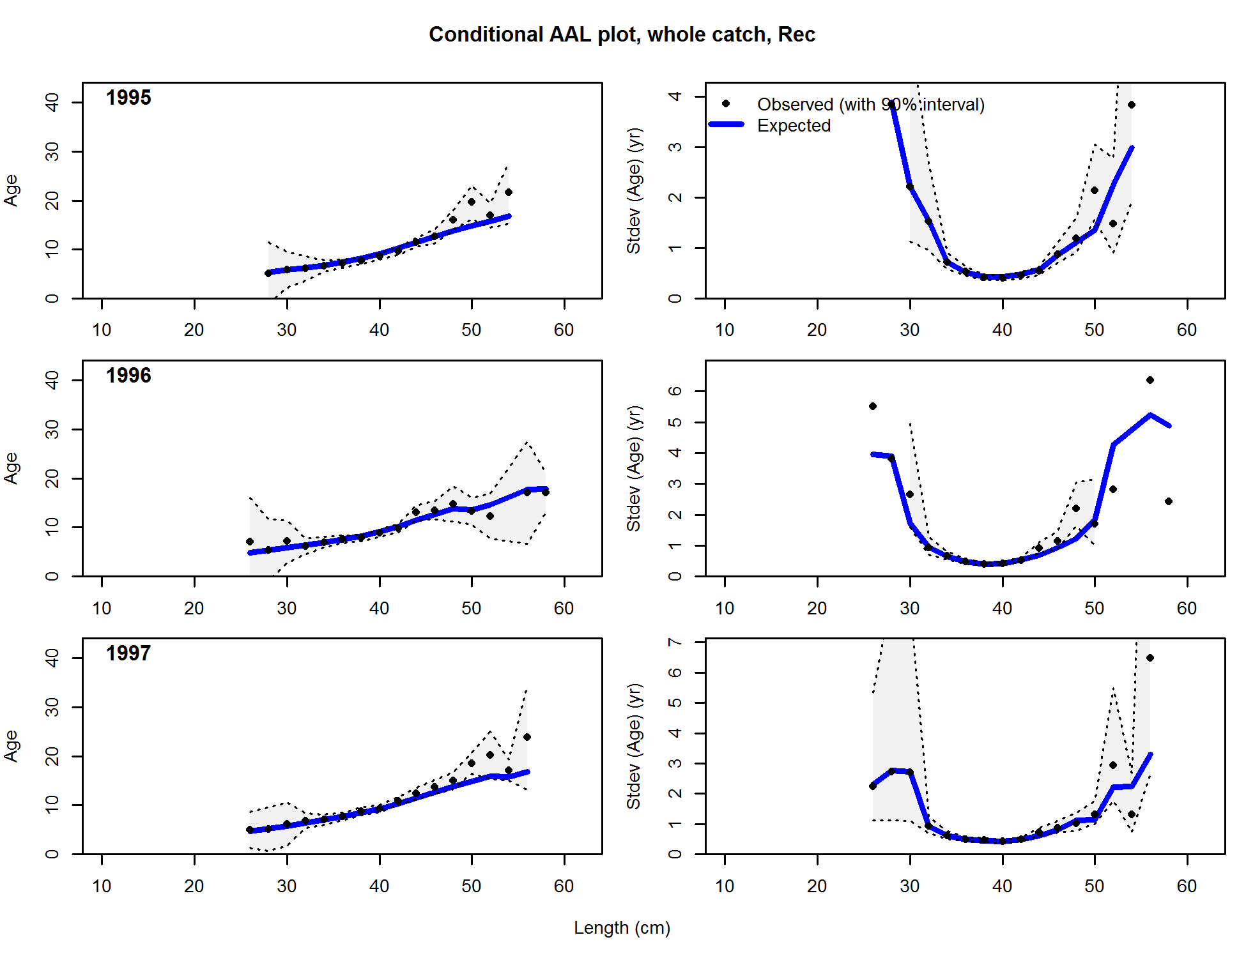

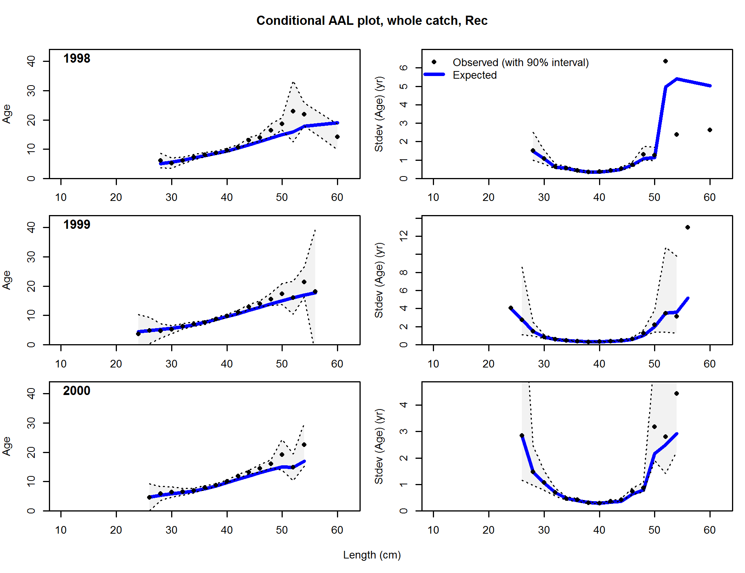

**Figure 186 (continued)**

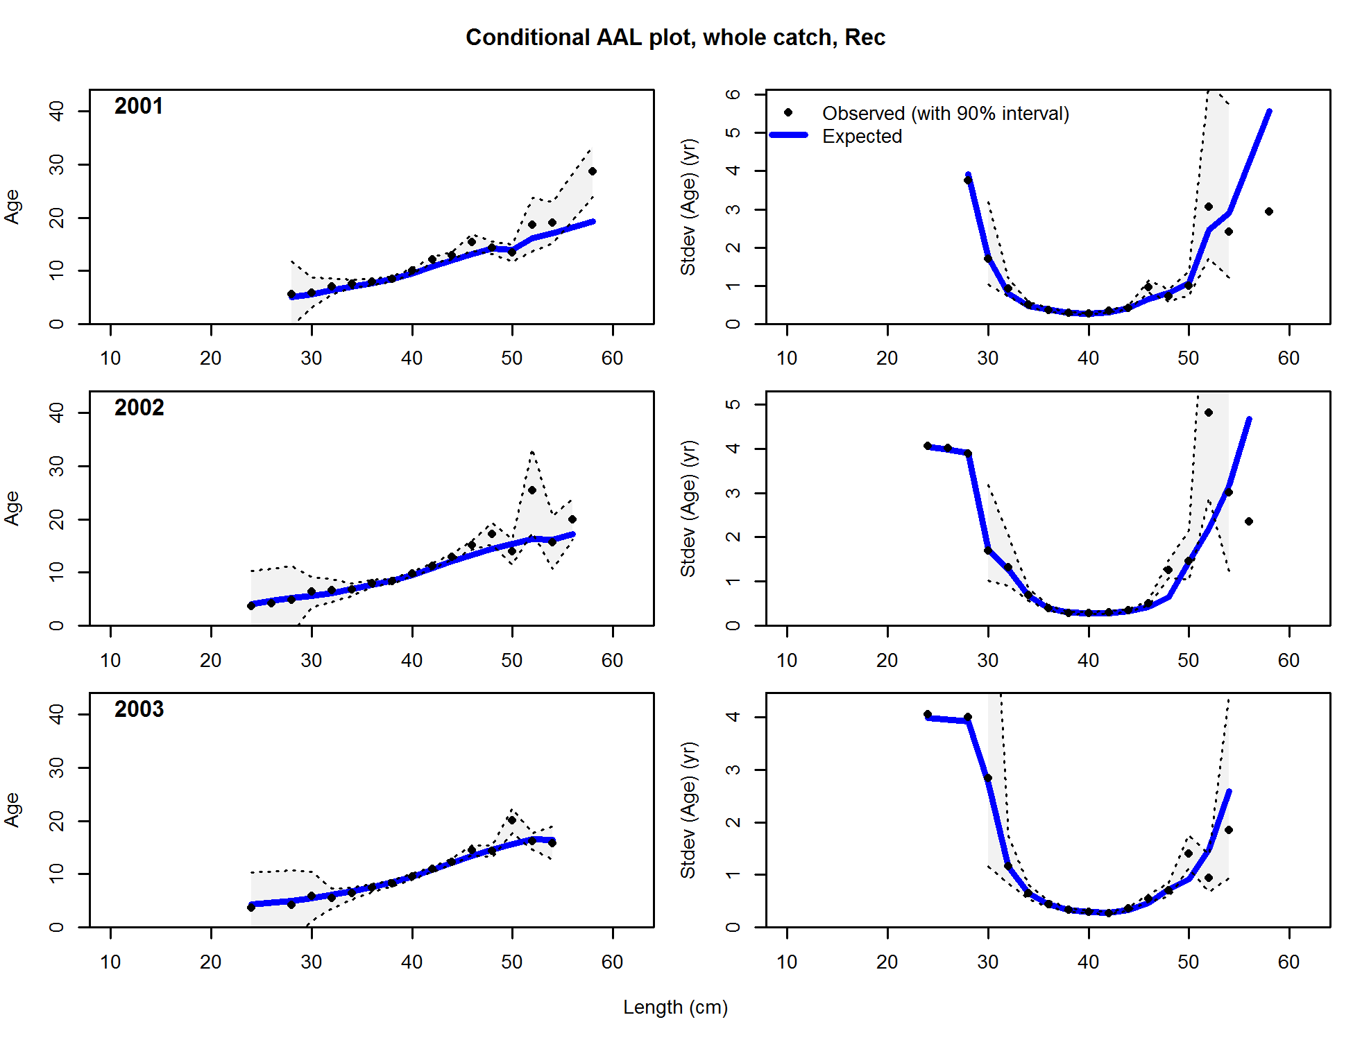

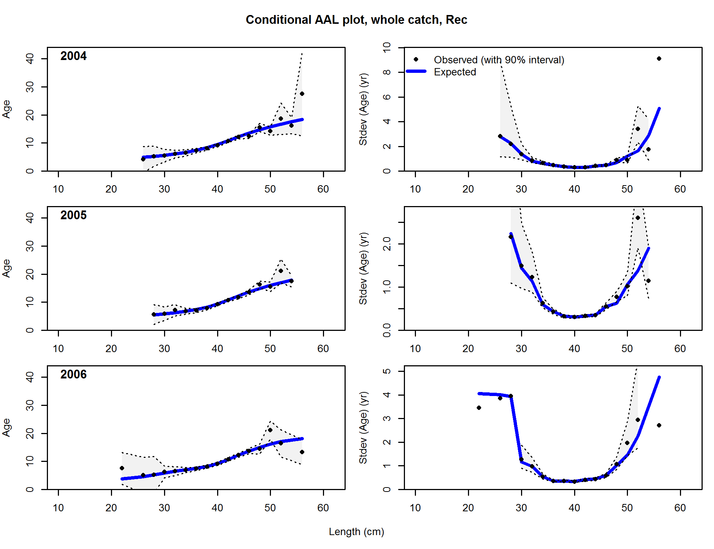

**Figure 186 (continued).**

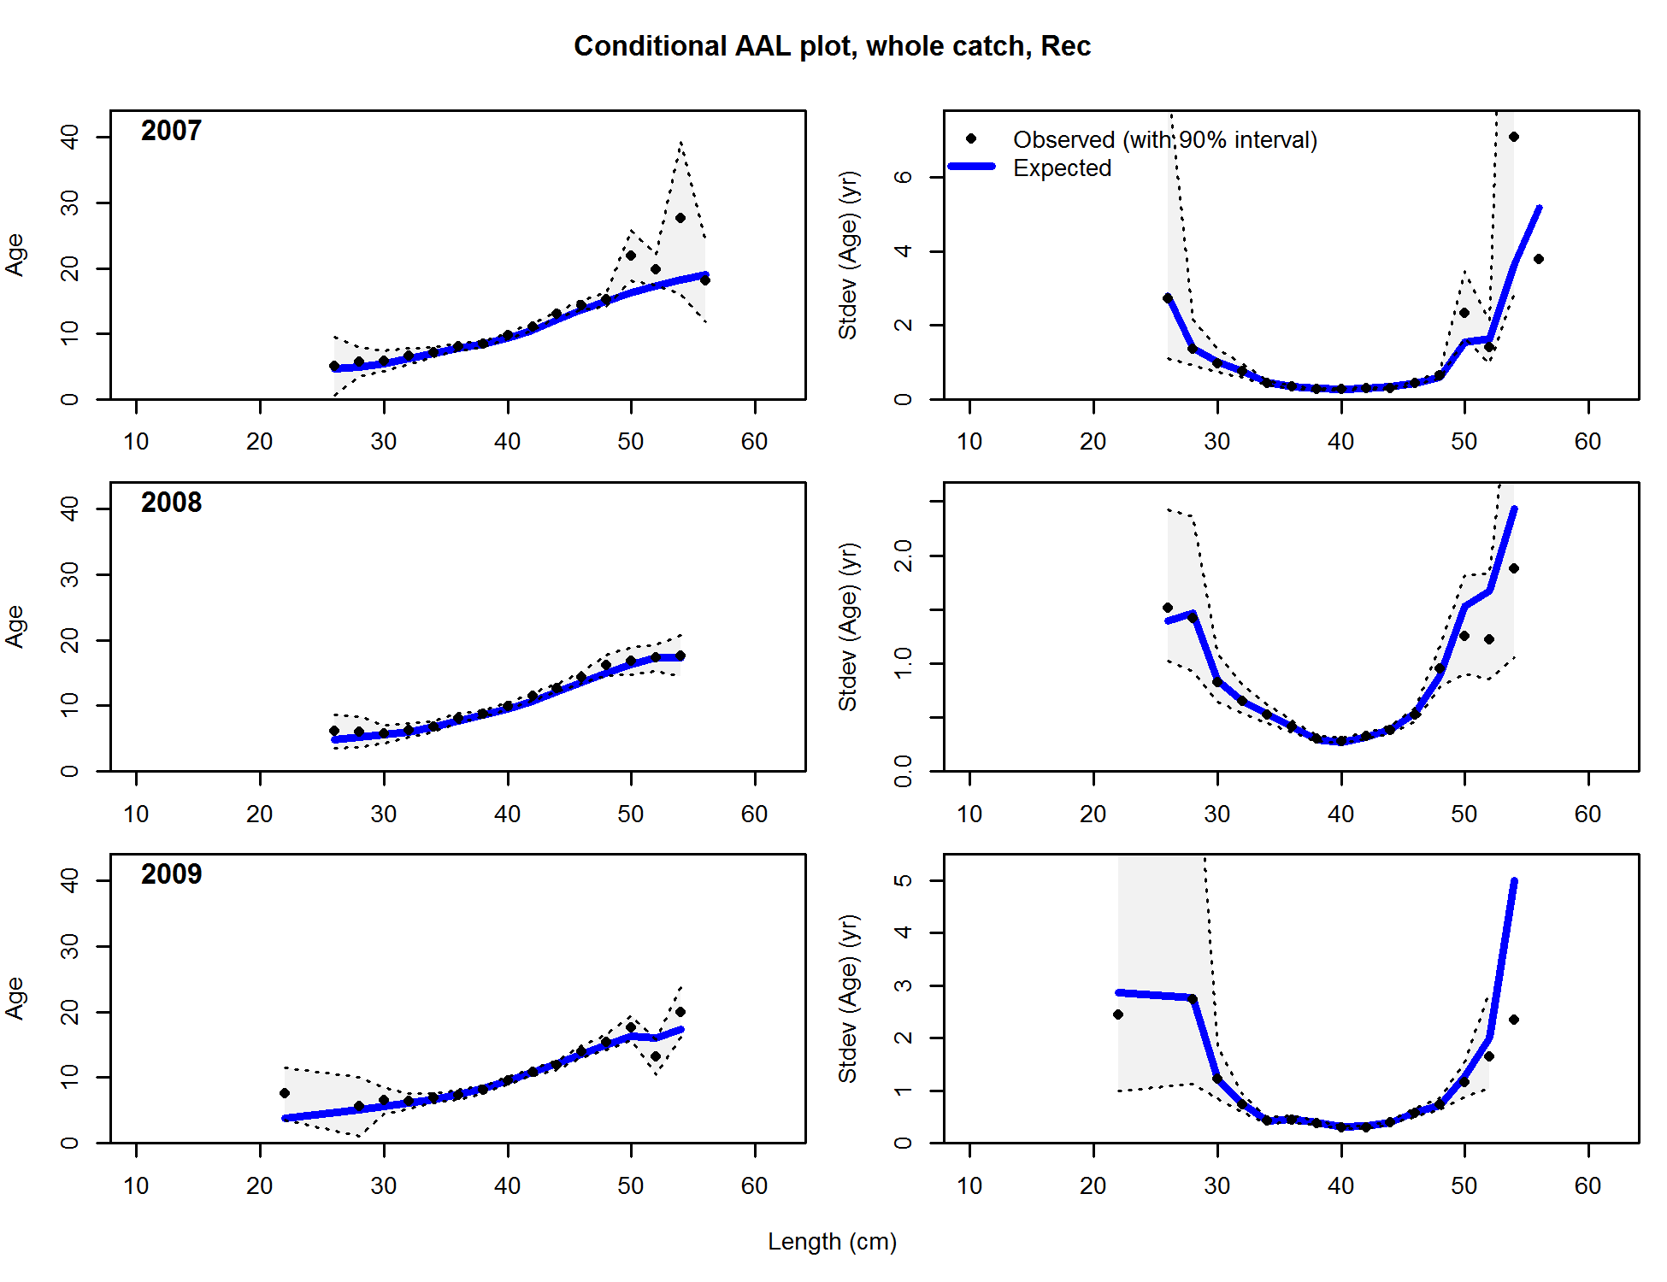

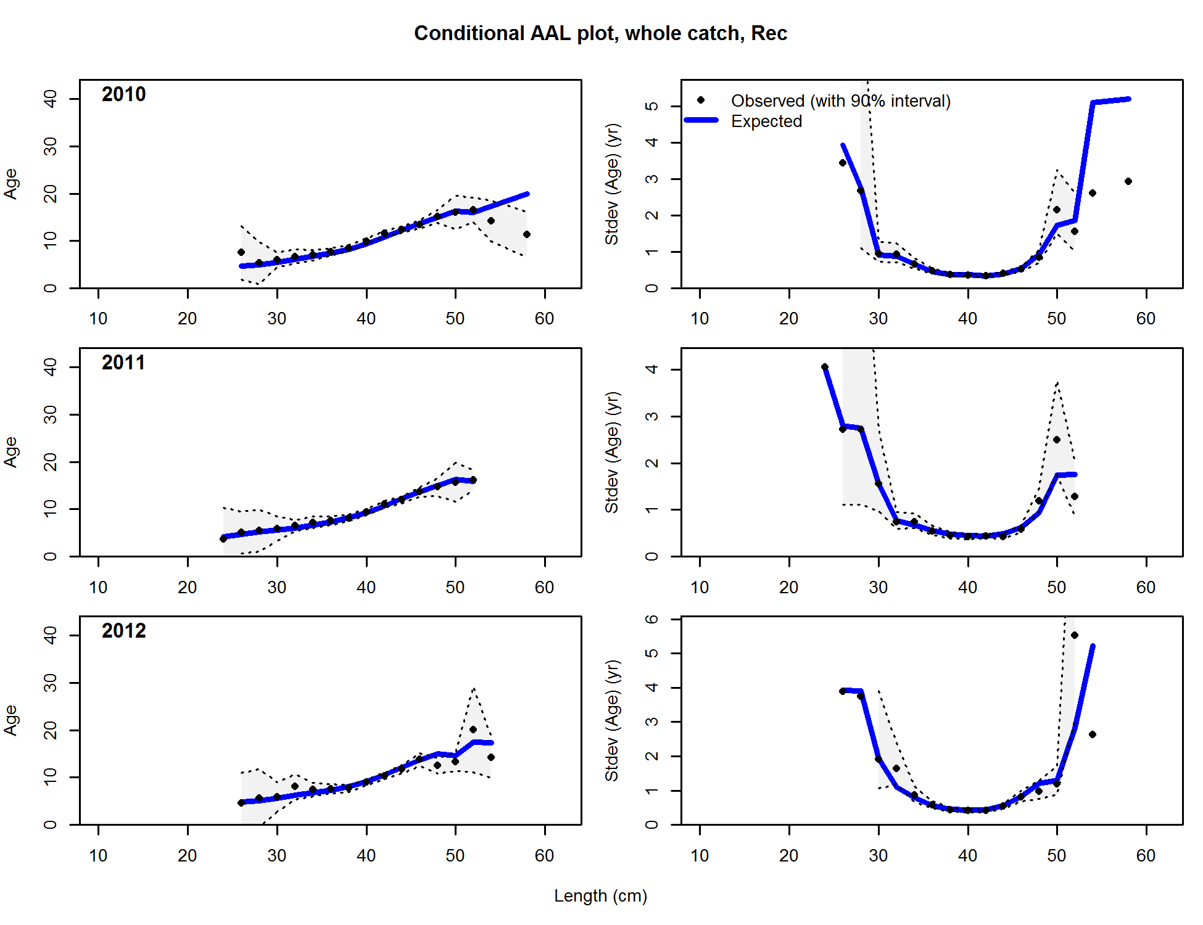

**Figure 186 (continued).**

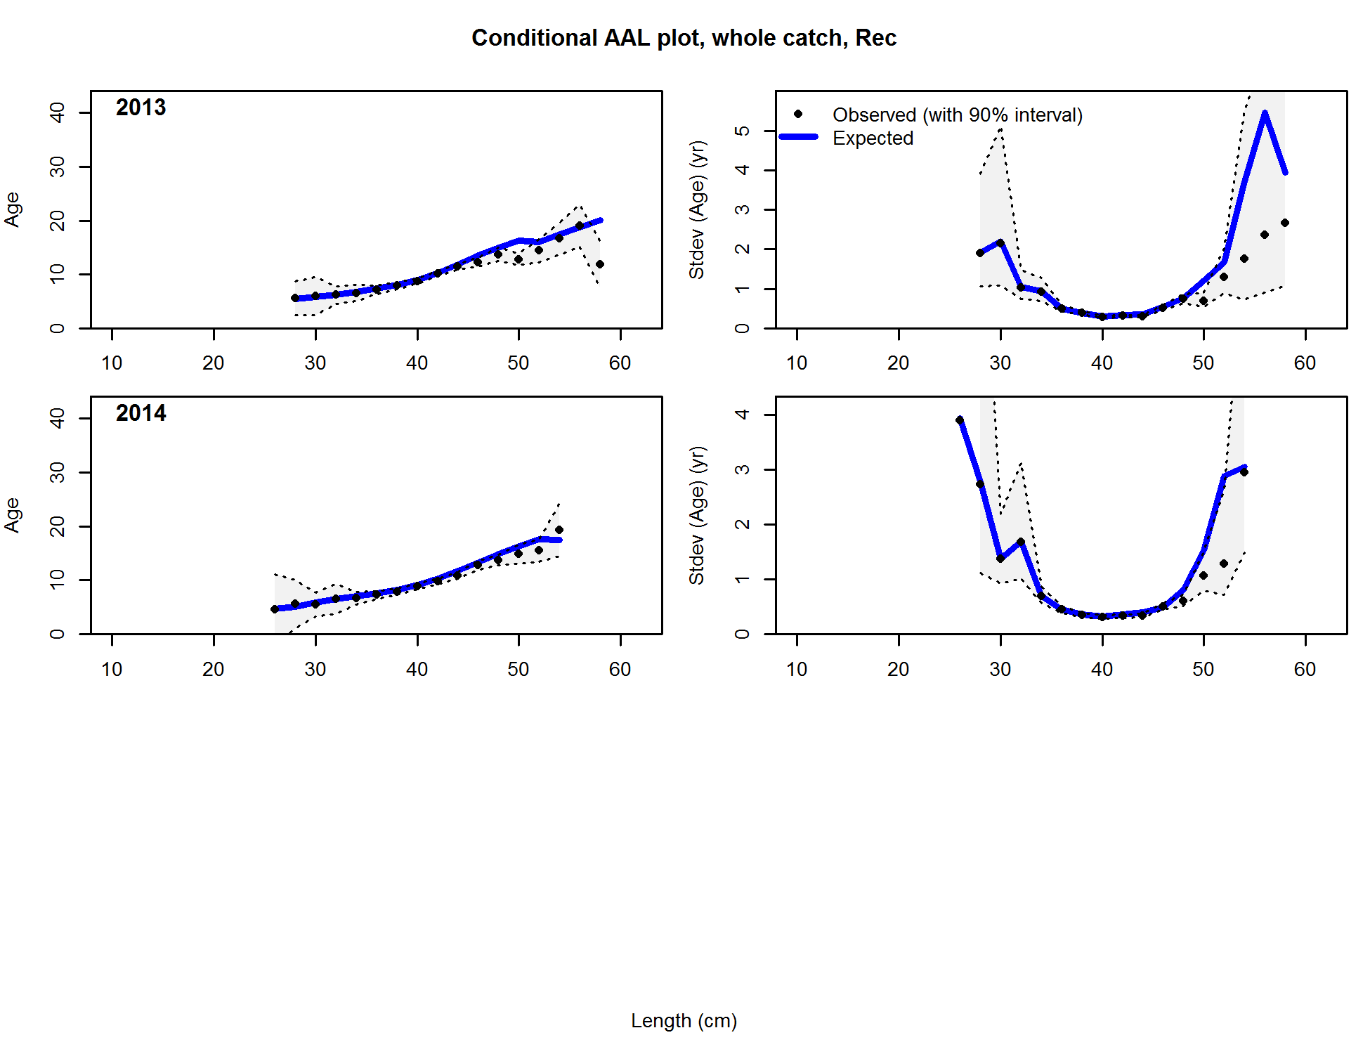



**Figure 186 (continued).**

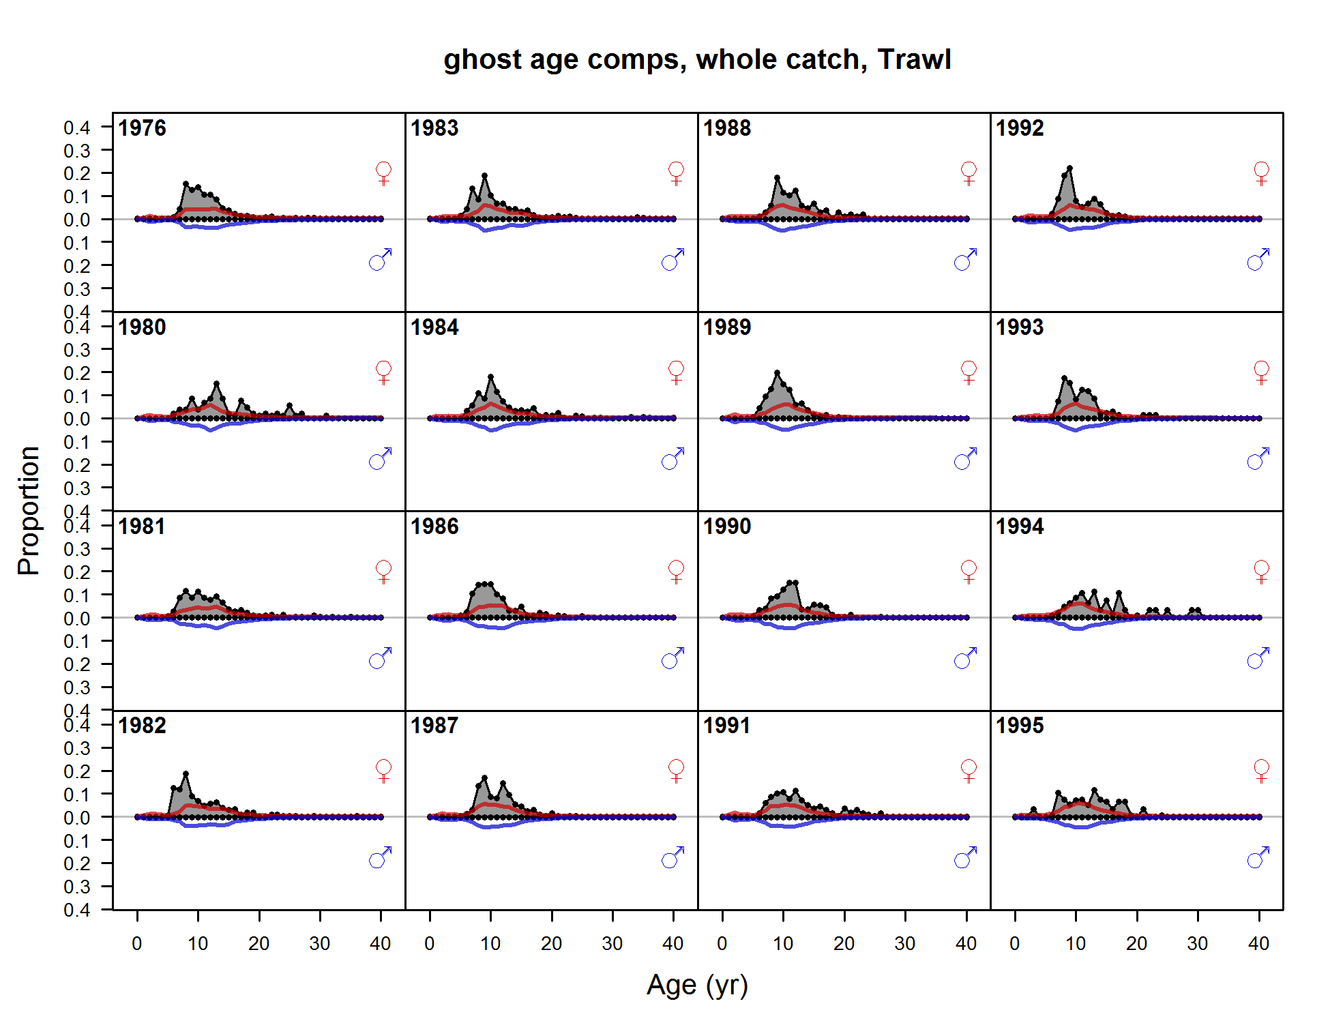

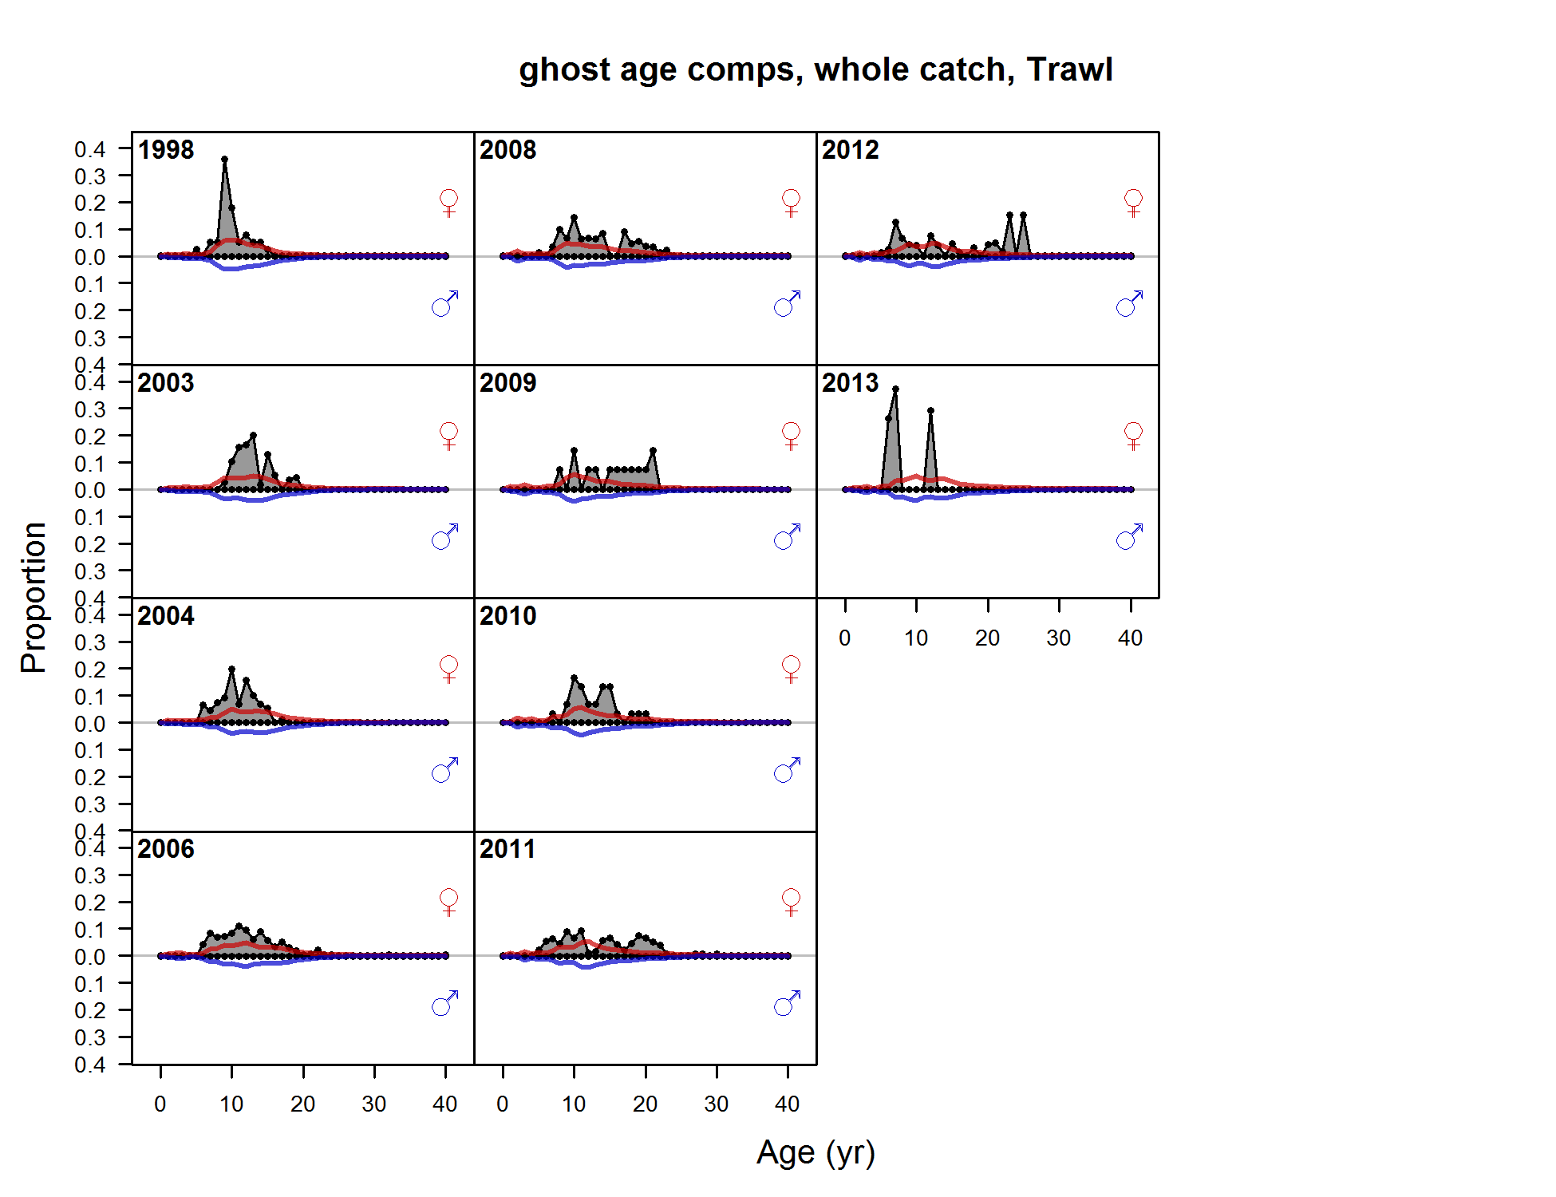

Figure . Age composition samples and predictions for the Washington trawl fishery.

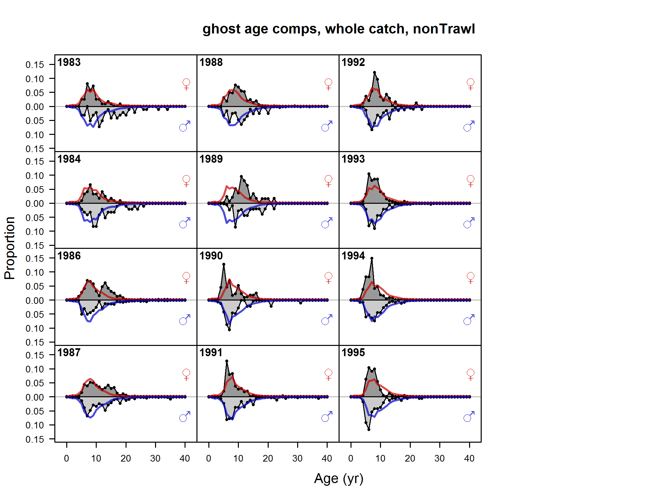

Figure . Age composition samples and predictions for the Washington non-trawl fishery.

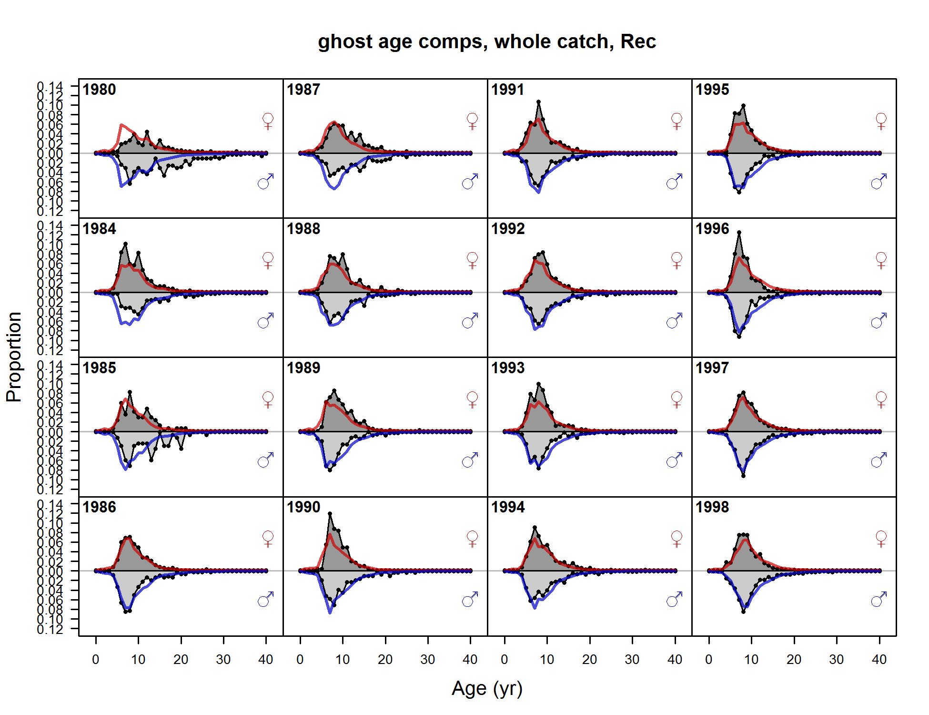

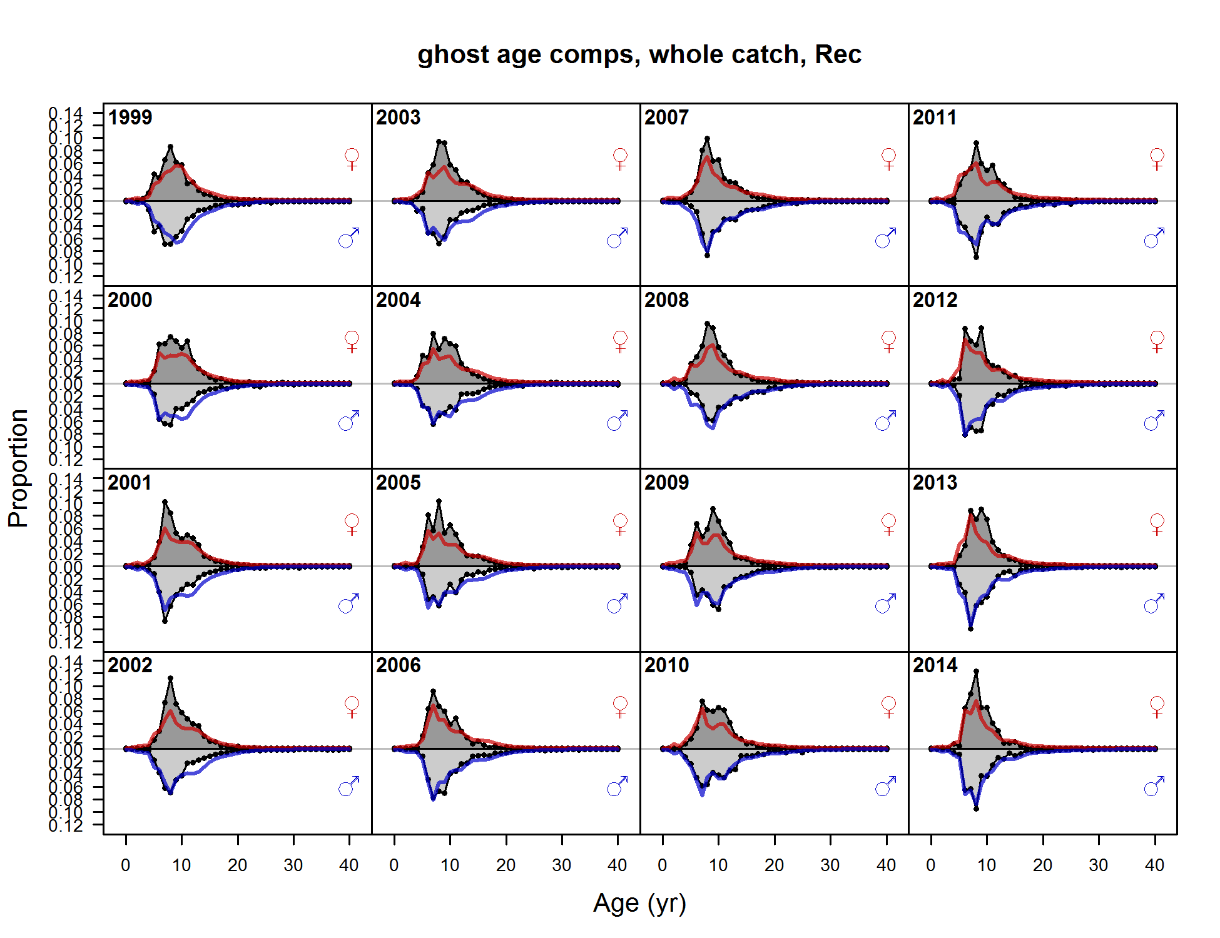

Figure . Age composition samples and predictions for the Washington recreational fishery.

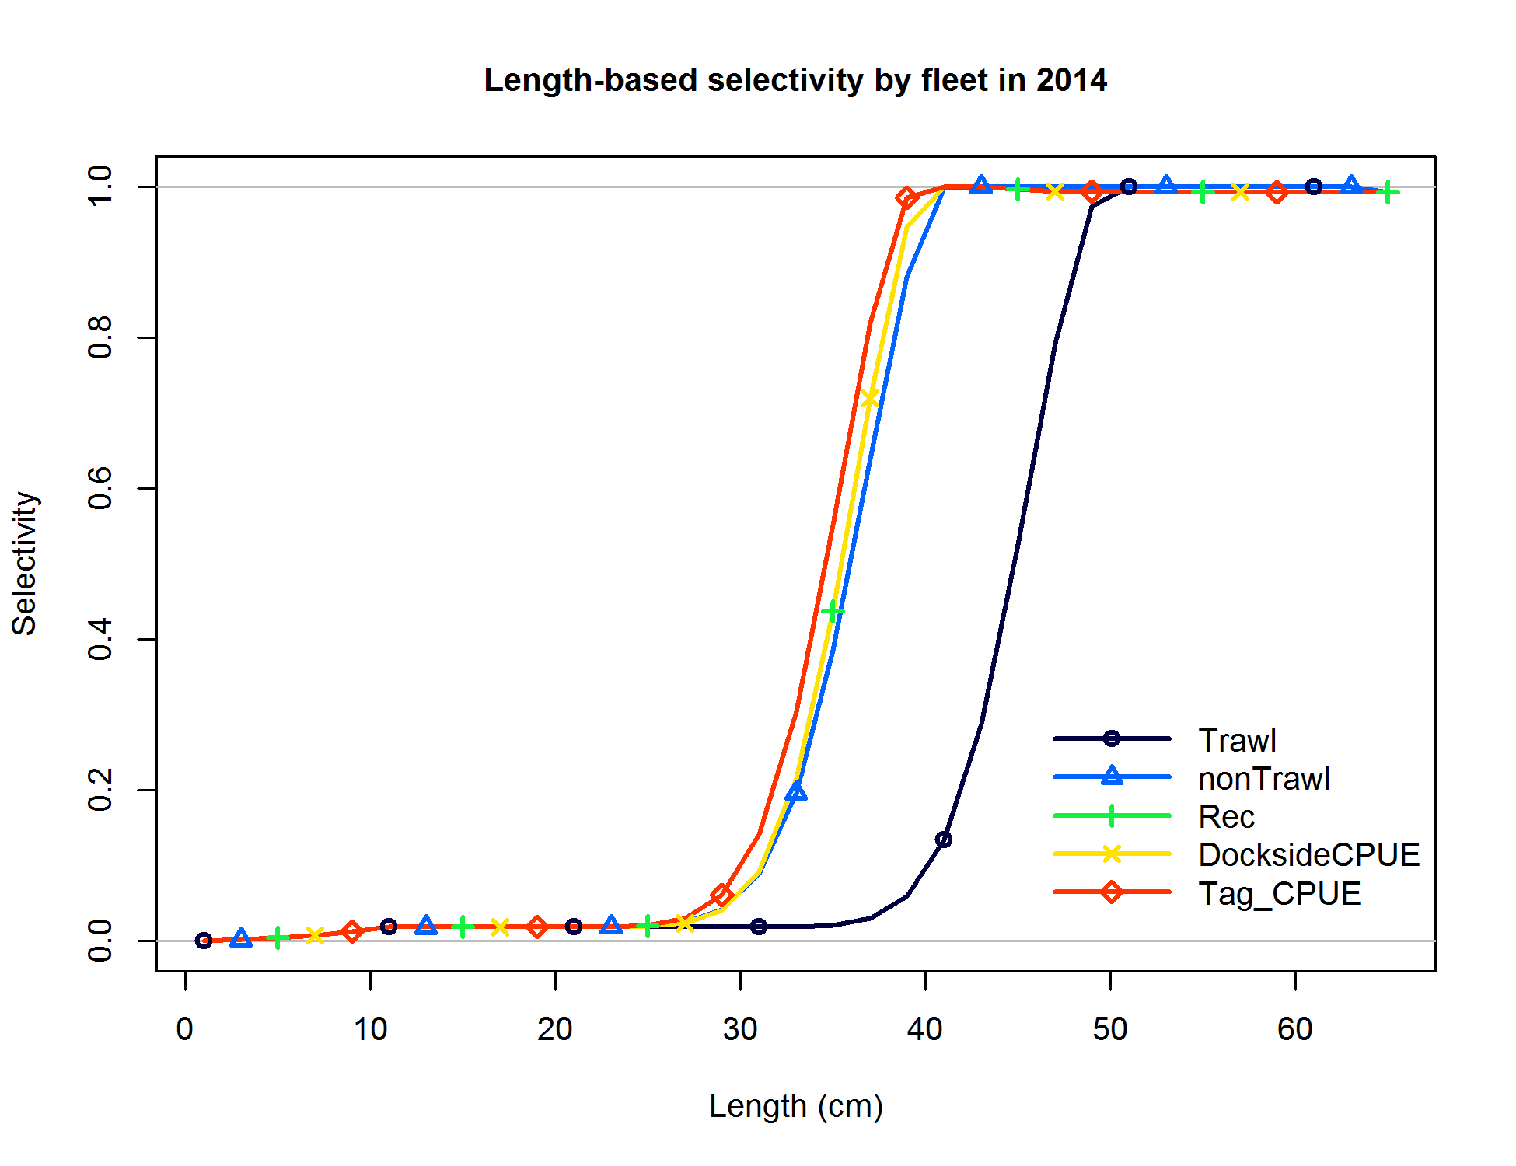

Figure . Base case estimates of length-based selectivity by fleet and survey for the Washington model.

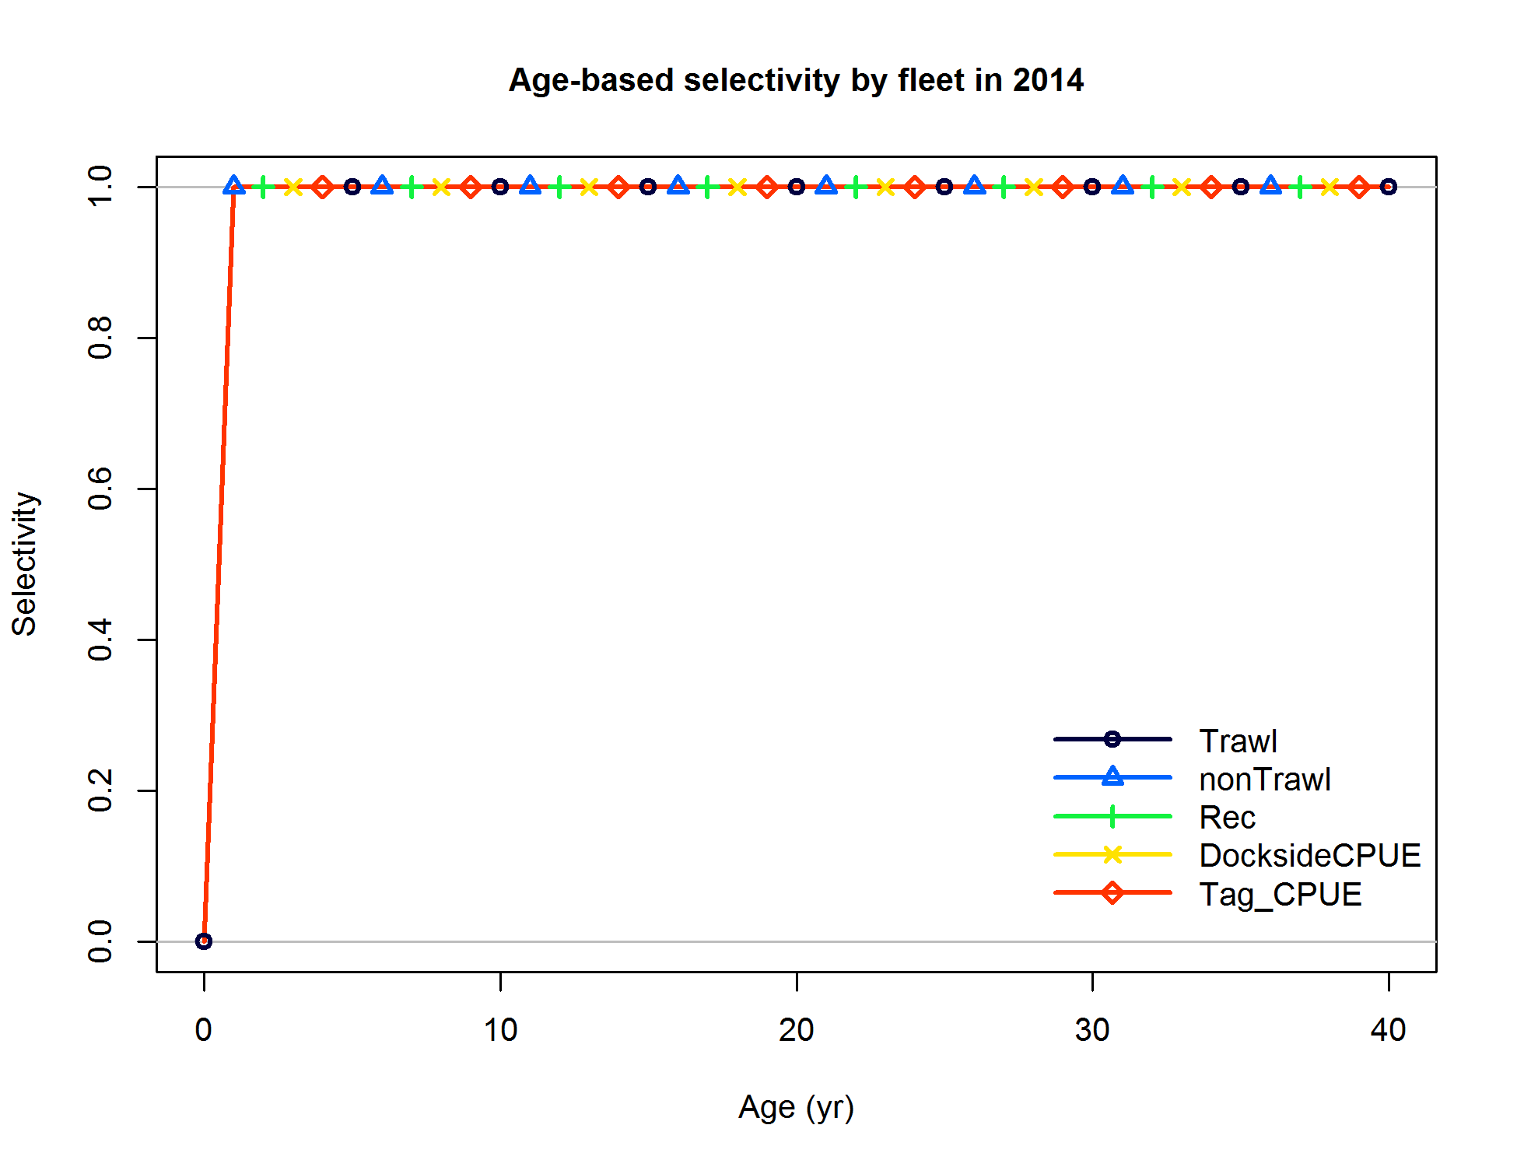

Figure . Base case estimates of age-based selectivity by fleet and survey for the Washington model.

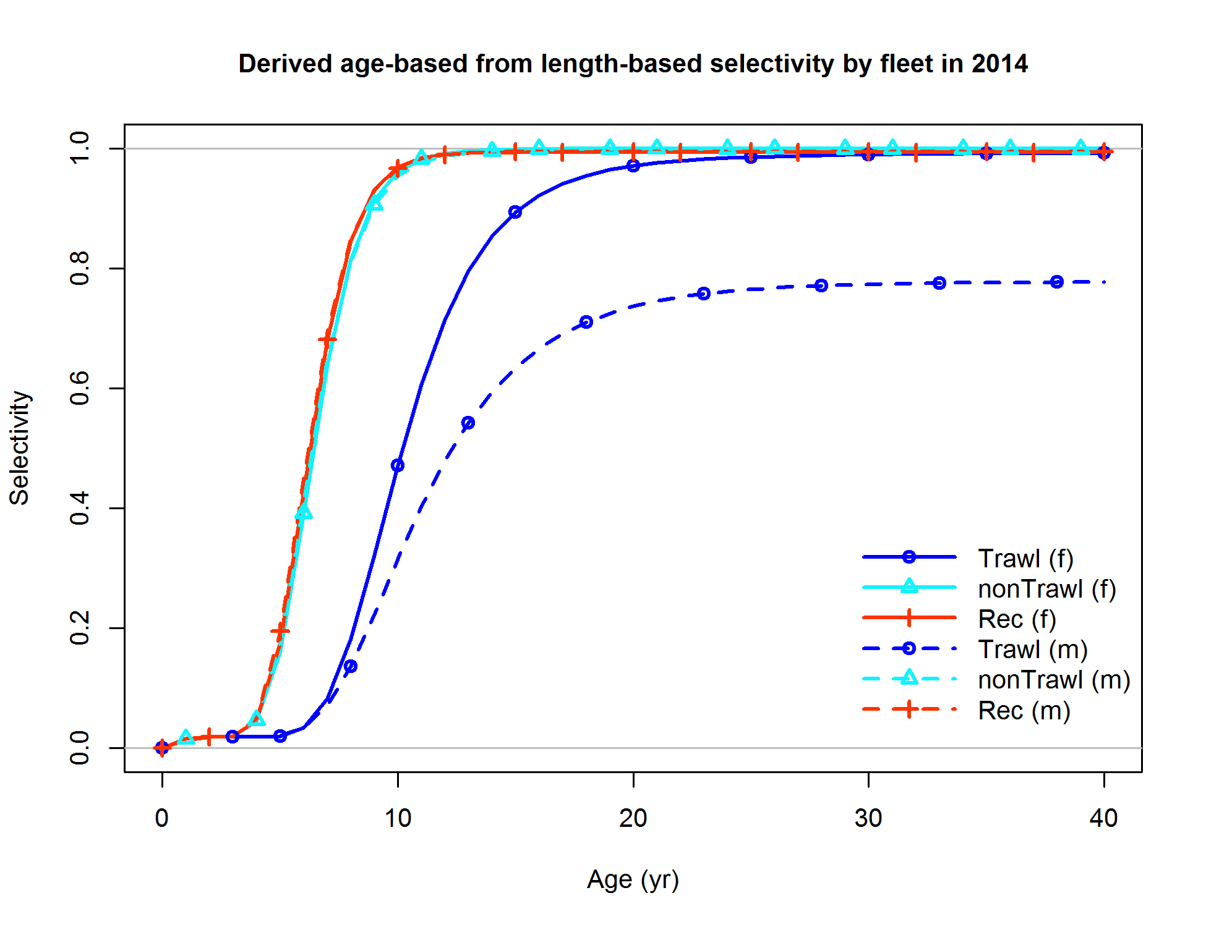

Figure . Base case estimated realized selectivity curves for each gear by sex for the Washington model.

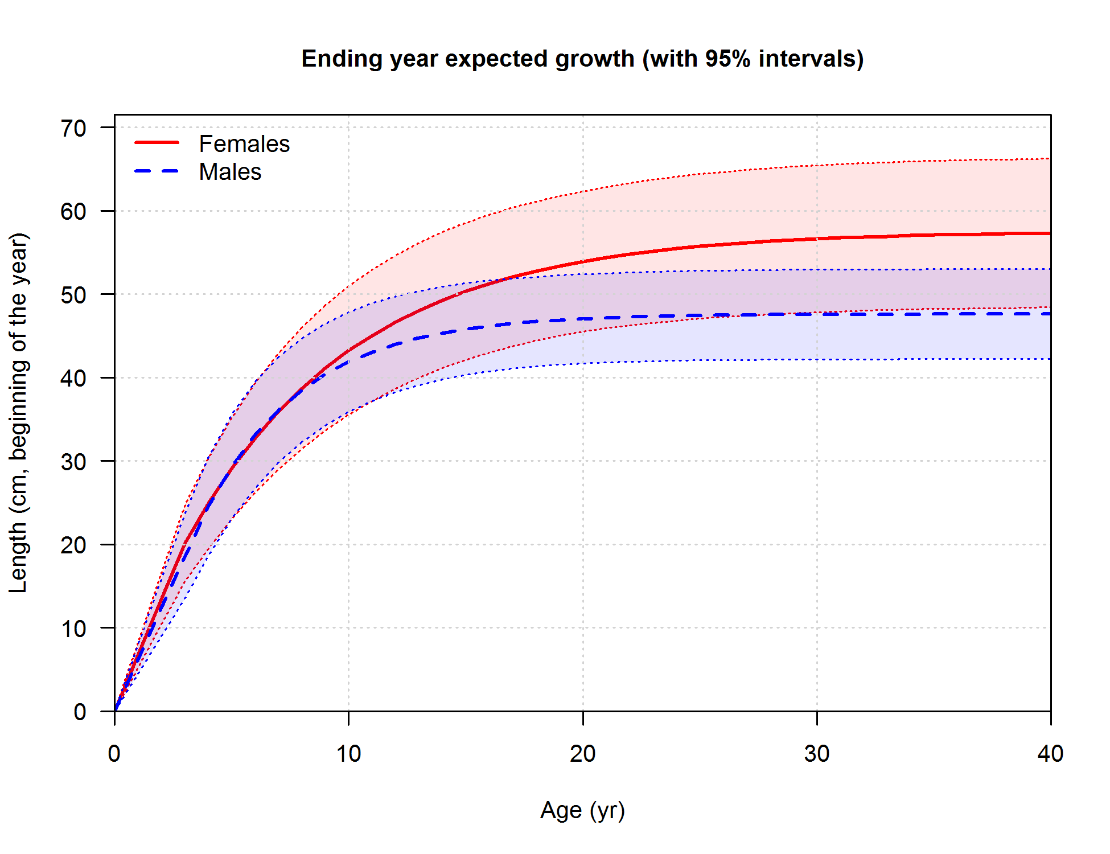

Figure . Base model estimates of sex-specific growth for the Washington model. Shading indicates 95% confidence intervals.



Figure . Washington base model estimate of spawning output with 95% confidence intervals.



Figure . Washington base model estimate of stock status (i.e., spawning depletion) with 95% confidence intervals.



Figure . Washington base model estimate of age-0 recruits with 95% confidence intervals.

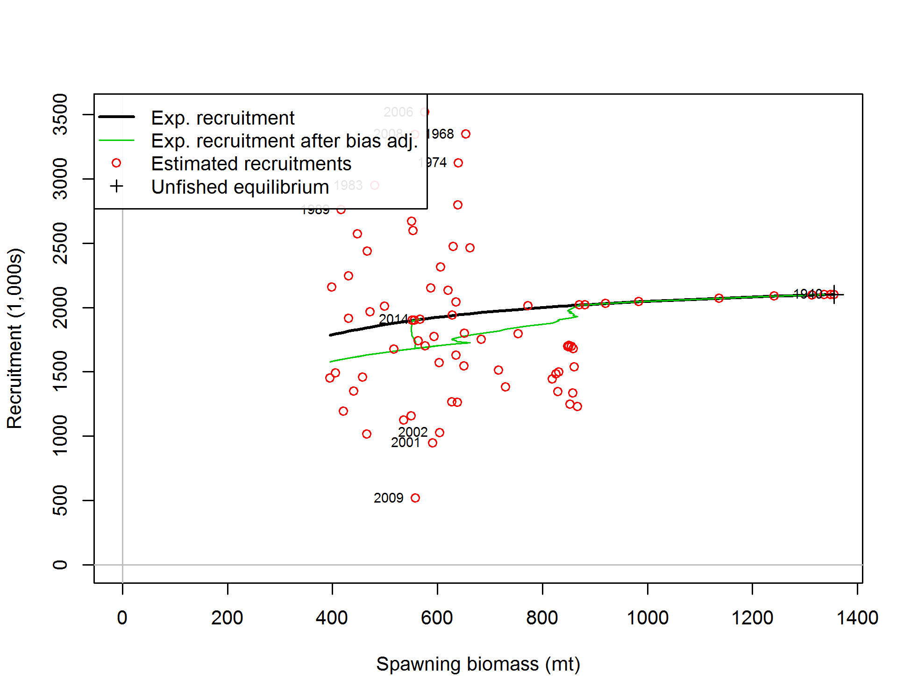

Figure . Stock-recruitment relationship from the Washington base case model.

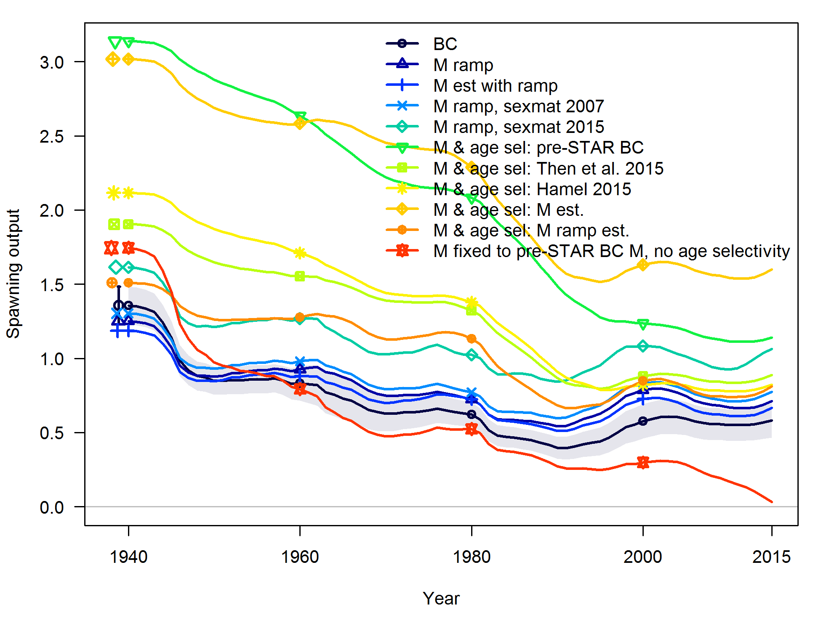

Figure . Comparison of stock output for sensitivity runs that alter natural mortality specification in the Washington model. Shading indicates 95% confidence intervals. BC = base case model.

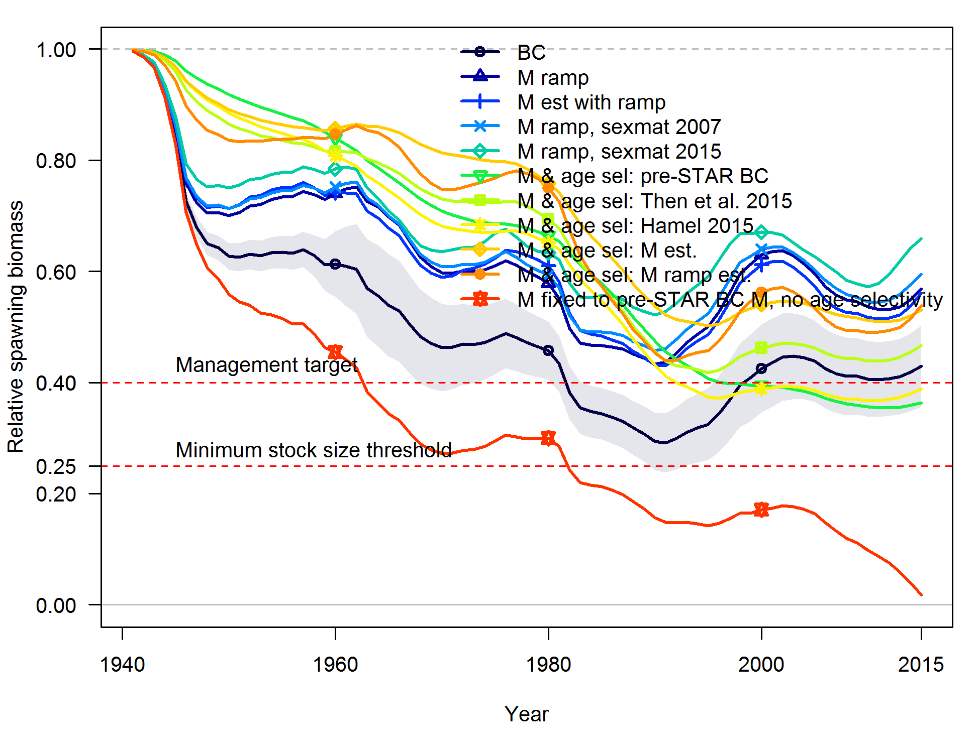

Figure . Comparison of relative stock output for sensitivity runs that alter natural mortality specification in the Washington model. Shading indicates 95% confidence intervals. BC = base case model.

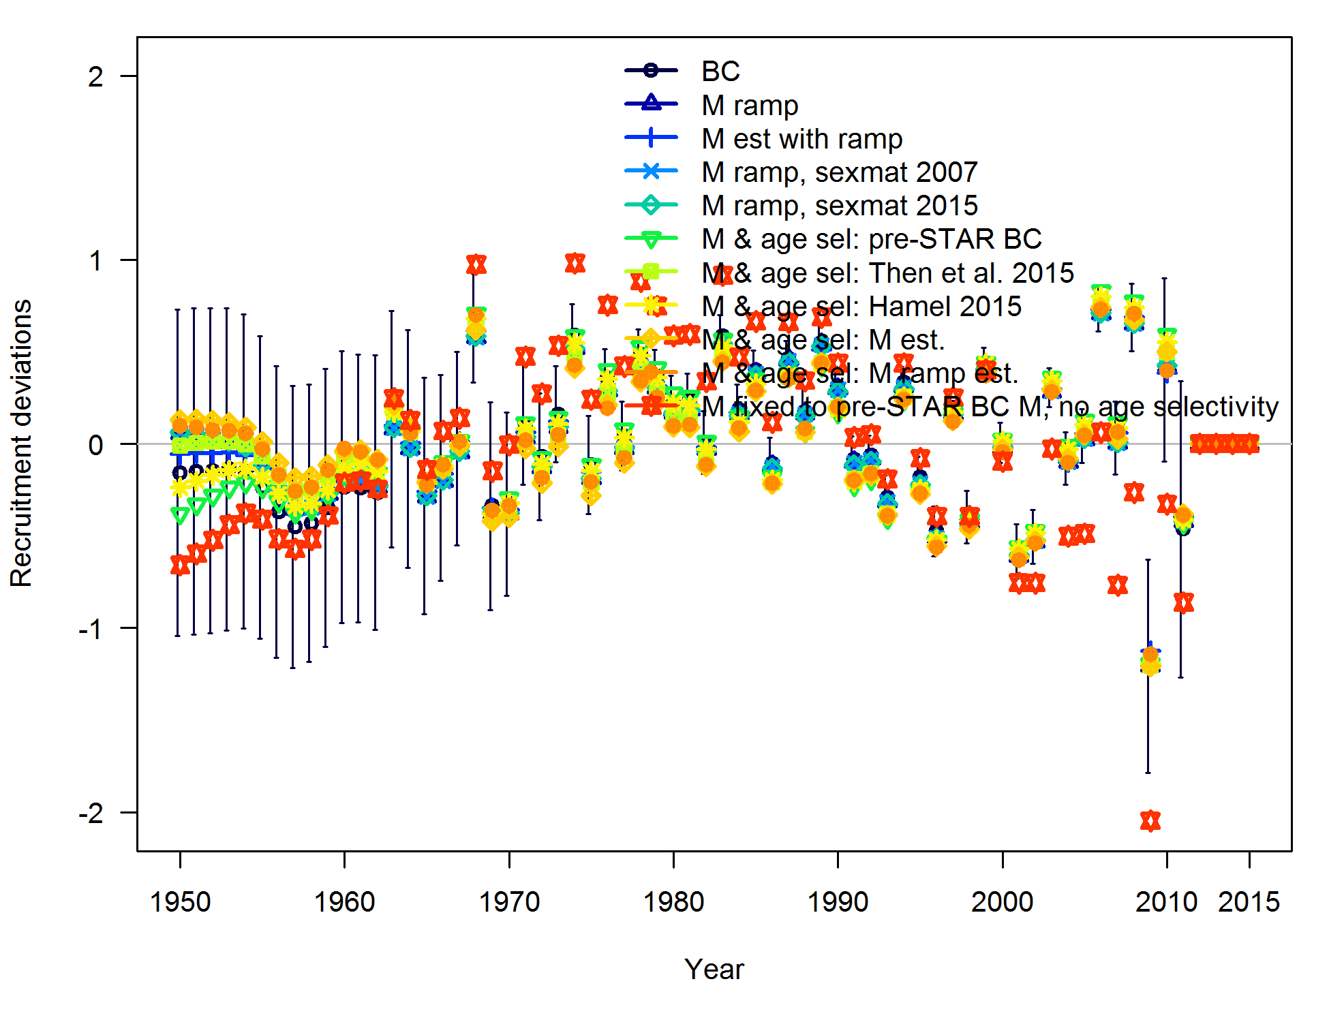

Figure . Comparison of recruitment deviations for sensitivity runs that alter natural mortality specification in the Washington model. Vertical lines indicate 95% confidence intervals. BC = base case model.

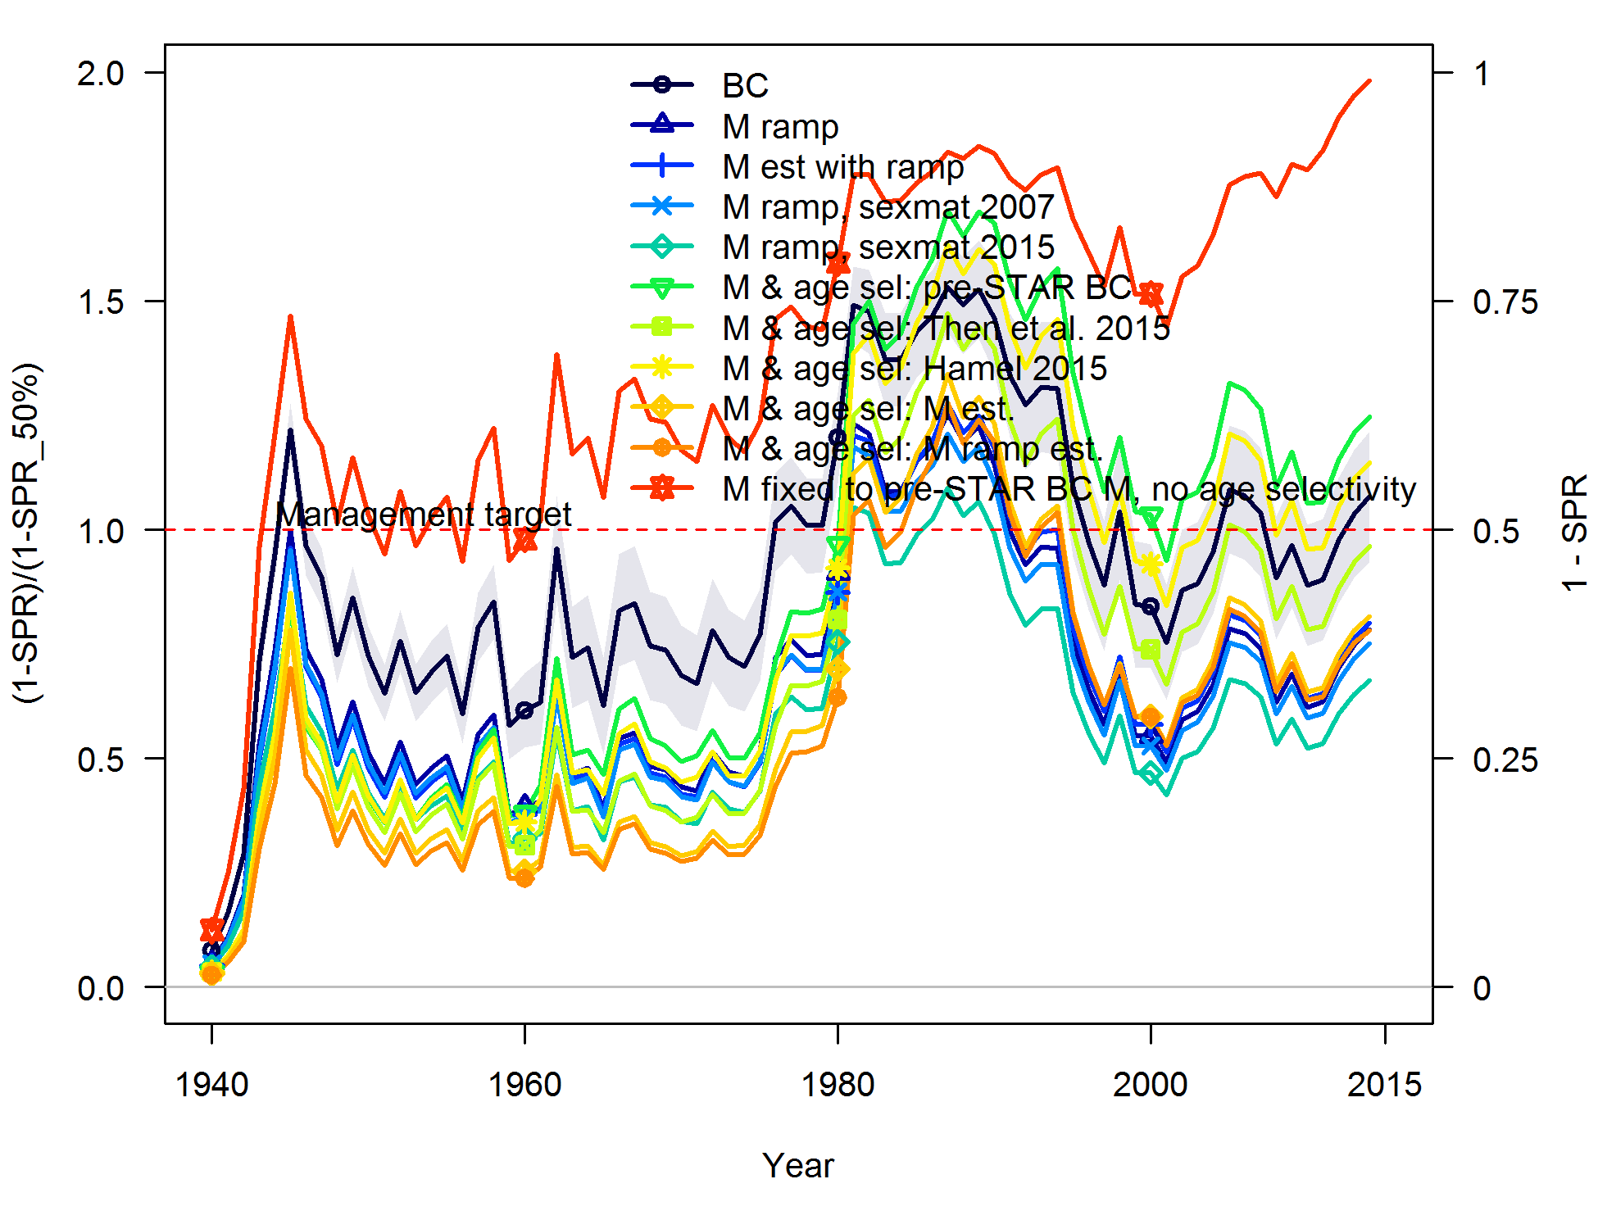

Figure . Comparison of fishing intensity for sensitivity runs that alter natural mortality specification in the Washington model. Shading indicates 95% confidence intervals. BC = base case model.

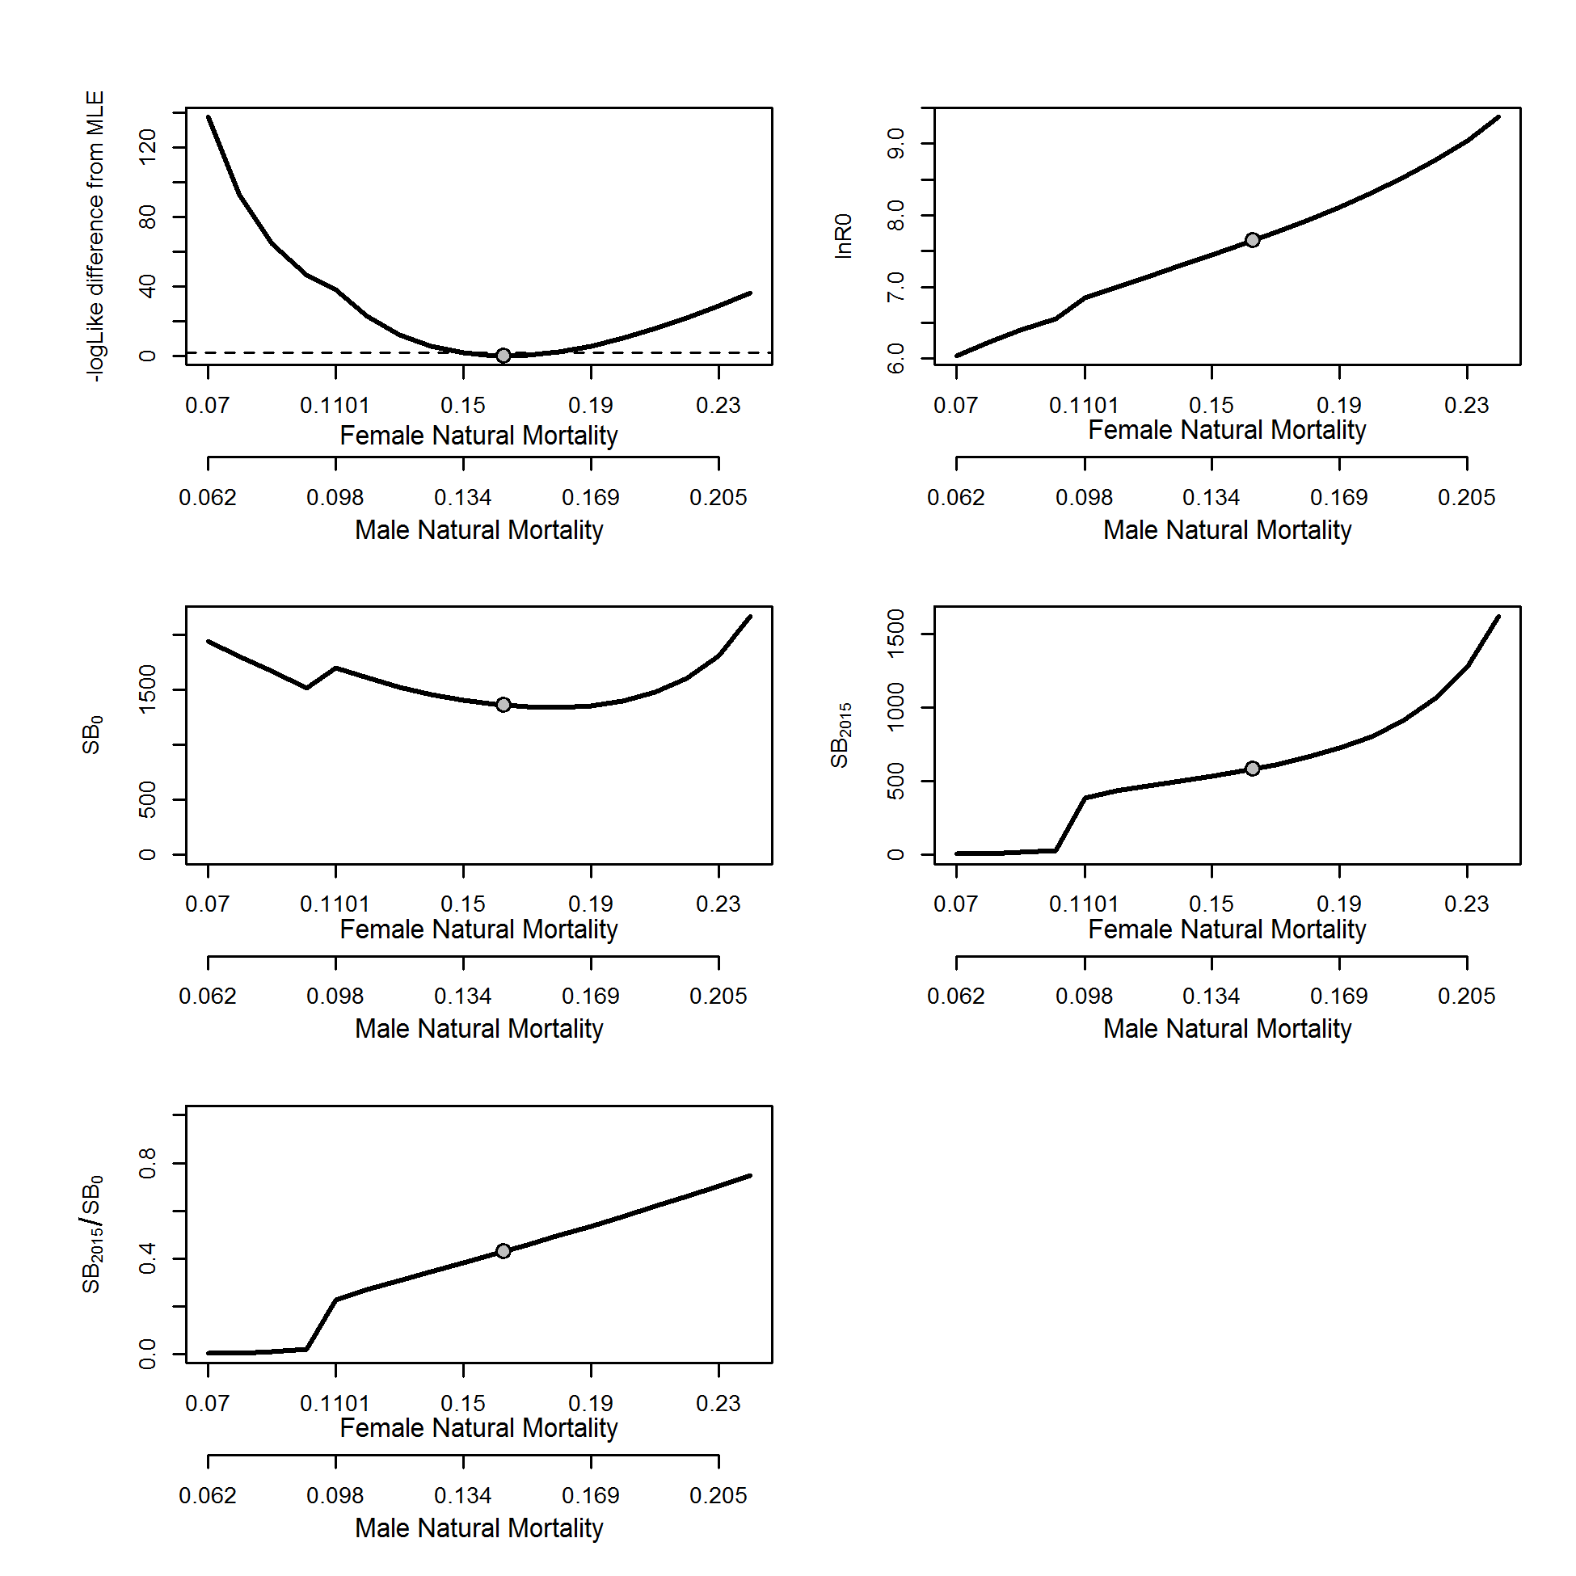

Figure . Likelihood profile in the Washington black rockfish model for female and male natural mortality and resultant estimated (lnR0) derived quantities (initial spawning output (SB0); spawning output in 2015 (SB2015) and stock status (SB2015/SB0)).

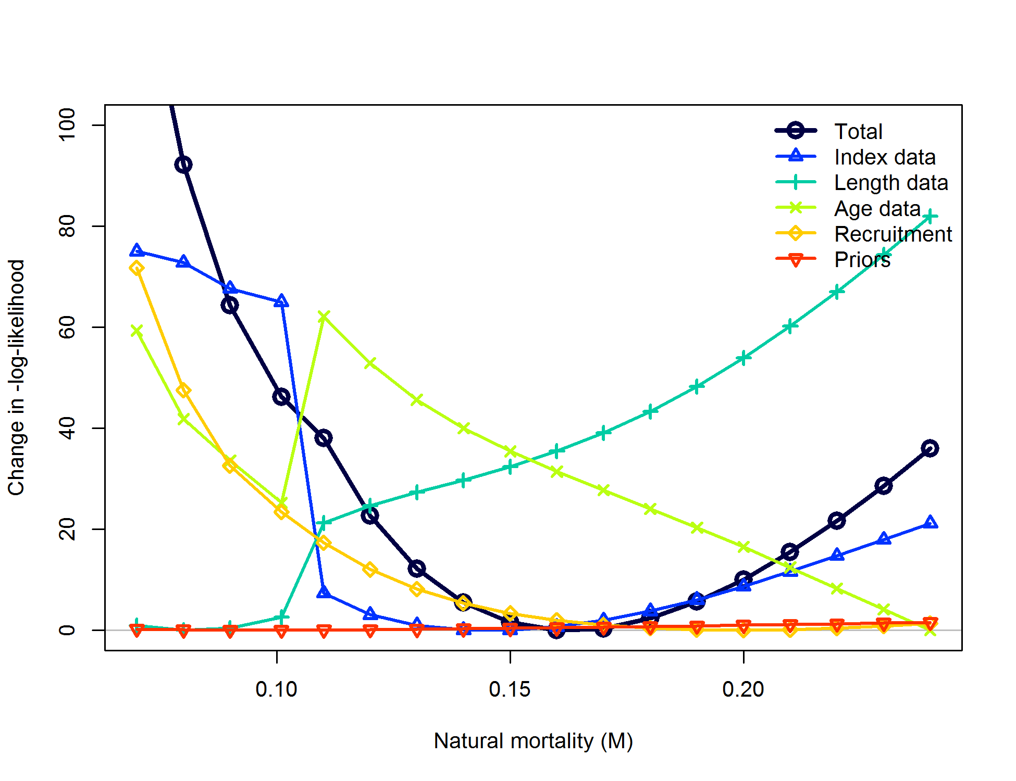

Figure . Likelihood component contributions across profiled values of female natural mortality in the Washington model.

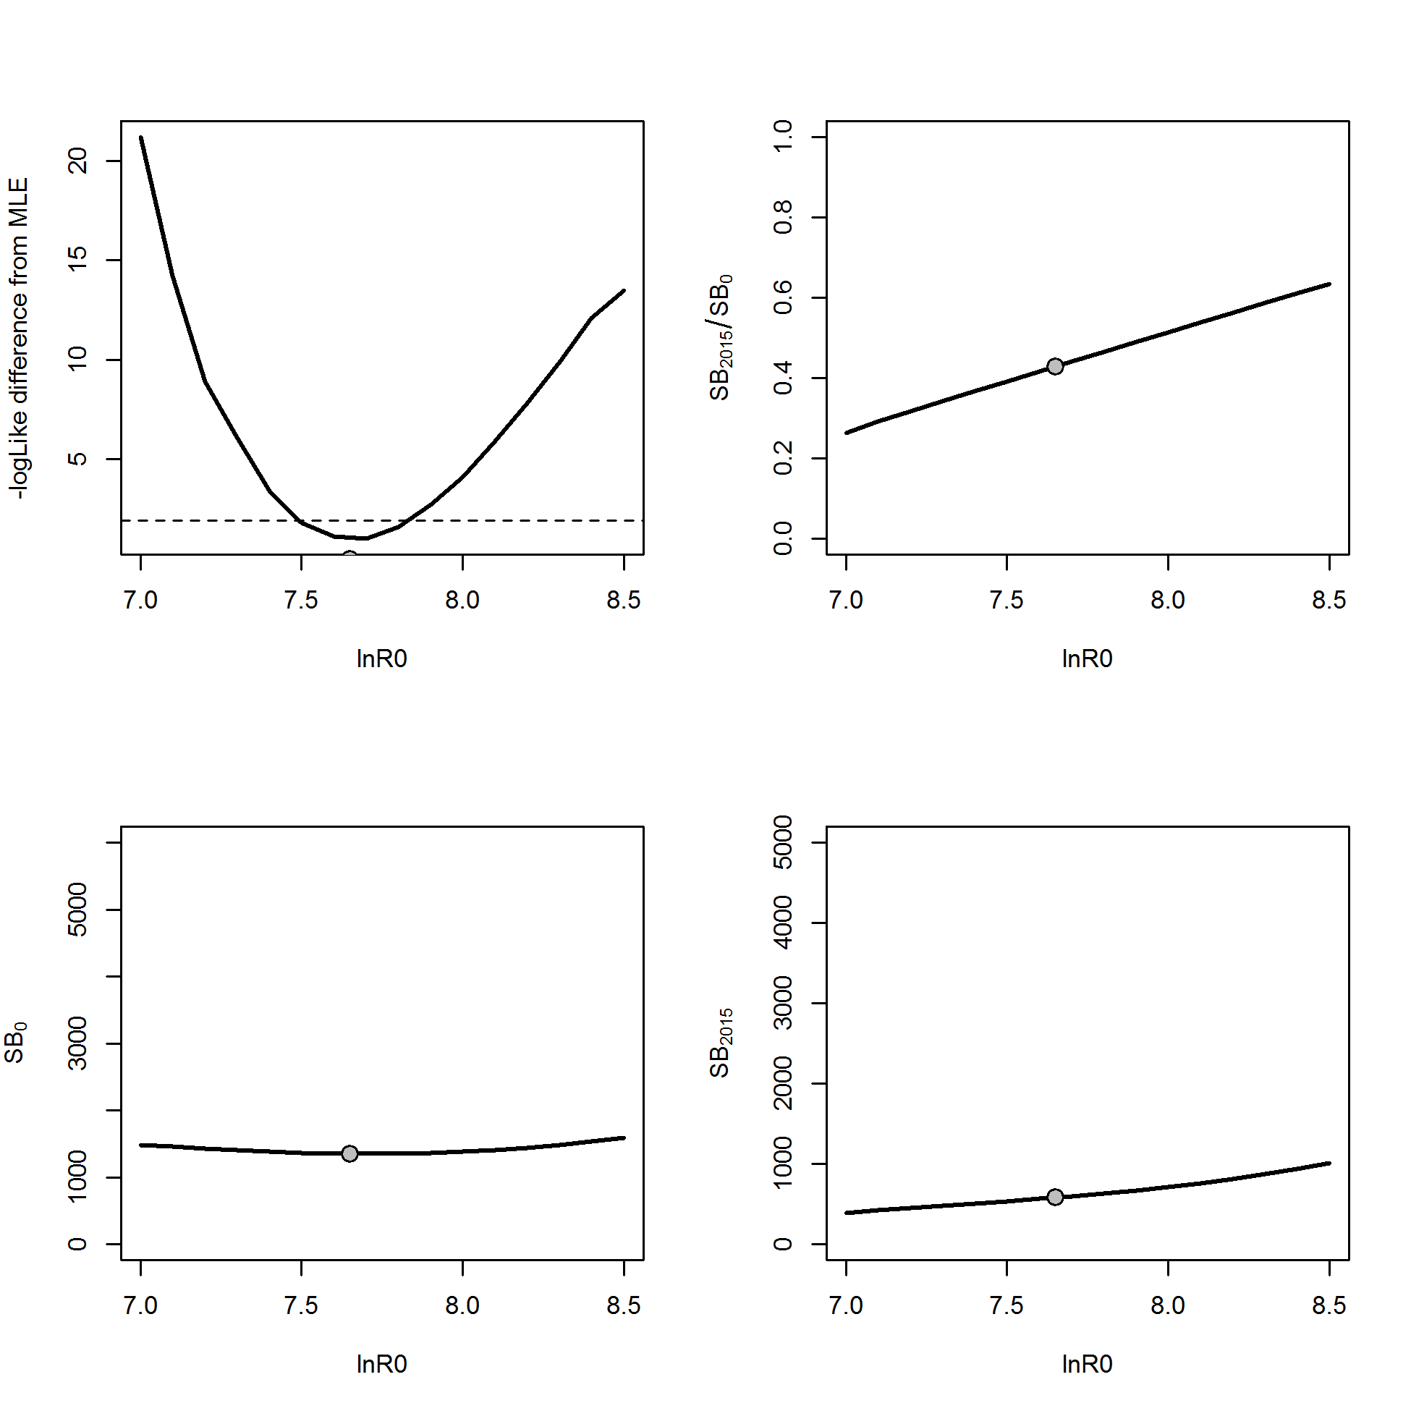

Figure . Likelihood profile in the Washington model for initial equilibrium recruitment (ln*R0*) and resultant derived quantities (initial spawning output (SB0); spawning output in 2015 (SB2015) and stock status (SB2015/SB0)).

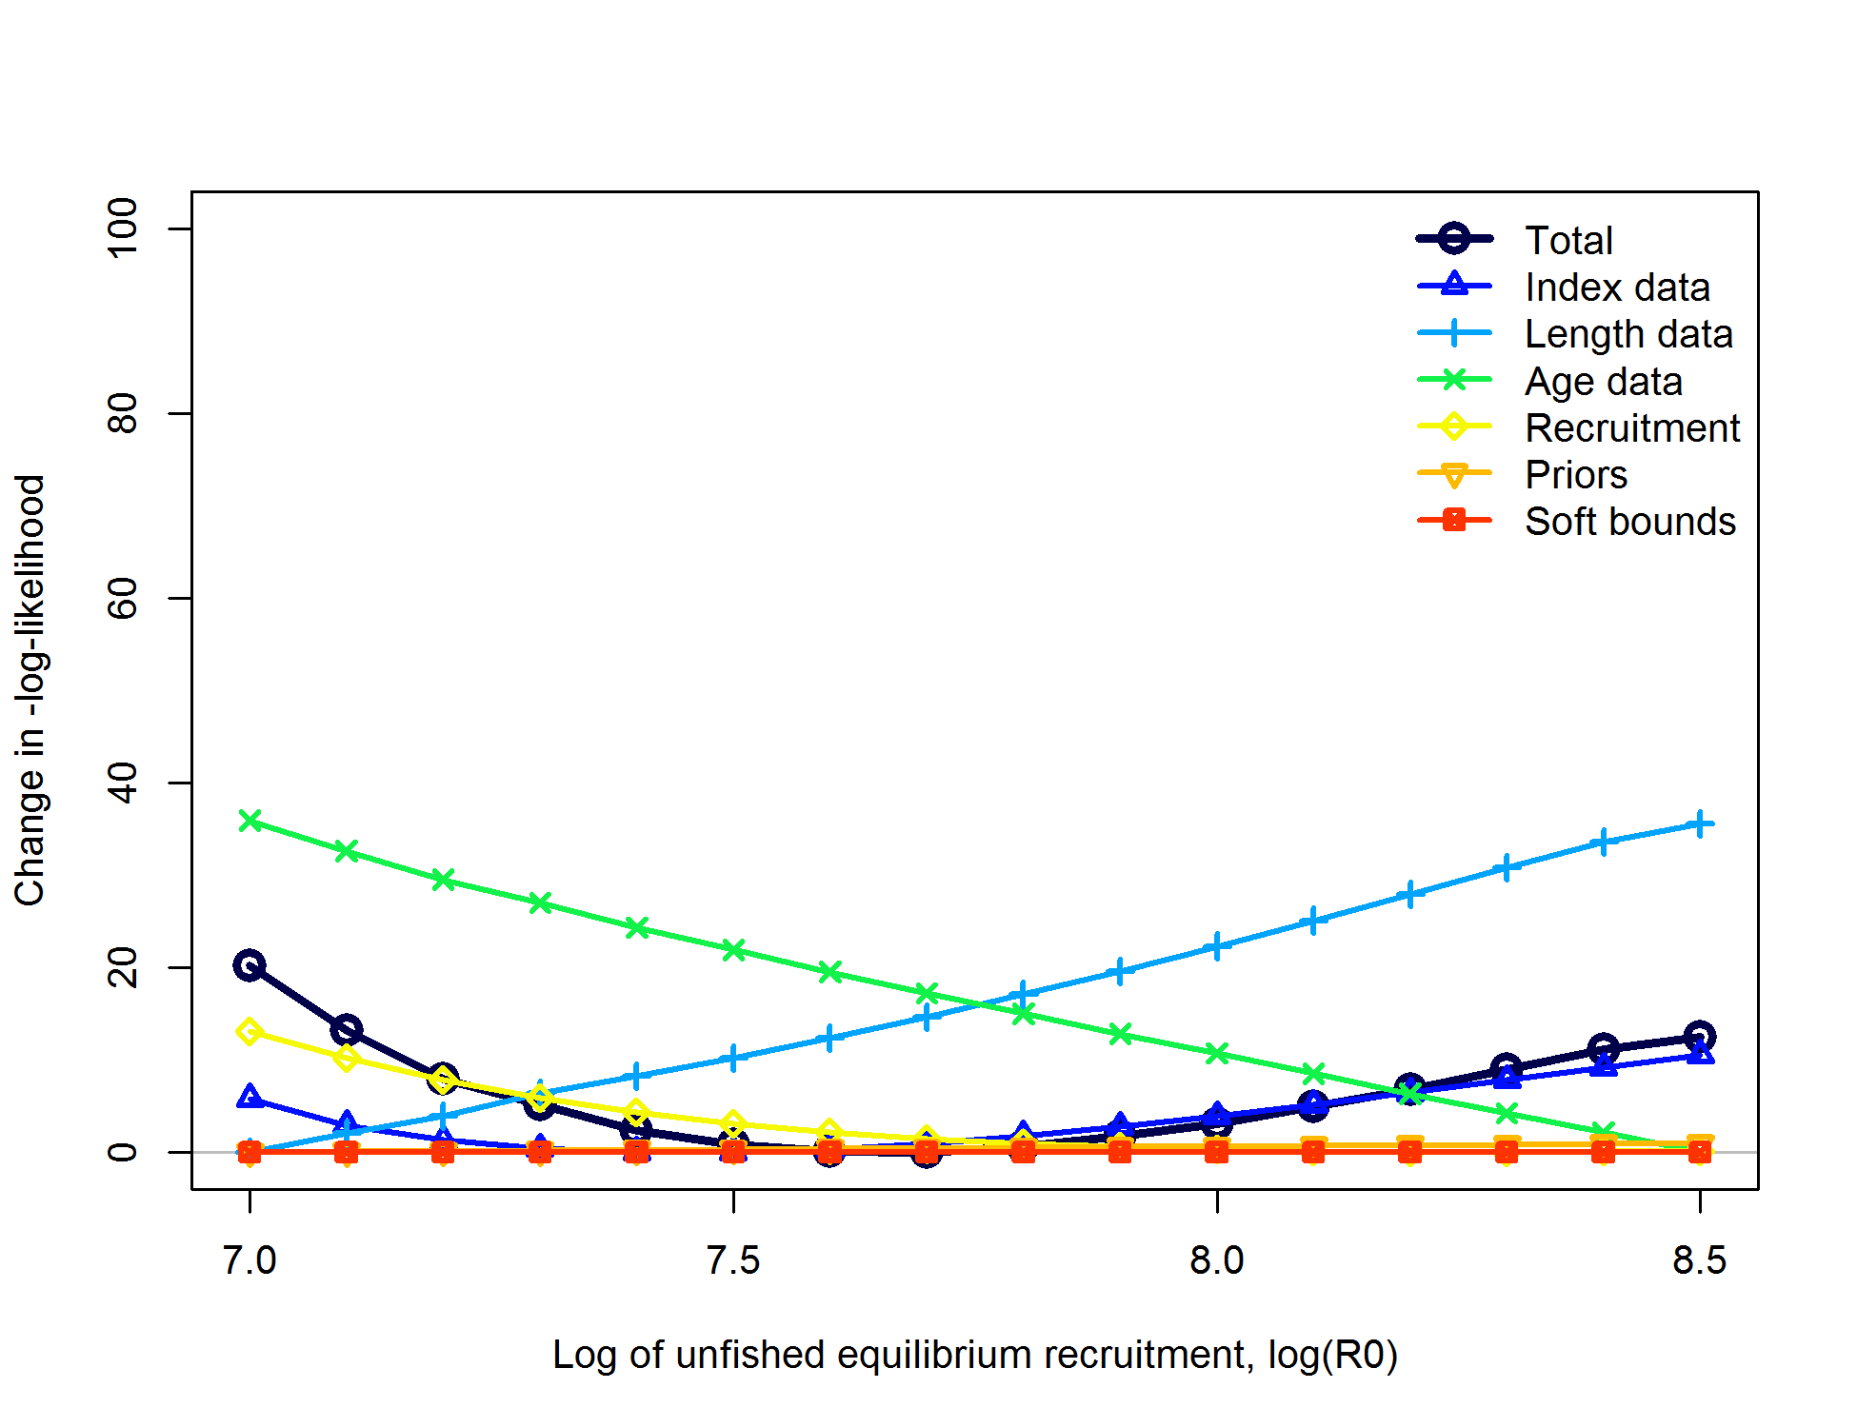

Figure . Likelihood component contributions across profiled values of initial recruitment in the Washington model.

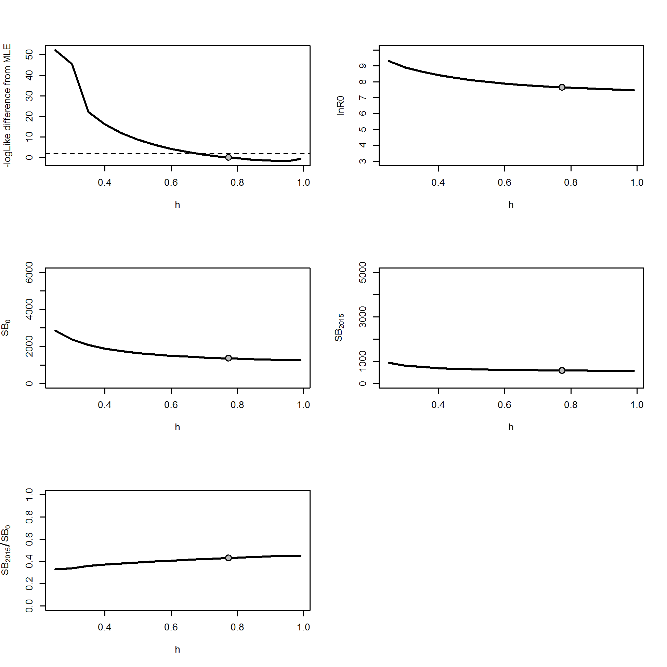

Figure . Likelihood profile in the Washington model for steepness (*h*) and resultant parameters and derived quantities (initial recruitment (ln*R0*); initial spawning output (SB0); spawning output in 2015 (SB2015) and stock status (SB2015/SB0)).

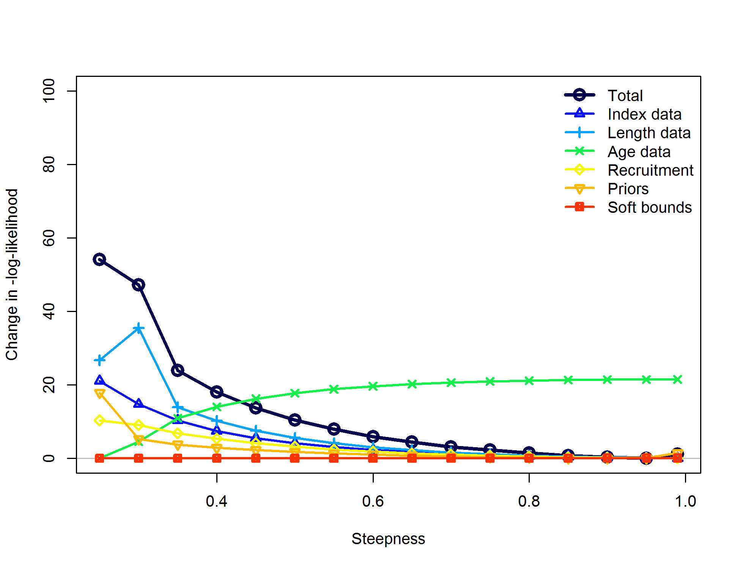

Figure . Likelihood component contributions across profiled values of steepness in the Washington model.

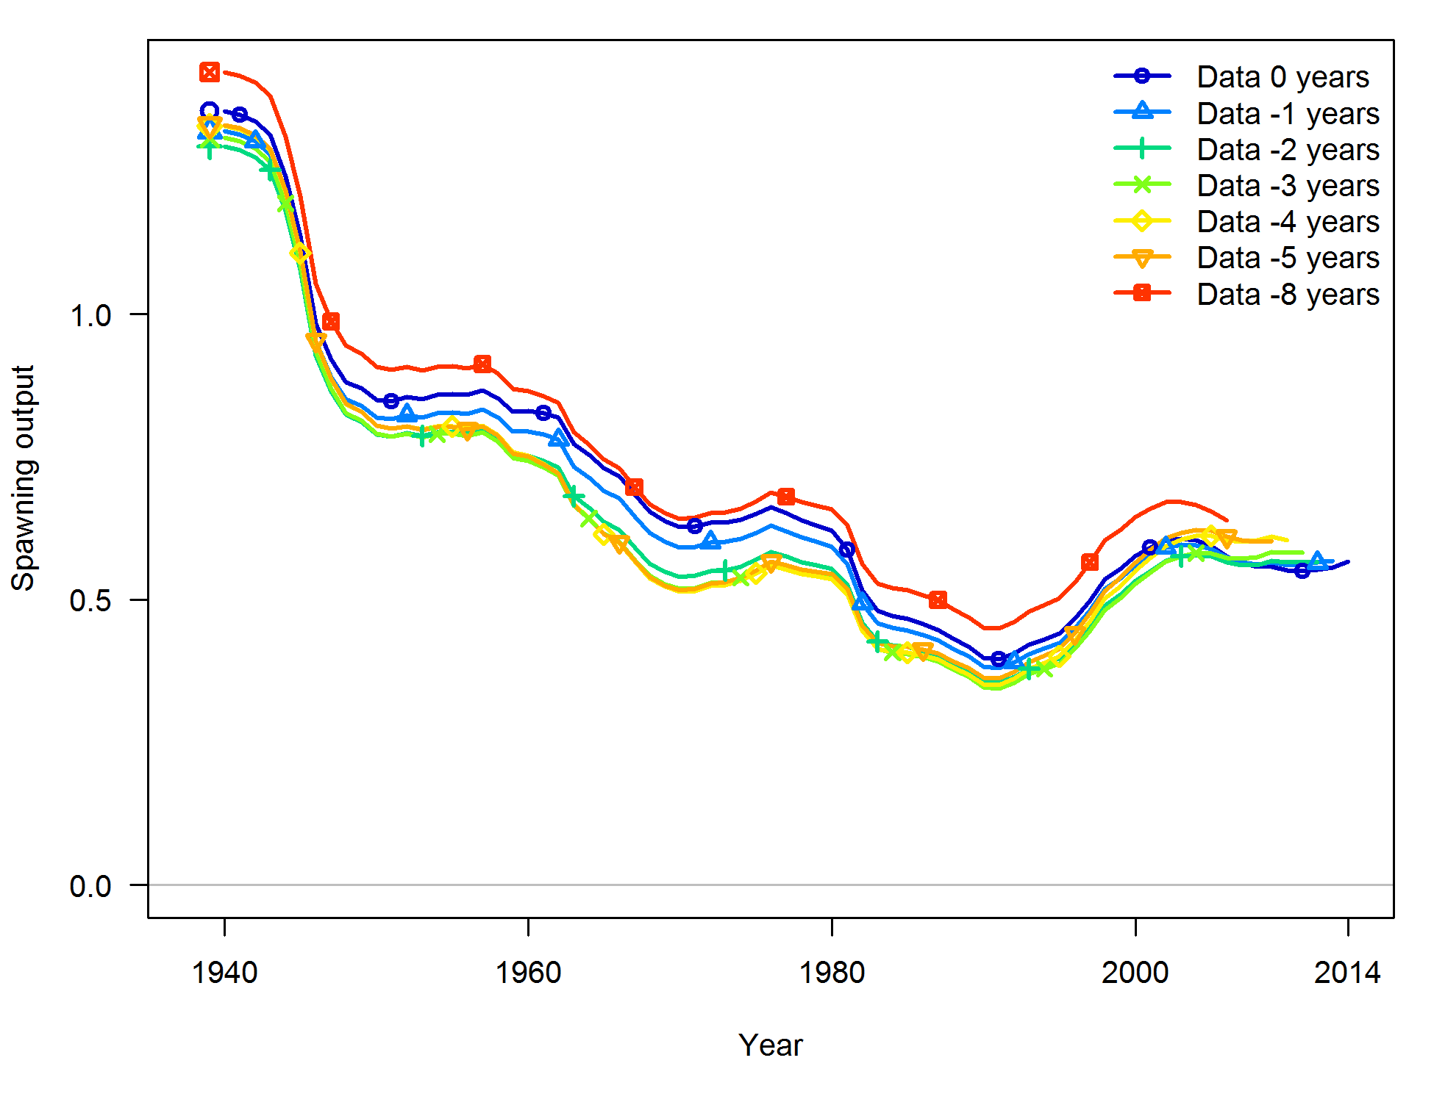

Figure . Retrospective model runs from the base case model of Washington (“Data 0 years”) for stock spawning output.

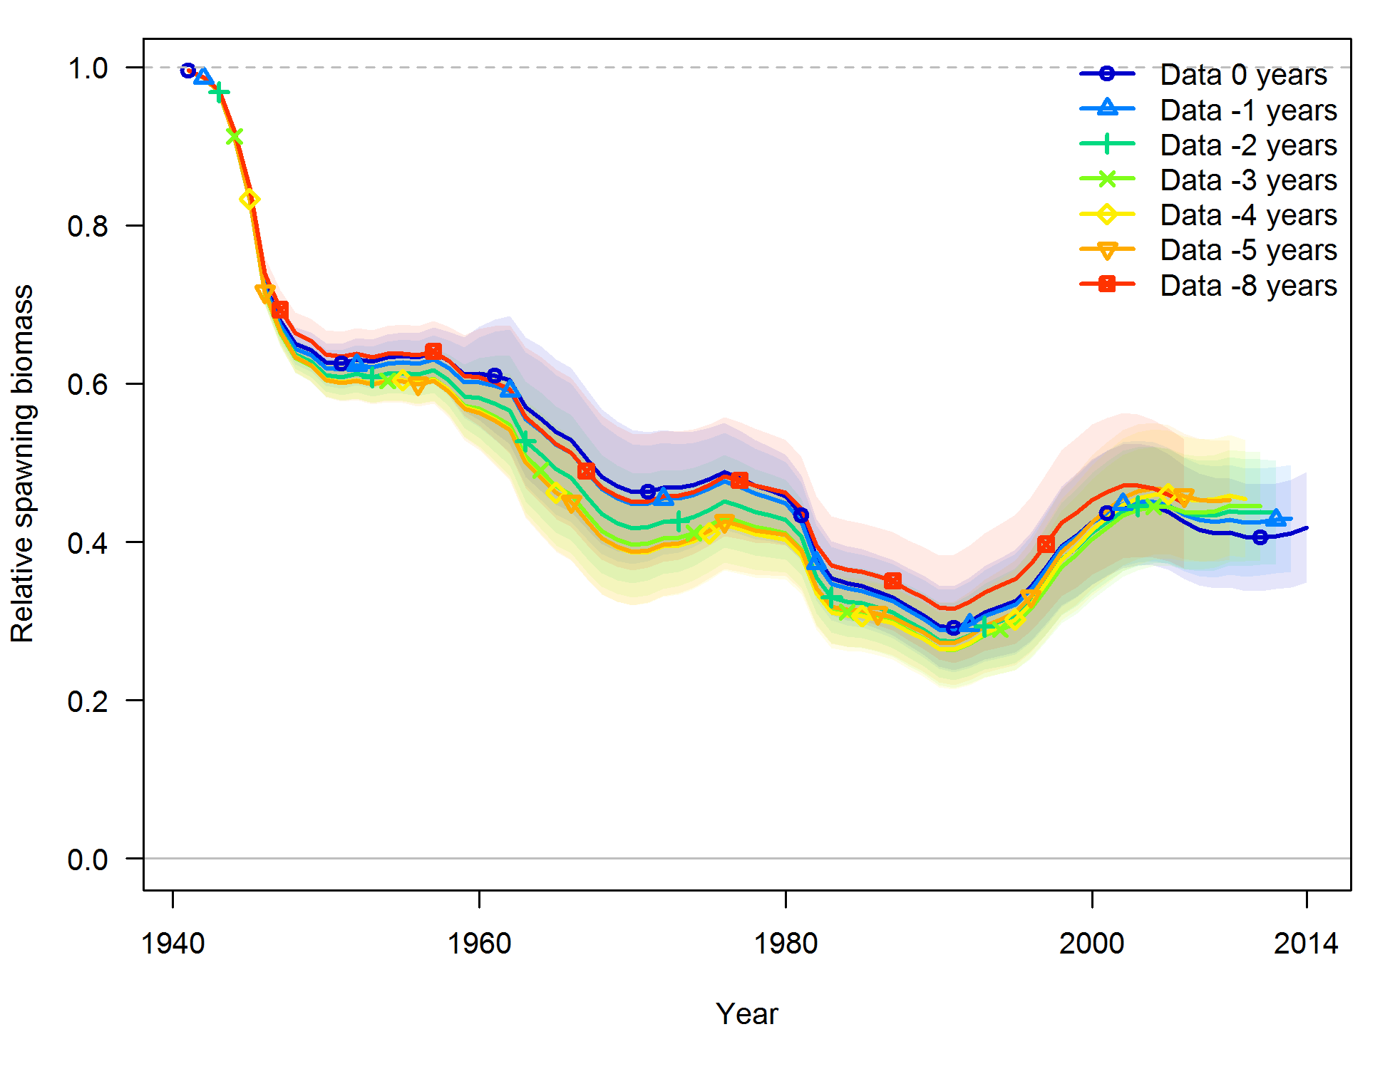

Figure . Retrospective model runs from the base case model of Washington (“Data 0 years”) for relative stock output (stock status). Shading indicates 95% confidence intervals.

.



Figure . Estimated spawning potential ratio (SPR) for the Washington base case model. One relative 1- minus SPR is plotted so that higher exploitation rates occur on the upper portion of the y-axis. The management target is plotted as a red horizontal line and values above this reflect harvests in excess of the overfishing proxy based on the SPR50% harvest rate. The last year in the time series is 2014.



Figure . Phase plot of relative spawning output vs fishing intensity for the Washington base case model. The relative fishing intensity is (1-SPR) divided by 50% (the SPR target). The vertical red line is the relative spawning output target defined as the annual spawning output divided by the spawning output corresponding to 40% of the unfished spawning output.



Figure . Equilibrium yield curve for the Washington base case model. Values are based on 2014 fishery selectivity and distribution with steepness fixed at 0.773. The depletion is relative to unfished spawning biomass.